The efficacy of different outdoor environments and activities as a medium for promoting health and well-being

Introduction
This report will cover the affordances of an outdoor environment and the positive mental and physical health benefit that go with participating in outdoor activities. The report will review the existing literature and research, in relation to health and wellbeing in the outdoors. The research in this paper will look at stress and anxiety before and after four different scenarios. It will also explore the extent to which a place, person or activity can positively influence mental health.
Literature Review
Health and well-being are fundamental to living a fulfilling and balanced life. “Health is a state of complete physical, mental and social well-being and not merely the absence of disease or infirmity” (WHO, 2025).
Well-being is a positive state experienced by individuals and societies. Well-being encompasses quality of life and the ability of people and societies to contribute to the world with a sense of meaning and purpose.
(WHO, 2025)
Stress and anxiety are particularly important when it comes to health and well-being. “Stress is any demand placed on your brain or physical body. Any event or scenario that makes you feel frustrated or nervous can trigger it” (The Healthline Editorial Team, 2022). Stress is more of a natural response to challenges, linked to a specific external trigger and usually temporary. On the other hand, anxiety is a more persistent, internal feeling of worry. “Anxiety is a feeling of fear, worry, or unease. While it can occur as a reaction to stress, it can also happen without any obvious trigger” (The Healthline Editorial Team, 2022). According to Cherney (2023), anxiety can cause many physical symptoms such as increased breathing and heart rate as well as stomach pains, depression and loss of libido.
Research shows that spending time outdoors has long been associated with improved health and well-being. Natural environments can provide essential affordances for reducing stress and anxiety. A study by Su and Huang (2024), assessed the effects of biophilic green walls and outdoor views on stress, anxiety and recovery in older adults. In the study, 23 adults were exposed to stressors before undergoing four randomized 5-minute Virtual Reality (VR) sessions. The VR environments included non-biophilic and biophilic settings. Anxiety was measured through the State-Trait Anxiety Inventory as well as heart rate and blood pressure. The participants reported lower anxiety levels after experiencing biophilic VR. The limitations of this study were that it was completed using VR, therefore the participant did not experience the full effect of a natural environment. However, in the article by Shaffee and Abd (2018) the authors conducted a systematic review of 42 studies to analyse how different types of landscapes influence psychological well-being. They found that nature exposure such as green spaces, forests and restorative landscapes can help reduce stress and improve mental health. This shows there are many of studies available which prove being in a biophilic environment can positively affect mental health and well-being.
“The biophilia hypothesis posits an innate biological and genetic connection between human and nature, including an emotional dimension to this connection” (Gaekwad, Sal Moslehia, Roös and Walker, 2022). Combining a natural environment with both exercise and biophilia could be more of a beneficial way to help reduce anxiety. According to Ratey (2019), exercise reduces anxiety by shifting focus, relaxing muscles and boosting anti-anxiety neurochemicals such as serotonin and GABA. It also strengthens brain regions that regulate stress, improving resilience over time. Nature connection could further amplify these benefits contributing to an overall deeper sense of well-being.
The study by Brown, Christian and Crowson (2023) examines the effects of adventure therapy, specifically mountain biking with middle school students. The study found to have showed an increased ability to manage stress and adapt to challenges, as well as students experiencing outdoor environments and physical activity which reduced anxiety and improved mood. “Participants reported many positive mental health benefits directly linked to their participation in mountain biking, including an improved mood, a decrease in stress and worry, and increased self-esteem “(Roberts, Jones and Brooks, 2018).
One could argue that just the activity itself is having a positive effect. However, a review by Gladwell et al. (2013) showed that the nature element of green exercise helped achieve a greater intensity of exercise without the perception of effort changing. The authors also state, by participating in physical activity in a natural environment may engage people in physical activity by increasing enjoyment of participation, offering social interaction and increased frequency of activity.
Theories such as Attention restoration theory can have an effect on anxiety. Self-determination theory emphasizes the satisfaction of fundamental psychological needs, namely autonomy, competence, and relatedness (Ryan and Deci, 2017). Individuals may experience heightened anxiety due to the lack of autonomy, competence and relatedness causing feelings of helplessness, inadequacy, or social isolation. According to Barth (2023) Attention restoration theory (ART) can be a way of a way of calming, restoring and soothing ourselves. According Basu and Duvall and Kaplan (2019) ART proposes that spending time in natural environments allows the mind to rejuvenate, alleviating stress and mental fatigue accumulated from daily demands by increasing soft fascination. These theories may help in combating stress and anxiety, however there is more recent research out there about the great outdoors helping with mental health and well-being.
An analysis of existing research revealed gaps in understanding whether the environment, activity or social factors work together or not, and which factors play the most significant role in improving health and well-being.
Method
For this study, random University students were selected through convenience sampling. The participants took part in four activities: breathing exercises at Celtic Deep, mountain biking, a cold-water swim and a solo activity where the participant had to spend at least an hour in a nature environment lone without technology. The participants were asked to complete two questionnaires before and after completing the activity. Perceived Stress Scale (PSS) and Positive and Negative Affect Scale (PANAS) were the questionnaires used as they are a robust way of measuring anxiety and mood. “Both PSS-PW and PSS-NW showed adequate internal consistency and retest reliabilities” (Jiang et al. 2017). Activities were selected to acquire data from various scenarios such as an adventurous activity, relaxation techniques, a social and an effect caused by a certain environment.
Results
PSS Mean Scores
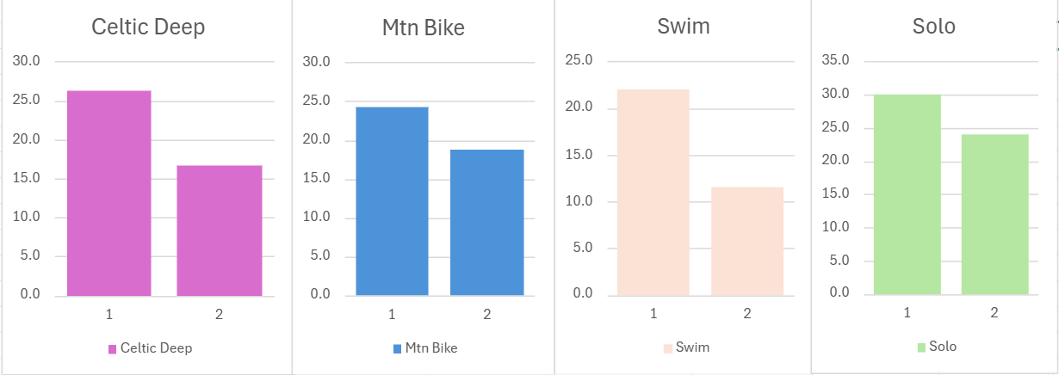
(Figure 1)

PANAS Mean Score
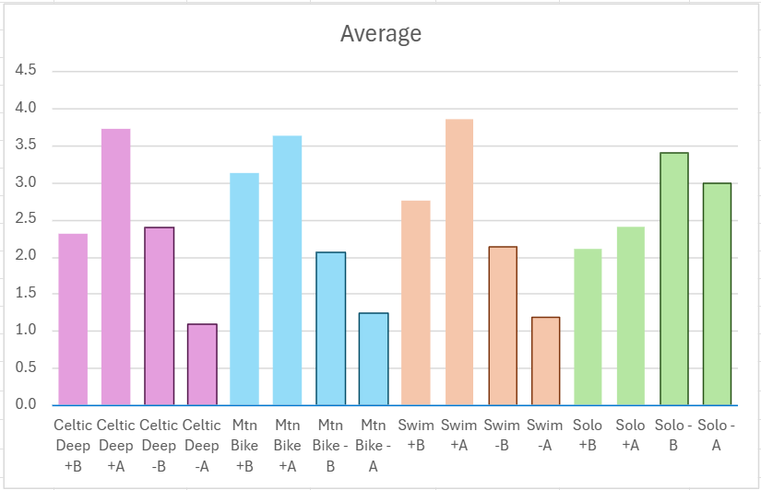
(Figure 2)
Results
From the graph (figure 1) the results showed that in all activities there was a significant decrease in perceived stress, the Cold-water Swim being the biggest decrease at 47%, compared to Mountain Biking with only a 23% decrease. The breathing exercises at Celtic Deep showed a 37% decrease and the Nature Solo showed a 20% decrease in stress. The PANAS mean results (Figure 2) showed a decrease in negative mood scores. The breathing exercises at Celtic Deep showed biggest decrease in negative mood scores at 54% followed by the cold swim at 45%, Mountain Biking at 38% and 12% decrease with the Nature Solo. All positive mood scores (Figure 2) showed and increase. The breathing exercises at Celtic Deep showed the biggest increase in positive mood at 61% scores with the Cold Swim next showing an increase of 39%, followed by Mountain Biking at 16% and the Nature Solo at 14%. These results may be skewed as there was a different number of participants on each activity.
Discussion
The data collected from this research shows that outdoor activities can have a significant impact on both stress reduction and mood enhancement. Across all four scenarios, participants reported reduced stress and negative mood scores, alongside increased positive mood scores, reinforcing that nature and exercise play a critical role in emotional well-being.
The Cold-water Swim showing the greatest reduction in perceived stress as well as the Celtic Deep breathing exercise showing the largest drop in negative mood relates to existing literature on the physiological and psychological effects. The article Greenspan, J. (2024) suggests that Cold-water immersion can help ease mood swings caused by menstruation and menopause as well as helping to reduce anxiety and improve mood. “Women reported that cold water swimming reduced their menstrual symptoms, notably psychological symptoms such as anxiety” (Pound, M. et al. 2024) The reduced anxiety was also shown in the breathing exercises which is presented in other research, for example the study by Cho, H. et al. (2016) found that daily mindful breathing practices significantly reduced test anxiety in university students.
Mountain Biking demonstrated moderate reductions in stress and negative mood. This can be shown in the study by Roberts, Jones and Brooks (2018) which found that mountain biking serves as an effective coping strategy for many riders, helping to reduce stress and improve mood. This can be found with other adventurous activities for example according to Clough, Mackenzie, Mallabon and Brymer (2016) adventurous physical activities, such as rock climbing and kayaking can serve as effective mental health interventions by promoting resilience, self-efficacy and emotional regulation. However, mountain biking requires skill, decision-making, and environmental awareness which may place more stress on the individual depending on their competency on a mountain bike.
The Nature Solo activity produced the smallest effects in stress reduction. This may have been due to the lack of social interaction therefore making the natural environment seem daunting. However, evidence such as the biophilia hypothesis and ART provide support for nature connectedness and its benefits to mental health and wellbeing. A study by Guo, D. et al. (2024) found that both forest walking and guided forest therapy effectively reduced stress and supported mental and physical recovery with increased nature connectedness lowering state anxiety. This could be due to the biophilia hypothesis and ART. The study by Abdelaal, and Soebarto (2019) explores how biophilic and salutogenic design in healthcare architecture can enhance patient recovery and well-being by integrating natural elements into hospital spaces.
This research as well as existing research shows strong evidence that there are significant psychological benefits to outdoor activities. This is why green social prescribing is a beneficial way to help combat mental health problems. “Green social prescribing is the practice of supporting people to engage in nature-based interventions and activities to improve their mental and physical health” (NHS England, 2022). NHS England (2022) says that there is strong evidence that nature-based activities such as walking, gardening, and open-water swimming help to improve mental and physical health, reduce stress, and enhance well-being. This links to the research by backing up the idea that outdoor environments and activities can serve as an effective strategy for stress reduction and mood enhancement. Projects such as Coed Lleol (2025) run woodland-based health and well-being initiatives across Wales, utilizing nature-based activities and social prescribing to promote both mental and physical health. Developing Mountain Biking in Scotland (2025) believes trail therapy can also help with the mentally ill and improve one’s health and wellbeing. Wildlife and Countryside Link (2024) are proposing an Outdoors for All Manifesto which advocates for a Natural Health Service that ensures free and accessible green and blue spaces, promoting mental and physical well-being through nature-based activities. If there is strong evidence then the government should be promoting and implementing projects such as these to move more towards a preventative health care system.
Overall, this research and the existing literature provides strong evidence that outdoor activities can meaningfully reduce stress and improve mood. This study lacked participants, however there was a clear link between reductions in stress and anxiety and the great outdoors.
Word Count: 1909
I acknowledge the use of ChatGPT (https://chatgpt.com/) on 15 May 2025 to help me read the article, using the prompt(s):
1. Please summarize this article
I confirm that I have not presented any AI generated text as my own work. I confirm I have copies of my drafts, notes, and other resources I used before, and after the use of AI tools which I may be asked to provide in evidence.

Appendices
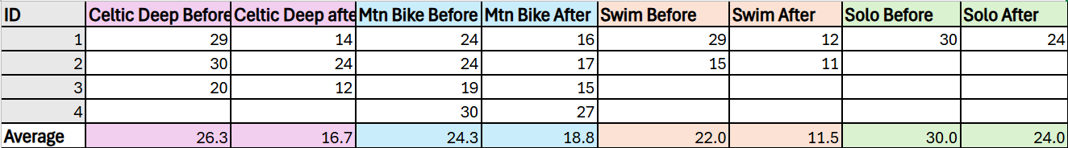

References

Abdelaal, M. S., & Soebarto, V. (2019) ‘Biophilia and Salutogenesis as restorative design approaches in healthcare architecture’, Architectural science review, 62(3), pp. 195–205. https://doi.org/10.1080/00038628.2019.1604313.

Barth, D (2023) Stressed, Worried, or Overwhelmed? Soft Fascination Can Help. Available at: https://www.psychologytoday.com/gb/blog/off-the-couch/202310/stressed-worried-or-overwhelmed-soft-fascination-can-help (Accessed: 12 May 2025).

Basu, A., Duvall, J., & Kaplan, R. (2019) ‘Attention restoration theory: Exploring the role of soft fascination and mental bandwidth’, Environment and behaviour, 51(9-10), pp. 1055-1081.

Brown, C.L., Christian, D.D., & Crowson, H.M. (2023) 'Effects of an adventure therapy mountain bike program on middle school students’ resiliency', Journal of Child and Adolescent Counseling, 9(2), pp. 222–241. https://doi.org/10.1080/23727810.2023.2229084.

Cherney, K. (2023) Effects of Anxiety on the Body. Available at: https://www.healthline.com/health/anxiety/effects-on-body (Accessed: 05 May 2025).

Cho, H., Ryu, S., Noh, J., & Lee, J. (2016) ‘The Effectiveness of Daily Mindful Breathing Practices on Test Anxiety of Students’, PloS one, 11(10), pp. e0164822–e0164822. Available at: https://doi.org/10.1371/journal.pone.0164822.

Clough, P., Houge Mackenzie, S., Mallabon, L., & Brymer, E. (2016) ‘Adventurous Physical Activity Environments: A Mainstream Intervention for Mental Health’, Sports medicine (Auckland), 46(7), pp. 963–968. https://doi.org/10.1007/s40279-016-0503-3.

Coed Lleol (2025) Wellbeing Projects. Available at: https://www.smallwoods.org.uk/en/coedlleol/what-we-do/projects/ (Accessed: 15 May 2025).

Developing Mountain Biking in Scotland (2025) New MTB and Mental Health 'Trail Therapy' Project - Ready to Ride. Available at: https://www.britishcycling.org.uk/scotland/article/20210429-scottish-cycling-news-New-MTB-and-Mental-Health--Trail-Therapy--Project---Ready-to-Ride-0 (Accessed: 15 May 2025).

Gaekwad, J. S., Sal Moslehian, A., Roös, P. B., & Walker, A. (2022) ‘A Meta-Analysis of Emotional Evidence for the Biophilia Hypothesis and Implications for Biophilic Design’, Frontiers in psychology, 13, pp. 750245. https://doi.org/10.3389/fpsyg.2022.750245.

Gladwell, V.F., Brown, D.K., Wood, C., Sandercock, G.R., & Barton, J.L. (2013) 'The great outdoors: how a green exercise environment can benefit all', Extreme Physiology & Medicine, 2(3). https://doi.org/10.1186/2046-7648-2-3.

Greenspan, J. (2024). Taking the Plunge: Tallying the benefits of cold-water swimming. In Scientific American (Vol. 330, Number 6, pp. 16–16). Scientific American, Inc. https://doi.org/10.1038/scientificamerican062024-4rsHRiMTx6VSBo9Ykolv8a.

Guo, D., Xu, T., Luo, J., Wang, X., Lin, S., Lin, C., Hong, Y., & Chang, W. (2024) ‘The evidence for stress recovery in forest therapy programs: investigating whether forest walking and guided forest therapy activities have the same potential?’, Journal of forestry research, 36(1), pp. 15–15. https://doi.org/10.1007/s11676-024-01812-9.

Jiang, J.M., Seng, E.K., Zimmerman, M.E., Sliwinski, M., Kim, M., & Lipton, R.B. (2017) ‘Evaluation of the reliability, validity, and predictive validity of the subscales of the Perceived Stress Scale in older adults’, Journal of Alzheimer’s Disease, 59(3), pp. 987–996. doi:10.3233/JAD-170289.

NHS England (2022) Green social prescribing. Available at: https://www.england.nhs.uk/personalisedcare/social-prescribing/green-social-prescribing/ (Accessed: 12 May 2025).

Pound, M., Massey, H., Roseneil, S., Williamson, R., Harper, C. M., Tipton, M., Shawe, J., Felton, M., & Harper, J. C. (2024) ‘How do women feel cold water swimming affects their menstrual and perimenopausal symptoms?’, Post reproductive health, 30(1), pp. 11–27. https://doi.org/10.1177/20533691241227100.

Ratey, J.J. (2019) Can exercise help treat anxiety? Available at: https://www.health.harvard.edu/blog/can-exercise-help-treat-anxiety-2019102418096 (Accessed: 05 May 2025).

Roberts, L., Jones, G., & Brooks, R. (2018). Why do you ride? A characterization of mountain bikers, their engagement methods, and perceived links to mental health and well-being. Frontiers in psychology, 9, 1642.

Ryan, R. M. & Deci, E. L. (2017) ‘Self-determination theory: Basic Psychological needs in motivation, development, and wellness’, New York: The Guildford Press.

Shaffee, N. & Abd Shukor, S.F. (2018) 'The effect of natural settings on stress reduction', Department of Landscape Architecture, Faculty of Design and Architecture, University Putra Malaysia.

Su, X. & Huang, X. (2024) 'Promoting stress and anxiety recovery in older adults: assessing the therapeutic influence of biophilic green walls and outdoor view', Frontiers in Public Health, 12. https://doi.org/10.3389/fpubh.2024.1352611.

Wildlife and Countryside Link (2024) Outdoors For All Manifesto sets out a vision for a natural health service that is free and available for all. Available at: https://www.wcl.org.uk/vision-for-natural-health-service-that-is-free-and-available-for-all.asp (Accessed: 15 May 2025).

World Health Organization (2025) Constitution. Available at: https://www.who.int/about/governance/constitution (Accessed: 05 May 2025).

World Health Organization (2025) Promoting well-being. Available at: https://www.who.int/activities/promoting-well-being (Accessed: 05 May 2025).

