“Discuss how you would plan and design a project management process for the workplace”

Introduction
In this commentary, I will utilise the research undertaken into project management approaches thus far and apply the findings of this research to a specific project within the context of my workplace.
The implications of the question are such that I will need to provide specific details about a tangible project as a means of discussing how I would plan and design a project management process within the context of my workplace. To achieve this, I have chosen to reflect on a large-scale project that I first became involved in when I was appointed as Digital Learning Manager.
In addition to discussing and reflecting upon the chosen project, I will need to take into consideration the key project management approaches I have researched as part of this module, including the affordances and limitations of each approach according to the literature, as well as the recommendations made in the first assignment of this module.
As part of this reflection process, it will be worthwhile considering the key challenges encountered during the project itself and seeing how these compare with current ongoing projects. Likewise, it will be useful to look forwards to forthcoming projects and consider how lessons learned from previous projects, as well as a growing knowledge of project management approaches and methodologies, can be applied in the future.

Project context

Project significance
The significance of the chosen project is that it is the largest project the team and I have worked on to date, both in terms of scale and in terms of reputation within the institution. Additionally, although this is a project that has been worked on by the Digital Learning team since its first iteration, there have been changes in project managers, Digital Learning Managers, as well as team name and structure over the course of the iterations.
In this commentary, I will be focusing on how we as a team approached the management of our section of the project, i.e., the learning design aspect, rather than looking at the overarching management of the project as a whole. Similarly, I will be considering lessons learned from our perspective and what we can do to avoid specific issues in future projects. For the purposes of anonymity, the project selected will hereon be referred to as ‘Project X’.

Project factors
In any learning design project, there are a number of key factors to take into consideration which will determine the ability of the team to accept a design request and, subsequently, start working on developing learning materials. Such factors are usually discussed and established during an initial scoping meeting with the client, which is likely to be the ‘content author’ or ‘academic lead’ within our context. These factors include, but are not limited to: stakeholders (internal and/or external), project size/scale, target audience and branding. Each of these will most definitely have implications for the project schedule, including our capacity as a team to work on the project and the potential need to draw on the expertise of other members of the wider unit to develop assets. Nevertheless, they may also have budgetary implications – especially if there are external stakeholders involved in the project. As stated above, this is not an exhaustive list and there are many others factors to be considered, some of which can be applied to every learning design project and others are project-specific. However, the one common factor in all projects we work on is that the materials must be designed and used for learning. Without this underlying principle, the project will lay outside our remit.
The purpose of Project X was to develop and deliver a suite of common modules to be consumed by all level 4 and 5 students within the institution, alongside their main programme of study, with the aim of providing them with key skills in preparation for the world of work. This instantly meant that it was a large-scale project, both for us and for all stakeholders involved. The stakeholders for this project were all internal and from partner institutions, which meant that there were no cost implications in terms of clients paying us to complete work. Nonetheless, there were implications for the department further in the process due to certain requirements.
In the first iteration, the content for these modules was written collaboratively by a number of academic staff (content authors) within the university and this was then developed into engaging eLearning content by an internal team of staff. Since there was no dedicated Digital Learning Team or indeed a team of Learning Designers at this point in time, the completion of the content build was reliant on the joint effort of a number of colleagues with relevant expertise and knowledge (digital pedagogy, graphic design, knowledge of the virtual learning environment (VLE) etc.).
In the first iteration, the materials were developed to be largely completed asynchronously. However, tutors were able to deliver the content in synchronous sessions and were encouraged to create opportunities for discussion and build a sense of community (e.g., the use of polls, forums, etc.). At this point, the learning materials were hosted within Moodle (the VLE), but also contained links to external webpages and resources.
The second iteration was outsourced to an external company, who took the content, redeveloped it, and hosted it in a different VLE. Ultimately, this meant that students were taken out of Moodle to access the content on an external page, which had a negative impact on user experience. Moreover, this approach was not deemed pedagogically sound in the way content was presented.
When it was decided that the third iteration would be built in-house, once again, this time colleagues understandably had higher expectations of what the final product would be like and were keen to ensure that the latest iteration was able to provide students with the best possible learning experience(s).
In iteration three, we sought to make a number of radical changes to the way in which content was presented, with more of a focus on providing an accessible, engaging, and consistent experience for students based on pedagogical good practice.
When (re)building the third iteration of Project X, we adopted the following guiding principles (see Figure 1) which remained integral throughout each and every stage of the build, and these were agreed upon by relevant academic staff at the beginning of the process.

Figure 1 - Guiding principles developed by Digital Learning Team throughout iteration three of Project X

Learning design approach

ADDIE Model and the Learning Design Team
The Analysis, Design, Development, Implementation and Evaluation (ADDIE) model is an approach specifically designed for use in instructional or learning design, and is used by the Learning Designers in our team for every project they undertake, including Project X. Whilst initially linear in structure, the ADDIE model was later revised to account for the importance of the ‘Evaluation’ stage (see Figure 2). Users are encouraged to evaluate and reflect throughout the process, as and when is appropriate for them, rather than solely at the end of the process.
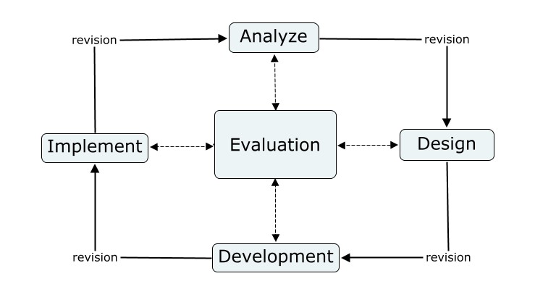
Figure 2 – The ADDIE Model (revision version), by Fav203 - Own work, CC BY-SA 3.0: https://commons.wikimedia.org/w/index.php?curid=19136887
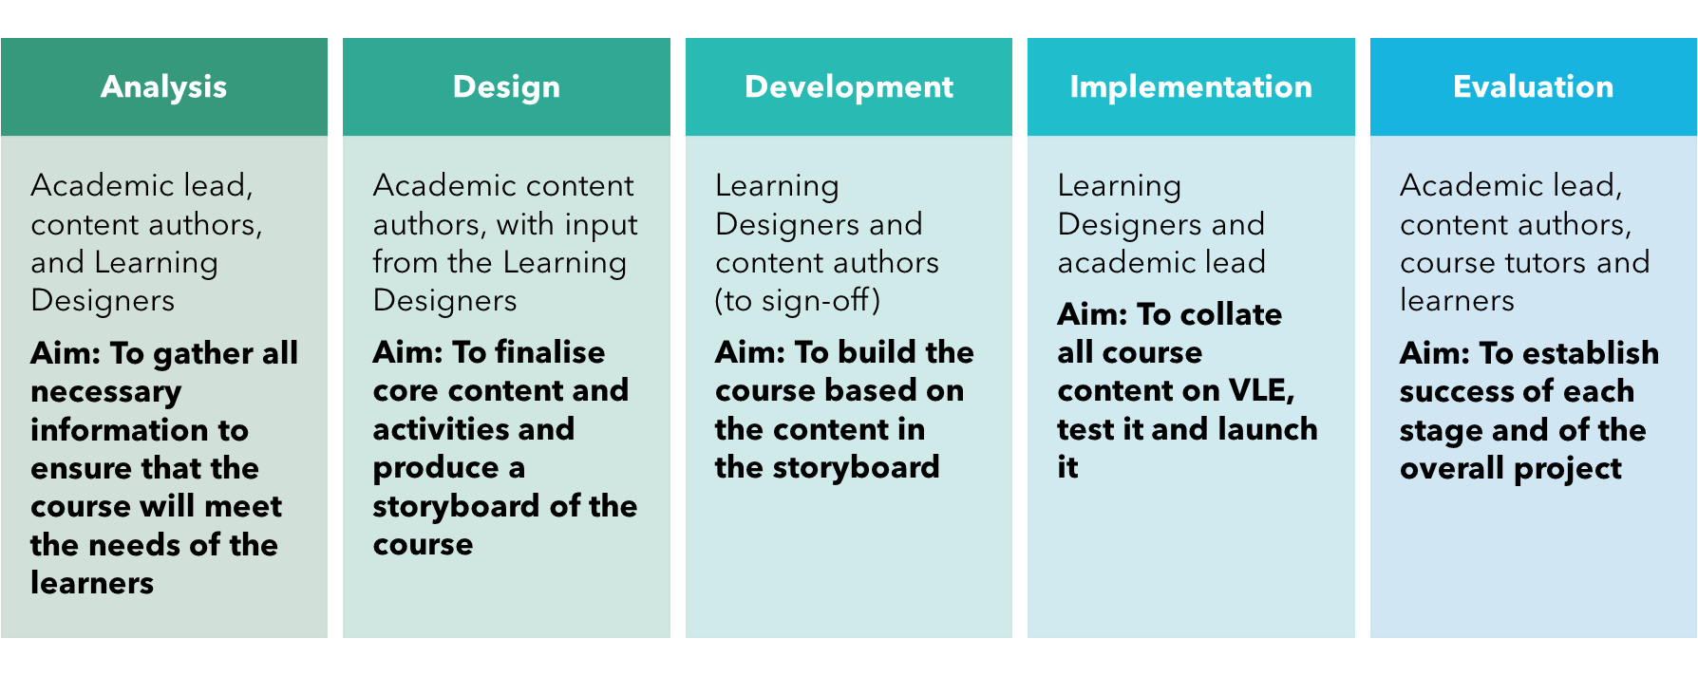
First impressions of ADDIE might be that it can be aligned to the typical waterfall approach, such that each stage of the process seems similar in its function within the process (see Figure 3). This might be the case for the first few stages, but it is my belief that there is more iteration involved in ADDIE which lends itself to a more agile approach.
Figure 3 – The ADDIE model in context, retrieved from: UWTSD. (2021) Guide for content authors

Adapting the process
The learning design process (Figure 3) was the result of adapting the previously established learning design process to suit the specific needs of the project. The most notable difference between this and previous iterations of this process is the ‘pedagogy review’ stage, which was an added step completed by the Digital Learning Technologist as way to review content from a pedagogical perspective in the absence of a dedicated content author.

Figure 4 - Adapted version of the learning design process
Although we made colleagues in the wider project group aware of our approach and were in communication with them on a regular basis, one thing that we could perhaps have done was to capture this in a document which could be readily accessed by project stakeholders at any time. This would have been particularly useful due to the frequent changes in roles and responsibilities, which is expanded upon on in the next section.

Key challenges
At the end of this project, my colleagues and I discussed lessons learned from Project X. We have used and will continue to use the reflections from this to inform our approach moving forward in future projects.
During this process, we identified a number of key challenges encountered during the project, and sought ways to mitigate these risks in future projects. Some of these challenges are outlined below.
Poorly defined roles and responsibilities
One of the central problems within Project X was poorly defined roles and responsibilities in the wider context of the project, and these changed throughout the project, which had continuous implications throughout the process but also for the handover process at the project closing.
In a typical project, we will work with a content author and/or content lead from the initiation to the closing of the project. Although additional stakeholders may be involved from the beginning and perhaps sometimes integrated into the process at a later stage, the content author and/or lead will be a consistent point of contact throughout the process, with whom we can communicate about anything relating to the project; from providing updates on progress to gaining clarity on issues encountered and asking for feedback so that we can proceed accordingly.
Difficulty in resolving issues
However, in Project X the writing of the content had been a collaborative task completed by numerous academic staff prior to iteration 1, some of whom were no longer working at the institution. This made it extremely difficult and timely when we needed to flag any issues with content (e.g., out of date/disproved content), as the only person who was prepared to resolve such issues was one academic colleague; this was not appropriate for the size of project.
Pedagogy reviews
Moreover, the lack of a dedicated content author had implications for our team, such that the Digital Learning Technologist had to undertake the ‘Pedagogy Review’ stage. This step consisted of reviewing all learning content across L4 and L5, and identifying where we could build richer and more meaningful learning activities. This should, however, have been the responsibility of the content author.

Developing an innovative approach
Following the recommendations made in the first assignment and based on the reflection of Project X, I will discuss below how I would look to alter our approach moving forwards using a hybrid approach. I have chosen to use a typical project management lifecycle to explain my approach, because even though ‘many project management commentators offer an agile approach as an alternative to a traditional waterfall-based life cycle, it is most useful to think about how agile methods can be incorporated into the overall project life cycle’ (Simon et al., 2018, p.42).

Initiation
Project X has taught me the importance of being present at initial scope meetings with all relevant stakeholders. If this is not possible, such was the case with Project X, because we joined at a later stage in the process, I would seek to set up a meeting with stakeholders to bring myself up to speed with the project and ask key questions.

Planning
I would capture client requirements in a project initiation document (PID) or similar. This was another element lacking in Project X, perhaps due to its large scale. However, it might have been a way to manage expectations, and define roles and responsibilities of all stakeholders. This is one of the key affordances of both waterfall and PRINCE2.
Additionally, we find in many projects that our content authors ‘only begin to understand what they actually desire when they are provided with someone’s impression of what they want’ (Larson et al., 2014, p.592). Consequently, I would like to provide tangible examples of previous materials we have produced to provide them with a more realistic idea of exactly what we can do.

Execution + Monitoring and Controlling
The ADDIE model and learning design process were already in place for projects prior to Project X and continue to be used by our Learning Designers. The specific tool used to manage Project X was Microsoft Planner, and this not only provided more structure with the use of buckets to display tasks, but it also enabled the Learning Designers to take ownership of tasks, choosing which tasks they completed and when, due its transparency and ease of use. I would perhaps look at derivatives to agile to find a tool that is more streamlined. Kanban boards have been used in the past and it would be worth us revisiting such tools/approaches given the experience gained as a team and the subsequent projects completed since Project X.

Completion
Defining roles and responsibilities early on will help to facilitate the handover stage, which was identified as a key challenge within Project X. This is where we could draw on the affordances of PRINCE2 to define role and responsibilities, and make these clear in documentation, so that all stakeholders are aware of what they should be doing. This will contribute to the project being completed on schedule.

Conclusion
In conclusion, by utilising my knowledge of the project management approaches explored in the first assignment, I have been able to deepen my understanding through applying that knowledge to my own working context. It has demonstrated to me that there really is no one size fits all approach to project management and that a hybrid approach can be just as effective.
It is obvious that many of the challenges encountered in Project X are not specific to this project itself. Nevertheless, it has been meaningful to use this particular project as a way of thinking forwards and considering how to avoid these challenges in the future. Project X has shaped us as a team and has helped to inform our current approach to new and ongoing projects.
In the context of eLearning projects, Doherty (2010, p.91) proposes that the following two factors are contributors to project management success: ‘The first is maintaining a clear educational focus in (…) eLearning projects whilst defining project success in terms of facilitating and/or enhancing student learning. The second is ensuring that (…) processes mesh with the collegial nature of a university culture.’ Ultimately, as much as our future project management approach may evolve, we must maintain these values.

References
Branch, R.M. (2009) Instructional design: the ADDIE approach. New York, Springer
Doherty, I., 2010. Agile project management for e-learning developments. International Journal of E-Learning & Distance Education/Revue internationale du e-learning et la formation à distance, 24(1), pp.91-106.
Larson, E.W. and Gray, C.F. (2014) Project management: the managerial process. Sixth edition, International student edition. New York, NY: McGraw-Hill Education.
Simon, P. and Murray-Webster, R. (2018) Starting out in project management. Third edition. Buckinghamshire, England: Association for Project Management. pp. 36 – 42 – Project life cycles/Agile and Waterfall
UWTSD. (2021) Guide for content authors
Wiley, D. (2018) Project Management for Instructional Designers. EdTech Books. https://pm4id.org/pm4id

