UNIVERSITY OF WALES: TRINITY SAINT DAVID PRIFYSGOL CYMRU: Y DRINDOD DEWI SANT

Unit Code: LCBB4003
Introduction to Modern Workplace
Management and leadership – case study Nokia

Student: 2008573
Ionut-Adrian Voinea
Dated: 20th of October 2020

Words: 1905

Contents
Introduction 1
Management – leadership at Nokia Corporation 1
Historical background – Nokia 3
Impact of leadership and management styles on the business 4
Conclusions 6
References 7
Appendices 8

Introduction
Seen frequently as the two sides of a coin, leadership and management plays a crucial role in any organization performance and effectiveness. Current paper will analyze and evaluate the differences between management and leadership, evaluating line managers roles and responsibilities and the way in which the two mentioned concepts and the specific styles related to them shape the employee’s behavior in a certain organization – Nokia Corporation.

Management – leadership at Nokia Corporation
Management functions are understood as functions related to organizing, planning, controlling, measuring, monitoring and controlling actions meant to reach the corporate objectives. In nowadays organizations an increased attention is allocated to leadership / management approach, considering that, even the differences are minimal, the impact on efficiency is significant.
Leaders motivates the team to achieve a certain objective, inspire the team towards achieving goals, encourages people to be the best they can be, directs people when they have to overcome a challenge – in which direction they should act, persuades people to follow their course of action. Leadership is defined as “the skill to getting people to willingly do something you need doing (McMunn, 2020).
Managers will plan of what should be done, the plan of how to get from point 1 to point 2; control people, resources , finances to complete a certain plan, delegate responsibilities, recruit/hire/train, organize own and their staff daily work (direct telling them what they need to do) (McMunn, 2020) .
Leadership is inspiring, motivating, directing a team to achieve an objective, management is the process if dealing with or controlling resources and people; making effective use of the resources, people and tools they have available to achieve the same goal. A person must have a strong balance between management and leadership skills in any managerial or leadership role will act (McMunn, 2020). According to Ketchen & Hult (2006) leaders are seen as force driving the change with focus on achieving corporate goals while managers are seen as force to instruct employee. Leaders will focus on people strengths rather on their weaknesses, leaders are always treating people with respect, they’re open about what people can do, in the same time committing to help people instead of hurting them. It was found that only motivation in management is empathy, people responds better to this then to coercive actions. As both categories of employees (managers and subordinates) wants to feel safe, the people in management position can offer to their employees’ empowerment, enriching their responsibilities as employees (Lussier,2004).
Discussing about achievement of organization objectives: a) leaders are the people who empower, support employees, using management tools (delegation) to increase confidence among subordinates; b) managers are the people who promotes the attitude that the objectives must be achieved through a proper management and guidance of the employees.
Nokia corporation, an organization acting in a highly competitive industry, the leaders are expected to be superior in actions and performance in comparison with the one from the competitors (Samsung, Apple, Ericsson), seen are the ones driving the market in terms of innovations. Currently, Nokia management is focused more on drive and maintain organization competitiveness and less on innovation.

Historical background – Nokia
Nokia Corporation, one of the largest communications and information technology companies provides its products to customers from 130 countries, with headquarters in Finland. It was founded in 1865 the company developed over the years attempting different markets, employing today 98000 people (Statista, 2020). Nokia corporation played important role in mobile phones, GSM and equipment market in early 1990s. According to (Statista, 2020) Nokia was leader in mobile phone market worldwide until early 2012, when the company didn’t adapt enough fast to the developments towards smartphones, losing market leading position in front of competitors like Samsung and Apple. Thus, the company started to lose money since 2013 and sold the phone division to Microsoft. After this movement Nokia Corporation focused its operations on data networking services and equipment dedicated to telecommunication industry through Nokia Networks subsidiary (who generated most revenue in 2019). Adapting to market developments and movements, Nokia involved its activities in cloud computing and mapping applications (acquiring in 2008 Here and selling its services in in 2015 to BMW, Audi, Daimler). 2016 was also an important year in Nokia evolution, through the acquisition of a majority stake of Alcatel-Lucent, French telecommunication equipment company (Shanhong, 2020). In 2020 Nokia is recognized as one of the leading world companies in telecom infrastructure, competing with Cisco, Qualcomm, Ericsson with a 16.1% market share (Statista, 2020). Details about Nokia revenues per business unit are detailed in Appendix 1.
According to Kuprenas (2003) there are various organizational structures, mentioning here: functional, divisional and matrix organizational structures.
From organizational perspective, Nokia changed during years its organizational structure to better respond to the external environment factors and to enhance its profitability. Thus, Nokia focused on departmentalization, grouping similar activities into the same group of activities (department). Going back in 1990s, Nokia adopted at that time the product base type of organization, enabling managers to be experts in the specific field of interest. Due to the increased competition. Nokia evolved into a matrix organizational structure since 1998, including functional and organizational structure. As example, due to technological rapid developments, Nokia introduced multimedia division as separate department in its organizational structure, being very useful for company profitability (Sy, 2005). As an evolution for Nokia corporation, the organic structure must be considered, as a flexible in its nature, considering the knowledge from 3rd parties, with all employees at the same level, without job descriptions or classifications. With the disadvantage of more hierarchical levels and high degree in job specialization, organic structure might be adopted by Nokia Corporation in product development, allowing employees to be involved in some degree in decision making process (e.g. components included in a cell phone). According to Rao (2008) the less decentralization will contribute to the staff motivation as they are the chance to contribute with own ideas to the production process and quality improvement.

Impact of leadership and management styles on the business
Literature findings related to the role of leadership in business performance of an organization are different. According to Martorana, & Owens (2003) leadership role is crucial in any organization to achieve the highest performance level, while Farah et. all (2019) emphasis that organizational performance is not critically influenced by the leadership style. Leadership is defined as a process involving a leader in various activities to achieve certain objectives, directing people in line of goals achievements. According to Sichone (2004), leadership is “capacity of moving and awing follower by furnishing them with the reasons to battle for them”. Leadership can be observed in a specific position including mandatory tasks and functions of an organization, allowing people to create and be efficient (Firestone, 1996). Thus, leadership will play two significant roles: leadership in current operations and leadership in transformation. Strategic leadership refers to the ability of a leader to influence other people to take decisions on daily basis, freely, in the direction of an organization growth and development (Nejad&Rowe,2009). A key characteristic of strategic leadership relies in its possibility to create and communicate a clear vision, inspiring employees to take and implement operational decisions and allowing leaders to be focused on strategic decisions.
Organizational performance is described as the ability an organization has to achieve its objectives in terms of financial profitability, qualitative services and products, sustainability and business continuity in any specific market conditions (Koontz & Donnel, 1993), needing appropriate strategies in this regard. According to Griffin (2003), organizational performance is the organization ability to meet both stakeholders needs and organizational needs to remain competitive.
Leadership styles (transactional and transformational) embraced by an organization management will have a significant influence on the company overall performance, as shown in Appendix 2. Transformational leadership was found as a factor with positive effect on organizations performance and profitability by various studies especially in small and medium enterprises, but corporations also will benefit from it (Noruzy,2013).
For the organizations acting in the global market leadership style adopted in the organization has also significant influence on business performance together with other variables. Discussing at this scale, the leadership style will affect the processes and policies implemented by the organization, bearing a vital impact on a competitive environment and allowing organization to build a competitive advantage.
The companies acting in a global environment, as Nokia Corporation, needs leaders with global leadership skills, mentioning few of them as:
- commitment to a global vision, plan a strategy to attain the current and long-term objectives
- understanding the customers differences (worldwide) considering the local or global influences (including the cultural needs)
- managing the organization in relationship with environment and culture
- curiosity: global leaders must be inclined to learn about differences about staff and customers from various cultures, which will allow organization to better overcome some risks
- anticipate, recognize and include global market developments, trends, technology developments into managed organization
- built and lead effective teams across the world
- inclined to innovation, risk taking and show commitment
For Nokia Corporation study case, the management adopted the role of creating, maintaining and enhancing a positive culture among the organization, based on effective communication and starting from the company logo message “Connecting people” (Nokia,2020). Therefore, the company enabled various channels where staff can share their opinions and views considered by management in decision making process. Human Resource function adopted policies that allows employees to investigate, develop and apply their talents and skills, approach that determined an innovative teamwork. Using the departmental structure, Nokia empowered employees to apply their strengths and abilities in the company development. As the change is present in an accelerate way in the industry Nokia operates, it is important for the company to maintain an adapted organizational culture to allow its employee to understand the change, to embrace it accordingly. Management operations ethics are incorporated in the organization philosophy, allowing both staff and leaders to follow a common approach in operational and strategic activities. There are also issues that might influence the Nokia performance, referring here at the divisional management, leading to situations where people are not sure who should do a specific task and generating in some cases some crisis in management powers. As example, marketing department includes market research in some divisions and the company has an overall department for marketing research.
This kind of issues might lead to decrease of motivation of staff in some cases, as the leadership direction is not all the time clear and aligned. Therefore, a recommendation in this case will be a global strategy adopted, aligned and accepted, if there are policies addressing same products in regions, the global ones will be applied, considering the revenue drivers among different regions. Managerial approach will be adopted in this kind of identified weaknesses, in order to set, adopt and apply a clear direction for the entire company.

Conclusions
After discussing the management and leadership impact on business performance, assessing Nokia Corporation success in a competitive, fast moving industry is determined by its innovative, motivated and robust workforce. Thus, the company managed to face significant changes during the past two decades, adopting its strategy and organizational structure to these developments. A strong point to be mentioned is the strong and positive organizational culture to encourage talents to be promoted, innovation. Improvments in terms of global teams’ alignments should be considered further, to prevent overlapping activities that might lead to staff demotivation and slowdown in operational activities.

References
Drucker, P. (2012). The Practice of Management. Routledge.
Farah, B., Elias, R., De Clercy, C., & Rowe, G. (2019). Leadership succession in different types of organizations:
What business and political successions may learn from each other. The Leadership Quarterly. doi:
https://doi.org/10.1016/j.leaqua.2019.03.004
Firestone, W. A. (1996). Leadership: Roles or Functions? K. Leithvvoodvediğ. (eds.), International Flandbook
Educational Leadership and Administration, Kluwer Academic Publishers, Netherlands: 395-418
Hirsh W (2003). Positive Career Development for Leaders and Managers. In J. Storey (ed.) Leadership in Organizations: Current issues and key trends, RoutledgeGriffin, & Ricky, W. (2003). Management. Boston: Houghton Miffi
Kuprenas, J. A. (2003). Implementation and performance of a matrix organization structure.International Journal of Project Management 21 , 3-5.
Maslow, A. (1954) Motivation and Personality. New York: Harper Row.
Mckinsey (2012) 10 Reasons Leadership Development Programs Fail. Available at http://www.mckinsey.com/global-themes/leadership/why-leadership-development-programs-fa) Accessed 11th of October 2020

McMunn, R. (2020) Leadership vs. management! What is the difference? Available at: https://www.youtube.com/watch?v=YNGO1GWnbm4&feature=youtu.be Accessed 01st of October 2020
Nejad, H., & Rowe, G. (2009). Strategic leadership: Short-term stability and long-term viability. Ivey Business Journal,73(5), 2–6.
Noruzy, A., Dalfard, V.M, Azhdari, B., Nazari-Shirkouhi, S. and Rezazadeh, A. (2013), Relations between Transformational Leadership, Organizational Learning, Knowledge Management, Organizational Innovation, and Organizational Performance: An Empirical Investigation of Manufacturing Firms, Int.J.Adv.Manuf. Technol., 64: 1073-1085
Rao, S. R. (2008). Departmentalization Organization Structure. Journal of Managemen structure, 11-16
Shanhong, L. (2020), Nokia – Statistics and facts, Available at: https://www.statista.com/topics/1183/nokia/, Accessed 05th of October 2020
Sy, T. &. (2005). Challenges and Strategies of Matrix Organizations. Journal of Human
Resource Planning, 28, 39 , 15-16

Appendices
Appendix 1 – Revenue by business segment 2016 – 2019 (billion euros) - Nokia

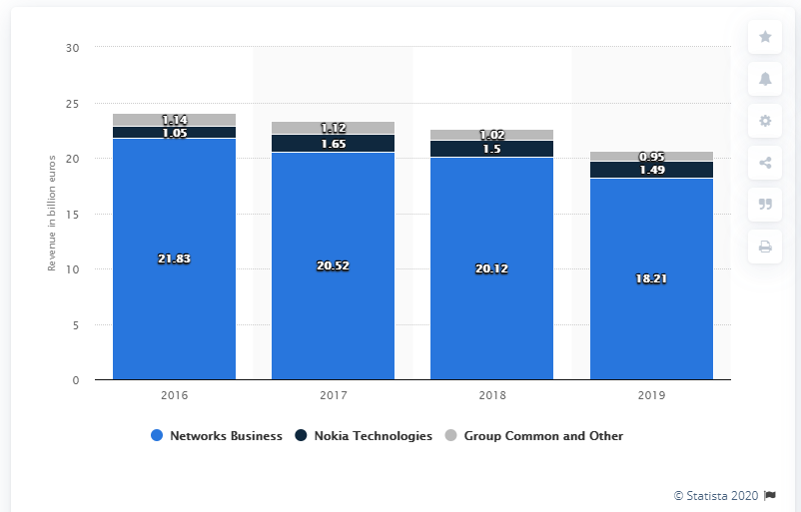
Source: Statista (2020)

Appendix 2 Framework transformational/transactional leadership and influence in company performance

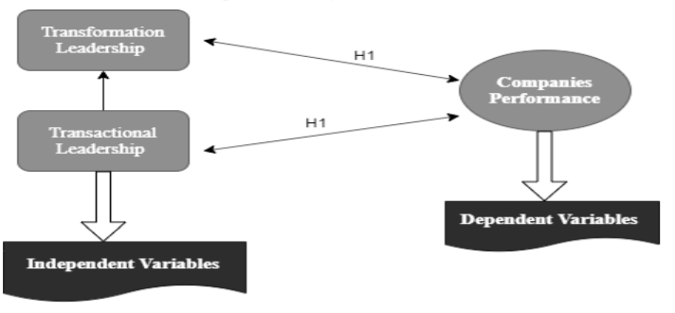
Source: Mckinsey (2012)

Appendix 3 – Motivation theories – summary using Microsoft Excel

