Reflective portfolio

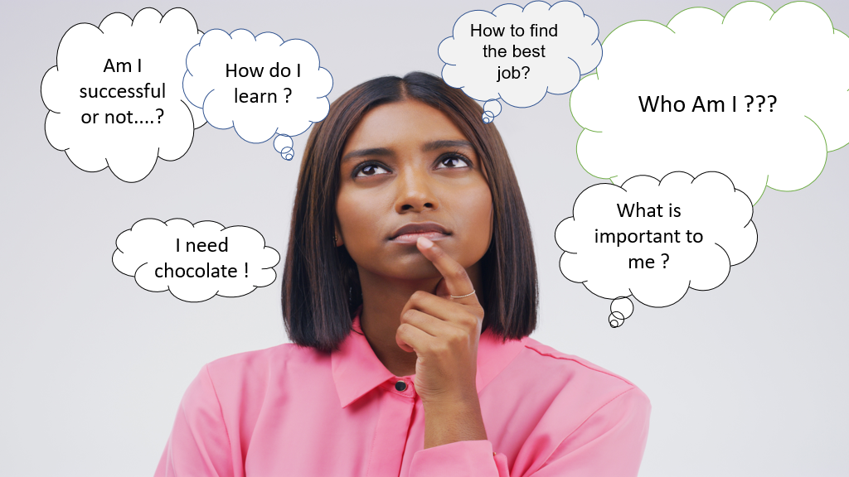

Module Code: BMSW4005 Professional Career Development Module
Student name: Ralitsa Kircheva (2025993)
Assignment Title: Reflective portfolio

Lecture Name: Besty Jose

1. Introduction......................................................................................3
2. Swot analysis....................................................................................4
3. Personal Development Plan (PDP)…..............................................5
4.Workplace Learning and Development............................................7
5. Theories and Methods......................................................................8
6.Gibbs Reflective Cycle............................................................................10
6.1 Gibbs Reflective Cycle-open book assessment....................................10
6.2 Gibbs Reflective Cycle-mock interview..................................................11
6.3 Gibbs Reflective Cycle- UK employment legislation.............................11
7. Conclusions.....................................................................................12
8. References........................................................................................13
9.Appendices........................................................................................14

1.Introduction

In this reflective report I will try to share some of the knowledge, tools, methods and theories I learned during my studies as a student in ‘Social Care and Health’ - module Professional Career Development Module. In addition to knowledge about ourselves, these tools are very useful for discovering, analyzing and developing our professional interests and needs.
Through tools of self-awareness, we could learn a lot about ourselves and others. They are a good method both for researching personal personality and for researching other people who could be our colleagues, friends or employees.

2. SWOT analysis
Swot (fig.1) is a planning technique that presents weaknesses, strengths, opportunities we have and threats. Through this language tool to analyze the current and future potential, as well as internal and external factors. SWOT analysis is applicable at different levels in organizations and can be used for both simple and complex analyzes (Sorsby and Lunn, 2015). Through my own swot analysis, I was able to see positive and negative aspects of my character, as well as future opportunities based on the work of a social worker.

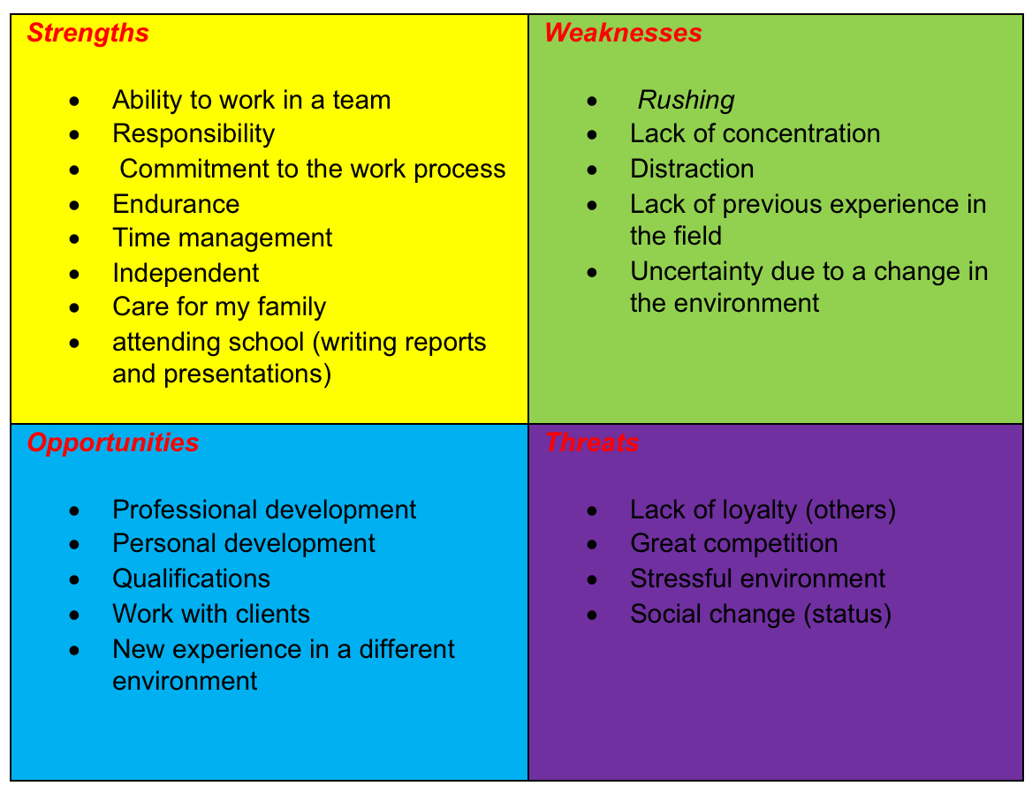
Figure 1. swot analysis *

3.Personal Development Plan (PDP)
Personal development plan or PDP (fig.2) is an option through which we can see our future plans and goals, as well as think about how to develop the necessary capabilities to achieve our ambitions, through PDP we could set deadlines for achieving our goals, to see clearly our priorities and to recognize the opportunities. For me was interesting to use this tool.
According to The Open University (2022), PDP gives us the opportunity to reflect on our success and achievements and to plan our own development.

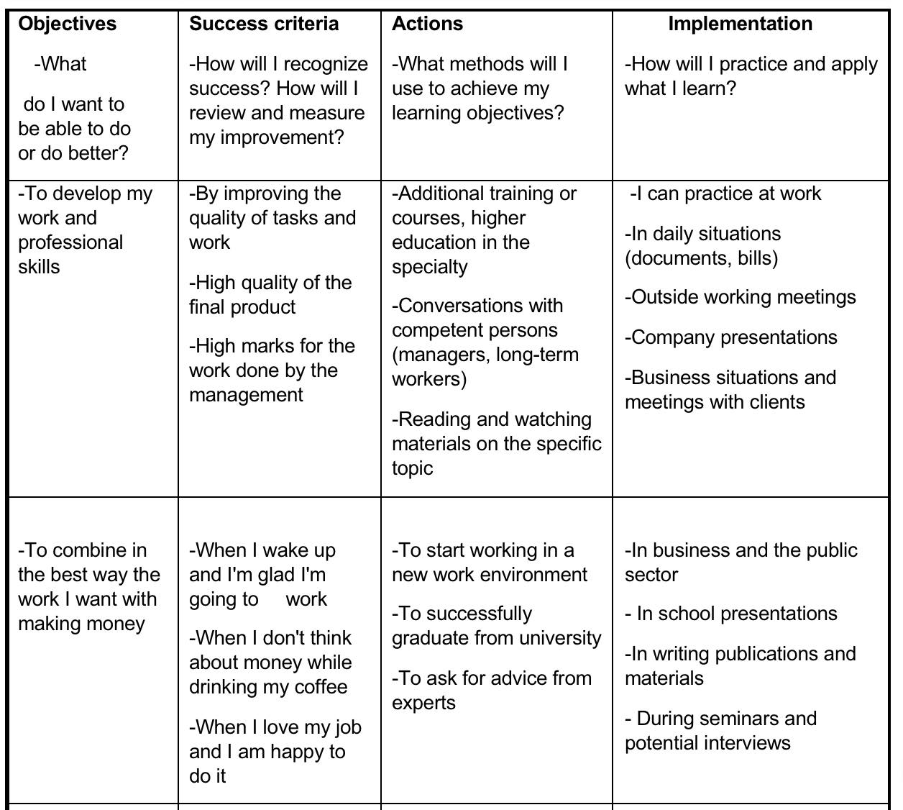
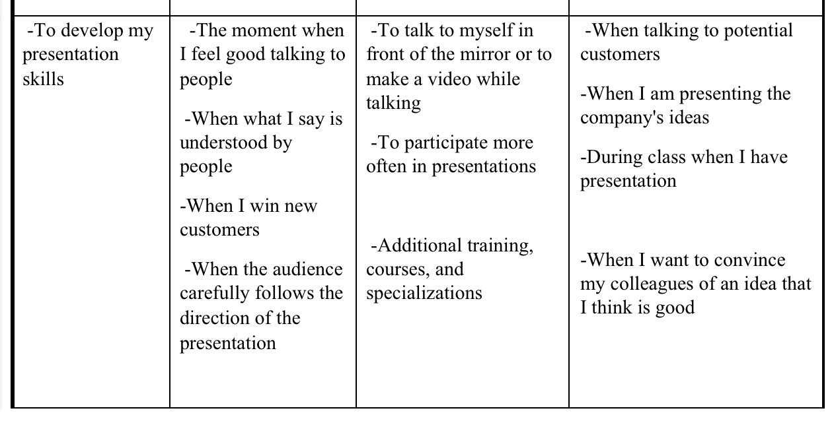
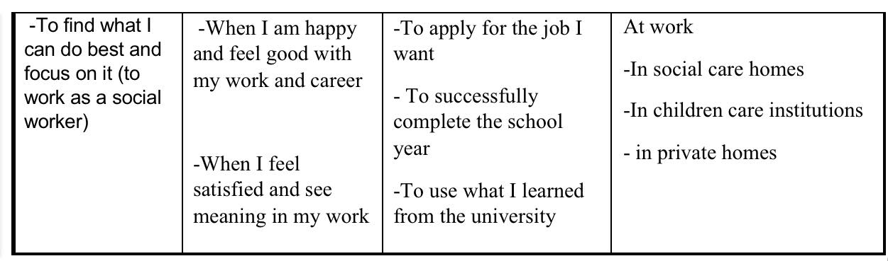 Figure 2. PDP *

4.Workplace Learning and Development
Workplace learning and development is considered a two-way process from which both the employer and the employee have a mutual interest and benefit. Some of the advantages for the employees and the organization, as well as for the management are increased confidence, improved career prospects, quality services, up-to-date advice and information, development of skills useful for the organization (Beevers & Rea, 2016, p.23).
Understanding how others learn is essential if we want good results. If we want to change the quality of the work of the individual (employee), we must change the quality of knowledge and skills through training (Gold, Holden, Stewart, Iles, Beardwell, 2013, p.274).
In today's competitive and dynamic environment of technology and innovation, it is not possible to make progress without constantly developing new skills and knowledge. According to Parry-Slater (2021) learning organizations are those who understand the dynamics of the time in which we live and are inspired to develop their talent and the talent of their employees. In the next 10 years, a culture of learning will be the only way for organizations to survive (Paine, 2021, p.3). To develop successfully in our profession, it is important to have clear answers to questions such as ‘What is best that you can do? & What other people say, you do well?’ (Headlee, 2017). Once we find the right career, the next step is its continuous improvement or also known as CPD-Continuous professional development is the conscious and continuous maintenance and growth of the information and skills necessary for the proper performance of your work. We have to look at our career as a small child that we have to take care of if we want it to grow up. We all learn throughout our lives and to the very end. Understanding how it is easier for others and for us to learn and develop is necessary and useful, both for our work and for ourselves.

5. Methods and Learning theories

People are different in everything, including the way we learn and remember information.
According to Peterson & Kolb (2017, p.2) The learning process is always rewarded with experience and new opportunities.
To learn more easily and effectively we need to understand what our strengths are and use them properly. One of the famous methods is learning style of Honey and Mumford (1982) includes four main learning styles: activist, reflector, pragmatist, and theorist.
Activists usually have a high level of energy and low attention. They are eager to get to work on their own and yes try.
Reflector- They love to have time to absorb the information before acting. Reflexive learners usually produce very precise products in their work.
Pragmatist- This type of learners is focused on what to do and how to do it. Pragmatist is often found greatest satisfaction when the learner is facing a problem
Theorist- They are usually very objective. They are interested in gathering facts in a logical sequence and then from applying this knowledge in a methodical way.
From Honey and Mumford learning style I recognized myself as an activist. I was surprised to see so correctly definition of myself. When you recognize yourself in something, you tend to believe it. This is the reason why I chose the model of Mumford and Honey over the models of Fleming and Kolb. The positive in Mumford and Honey model is that you can see a definition of yourself without thinking specifically about it and without even suspecting that someone has made a whole model that describes parts of your character. The downside is that, like any scientific project, this model could not give complete and accurate information about the individual, but only assumptions which can frame the individual. In the theory of different learning styles - Kolb (1984) concrete experience, reflective observation, abstract conceptualization, active experimentation I could not find a close definition of myself and my learning style.
The learning styles and theories around them are an interesting experience to make it easier to reach students not only in schools and universities, but also among workers who need to be constantly retrained if they want to be adequate in a rapidly evolving environment but are they really that useful?! According to Daniel Willingham - a psychologist at the University of Virginia - there is evidence that people try to approach their tasks according to their accepted style of learning, but the style itself does not help them.
For sure, each of us has our own style and method of learning, including the person who teaches us, but this does not change the fact that we must learn to adapt to each other, because there is no institution or organization that can provide knowledge to people in 4 or 5 different ways (styles), but teachers or instructors can try to intrigue the audience with interesting and accessible material. Socrates says that the education is not only in the designated places, but it always happens when two or more people have a meaningful dialogue. (Bates, 2019 p.8).

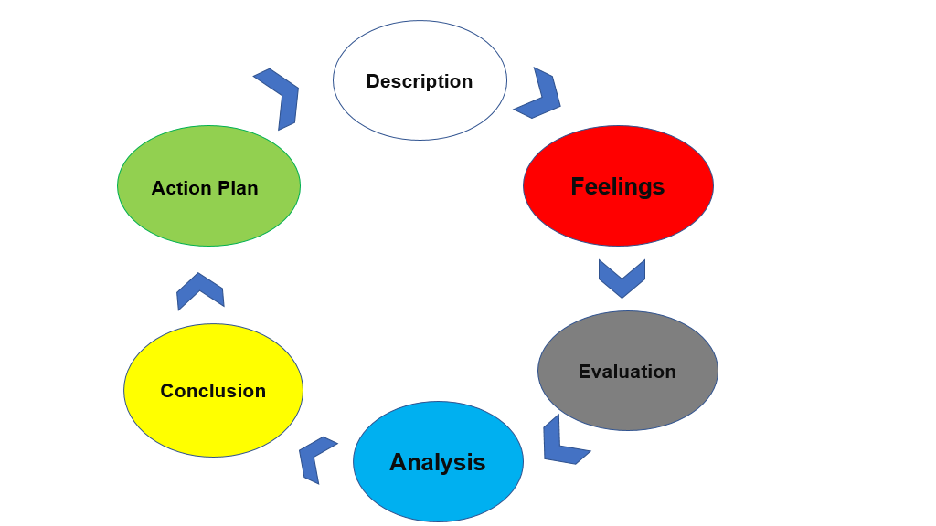
Figure 3. Gibbs Cycle

6. Gibbs Reflective Cycle

Gibbs reflective cycle (1988, fig.3) is a tool for conclusions and reflection after a certain event. The idea is to learn from the experience. The cycle has 6 main stages that are directly related to each other, they are: description-a description of the experience, what happened? feelings- feelings and thoughts during what is happening, evaluation-what went right and wrong, analysis- understanding the situation, conclusion-what was learned and what could have been done differently and action- how to deal with the situation in the future (Amaechi, 2021). Using this method, I will try to explain what happened with me (emotions, experience) during class.
6.1 Gibbs reflective cycle-open book assessment.
Description: We had book assessment on week four. When the time came, we had a choice between two topics we started writing with cameras on. Everything passed calmly, only the lecturer reminded for the time left.
Feelings: while we were writing everything was fine with me, I did not feel stressed. I did not have time to look around or think about how others were feeling because I wanted to finish on time.
Evaluation: I do not like to write without knowing the topic in advance, because I cannot prepare myself with appropriate arguments and references, but this is also an opportunity for self-knowledge.
Analys: it went well because I worked alone and not in a group, it is always harder to work in group. It was not good, because I could not orient myself properly in the subject of assessment.
Conclusion: from the feedback I realized that I do not use enough arguments and I have not developed the topic and the possible risks that need to be noted. The good news is that I have demonstrated some simple knowledge.
Action: the next time I have such a task I will prepare better, I will look for more sources of information and other points of view that I will include in my work.
6.2 Gibbs cycle- mock interview including appendices.
Description: my interview was online because I do not have the opportunity to be on campus. on the day of the interview, I dressed well and joined 10 minutes earlier because I like to be on time, which was noticed by my lecturer in appendices (fig. 4).
Feelings: the day of the interview I felt a little nervous and sorry because I was almost last, not first. During the interview everything was fine, and I do not think I exposed myself much. I don't know how it went with others because we do not communicate much.
Evaluation: my impression from the interview is that it was good, from the appendices it can be seen that I left good general impressions, but I could mention how I think to overcome my weaknesses and the next time to clearly demonstrate my career goals.
Analys: I think it went well because I had time to prepare and rehearse. It was not perfect because of gaps that can be seen in the application and because of my lack of experience in social care.
Conclusion: I learned that I could improve my skills and my CV, as well as respond with concrete examples. Surely my performance could have been better.
Action: next time I would talk more about my goals and how they complement the position I am applying for. I would think about how to turn my weaknesses into useful skills, and I would improve more than CV.

6.3 Gibbs reflective cycle- UK employment legislation
Description: during one of our last classes, we took a lesson for ‘Employment Legislation’. This was useful information to understand employment and the relevant laws and rights that exist in UK. Our lecturer included our whole group in discussions, asking questions about the laws
Feelings: for me as a worker it was interesting to learn some of the laws and their application in the relevant circles. This created a sense of potential knowledge that I could use in case of need.
Evaluation: Knowing the laws and rights is always a good thing, bad in this situation can be for the employer who wants to use you. I'm sure this information is important for the whole class.
Analys: the class went well because everyone participated. The knowledge I received is a clear definition of laws I had previously suspected.
Conclusion: If you know your rights, you can change many things. I have seen situations of incorrect employers both with me and with my acquaintances. Knowing my own rights can be a key factor in some hard situation.
Action: next time I would ask the whole class about their experience in such situations. It would be interesting if we all give examples.

7. Conclusion:
At the end of our reflective report, we used many of the theories and tools we learned in class, such as various analyses, theories, and methods of self-awareness. We consulted the experience of Honey, Mumford and Kolb. We've seen tools like Swot analysis and PDP work. Together, we looked at the Gibbs cycle and realized that self-awareness and improvement continues throughout our lives and is something we should all strive for, if we want to be useful to ourselves and our society.

8.References:

Amaechi, U. (2021) My Management Styles using Gibbs’ Reflective Cycle. United Kingdom: Amazon self-publishing.
Bates, B. (2019) Learning Theories Simplified: and how to apply them to teaching. SAGE Publications Ltd.
Beevers, K. & Rea, A. (2016) Learning and Development Practice in the Workplace. London: Kogan Page.
Gibbs, G. (1988) Learning by Doing: A guide to teaching and learning methods. Further Education Unit. Oxford Polytechnic: Oxford.
Gold, J., Holden, R., Stewart, J., Iles, P., Beardwell, J., (2013) Human Resource Development, Theory and Practice. New York: Palgrave Macmilan.
Headlee, C (2017) TED Don't find a job, find a mission [video]. Available at: https://www.youtube.com/watch?v=VVx6ntr5OqI (Accessed: 29 March 2022).
Honey, P. & Mumford, A. (1982) Manual of Learning Styles London: P. Honey.
Kolb, D. A. (1984) Experiential learning: Experience as a source of learning and development. Englewood Cliffs: Prentiss Hall.
Paine, N. (2021) Workplace Learning: How to Build a Culture of Continuous Employee Development. United States: Kogan Page.
Parry-Slater, M. (2012) The Learning and Development Handbook: A Learning Practitioner's Toolkit. United Stated: Kogan Page.
Peterson, K. & Kolb, A.D (2017) How You Learn Is How You Live: Using Nine Ways of Learning to Transform Your Life. Berrett-Koehler Publishers, Inc.
Sarsby, A., Lunn, E. (2015) Swot analysis. United Kingdom: Spectaris Limited.
The Open University (2022) Help Center. Available at: https://help.open.ac.uk/pdp (Accessed: 22 March 2022).
Willingham, D. T., Hughes, E. M., & Dobolyi, D. G. (2015) PDP. The Scientific Status of Learning Styles Theories. Teaching of Psychology.

9.Appendices:

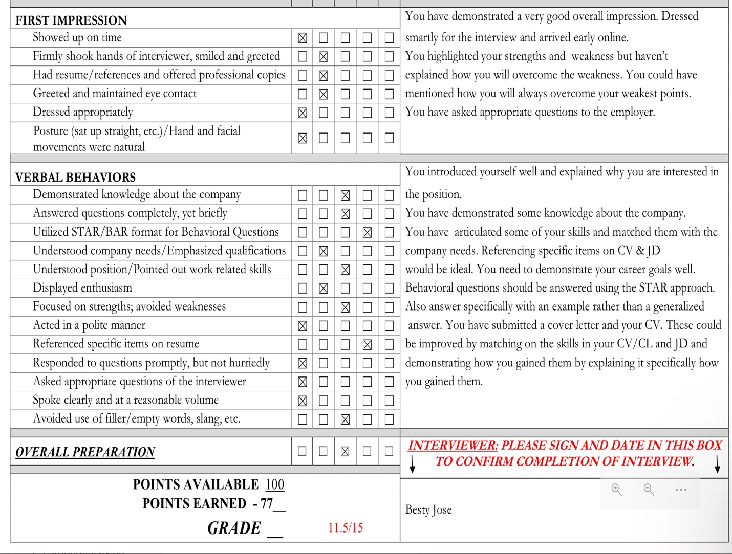 Figure 4. appendices *

* All tables with star (*) are made by a screenshot, because by copy and paste, the words in the report become many times more than the provided 2000-2100 words.

