Acknowledge Use of AI

I acknowledge the use of Copilot (https://copilot.microsoft.com) on 21 March 2026 to give a proper outline of the writing structure using the prompt(s):
- Please draft an outline of the writing structure in bullet point form.
I confirm that I have not presented any AI generated tezts as my own work. I confirm that I have copies of my drafts, notes, and other resources I used before and after the use of AI tools which I may be asked to provide in evidence.
Abstract
With many study exists on children with Autism Spectrum Disorder (ASD), there is a lack of knowledge about adults with autism. More recently, there has been an increasing recognition of the number of ageing autistics and the issues they face. This study explores issues of social and psychological support for adults with autism, particularly how social exclusion affects them and how difficulties are exacerbated by loneliness, anxiety, and depression. Social communication difficulties and a lack of support from family, friends, and professionals are also well discussed. Society’s negative perception of autism and the lack of autism-focused adult services create more issues for individuals with ASD. An increment in awareness and support for autistic individuals is a current venture across a range of age groups. However, there is a particular need for research and policy focusing specifically on the long-term outcomes of autistic adults. Nonetheless, this study is a rare exception.
Introduction
Autism Spectrum Disorder (ASD) is a neurodevelopmental disorder affecting mostly children, in which signs typically first appear in early childhood. Characteristics of ASD include difficulties with social communication and restricted behaviours, interests, and activities (American Psychiatric Association, 2013). In recent years, there has been an increase in recognition of the needs of individuals with autism spectrum disorders in older adulthood and the lifelong social experiences of people with autism spectrum disorders (Happé and Charlton, 2012). Social exclusion is another issue that affects individuals and groups, in most members are, to a greater or lesser degree, marginalised from participation in reflection of broader society (Levitas et al., 2007). This can result in individuals being socially isolated and not taking part in social activities.
In addition to being at risk of social exclusion for reasons related to their social difficulties such as misunderstanding social signs, failing to maintain and develop a conversation, failing to follow social rules and expectations, people with ASD are prone to experience even greater social exclusion due to broader stigma and lack of public knowledge about autism (Cage, Di Monaco and Newell, 2018). In older adulthood, social exclusion is likely to be further affected by a decrease in social networks, poorer physical and mental health and loss of resources to support individuals with ASD (Wilde and Dozois, 2019).
Social exclusion can have serious psychological effects for individuals without autism, increasing symptoms of anxiety and depression, however, for autistic individuals, social exclusion can worsen existing difficulties related to mental health. Both groups, autistic and older adults are already at risk factors for cognitive decline with effects on memory and attention in older adults (Kuiper et al., 2016; Kelly et al., 2017). However, with increased public awareness, early identification, more understanding of needs and appropriate support and structured social provision in the physical health promoted (Gillespie-Lynch et al., 2014; Cage, Di Monaco and Newell, 2018; Crane et al., 2019; Lord et al., 2020).
Despite these deep insights, there remains limited research focusing specifically on older adults with ASD, particularly regarding how social exclusion is perceived by others. Much of the existing literature centres on clinical outcomes or younger populations, with little attention given to broader societal perspectives. Therefore, the present study aims to explore undergraduate students’ notions of the risk of social exclusion in older people with autism, and how they believe its negative effects may be alleviated.
Method
Participants
The study included two participants. The researcher interviewed one participant and obtained the other transcript from a fellow group member to meet the assignment requirements. Both participants were undergraduate students recruited using convenience sampling. All participants provided informed consent before taking part. Demographic information, including age and gender was collected before the interview.
Design
This study was undertaken using qualitative methodology. Participants were interviewed using semi-structured interviews to explore perceptions of social exclusion in older adults with Autism Spectrum Disorder (ASD).
A scenario-based approach was used whereby participants were presented with a vignette describing the life of an older autistic adult known as Alan. This scenario served as a catalyst to explore the social, emotional and cognitive aspects of social exclusion through discussion.
Data Collection
Participants were provided with an information sheet laying out the purpose of the study, followed by signing the consent form. Demographic information was collected at the beginning of the interviews.
Each interview was conducted in a quiet room using a semi-structured format. Each participant was introduced to a scenario about Alan, an older person with Autism Spectrum Disorder (ASD), and was asked a series of open-ended questions while diving into their perceptions of social exclusion, its potential emotional and cognitive effects, and considering possible interventions.
Each interview lasted approximately 10 to 20 minutes, and audio recordings of participants were obtained after consent and transcribed verbatim for analysis.
Data Analysis
As outlined by Braun and Clarke (2006), the data were analysed using thematic analysis, which is a widely used method for identifying and interpreting patterns that are within qualitative data. As a first step, transcripts were reviewed multiple times to allow for familiarisation with the content.
Following this stage, the initial codes were then generated to identify important parts of the data relevant to the research question. These codes were then organised into broader themes and subthemes. The themes were then reviewed and refined to ensure coherence and clear separation between each theme. Moving forward, each theme was clearly defined and given an appropriate name. In line with qualitative research principles, instead of assuming directly from the data, themes were actively interpreted by the researcher.
Results
Themes | Subthemes | Example Quote
Theme 1: Perceived Compounding Risk Factors for Social Exclusion | 1.1 Structural constraints associated with ageing | “As you get older, your social circle becomes smaller”  “They get less mobile so they can’t [move around as freely].”
 | 1.2 Autism-related social and communicative challenges | “People don’t know how to communicate”  “They’re isolated because they’ve got autism.”
 | 1.3 Dependency and anticipated loss of support | “He’s going to be on his own”  “Get more isolated, even more not having his dad.”
Theme 2: Perceived Psychological and Cognitive Deterioration Resulting from Exclusion | 2.1 Intensified emotional distress | “Detrimental impact on your mental health”  “Be bigger.”
 | 2.2 Cyclical loss of confidence and withdrawal | “The less likely you do it, the less likely [you are] to put yourself out there and be confident with it.”  “Don’t know how to socialise”
 | 2.3 Perceived cognitive decline through under-stimulation | “It could affect their memory”  “Keeps you fit and healthy in your mind”
Theme 3: Perceived Protective Role of Awareness, Intervention, and Support Systems | 3.1 Increasing societal awareness to reduce stigma | “Knowledge is power”
 | 3.2 Early intervention as a foundation for social competence | “Help him feel more confident”
 | 3.3 Safe and structured environments to facilitate inclusion | “Day centres… social groups”

Table 1: Table for Themes
Theme 1: Perceived Compounding Risk Factors for Social Exclusion
This theme explores how social exclusion of older autistic individuals is caused by a complex array of factors that interact with each other. These factors create vulnerability which is cumulative in nature and whilst potentially changeable, it can also be self-reinforcing.
Subtheme 1.1: Structural constraints associated with ageing
Both participants collectively identified that as people get older, their social contact decreases.
Participant 1 emphasises the gradual narrowing of social networks:
”As you get older, your social circle becomes smaller.”
Similarly, participant 2 highlighted that they have fewer opportunities for social contact because of the restrictions on their health:
“They get less mobile so they can’t [move around as freely].”
Although both participants referred to limitations that they anticipate having in old age, these were portrayed more differently than similarly by the two participants. Participant 1 referred more to limitations that arise from lifestyle changes, such as work demands and lack of time, whereas Participant 2 leaned more towards physical and health-related limitations that he perceived as he would have in old age.
Ageing is depicted as introducing barriers that limit opportunities for social contact and increase vulnerability to social exclusion.
Subtheme 1.2: Autism-related social and communicative challenges
Participants further interpreted the increased risks associated with social interaction. It was brought to attention by both participants about the difficulties in social communication.
Participant 1 noted that with autistic individuals, seeing an element of risk in the unpredictability of such interactions.
“People don’t know how to communicate.”
Participant 2 also brought up the same note:
“They’re isolated because they’ve got autism.”
Both participants identified that having an autism spectrum condition added to the difficulties that they were experiencing. However, Participant 1 focused on how the difficulties of having an autism spectrum condition are increased by the way that autism is perceived by mainstream society, whereas Participant 2 was more focused on the difficulties that are inherent to having an autism spectrum condition due to the natural social nature of the diagnosis.
Communication difficulties both between the individual experiencing social isolation and others within society, and those experienced by the individual themselves may contribute to the exacerbation of social exclusion.
Subtheme 1.3: Dependency and anticipated loss of support
This concern was further raised by participants the reliance on close family members and the risks of losing this support.
Participant 2 stated explicitly which highlights anxiety around future independence:
“Get more isolated, even more not having his dad.”
Participant 1 also supported this indirectly by highlighting the importance of external support systems, specifically in stressful situations.
This highly indicates that dependence on limited support networks is seen as increasing long-term risk of severe social isolation.
Theme 2: Perceived Psychological and Cognitive Deterioration Resulting from Exclusion
This theme represents both participants’ interpretations that social exclusion has progressive and multifaceted negative consequences, therefore affecting emotional well-being, behaviour, and cognitive functioning.
Subtheme 2.1: Intensified emotional distress
Both participants reported strong emotional consequences of social exclusion, specifically anxiety, depression, and loneliness.
Participant 1 highlighted this especially during prolonged isolation:
“Detrimental impact on your mental health.”
Participant 2 suggested that these effects may be more severe for autistic individuals, stating the intensity of depression due to difficulties in understanding and managing emotions:
“Be bigger.”
This comes to show that social exclusion is interpreted as significantly worsening emotional well-being, especially for neurodivergent individuals.
Subtheme 2.2: Cyclical loss of confidence and social withdrawal
Participants were made aware of a self-reinforcing cycle in which social exclusion leads to reduced confidence and increased avoidance.
Participant 2 stated that individuals experience anxiety when attempting to interact:
“Don’t know how to socialise.”
Participant 1 similarly agreed with highlighting a pattern of withdrawal:
“The less likely you do it, the less likely [you are] to put yourself out there and be confident with it.”
This clearly suggests that with confidence being reduced and avoidance behaviours contributing to a cycle that both maintains and deepens social exclusion.
Subtheme 2.3: Perceived cognitive decline through under-stimulation
Both participants interpreted social exclusion as having cognitive consequences.
Participant 2 proposed that isolation leads to reduced opportunities for decision-making:
“It could affect their memory.”
It was emphasised similarly by Participant 1 the importance of engagement, stating that it helps to have better social interaction:
“Keeps you fit and healthy in your mind.”
Both responses suggest that social exclusion is perceived as limiting cognitive stimulation, potentially accelerating decline later in life.
To sum this section up, the analysis highly indicated that participants perceived social exclusion in older autistic adults as being caused by multiple vulnerabilities, which leads to significant emotional and cognitive effects, but also proposes that these challenges could be reduced through better awareness, early support, and inclusive environments.
Discussion
This study explores undergraduate students perceptions of the risk of social exclusion in older adults with Autism Spectrum Disorder (ASD), and potential strategies to decrease negative outcomes. Three themes were identified. However, due to the constraints of words, only two themes with three sub-themes each were discussed. The two themes are compounding risk factors for social exclusion of older autistic adults and cognitive deterioration resulting from social exclusion of older autistic adults. The findings from this study suggest that the participants perceive the social exclusion of older autistic adults as a complex and cumulative process, with a variety of individual and societal factors being involved.
Participants viewed social exclusion as occurring from the combined effects of age-related changes and challenges that come with autism. This outlook is supported by existing research that shows that older adults are particularly vulnerable to social isolation due to factors like decreased mobility, reduced social networks, and major life transitions such as retirement (Courtin & Knapp, 2017). Participants emphasised that autism-related difficulties in social communication can further exacerbate this risk.
This interpretation aligns well with the deposition, portraying that autistic individuals often encounter persistent social challenges throughout their lives and this includes the difficulties with understanding social cues and sustaining relationships (American Psychiatric Association, 2013). Distinctly, participants highlighted the role of societal misunderstanding, reflecting on the views that social exclusion should be understood as a product of social and environmental factors rather than individual limitations alone (Milton, 2012; Cage et al., 2018).
Adding to that, the importance placed on support networks, focusing specifically on family support, reflects research suggesting that the dependence on caregivers of many autistic adults continues well into later life (Happé and Charlton, 2012). Both participants portrayed a great concern of the potential loss of this support.
Looking at the next theme, it was highlighted consistently by both participants as the emotional impact of social exclusion, with issues like anxiety, depression, and loneliness frequently brought up. With extensive research, this view demonstrates clear links between social isolation and poorer mental health outcomes in both older adults and autistic individuals (Holt-Lunstad et al., 2015; Lever and Geurts, 2016). Both participants also proposed that these emotional effects may be more pronounced for autistic adults, supported by evidence showing higher rates of mental difficulties within autistic populations as compared to neurotypical populations (Cassidy et al., 2018).
The findings revealed a cyclical pattern of withdrawal in which a decline in confidence leads to a rise in social avoidance. This exposition is well aligned with behavioural and social skills models, which propose that limited social engagement can be reinforced, and that over time, this can maintain or worsen isolation (Wilde and Dozois, 2019). For autistic individuals, previous bad social experiences, such as stigma, rejection, and exclusion, may exacerbate this cycle.
Participants also connected social exclusion to decreased cognitive functioning in domains such as memory, attention, and decision-making. Although these opinions were mostly interpretive, they are broadly in accord with the data showing that continuing social involvement has a protective effect on cognitive health in older adulthood (Kuiper et al., 2016; Kelly et al., 2017). Reduced possibilities for social connection therefore may lead to cognitive decline by restricting mental stimulation.
Summing up this section, participants believed that age-related and autism-specific issues interacted to shape social exclusion in older individuals. It is important to understand the significance of this exclusion as a public health issue which was emphasised by the perception that it had detrimental emotional and cognitive impacts.
Strengths, Limitations, and Further Research
This study uses qualitative methods, which enabled a thorough examination of participants’ perceptions while providing rich, detailed data is one of its main strengths. Semi-structured interviews gave room for flexibility and the chance to record nuanced views on a complex matter.
However, certain drawbacks that should be acknowledged. The number of participants (n = 2) can be considered insufficient for ensuring generalizability. Secondly, the participants were university students. Therefore, their views may be viewed from the perspective of the perception of reality rather than experience. Finally, the use of Alan as a hypothetical case could influence the answer of the participants and may lead to them providing theoretical responses instead of.
Future research should aim to incorporate larger, more diverse samples to have more generalisability. However, future research must focus on the involvement of older people with autism rather than solely relying on the perceptions of others.
Conclusion
As a conclusion, the results suggest that social exclusion among elderly autistic adults is perceived as a multidimensional problem majorly influenced by the interaction of several factors which include ageing, neurodevelopmental differences, and societal aspects. Social exclusion was associated with significant emotional and cognitive implications but considered reducible, with greater awareness, earlier prevention, and a positive environment at the same time. These findings clearly highlight the necessity to take a more comprehensive approach to solving issues of social exclusion among this particular group.

References
American Psychiatric Association. (2013). Diagnostic and Statistical Manual of Mental Disorders (5th ed.). American Psychiatric Publishing.
Braun, V. and Clarke, V. (2006). Using Thematic Analysis in Psychology. Qualitative Research in Psychology, 3(2), pp.77–101. doi: https://doi.org/10.1191/1478088706qp063oa.
Cage, E., Di Monaco, J. and Newell, V. (2018). Experiences of Autism Acceptance and Mental Health in Autistic Adults. Journal of Autism and Developmental Disorders, [online] 48(2), pp.473–484. doi: https://doi.org/10.1007/s10803-017-3342-7.
Cassidy, S., Bradley, L., Shaw, R. and Baron-Cohen, S. (2018). Risk Markers for Suicidality in Autistic Adults. Molecular Autism, [online] 9(1), pp.1–14. doi: https://doi.org/10.1186/s13229-018-0226-4.
Courtin, E. and Knapp, M. (2017). Social isolation, loneliness and health in old age: A scoping review. Health & Social Care in the Community, 25(3), pp.799–812. doi: https://doi.org/10.1111/hsc.12311.
Crane, L., Adams, F., Harper, G., Welch, J. and Pellicano, E. (2019). ‘Something needs to change’: Mental health experiences of young autistic adults in England. Autism, 23(2), pp.477–493. doi: https://doi.org/10.1177/1362361318757048.
Deserno, M.K., Borsboom, D., Begeer, S., Agelink van Rentergem, J.A., Mataw, K. and Geurts, H.M. (2019). Sleep determines quality of life in autistic adults: A longitudinal study. Autism Research, 12(5), pp.794–801. doi: https://doi.org/10.1002/aur.2103.
Gillespie-Lynch, K., Kapp, S.K., Shane-Simpson, C., Smith, D.S. and Hutman, T. (2014). Intersections Between the Autism Spectrum and the Internet: Perceived Benefits and Preferred Functions of Computer-Mediated Communication. Intellectual and Developmental Disabilities, 52(6), pp.456–469. doi: https://doi.org/10.1352/1934-9556-52.6.456.
Happé, F. and Charlton, R.A. (2012). Aging in Autism Spectrum Disorders: A Mini-Review. Gerontology, 58(1), pp.70–78. doi: https://doi.org/10.1159/000329720.
Holt-Lunstad, J., Smith, T.B., Baker, M., Harris, T. and Stephenson, D. (2015). Loneliness and social isolation as risk factors for mortality: A meta-analytic review. Perspectives on Psychological Science, [online] 10(2), pp.227–237. doi: https://doi.org/10.1177/1745691614568352.
Kelly, M.E., Duff, H., Kelly, S., McHugh Power, J.E., Brennan, S., Lawlor, B.A. and Loughrey, D.G. (2017). The Impact of social activities, Social networks, Social Support and Social Relationships on the Cognitive Functioning of Healthy Older adults: a Systematic Review. Systematic Reviews, [online] 6(1). doi: https://doi.org/10.1186/s13643-017-0632-2.
Kuiper, J.S., Zuidersma, M., Zuidema, S.U., Burgerhof, J.G.M., Stolk, R.P., Oude Voshaar, R.C. and Smidt, N. (2016). Social relationships and cognitive decline: a systematic review and meta-analysis of longitudinal cohort studies. International Journal of Epidemiology, 45(4), p.dyw089. doi: https://doi.org/10.1093/ije/dyw089.
Lever, A.G. and Geurts, H.M. (2016). Psychiatric Co-occurring Symptoms and Disorders in Young, Middle-Aged, and Older Adults with Autism Spectrum Disorder. Journal of Autism and Developmental Disorders, [online] 46(6), pp.1916–1930. doi: https://doi.org/10.1007/s10803-016-2722-8.
Levitas, R., Pantazis, C., Fahmy, E., Gordon, D., Lloyd, E., & Patsios, D. (2007). The Multidimensional Analysis of Social Exclusion. University of Bristol.
Lord, C., Brugha, T.S., Charman, T., Cusack, J., Dumas, G., Frazier, T., Jones, E.J.H., Jones, R.M., Pickles, A., State, M.W., Taylor, J.L. and Veenstra-VanderWeele, J. (2020). Autism spectrum disorder. Nature Reviews Disease Primers, [online] 6(1), pp.1–23. doi: https://doi.org/10.1038/s41572-019-0138-4.
Milton, D. (2012). On the ontological status of autism: the ‘double empathy problem’. Disability & Society, [online] 27(6), pp.883–887. doi: https://doi.org/10.1080/09687599.2012.710008.
Wilde, J.L. and Dozois, D.J.A. (2019). A dyadic partner-schema model of relationship distress and depression: Conceptual integration of interpersonal theory and cognitive-behavioral models. Clinical Psychology Review, 70, pp.13–25. doi: https://doi.org/10.1016/j.cpr.2019.03.003.

Appendices

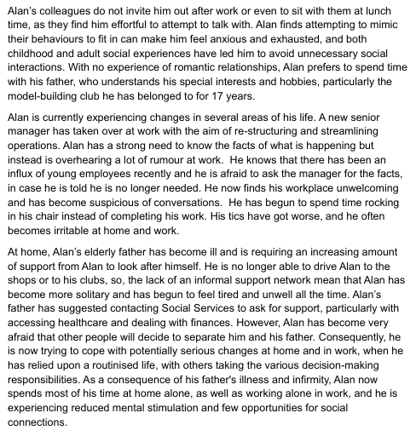
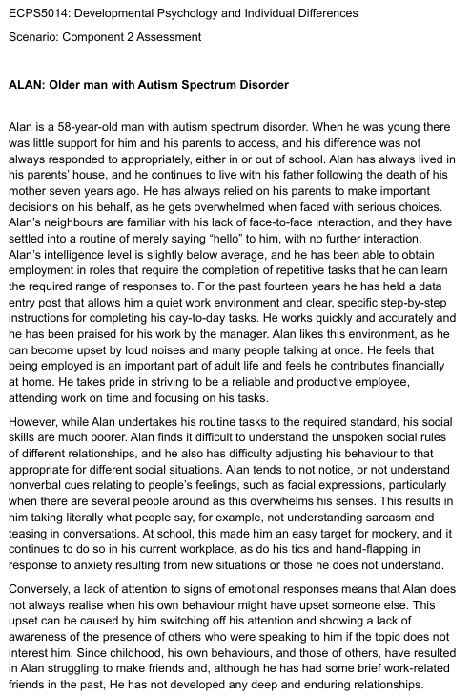

Picture 1 & 2: Scenario of Alan, an Older Man with Autism Spectrum Disorder

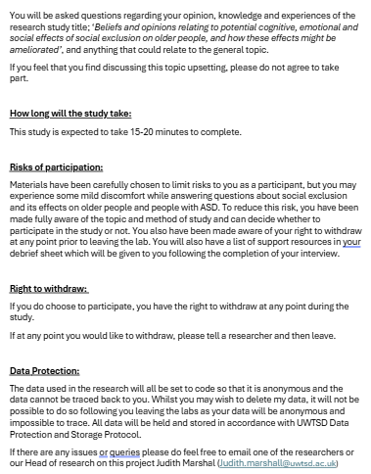
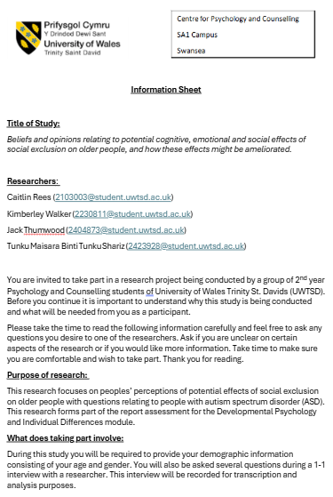

Picture 3 & 4: Information Sheet

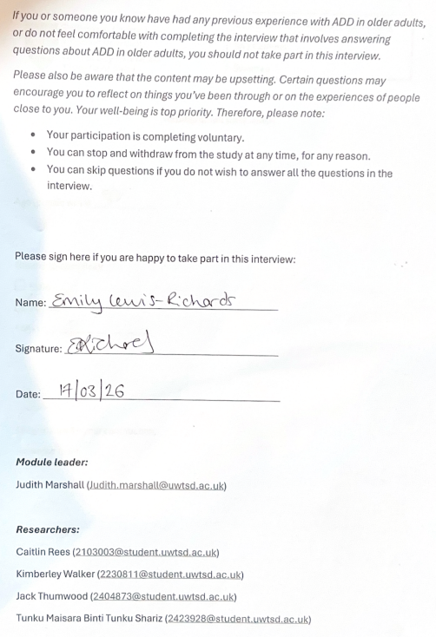
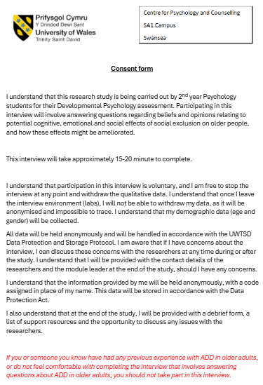

Picture 5 & 6: Signed Consent Form
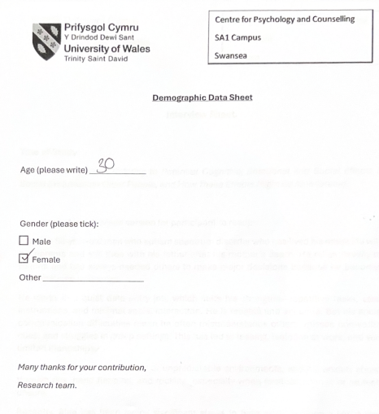

Picture 7: Filled Demographic form

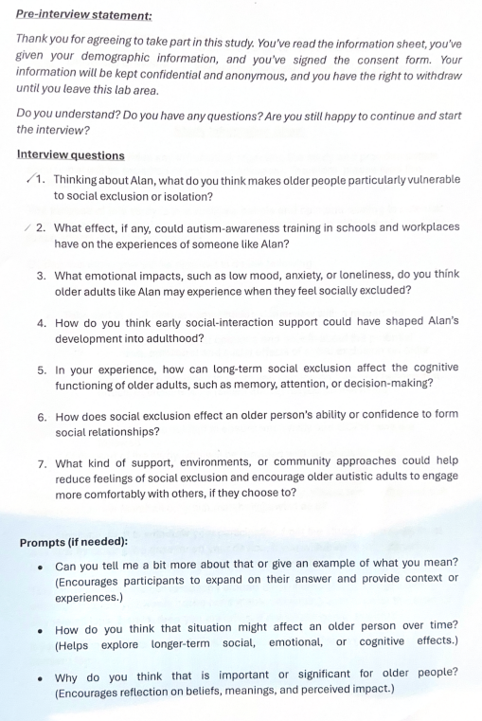

Picture 8: Interview Questions
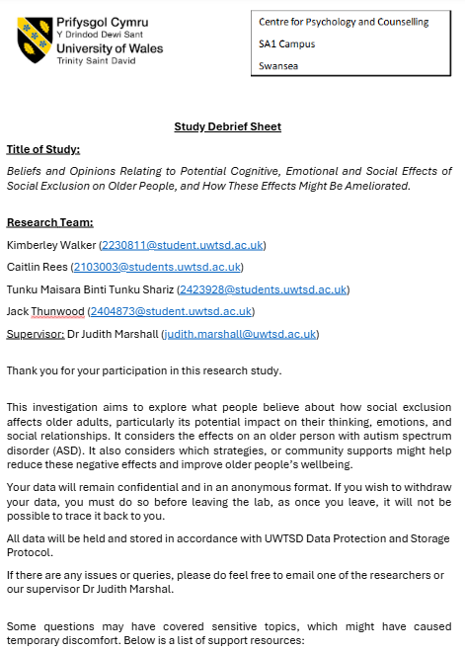
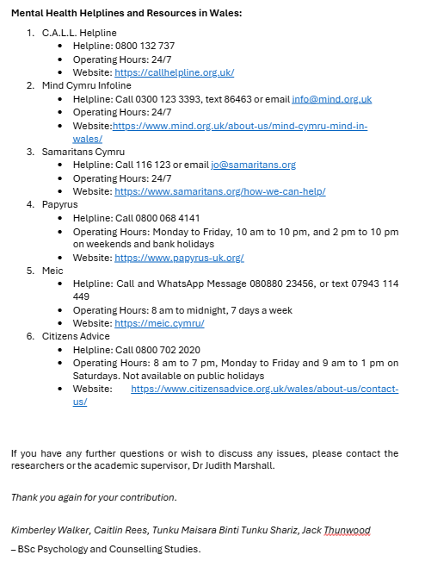

Picture 9 & 10: Debrief Form
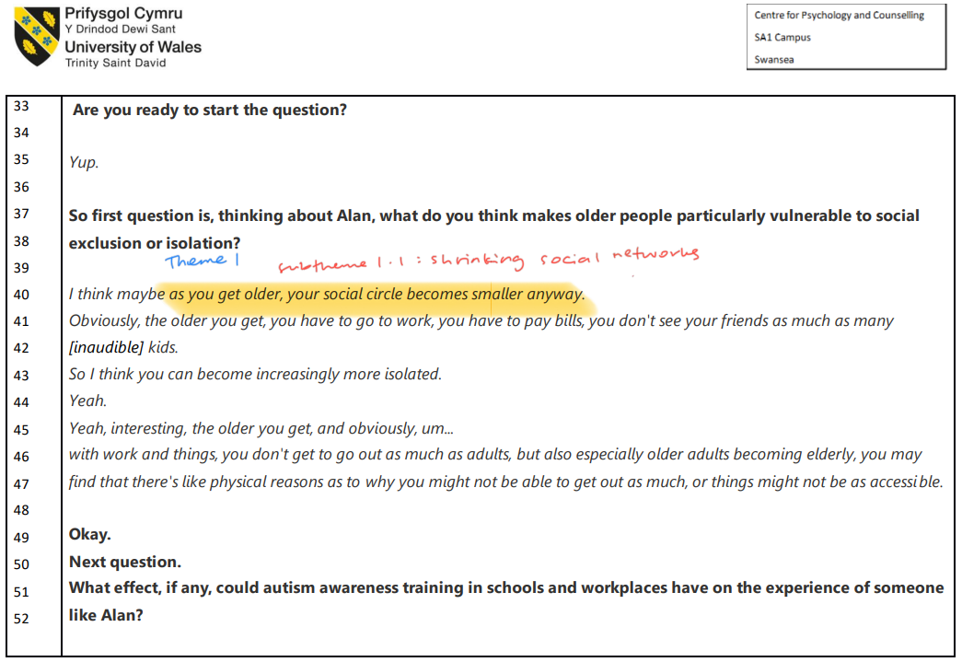

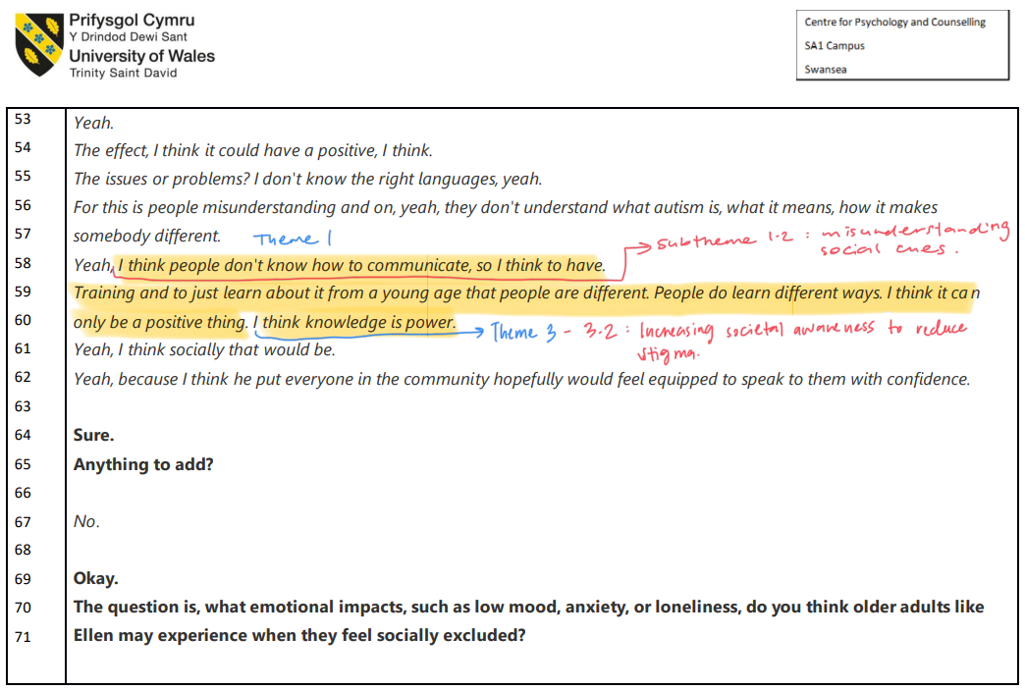

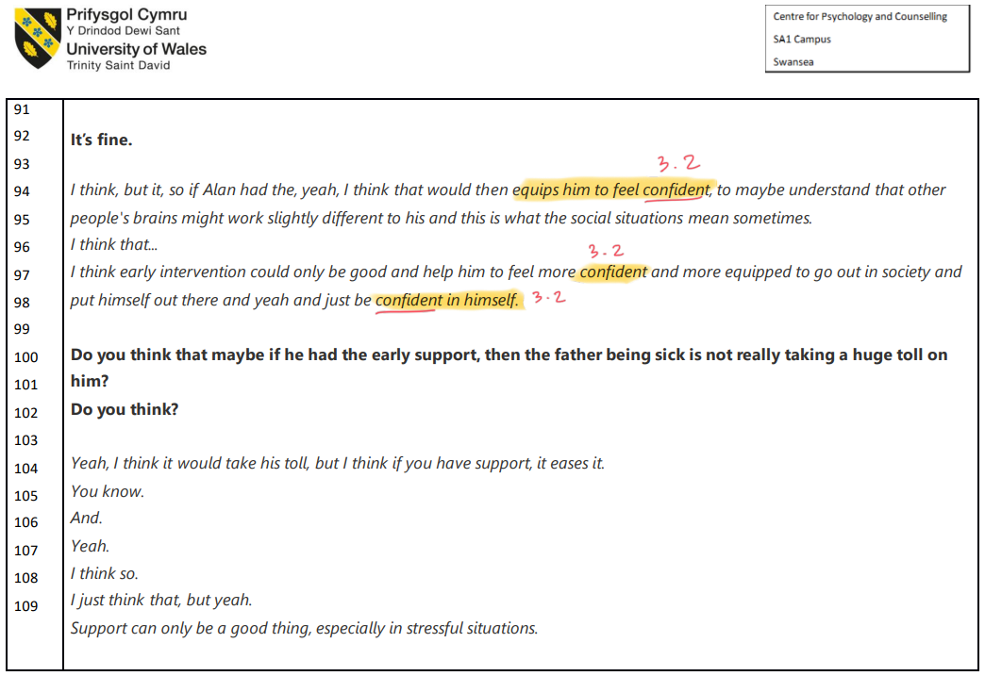

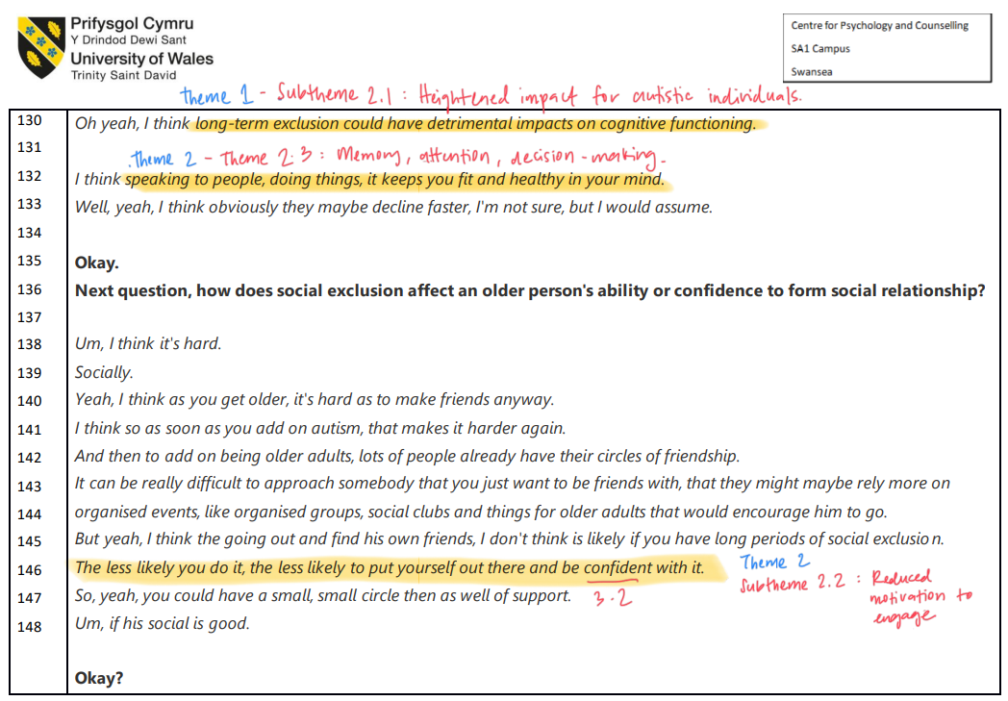
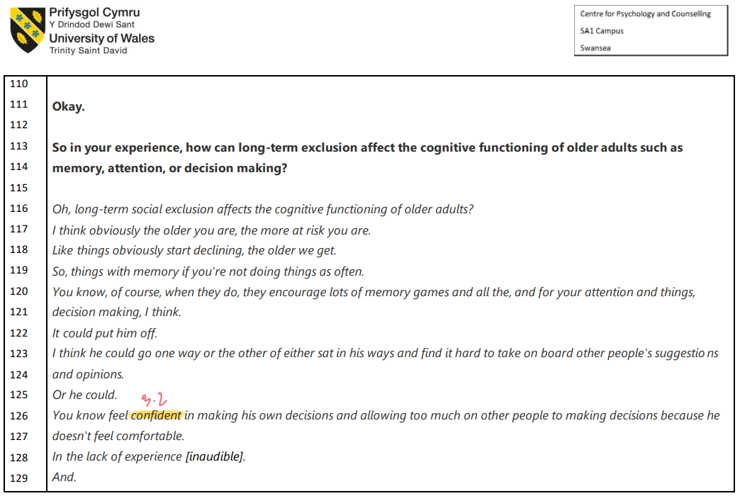
Picture 11-15: Annotated Transcriptions of Participant 1
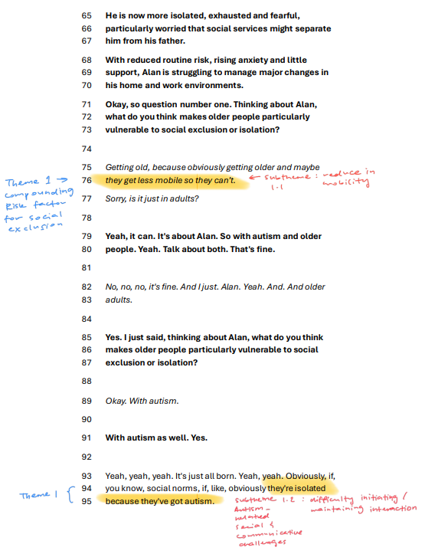

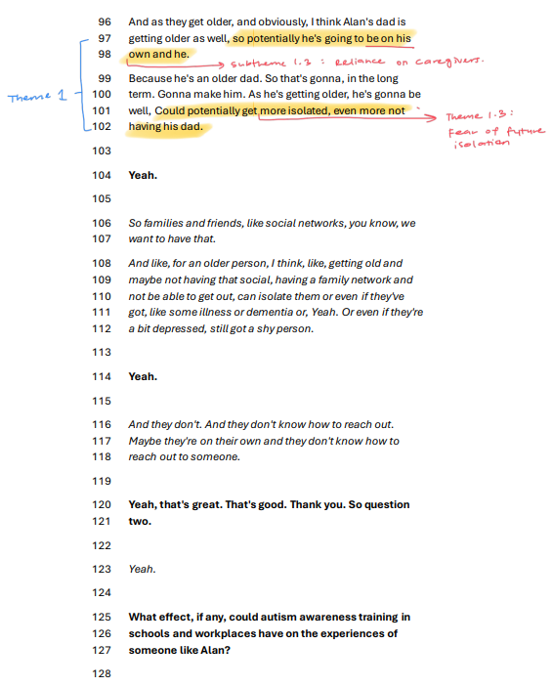

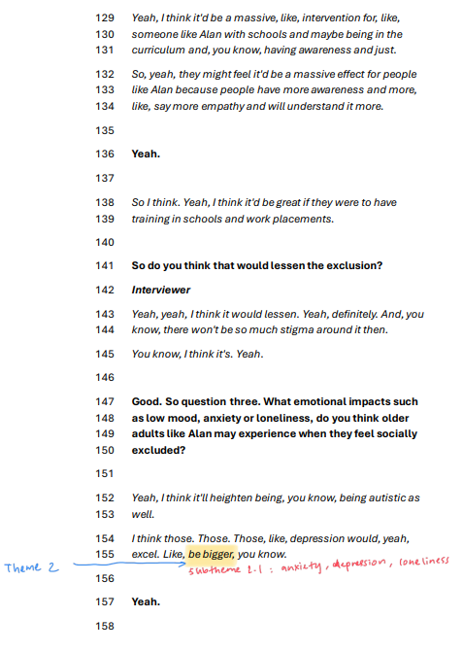

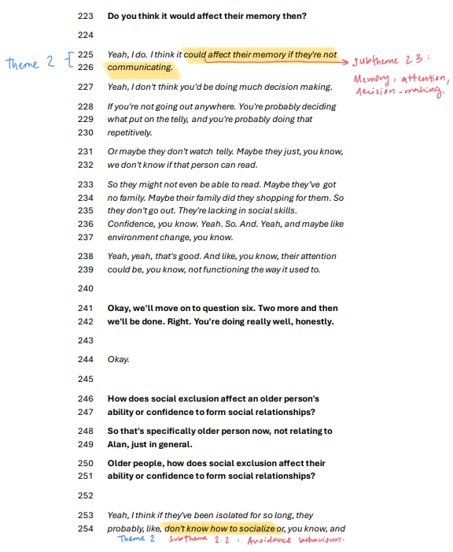

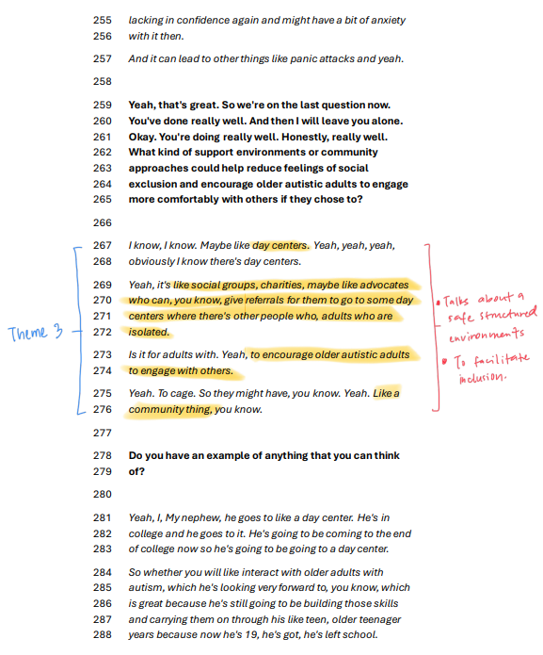

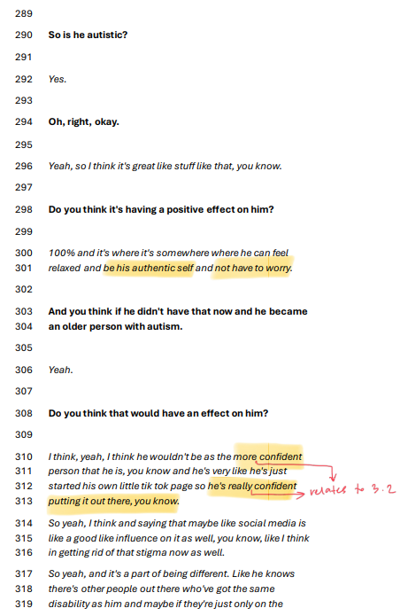

Picture 16-21: Annotated Transcriptions of Participant 2

