Major Project pitch

after reading the brief, I saw the opportunity of really pursuing something that I would be invested in.
During my previous modules I never felt I got a chance to create something that I had an interest in such as I do with my art. I enjoy creating creatures that have some form of body horror, so I felt I could pursue that.
The last animation I created was of the horror genre and I enjoyed the process of trying to push forth an atmosphere that I was proud of.
I want to take that further with this but have a spin to it and also adding body horror to it, as I feel that’s where I excel. Doing this will hopefully advance my skills in certain areas but also solidify existing ones.

Aiming for a minute in length of animation, the story follows a confrontation between a knight that has been assigned a duty to eliminate the creature. And a human infected with a parasite that has taken the lives of multiple residents.

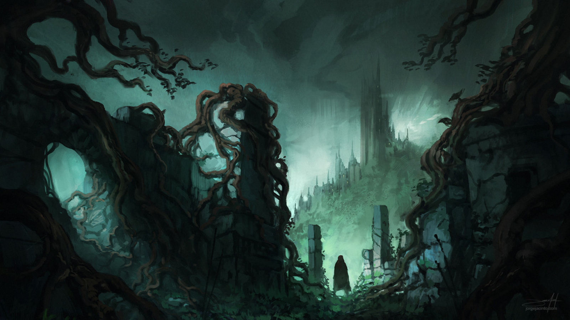
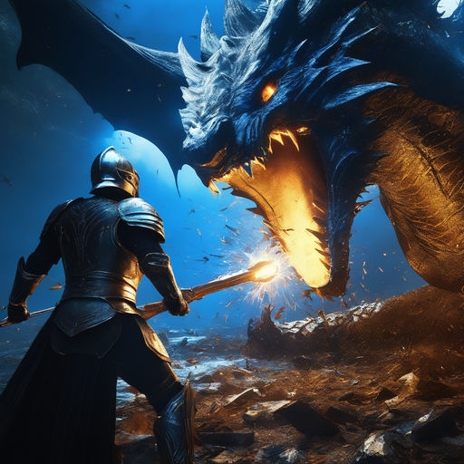

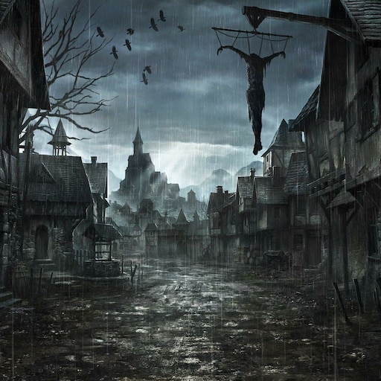

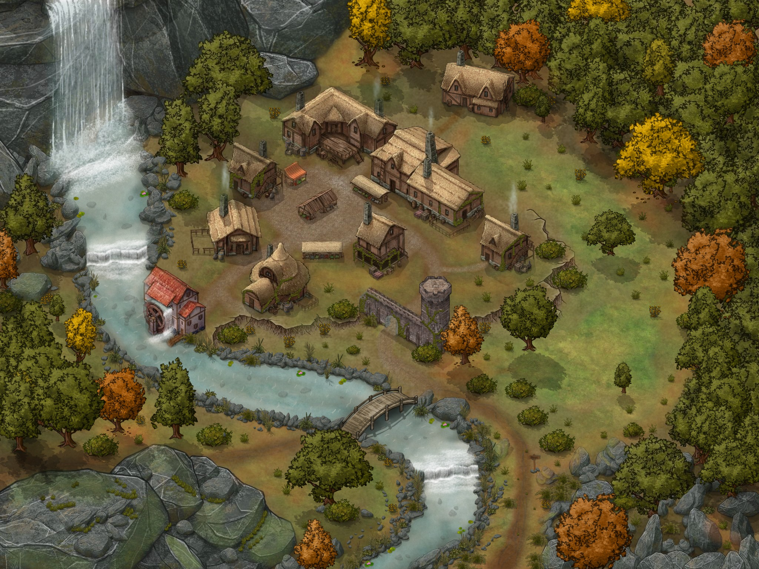
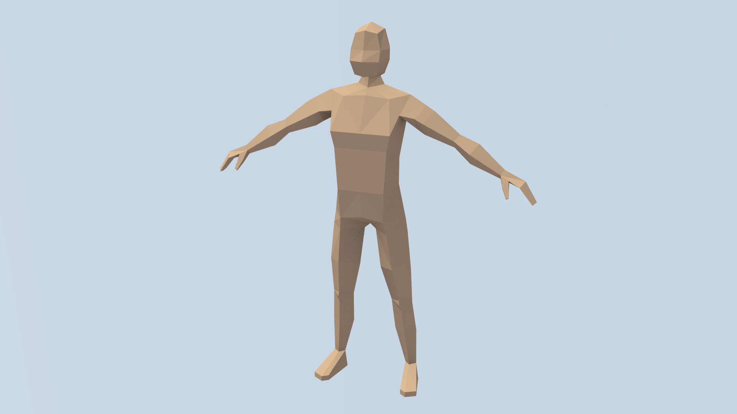

The environment will be of a fantasy town with small wood and stone houses that look incredibly similar to one another to create a labyrinth/maze of dirt paths., alleyways and dead ends.
- The town is rather dirty as it’s inhabitants are struggling.
Blood splatters on the walls of houses and a blood trail that leads to the antagonist.

I was mainly inspired by the dark fantasy video game ‘The Witcher 3: The Wild Hunt’ when it comes to how I want the environment to look. It includes many grungy and poor looking towns that I would like to try and capture the aesthetic of.

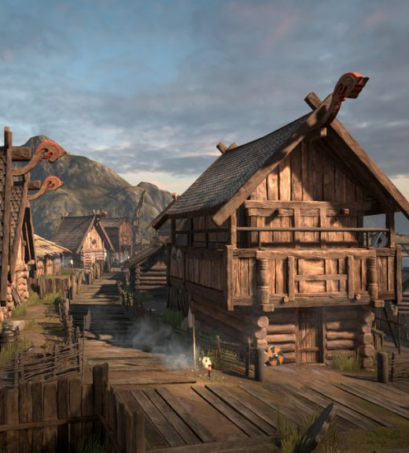

Reference: https://timcorpus.net/index.php/2020/01/09/viking-village-part-i/

The scene will have lighting that resembles that of a sunsets. I want an orange and yellow glow to the surroundings.
Harsh shadows being cascaded by surrounding buildings and objects.


Gives a dramatic edge to the animation as a whole.

Reference: https://www.bbc.co.uk/news/uk-england-norfolk-61867536

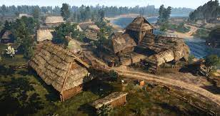
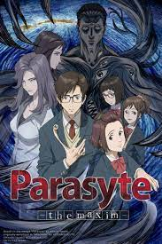
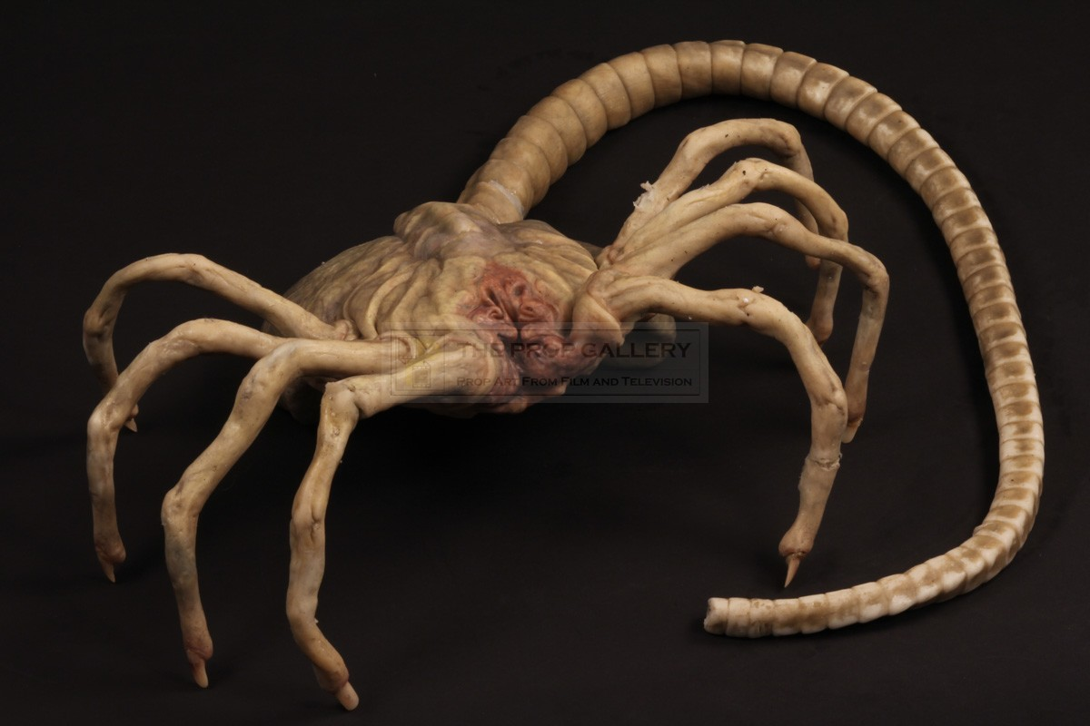

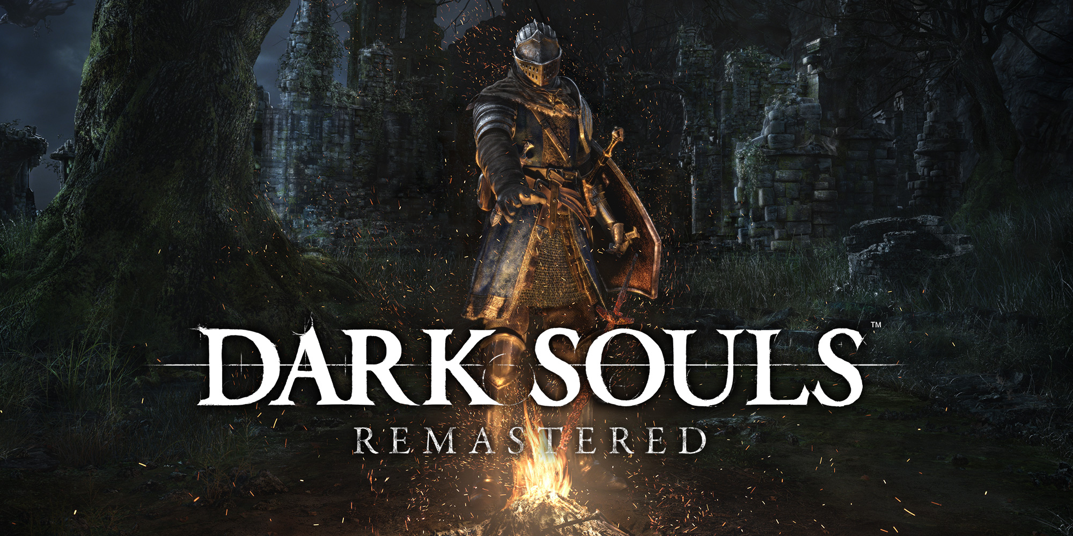

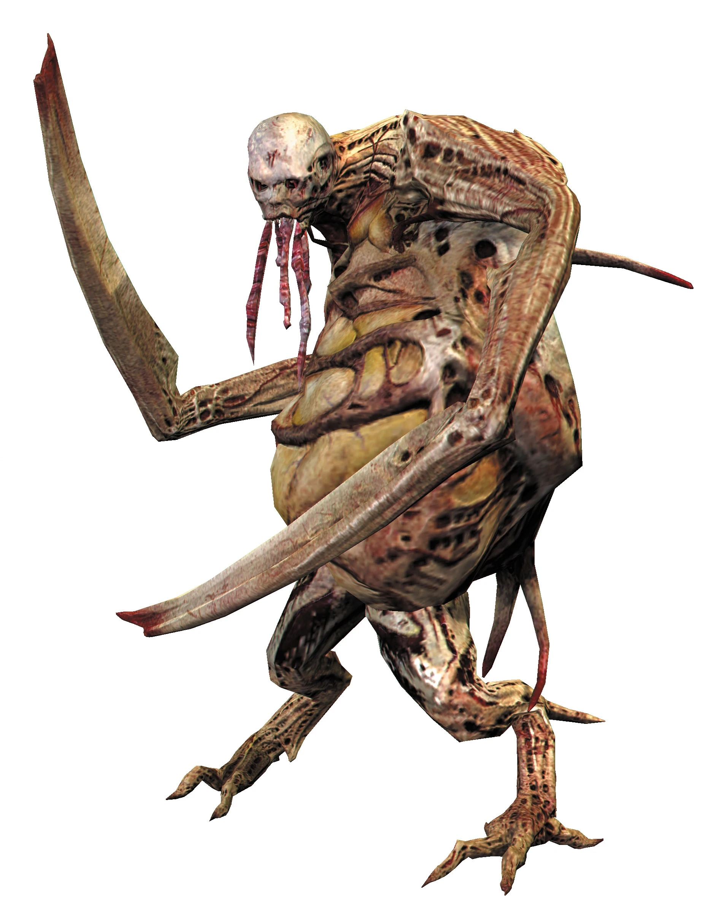
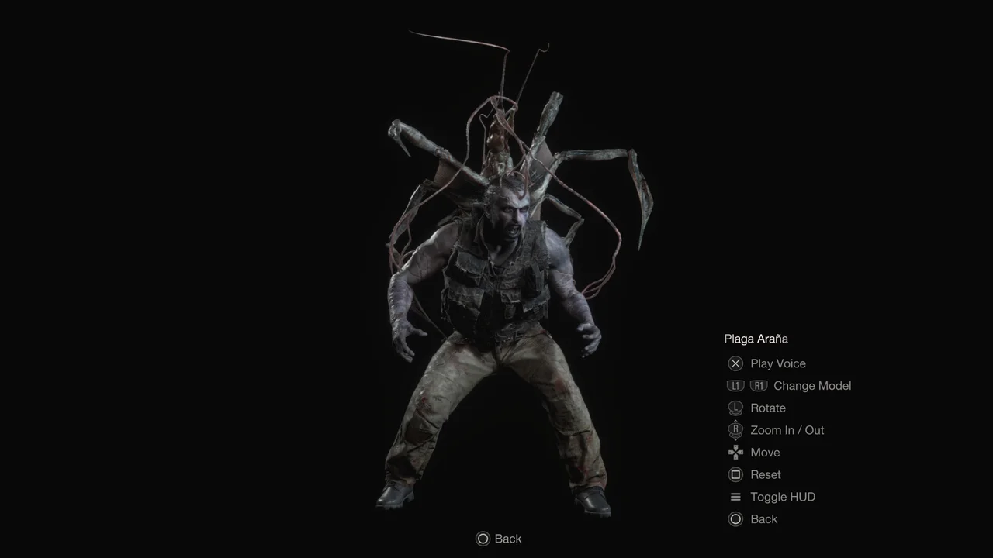
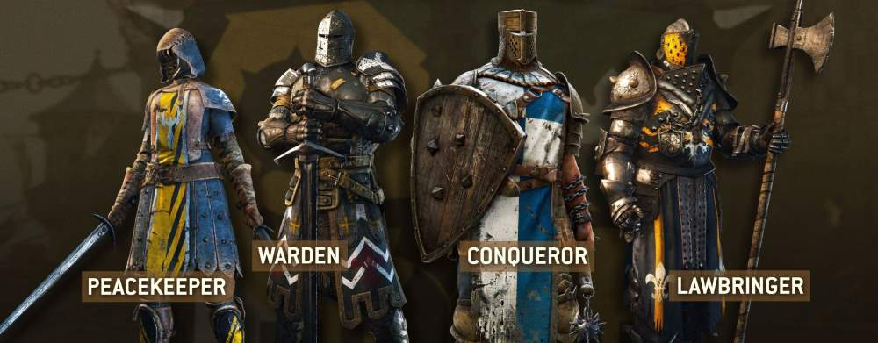
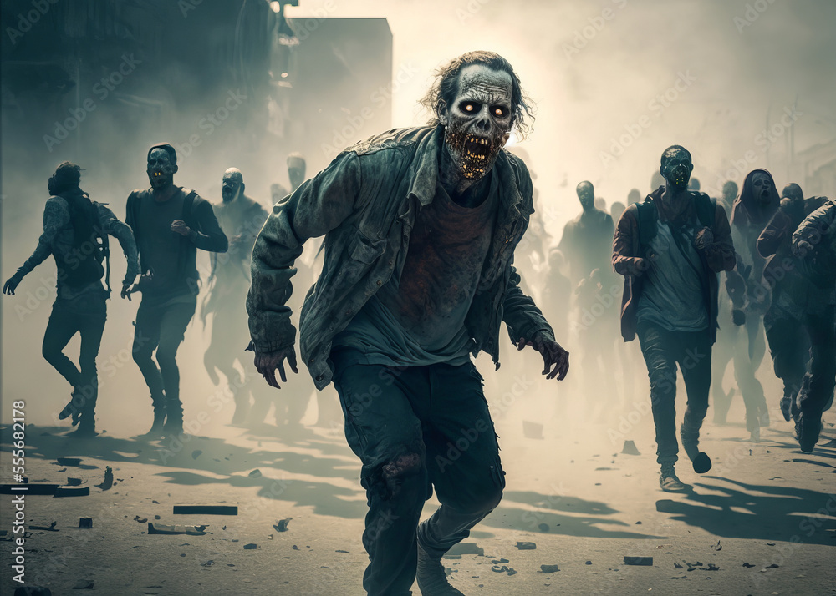
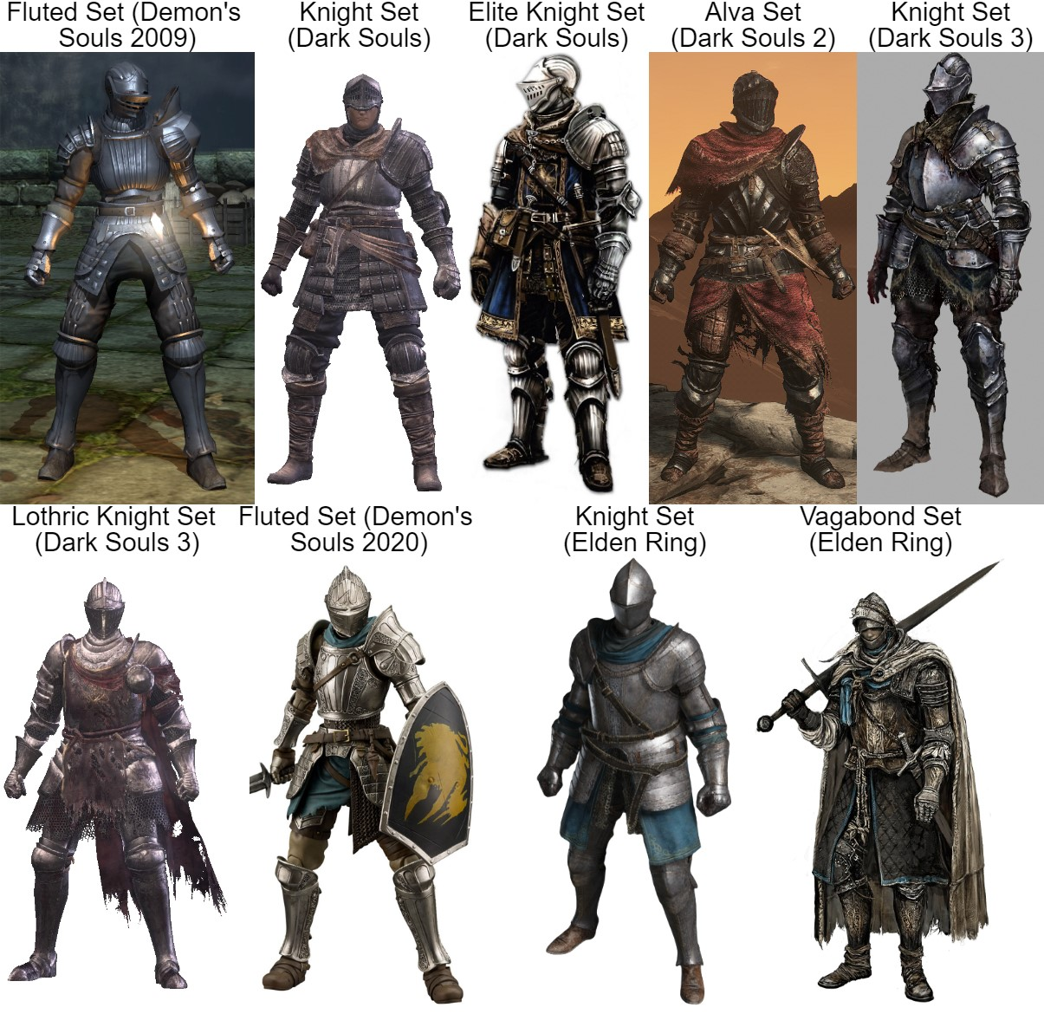
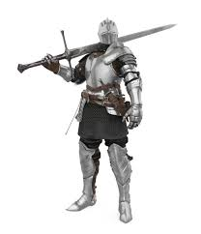

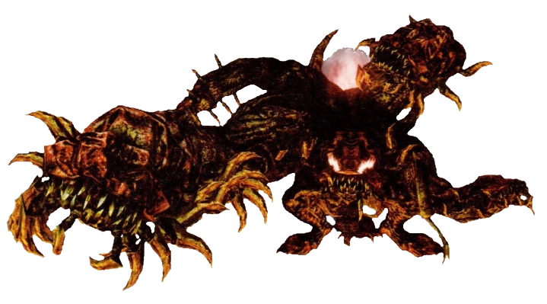

Looked into the dark souls series for inspiration and to research armour and weaponry
Default armour knight set
Lothric Knight Set
Cathedral Knight Set
Astora Straight Sword
Caduceus Kite Shield

I
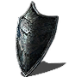
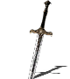
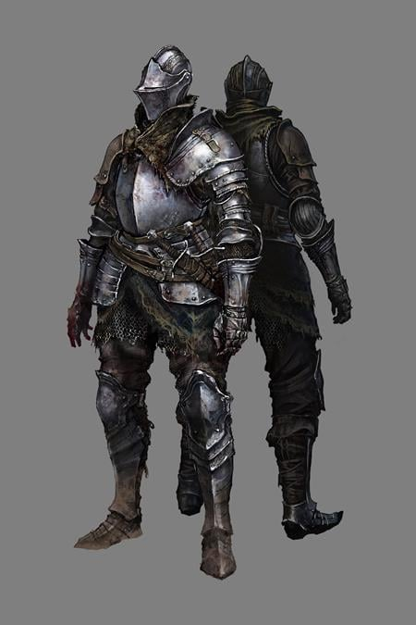
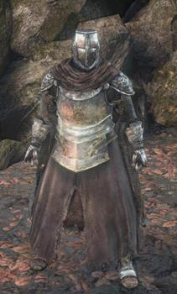
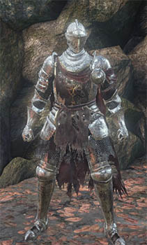

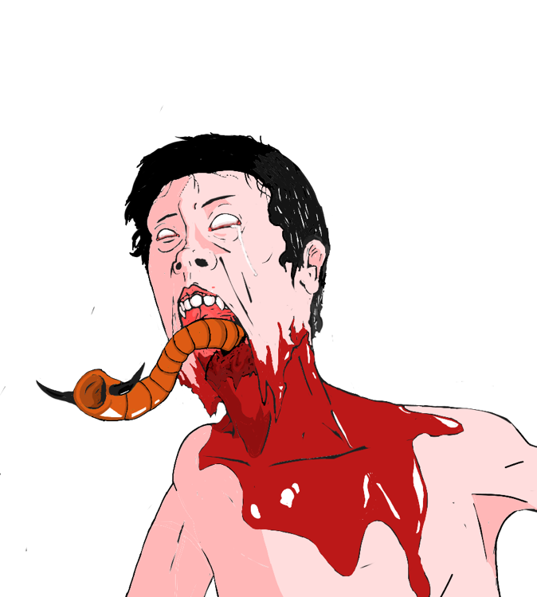
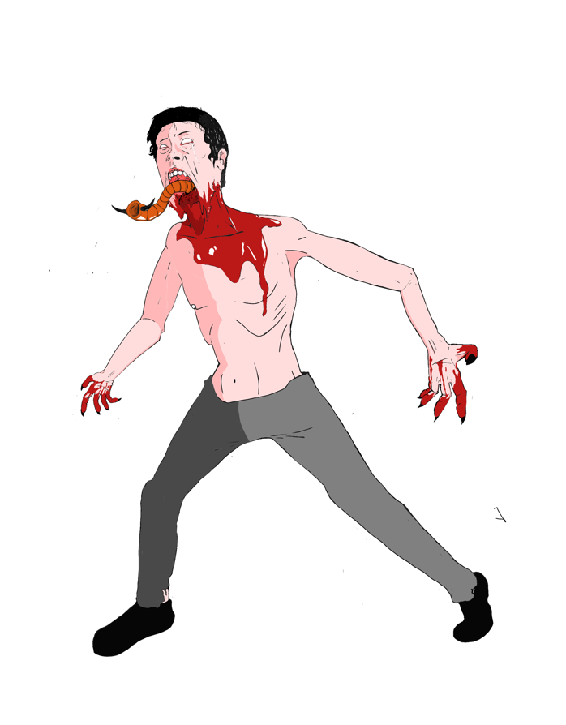
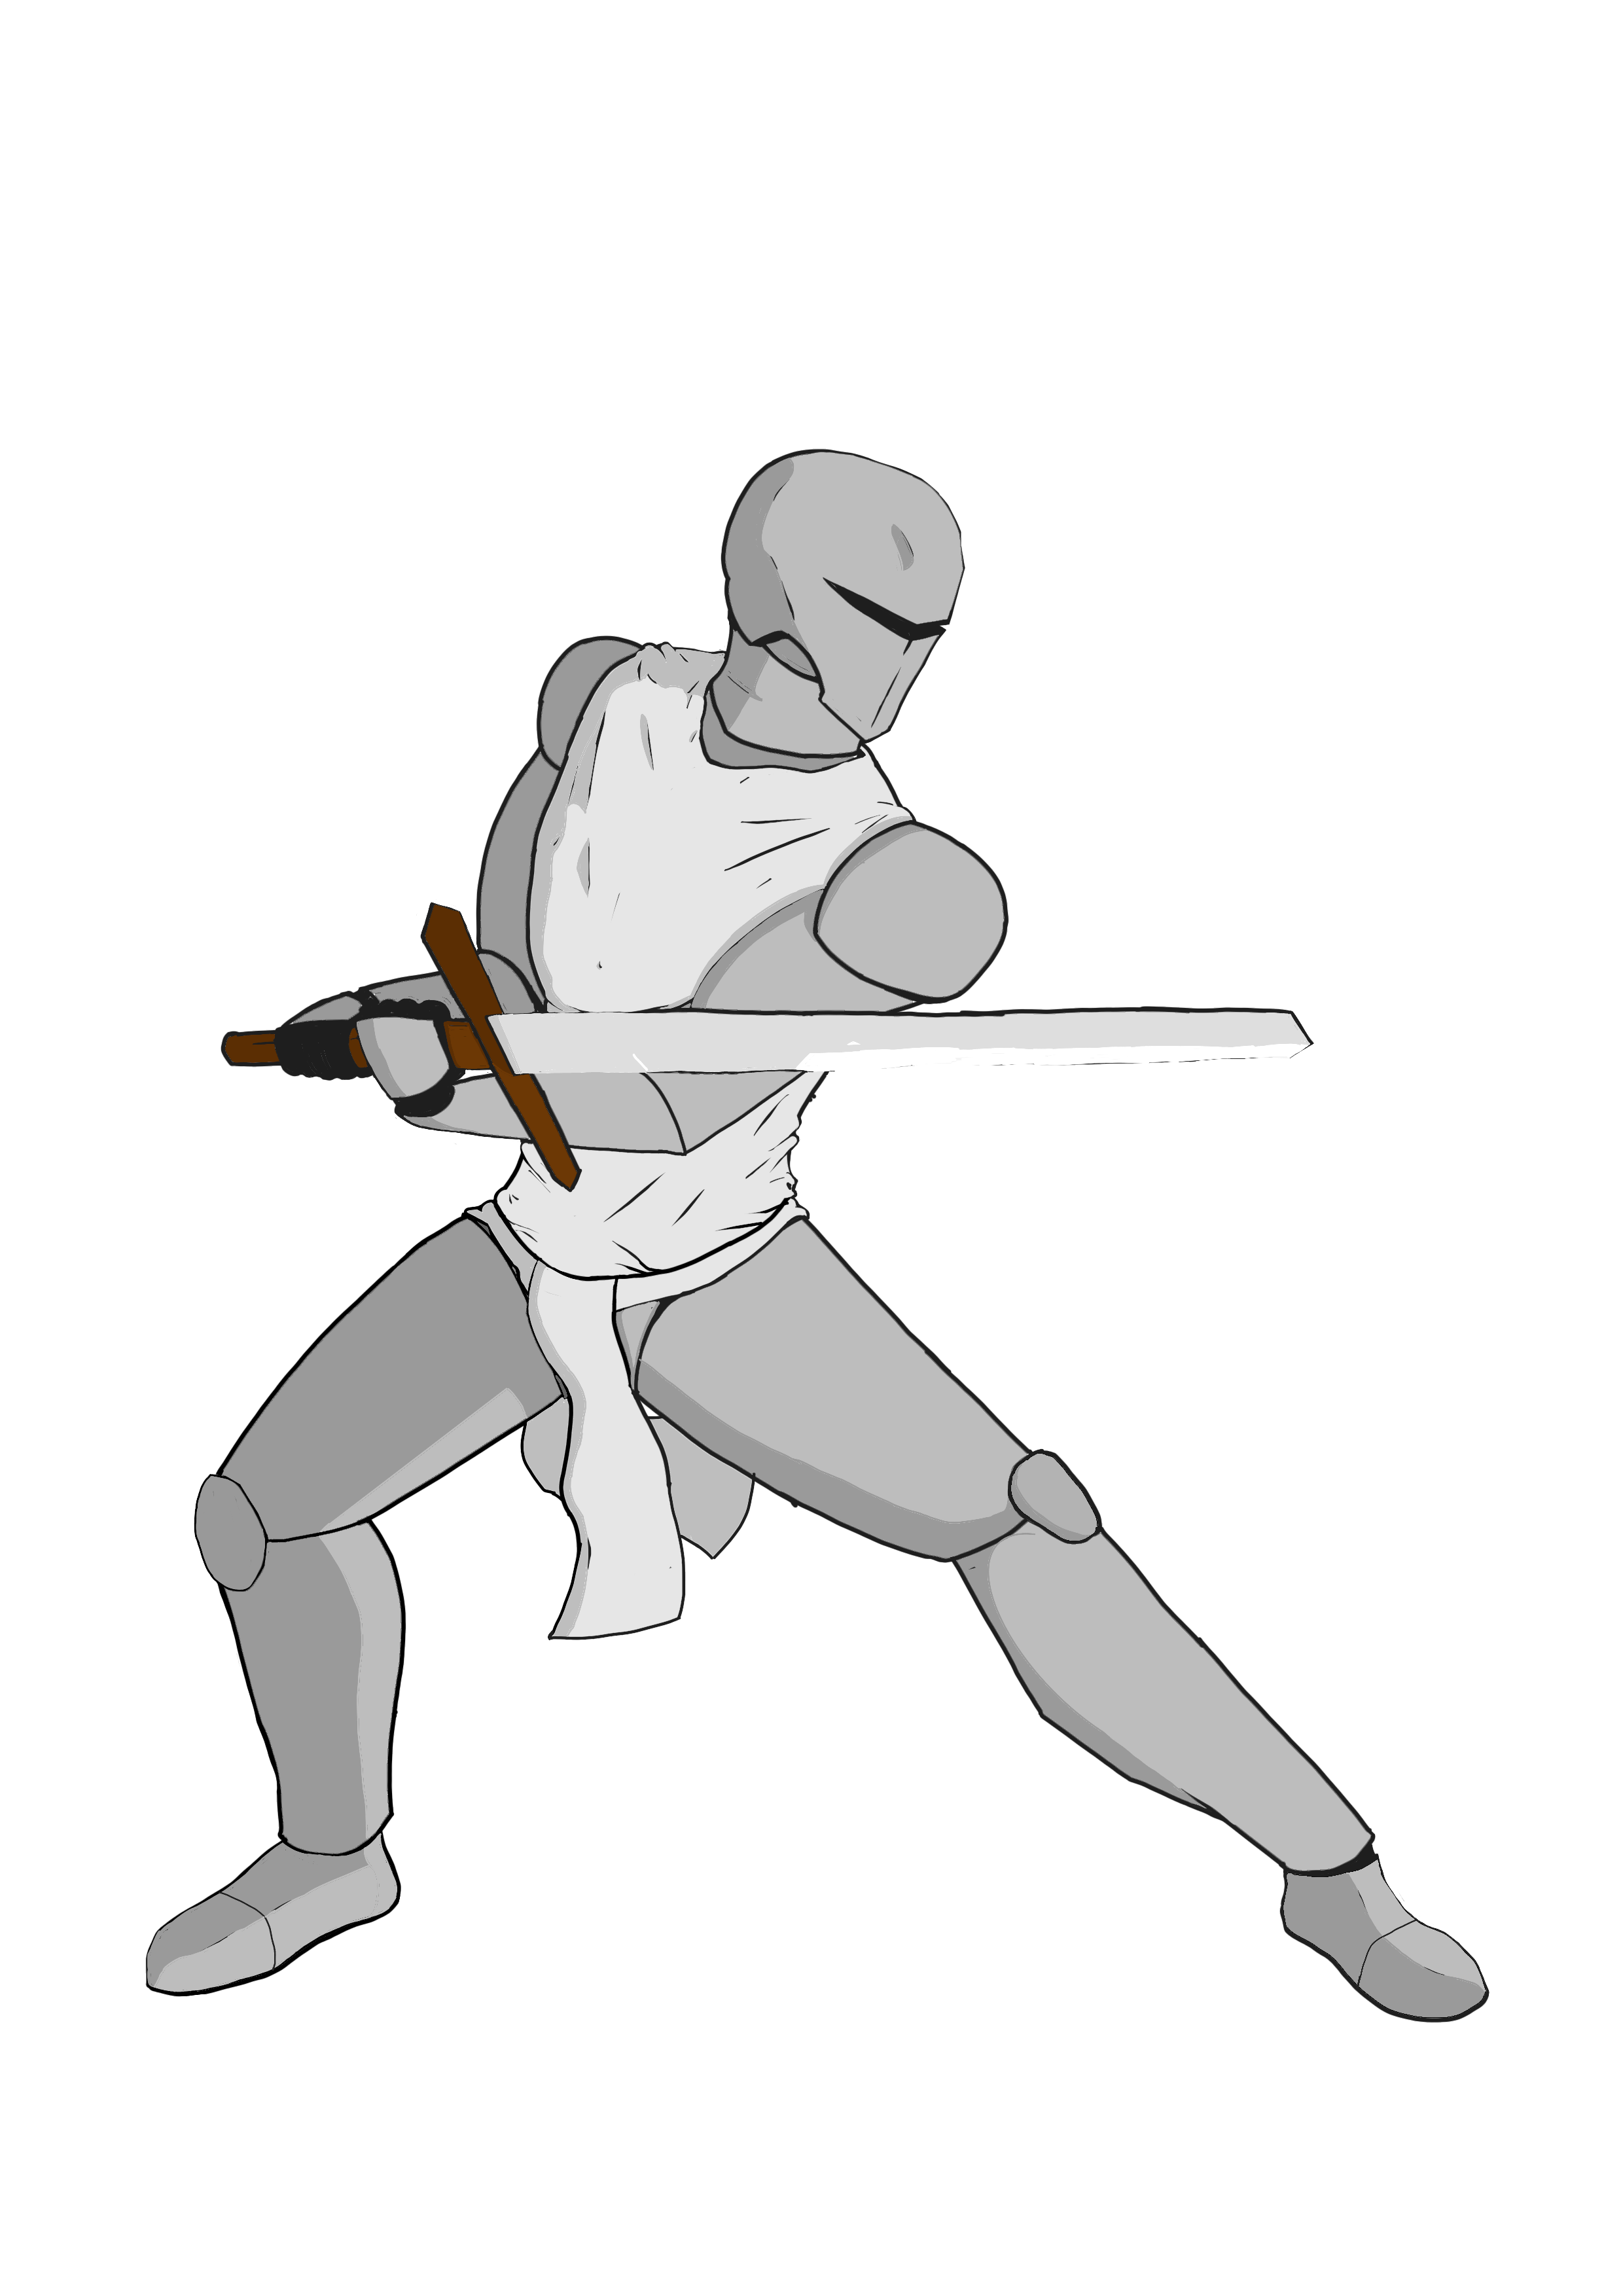
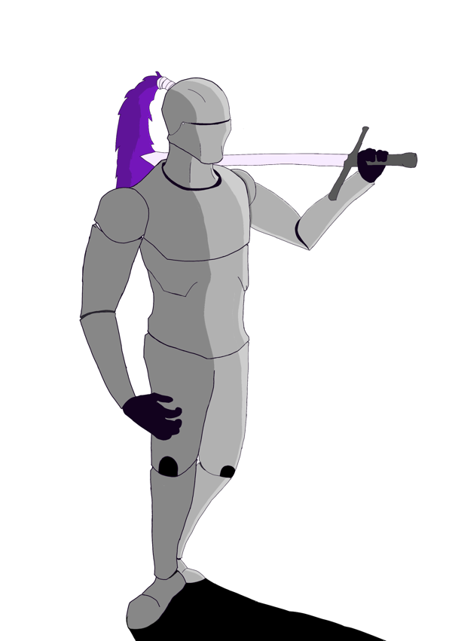

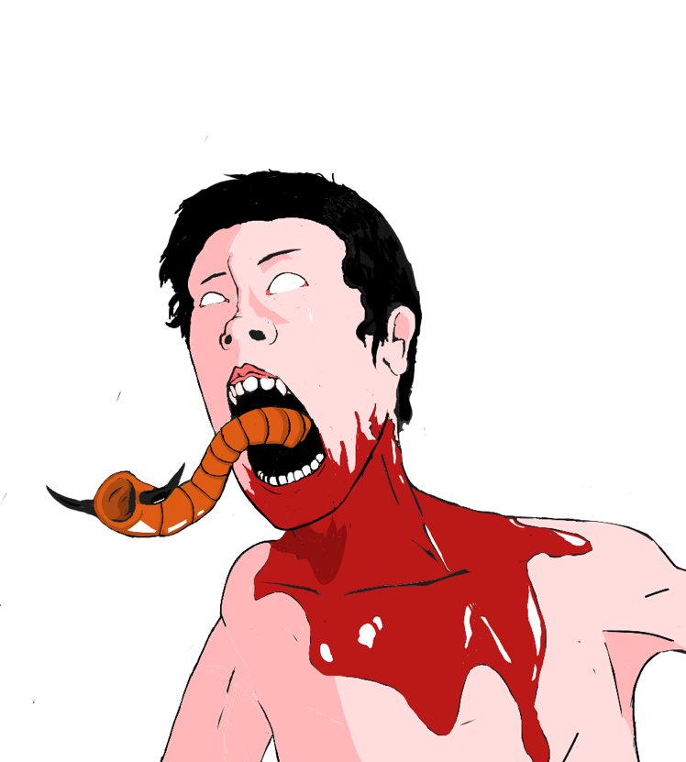

Slash
Dodge
Thrust
parry
Block
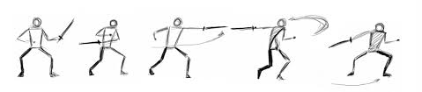
half swording

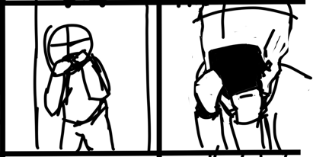
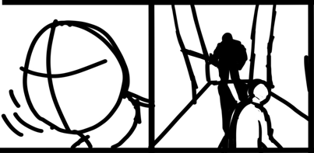
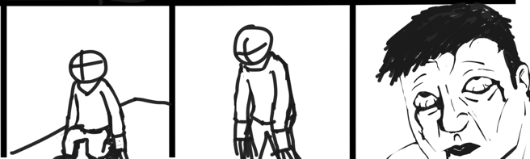
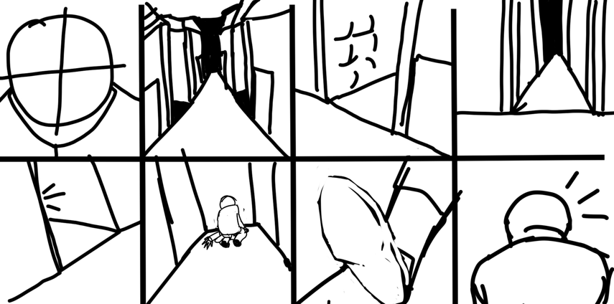
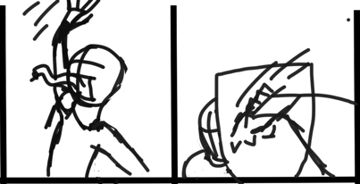
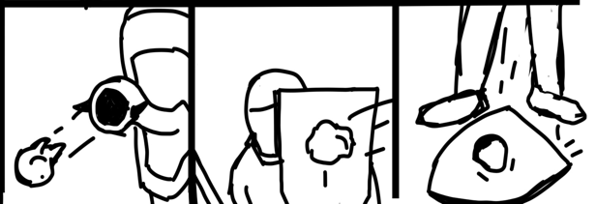
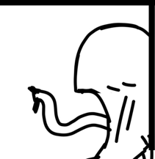
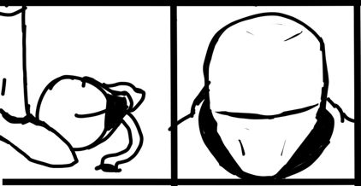
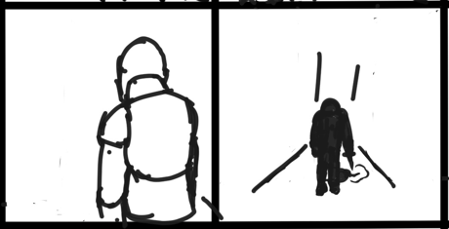
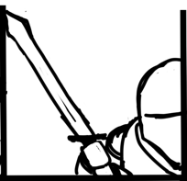
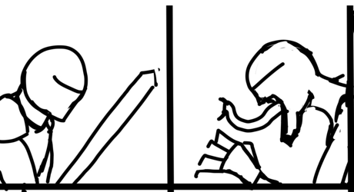

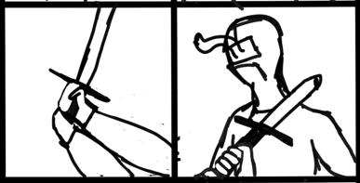

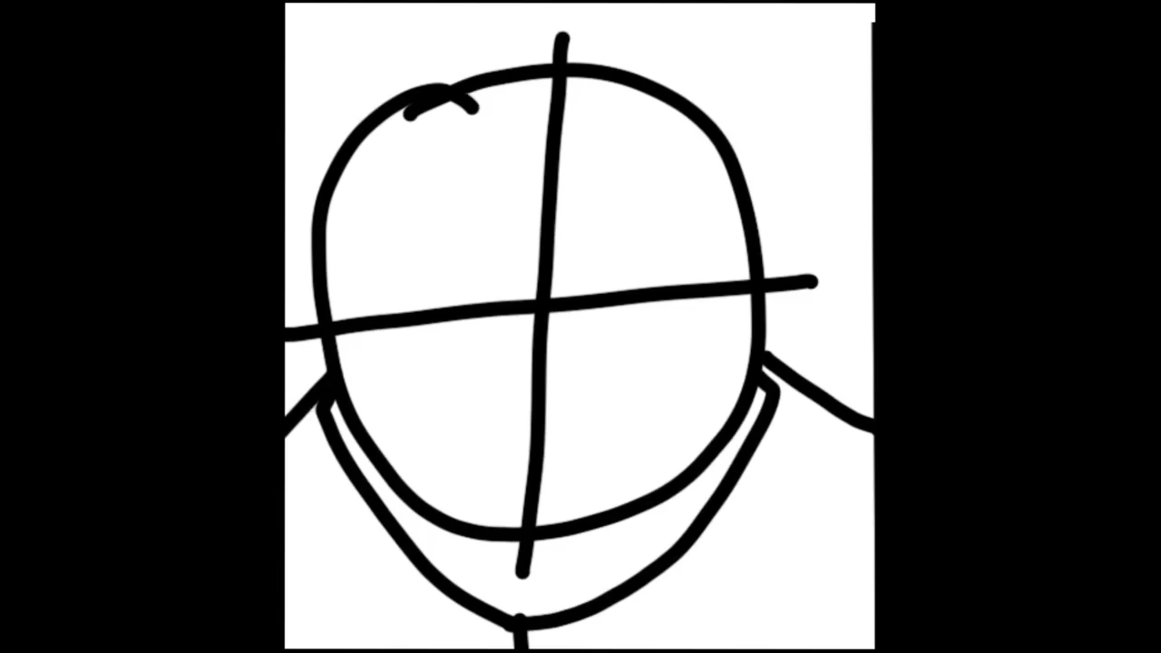
Knight - https://www.shutterstock.com/image-illustration/medieval-knight-armor-isolated-3d-rendering-1761389720
Centipede demon - https://darksouls.fandom.com/wiki/Centipede_Demon
Parasyte - https://www.imdb.com/title/tt3358020/
Witcher 3 village - https://witcher.fandom.com/wiki/White_Orchard
Resident evil 4 - https://www.ign.com/wikis/resident-evil-4-remake/Plagas
Dead Space Necromorph - https://deadspace.fandom.com/wiki/Pregnant
Facehugger –
https://www.thepropgallery.com/avp-facehugger
Dark Souls - https://www.nintendo.co.uk/Games/Nintendo-Switch-games/Dark-Souls-Remastered-1325790.html
Dark Souls armour - https://www.reddit.com/r/darksouls/comments/11z5c0b/which_is_your_favorite_typicalclassictype_knight/
Zombies –. https://stock.adobe.com/images/zombie-horde-zombie-apocalypse-scene-generative-ai/555682178
For Honor - https://www.greenmangaming.com/for-honor-hub/story-knights/
Dark fantasy world - https://www.google.co.uk/search?q=dark+fantasy+world&client=safari&sca_esv=573232648&hl=en-gb&tbm=isch&source=lnms&sa=X&ved=2ahUKEwjd4YnkvPOBAxXyZEEAHatlAeUQ_AUoAXoECAIQAw&biw=1194&bih=701&dpr=2#imgrc=_yGZE1f9n1qvlM
Dark fantasy town - https://steamcommunity.com/sharedfiles/filedetails/?id=1597290290
Knight fighting a monster - https://playgroundai.com/search?q=monster+fighting+a+knight+with+a+weapon
Small village - https://www.reddit.com/r/inkarnate/comments/exwmzt/small_village_near_waterfall/
Low poly model - https://opengameart.org/content/low-poly-character-basemesh
Caduceus Kite Shield – https://darksouls.wiki.fextralife.com/Caduceus+Kite+Shieldhttps://darksouls.wiki.fextralife.com/Caduceus+Kite+Shield
Astora Straightsword – https://darksouls.wiki.fextralife.com/Astora's+Straight+Sword
Dark Souls 3 Knight - https://darksouls3.wiki.fextralife.com/Knight
Cathedral Knight Set - https://darksouls3.wiki.fextralife.com/Cathedral+Knight+Set
Lothric Knight Set - https://darksouls3.wiki.fextralife.com/Lothric+Knight+Set
Facehugger 2 – https://www.ebay.co.uk/itm/334527550872
Sword fighting - https://cascadeur.com/blog/general/separation-and-compensation-principle-in-strikes-animation

