Adidas's Differentiation Strategy Analysis



Module Name: Strategic & Sustainability (M3X9111)
Student Name: HaiYang Fang
Student ID: 1800186

Table of Contents
1. Executive Summary 4
2. Introduction 5
2.1 Report Remit 5
2.2 A Brief Introduction to Adidas 5
2.3 Definitions of Major Concepts 5
3. Differentiation Strategy Selection and Formulation 6
3.1 Corporate Mission and Strategic Objectives 6
4. Implementation of the Differentiated Strategic Plan 7
4. 1 Brand Differentiation Strategy and Critical Evaluation 7
4. 2 Product Differentiation Strategy and Critical Evaluation 8
4. 3 Service Differentiation and Critical Evaluation 10
5 Comparative Analysis with Competitors 11
5.1 Differences in Brand Differentiation Strategies 11
5.2 Differences in Product Differentiation Strategies 12
6. Advantages and Disadvantages of Differentiation Strategies 13
6.1 Advantages 13
6.2 Disadvantages 14
7 Conclusion 15
7.1 Recommendation 15
Reference 16

Table of Figures
Figure 1 Adidas’ Organizational Structure 5
Figure 2 Adidas’ brands 6
Figure 3 The Key of Business Among Three Adidas Brands 7
Figure 4 The Hot Sneaks in Recent Years 10
Figure 5 Adidas Portfolio Map 12

- Executive Summary
This report mainly analyzes the differentiation strategy adopted by Adidas. This report describes Adidas' choice of differentiation strategy based on its corporate mission and strategic goals. Adidas implements its strategy from three aspects: brand, product and service differentiation strategy. The differentiation strategy can increase the competitiveness of Adidas and maintain its price advantage, but at a higher cost. Finally, the report concludes that Adidas's differentiation strategy is effective, but it also has some shortcomings. The report suggests that Adidas may need to further develop a differentiation strategy to build consumer brand loyalty compared to competitor Nike.

- Introduction

2.1 Report Remit
This report describes Adidas' differentiated strategy selection, formulation and implementation, and then compares Adidas' differentiation strategy with its biggest competitor, Nike, and concludes that Adidas needs to continue its differentiation strategy to shape higher brand loyalty in the minds of consumers.

2.2 A Brief Introduction to Adidas
Adidas is a German exercise equipment maker founded by Adolf Adi Dassler and registered in 1949 under the name Adidas AG. Sneakers are the traditional products of Adidas. With the expansion of the company's scale and the increase of the brand effect, Adidas has successively developed and launched sports goods such as clothing, clothes, and equipment around the center of sports shoes. In 2014, Adidas' performance declined significantly, but it actively took measures such as launching new shoes. In 2017, Adidas officially surpassed Air Jordan and became the second child of sports brands (Gao, 2018).

General Manager
Marketing Director
Sales Director
Senior Manager
Operation Manager
Figure 1 Adidas’ Organizational Structure
The organizational structure of Adidas is shown in the figure above. The general manager has jurisdiction over four directors.
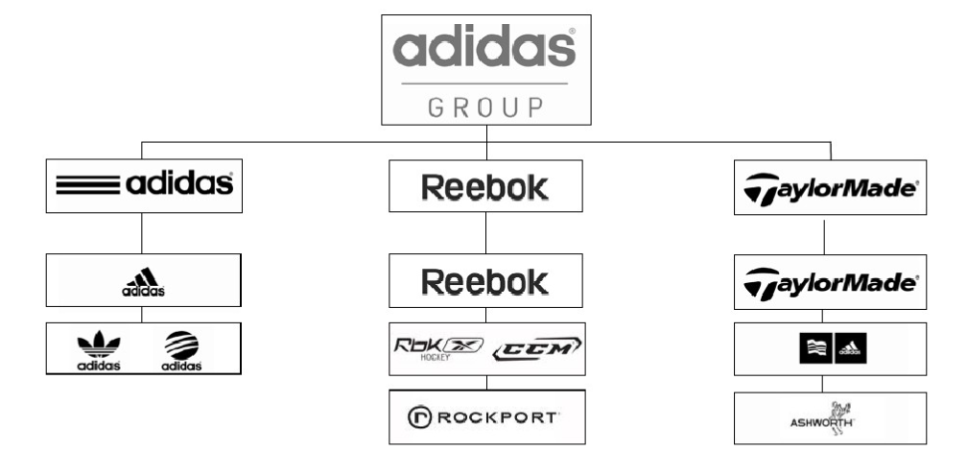
Figure 2 Adidas’ brands

2.3 Definitions of Major Concepts
Differentiation strategy means that the strategy applying to realize a competitive superiority for the sake of making the company's products, services, and brand image which clearly differentiate from contenders (Gao, 2018).

The business level strategy refers to leading actions that manage the unit plan under the constraints of the company level strategy. It serves the overall goals of the business (Lebron, 2010).

Competitive advantage is a sustainable superiority compared to contenders, divided into focus advantage, difference advantage and cost advantage (Ly, 2018).

- Differentiation Strategy Selection and Formulation
The strategies used by the three Adidas brands are different. The choice below is mainly to illustrate the issue from the differentiation strategy (one of Adidas' business level strategies).

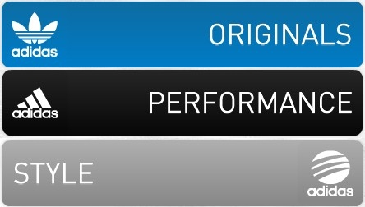
Keeping its original model and no longer invest more in its business
Focusing on the development of sports performance products
The focus is to expand its market share
Figure 3 The Key of Business Among Three Adidas Brands

3.1 Corporate Mission and Strategic Objectives
Mission of Adidas is to turn into a lead in the world of exercise equipment. Leadership is not just a return on interest, but a course of making a hit. Adidas' mission is to acquire development of their own (Grant, 2014).

4. Implementation of the Differentiated Strategic Plan

4. 1 Brand Differentiation Strategy and Critical Evaluation
Identity of brand differentiation strategy is on account of knowledge, which confirms that it could be more individuality than product differentiation based on technology. Therefore, identity of brand differentiation is the primary strategy of enterprises after rate war and product homogenization (Lebron, 2010).

Adidas has been on the road to building brand differentiation. The following is an example of the acquisition of the golf products company TaylorMade by the Adidas Group in 1998 (Ly, 2018). After the acquisition of TaylorMade, Adidas re-formed the new brand TaylorMade-Adidas. With the reputation of TaylorMade, TaylorMade-Adidas has succeeded in capturing the high share of the golf products market through its accurate brand positioning and has become the most influential brand in the golf equipment field.

TaylorMade-Adidas belongs to the sports performance series of the Adidas brand and adopts a dual-brand positioning strategy: TaylorMade Golf and Adidas Golf respectively (Dickson, 2011). The two brands are clearly defined, and each has different positioning and marketing methods in golf apparel and golf equipment, belonging to a dual structure, respectively occupying different market segments.

In terms of brand recognition, its brand is not very high. The competitive brand Callaway has a wide range of consumer awareness and far-reaching brand influence, posing a threat to TaylorMade-Adidas, and some consumers do not know that TaylorMade is a brand of adidas, which means that TaylorMade Golf has not yet fully integrated into Adidas and successfully reach the mind of the consumer.

In terms of brand meaning, its brand efficacy, product reliability and price have been recognized by consumers, and the speed of after-sales service and service needs to be strengthened. However, its brand image does not accurately grasp the mind of consumers in the marketing of celebrity effects. The brand can have a good brand association with consumers, and the imagination is the most unique feature of TaylorMade-Adidas (Roulin, 2016).

In terms of brand relationship, there is no strong brand resonance with consumers on the online homepage, and it is impossible to establish a strong loyal relationship with target consumers.

Now, Adidas can make full use of the star effect, favor the female market, expand the trend, and use the original to achieve brand differentiation. At the same time, it also utilizes outdoor marketing strategies and large-scale trend-oriented advertising output to achieve better inclusiveness of brands and online media, and to achieve brand rejuvenation with “creative and interactive”, focusing on media interaction and fun.

4. 2 Product Differentiation Strategy and Critical Evaluation
For the time being, Adidas principally focuses on footwears (basketball shoes, soccer shoes, tennis shoes, etc.) ceaselessly enriching its production line. Through the production portfolio tactic, the production ecosphere circulation is endlessly replaced to achieve sustainable profitability. Adidas has a high sense of fashion and outstanding ability to grasp the direction of combining sports and fashion. At the same time, the company frequently launches new line products jointly with trendy people and well-known designers (Wunsch, 2016). The sub-brand NEO is positioned in the trend direction.

In terms of product packaging, Adidas believes that the choice of packaging materials could reflex the trait of clothing productions. The color scheme should reflex the style and individuation of the clothing trademark. The figure design could be easiness for customers to recognize. It could attach importance to the communication of apparel brand information and print technology and structural modeling (Su, 2010). And the company could attach importance to the marketing character of pack, through the packaging to promote the market standing of sport suit products and the market merit of sportswear brands.

Adidas has often paid great attention to the quality and update of productions, taking production update as the driving powers for progression, and achieving production differentiation through technology leadership ability. Among the Adidas sport shoes products, the world's first pair of skates, the first pair of multi-studded shoes, the first pair of rubber-studded soccer spikes, particularly its adidas spine-type studs, was a very novel conception. It is believed that it play a great significant role to the German football team winning the 1954 World Cup (R McGuigan, 2014). The fabric fiber of the clothes is mainly made of "Nano", which is only one-fifth of the hair silk and greatly promotes the advance of the result of exercise equipment.

At the same time, in the market orientation, Adidas has install a marketplace analysis section to organized analyze and report on the ever-changing surroundings of the exercise equipment marketplace and the business, and propose strategies for timely response.

Adidas' product prices are fairly at a high level, but its product line is fairly abundant, and the products are relatively complete from the low-end to the high-end, and fully meet the needs of consumers (Nieddu, 2010). The high-end products and low price make the product acceptance range wide, and the audience is younger and more extensive. However, compared with Nike, there are more price discount activities, which makes it easier for customers to feel uneconomical after buying, which causes consumers to press time to buy, which so not contribute to the build of long time brands (Ari, 2017).
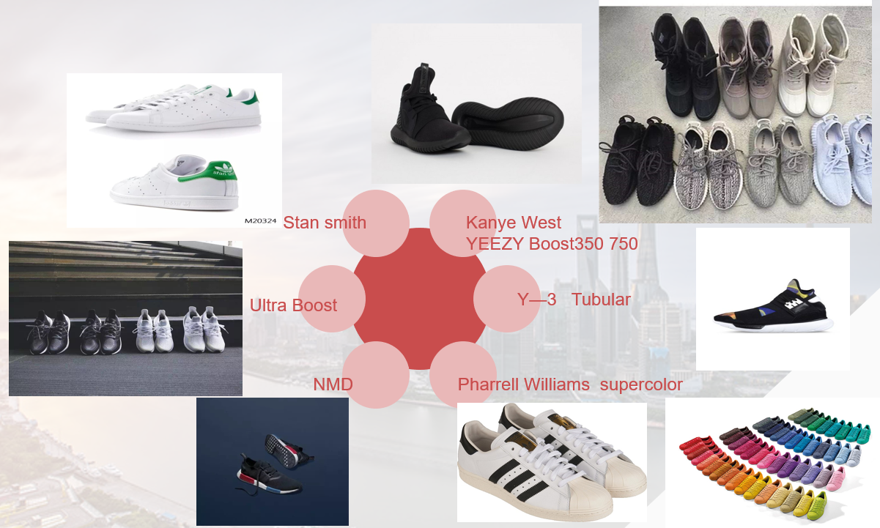
Figure 4 The Hot Sneaks in Recent Years

NMD is an abbreviation for NO MAD. It has the soles of Boost, the uppers of Primeknit, and then carries the important signs of the three prestigious moments of innovation in adidas history.

Designed in the 1960s, the Stan Smith series is the best pair of adidas single-sales shoes, with a total of more than 30 million pairs.

4. 3 Service Differentiation and Critical Evaluation
In addition to the products quality and the figure of the firm, most important thing of all is service quality. Service could guide the tendency of sales volumes of production. The final aim of the service is to enhance the client's return rate and amplify market share (LIU, 2012). Only differentiated services could make enterprises and products occupy a "place" in the hearts of consumers. Sales service system of Adidas is very prosperous. In the arena, Adidas often let itself serve the staff. When an athlete feels that the shoes are uncomfortable, the Adidas people will settle the issue immediately. For instance, in a World Cup match, the spokesperson of Germany's main soccer team was injured in the leg, and the firm promptly made a pair of special shoes for him overnight, so that he can return to the stadium. And in the aspect of sports sponsorship, Adidas is a continual participator to the Olympic Games. Since the firm was established, it has provided sports productions for the Olympic Games (Wirtz, 2016). In the meantime, Adidas also used Olympic marketing to become the most successful exercise equipment firm in the world. But the service differentiation strategy is easy to imitate, and Adidas needs to work hard in this area.

5 Comparative Analysis with Competitors

5.1 Differences in Brand Differentiation Strategies
Adidas has always adopted an expansionary brand strategy from the beginning to the world's leading sports goods brand, and it has been effective. In the United States, the world's biggest sports product marketplace and the quantity of customers participating in running fitness at the base of the pyramid has soared. Nike seized the chance and achieved great success. And Adidas still believes that jogging is not a group or competitive sport, it is not the same as the company's semblable market - jogging fitness is not in Adidas’ pyramidal model of the three gradations of customer groups (D. Banker, 2014). This also makes Adidas miss a bigger development opportunity and indulge an increasingly sophisticated competitor - Nike.

5.2 Differences in Product Differentiation Strategies
The main competitors of Adidas are not puma, New Balance etc., but NIKE (Ari, 2017). Nike is the first to diversify the product portfolio, and then develop diverse categories of products, so it could be comprehensively aimed at different ages of customers in disparate business (Ciocchetti, 2013).
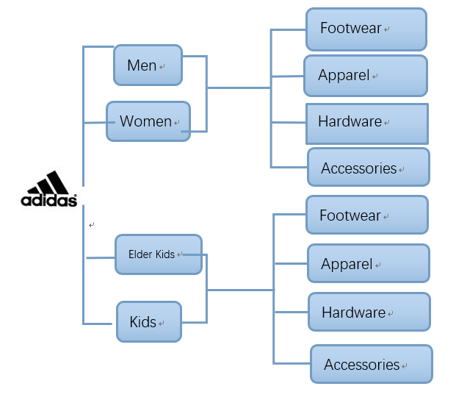

Figure 5 Adidas Portfolio Map

6. Advantages and Disadvantages of Differentiation Strategies

6.1 Advantages
The differentiation strategy can effectively improve the competitive edge of Adidas. Adidas' highly differentiated productions can satisfy the peculiar requirements of consumers with different characteristics. Adidas differentiates its products and increases its competitiveness. In addition, product or service differentiation can reduce customer sensitivity to price (Bassi, 2015). Consumers are less likely to buy other products because they are cheaper, so that Adidas has the opportunity to avoid price competition. It can always set the product at a higher price without affecting its market share. Specifically, it can be seen from the following aspects:

Differentiation can fetch a higher earnings to Adidas products. This earnings can bring up to full strength for the increasing costs due to differentiation and can bring additional profits to Adidas.

The greater the degree of differentiation of the production, the more difficult it is to substitute or simulate the characteristics or functions. Consumers are more inclined to pay higher charges for this preponderance. Adidas has a greater differentiation edge.

Differentiated productions are contenders that cannot be offered at same price, thus markedly reducing the bargaining power of consumers (KuÅŸay, 2014). Adidas will be in a better position than the average competitor in dealing with alternatives.

Consumers who buy differentiated productions are reluctant to receive alternatives. Product differences can format certain hinders. The more obvious the product differentiation, the higher the hinders to entry.

6.2 Disadvantages
Establishing differentiated activities is costly. For a long time, Adidas has conducted extensive research to form differentiated features of products. It invests a lot of time and money in product design, finding high-quality materials or providing customers with thoughtful services. Therefore, achieving product differentiation will mean that Adidas must be at the expense of cost (Wirtz, 2016).

Differentiation is easily imitated by powerful competitors. If a competitor releases a similar product, it will decrease the characteristics of product differentiation.

Competitors launch more differentiated and innovative products, turning the original buyers of Adidas to competitors.

The purchaser may lose interest in the product differentiation factors that Adidas relies on to survive. As a result, Adidas needs to invest more ads to stimulate and maintain the buyer's interest.

7 Conclusion
In the exterior surroundings, compared with other companies in the business, Adidas has sheer market opportunities and in the aspect of menaces, “brand consciousness and brand loyalty” is the key to success. For the rising star, Nike has faced tremendous pressure from Adidas. In the next 20 years, Nike has surpassed Adidas to become the world's number one sports brand. When two disparate brands contend for the identical market segmentation and even adopt semblable market positioning, the weaker trademark is in an extremely disadvantageous orientation for it has acted as a follower.

7.1 Recommendation
In summary, Adidas needs to differentiate its brand and marketing tactics to give consumers the ability to build brand loyalty, and let consumers recognize Adidas' values from the bottom of their hearts in order to gain more market share.

Reference
Adidas v. Pepkor. (2013). IIC - International Review of Intellectual Property and Competition Law, [online] 44(8), pp.999-1000. Available at: http://dx.doi.org/10.1007/s40319-013-0137-z [Accessed 18 Nov. 2018].
Ari, I. and Sari, R. (2017). Differentiation of developed and developing countries for the Paris Agreement. Energy Strategy Reviews, [online] 18, pp.175-182. Available at: http://dx.doi.org/10.1016/j.esr.2017.09.016 [Accessed 18 Nov. 2018].
Bassi, M., Pagnozzi, M. and Piccolo, S. (2015). Product Differentiation by Competing Vertical Hierarchies. Journal of Economics & Management Strategy, [online] 24(4), pp.904-933. Available at: http://dx.doi.org/10.1111/jems.12115 [Accessed 18 Nov. 2018].
Ciocchetti, C. (2013). Article III: Cases & Controversies - Teaching the Already v. Nike Case. SSRN Electronic Journal. [online] Available at: http://dx.doi.org/10.2139/ssrn.2270905 [Accessed 18 Nov. 2018].
D. Banker, R., Mashruwala, R. and Tripathy, A. (2014). Does a differentiation strategy lead to more sustainable financial performance than a cost leadership strategy?. Management Decision, [online] 52(5), pp.872-896. Available at: http://dx.doi.org/10.1108/md-05-2013-0282 [Accessed 18 Nov. 2018].
Dickson, M. and Fuss, F. (2011). Effect of acceleration on optimization of Adidas Bounce shoes. Procedia Engineering, [online] 13, pp.107-112. Available at: http://dx.doi.org/10.1016/j.proeng.2011.05.059 [Accessed 18 Nov. 2018].
Ehrenberg, K. and Bueno, W. (2016). As marcas entram em campo nas mÃdias sociais: O embate entre Nike e Adidas na Copa do Mundo de 2014. Logos, [online] 23(1). Available at: http://dx.doi.org/10.12957/logos.2016.22305 [Accessed 18 Nov. 2018].
Gao, Y. and Hafsi, T. (2018). Does charitable giving substitute or complement firm differentiation strategy? Evidence from Chinese private SMEs. European Management Review. [online] Available at: http://dx.doi.org/10.1111/emre.12180 [Accessed 18 Nov. 2018].
Grant, A. (2014). Adonai/Adidas T-Shirt. Conversations: An Online Journal of the Center for the Study of Material and Visual Cultures of Religion. [online] Available at: http://dx.doi.org/10.22332/con.obj.2014.49 [Accessed 18 Nov. 2018].
Hadi, W. (2015). The Relationship between CRM Strategies Stage on Competitive Advantage: An Analytical Perspective. International Journal of Business and Management, [online] 10(8). Available at: http://dx.doi.org/10.5539/ijbm.v10n8p245 [Accessed 18 Nov. 2018].
KuÅŸay, Y. (2014). The Social Media Reflections of Communication Applications of Entities Operating in Sportswear Sector Examples of Nike, Puma and Adidas. AJIT-e: Online Academic Journal of Information Technology, [online] 5(14), pp.37-59. Available at: http://dx.doi.org/10.5824/1309-1581.2014.1.003.x [Accessed 18 Nov. 2018].
Lebron, W. (2010). The Best Fashionable Nike Shoes â€“ Nike Air Rift. SSRN Electronic Journal. [online] Available at: http://dx.doi.org/10.2139/ssrn.1649842 [Accessed 18 Nov. 2018].
LIU, H. and CHENG, L. (2012). Priority-based service differentiation and rate control strategy. Journal of Computer Applications, [online] 31(6), pp.1458-1460. Available at: http://dx.doi.org/10.3724/sp.j.1087.2011.01458 [Accessed 18 Nov. 2018].
Ly, S. and Alliot, C. (2018). Nike et Adidas: les secrets du succÃ¨s. Projet, [online] 366(5), p.12. Available at: http://dx.doi.org/10.3917/pro.366.0012 [Accessed 18 Nov. 2018].
Nieddu, M., Boatto, G., Pirisi, M. and DessÃ¬, G. (2010). Determination of four thiophenethylamine designer drugs (2C-T-4, 2C-T-8, 2C-T-13, 2C-T-17) in human urine by capillary electrophoresis/mass spectrometry. Rapid Communications in Mass Spectrometry, [online] 24(16), pp.2357-2362. Available at: http://dx.doi.org/10.1002/rcm.4656 [Accessed 18 Nov. 2018].
R McGuigan, M. (2014). The Relationship between Competitive Experience and Performance in Skeleton. Journal of Athletic Enhancement, [online] 03(03). Available at: http://dx.doi.org/10.4172/2324-9080.1000149 [Accessed 18 Nov. 2018].
Roulin, N. and Krings, F. (2016). When Winning is Everything: The Relationship between Competitive Worldviews and Job Applicant Faking. Applied Psychology, [online] 65(4), pp.643-670. Available at: http://dx.doi.org/10.1111/apps.12072 [Accessed 18 Nov. 2018].
Su, M. and Rao, V. (2010). New Product Preannouncement as a Signaling Strategy: An Audience-Specific Review and Analysis*. Journal of Product Innovation Management, [online] 27(5), pp.658-672. Available at: http://dx.doi.org/10.1111/j.1540-5885.2010.00743.x [Accessed 18 Nov. 2018].
Wirtz, B. and ElsÃ¤ÃŸer, M. (2016). Social Media Marketing: Das Fallbeispiel Adidas. WiSt - Wirtschaftswissenschaftliches Studium, [online] 45(8), pp.453-458. Available at: http://dx.doi.org/10.15358/0340-1650-2016-8-453 [Accessed 18 Nov. 2018].
Wunsch, T., KrÃ¶ll, J., StÃ¶ggl, T. and Schwameder, H. (2016). Effects of a structured midsole on spatio-temporal variables and running economy in overground running. European Journal of Sport Science, [online] 17(3), pp.303-309. Available at: http://dx.doi.org/10.1080/17461391.2016.1253776 [Accessed 18 Nov. 2018].

