Student Name: Mary O Leigh
Student ID: 2327314
Module Code: BMHP5015
Module Name: Changemakers: Building your Personal Brand for Sustainable Employment.
Lecture Name: Brian Mashumba
Assessment 1 Report Writing

Table of Contents
Introduction .............................................................................................................................. 1
Task 1 – Reflection on Unit 1: Brand You ............................................................................... 1
Task 2 – Reflection on Unit 2: It’s a Small World .................................................................... 2
Task 3 – Reflection on Unit 3: Opportunity Knocks ................................................................. 3
Task 4 – Reflection on Unit 4: The Pursuit of Happiness and Conclusion .............................. 5
Conclusion ............................................................................................................................... 5
References ............................................................................................................................... 6

Introduction
This portfolio is a reflects my learning experiences throughout the module. Changemakers, which focuses on developing a Personal brand for future employment, showing how online activities on Moodle have improved my employability within the health and social care sector.
I plan to present reflections from the four units covered in the module, it’s a Small World, Opportunity Knocks, including the final unit on well-being, by evaluating my skills against the ones required in the profession and creating a personal brand to be able to work, for example, as a community health coordinator. Involvement in forum discussions and completion of tasks allowed me to take the concepts off the page and apply them to culturally sensitive care and resilient teamwork situations. This is in line with the learning outcomes, which involves self-reflection and professional identity.
I have also developed my digital networking skills as well as strategies for well-being, which will allow me to hold sustainable positions in a sector that demands empathy and adaptability. To sum up, this portfolio is evidence of my move from the theoretical to the practical aspects of branding with the help of contemporary literature, thereby achieving a fit with the real-world health and social care ​‍​‌‍​‍‌​‍​‌‍​‍‌environments.

Task 1 – Reflection on Unit 1: Brand You

“Brand You”, covered essential subjects through lectures and Moodle activities and opened my eyes to how personal branding is significant for standing within the health and social care environment. This unit explains that personal branding is not simply a way of marketing oneself but rather the development of a brand story that bridges personal values with professional standards, especially in a sector where trust and empathy are the basis of effective patient and client relationships.

I worked on a personal SWOT analysis, identified my strengths through the example of developing a strong set of communication skills in the course of my previous caregiving experience in community-based settings, my weakness being lacking advanced healthcare technologies skills, opportunities like the rise of virtual healthcare post-COVID-19, and threats like very high competition in the overpopulated health and social care job market. The process shined a light on strategic alignment with professional roles like reliable and adaptable community health workers. As per the findings of Mohamed et al. (2025), staff nurses, who successfully brand themselves personally, experience a progression in their career and thus gain better job congruence and long-term success.

Another significant idea to identity storytelling concept. I produced stories during an online activity to show my dedication to patient advocacy, thus, establishing real bonds and trust. These ideas work well in the health and social care sector where stories from real life serve to humanize the staff and gain the clients' involvement. Szwed (2024) in his article investigates the role of socially shared personal branding in medical decision-making and concludes that the factor most responsible for the healthcare consumers choosing the presented option is the real and truthful self-presentation which is in line with the authenticity necessary for the long-term relationship building.

All through, online presence optimization, for instance, by updating LinkedIn profiles, was important for networking effectively. I understood that it is very useful in establishing contacts with healthcare peers and sharing insights into the best practices. Zhang et al. (2021) studied physicians' strategies for establishing credible online brands to engage and become visible to their target audience. The findings provide me with a road map to publicize my mental health skills.

In short, these ideas were a good opportunity for me to think deeply about myself and to be more eager and ready to take action, traits which are crucial for building up a solid brand in health and social care that would constantly portray to the stakeholders the qualities of being reliable, caring, and proficient, thus, opening the way for securing jobs that offer the possibility of career growth and are ​‍​‌‍​‍‌​‍​‌‍​‍‌sustainable.

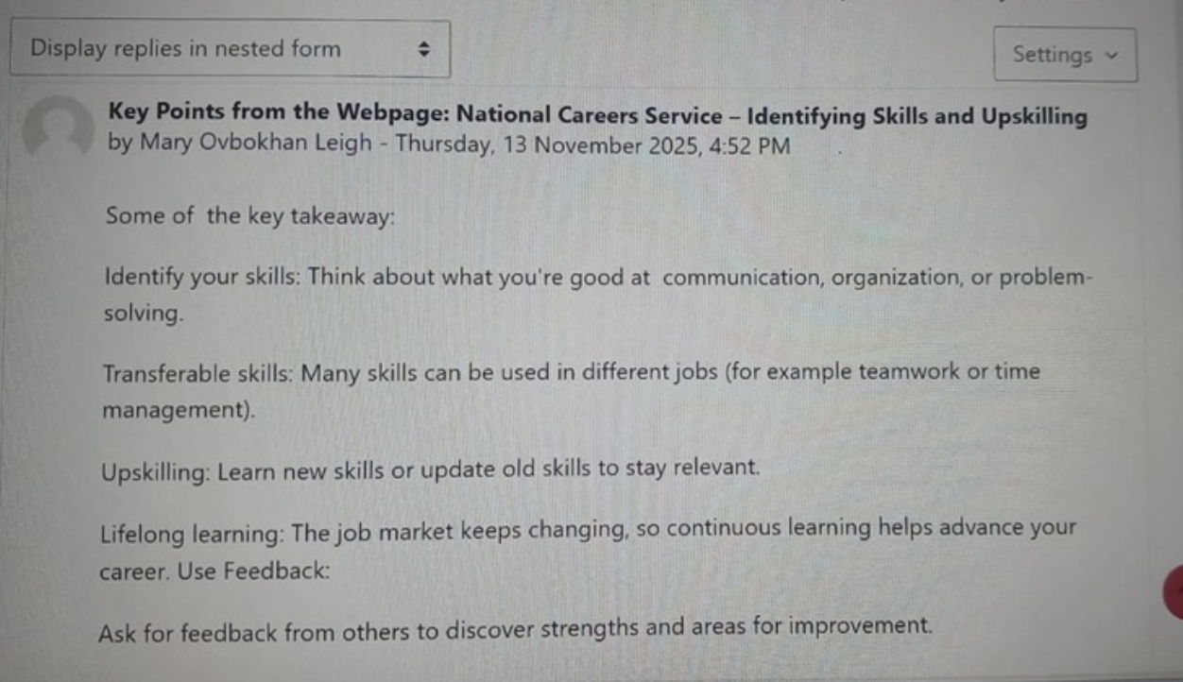

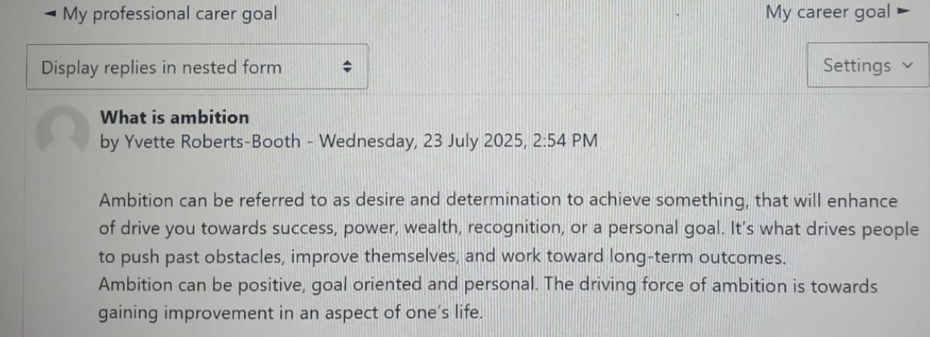

Task 2 – Reflection on Unit 2: It’s a Small World

​‍​‌‍​‍‌​This unit deeply interactive with lectures as well as Moodle activities, led me to comprehend various interconnected global systems and their potential in health and social care through fascinating topics like global networking, cultural competence, and digital collaboration tools. I was particularly fascinated to learn how these factors provide the possibility of the unification of a myriad of different international viewpoints, for example, by modifying worldwide health models' best practices to suit local needs such as multicultural patient care in the UK.
One of the most practical themes was global networking, I discovered that the use of online tools such as LinkedIn and professional forums is one of the most effective ways to cultivate cross-border collaborations between health professionals. In an online exercise, I explain my opinion that such networking is important because it helps professionals stay calm, show empathy, communicate well and create a supportive environment. This reelects how emotional intelligence and communication skills support relationship-building within global networks. Agents’ knowledge transfer leading to adopting different elderly care methods, say, from the Scandinavian models to the UK, which would then be used to improve services. This is consistent with the assertion that social networks act as a tool through which healthcare professionals can be appointed because they offer easily accessible information and connections. A systematic review documents the ways in which networks in healthcare lead to collaborative treatment and management thus, not only, revealing their contribution to professional development but also, their activating co-existence. (Dorairajan and Mala, 2025).
In addition, this made me reflect that significance in the implementation of fair health measures across different groups. Through a Moodle activity, I analyzed on ways to modify the communication method when addressing clients who have come from immigrant backgrounds, basing it on my experience in volunteering. This helped me to understand better how cultural humility and awareness can lessen the gap in equality of the care provided, which was the focus of recently published social work practice standards that prioritize self-awareness and pledge to embracing culture as a factor in the most efficient care. The research on nursing interventions shows that nurses can be helped to overcome the challenge of diversity and deliver improved patient outcomes through the successful implementation of the cultural competence interventions.
The unit drew on ethical issues related to digital collaborations, providing me with the necessary skills to participate in virtual international exchanges for crisis response and innovations. There is evidence in the literature on social networks in healthcare that shows the effect of the post-2015 period on the potential of these networks to form solid professional relationships worldwide.
In sum, these themes have done a lot to elevate my understanding of the importance of being Globally connected when it comes to the provision of health and social care that is both inclusive and resilient, thus, gearing me up for roles that involve foreign partners and culturally aware ​‍​‌‍​‍‌​‍​‌‍​‍‌teamwork.
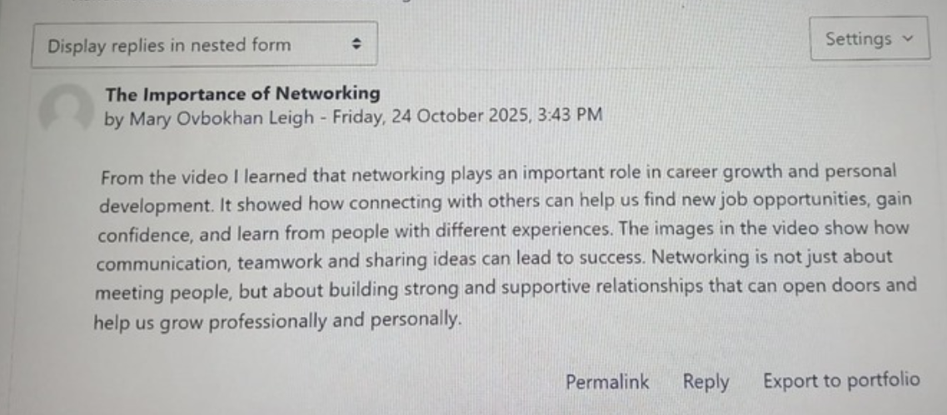

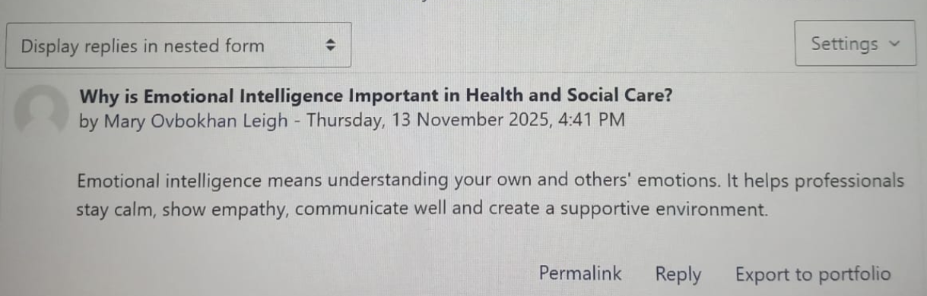

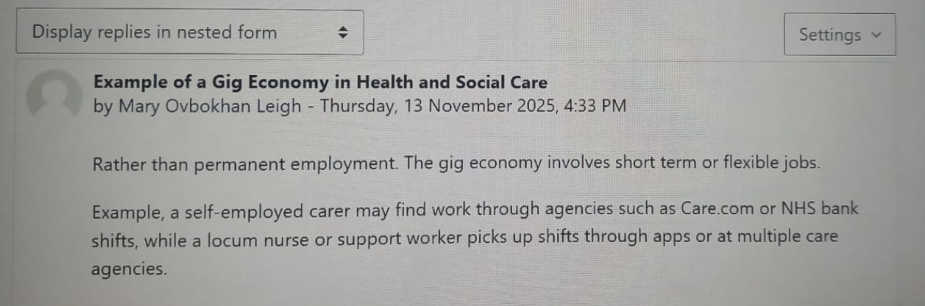

Task 3 – Reflection on Unit 3: Opportunity Knocks

​‍​‌‍​‍‌​‍Opportunity Knocks explored the topics of skill audits, mentorship programs, and market trend analysis within health and social care careers, which were very informative. These conversations have a major impact on my ability to spot and use opportunities for my personal and professional growth, thus, developing my strategic thinking skills in a field influenced by demographic shifts, technology, and policy changes.

I completed a skill audit activity on Moodle, where I identified my strengths such as good communication skills gained through community volunteering and my weaknesses such as limited data-driven experience. This analysis made me aware of my development areas, especially through digital health certifications for telehealth roles. The study highlights that the ability to recognize opportunities is a major factor in the setting up of new businesses in the health sector which requires the adoption of the latest models of care (World Economic Forum, 2025). In addition, research points out that internal aspects such as locus of control can motivate one to seize opportunities, hence, become more resilient in a tough market (OECD, 2025).

In a forum role-play, I learned a lot about mentors' support for the discovery of opportunities through their comments on networking, and career progression, e.g., by joining health associations. Review of the literature on academic nursing mentorship shows that it is a valuable tool in overcoming the challenges of the real world, which helps the development of the right skills and raises the level of satisfaction (Nowell et al., 2017). The recent studies of preceptorship for early-career health and social care academics indicate that it is a source of a strong, supportive workforce, and therefore, provides a solution to retention issues (McLeod et al., 2021).

I also aligned my goals with the needs of the market by examining trends such as the focus on integrated care during staff cuts. The reports on healthcare changes in the UK are very clear that the quality of the job and the protection of the workers' rights should be the main objectives, thus, facilitating the creation of sustainable employment routes (Anderson et al., 2022).

In a nutshell, this unit was a great tool for me to convert my planned opportunities into reality, which also led to an increase in my personal brand through self-awareness and trend integration for health and social care long-term success.

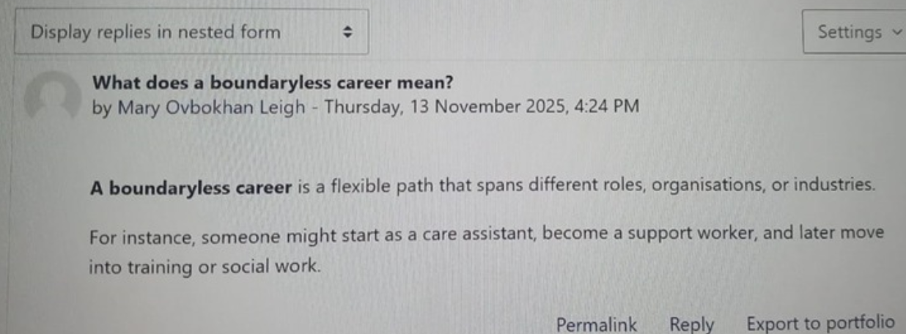

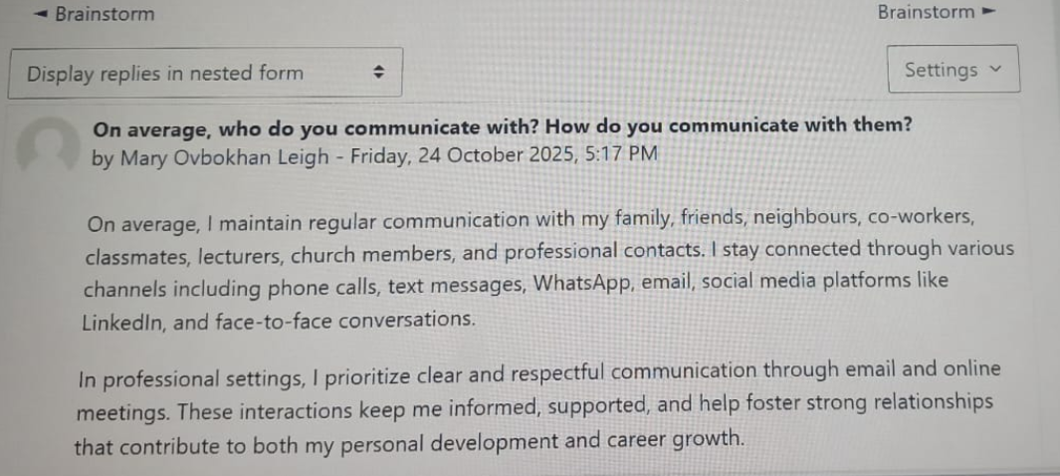

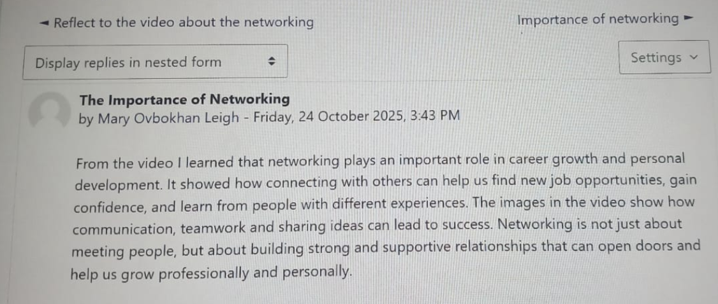

Task 4 – Reflection on Unit 4 and overall Conclusion
This unit on well-being and happiness was about well-being strategies, work-life balance, and building resilience in professional settings, especially in health and social care. Lectures and Moodle exercises helped me to see that personal happiness is what keeps a person employable in the long run, especially in a high-stress environment where, for example, burnout among caregivers and practitioners is a common occurrence.
A significant idea was mindfulness-based interventions, which I investigated through an online journaling activity to handle the emotional aspect of the client interactions. This gave me the idea that such practices relieve stress portions, which is a problem that is solved in the studies, to mention one where mindfulness programs are shown to enhance work engagement and overall resilience in health professionals (Luberto et al., 2020). When thinking about my own experiences, I concluded that these methods not only help care staff maintain their own mental health but also provide a way to handle heavy workloads.
Resilience strategies were the focus of another main point, one of the forums, I explored how social workers support networks help individuals cope with workplace and maintain emotional strength, for example, use the social support networks to get through workplace adversity. The latest research shows that among the resilience skills, such as self-care and the ability to use certain strategies, social workers' well-being is the foundation that leads to their successful coping with the continual challenges they face (Ferguson, 2025). This deeply resonated with me, and I felt that it was important to take the initiative with the corresponding actions to keep up psychological health, which is also supported by the findings that focus on work environment factors that affect health care workers’ resilience during crises (Förster et al, 2023).
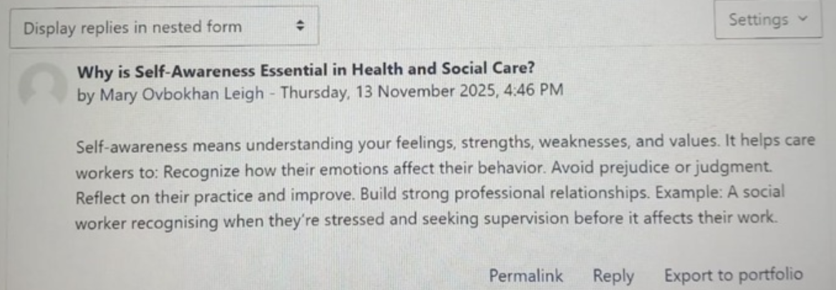
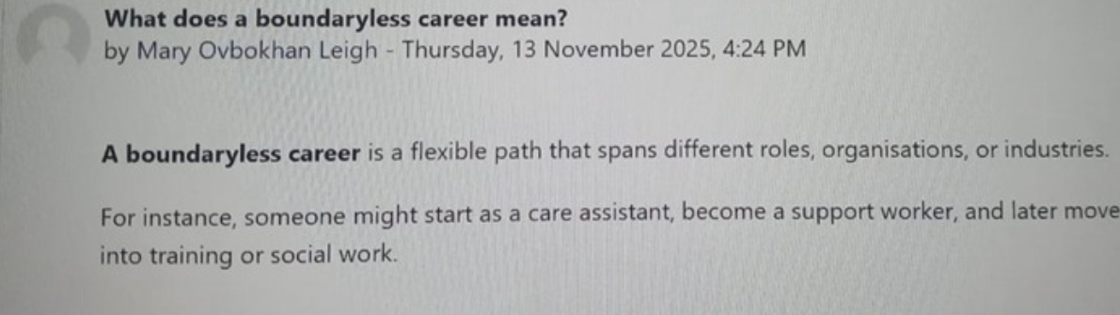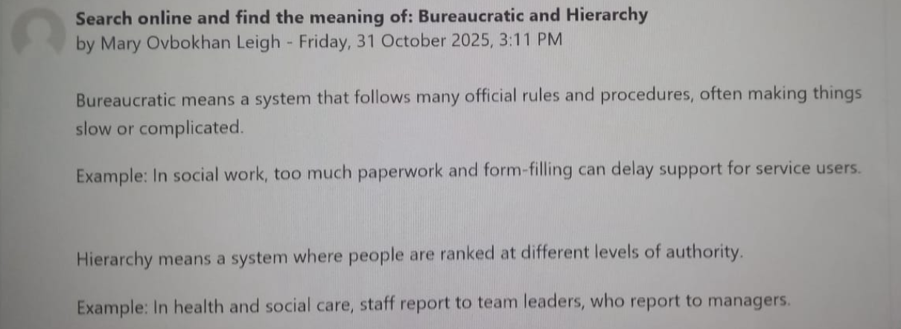

Conclusion
Basically, the module combined learning has influenced my growth and development as a future health and social care professional. It started with Unit 1's self-assessment and branding, followed by Unit 2's global networking, Unit 3's opportunity recognition, and Unit 4's well-being strategies where I have grown authenticity, cultural sensitivity, strategic planning, and resilience. These qualities make sure that my brand is in line with the requirements of the sector for empathetic, inclusive care in diverse communities. The understanding can be used in the future care of clients through client advocacy, interdisciplinary collaborations, and sustainability despite workforce pressures. At the end of the day, it is a step towards becoming a professional whose identity contributes to health, personal satisfaction, and organizational ​‍​‌‍​‍‌​‍​‌‍​‍‌effectiveness.

References
Anderson, M., Pitchforth, E., Edwards, N., Alderwick, H., McGuire, A. and Mossialos, E., 2022. United Kingdom: Health System Review. Health systems in transition, 24(1), pp.1-194.
Dorairajan, S. and Mala, Y.V., 2025. Happiness, work engagement, and flourishing among healthcare professionals. International Journal of Indian Psychȯlogy, 13(2).
Ferguson, G., 2025. Learning 33 in an Extraordinary Job: Social Work Professional Development. Social Work Reflections, p.262.
Förster, C., Füreder, N. and Hertelendy, A., 2023. Why time matters when it comes to resilience: how the duration of crisis affects resilience of healthcare and public health leaders. Public Health, 215, pp.39-41.
Gamal Mohamed, E., Mohamed Elsayed, S. and Abdelaziz Rashed, S., 2025. Relationship between Personal Branding and Career Development among Staff Nurses. Egyptian Journal of Health Care, 16(1), pp.246-257.
McLeod, C., Jokwiro, Y., Gong, Y., Irvine, S. and Edvardsson, K., 2021. Undergraduate nursing student and preceptors’ experiences of clinical placement through an innovative clinical school supervision model. Nurse Education in Practice, 51, p.102986.
Luberto, C.M., Goodman, J.H., Halvorson, B., Wang, A. and Haramati, A., 2020. Stress and coping among health professions students during COVID-19: a perspective on the benefits of mindfulness. Global advances in health and medicine, 9, p.2164956120977827.
Nowell, L., Norris, J.M., Mrklas, K. and White, D.E., 2017. A literature review of mentorship programs in academic nursing. Journal of Professional Nursing, 33(5), pp.334-344. d
OECD, 2025. Building pathways to opportunity. Paris: OECD Publishing. Available at: https://www.oecd.org/en/publications/2025/09/building-pathways-to-opportunity_fb9632a2/full-report.html (Accessed: 3 December 2025).
Szwed, M., 2024. Would You Pay an Insta-doctor a Visit? Social Media Personal Brands and Young Consumer Perception. Journal of Marketing and Consumer Behaviour in Emerging Markets, 19(2), pp.1-14.
World Economic Forum, 2025. The Future of Jobs Report 2025. Geneva: World Economic Forum. Available at: https://reports.weforum.org/docs/WEF_Future_of_Jobs_Report_2025.pdf (Accessed: 3 December 2025).
Zhang, T., Yan, X., Wang, W. Y. C. & Chen, Q. 2021. 'Unveiling physicians’ personal branding strategies in online healthcare service platforms', Technological Forecasting and Social Change, 171, article 120964. doi: 10.1016/j.techfore.2021.120964.

