Lab and field
This is work carried out in the lab to determine what owls are eating on two local sites. The Para-le-Breos and the Newport Wetlands.
Some information on what Owls eating on other parts of the UK.
Mosly the same as on our sites Field Voles then Common Shrew, Wood Mouse and a small amount of Rat, House Mouse, Bank Voles and Pygmy Shrew.
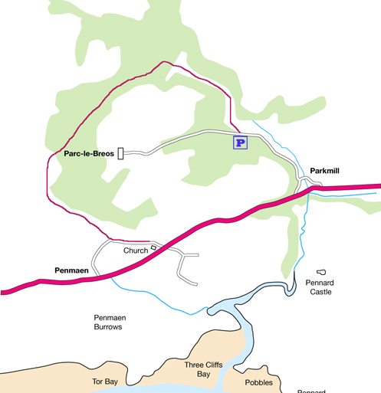
Gower barn owls in Para-le-Breos
The park is 70 acers , which was a Deer Park
Belonging to Willaim de Breos originally a 2,000 acres estate, as you can see by the map there is large areas of mature trees which gives cover to the owls. As you can see by the diagram there are large areas of kept cut grass and also large areas of unkept grassland these are ideal for the owls to hunt their prey.
The boxes was in Para-Le-Breos Swansea from 2007 to 2011 when the boxes was taken down the owl pellets was given to Trinity St. David's Swansea. The pellets have broken into bits so it is much harder to get a full pellet

The group examined 5 separate amounts of 5g of owl pellets from this site and dissected the pellets to see what the owls had been eaten in the park my five sample, was mostly Field Vole.
Looked under a microscope to see what bones and skulls where there. A Field Vole skull was found whole

To identify small mammal skills
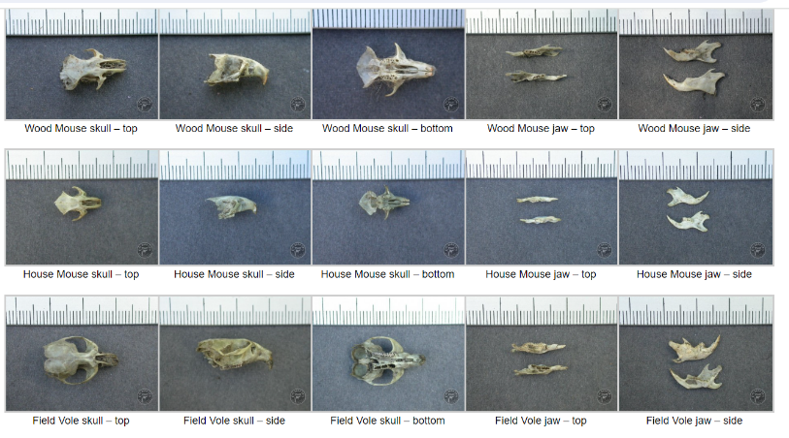
Measurement can be taken on any bones that are found in the owl pellets these can show the size and the Mammal species, there are some examples of skeletal remains in these pictures and they also show the measurements of the different bones

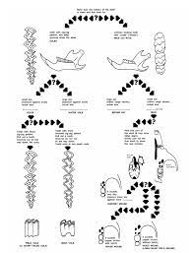
Counting Teeth
The number of teeth and the shape of the teeth. Is also a indicator off what type of mammal it come from, the skull and lower jaw will also help.
If the skulls are not whole you can look at the upper jaw or the lower jaw you can pull out teeth and count the number of holes.

As you can see in the chart these are some of the mammals these are taken from the Barn Owl Trust
In the graphs below you can see the results of the examination of the pallets and what the owls was eating on the site

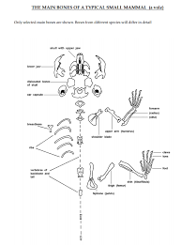

The diagram shows the skeleton of a small mammal. This is a vole this will help you to identify the smaller bones that would be found in an owl pellet.

If we had fresh pellets we wood have to soke them to get them apart, this wood be better in some ways, we wood get more bones intact to identify.

I have looked at the RSPB web site the Owls trust, store in stone the wetland trust, Swansea council these sites gives good information and facts and figures they have very qualified and academic members that give out valid information.
The graph show that the owls main diet was made up of field voles. The next was Pygmy shrew and common shrew, these was tied on Wood mouse and Harvest mouse.
This shows that the owls was getting most of their prey from the slightly unkept grass from the park. It also showed that the type of animals they were eaten was in decorative to the area in question.
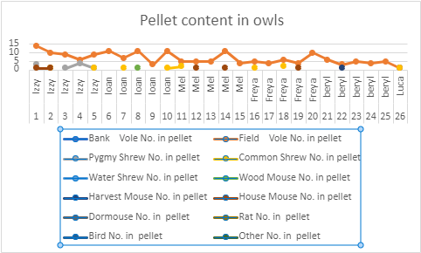

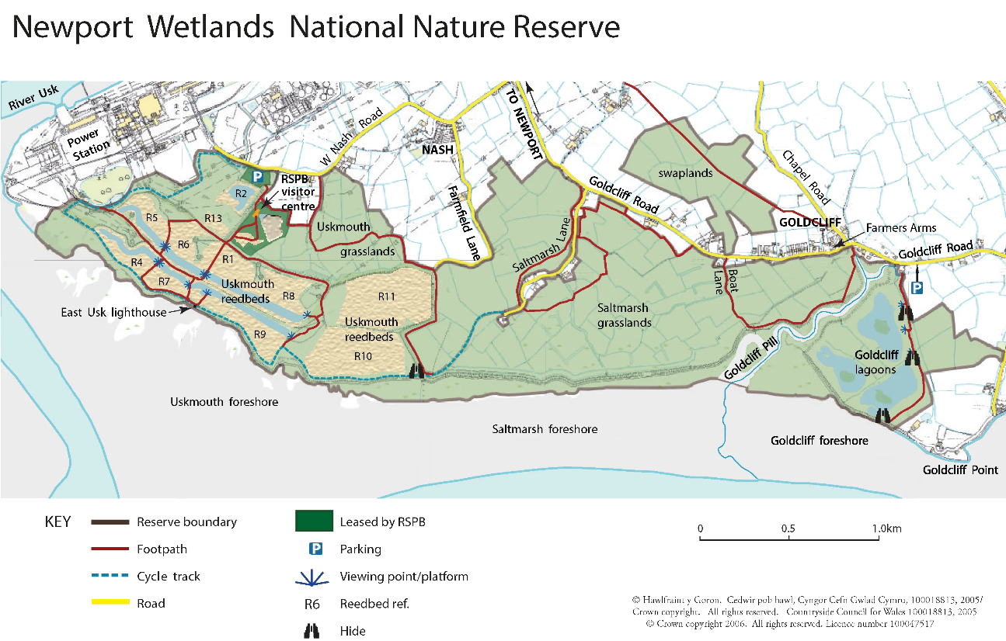
Newport Wetlands
The Newport wetlands was a sight created to offset the build in of the Cardiff Bay barrier, the loss of the mud flats would have been devastating to the bird population that was relying on this for their food and habitat. the mouse of the Usk river was used to replace the loss of the mud flats at Cardiff. The Newport wetlands consist of 438 hectares of land. This site provide Reed beds, saltwater pones and mashes, mud flats and wetland grazing
Data for the Newport Wetlands
The second set of data that we looked at was from the Newport wetlands centre, collected in 2021 and given to the university but the age of the owl pellets is unknown these were more intact than the owl pellets form the ,first site,
Sample two from this site had a better indication and was whole so gave a whole pellet to determine the Mammal type the owls was eating, on a regular basis on this site
The main type of mammals that have been eaten on the Newport wetland site were Field Voles by a significant margin. The next were Wood Mouse , Bank Voles, Common Shrew, Pygmy Shrew, and one Water Shrew.
The chart below shows all the Owl Pellets that was used, as we can see it is one type of mammal that has been court this shows it is a dominant species of mammal on site.
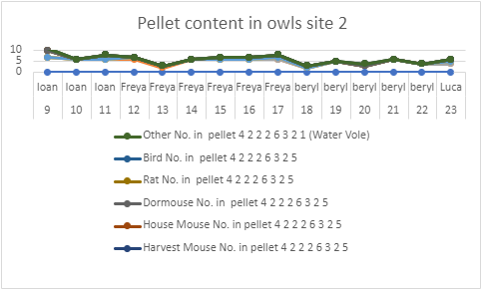

What are the aims
The aim of carrying out this experiment on the two sides are to find out the health and numbers of owls present on the sites. The pallets would show also the type of mammals present on the site for the owls to eat, if the number of one species is a larger number more than any of the others this could indicate that the sites are not doing well four some of the other species on the site, and will need improving .
The pallets collection should be carried out on a regular basis to see how well the sites are doing and to record the number of owls on site
Managing of the sites
The Parc-le-Breos site run by Swansea council the nest boxes need to be replaced in the park so that the birds can be monitored and to see how many will return to the site or are already on the site in other trees or buildings some of the areas in the park should be set aside and left four the mammal population, to increase and numbers of some types all mammals to increase, this will allow the pellets to be collected and to see if the types of mammals are growing or decreasing.
It may also help to get groups of volunteers to help with the day-to-day maintenance on the site and to get local groups of young people and children to do some activities this will help with awareness of the site and of the habitat and diversification all the different types of birds and animals on the site.
Newport wetlands This site is well managed by the RSPB and other ornithological societies, with large numbers of volunteer groups and other parties like the owl trust there is a good basis on the site. Putting up of more bird boxes with camera will help with monitoring.
Discussion and Conclusion
I feel that the Parc-le-Breos on the Gower is an unfair and not trustworthy data because the pellets are to old, this will not give a true description of the type of birds and mammals on the site the youngest pellets are12 years old the older ones are 15 years old in this time the area has changed quite a bit. I feel it does not give a true reading of what is on the site now. The only way to get a true reading is to re establish the nesting boxes and to see if any owls are there to give fresh pellet, for more up to date analysis of the site.
Newport wetlands these pellets are two years old even these may not give a true reading, of what animals ,birds, mammals are on the site but it will give a better indication of habitat and ecology.

Bibliography
For image 1:
https://www.google.com/url?sa=i&url=https%3A%2F%2Fparc-le-breos.co.uk%2Fwalks-for-guests%2Fdiversion-map%2F&psig=AOvVaw2AMaxsfsuQDulvz-GocNJo&ust=1701902983476000&source=images&cd=vfe&opi=89978449&ved=0CBIQjRxqFwoTCIjTgOiw-YIDFQAAAAAdAAAAABAE
For image 2,3 and 4:
https://www.storiesinstone.org.uk/Portals/0/Documents/Projects/Skills/Handout%20-%20Owl%20pellets.pdf?ver=2021-02-05-102948-220
For image 5:
http://www.gwentbirds.org.uk/recommended-site-newport-wetlands-national-nature-reserve/

