The Usage of Archaeological Interests by Israel to Aid Occupation in Palestine
The occupation of Palestine by Israel has been ongoing for over 30 years, however global relevance of the conflict has sky-rocketed since the events of October 7th, 2023; when Palestinian Islamist militant group Hamas launched a responsive attack on the Israeli blockade in Gaza [1]. Since then, attempts have been made by Israel to expand control over Palestine and its residents, utilising all industries – especially archaeology. I have chosen to summarise a 2026 article by the BBC that details the usage of archaeology to aid occupation, specifically at significant heritage sites in the West Bank [2].
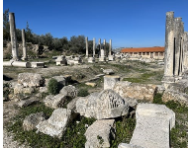
The article begins by introducing Sebastia, an ancient village in the occupied West Bank. The area is established as significant to Palestinian heritage as well as a home to a large community of residents that cultivate the olive fields in the area. Resident Abu Mudif explains that his 450 acres of land has been selected for repossession by Israeli authorities. He expresses that the reasoning given is focused on archaeological protection and development of the area into a national park, which would highlight the area’s ancient Jewish history. It is explained that, typically, Palestinian landowners are offered little to no payment for expropriation. When payment is offered, most refuse due to the feeling that payment would be construed as support for expropriation and that loss of land would equal loss of the patrimony attached to the site.
Figure 1: Roman ruins at Sebastia
As well as financial consequences, Mudif describes the personal impact of this:
"If I wanted to describe it, the closest description I can give is that it is like having your soul ripped away. I cannot imagine myself without my land."
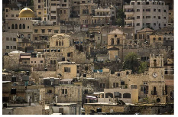
The article also details the experiences of Sebastia resident Nahed Sakha, who’s local restaurant is under threat for demolishment. Sakha asserts that he sees the Israeli plan as aiming to use archaeology as a pretext to remove Palestinian access from the site and neglect Palestinian history, in favour of preserving other heritage. The main culture that the Israeli government is hoping to protect with their authority is ancient Judaism, but the sites also have links to the Romans, Crusaders and Ottomans.
Figure 2: Residential region in Sebastia village
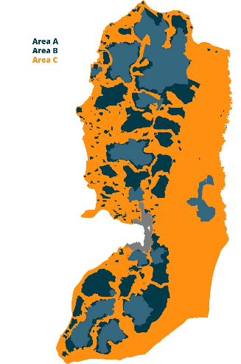
The article details the potential attitudes of Israeli authority figures towards Palestinian residents. Village mayor Mohammed Azem stated to the BBC that he worries that local efforts to maintain the area from things like litter could cause issues with Israeli security forces as well as settlers. The site at Sebastia rests between zones B and C of the West Bank. Zone B is under Palestinian civil responsibility but Israeli security control, whereas Zone C is entirely under Israel’s authority. A week before the article was published, Israel allocated a further £27.8 million to advancing its control over archaeological sites – many of which are regions administered by Palestinian authority.
It is made clear that the opinions of archaeological professionals are divided. Israeli activist and archaeologist Alon Arad is head of Emek Shaveh, a group dedicated to ensuring that the ancient heritage of the region belongs to all. Arad tells the BBC that Israeli authorities have bypassed consultation with local administration or residents when making plans. He also expresses explicitly his belief that Israel is using archaeological interest as pretext to seize land.
Figure 3: Map of the 3 Zones within the West Bank. Area C (orange) is under Israeli control.

Arad (2026):
"The thing is that Israel is not the owner of this place. This is a Palestinian heritage site. And in order to develop it in a positive way, it has to be done with the local community, with the municipality, so they can benefit."

Sebastia village was added to the UNESCO World Heritage List and the List of World Heritage in Danger in July 2026. UNESCO identified the main threat to be the establishment of the Samaria national park. This status, however, is contentious. Palestinian tourism and foreign ministries have expressed hope that UNESCO recognition may garner international support for the communities within these sites. On the other hand, Israeli foreign minister Gideon Saar states that UNESCO is enabling what he sees as Palestinian efforts to diminish Jewish historical ties to the West Bank.

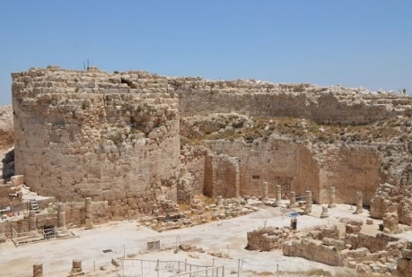
To continue archaeological focus, the article also references Herodium - another significant site in Zone C. Herodium is a palace-fortress and town commissioned by the Roman King Herod I between 23-18BC [3]. In 2020, Palestinian locals lost access to the 80-acre site, which has been sealed and turned into a national park [4]. The BBC article states that Herodium’s expropriation has been justified by Israel as “preservation and development.”
Figure 4: Herodium’s palace-fortress, sealed with barbed wire by Israel’s army.
The article proceeds to highlight potential legal consequences to Israel’s expropriation of heritage sites. Peace Now, an Israeli organisation that oversees settlement, has contended that expropriating land for settlement purposes is prohibited under international law. The organisation posits that the Israeli state will likely argue that their occupation under archaeological reasoning is intended to serve both Palestinian and Israeli populations, despite the primary rationale being control and ostracisation of locals. Shmuel Browns, excavator and guide in Herodium, says that it is vital for Israeli archaeologists to oversee places with historical and religious significance.

Far right members of Israel’s current government have attempted to drive authorities to go further with expropriation. A new law was proposed in 2026 with the aim of transferring control of sites to the Israeli heritage ministry from civil administration. This ministry operates under military authority and, under the law, would have absolute authority to seize land with the justification of archaeological preservation. This bill was passed in parliament in May but is now on hold as elections approach in the region. Alon Arad tells the BBC that the bill’s suggestion shows how archaeology as a concept has been weaponised.
In conclusion, the article presents clear reasoning for the assertion that archaeology has been weaponised by Israel to aid expansion over Gaza but also shows the opinions of those in favour of Israeli control. Historically, language of preservation has been used to aid nationalist and territorial claims, where states annex land and fund excavations with the aim of discovering materials that support specific ideologies – the biggest example being Nazi claims of ancient Germanic/Aryan tribes as native ancestors to modern Germans [5]. Israel has been citing archaeological progression as a reason for expansion since the 1980s, but this has accelerated under the current government. This has drawn criticism from not just Palestinian activists but also the wider archaeological community, who say that expropriation orders cannot be justified “[not] legally, [not] professionally, [not] ethically.” [6]

Word count: 1076 (without headers, title, captions or bibliography)

Bibliography
References:
[1] Britannica Editors (2026) ‘October 7 Attack’, Encyclopaedia Britannica, 28th July. Available at: https://www.britannica.com/event/October-7-attack (Accessed 30/9/2026)
[2] BBC News (2026) ‘Israel accused of weaponising archaeology at ancient West Bank sites’, 9th August. Available at: https://www.bbc.co.uk/news/articles/c20d8qre98do (Accessed 30/9/2026)
[3] Milligan, M (2020) ‘Herodium – The Palace Fortress of King Herod’, Heritage Daily, 22nd December. Available at: https://www.heritagedaily.com/2020/12/herodium-the-palace-fortress-of-king-herod/136563 (Accessed 30/9/2026)
[4] The Palestine Chronicle (2020) ‘Israeli Army Seals off Ancient Mountain, Hindering Palestinians’ Access to the Site’, 14th July. Available at: https://www.palestinechronicle.com/israeli-army-seals-off-ancient-mountain-hindering-palestinians-access-to-the-site/ (Accessed 30/9/2026)
[5] Fiveable (2026) ‘Intro to Archaeology’ section 17.4 ‘Political Uses and Abuses of Archaeological Interpretations’, March. Available at: https://fiveable.me/introduction-archaeology/unit-17/political-abuses-archaeological-interpretations/study-guide/w7IohTwxyYam9mXP
[6] Kocak, A (2026) ‘Israel Turns Archaeology Into a Tool for West Bank Land Seizures’ Clash Report, 24th September. Available at: https://clashreport.com/world/articles/israel-turns-archaeology-into-a-tool-for-west-bank-land-seizures-cdbb2mmxmqq (Accessed: 30/9/26)

Figures:
1: Burke, J/The Guardian (2025) Available at: https://www.theguardian.com/world/2026/feb/02/palestinian-uproar-israel-plan-seize-historic-site-sebastia-west-bank (Accessed 30/9/2026)
2: Walk Palestine (2021) Available at: https://www.walkpalestine.com/en/activity/110382/wednesday-10-of-nov-2021-sebastia-to-nablus-thru-hike (Accessed 30/9/2026)
3: Anera (2024) Available at: https://www.anera.org/what-are-area-a-area-b-and-area-c-in-the-west-bank/ (Accessed 30/9/2026)
4: The Palestine Chronicle (2020) Available at: https://www.palestinechronicle.com/israeli-army-seals-off-ancient-mountain-hindering-palestinians-access-to-the-site/ (Accessed at: 30/9/2026)

