

Accounting Fundamentals (LCBB4001)

Assessment 1

Coursework: Essay

Submission Date:

Name of the Lecture:

Student ID: 2236843
Student name: ANDRIYANA EFTIMOVA

Table of contents:

Introduction……………………………………………………………………………3
Solutions:
Question 1…………………………………………………………………………….
a) Income Statement
Statement of financial position
b) Why does the statement of financial position balance?

Question 2.
a) Ratios ………………………………………………………………..
b) Financial performance and position

References

Introduction:
The accounting fundamentals are generally considered to encompass all the important aspects of business finances, including tasks such as writing checks, preparing income statements, and closing accounts at the end of each fiscal year. It is crucial for businesses to apply appropriate accounting fundamentals as it plays a significant role in the smooth operation of the business. This helps in accurately tracking business expenses and income, ensuring compliance with legal standards, and providing quantitative financial information to management, government, and investors for making informed decisions (Monte-Mor, et al., 2018).
This report aims to examine how accounting principles, such as the income statement and statement of financial position, are generated to gain insight into a company's financial aspects. Additionally, the report will conduct a comprehensive ratio analysis of an organization to understand its financial position and market operation.

SOLUTIONS:

Question 1 a)
The statement of financial position, also known as the balance sheet, is a crucial financial statement that provides a snapshot of an entity's financial position at a specific point in time. It presents information about the organization's assets, liabilities, and shareholders' equity. One of the fundamental principles of accounting is the balance sheet equation, which asserts that the sum of an entity's assets must always equal the sum of its liabilities and shareholders' equity. This balance reflects the dual aspect concept of accounting, which requires that every transaction has a corresponding impact on two different items within an entity's financial records.
Reasons why the statement of financial position must always balance. The primary reason is the adherence to the accounting equation. According to the equation, assets are financed by either liabilities or equity. Assets represent what the entity owns, while liabilities and equity represent what the entity owes. If the equation is not balanced, it suggests an error or omission in the accounting records, indicating that some transactions may have been overlooked or miscalculated. Therefore, balancing the statement of financial position serves as a mechanism for ensuring the accuracy and completeness of an entity's financial records.
Another reason for the balance in the statement of financial position is the accounting principle of double-entry bookkeeping. According to this principle, every transaction must be recorded with equal and offsetting debits and credits. When a transaction affects the statement of financial position, it must simultaneously impact two or more components of the balance sheet. For example, if a company borrows money from a bank, it would record an increase in both its liabilities and assets. This ensures that the equation is balanced and accurately represents the financial position of the entity. The balanced nature of the statement of financial position provides transparency and facilitates the analysis of an entity's financial health by stakeholders such as investors, creditors, and regulators.

The balance in the statement of financial position is also necessary for tracking changes in an entity's financial position over time. By comparing the statement of financial position from different periods, the stakeholders can assess the entity's liquidity, solvency, and overall financial performance. Any imbalances can raise concerns about the accuracy of the financial statements and the reliability of the reported financial information. To maintain the credibility of financial reporting, organizations are required to ensure that the statement of financial position is balanced and in compliance with accounting standards and regulations.

In conclusion, the statement of financial position balances due to the fundamental principles of accounting, such as the accounting equation and double-entry bookkeeping. This balance ensures the accuracy, completeness, and reliability of an entity's financial records. It enables stakeholders to evaluate an entity's financial position, make informed decisions, and assess its overall financial health. Therefore, balancing the statement of financial position is crucial for the preparation of reliable and meaningful financial statements.
Projected financial statements are essential in the final stages of the planning process, particularly when evaluating long-term strategic options and developing short-term plans. These statements are crucial in forecasting future financial performance and position. It is important to prepare projected financial statements for both short and long time periods, although the level of detail may vary depending on the length of the time horizon. Simplifying assumptions may need to be made for longer time horizons.
The key projected financial reports utilized for planning purposes are the projected cash flow statement, projected income statement, and projected balance sheet. Examined together, these statements furnish an all-encompassing outlook of a business's anticipated future performance and financial standing. By evaluating different scenarios, management can gauge how each option affects future profitability, liquidity, and financial shape. This analysis facilitates recognizing the optimal strategic path forward for the enterprise. Developing and analysing projected financials provides vital insights that guide data-driven planning and decision-making. (Atrill, 2020).

INCOME STATEMENT FOR THE YEAR ENDED 31st DECEMBER 2022

£ £
Sales 800,980
Cost of good sales (578,650)

Gross Profit 222,330

Expenses:
Administrative expenses (30,000)
Distribution costs (28,000)
Director’s remuneration (5,000)
Interest expenses (2,000)
Sales commission (3,000)
Total expenses: 68,000

Income before tax 154,330
Corporation tax 100,000

Net income 54,330

Statement of financial position for the year ended 31st December 2022

£
Assets
Non - current Assets
Plant and equipment 1,250,000
Current assets
Stock 510,850
Trade receivable 171,105
Cash and bank 96,000

Total Assets 2,027,955

Liabilities
Currents Liabilities
Trade payables (188,625)
Outstanding sales commission (3,000)
Corporation tax (100,000)
Total current Liability 291,625
Non-current liabilities
2% debentures 200,000
Shareholder’s equities
£1 Ordinary shares 900,000
Less: Dividend 20,000 880,000
10% £1 preference shares 500,000
Less: Dividend 30,000 470,000
Add: Retained Profits 132,000
Add: Net Profit 54,330
Total shareholders equities 1,536,330

Total liabilities and shareholders equities 2,027,955

b) Why does the statement of financial position balance?

The fundamental accounting equation that assets equal liabilities plus equity is the foundation of the balance sheet. To maintain this equation, accountants use double-entry bookkeeping, recording each transaction in a minimum of two accounts. This ensures that every debit has a corresponding credit so that the books remain in balance. Specifically, increases or decreases in assets must have offsetting increases or decreases in liabilities or equity. The dual entry for each transaction serves as a control mechanism to verify accuracy. Thus, adherence to the double entry accounting system is the primary reason that the balance sheet balances. This time-tested approach provides a consistent mathematical check on the recording of financial transactions.

Question 2.

a)
1- ROCE
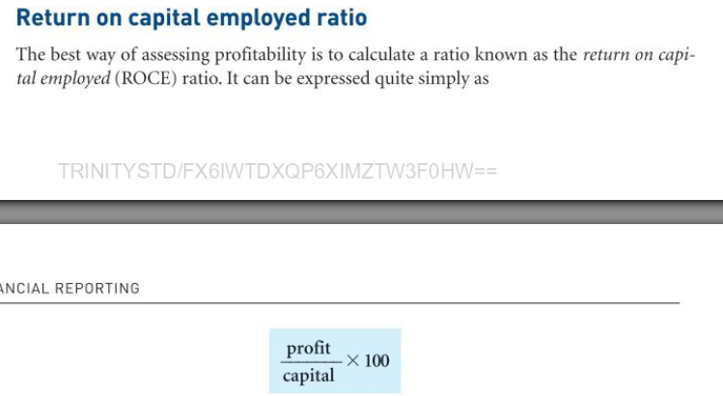(Dyson, 2010)

First we need to count The Capital Employed
Capital employed= Total assets – Current Liabilities

2021: Capital employed= 9,736-2,511=7,225
ROCE: 620/7,225=0.0858 x 100%= 8,58%

2020:
Capital employed=10,087-3,046=7041
ROCE: 539/7041=0,0765x100%= 7.65%

2-ROE
(Return on Equity) = (Earnings / Equity) x 100%

2021: 431 / 3,088=0,1395
0,1395 x 100 = 13.96%

2020: 366 / 2,912=0,1256
0,1256 x 100 = 12.57%

3- Earnings per Share

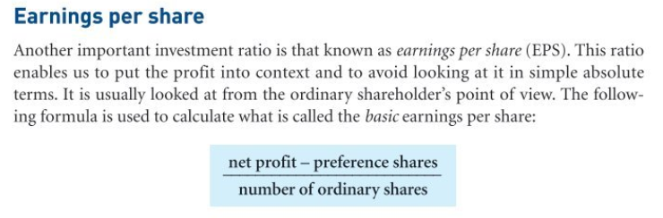(Dyson,2010).

2021: 431-255 =176
176/300 = £0.59 per share

2020: 366-242=124
124 /300 = £0,41 per share

4- Net Profit Margin

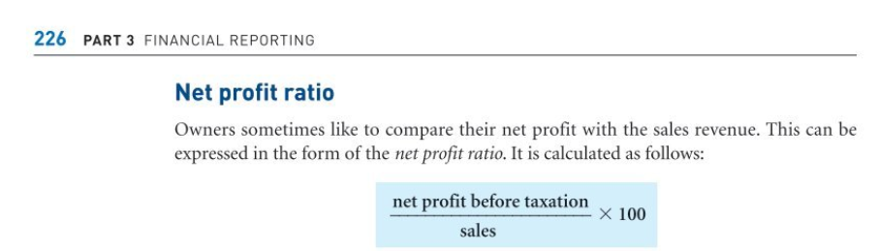(Dyson, 2010).

2021: (431 / 6,738) x 100 = 6.4%
2020: (366 / 6,441) x 100 = 5.7%

5- Asset Turnover
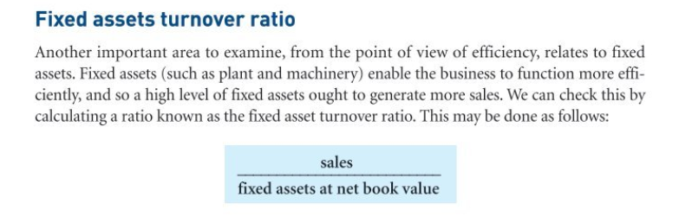(Dyson,2010).

2021: 6,738/9,736=0.69 times
2020: 6,441/10,087= 0.63 times


2021: 708/3,235 x 365 = 0.218 x 365= 79,88that mean 80 days
2020: 659/3,096 x 365 = 0,212 x 365 = 77,69 that mean 78 days

7- Debtors Collection Period

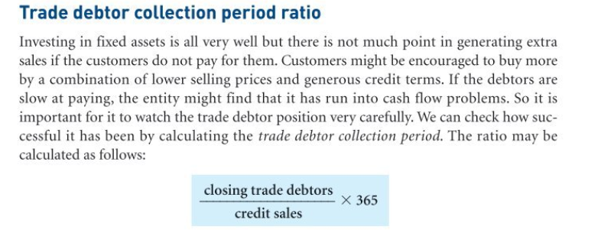(Dyson, 2010).

2021: (1,249 / 6,738) x 365 = 0.185 x 365 = 67.65 that mean 68 days
2020: (1,287 / 6,441) x 365 = 0.199 x 365 = 72.93 that mean 73 days

8. Current Ratio
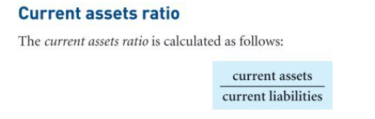(Dyson, 2010).
2021: 2,303 / 2,511 = 0.92 times
2020: 2,355 / 3,046 = 0.77 times

9- Gearing Ratio = (Long Term Debt / (Long-Term Debt +Equity)) x 100%

2021: 4,137 / (4,137 + 3,088) x 100=4137/7225 x 100 = 0.5725 x 100= 57.25%

2020: 4,129 / (4,129 + 2,912) x 100 = 4,129/7,041 x 100= 0,5864 x 100= 58.64%

10- Interest Cover
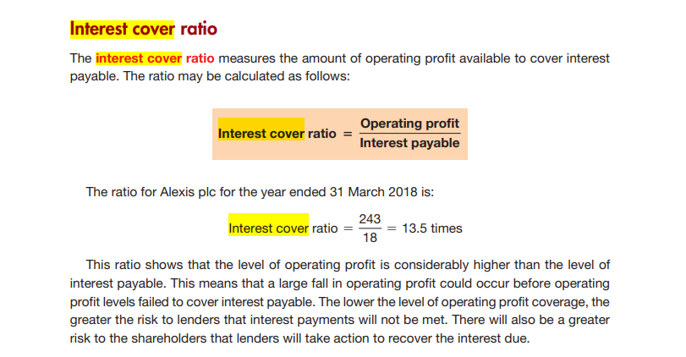
(Atrill,2020)

2021: 805 / 226 = 3.56 times

2020: 699 / 181 = 3.86 times

b) financial performance and position

The financial performance of Sweets plc has improved in 2021 compared to 2020. The ROCE increased from 7.65% to 8.58%, indicating better utilization of capital.
The ROE also improved from 12.57% to 13.96%, showing a higher return for shareholders. The earnings per share increased from £0.41 to £0.57, indicating higher profitability per share.
The net profit margin increased slightly from 5.68% to 6.39%, indicating improved profitability. The asset turnover increased from 0.63 times to 0.69 times, suggesting better efficiency in generating revenue from assets.
The stock holding days increased from 78 days to 80 days, indicating some difference with management of inventory.
The debtor’s collection period also improved from 73 days to 68 days, suggesting better management of accounts receivable.
The current ratio improved from 0.77 times to 0.92 times, indicating better short-term liquidity. The gearing ratio decreased slightly from 58.64% to 57.25%, indicating a lower dependency on debt financing.
The interest cover decreased from 3.86 times to 3.56 times, indicating a slightly reduced ability to cover interest expenses.
Overall, Sweets plc has shown an improvement in profitability, efficiency, and liquidity in 2021. However, the company still has a relatively high level of debt and needs to focus on maintaining or increasing its interest cover to ensure financial stability.

DRAFT
1. ROCE (Return on Capital Employed)
2021: (Operating Profit / Capital Employed) x 100
= (805 / (7,433 + 2,303 - 2,511)) x 100
= 8.9%

2020: (699 / (7,732 + 2,355 - 3,046)) x 100
= 7.8%

2. ROE (Return on Equity)
2021: (Net Profit / Shareholders' Equity) x 100
= (431 / 3,088) x 100
= 14.0%

2020: (366 / 2,912) x 100
= 12.6%

3. Earnings Per Share
2021: (Net Profit / Number of Shares)
= (431 / 600)
= £0.72

2020: (366 / 600)
= £0.61

4. Net Profit Margin
2021: (Net Profit / Revenue) x 100
= (431 / 6,738) x 100
= 6.4%

2020: (366 / 6,441) x 100
= 5.7%

5. Asset Turnover
2021: Revenue / Total Assets
= 6,738 / 9,736
= 0.69 times

2020: 6,441 / 10,087
= 0.64 times

6. Stock Holding Days
2021: (Average Inventory / Cost of Sales) x 365 days
= (708 + 659) / 2 / 3,235 x 365
= 67 days

2020: (659 / 3,096) x 365
= 79 days

7. Debtors Collection Period
2021: (Average Trade Receivables / Revenue) x 365 days
= (1,249 + 1,287) / 2 / 6,738 x 365
= 63 days

2020: (1,287 / 6,441) x 365
= 71 days

8. Current Ratio
2021: Current Assets / Current Liabilities
= 2,303 / 2,511
= 0.92 times

2020: 2,355 / 3,046
= 0.77 times

9. Gearing Ratio
2021: (Debt / Equity) x 100
= (4,137 / 3,088) x 100
= 134%

2020: (4,129 / 2,912) x 100
= 142%

10. Interest Cover
2021: Operating Profit / Interest Payable
= 805 / 226
= 3.6 times

2020: 699 / 181
= 3.9 times

References:

Atrill, P. (2020) Financial Management for Decision Makers. Harlow, England: Pearson.
Dyson, J.R. (2010) Accounting for non-accounting students. Harlow, England: Financial Times Prentice Hall.
Monte‐Mor, D., Galdi, F. & Costa, C., 2018. The role of accounting fundamentals and other information in analyst forecast errors. International Finance, 21(2), pp. 175-194.

