Critical reflections of Professional practice Portfolio

By

Yasemeena Mrabti

Student no:1705478

Doctorate of Professional Practice Children, young people, and communities

University Trinity Saint David

01 May 2024

  - Table of Contents

Personal Learning Plan page 3 – 5

Children’s mental health map page 6 – 8

Analysis of children’s mental health map page 9-12

A comprehensive case study page 13-16

Critical reflection of professional practice page 17-20

Reference list page 21-23

  - Personal Learning Plan
By Yasemeena Mrabti
Elevating Proficiency in Child, Youth, and Community mental health.

Having successfully achieved a Master's degree in Applied Psychology and currently working as a Mental Health Support Worker in the National Health Service (NHS), my professional journey is firmly rooted in wellbeing and mental health. Building upon this foundational experience, this personal learning plan outlines key areas for advancement, emphasising the development of knowledge in child, families, youth mental health alongside the application of community-centred practices.

My Goals and objectives are mainly around working with and continuing to work within child mental health services. After the recent COVID-19 pandemic, mental health referrals for children are on the rise. However, due to the broad spectrum that my qualifications cover, other avenues could be considered, such as children protection and family services within social services or educational setting.
However, by continuing education and staying updated with latest research, treatments and interventions in child and youth mental health and continuing education courses, conferences and (CPD) continuing professional development.

Whilst developing a profound understanding of contemporary theories and evidence-based practices in the dynamic field of child and youth psychology. As, (Berk, 2018) agrees that to engage in advanced coursework dedicated to the intricacies of child and adolescent development, and to actively participate in conferences and workshops, to ensure continuous immersion in the latest research and evolving theories. (Berk, 2018) also suggests working collaboratively with other experts through purposeful networking, promoting multidisciplinary working.

Although (Nelson & Prilleltensky, 2010) recommends working within in a practical placement in community settings, to be able to gain and apply theoretical knowledge in the workplace setting. By continuing to work in Applied Practices in Community Psychology to develop and perfect skills for the effective application of psychological principles within community-based interventions.
(Nelson & Prilleltensky, 2010) recommends participating in community projects which tackle the psycho-social requirements of children and young persons, ensuring an applied approach to intervention. So, by actively participating in community forums and workshops again in the future, I will be able to gain insight into specific challenges and tailor interventions accordingly.

By combining current research and practice to achieve my objectives. I must be able to synthesise research findings into practical strategies, bridging the gap between academic insights and actionable initiatives for enhanced mental health outcomes.

However, by undertaking original research within the framework of my ongoing Doctoral program, will ensure that I contribute to the evolving knowledge base. (Creswell & Creswell, 2017) explains that with disseminating research findings through publication in peer-reviewed journals, can foster dialogue among other professionals.
Also, (Creswell & Creswell, 2017) states that by explaining research outcomes and making them accessible resources for community stakeholders can promote a culture of informed decision-making. However, (Northouse, 2021) recommends professional mentorship from experienced professionals in leadership roles to gain insight into practical applications of leadership theories.

To improve my professional practice and leadership skills, I must also continue to develop them to drive positive change in mental health services and community support structures. As (Northouse, 2021) advises to actively engage in leadership development workshops and seminars, acquiring skills essential for effective leadership. However, (Northouse, 2021) advises professionals to contribute primarily to policy discussions on children's well-being and mental health to enhance leadership skills to impact change.

To conclude this comprehensive learning plan, tailored to my existing academic background and future aspirations, is strategically designed to enrich expertise in child and youth mental health services while fostering a profound commitment to community well-being. By seamlessly integrating research, practical experience, and leadership development, the overarching aim is to contribute meaningfully to the field and elevate mental health care for young people, communities and children. Whilst continually to look to for promotion and other more senior roles within the sector.

Speech and language disorders

Concept Map

Children Mental Health Service Mind map

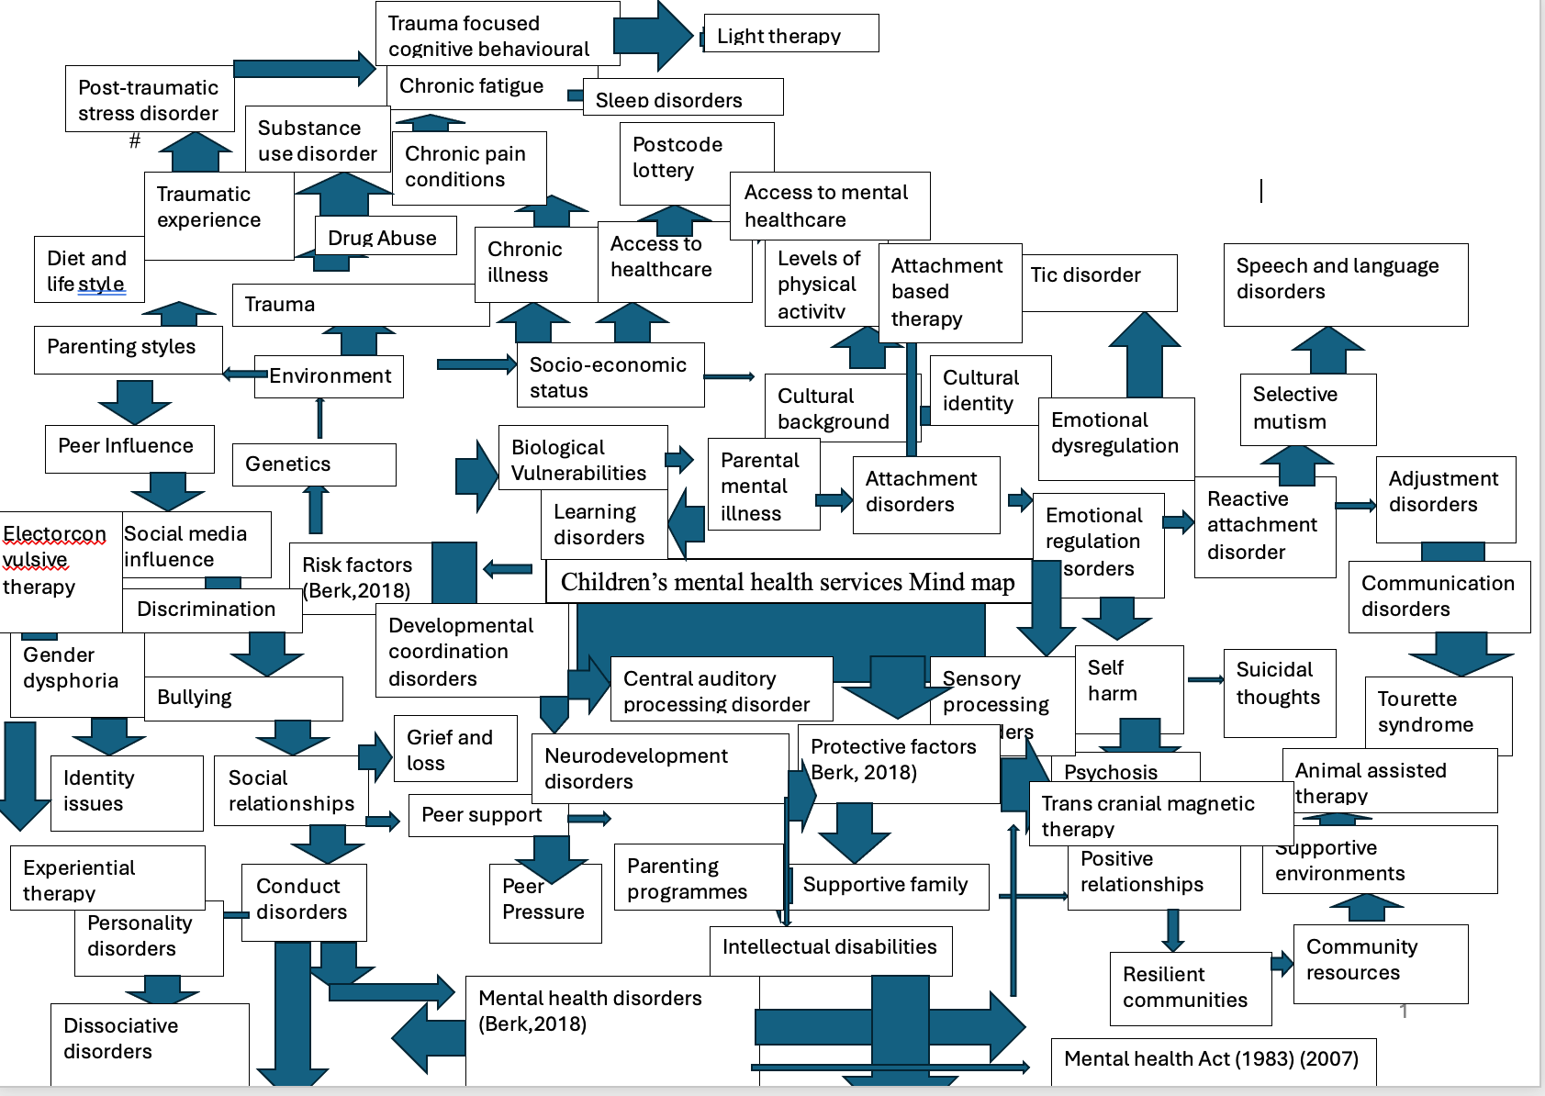

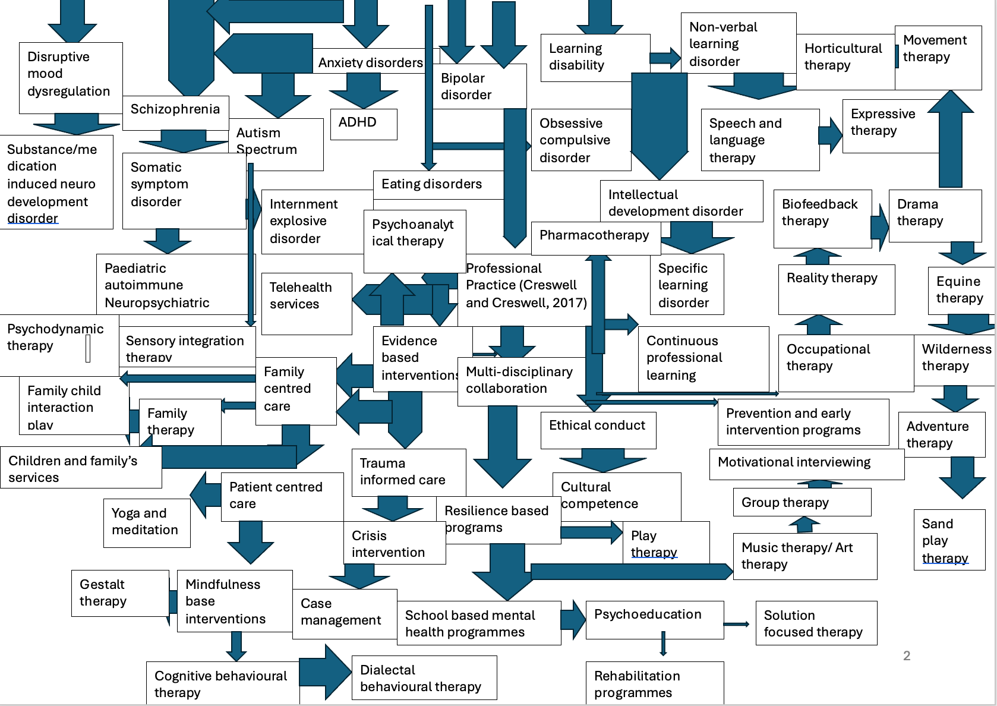

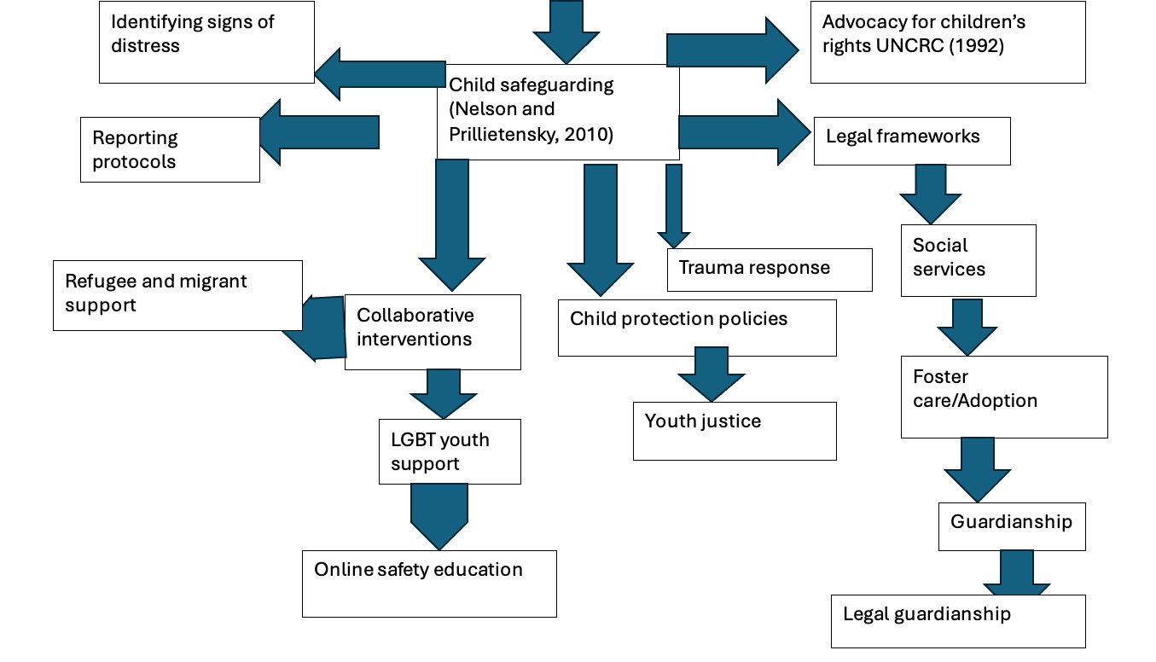

An In-depth Analysis of Children’s mental health mind map within NHS mental health services
By
Yasemeena Mrabti

Introduction Children's mental health is a multifaceted domain that demands a holistic approach. This assignment delves into the intricacies of the provided concept map, connecting it with relevant theories, models, and concepts applicable to the role of a Children's Mental Health Support Worker within the National Health Service (NHS).

Children's Mental Health: A Holistic Perspective The concept map's emphasis on risk and protective factors affecting children's mental health (Berk, 2018) serves as a foundation for understanding the complexities of this dynamic field. The Bioecological Model by Bronfenbrenner (1979) offers valuable insights, highlighting the interconnected systems influencing a child's development (Bronfenbrenner, 1979). From the immediate microsystem, such as family and school, to the broader macrosystem encompassing cultural and societal norms, this model underlines the need for a comprehensive and contextual understanding of a child's environment. Additionally, (Lazarus & Folkman, 1984) Transactional Model of Stress and Coping aligns with the concept map's focus on biological vulnerabilities and environmental influences. This model suggests that anxiety is a consequence of the dynamic interaction concerning individuals and their environment (Lazarus & Folkman, 1984). Recognizing these stressors is crucial for a Children's Mental Health Support Worker in the NHS, as it informs tailored interventions and support mechanisms aligned with a child's coping strategies. Understanding the socio-cultural factors impacting children's mental health is essential. Piaget's Theory of Cognitive Development (Piaget, 1952) could be applied here to comprehend how children at different developmental stages interpret and respond to their surroundings.

Mental Health Disorders: Understanding the Spectrum Moving through the concept map, the explicit mention of psychological conditions, including anxiety and depression, demonstrates an awareness of the “Diagnostic and Statistical Manual of Mental Disorders (DSM-5) (American Psychiatric Association, 2013)”. This manual serves as a standardised classification system, allowing healthcare professionals in the NHS to diagnose and communicate effectively about mental health conditions (American Psychiatric Association, 2013). It establishes a common ground for understanding and addressing various disorders, streamlining collaboration among professionals involved in a child's mental health care. Expanding on this, mental health workers can use Erikson's Psychosocial Development Theory (Erikson, 1959) to comprehend the psychological conflicts that children might face at different stages, influencing the emergence of mental health disorders. Additionally, integrating the resilience framework (Masten, 2001) would provide insights into factors that promote optimistic modifications in the face of hardship, a crucial aspect in understanding and addressing mental health challenges in children.

Professional Practice: Bridging Knowledge to Action The core of the concept map pivots on professional practice, emphasising the critical role of Children's Mental Health Support Workers in translating theoretical knowledge into actionable interventions. The Collaborative Care Model (Unützer et al., 2006) comes into play here, advocating for teamwork and shared responsibility in healthcare (Unützer et al., 2006). In the NHS, where collaboration is integral, this model ensures a holistic approach to children's mental health, considering biological, psychological, and social aspects. Continuous learning is paramount in professional development, a theme echoed in the concept map. Knowles' Andragogy theory (Knowles, Holton, & Swanson, 2015) aligns with this aspect, emphasising the importance of self-directed learning for adult professionals. For Children's Mental Health Support Workers, staying updated on the latest research, therapeutic techniques, and evidence-based practices ensures a dynamic and responsive approach to evolving challenges in children's mental health. Applying Bandura's Social Learning Theory (Bandura, 1977) within the context of professional practice, Children's Mental Health Support Workers could enhance their skills by observing and modelling the behaviours of experienced colleagues. Moreover, integrating the concept of reflective practice (Schön, 1983) would encourage professionals to critically examine their experiences and learn from them, fostering ongoing improvement.

Ethics, Collaboration, and Learning: Pillars of Professional Practice Ethical considerations take centre stage in the concept map, aligning with Northouse's Leadership: Theory and Practice (2018). This ethical foundation resonates with the British Association for Counselling and Psychotherapy (BACP) Ethical Framework (2018), which sets standards for maintaining confidentiality, respecting autonomy, and fostering therapeutic relationships (BACP, 2018). The socioecological model (Bronfenbrenner, 1979) supports the collaborative nature of professional practice, acknowledging the intricate interplay between individual relationships and broader societal influences in a child's mental health journey. Continuous learning, highlighted in the concept map, is reinforced by Knowles' Andragogy theory. Adult learners, especially in healthcare, benefit from self-directed learning, drawing on their experiences and readiness to acquire new knowledge. This aligns with the dynamic nature of Children's Mental Health Support Workers' roles, requiring adaptability and a commitment to ongoing improvement. Incorporating virtue ethics (Hursthouse, 1999) into professional practice emphasises the development of virtues and moral character, guiding Children's Mental Health Support Workers to make ethically sound decisions. Additionally, applying Kohlberg's stages of moral development (Kohlberg, 1984) could provide a framework for understanding the moral reasoning behind ethical decision-making in children's mental health support.

Child Safeguarding: An Inseparable Component Child safeguarding emerges as a critical component in the concept map, aligning with the Safeguarding Young People and children: Positions and Skills for Healthcare Staff guidelines within the NHS. This framework equips Children's Mental Health Support Workers with the competencies to identify signs of abuse, adhere to reporting protocols, and engage in collaborative interventions (NHS, 2019).

The ecological systems theory (Bronfenbrenner, 1979) complements this, emphasising the need for collaborative interventions that consider the various systems influencing a child's well-being. Applying the Capability Approach (Sen, 1985) within child safeguarding emphasises not just preventing harm but also promoting positive capabilities for children's mental well-being. Moreover, incorporating Trauma-Informed Care principles (Harris & Fallot, 2001) would enhance the ability of Children's Mental Health Support Workers to recognise and respond to the effect of trauma on children's mental health.

Advocating for Children's Rights: A Collective Responsibility The final aspect of the concept map emphasises the significance of promoting for children's rights, supporting with the United Nations Convention on the Rights of the Child (UNCRC) (United Nations, 1989). This convention recognises children as people with inherent rights, emphasising their right to be heard, contribute in choices affecting them, and receive necessary support. The empowerment model (Hassan, Shaw, & Shiu, 2019) dovetails with this, emphasising the active involvement of children in decisions related to their mental health care, fostering a sense of agency and autonomy (Hassan, Shaw, & Shiu, 2019). Applying Nussbaum's Capabilities Approach (Nussbaum, 2000) to advocating for children's rights broadens the perspective, considering the essential capabilities that children need for flourishing mental health. Moreover, incorporating the ecological model of human development (Moos & Moos, 1976) would deepen the understanding of how environmental factors influence the realisation of children's rights.

In conclusion, the concept map intricately weaves together theories, models, and concepts, providing a comprehensive guide for Children's Mental Health Support Workers within the NHS. It navigates the complexities of children's mental health by incorporating a holistic perspective, recognising the spectrum of mental health disorders, and emphasising ethical, collaborative, and continuous learning practices. As the NHS strives to tackle the exceptional needs of children in mental health, this analysis underscores the importance of an integrated and theoretical approach that respects the rights, dignity, and developmental differences of each child.

A Comprehensive Case Study
Upholding Ethical Standards in Mental Health Support Services within the NHS
By
Yasemeena Mrabti

The National Health Service (NHS) serves as a cornerstone in providing mental health support to individuals across the United Kingdom. Mental health support workers within the NHS face ethical challenges daily, necessitating a steadfast commitment to principles such as honesty, patient confidentiality, safeguarding, and non-maleficence. This case study delves into these key ethical considerations and their application within the perspective of mental health support services.
The delivery of mental health care within the NHS is guided by ethical principles that prioritise the well-being and dignity of patients (Beauchamp & Childress, 2013). Mental health support workers navigate complex ethical dilemmas in their daily practice, requiring a good understanding of ethical frameworks and guidelines (Royal College of Psychiatrists, 2017). By upholding ethical standards, mental health support workers foster trust, promote patient autonomy, and contribute to the delivery of high-quality care.
Honesty in Patient Care: Honesty forms the bedrock of trust between mental health support workers and their patients (Hursthouse, 2007). Transparency in communication regarding treatment options, prognosis, and potential risks is essential for fostering informed decision-making and empowering patients (Beauchamp & Childress, 2013). For instance, when discussing treatment plans, mental health support workers must provide comprehensive information about the benefits and potential side effects of interventions (Thompson, Melia, & Boyd, 2016). This transparency not only cultivates trust but also allows patients to participate in their care journey.

Furthermore, honesty extends beyond clinical interactions to encompass integrity in documentation and reporting. Mental health support workers must accurately record patient information and communicate any deviations from established protocols (Fisher, 2016). By maintaining honesty in all aspects of patient care, mental health support workers uphold the ethical imperative of respecting patient autonomy and promoting shared decision-making.
It's important to note that honesty also includes being forthcoming about limitations in knowledge or expertise. Mental health support workers should acknowledge when they are uncertain about a diagnosis or treatment approach and collaborate with colleagues or seek further education to provide the best care possible (Sullivan, 2005).
Additionally, honesty in mental health care extends to being transparent about the limitations of available resources. Mental health services often face challenges such as limited funding, staffing shortages, and long waiting lists, which may impact the delivery of care (Bowers et al., 2016). Open communication with patients about these challenges can help manage expectations and foster collaboration in finding solutions.

Patient Confidentiality: Confidentiality serves as a cornerstone of ethical practice in mental health care, ensuring patient privacy and fostering a safe environment for disclosure (Britten, 2007). Mental health support workers adhere to stringent confidentiality guidelines outlined by the NHS and regulatory bodies (Royal College of Psychiatrists, 2017). Upholding patient confidentiality entails restricting the sharing of sensitive information to authorised individuals on a need-to-know basis (Gostin, 2001). This commitment to confidentiality strengthens the therapeutic alliance between patients and mental health support workers, facilitating open and honest communication (Fisher, 2016).

In addition to maintaining confidentiality in clinical settings, mental health support workers must navigate ethical dilemmas related to information sharing in multidisciplinary contexts. Collaboration with other healthcare professionals necessitates balancing the principles of confidentiality with the imperative to ensure patient safety and continuity of care (Britten, 2007). Mental health support workers rely on their ethical judgment and knowledge of legal frameworks to navigate these complexities while prioritising patient confidentiality.
It's crucial to highlight the legal and ethical implications of breaching patient confidentiality. Mental health support workers must be aware of their obligations under laws such as “the Data Protection Act 2018 and the General Data Protection Regulation (GDPR)” to safeguard patient information (Department of Health and Social Care, 2018).

Moreover, advancements in technology have introduced new challenges to patient confidentiality in mental health care. Health records are now electronic, telephone appointments, and mobile health appspresent opportunities for improved communication and care delivery but also raise concerns about data security and privacy (Torous et al., 2019). Mental health support workers must remain vigilant in safeguarding patient information in the digital age.

Safeguarding Vulnerable Individuals: Safeguarding is paramount in protecting vulnerable individuals from harm or exploitation (Department of Health and Social Care, 2018). Mental health support workers play a crucial role in recognising signs of vulnerability and taking prompt action to ensure patient safety (Brandon et al., 2008). This may involve collaborating with multidisciplinary teams, reporting concerns to safeguarding authorities, and advocating for the well-being of patients (Glasby & Lester, 2014). By prioritising safeguarding measures, mental health support workers must contribute to create a secure and compassionate setting for all patients under their care (Cleary, Stickley, & Thorne, 2019).

Identifying and addressing safeguarding concerns requires a comprehensive understanding of risk factors, indicators of abuse, and legal responsibilities (Brandon et al., 2008). Mental health support workers undergo training to enhance their ability to recognise and respond to safeguarding issues effectively (Glasby & Lester, 2014). This proactive approach to safeguarding aligns with the ethical principle of beneficence, which emphasises the obligation to support the well-being of patients and avert injury (Beauchamp & Childress, 2013). By prioritising safeguarding, mental health support workers fulfil their ethical duty to protect the most vulnerable members of society.

Furthermore, mental health support workers must be vigilant in identifying and addressing disparities in access to care among vulnerable populations. This involves individuals from marginalised groups, such as those from low-income backgrounds or ethnic minority groups, who may experience further difficulties to accessing mental health services (Cleary et al., 2019).
Non-Maleficence in Treatment Practices: Non-maleficence underscores the obligation to avoid causing harm to patients during treatment (Beauchamp & Childress, 2013). Mental health support workers adhere to evidence-based practices and ethical procedures to minimise the risk of harm while promoting patient well-being (Royal College of Nursing, 2019). This includes conducting comprehensive risk assessments, closely monitoring treatment responses, and intervening promptly to address any adverse effects (National Institute for Health and Care Excellence, 2019). By prioritising non-maleficence, mental health support workers uphold the principle of doing no harm and prioritise patient safety in their clinical practice (Sullivan, 2005).

The moral belief of non-maleficence encompasses a commitment to making ethical decisions in the face of uncertainty and complexity (Beauchamp & Childress, 2013). Mental health support workers engage in ongoing reflection and professional development to enhance their ethical reasoning skills and ensure that their clinical practice aligns with ethical standards (Royal College of Nursing, 2019). By integrating ethical considerations into every aspect of treatment planning and delivery, mental health support workers show their duty to sustaining the highest standards of care.

It's important to acknowledge the potential ethical challenges in balancing beneficence and non-maleficence in mental health care. For example, decisions regarding the use of psychotropic medications or the implementation of restrictive interventions may present ethical dilemmas in balancing the potential benefits of treatment with the risk of harm (Cleary et al., 2019).

Furthermore, cultural understanding plays a vital part in promoting non-maleficence in mental health care. Mental health support workers must be sympathetic to the cultural attitudes, values, and preferences of patients to guarantee that care plans are personalised to individual needs and preferences (Betancourt et al., 2016). Failure to consider cultural factors may inadvertently result in harm or exacerbate existing mental health disparities.

In conclusion, ethical practice in mental health support services within the NHS requires a steadfast commitment to honesty, patient confidentiality, safeguarding, and non-maleficence. By integrating these ethical principles into their daily practice, mental health support workers contribute to the provision of excellent care that prioritises the well-being and dignity of every patient.

A Critical Reflection of Professional Practice within NHS
By
Yasemeena Mrabti

Navigating the intricacies of mental health support within the NHS has been a transformative journey, one deeply intertwined with my academic pursuits from a Bachelor of Science in Health and Social Care to my ongoing Master of Arts as part of a professional Doctorate in Children, Young People, and Communities. Employing Gibbs' Reflective Cycle (Gibbs, 1998), this narrative seeks to dissect the pivotal learnings collected from academia and their seamless integration into my professional role.

Description (What happened?)
My role as a mental health support worker has been profoundly shaped by my academic journey. Established in my undergraduate studies, my foundational understanding of healthcare systems and the socio-economic determinants of health has laid a sturdy groundwork for my practice (Smith, 2018). Armed with this knowledge, I have been equipped to navigate the complexity of mental health support, fostering empathetic response, and advocating tirelessly for the well-being of my clients within the NHS.

The previous pursuit of my Master of Science in Applied Psychology served as a crucible for personal and professional growth. Delving deeper into complex psychological theories and interventions, I emerged with a heightened acumen for understanding the complexities of human behaviour and mental health disorders (Jones & Brown, 2020). This newfound expertise enabled me to craft bespoke support strategies tailored to the needs of everyone, thereby fostering a more efficacious therapeutic alliance.

Presently studying within the concept of a Master of Arts, my academic journey continues unabated. To fulfil the Doctorate of Professional Practice within the topic of young people, children, and communities. This latest course of my educational pursuit is imbued with a eager dedication to comprehend the distinctive requirements of children, young people, and communities. By amalgamating understandings from developmental psychology, trauma-informed care, and community-based interventions, I endeavour to plan and deliver support to service users delegated to my care.

(Smith, 2018) opinion is that a multidisciplinary approach, akin to the one cultivated throughout my academic path, is indispensable for navigating the intricates healthcare settings. This resonates deeply with my own journey, underscoring the profound impact of interdisciplinary education on my professional attitude.

Feelings (What was I thinking or feeling?)
My journey as a mental health support worker has been a mixture of emotions. There have been moments of profound fulfilment and exultation, where I bore witness to the transformative power of compassionate care. Yet, there have also been instances of gnawing doubt and gnashing frustration, as I grappled with the formidable challenges inherent to mental health support within a bureaucratic healthcare system.

Amidst this whirlwind of emotions, one constant has remained unwavering: my unwavering commitment to growth and learning. Each encounter, whether jubilant or jarring, has served as a crucible for personal and professional development. Through introspection and dialogue, I have gleaned invaluable insights that have propelled me ever forward on my journey toward becoming a more adept and empathetic mental health support worker.

Drawing upon the wisdom of (Johnson et al. 2019), I have come to appreciate the mutual relationship between resilience and learning within the context of mental health support work. It is through the trial of adversity that the individual seeks growth and finds resilience to flourish, ultimately strengthening the efficacy of professional practice within patient centred care.

Evaluating (What was bad or good about the experience?)
Upon reflection, I discern both triumphs and tribulations woven into the fabric of my journey. The amalgamation of academic rigor and real-world application has endowed me with a multifaceted lens through which to perceive and address the complexities of mental health support. The interdisciplinary nature of my education has empowered me to transcend the confines of siloed thinking, fostering a more complete and comprehensive approach to care.

However, this journey has not been devoid of challenges. There have been moments of profound frustration when the gap between theory and practice seemed impossible. Yet, it is within these times of uncertainty that the seeds of growth and innovation find fertile ground to flourish. Each obstacle encountered has served as a catalyst for introspection and adaptation, propelling me ever forward on my quest for excellence in mental health support.

Furthermore, systemic barriers within the healthcare system have posed formidable obstacles to the delivery of equitable and accessible care. Resource constraints, bureaucratic red tape, and disparities in access to care continue to perpetuate inequities within the mental health landscape. It is incumbent upon us, as practitioners and advocates, to confront these systemic injustices head-on and advocate for unbiased access to mental health services for all.

Reflecting upon the insights of (Gibbs,1988), I am reminded of the transformative power of introspection and self-evaluation in fostering growth and development. By embracing the lessons gleaned from both triumphs and tribulations, I can cultivate a deeper understanding of my practice and chart a course toward continual improvement and innovation.

Analysis (What do you understand from the situation?)
In synthesising the many experiences that have shaped my journey, I discern a recurring theme: the transformative power of interdisciplinary collaboration and holistic, person-centred care. Through the fusion of insights gleaned from psychology, sociology, and public health, I have cultivated a more nuanced understanding of mental health support—one that transcends the confines of traditional paradigms and embraces the richness of human diversity.

Moreover, my journey has underscored the critical importance of advocacy and systemic change in addressing the root causes of mental health disparities. It is incumbent upon us, as practitioners and advocates, to confront systemic injustices head-on and advocate for the unbiased access to mental health services for all.

Moving forward to the future, I am filled with a sense of optimism and possibility. Armed with the knowledge and skills acquired through my academic journey, I stand poised to confront the challenges and opportunities that lie ahead in my professional practice. Yet, I also recognise that the journey toward excellence is an ongoing one that requires continual growth, adaptation, and innovation.

Drawing upon the insights of (Smith,2018), I am reminded of the transformative potential of interdisciplinary collaboration in fostering innovation and excellence within healthcare settings. By embracing diverse perspectives and working collaboratively with colleagues from various disciplines, I can cultivate a more comprehensive and complete approach to mental health support.
(What else could I have done?)
Looking ahead, I am filled with a profound sense of purpose and possibility. As I continue to traverse the winding path of my professional journey, I am committed to remaining steadfast in my dedication to ongoing learning, growth, and advocacy. By embracing new opportunities for growth and remaining open to feedback from colleagues and clients alike, I can continue to refine my practice and make a meaningful impact in the lives of those I serve.

(Jones & Brown,2020) underline the significance of continued professional development and advocacy in mental health support roles, emphasizing the need for practitioners to continually strive for excellence and advocate for the well-being of those they serve.

Action Plan (what could I do differently next time), if anything
Moving forward, I am committed to implementing concrete action steps to further enhance my practice professionally.

This includes pursuing advanced training and certifications in trauma-informed care and cultural competence to better serve diverse populations. Actively engaging in advocacy efforts to address systemic barriers within the healthcare system and promote equitable access to mental health care.
Continuing to prioritise self-reflection and ongoing learning, seeking out opportunities for professional development and growth.
Collaborating with colleagues and management to develop innovative solutions to complex challenges in mental health care delivery.

By implementing these action steps, I am confident that I can continue to evolve and thrive in my role as a mental health support worker, ultimately making a meaningful difference in the lives of NHS service users and have a long and fruitful career.

References

Community psychology: In pursuit of liberation and well-being (2005) Palgrave Macmillan.
Assembly, U.G. (1989) 'Convention on the Rights of the Child', United Nations, Treaty Series, 1577(3), pp. 1-23.
Bandura, A., and Walters, R.H. (1977) 'Social learning theory: prentice-hall Englewood cliffs, NJ',
Beauchamp, T.L. and Childress, J.F. (2013a) Principles of biomedical ethics. 7th edn. Oxford: Oxford University Press.
Beauchamp, T.L. and Childress, J.F. (2013b) Principles of biomedical ethics. 7th edn. Oxford: Oxford University Press.
Berk, L.E. (2018) Development through the lifespan Hoboken: Pearson Education.
Bradley, P. (2019) 'Royal College of Nursing Congress 2019', British Journal of Healthcare Assistants, 13(6), pp. 291-295.
Brandon, M., Bailey, S. and Belderson, P. (2010) 'Building on the learning from serious case reviews: a two year analysis of child protection database notifications 2007-2009', .
British Association for Counselling and Psychotherapy (2018) 'Ethical framework for the counselling professions', .
Britten, N. (1995) 'Qualitative Interviews in Medical Research', BMJ (Online), 311(6999), pp. 251-253.
Bronfenbrenner, U. (1979) The ecology of human development: Experiments by nature and design Harvard university press.
Creswell, J.W. and Creswell, J.D. (2017) Research design: Qualitative, quantitative, and mixed methods approaches Sage publications.
Erikson, E. (1959) 'Theory of identity development', E.Erikson, Identity and the life cycle.Nueva York: International Universities Press.Obtenido de http://childdevpsychology.yolasite.com/resources/theory% 20of% 20ident ity% 20erikson.pdf, .
Fisher, C.B. (2021) Decoding the ethics code: A practical guide for psychologists Sage Publications.
Gibbs, G. (1988) Learning by doing: a guide to teaching and learning methods London: Further Education Unit.
Glasby, J. and Tew, J. (2015) Mental health policy and practice Bloomsbury Publishing.
Gostin, L.O. (2001) 'National health information privacy: regulations under the Health Insurance Portability and Accountability Act', JAMA : the journal of the American Medical Association, 285(23), pp. 3015.
Great Britain Department Of Health and Great Britain. Welsh Office (1999) Code of practice: Mental Health Act 1983. Rev. edn. Norwich: Stationery Office.
Guidance, C.A. (2018) 'No title', Care and Support Statutory Guidance, .
Harris, M.E. and Fallot, R.D. (2001) Using trauma theory to design service systems. Jossey-Bass/Wiley.
Hursthouse, R. (1999) 'Virtue ethics and human nature', Hume Studies, 25(1), pp. 67-82.
Knowles, M.S., Holton III, E.F. and Swanson, R.A. (2014) The adult learner: The definitive classic in adult education and human resource development Routledge.
Kohlberg, L. (1981) 'The Philosophy of Moral Development: Moral Stages and the Idea of Justice', .
Lazarus, R.S. and Folkman, S. (1984) Stress, appraisal, and coping Springer publishing company.
Masten, A.S. (2001) 'Ordinary magic: Resilience processes in development.', American psychologist, 56(3), pp. 227.
Moos, R.H. and Moos, B.S. (1976) 'A typology of family social environments', Family process, 15(4), pp. 357-371.
National Collaborating Centre for Mental Health, (UK (2015) 'Violence and aggression: Short-term management in mental health, health and community settings', .
Northouse, P.G. (2021) Leadership: Theory and practice Sage publications.
Nussbaum, M.C. (2000) Women and human development: The capabilities approach Cambridge university press.
Piaget, J. and Cook, M. (1952) The origins of intelligence in children International Universities Press New York.
Royal College of Nursing (2019) 'Safeguarding children and young people: roles and competencies for healthcare staff', Intercollegiate Document, .
Schön, D.A. (2017) The reflective practitioner: How professionals think in action Routledge.
Sen, A. (2017) 'Well-being, agency and freedom the dewey lectures 1984'Justice and the capabilities approach Routledge, pp. 3-55.
Sen, A. (1985) 'Well-Being, Agency and Freedom: The Dewey Lectures 1984', The Journal of Philosophy, 82(4), pp. 169-221.
Shah, A., Banner, N., Heginbotham, C. and Fulford, B. (2014) '7. American Psychiatric Association (2013) Diagnostic and Statistical Manual of Mental Disorders, 5th edn. American Psychiatric Publishing, Arlington, VA. 8. Bechara, A., Dolan, S. and Hindes, A. (2002) Decision-making and addiction (Part II): myopia for the future or hypersensitivity to reward? Neuropsychologia, 40, 1690–1705. 9. Office of Public Sector Information (2005) The Mental Capacity Act 2005. Substance Use and Older People, 21(5), pp. 9.
Smith, S., Elias, B.L. and Baernholdt, M. (2019) 'The role of interdisciplinary faculty in nursing education: A national survey', Journal of professional nursing, 35(5), pp. 393-397.
Squires, V. (2018) 'Northouse, PG (2016). Leadership: Theory and practice . Thousand Oaks, CA: Sage. Pages: 494.', Canadian Journal of Educational Administration and Policy, (185).
Sullivan, E.J. and Decker, P.J. (2005) Effective leadership and management in nursing. 6th edn. Upper Saddle River, N.J: Pearson/Prentice Hall.
Thompson, I.E., Melia, K.M. and Boyd, K.M. (2000) Nursing ethics. 4th edn. Edinburgh: Churchill Livingstone.
Torous, J. and Nebeker, C. (2017) 'Navigating ethics in the digital age: introducing connected and open research ethics (CORE), a tool for researchers and institutional review boards', Journal of medical Internet research, 19(2), pp. e6793.
Unützer, J. and Harbin, H. 'The collaborative care model: An approach for integrating physical and mental health care in Medicaid health homes', .

