Name : Naila Amir

Student Number : 2434403

Module : Introduction to Health and social care LCHS4003

Assignment title : written Report

Lecturer Name : Mumtaz Goolam

Submission date : 21/11/2025

Component task 2

Introduction

This report will discuss the situation of 72 year old women with hip replacement surgery who live alone and receive care from the domiciliary care agency twice a day. She lives alone and her daughter lives nearby. Mrs.Mann’s first language is Urdu and her english is very limited and her daughter translates for her. In this situation care agency, GP and community physiotherapist collaborated for fostering the effecting care to Mrs.Mann. Unfortunately there is a huge concern regarding inconsistent documentation in her care records. This report will explore the importance of effective communication , administrative skills and collaborative skills in health and social care. This report will explain Berlo’s communication model. This research will also underline the Equality of Act 2010 as well as data protection Act 2018.

Importance of effective communication in the Health and social care :

The BMC health services (2023) explains thoroughly the importance of effective communication as a centre of quality healthcare. Communication helps to build the connection between the providers and the patients also forming a good relationship that benefits patient-centered outcomes. Excellent communication is crucial for all healthcare professionals as well as impacts patients health and satisfactions that benefits both the provider and the service users. Communication in healthcare plays several roles and functions. Clear and effective communication established a trust between the physician and the patient. Communication helps the physician to understand and manage patients' doubts, addressing their emotions and also allowing them to question. Communication also allows the patient to understand their state of illness and related signs and symptoms also the treatment. Communication between the physician and patient helps in making self decisions without any interruptions by using the language the patient can properly understand that helps the providers in making patient-centered plans.

Types of communication in the Healthcare:

High skills training organization Uk in (2025) explained with detail about communication in care setting and also underlined the major types of communication in health and social care and they are :

1- Verbal Communication:

Verbal communication means interacting with patients including face-to-face conversation ,video calls ,telephone calls and discussing the procedures, explaining the care plans as well as providing emotional support. Verbal communication is crucial in health and social care that involves eye contact and creating a comfortable space for questions. It is important using clear and positive body language to convey your message and showing support, care and professionalism . In addition, addressing individuals by their name.

2- Non-Verbal Communication

Effective non-verbal communication is essential in providing quality care when an individual struggles to express verbally. It is important to understand their needs through posture,gesture,facial expressions,nodding,smiling and eye contact. Non-verbal communication helps when the word fails. It can create a supportive environment for effective care.

3- Written Communication

Written communication plays an important role in health and social care for several reasons including, emails, writing reports, notes, care plan, and all kinds of reports are essential for accurately reporting and sharing the right and important information especially when it comes to details like delivery timings , medication dosages and changes in treatments.

Formal Communication

Formal communication is used in professional settings with clear and respectful language that people can understand. In health and social care it includes sharing sensitive information to someone’s health and care should be handled carefully. It is crucial to avoid the jargon and use clear and plain language to convey the message.

Berlo’s (1960) Model of communication

This information has been taken from UWTSD.moodle week 6 where we have been taught regarding David Berlo’s (1960) model of communication. Berlo’s model (1960) has mainly four principles to explain the communication process: Sender, Message ,Channel and Receiver .
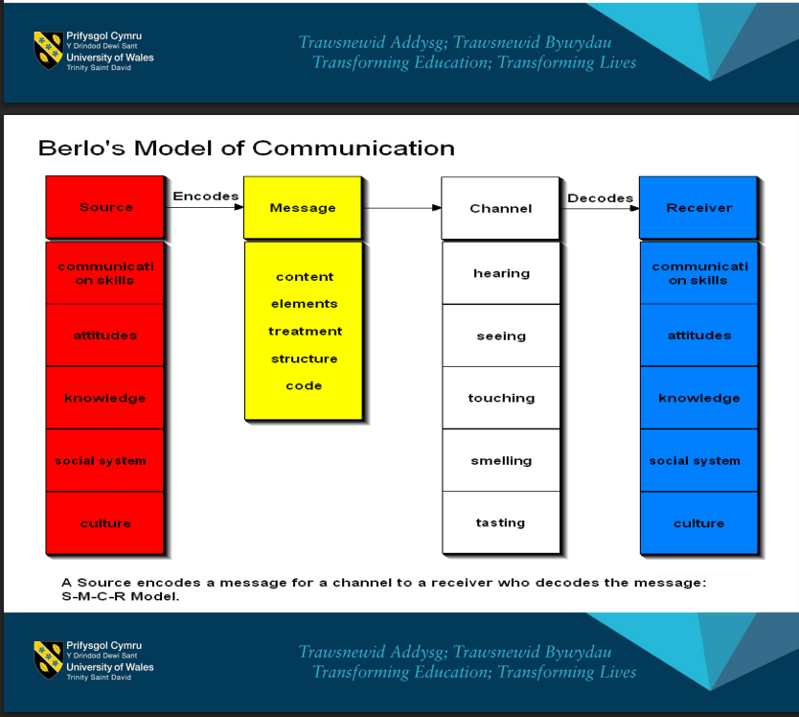

This image has taken from the same resource and this shows that each component has required essential key points to improve the effective communication process.

Language barriers

Training Express Organisation UK ( 2025) discusses that language barrier is the common problem in health settings. Language barriers happen when people cannot speak the same language and belong to different countries and cultures. They struggled to explain their feelings in the language healthcare workers speak. It is also difficult for healthcare workers to explain things clearly which is the biggest barrier in effective communication.
To break this barrier, healthcare workers should use the interpreter , language apps or images .

Communication strategies in health care

This resource also explains the main four effective communication techniques to enhance the communication process.
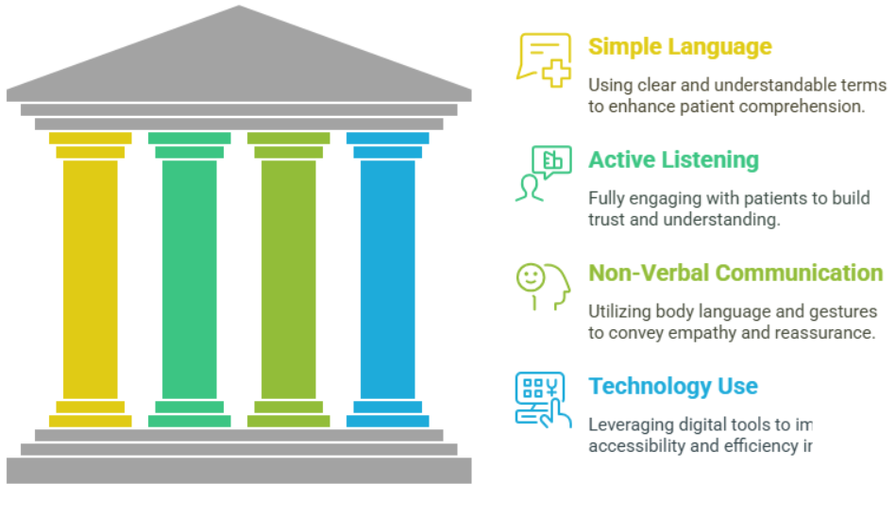

Image shows the techniques for effective communication.

Importance of Accurate Documentation

The data protection Act (2018) makes data protection laws fit for the digital increasing amount of data being processed and empowers people to take control of their data.
Royal College of Nursing (2023) describes that good record keeping is an important part of effective communication in nursing and care to promote safety and continuity of care for patients and clients.

Poor record-keeping

Parliamentary and health service (2024) explained that poor record-keeping can affect patient safety care plans that are missing or not managed well can have several negative results for care. Poor management of care plans also affect family , carer and patient involvement in planning for care.

Caldicott principles
The national data guardian GOV.UK website (2020) defines the eight caldicott principles are,
- Justify the purpose for confidential information
- Use confidential information only when it is necessary
- Access to confidential information should be a strict need-to-know basis
- Use the minimum necessary confidential information
- Everyone with access to confidential information should be aware of their responsibilities.
- Comply with law
- The duty to share information individual are is as important as duty to protect patient confidentiality
- Inform patients and services users about how their confidential information is used.
Importance of multi-agency collaboration
West berkshire council , explains that teamwork is an important part in the health care .There are several benefits working with multi-agency are, established pathway for information gathering and access to services from all partners , maximised effectiveness in decision making ,improve the protection and service delivery to the families.
Approaches of multi-agency
CPD online collage (2025) outlined the approaches involved in the collaboration are, health services , education departments , social workers , law enforcement , housing providers, volunteer and community sectors.
Conclusion
In conclusion , language barriers and poor record keeping are challenges that have been found. The research explained thoroughly the importance of communication and good record keeping in health care settings. Also language barriers can impact the patient care plan. To break the language barriers can be provided a professional interpreter or use language apps.

References

1-Sharkiya, S.H. (2023) ‘Quality communication can improve patient-centred health outcomes among older patients: A rapid review’, BMC Health Services Research, 23(1). doi:10.1186/s12913-023-09869-8.

2-High Skills Training. (2025). Communication in care settings - a complete guide. Retrievedhttps://highskillstraining.org.uk/blog/communication-in-care-settings-a-complete-guide/
3-Online resource lists. (2025b). Retrieved from https://www.uwtsd.ac.uk/library/student-essentials/online-resource-lists/

4-training Express. (2025). Effective communication in health and social care. Training Express. Available at: https://trainingexpress.org.uk/effective-communication-in-health-and-social-care/#:~:text=What%20are%20the%20key%20principles,trust%20and%20improves%20healthcare%20outcomes

5-Health and Care Professions Council (HCPC). (2025). Record keeping. HCPC. Available at: https://www.hcpc-uk.org/standards/meeting-our-standards/record-keeping/#:~:text=Full%2C%20clear%20and%20accurate%20record,if%20later%20queried%20or%20investigated

6-Royal College of Nursing. (2023) Record keeping: The facts. Publication code: 011 016. 20 Cavendish Square, London: Royal College of Nursing. Available at: https://www.rcn.org.uk/Professional-Development/publications/rcn-record-keeping-uk-pub-011-016

7- Parliamentary and Health Service Ombudsman. (2024) Discharge from mental health care: making it safe and patient-centred – Case studies: poor record-keeping. Manchester: Parliamentary and Health Service Ombudsman. Available at: https://www.ombudsman.org.uk/publications/discharge-mental-health-care-making-it-safe-and-patient-centred/case-studies-poor-record-keeping

8-Home Office, Department for Digital, Culture, Media & Sport. (2018) Data Protection Act 2018 overview. Published 25 May 2018. Available at: https://www.gov.uk/government/publications/data-protection-act-2018-overview

9-National Data Guardian. (2020) The Caldicott Principles. Published 8 December 2020. Available at: https://www.gov.uk/government/publications/the-caldicott-principles

10-West Berkshire Council. (n.d.) The Benefits of Having a Multi Agency Safeguarding Hub (MASH). West Berkshire Council. Available at: https://www.westberks.gov.uk/article/39758/The-Benefits-of-Having-a-Multi-Agency-Safeguarding-Hub-MASH

11-CPD Online College Ltd. (2025) Multi‑Agency Working: 7 Riveting Benefits, CPD Online. Available at: https://cpdonline.co.uk/knowledge-base/care/multi-agency-working/#key-sectors-involved-health-education-social-care-and-more

