UWTSD
CertHE Skills for the Workplace(Health and Social Care)
Term 2/Group 2

Student : Margareta Nicoleta Dragoi Lecturer: Mr. Koushik Modak
Student number 2019145
Module :BMSW4004
PROBLEM SOLVING AND DECISION MAKING

Assignment title: Practical Portfolio
Task 1- Written report

Date: 2 of September 2021

Table of Contents

1. Introduction - an overview of problems in healthcare ………………………………….3
2. Short staff and heavy workloads - related to the care agency I work for…………….3
3.The impact of short staff and heavy workloads on all the stakeholders……………..9
4. Analyse of the decision-making process including the relevant legislation……….11
5.Recommendations/Alternative solutions………………………………………………12
6. Conclusion……………………………………………………………………………….17
7. Reference list…………………………………………………………………………….18
8. Appendix………………………………………………………………………………….20

- Introduction – an overview of problems in healthcare

Healthcare is one of the most problematic issue for every state in the world. Despite the fact UK is one of the most developed country worldwide, there are still many problems they are facing in healthcare system. Even if more and more people have been taking private health insurance in the last years, there is still a huge pressure on the public health system. The UK healthcare is facing considerable pressure in its budgets because of the rise in the cost of new technology, rising income and demographic change( Emmerson, Frayne & Goodman, 2007).
Within the large range of problems in healthcare, many of them are work-related, and the problem of shortage of staff and heavy workloads is one of them.
The following report will focus on the short staff and heavy workloads problem in the healthcare, particularly related to a private care agency which I work for, as a live in carer.

- Short staff and heavy workloads in healthcare

Most of people wants to live well at home and thrive in their communities, regardless of age or disability. Living at home independently can be possible for older and disabled people if they have support of family, friends and professional care workers. Failure to support older and disabled people with needs in their own homes risks avoidable deterioration in their health and well-being. The repercussions are very serious: crisis admission to hospital or care homes, badly impacting the individual concerned, costly for the state and further decline in function. This is why a well-supported care sector, able to provide quality service, must to be available for people when they need it.(Townson, 2021). Hence, it is obviously that one of the most important resource in the healthcare is the human resource.
Nowadays, the shortage of staff and heavy workloads is a huge issue for the system. Both public and private healthcare systems are badly affected by this. A leading think tank -The Institute for Public Policy and Research (IPPR) has reported that a shortfall of nearly 400,000 social care staff is expected to exist in England by 2021, due to low pay and Brexit. (Albert, 2018). This expectation we can say now is a mild one because meanwhile, the Covid-19 pandemic made the issue of short staff in healthcare to become worser than ever.
Below the report shows the results of a survey made by an important stakeholder in the healthcare -Association of Directors of Adult Social Service, in their Spring Survey 2021, made on 140 homecare providers, all members of UKHCA. Respondents represented a mix of state-funded and private-pay providers, as we can see chart below:

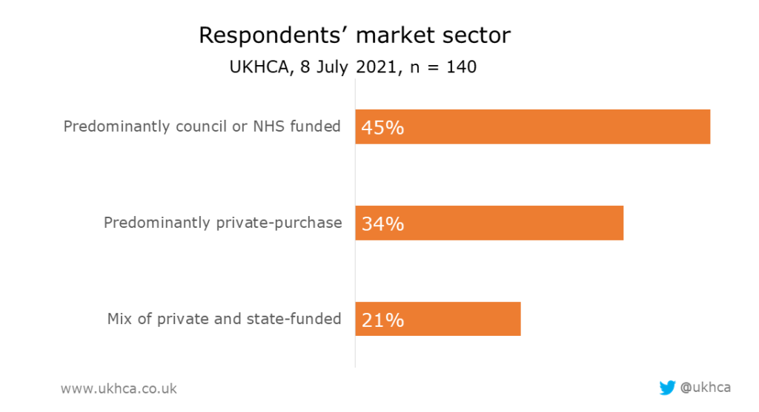
The magnitude of the shortage of staff in the healthcare can be easily observed in the survey results:
In terms of retention, two-thirds of providers responded that more care workers are leaving their roles than before of pandemic and even worse, more than the employers could ever remember.(see chart below)
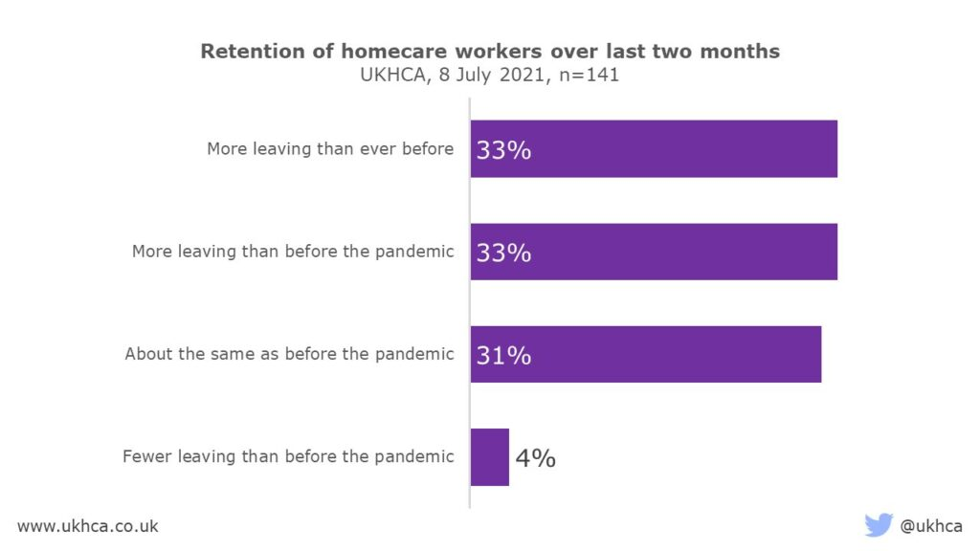
In terms of recruitment of care workers the situation is particularly worrying, 91 per cent of the respondents said that recruitment is harder now than before pandemic or the hardest it has ever been.(see chart below).
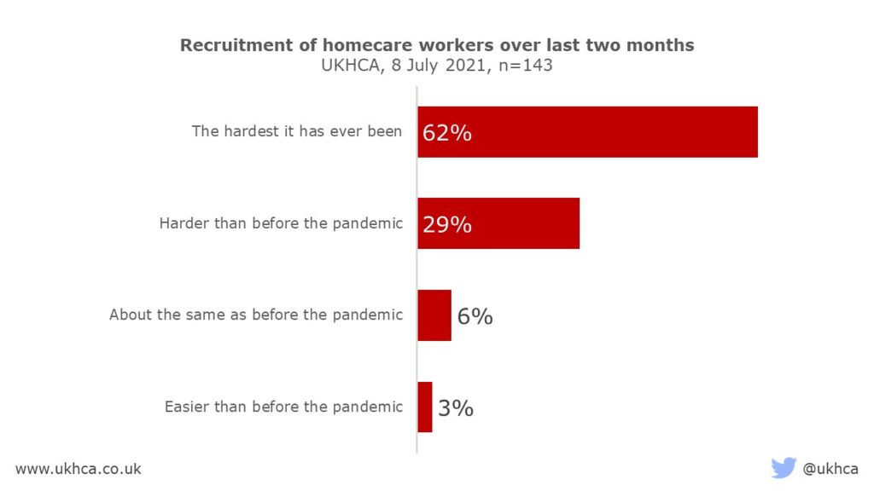
Further on, the report will show how the care agency I work for is facing of course same big issue of shortage of staff and heavy workloads. I will use both P.E.S.T.L.E. and Fishbone techniques to analyse the large extent of this problem within the agency.
2.1 P.E.S.T.L.E technique is used to understand the impact of outside factors on a location, business or organisation, in our case we use it for a business (BBC News, unknown).
I am working for a care agency as a live in carer. I will try to find out how PESTLE factors have an impact on this care agency.
Political influence:
In healthcare field the political Brexit decision has a huge impact especially in the number of staff. I know that the company which I work for is facing at this moment a big shortage of staff, as many of them were coming from EU. The rules imposed by Government for people coming from aboard to quarantine or self -isolating, to pay for Covid-19 test from their own money, has increased the shortage of care workers.
Moreover, asking for visa permit work has decreased the number of people willing to come into UK and work in healthcare system, the result is that the agency must to do a huge effort to retain as many carers as possible because the prospective to recruit new carers has dramatically. decreased.
The wage is also determined by Government and in healthcare the payment is a disproportionate one. As the agency I work for is a private one, the payment for care workers is negotiated directly with the clients but working as a live in carer is a very demanding and exhausting work and very often the payment is a disproportionate one.
Economic influence:
Due of shortage of staff many care companies were forced to close or to reduce their activity and as a conclusion there is an economic impact as they will not pay tax or they will pay less. In the case of my agency they have been forced to refuse new clients due of shortage of staff, loosing money.
Moreover, poor quality in care service due to shortage of care workers will increase the number of hospital admissions and this will involve higher expenses for the state.
Social influence:
The shortage of staff In healthcare has also a social impact as many vulnerable people will not receive a good quality care or worse, they will not receive it at all. Our customers, as stakeholders of healthcare system, ask and expect for a very high quality services, which will not be delivered if the staff is insufficient. On the other hand, the care workers, as stakeholders too, they will be impacted by working extra hours and this will end on exhausted staff.
A low level in quality in healthcare service will impact not only the users service but also their families , which may have to involve emotional and financial more than they may could afford.
Technological influence:
The impact of technology in healthcare is a very big one and is most of the time a positive one, the agency I work for is using now many software and technical devices to improve the quality of their services, to fasten them, to monitories better.
Legal influence:
At this moment all the business in healthcare ( and not only) are still struggling with acknowledging and implementing the new legislation which is different now than previous EU legislation. Brexit comes with new laws and regulations in the field and this will take quite long time to be assimilated by the healthcare companies.
Environmental influence:
The high level of pollution, especially within urban areas cause health problems to people so they will need care and treatment earlier than normal because of this.
Another environmental factor in nowadays is the Covid-19 pandemic which has affected the activity of the care agency at a very large scale.
The fight with this pandemic has involved huge expenses for care workers to overcome the travel restrictions, the cost of tests, accommodation while quarantine or self -isolation, cost of PPE, and a serious disturbance of whole agency’s activity as many carers have chosen do not work for long periods of time.
The PESTLE analyse can be concluded that all those factors affected within my care agency have high or medium but ongoing importance for it and the scope of shortage of staff is a very large one due to those external factors.

  - FISHBONE ANALYSE

One of the essential quality control instruments is the cause and effect diagram or fishbone diagram. You use it in Six Sigma during DMAIC’s “Analyze” phase. DMAIC stands for defining, measuring, analyzing, improving, and controlling. This diagram got the name, Ishikawa, because it was developed in 1960 by Japanese professor Kaoru Ishikawa. Mr. Ishikawa was a leading specialist in quality management. It is used as a very critical instrument for determining the root cause of a problem and as a problem solving method. There are many names in the Fishbone diagram, Ishikawa diagram, the Herringbone diagram, and the diagram of cause and effect. (Rodriguez, 2020).
The fishbone diagram below finds the causes/roots for the shortage of staff within the care agency which I work for.

Brexit
Covid-19
Limited freedom of movement
for careworkers
Lockdown, travel restriction
Careworkers leaved UK
Fear of infection
Covid-19 Infections

Expenses and long time for obtaining work permit
work permit

Short staff
Sickness-others than Covid infrctions
Loneliness at work
Careworkers leaving this field
Low/disproportionated payment
Very challenging and demanding work

Many don’t like/want this job
Work environment
People

Cause and effect Fishbone diagram created by the author
PESTLE and Fishbone analyses have helped therefore to identify the external and internal causes for our problem-short staff and heavy workloads- and now the decision making process to fix or at least to mitigate the problem can be thought within the organisation by the leadership.

- The impact of the shortage of staff and heavy workloads on the stakeholders.

Stakeholders are those parties that have an interest in a company and can either affect or be affected by the business. The primary stakeholders in a typical business are its investors, employees, customers, and suppliers. The increased attention on businesses social responsibility observed in the las decades, has extended the concept of stakeholders to communities, governments and different associations operating in the field. (Brock, 2021)
Stakeholders can be internal or external to a business;
- Internal stakeholders are people whose interest in a company comes through a direct relationship, such as employment, ownership, or investment.
- External stakeholders are those who do not directly work with a company but are affected somehow by the actions and outcomes of the business. Suppliers, creditors, and public groups are all considered external stakeholders
In the case of the care agency I work for, the internal stakeholders are:
- The owner of the agency
- The employees
- The clients
The external stakeholders are:
- The government, as the policy maker in the healthcare
- Others organisations and associations operating in the healthcare field.
The internal stakeholder are those affected by the shortage of staff, mainly the care workers because there is a big pressure on them in this situation but also the other staff is affected by the effort to maintain a good function of the agency. Therefore all employees are badly affected and they all will be involved in changing the strategy of the agency related to retaining and recruiting care workers for the next months or even years.
The owner of the agency is affected as the values and mission of his business is to provide high quality care to our clients(service users) and the shortage of care workers is largely impacting the quality of care. This will impact the business in a very negative way as the clients might lose the confidence in the business.
Moreover the owner is affected by refusing new clients or even not being able to maintain the existing ones due to shortage of care workers. Because of this the income of the business will be reduced.
The most affected by shortage of staff are the service users-our clients. Some of them will not benefit of the care they need, some of them will receive a low quality care due to exhausted and insufficient care workers. Also the nuclear and the extended family will be affected, as they are stakeholders too.
The government, as an external stakeholders in the healthcare, has a huge role in doing efforts to mitigate the shortage of staff in healthcare.
Government has the power to control the policies which directly impact the care providers by urgently changing its policy related to migration by adding all care workers on the Shortage Occupation List, reducing the salary threshold for immigration, review restriction of movement for those fully vaccinated, consider exemption for quarantine for live in care workers arriving in the UK from EEA and EU countries( if they provide that are vaccinated, PCR-tested and without Covid-19 symptoms. Also the government can encourage the national recruitment campaign for care workers, provide bonuses for those have been working at a time of national emergency, fund occupational health support for care workers. All these action will mitigate the problem of short staff in healthcare (Townson, 2021).
Other organisations/association involved in the healthcare can make their voices heard for making a change for the care workers condition of work, to make them better and more attractive.
There is known that in adult social care, staff are affected by the lack of value given to social care by society, so they can fight for changing the public perception about this really special and dedicated work. They can ask the government to adequately fund the social care sector so the care workers to be paid fairly for the skilled work they perform.
- Analyse of the decision-making process including the relevant legislation.

Successful decision making involves making the right choices in order to achieve the desired goal.
Planning and carrying out specific actions to correct identified problems, in our case the shortage of care workers and heavy workloads, is on the hand of the leadership management. They have to make the decision to change something within the business in order to fix or mitigate the problem they confronted with. An organizational change program may go through repeated cycles of data gathering, information sharing, and action planning and implementation. The action research often concludes with a follow-up evaluation of the implemented actions. (Hellriegel, Slocum, & Woodman, 1998, p. 592).
The management of the care agency needs to gather information about the problem of shortage of care workers from all employees, to ask them about their concerns about problem and to know their opinions on how the problems impacts them and what need to be changed to fic the problem. The gathered information must be organized in a meaningful way and shared with all the employees involved in the change effort. This can be done by keeping open meetings and making surveys. When the leadership have all the information about the problem, they can identify what change must to happen within the business. Further on the employees must be informed about the solution so they all will put their effort in order to achieve the success of the solution.
The solution which will be adopted must to fallow the Health and safety Act related to care workers work as the health and well-being of them is very important.

- .Recommendations/Alternative solutions

To identify the right solution the leadership -the owner of the agency, together with the HR manager and managers from other departments will implement the coming change and find the solution using the Burke -Litwin model and PMI model.

5.1 PMI model
The owner and the others departments managers have now to decide between 2 solutions:
- retaining of existing care workers staff or
- recruiting more care workers,
as they come as eligible solution for the problem of shortage of staff. They use PMI tool to choose the best of them.
PMI is a decision making tool developed by Dr. Edward de Bono, who originated the term lateral thinking and was a famous teacher in thinking tools related to solutions, as is the case with PMI.
PMI solution 1- retain the existent care workers and motivate them to work more

PLUS | MINUS | INTERESTING
Experienced care workers , they already know their role and have good skills | Heavy workloads | Forming a very skilled and united team, a core of care workers in the agency
Care workers already know the organisational culture | Poor work/life balance for care workers | To establish stronger relationship between care workers
Less money spend for induction trainings and specifics trainings for new care workers | Care workers might be unhappy working longer
Less human resource spent for induction trainings and specifics trainings for new care workers | Care workers will ask more money and other benefits and rewards to work longer
Customers usually prefer already known care workers, they don’ t like changes
Care workers are already into UK and have right to work

PMI solution 2- hire more care workers to overcome the shortage
PLUS | MINUS | INTERESTING
More care workers will ease the work for all care workers staff | New care workers has not good enough skills for their role | To meet new people
 | New care workers do not know the business culture, they need time to integrate and adapt | To have a bigger team
 | Good amount of money spent for recruitment and obtaining work permit/DBS, other papers needed to work in social care
 | Good amount of money spent for trainings
 | Recruitment of new carers involves a lot of time
 | Clients prefers known carers, they like continuity.

PMI analyse shows that the best decision to make is retention of existing staff and motivate them to work more, with a fairly payment for it.

5.2 Burke – Litwin model
Also known as The Performance and Change Model, developed in 1992 by two organisational change consultants, is a tool used to understand a business’s component parts and how they relate to each other in a time of change. A common reason for a change initiative failing is all areas of the business affected by the change are not accounted for. Therefore, using this model can reveal what areas of the business are affected and how they are interrelated (Accipio, unknown date).
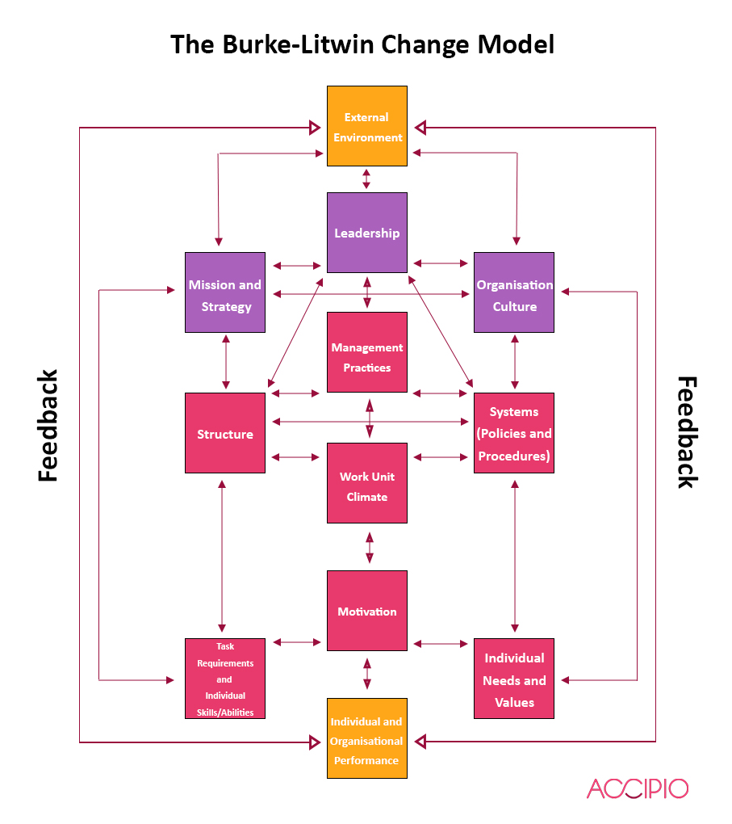
Further on, the report shows how the Burke -Litwin change model has been used by the leadership, through its factors.
- The external factors.
- The strategic factors, which include organizational culture.
- The operating factors
- The individual factors

The external factors which recently impacted the short number of carers are Brexit and Covid-19 Pandemic. To be able to go further with their business, the care agency must change its strategies in some aspects. They must change something within their strategic (transformational) factors, the operational (transactional) factors and the individual factors having in mind that the outcome of the changes must be their capability to continue operate in this field and to offer care services to their customers at a high quality level.
Given the situation of short staff and heavy workloads, the care agency need to make a decision about what solution to find such that they will be sustainable furthermore on the market. Solutions could be related to the retention of the staff or related to the recruitment system, as now they have to assure a much effective strategy of retaining the existent staff or to find more persons interested to work in this field, reconsidering their recruitment strategy.
The leadership decided to adopt the first solution -retaining and improve skills of the existing care workers.
For successfully doing this, they have to communicate the change to all employees, then to implement it and then to monitories it.
The main goal of the care agency is to maintain same quality level of their service.
Moreover, they need to put in place a very good system of training for care workers, to improve their skills such that they will be able to perform their tasks in a professional way and to understand their role and their responsibilities within company.
In terms of strategic factors, they first need to announce within company about the change they want to make, through the leadership. Each department and each employee must be involved in this effort: to retain the existing care workers, such that the agency can continue to keep its customers and to offer them same high quality care. They need to be explained in a transparently way, by the leadership, about what and how external factors impact the shortage of care workers and about how this may impact the agency if no change is done; loosing clients, then loosing incomes. The employees need to know clearly their role so they can adapt rapidly and efficiently to the change and do their best to fulfil the mission of the company-providing high quality care services.
In terms of operational(transactional) factors, the change regards the structure, as it is needed to enlarge the training department to boost care workers skills. For those affected by quarantine and self-isolation government requirements, they need to offer financial support to pay the cost of those-the agency done it as a loan . Moreover they need to implement a smooth system for providing Covid-19 tests when and where required. The company need to look into and to put in place effective mechanisms allowing employees to align and accurately inform workers about free Covid-19 testing, and to give them confidence that they are supported and protected and they are part of a team. If care workers have a feeling of insecurity they might chose to leave country.
To have a high rate of staff retention the company need to pay high attention to individual factors. Increasing the payment, doing it a fairly one according with the demanding work care workers are performing, and offering a good balanced work/life condition and possibility to be promoted in the future, will create a good environment for retention. Developing their skills and abilities through proper and adapted to their need trainings will give motivation and confidence to them as they will feel able to perform their task. Moreover, leadership must to motivate care workers praising them for the good work they done, must find a system to reward the best of the care workers.

Both PMI and Burke-Litwin analyse shows that the best decision to make is retention of existing care workers and motivate them to work harder for the next months, with a proper payment for their work and the prospective of promotion in the future.
- Conclusion

The report has focused on one of the more actual problem in the healthcare-the shortage of staff and heavy workloads, analysing its scope and its impact in the workplace. The findings reveal that on the current context of Brexit and Covid-19 pandemic, a proper solution for the business operating in the healthcare is to make all efforts to retain the existing staff they have, as the option of recruit new staff appears to be more costly, time consuming and difficult in the current context.

Reference list:
Emmerson, C., Frayne, C., &Goodman, A (2007) “ Pressures in the UK Healthcare: Challenges for the NHS”, London, KKS Printing

Townson, J., (2021), “ The shortage of careworkers in homecare”, The UKHCA Blog, 8 July , Available at: Shortage of careworkers in homecare – The UKHCA Blog (Accessed: 31 August 2021)

Albert, A., (2018), “ Low pay and Brexit risks shortage of almost 400,000 care workers”, Homecare.co.uk, 26 November, Available at: https://www.homecare.co.uk/news/article.cfm/id/1602593/Low-pay-and-Brexit-risks-shortage-of-almost-400000-care-workers-by-2028, (Accessed : 31 August 2021).

BBC News, date unknown, “ Understanding critical thinking and problem solving – Critical thinking and problem solving – WBQ National: Foundation KS4 Revision – BBC Bitesize” , Available at : https://w.w.w.bbc.co.uk/bitesize/guides/zcjhfcw/revision/1, (Accessed at 31 August 2021).

Rodriguez, D., (2020), “Importance of Cause and Effect Diagram(a.k.a. Fishbone Diagram)”, Quality management, Invensislearning, 21 October 2020, Available at: Cause and Effect Diagram (Fishbone Diagram): Importance and Purpose (invensislearning.com), (Accessed : 01 September 2021).

Brock, T., (2021), “Stakeholders”, Investing essentials, Investopedia, 19 August, Available at: Stakeholder Definition (investopedia.com), (Accessed : 02 September 2021)
Hellriegel, D., Slocum, J., W., Woodman, R., W., (2001), “Organizational Behaviour”, Vol.1, South-Western College Pub., Cornell University.

Accipio, date unknown, “Burke-Litwin-The Performance and Change Model” , Change management, Accipio, Available at: Burke-Litwin: The Performance and Change Model (accipio.com), (Accessed : 02 September 2021)

Appendix

Homework week 4

Activity 2
Case study Syed’s business opportunity

SWOT Analysis
STRENGTHS  - Very good skilled workforce  - Uniqueness of products(quite different to others from shops)  - Good marketing  - Ethical  - Aware of social factors(TRENDS) in the market: he very quickly introduced the new baby horse puppet when market asked for it  - Good wage for employees-not only basic salary but also a profit share | WEAKNESSSES  - Rely on only one supplier for raw materials  - Quite a new and small business-3 years old  - Heavy dependence between employess (as he need very skilled ones)
OPPORTUNITIES  - New stores willing to sell his products  - An enquiry from a turist to export quantities  - Good relationship with local market, enabling him to extend the number of store selling his products  - Selling to Muhammad  - Good relation with his employees which can bring more clients through a very good customers care | THREATS  - He can fail to product puppets any moment because of his sole supplier  - Shortage in workforce(leaving or sickness or simply not available on the work market) at any moment, as they need to be very skilled.

Activity 3

Based on SWOT analysis, I will not recommend Syed to sell to Muhammad. There are a large number of strengths which overcome the number of weaknesses and also he has very good and promising opportunities. At the first sight selling might sounds good but long term is not a good idea. The money could be gone quickly and nobody can guarantee an endless employment.
I will advise him to urgently find at least another 2 suppliers for raw materials, even so he will pay more for materials he can have continuity of manufacturing and in time he can negotiate a better price with suppliers.
Furthermore, as his workforce should be a very skilled one, I will advise him to hire more few people and to organize for them as soon as possible a very good training, such that the continuity of production to be assured.
Meanwhile he should contact all stores in his area and offer them his products for selling and of course to start as soon as possible the legal procedures for exporting his products through that interested tourist.

Activity 1
P.E.S.T.L.E.
I am working for a care company as a livein carer. I will try to find out how PESTLE factors may have an impact on healthcare.
Political:
In healthcare field I think the political Brexit decision has a huge impacts especially in the number of staff. I know that the company which I work for is facing at this moment a big shortage of staff. The rules imposed by Government for people coming from aboard to quarantine or self isolating increased the shortage of care workers.
Moreover, asking for visa permit work will decrease the number of people willing to come into UK and work in care system and NHS.
The wage is also determined by Government and in healthcare it is a low one.
The whole health system also depends on how well is funded by the Government.
Social
The shortage of staff In healthcare has also a social impact as many vulnerable people won’t receive a good quality care or worse, they won’t receive it at all. Our customers, as stakeholders of healthcare system, ask for a very high quality services, which will not be delivered if the staff is insufficient. On the other hand, the care workers, as stakeholders too, they will be impacted by working extra hours and this will end on exhausted staff
In the same time due of insufficient time, the staff will not get enough training and this will have also a huge impact on quality of services.

Legal
At this moment all the business in healthcare ( and not only) are still struggling with acknowledging and implementing the new legislation which is different now than previous EU legislation. Brexit comes with new regulation and this will take quite long time to be assimilated by the healthcare companies.
Economic
Due of shortage of staff many care companies were forced to close or to reduce their activity and as a conclusion there is an economic impact as they won’t pay tax or they will pay less.
Technological
The impact of technology in healthcare is a very big one and is most of the time a positive one, the care companies for example are using now many software and technical devices to improve the quality of their services, to fasten them, to monitories better.

Activity 2
Internal factors:
Pricing
Knowledge of team members
Product quality
People and skills (team members)

External factors:
Society, culture and politics
Competitor activity
Value for money- I am not very sure on it
Economic climate
Legislation
Technological change

Home work week 6

Burke-Litwin Change Model
Consider the issue/problem you are focusing on your report and discuss the decisions and solutions linked to:
- The external factors.
- The strategic factors, which include organizational culture.
- The operating factors
- The individual factors

Short staff and heavy workloads.
Staff shortages are hugely widespread in healthcare and it is already a deep and chronic issue. Obviously the shortage of staff has as consequence a heavy workloads on healthcare workers, which hugely impact the quality of care.
Currently, the care providers are struggling to cover the demand for care workers, either in public or private sector. The agency which I work for is facing of course the same problem.

The external factors which recently impacted the short number of carers are Brexit and Covid-19 Pandemic. Businesses operating in this field are now hardly trying to find out how they can minimise the adverse effects meaning less persons willing to work as carers and less persons able to come into UK for working in care.

In order to be able to go further with their business, care agency and companies must change their strategies in some aspects. They must change something within their strategic (transformational) factors, the operational (transactional) factors and the individual factors having in mind that the outcome of the changes must be their capability to continue operate in this field and to offer care services to their customers at a high quality level.
Given the situation of short staff and heavy workloads, the companies need to made a decision about what to solution to find such that they will be sustainable furthermore on the market. Solutions could be be related to the retention of the staff or related to the recruitment system, ???????????as now they have to assure a much effective strategy of retaining the existent staff and finding more persons interested to work in this field, reconsidering their recruitment strategy.
…pros and cons
The leadership decided to chose first solution---retain and improve the existing employees.
How they will do this ? they need to do some change. They have to communicate the change, then to implement it and then to monitories it
What is the expectation ? to maintain same quality level of their service.
Moreover, they need to put in place a very good system of training for care workers, to improve their skills such that they will be able to perform their tasks in a professional way and to understand their role and their responsibilities within company.
In terms of strategic factors, which play a very important role when changes are required, they first need to announce within company about the change they want to make, through the leadership. Each department and each employee must be involved in this effort: to retain care workers and to extend their number, such that the company can continue to keep its customers and to offer them same high quality care. They must need to know that this is the goal. They need to be explained in a transparently way, by leadership, about what and how external factors impact the shortage of care workers and about how this may impact the company if no change is done. As providing care is the activity of the company, shortage of care workers will reduce the number of customers and as a consequence the turnover so even the existence of the company might be put on risk. Moreover, heavy workloads will impact the quality of care and if customers will be unsatisfied with care service they might move out to other care providers. Each lost customer is a losing for the company. The employees need to know clearly their role so they can adapt rapidly and efficiently to the change and do their best to fulfil the mission of the company-providing high quality care services.
Doing that, the organizational culture of the company will be set for achieving the goal and to work effectively to adapt to changes and to fallow the norms and the values of the company.
In terms of operational(transactional) factors, the change regards the structure, as it is needed to enlarge the HR department and in the same time to refresh their training. As before Brexit the main basin of care workers have been EU and South Africa, now they need to be trained to look into different direction-UK. For those still willing to come from EU they need to be informed about the new legally requirement for work permits and visa. Existing EU and NON EU workers need to be informed by managers how they can secure they right to work in UK and they need receive guidance and support for this. For those affected by quarantine and self-isolation government requirements, they need to offer financial support to pay the cost of those (my agency done it as a loan ). Moreover they need to implement a smooth system for providing Covid-19 tests when and where required. The company need to look into and to put in place effective mechanisms allowing employees to align and accurately inform workers about new immigration system, about free testing, and to give them confidence that they are supported and protected and they are part of a team. If care workers have a feeling of insecurity they might chose to leave country.
The managers must look into communication channels between departments and where they identify barriers to communication they need to overcome those such that communication to be effective and feedback from employees can be heard. As many care workers are working remotely into customer’s houses, company must pay a special attention at online communication so the IT departments need to change and adapt for this, they need to invest in good quality electronic devices to enable carers to see customer’s profile and care plan online, to do their reports fast and accurate, to communicate with managers easy and effective.
Developing recruitment system inside UK means to change the way how they advertise those jobs ( could be done through radio, TV, magazines, job websites) and also they need to look into apprenticeships, professional conversion, better salary and other benefits like pension, medical insurance, childcare cost, which could make this work more attractive people already living into UK.
To have a high rate of staff retention the company need to pay high attention to individual factors. Increasing the payment or anyway offer a fair one according with their work and offering a good balanced work/life condition and possibility to be promoted to employees will create a good environment for retention. Developing their skills and abilities through proper and adapted to their need trainings will give motivation and confidence to them as they will feel able to perform their task. Moreover, leadership must to motivate care workers praising them for the good work they done, must find a system to reward the best of the care workers , must show empathy and understanding when they need it.

