On the job training
Understanding Employee Engagement

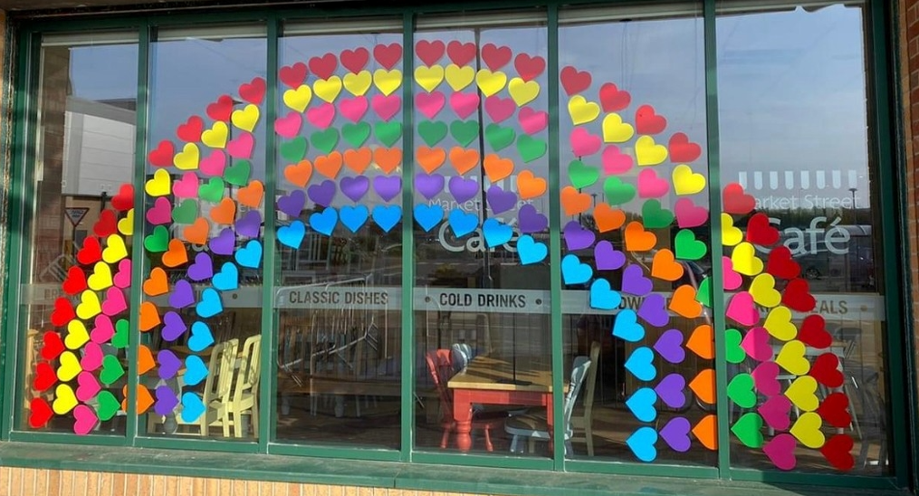

For the past five years I have worked for Morrisons Haverfordwest which is part of a large corporate company. In January 2022 I changed workplace to work in CWM Environmental, a small private company in Carmarthen.

Within Morrisons there was a structured approach to colleague engagement which was built into their core values ‘Teamwork, We Care and Listening and Responding’.

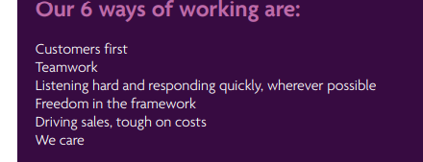

Morrisons annual performance reviews are set out to meet the objectives of their six ways of working, having a two-way conversation with each colleague to clarify understanding and gain the colleagues perspective of their added value with next steps to improve.
Morrisons have a monthly forum (Your Say) for colleagues to attend (one from each department) within the store, chaired by the Store Manager and People Manager, there is a further Quarterly forum for one representative from each store to attend within the regional group, chaired by the Regional Manager and Regional People Manager and an annual forum for one representative from each region to attend chaired by leaders of the business. The forums are a great way of listening to colleagues and responding, ‘you said, we did’.
As well as having the (Your Say) forum meetings as described above Morrisons conducts an annual anonymous survey using The Utrecht Work Engagement Scale (UWES) technique (CIPD, 2021).
Morrisons have an intranet, all colleagues have their own individual log on with company email included. The intranet comprises of, handbook, policies, communication updates, wellbeing site, religious calendars. All colleagues can access the intranet at any time with specific provisions instore for colleague unable to access on a mobile device or personal PC/laptop, this makes it inclusive for all.
Weekly bulletin/newsletters are sent weekly directly to colleagues’ emails for transparent communication regarding the business, what they are working towards, sharing the vision, detailing how the past week has gone and celebrating colleague recognition. The CEO records a video which is included within the bulletin.
There is a dedicated Employee Assistance Programme fully accessible for all colleagues provided by an external provider which includes all aspects of wellbeing and financial advice, this well received as previous large retailer did not provide this. Other benefits include a structured PayScale for hourly paid colleagues, however salaried managers banding is so vast this can lead to frustrations which impact on engagement when comparing salaries in the organisation.
Morrisons recognise the need to be diverse and celebrate all religious and cultural events throughout the year. Posters and gifts are provided for all colleagues as a way of thanking them.
During the pandemic, Morrisons was quick to respond with twice daily communication in different forms, video conference, recorded messages, emails and bulletins detailing the needs of the business and recognising the frustrations of all key working colleagues. To recognise and thank colleagues all colleagues were provided with new sweatshirts/t-shirts and key worker pin badges. These were well received, and all colleagues wore them with pride.
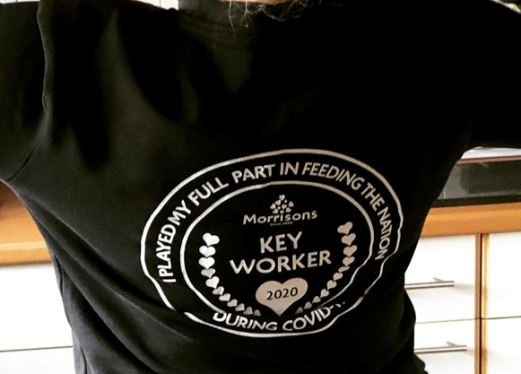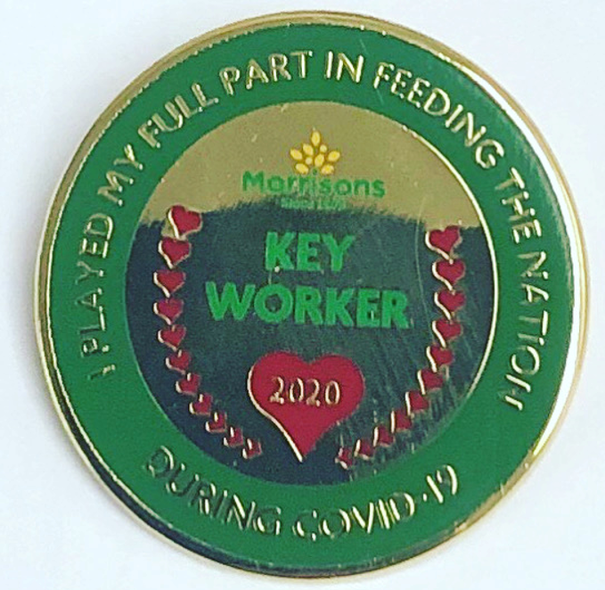

My conclusion regarding Morrisons is that they have all the structure in place regarding employee engagement, however I feel that they need to take more of a holistic approach and understand the feelings of people as colleagues are more aware of their what they want which align to the 10 Essential Pillars (Officevibe, (2022). Line managers do not fully engage their colleagues, living the values and promoting forums and performance reviews. Line Managers do not see the benefit; therefore, it can be forced which defeats the object of engagement. It is difficult to train behaviour and holistic approaches, this needs to be inbuilt in a natural way. My suggestion would be to promote the values within the Job description and emphasise these during the recruitment process, maybe its time to employ for attitude? Current trend state that employee engagement is more important with well-being high focus (Quantum, 2021).

Morrisons Handbook is aesthetically pleasing with an engaging flow. The Handbook was revised in 2021 with a new layout, it is more interactive and clearer. The new handbook feels and looks totally different to the previous edition; however, the content is the same. The fonts have been changed to softer print with bright colours differentiating each section. It is easily accessible, available within the intranet, no hard copies are printed out. This is a change from when I started in 2016, where all communications were paper based in black and white font.
I believe that Morrisons focusses on topics that matter to colleagues, especially focussing on building a dedicated wellbeing site within the intranet, included in this is also a diversity and cultural calendar which reenforces their core value that everyone is welcome.
Bulletins are sent weekly and although these are done in a professional style with video messages from the Leadership team, I believe that the video messages are too long, they are sometimes five to seven minutes in length and do not appeal to every colleague. Video messages need to be shorter and to the point to capture a wider audience.
There is more response to the private colleague Facebook site where listening and responding by leaders of the business is prevalent, it is more interactive, and colleagues feel like they have been listened to.
Within my new employment at CWM Environmental there is no intranet system, all communication is paper based and very old fashioned. The handbook comprises of policies only with no core values or engagement mentioned. When speaking to managers and colleagues there is a clear want for a more inclusive way of working. There are no performance reviews or one-to-one conversations, so colleagues haven’t been given ay objectives and the team feels totally disconnected. The hierarchy of managers is dictatory and after speaking with the managers gaining feedback, the need for change is clearly visible. I have taken steps to include the managers, linking them to the senior team by making use of the ‘one drive’ sharing job descriptions, handbook, and policies and procedures. The next step is to enable all colleagues with a personal log in and to make a colleague platform.

I have a new direct Line Manager that has not got much experience with colleague engagement. It is clear to see that the level of training provided to the section managers is lacking. Have planned in training regarding engagement for all managers in the next 4 weeks and have asked for feedback regarding what training they would like to see. Initial observations are that there is no clear training programme or guidance for colleague engagement. There is no reward and recognition. On my first week, I held a poetry at work competition where the response was great, I let the colleagues decide on which one they thought was best then rewarded the colleague. It is very small steps in the right direction starting off with effective communication channels.
For people analytics a forum meeting has been pre-arranged where I will firstly gain an understanding of what the colleagues want and set out my vision for the company and that employee participation is key to moving the business forward, emphasising teamwork CIPD, 2022).

References

CIPD (2021), Employee Engagement – Definitions, measures, and outcomes. Available at: https://www.cipd.co.uk/Images/employee-engagement-discussion-report_tcm18-89598.pdf (Accessed on 8th January 2022).

CIPD (2022), The People Profession map. Available at: https://peopleprofession.cipd.org/profession-map (Accessed on 6th February 2022).

Officevibe (2022), 10 Essential pillars of Employee Engagement. Available at: https://moodle.uwtsd.ac.uk/pluginfile.php/255714/mod_resource/content/1/10-essential-pillars-of-employee-engagement.pdf (Accessed on 8th January 2022).

Quantum Workplace (2021), Top 6 Trends In 2021. Available at: https://www.quantumworkplace.com/future-of-work/employee-engagement-trends (Accessed on 30th January 2022).

