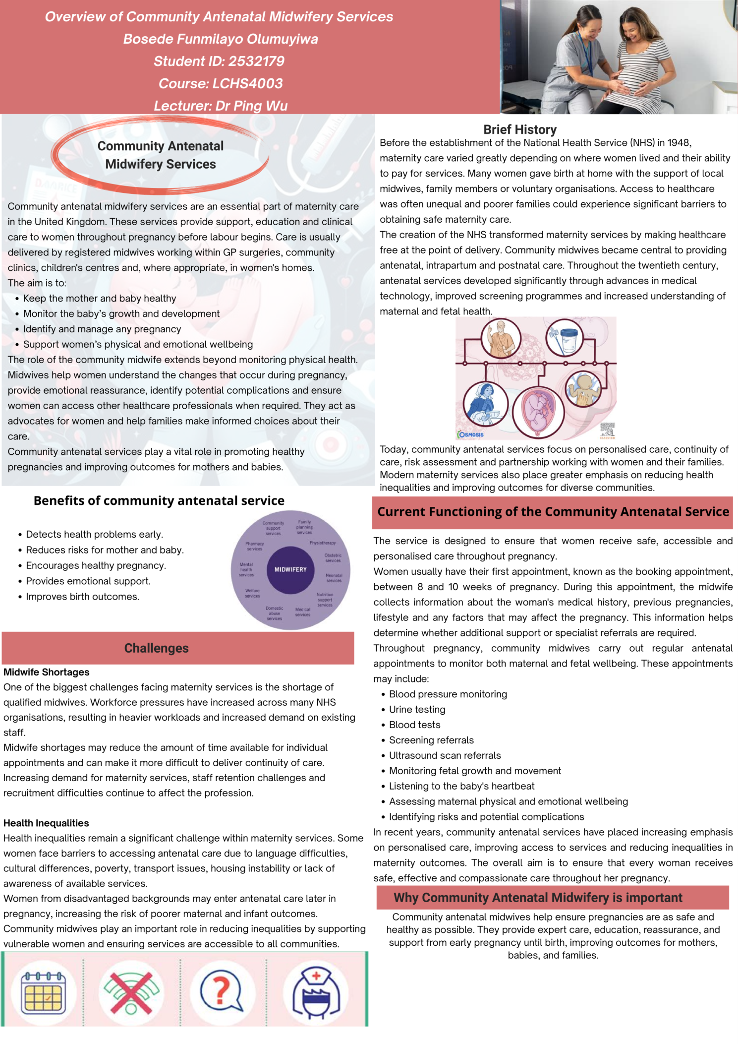



TASK 2 A 600 -WORD ESSAY
BOSEDE FUNMILAYO OLUMUYIWA
STUDENT ID NO 2532179
LCHS4003
LECTURE NAME Dr Ping Wu

Community Mental Health Services
Introduction
Community mental health services are social care services that provide support, and rehabilitation for people experiencing mental health problems while allowing them to live in their own homes and communities.
Community mental health services were developed to provide support and treatment for people with mental health problems within their local communities rather than in large psychiatric hospitals or asylums.
These services aim to improve mental wellbeing, promote independence, and reduce the need for long term hospital admissions.
The origins of community mental health services can be traced back to the 19th and early 20th centuries when people with mental illnesses were often cared for in large psychiatric hospitals or asylums. These institutions were frequently overcrowded and focused on containment than treatment
In the United Kingdom, major changes began after the introduction of the National Health service [NHS] in 1948.
During the 1960s and 1970s, concerns about the institutional care led to the policy of deinstitutionalisation, which encouraged the movement of people from psychiatric hospitals into community settings.
The publication of the mental Health Act 1983 and later the National service Framework for Mental Health [1999] further strengthened community-based care. The Care Act 2014 also promoted person centred care, independence, and safeguarding for vulnerable adults.
Today, community mental health services provide a range of support based on the individual needs of service users Community mental Health teams [CMHTs] may include
Psychiatrists, Mental health nurses, social workers, Psychologists, Occupational therapists, Support workers. These teams can assess mental health needs develop care plans, provide treatment and monitor a person`s progress. Support may include medication management, help with daily living and support to manage physical health problems.
Services also work with families, carers, GPs and other organisations to provide more coordinated care, NHS England states that modern community Mental health services aim to provide personalised, trauma informed and integrated support, including
- Counselling and psychological therapies
- Medication management
- Crisis intervention services
- Rehabilitation programmes Support with housing, education, and employment
- Family and carer support
Many services are delivered through community Mental Health Teams [CMHTs], crisis resolution teams, and early intervention services.
EVALUATION OF COMMUNITY MENTAL HEALTH SERVICES
Community mental health services offer several advantages. They allow individuals to receive care in familiar surroundings, maintain family relationships, and remain involved in education, work, and social activities. This approach promotes associated with long-term hospitalization.
However, these services also face challenges. Many areas experience staff shortages, long waiting times, users may struggle to access specialist support quickly, particularly during periods of crisis. Inconsistent service provision across different regions can also affect the quality of care received.
Despite these challenges, community mental health services are generally considered more person-centred and cost-effective than long-term institutional care.
Significance in Enhancing Quality of Life
Community mental health services significantly improve the quality of life of service users by:
- Promoting independence and self-management.
- Supporting social inclusion and reducing isolation.
- Helping individuals remain in employment or education.
- Providing early intervention to prevent deterioration.
- Supporting recovery and resilience.
- Encouraging service users to participate in decisions about their communities.
By delivering care closer to home, these services help individuals maintain dignity, autonomy, and meaningful relationships within their communities.
Therefore, effective services require sufficient funding, skilled staff and good partnerships working. Service users should also be involved in decisions about their care so that support is person-centred and respects their choices
In conclusion, community mental health services developed from the historical movement away from long-team institutional care towards treatment and support in the community. Today, they provide important multidisciplinary and person-centred care. Although challenges remain, these services can improve independence, recovery, social participation and overall quality of life for people experiencing mental health problems.
References
Bowl, R, [1996] Legislating for user involvement in the United Kingdom: mantal health services and the NHS and community care ACT 1990; International journal of social psychiatry, 42[3], pp. 165-180.
Commins, l [2020] mental health services and community care; A Critical History. Bristol; Policy Pess.
NHS England [2026a] community mental health services. Available at; NHS England community mental heath services [Accessed: 18 July 2026].
NHS England [2026b] commissioner guidance for adult community mental health rehabilitation services [Accessed: 18 July 2026].
Sayce, L, Craig, T.K.J. and Boardman, A. P. [1991] The development of community mental health centres in the UK: social psychiatry and psychiatric Epidemiology, 26[1], pp.14-20.
Department of Health [2011] No health without mental Health; A Cross-Government mental health outcomes strategy for people of all Ages. London; Department of Health.

