Name: Madison jones
Module: Ways of perceiving
Module code: ADDA4023/C
Lecture: Chris Harrendence
Collaboration between artist and cinema

My essay will be looking at the work of Brian Froud and how it transformed from paper to screen. I will be exploring his art and will heavily be making references to his contributions to the movie The Dark Crystal.
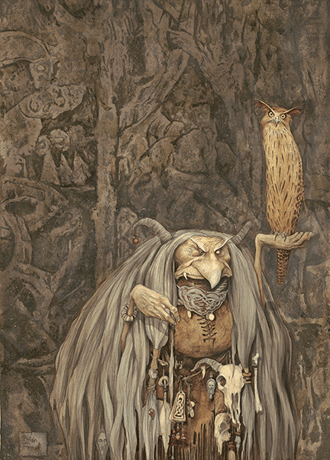
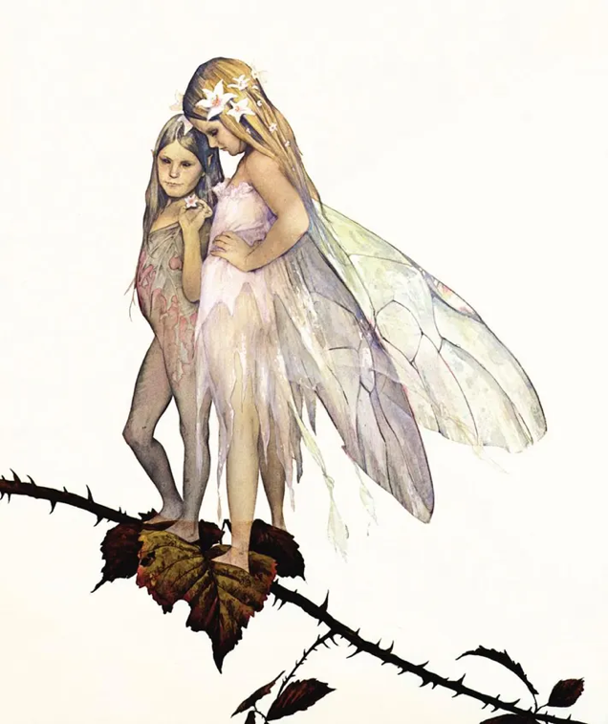
Fraud is an artist which is deep rooted into traditional drawing and paintings, He is renowned for his fantasy drawings, creating pieces with fine details and beautiful line work. using a variety of mediums; Paint, ink, pencil, charcoal or even natural materials such as dirt and sand embracing the natural look of his pieces. Froud process often includes draws from life, using references from nature to create his creatures which is why they adapt such earthy tones and shapes, with bumps and groves you would see amongst a forest with elements of rocks, leaves, bark and so on. His iconic style is what fuels the designs behind a number of movies, tow of the most popular being The labyrinth and The Dark Crystal.
(Brian Froud’s art)
Frouds style is so distinct that it has developed its own name, known as ‘Froudian’. The Froudian style is mostly shared within his family (wife and son) the name is used to reference Froud’s defining characteristic in his art, being his painterly and magical look often including fae creatures with distinct features, be it soft round faces or hash jawlines. The style developed it name through the making of the book series Faeries, the book gained widespread popularity and has been known as a ‘Cultural phenomenon’ which in turn his art also gained popularity.
Although Brian Fraud is known for creating beautifully crafted characters, due to his ability of including traits to make them feel real he also uses his imagination to build a world for them, which in turn makes the creatures feel even more alive by giving them a place they can reside, a clear example of this is The Dark Crystal, although not every detail made it into the movie Brian fraud orchestrated a whole world filled with details, where the audience could emotionally connect to, despite everything being new and different from our reality. looking at the content you can tell how fraud and the team surrounding the dark crystal payed attention to how different creatures would adapt to the environment and what resources they would uses to build towns and so on. As well as adding religions, hierarchy and customs for individual colonises to make the world feel more diverse and larger.
The company responsible for bringing frauds work to life on screen is the creature shop, ‘the creature shop is a character company, building big screen stars in latex and metal’ (no string attached the inside story, 1997, p9) the company is based in London, with offices and workshops to make inanimate objects come to life. The company was developed through the production of The Dark Crystal which was Jim Henson first ever movie, The Dark Crystal is a very unique movie full of imagination and craftsmanship. Henderson spelt a long period of time trying to picture what The Dark Crystal world would look like until he saw Brian Froud book The Land Of The Froud.
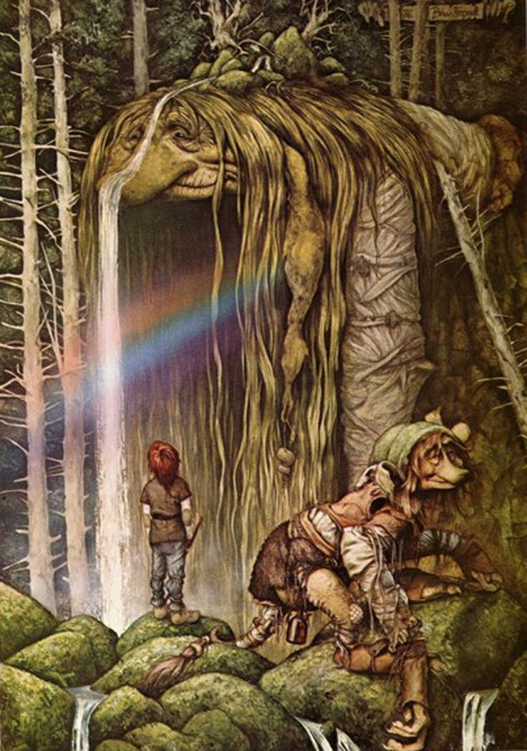
(Brian Froud’s art)

Henson was captivated by the drawing and immediately shared his vision with Froud, who gladly agreed to work with he Henson, which started his position of concept design in the creature shop. When developing his designs for the movie he took inspiration from folk traditions, philosophies and art, also using primary sources as simple as the carrion eating birds he saw around his home, giving the skekis there noticeable birdlike accents. Brian Frouds process is interesting, as Brian Froud stated ‘‘I’ll just scribble, and it’s just like looking at nature and trying to see a face in the bark of a tree’ (The Crystal Calls Making The Dark Crystal, Brian Froud, 38:11) resulting in his Lose style.
The process of Turing Brian’s art into something 3D is truly remarkable, as Toby states ‘it starts with Brian’s line, the pencil line that he draws on a page, the curve that he’ll use’ (The Crystal Calls Making The Dark Crystal, Toby, 36:54) showing how Frouds art is truly the base line of the puppet’s creation. Brian Froud goal is to encapsulate life within his drawing, he believes every line he makes has a meaning, the lines are what make up the characters, however due to Brian lose style the team in charge of turning the sketches into sculptures struggled to keep Brian natural forms trying to clean the designs up, Froud explains ‘once they understood it’s meant to be asymmetrical, it’s meant to be growing and organic…it becomes simple and everything falls into place’ (The Crystal Calls Making The Dark Crystal, Brian Froud, 41:19) once the team fully embraced Frouds style, embracing every line as a fold or crease his art finally started to show through the final products and could be easily recognised as the Froudian style.
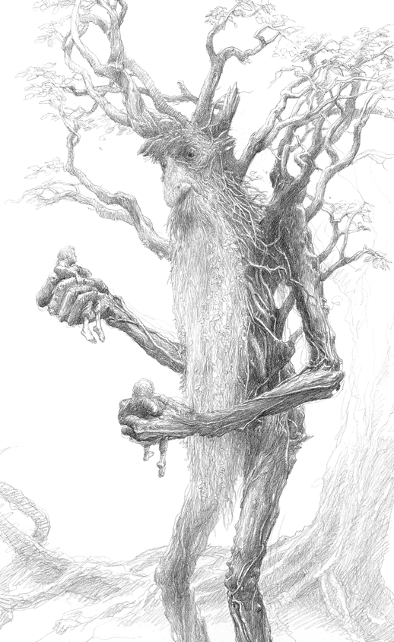
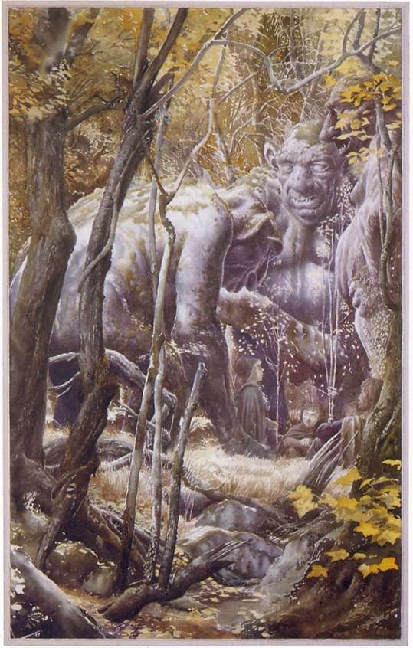
Brian Froud isn’t single-handedly the only artist where their art has had an impact in the cinematic world, there are numerous talented artist that are behind the designs showed on screen, one artist being Allan Lee who is a well known illustrator, renowned for his concept designs particularly for the movies Peter Jackson, Lord Of The Rings and The Hobbit. He designed landscapes and creatures, having a heavy influenced on the visual outcome of these movies. Lee’s style also follows the fantasy feel that Brian Frouds has, having a realistic style with detailed line work or a painterly look while including mythical themes.
(Allan Lee’s art)
In fact Brian Froud and Allan Lee have partnered up on projects before, such as for the book Faeries, the book included illustrations of fae creatures accompanied by narratives that explore the magical world, which shows the artists ability to create well rounded characters and worlds with purpose, using existing sources such as myths and legends and expanding on the ideas to create something beautiful. The book shows both Froud’s and Lee’s skill in world building having a detailed narrative with purpose for each drawing they do.
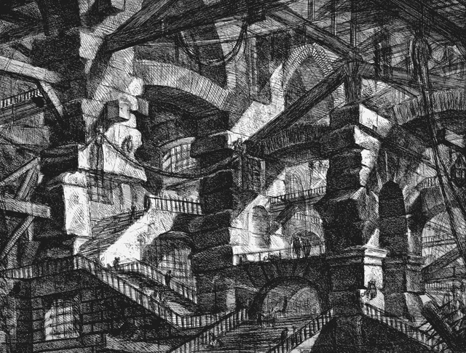
Froud’s designs were also used in the Labyrinth (another Jim Henderson movie) however sets such as the impossible staircase which were heavily inspired by M.C. Escher’s work, but it also has similarities to Giovanni Battista Piranesi, an architect during mid 18th century, who did a series of pieces coincidentally called Labyrinth , the series were surreal like drawing based of his dreams what have a similar feel to the staircase in the movie labyrinth, as both have a complex structures which create the feel of being lost or trapped within a maze. I feel there is a possibility that Piranesi work may just have a slight connection with the movie Labyrinth, as artists work can unknowingly inspire people and projects no matter how vague, as art has the ability to spread out and adapt many forms, which is apart of what we are exploring with Brian Froud.
(Giovanni Battista Piranesi’s art)

Froud work has the ability inspire, due to it his work not being limited to an art form, capturing a large amount of people with unique interests be it illustration, concept design, cinema or sculpting, his artwork has adapted to all these mediums. Through this essay it’s apparent the Fraudian style is the key thing that draw people in, his fantasy worlds filled with life inspiring a hand full of artist, known names being Allan Lee, Tony DiTerlizzi,and William Joyce.
In conclusion, Brian Froud’s work represents a unique blend of artistic skill and imagination, with a lasting impact on both the world of folklore and the cinema. His distinct style commemorating nature, and paying attention to detail, brings his creations to life, making them feel tangible and real, even in a fabricated world. his contributions to films like The Dark Crystal and others alike, not only shaped the visual language of these iconic films but also contributed to the evolution of fantasy cinema, due to the movie's uniqueness. The transformation of his art from paper to screen, made possible by the collaboration with the Creature Shop, which is a statement showing the weight of craftsmanship and creativity. Froud’s influence extends beyond his own work, indirectly influencing the worlds of mythology and surrealism as so many artists and creatives alike brake down his art for insight. In the end, his creations are more than just characters they are living, breathing entities that continue to enchant audiences and inspire future generations of artists.

Refrances list
Society of Illustrators. (2023). The Frouds - Society of Illustrators. [online] Available at: https://societyillustrators.org/award-winners/frouds/.
‌Glasgow.ac.uk. (2022). Brian Froud – Centre for Fantasy and the Fantastic. [online] Available at: https://fantasy.glasgow.ac.uk/index.php/tag/brian-froud/.
JennyDetroit (2025). Jennifer M. Baldwin. [online] Jennifer M. Baldwin. Available at: https://jmbaldwinwriter.com [Accessed 29 Apr. 2025].
‌Buckmaster, L. (2016). Why Labyrinth is so memorable. [online] Bbc.co.uk. Available at: https://www.bbc.co.uk/culture/article/20160621-why-labyrinth-is-so-memorable.
‌Fabulous Realms. (2011). The Art of Alan Lee. [online] Available at: https://ashsilverlock.wordpress.com/2011/12/15/the-art-of-alan-lee/ [Accessed 29 Apr. 2025].

‌Miller, L.M. (2018). Alan Lee: Artist Of Middle-Earth. [online] Enchanted Living Magazine. Available at: https://enchantedlivingmagazine.com/alan-lee-artist-of-middle-earth/.

‌Brooks, K. (2018). M.C. Escher’s ‘Relativity’. [online] BYU Museum of Art. Available at: https://moa.byu.edu/m-c-eschers-relativity/.

Darran Anderson (2018). Giovanni Battista Piranesi (1720-1778). [online] Architectural Review. Available at: https://www.architectural-review.com/essays/reputations/giovanni-battista-piranesi-1720-1778.

‌The (2023). Piranesi, Borges, and the Labyrinths of Time. [online] The MIT Press Reader. Available at: https://thereader.mitpress.mit.edu/piranesi-borges-and-the-labyrinths-of-time/ [Accessed 29 Apr. 2025].

Making The Dark Crystal: Age of Resistance (2019) [Film] Directed by: Randall Lobb, Available on: Netflix

Rawson, P. (1969). Drawing. [book] London Oxford University Press.
‌carol Brown. (1992). The Cutting Edge. [book] EGA, Brighton
Brazell, D. and Davies, J. (2011). Making great illustration. London: A & C Black

Froud, B., Larkin, D. and Lee, A. (2002). Faeries. New York H.N. Abrams.

Brian, F. (1998). Good Faeries. Simon Schuster.

Froud, B. (2003). The World of the Dark Crystal. Harry N. Abrams.

Bacon, M. (1997). No Strings Attached. MacMillan Publishing Company.
‌

‌

‌

‌
.
‌

‌

