

Describe a learning event which has happened during your recent school experience. Reflect upon what took place, connecting events to theories or learning and teaching. Make recommendations about how you could improve your own practice in the light of this. Produce a poster to illustrate how you would develop the elements of an effective learning environment.
Word count:

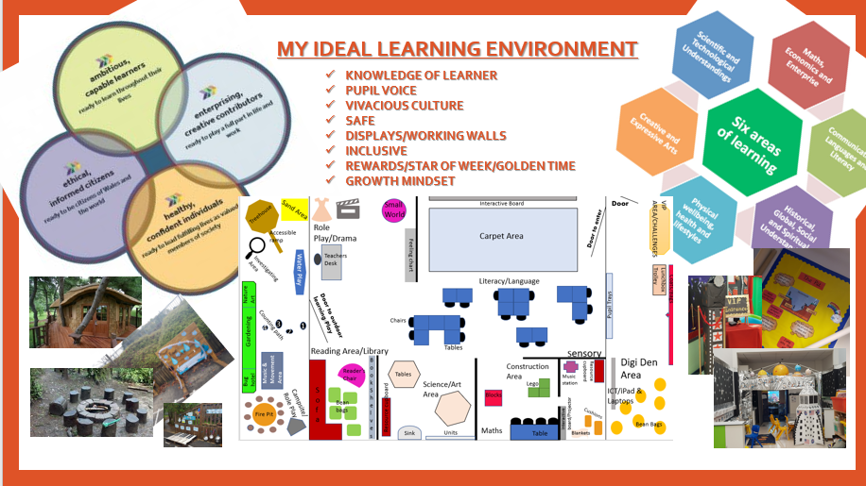

There are many philosophers such as Lev Vygotsky, Maria Montessori and Jean Piaget which strike a unique input into children’s learning today. However, no matter whether some of their theories vary or whether they are in agreement, there was a main belief amongst them to ensure they were ‘educating the young child’ (Gray, Mcblain, 2012). Learning is a vigorous process which continues throughout a persons’ life and more often than not it is believed that the acquisition of knowledge is risen from the help of teachers. Locke (1632 – 1704), was an early philosopher to identify this stating knowledge is attained through ‘experience, repetition, training and virtue’ (Gray & Mcblain, 2012). Making it vitally important that teachers recognise good practice, they observe and reflect on strategies implemented. As a result, it allows them to link their practice in with relevant theories to improve the learning that takes place in their classrooms. This research includes relevant factors such as; outdoor learning, questioning and exploratory talk (). However, stating this, one vast influence in the education of wales lately has been down to a singular man named Graham Donaldson. After he released his Successful Futures Report (2015) many pioneer schools have taken the role on to implement his theory and ideas into their schools. Though, in order to do that successfully the teaching profession need to ensure they are fully equipped of how children learn best. The aim of this essay will be to reflect skilfully on a learning event I recently had the chance to observe in a mainstream school. I will be sure to link in with relevant theory and literature and entail how I would hope to make this practice better or equally good in the future.
The learning event observed took place in an urban area and reflected English medium. It was a large primary school in South Wales which currently holds 750 students on register. The English as a foreign language (EFL) percentage was 31% and they had one ward which was classed as one of the most deprived children throughout Wales. Free school meals (FSM) were averaged at 31% and they are currently recognised as a Green support category school. The learning event was situated in a Year 2 class of 28 pupils, 5 of whom were identified with additional learning needs (ALN). Before any research was conducted, ethical issues were respected and BERA (2018) principles were adhered to. Anonymity was important to consider with all children referred to as numbers, for example ‘child 1’. I also ensured I never used the teachers or school name as it is important to keep their identity hidden and confidential. I obtained permission in the form of a letter (see appendix a) by the school to confirm that I was authorised to take pictures. All participants were also aware of the studies made and gave their consent. This all complies with the BERA (2018, p4) legislation and highlights one of the main ethical principles ‘all social science should respect privacy, autonomy, diversity, values and dignity of individuals, groups and communities’.
Observation
The nature of the learning event I observed was mathematics and numeracy. It included both the indoor and outdoor learning environment and was based around ‘more than and less than’ and engaged in the introduction of ‘time’. Though, to kick start their learning in the morning the teacher began with a ‘1K run’ to ensure that all children were awake, motivated and ready to learn. This is a new whole school initiative that links in with promoting children’s Health and Wellbeing which is highlighted throughout the Successful Futures report by Graham Donaldson (2015). This school also held its own food and fitness policy 2015 to ensure that the initiative takes place and works accordingly. The children completed 4 laps around the tennis courts, lined up and made their way back to class. When entering the classroom, the teacher vocally informed them it was time for maths by asserting “mae’n amser mathemateg”. Some children went to get a drink of water and others sat ready in rows on the carpet. This maths session was split into 3 parts, it started with a small introduction to kick start their thinking, the second part included reflecting on their learning from the previous week and then finished with a main activity which they participated in groups of mixed ability levels. The introduction included reciting the 3x tables which they participated in as a whole class. The teacher used a visual aid of a metre ruler stick and stuck post it notes along the stick of the chosen time table (3). This helped to reinforce all the children to join in and say the 3x tables all together. After repetition, the teacher then went on to ask questions such as “What is 3x3?” varying the order and the children put their hand up ready to answer. The aim if this recital is to check if the children have embedded the 3x table and see whether it is in the long-term memory with the effect of the information being stored and processed, not forgotten.
In the next part of the lesson the teacher moved on to ‘what is 10 more than….’. The activity took place on the carpet as a whole class. The teacher used the interactive whiteboard to engage the children and structure the activity through posing a question. All children had access to mathematic resources this being; whiteboards, pens and a whiteboard rubber. First, the teacher put forward a sum of ‘what is 10 more than 13’, the teacher then allocated time for the children to work out the sum independently. Whilst the children were working out the sum, the teacher would go around the children, check their understanding and crouch down to their level. If support was needed, the teacher would help the children using previously taught methods for the type of sum given. After 2/3 minutes of allowing the children to think, process and work out their calculations. The teacher stood back up and prepared the children to finish with the signal of “Barod?... un, dau, tri”. This part of the session was a recap from the previous weeks topic of ‘number vale and place’. As the children had learnt many strategies, this allowed the teacher to see if the children had retained the methods, understood and were able to use their core structure of numbers 1 – 10. I found this part of the activity interesting as the teacher engaged with the children using a checking strategy method rather than a straightforward one-way method which was known as right or wrong.
Teacher: What strategy did you use child 1?
Child 1: I counted on in 1s
Teacher: Can you show me how you done it on your whiteboard?
Child 1: Yes (holds up whiteboard)
Teacher: What did you use to help you count 10 ones?
Child 1: I used a number line Teacher: Well done. That is method 1.
Teacher: Right, so who can tell me a second method?
Teacher: Child 2, what method did you use?
Child 2: I used the tens and units method
Teacher: What did you change?
Child 2: I crossed out 1 and put a 2. I added one more 10 the one.
Teacher: Yes, that’s right. We add 1 to make 2 and the units stay the same.
Teacher: We have one more method. What did you use, child 3?
Child 3: I done a 100 square and jumped down 1 space.
Teacher: Fantastic. That’s our 3rd and final strategy.

Teacher: Well done. That is method 1.

The teacher used effective practice to engage children to talk and think about how they got to their answer and what methods of learning they found the easiest. Figure 1 shows the conversation dialogue of the talk used between the teacher and class of children. Figure 2 shows the methods in the class discussion held.
Figure 1: A conversation dialogue of the talk used during observation between teacher and class
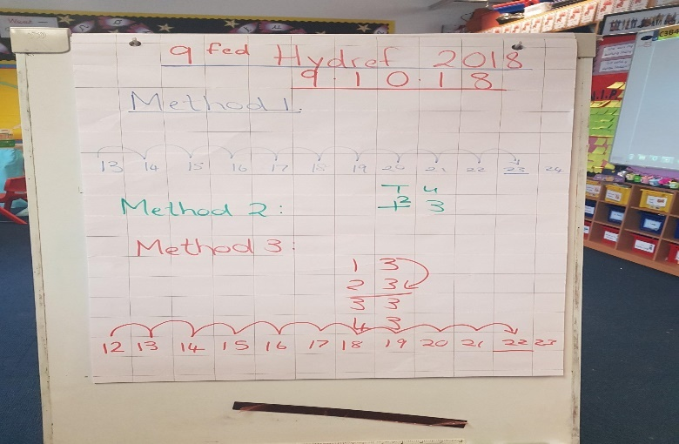

Figure 2: A picture to show the methods used by the children for ‘10 more than’

The most appropriate way of catching this kind of talk was through a transcribed method. The talk and engagement happened naturally, and it was important not to interrupt the social interaction that occurred as it may have led to the children’s attention being diverted or even being put of contributing ideas when trying to capture the moment by tape recording. It was important not to hinder the pupils thinking or participation. This method also allowed me to script exactly what was said making them reliable and easy to reflect on for the near future. However, if I had a video device to hand it would have been a more effective method for observation as it would have allowed me to capture the interaction in more detail encouraging a more tangible reflection through direct engagement. If my observation was solely based on behaviour and social engagement it would have been the key method used, but as this was not the case a correct observation was made through transcript (note taking).
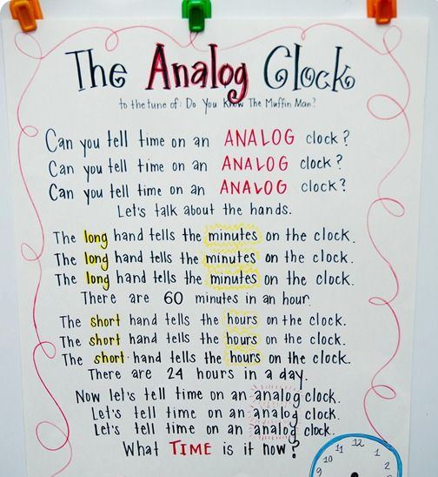

Figure 3: The Analog Clock poem to introduce time. Poem had been sent home to support the children’s ‘Flipped Learning’.

The teacher moved onto the next part of the maths session using the interactive whiteboard she introduced a new topic of ‘time’. The next task focus was on the ‘analogue clock’. This session followed on from a teaching strategy known as ‘flipped learning’ and a newly recognised teaching style called ‘the Singapore approach’. Coherently, the teacher was able to link both methods together and promote learning within the child. The teacher started the session with reading a poem called ‘the analogue clock’. This poem was sent home as part of their flipped learning task to ensure they had some recollection of how the clock worked. The teacher read through with the poem aloud with the children and repeated one instructional fact before allowing them to work in smaller groups. This being; “Remember, the long hand tells the minute of the clock and the short hand tells the hours of the clock”.

The teacher sent the groups out which were of mixed ability and planned in accordance with the skills needed to learn in the literacy and numeracy framework (2015). There were three groups; 1 gold, 1 silver and 1 bronze. The Singapore approach was implemented into this teaching practice and made the observation interesting as I had not heard of this methodology before. Therefore, it was insightful to hear and see how it worked. It is an approach that introduces a new topic weekly in maths, though, before the week starts, the teacher plans an activity; i.e. a YouTube video for the children to do at home before starting the topic on a Monday which connects to the ‘flip learning’. This allows the children to recognise and understand the subject area before the learning takes place in the classroom. The Singapore approach then follows on with a physical approach where children work independently as well as in pairs with plenty of visual resources to hand. Questioning is also effective here to embed the long-term memory. Another important theory to highlight is Jerome Bruner’s’ scaffolding model and the concrete, pictorial and abstract (CPA) philosophy. Harmoniously, Jean Piaget’s stages of development theory also sits alongside it.
The group activity I observed involved outdoor learning and was a Learning Support Assistant (LSA) led task. I watched the children pair up in 2 or 3s and become human clocks. They used appropriate resources which included a hoop (face of clock), long and short stick (hands) and chalk to draw the numbers outside.

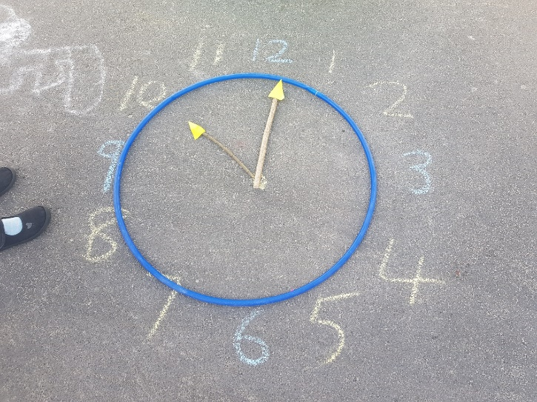
Child 1: “It is quarter to 10”
Child 2: “I put this one here”
Child 1: “That’s the longest one”
“Quarter TO 10”
“The big hands on the wrong one”
Child 2: “Am I right?”

Once the children had made their clocks the LSA briefly practised o’clock, quarter past, half past and quarter to reminding them where the hands would sit on each. I also recognised that the LSA would emphasise on tone and pitch when stating ‘past’ or ‘to’ when stating a time. The children then had an opportunity to question and test each other with several cards. Each card had a time written on it and a clock to symbolise the correct time. The children took it in turns to test each other and each time; 1 child would say a time and the other would place the correct hands on the correct time. Some dialogue and interaction is shown here:

After 5 minutes of the children testing each other the LSA prepared the children to stop the activity by saying “Un, dau, tri… Barod?”. She paused for a second and then engaged by lifting her hand and pointing to her ear saying “Gwrandewch” to ensure all children were ready to listen to her next command. The LSAs next task was to engage the children to listen to her question on time and question them as pairs to assess their understanding. The LSA stood in front of the groups and shouted out a time, allowing them 30 seconds to make that time with their hands on the clock. She repeated the time again if they had it incorrect whilst also reminding them again of the quarter past and quarter to rule in time. Once the children were happy, she would turn around her clock for them to see the time whilst stating the time again. They would check in their pairs whether they had it right or wrong and would self-correct if something was wrong. Social Constructivism and the ZPD (Lev Vygotsky) was shown here as the ZPD is the gap between a child’s aptitude of being able to complete a task under the supervision and guidance of an adult alongside peer collaboration. The task allowed the children to work out the problem independently.
Link with theory
In assessment to this critical incident, it is evident to state that in order to promote cognitive and social development, the educational strategy of scaffolding had been used. This strategy has been identified as one of the most influential theories advised by Jerome Bruner (). The teacher had broken down the learning into small steps to allow children to access the main learning aim. This included providing the children with learning tools, resources and structure within each step (). One of the first steps in scaffolding is to model what you want the students to know or how it is to be done. Usually this would be done in the form of a teacher, however, after the new implementation of the ‘flip learning’. The teacher set homework for every child and ensure that all could access the task of watching a YouTube video on ‘Time’.
My learning Environment

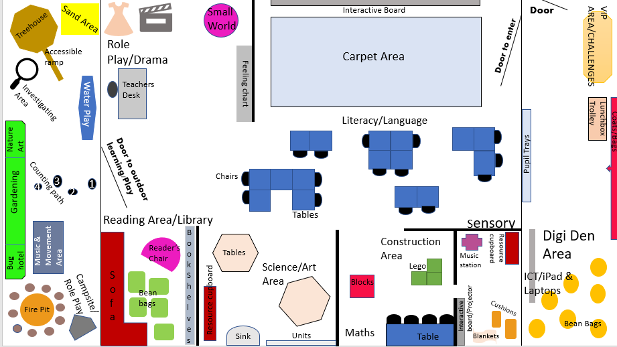
A classroom environment is one of the main factors that has an effect on children’s learning. It should be a safe place that heartens communication, exploration and develops many relationships at different levels (Montessori St Nicholas, 2018). Therefore, enthusing the correct layout by providing a positive and supportive environment should allow children to learn and engage better. (Dorman, Aldridge, & Fraser, 2006). This includes making a child feel like they belong, certifying trust and encouragement whilst also urging them to take risks, believe and challenge themselves to push further (Bucholz & Sheffler, 2009). It’s about affirming that growth mindset. Thus, I will consider the aspects of my ideal learning environment and state how it will create the constructive learning experiences mentioned above.
Figure 5: Birds eye view of my ideal learning environment

I have based my learning environment in a foundation phase classroom

Conclusion
In conclusion, it is evident to see that the importance of studying a critical incident is to ensure a teacher can reflect on their own teaching practice, link it with relevant theory and improve your style and teaching strategies. It’s not to focus on the things that didn’t go right or according to plan (Mcgrane & Lofthouse, 2010). In this learning event, I saw that the learning synchronised the social constructivist theory by Lev Vygotsky. A central belief was that language and social contact was effectively a key role in enhancing development (Vygotsky,).

