University of Wales Trinity Saint David
School of Engineering



Group Industrial Project: Final Report

Johnpaul Jones (2206145)

Engineering Management Degree
(October / 2024)
Group Industrial Project / ACMA5000

Contents Page

Contents
1. Contents Page 2
2. Introduction 4
3. Literature Review 5
Permit to Work Systems and Regulatory guidance. 5
Digital Transformation of Permit-to-Work Systems 5
Risk Management and Data Dashboarding in ePTW Systems 6
Organisational and Behavioural Considerations 6
4. Methodology 8
Methodologies Used 8
Tools and Techniques 8
Measurement and Validation of Results 9
5. Results 10
Microsoft Form and Word Template Implementation 10
Power Automate flows 10
Approvals 10
SharePoint Lists and Data Security 10
Power Apps Interface and Dashboard 10
Power BI Visualisations 11
Financial Analysis 11
Hardware and Software Costs 12
Labour Costs 12
Financial Outcome Analysis 12
Return on Investment 12
Survey and Feedback 13
Familiarity with Digital Systems 13
Navigation 13
Permit Completion 13
Meeting User Expectations 13
Benefits and Collaborative Feedback 14
6. Discussions 15
Integration and System Functionality 15
Automated Workflows and Data Management 15
User Interaction and Experience 15
Data Visualisation and Insights 15
Operational and Financial Insights 16
7. Conclusions 17
Comparison to Specification 17
Deviations from the Project Scope 17
Main Successes and Failures 17
8. Self-Evaluation 19
Technical Knowledge and Skill Development 19
Personal Growth Through Project Challenges 19
Reflection on Individual Contributions 20
9. References 21
10. Appendices 22

List of Tables

Table 1 - Financial Analysis 15
Table 2 - ROI Financial Analysis (Comparison) 16

List of Figures

Figure 1 - Word Template Permit (Blank) 10
Figure 2 - Approval Flow 1, Permit initiation 11
Figure 3 - Permit Flow 2, Permit Closure 12
Figure 4 - Approvals (Microsoft Teams) 12
Figure 5 - SharePoint Lists (Data View) 13
Figure 6 - Permit Records (Historical) 13
Figure 7 - Location Dashboard 14
Figure 8 - Open and Overdue Permits 14
Figure 9 - Work Aspect Dashboard 14
Figure 10 - Average Permit Completion Time 15

Abstract

This paper explores the development and implementation of an electronic Permit to Work (ePTW) system using Microsoft's Power Platform, which includes Power Automate, Microsoft Forms, PowerApps, and Power BI. The project aimed to address and improve the inefficiencies found in traditional paper-based PTW systems which are prone to errors, lack visibility, and often miss critical risk assessments due to decentralised processes. The digital solution aimed to enhance efficiency, accuracy in risk management, and streamline contractor monitoring while ensuring that sensitive information is securely integrated and accessible across company systems.
The scope of the project encompassed the creation of a digital PTW system that automated essential processes and was accessible on both mobile devices and desktop platforms to ensure user-friendliness for all stakeholders. The primary objectives were to reduce the time spent on manual permit management, enhance the accuracy and effectiveness of risk assessments, improve the monitoring of safety-critical contractor activities, and integrate seamlessly with other company applications for better data oversight and audit readiness.
Utilising the Microsoft Power Platform facilitated a robust transformation from manual to digital, enabling real-time data tracking and reporting, which significantly reduced human errors and operational delays. The system supports risk assessments and provides a centralised platform for managing and monitoring work permits, making it a comprehensive solution for enhancing operational safety and compliance. This paper details the design, development, and operational outcomes of the ePTW system, highlighting the technological advancements and the substantial benefits realised through digital transformation in permit management processes.

Introduction

The development of a Permit to Work (PTW) system using Microsoft's Power Platform includes Power Automate, Microsoft Forms, PowerApps, and Power BI. The objectives of this system were to improve efficiency in permit management, risk assessment completion, and contractor monitoring and ensure information is securely stored and accessible within company systems.
This Project assesses and improves on shortfalls in pre-existing PTW systems. These systems contribute to many potential incidents and miss critical risks in the work aspect. The current permit management processes operate with a paper-based PTW system (for the companies considered). This reduces efficiency and visibility, decentralises the core process, and increases the likelihood of human error. Therefore, there was a clear need for a more efficient, user-friendly solution that could offer real-time data and reporting.
This Project's scope included developing a digital PTW system that automates critical processes and is accessible through mobile devices and desktop platforms, ensuring ease of use for all stakeholders.
The core objectives of this Project were to:
- Increase the efficiency of the current processes, reducing time spent on writing, approving, and managing permits.
- Improve risk management and accuracy in risk assessments.
- Enhance monitoring of contractors and employees in safety critical situations.
- Ensure recorded information is available for other company applications and audits.
Using these Microsoft tools, this Project seeks to provide a comprehensive solution that meets the organisations' operational needs.

Literature Review

Permit to Work Systems and Regulatory guidance.
Permit-to-work (PTW) systems are required through regulatory compliance, particularly within industries with hazardous activities. The Health and Safety at Work Act (1974) provides the framework for workplace safety in the UK. This legislation outlines the general duties of employers to ensure the safety of employees, contractors, and the public during operational activities. It requires a systematic approach to risk management, which is critical to an ePTW system.
Regulations such as the Management of Health and Safety at Work Regulations (1999) (MHSWR) require employers to conduct thorough risk assessments and implement safety controls before commencing any hazardous work. The PTW system was developed using these requirements, documenting all necessary risk assessments and approvals before work begins. The Control of Substances Hazardous to Health Regulations (2002) (COSHH) and The Confined Spaces Regulations (1997) include specific requirements for handling hazardous materials and working in confined spaces, both of which are included in the PTW process.
The HSG250 Guidance, developed by the Health and Safety Executive (HSE), lays out best practices for implementing PTW systems, particularly within high-risk industries such as oil, chemical, and construction (Health and Safety Executive, 2005). A PTW system must go beyond simply issuing permits and include authorisation, training, and continuous monitoring of safety procedures.
Data-protection regulations highlight crucial personal information that require specific and robust data storage conditions and security features. Requiring the organisations to comply with legislation and maintain compliance ​(GOV.UK, 2024). The PTW system must uphold the regulatory requirement and safeguard both personal data and the organisation for legal risks.

Digital Transformation of Permit-to-Work Systems
The transition from paper-based to ePTW systems is part of a digital trend in safety management. Electronic systems improve efficiency, compliance, and real-time tracking of work permits. Research shows ineffective PTW systems are prone to errors, delays, and miscommunication, often leading to safety risks. These systems are labour-intensive, requiring physical documentation, storage, and manual approval processes, which can hinder operational efficiency.
The benefits of electronic PTW systems (ePTW) have been well-documented in the literature. Reddy and Reddy (2015) highlight the advantages of the ePTW system over the paper-based system, such as ensuring compliance with authorisation roles, easy access to permits, real-time monitoring, and integration with job hazard analysis and risk assessment. With paper-based processes manual entry and data processing drastically increases the risk of errors, misinterpretation, and oversight.
Further research by Martinez and Pfister (2023) on low code development platforms highlighting the critical advantages of using digital tools. Identifying scalability as a limitation in this case. The Power platform circumvents this by having heavily coded interfaces allowing data transference increasing scalability in the Microsoft suite. Demonstrated by Soultan et al (2021) using the Power platform to develop incident learning system for a medical application in radiotherapy. Power Bi was used to visualise the output data of the process to improve the current data analytics, Power BI has been previously used to detect accounting irregularities through data analytics (Nickell et al, 2023).
Another industry trend is integrating ePTW systems with other technologies, such as the Internet of Things (IoT) and mobile applications. Makkithaya et al (2023) demonstrate the beneficial use of IoT for agricultural risk management. Mobile devices can monitor work environments for hazardous conditions from anywhere, feeding data into the ePTW system. Mobile capabilities further enhance flexibility by enabling workers and supervisors to access, review, and approve permits from remote locations, improving responsiveness and reducing downtime.

Risk Management and Data Dashboarding in ePTW Systems
Risk management is at the core of any PTW system, and the digitalisation of this process offers new opportunities for improving safety. An effective ePTW system incorporates dynamic risk assessment tools that prompt users to identify and mitigate risks associated with specific tasks. This real-time evaluation of risks is critical for highly hazardous industries, where conditions can change rapidly, and unforeseen risks may arise during work activities.
The integration of data dashboarding within ePTW systems further increases risk management capabilities. Data dashboarding allows organisations to monitor permit trends, identify areas of non-compliance, and track near-misses or incidents associated with specific permits. Sorour and Atkins (2024) document the importance of data visualisation and its effect on accurate decision-making. These insights can influence continuous improvement efforts, helping organisations to improve their safety procedures and reduce the likelihood of future accidents. Leveraging data for decision-making is a crucial advantage of digital systems, providing organisations with the tools to manage safety risks.
Additionally, cloud-based solutions offer scalability and flexibility, allowing organisations to securely store large volumes of permit data while ensuring it is accessible from anywhere with an internet connection. Jing et al (2024) highlight the use of cloud services for flexible processes in cloud manufacturing. Cloud-based solutions are beneficial for large organisations operating across multiple sites or geographic regions, where centralised data management can drastically improve oversight of safety activities.

Organisational and Behavioural Considerations
Despite the clear advantages of ePTW systems, their successful implementation requires careful consideration of organisational and behavioural factors. Resistance to change is one of the biggest challenges transitioning from paper-based to electronic systems. Employees accustomed to traditional processes may be hesitant to adopt new technologies, particularly if they perceive them as complex or disruptive to their work.
Organisations must invest in training and change management strategies to overcome resistance, for example using Kotter’s model (1996) or Lewin’s Field Theory (1939). This approach ensures that the system meets users' practical needs and increases end-user buy-in. User-friendly interfaces, workflows, and adequate support are required to minimise disruption and increase the benefits of ePTW systems. This is demonstrated by Ghafoori et al (2024) used organisational culture to leverage the utilisation of new technologies organisationally.
Furthermore, compliance with the General Data Protection Regulation (GDPR) and ISO/IEC 27001 standards is critical when managing sensitive data in ePTW systems (GOV.UK, 2022). As organisations rely on electronic systems to store and process data, ensuring data protection measures, such as encryption or multi-factor authentication, becomes essential. These measures safeguard against unauthorised access, data breaches, and potential regulatory violations.

Methodology

Methodologies Used
A hybrid project management approach was used as per (Brandl et al, 2021). Who describes how incorporating agile into manufacturing project management is beneficial. The approach combined the structure of Waterfall for detailed planning, resource allocation, and risk management at the initial stages of the Project. This structure assisted in creating a clear plan, set scope and timeline. Agile practices were introduced during the implementation to improve continuous improvement.
Meetings with key stakeholders across the three businesses were conducted at the beginning and final stages of the Project to ensure their needs were understood during the system design. Stakeholders helped develop the scope requirements that shaped the design and functionality of the ePTW system. The existing processes and the current paper-based PTW systems were used to identify areas of improvement. This analysis allowed for specific objectives for the digital version. Key stakeholders were advised during the design of ePTW system workflows, aligning them with practical operational needs.
User interface design focused on usability to reduce the requirement for employee training using the application or for contractors to complete form information. This ensured the ePTW system was user-friendly and practical for the end users. This assisted in creating an easily navigable interface. A Feedback survey, during the later stages of development, allowed for further improvements based on user feedback. This feedback was crucial during data dashboarding, identifying critical focus areas while improving usability and operational functionality.
The initial risk assessment process identified and evaluated potential project risks. This approach proactively mitigated challenges. Mitigations were implemented from the planning phase to ensure the completion of subsequent tasks without significant challenges.

Tools and Techniques
The development leveraged the Microsoft suite: Microsoft Power Platform, PowerApps, Power Automate, and Power BI.
PowerApps was used to develop an intuitive user interface that allowed for easy viewing of permits critical information through dashboarding, ensuring the interface was user-friendly across various computer literacy levels.
Power Automate automated workflows for permit approval, notifications, and reminders, significantly improving the process and reducing administrative requirements.
Power BI was used to create integrated dashboards and reports that provide vital information to users related to risk assessments, open permits and high-risk permits, as well as to monitor risk throughout the permit process.
Mobile integration was key, allowing approvers and managers to approve, manage, and review permits remotely, drastically improving the system's flexibility and responsiveness compared to paper-based systems. Using the Microsoft suite, the system reduces delays, administration and approvals, typical with paper-based permit processing particularly in remote areas or during off-hours, improving overall efficiency.
The risk assessment is integrated within the form submission, prompting users to conduct risk assessments for each permit. These tools help to identify potential hazards with specific work aspects. The dashboard highlights these high-risk activities, providing visibility into both open and previously completed high-risk permits by location and other categorised data. This visualisation helps to prioritise safety measures and monitor compliance more effectively.

Measurement and Validation of Results
Performance metrics such as the time taken for permit submission, approval, and closure are continuously monitored. Additionally, Power BI was used to develop visual dashboards that tracked various essential information identified by stakeholders. These dashboards provided a dynamic view of the system, helping stakeholders identify areas for improvement. User feedback was collected through surveys and direct user engagements toward the end of the project phase. This feedback was crucial for assessing the system's usability and understanding user satisfaction. The collected feedback was analysed and used to identify future, informed improvements to the system, ensuring that the ePTW process will continue to improve and align with evolving operational objectives.

Results

Completing the electronic Permit to Work (ePTW) system highlights significant developments in efficiency, data handling, and compliance management. The ePTW system was created using Microsoft Forms, Word templates, Power Automate flows, SharePoint lists, Power Apps, and Power BI dashboards.

Microsoft Form and Word Template Implementation
The Microsoft Form is required for submissions, capturing essential details such as the submitter's information, start and end dates, specific work aspects and environmental conditions. This includes high-risk factors like confined spaces and hot work. Using forms allows the contractor to complete the administration, reducing administration time. Additionally, it allows the QR code to be displayed at the site entrance, security gatehouses, and/or reception. Having the potential to be used ahead of time, after the completion of the purchase order, prior to site entry.
Following form submission, an automated Word template, including the form details, is generated as the permit document. This automation significantly streamlines the permit documentation and storage process. The template can be stored online, emailed, or saved to local servers, improving the storage aspects of the PTW systems.
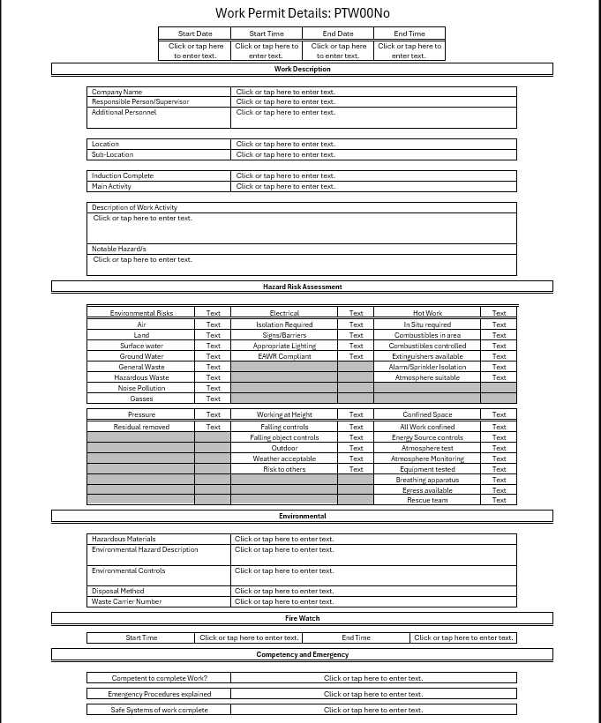
Figure 1 - Word Template Permit (Blank)

Power Automate flows
- Flow 1: The initial approval process upon form submission, transferring data from the form to SharePoint lists where the initial status of permits is logged. This flow also triggers notifications and approvals through Microsoft Teams, facilitating faster processing times.
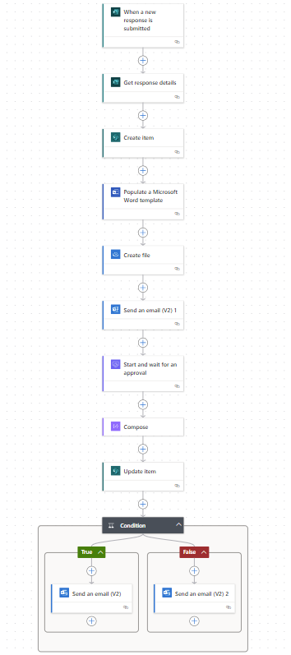
Figure 2 - Approval Flow 1, Permit initiation

- Flow 2: Activates at predetermined times (3 PM and 6 PM daily), targeting open and overdue permits for closure. This approach ensures that all permits are timely reviewed and actioned.
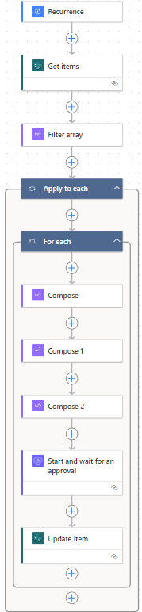
Figure 3 - Permit Flow 2, Permit Closure

Approvals
Approvals can be designated to individuals or groups, enhancing efficiency. The ability to redistribute specific requests to other individuals aids flexibility, risk management, and monitoring capabilities. Approvals are conducted through Microsoft Teams and Microsoft Outlook concurrently, demonstrating the objectives of mobile integration while ensuring the timely and accurate initiation and closure of permits.
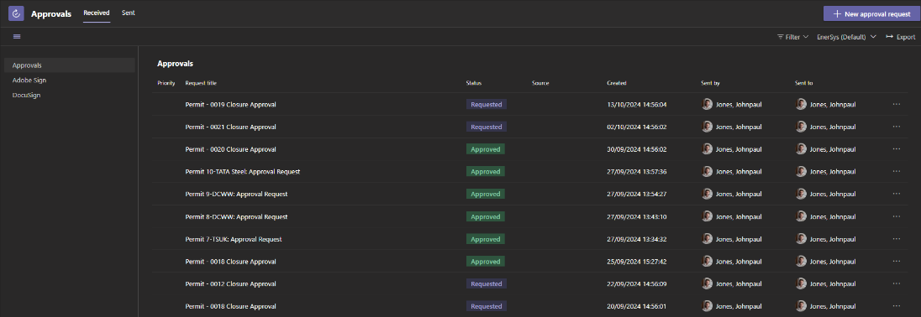
Figure 4 - Approvals (Microsoft Teams)

SharePoint Lists and Data Security
SharePoint lists function as the centralised repository for all permit-related data. This is designed to comply with GDPR requirements by isolating the stored data within a secured environment. The access controls ensure that sensitive data handling complies with data protection.
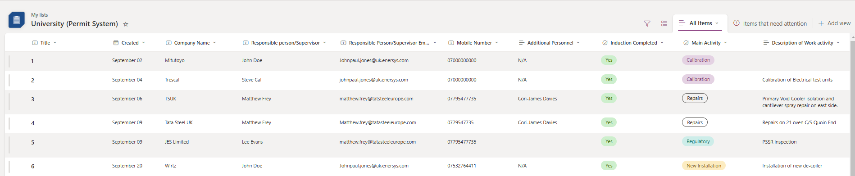
Figure 5 - SharePoint Lists (Data View)

Power Apps Interface and Dashboard
The Power Apps application features an intuitive user interface that displays currently open permits and multiple dashboards. These dashboards provide a real-time overview of permit quantities and highlight permits associated with high-risk activities. Including searchable records for improved user interaction, allowing for analysis while complying with GDPR.
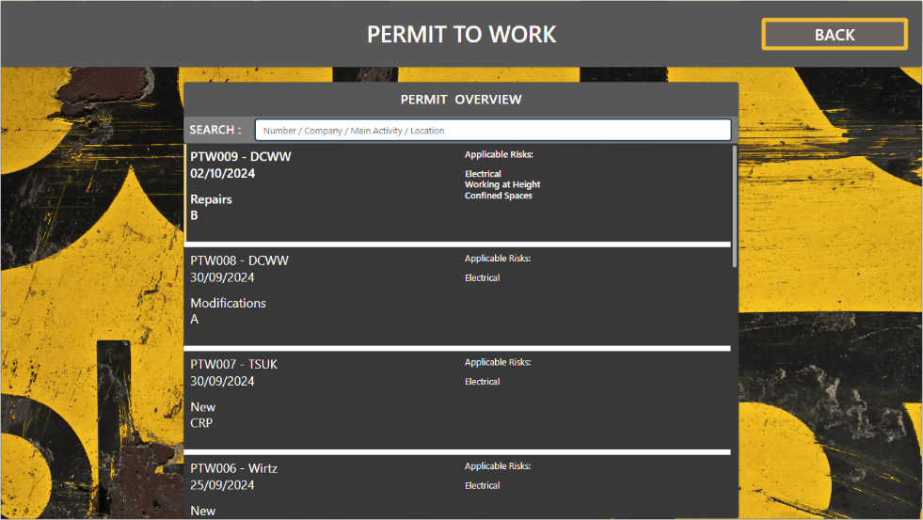
Figure 6 - Permit Records (Historical)

Power BI Visualisations
Integration with Power BI enables data visualisation, linking directly to SharePoint lists to represent data. The visualisations include:
- Graph 1: Permits by Location Total illustrates the number of active permits by location, allowing for real-time monitoring of areas with significant work activities currently active.
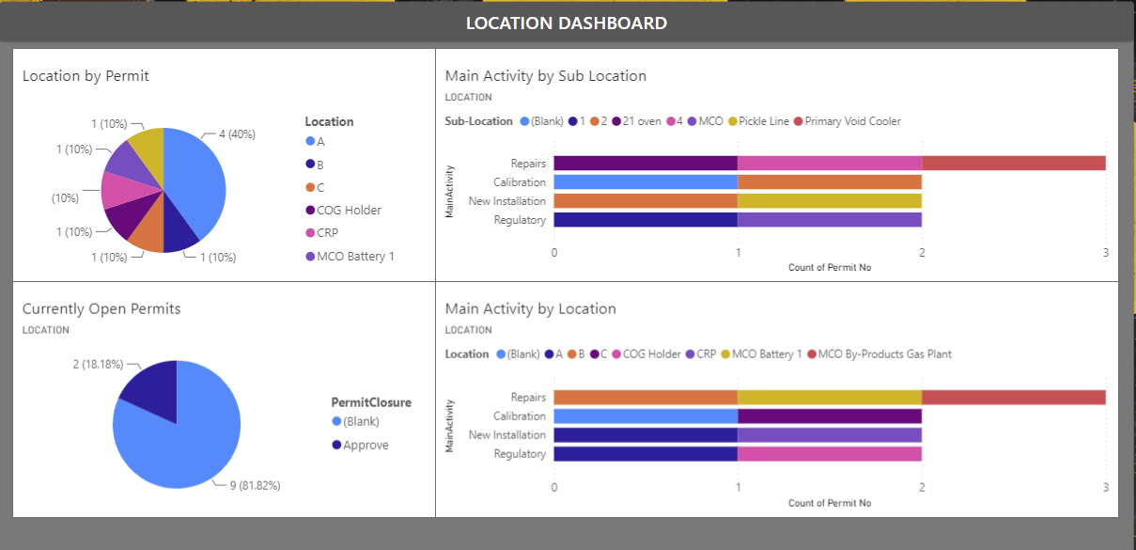
Figure 7 - Location Dashboard
- Table 1: Total Open Permits categorises the permits currently open, including overdue, providing insights into potential risk concentrations.
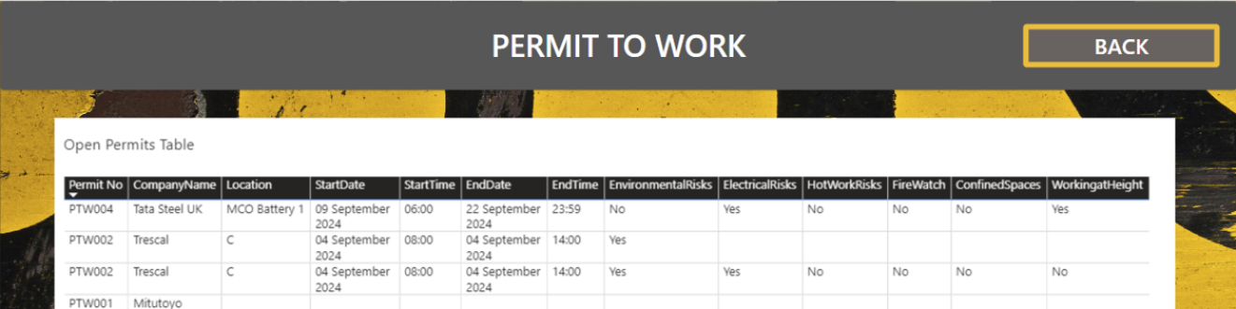
Figure 8 - Open and Overdue Permits
- Graph 2: Main Activity by Location monitors and highlights the most identified activity across all locations. Operationally, this allows for the identification of continuous improvement opportunities or areas to target for increased spending.
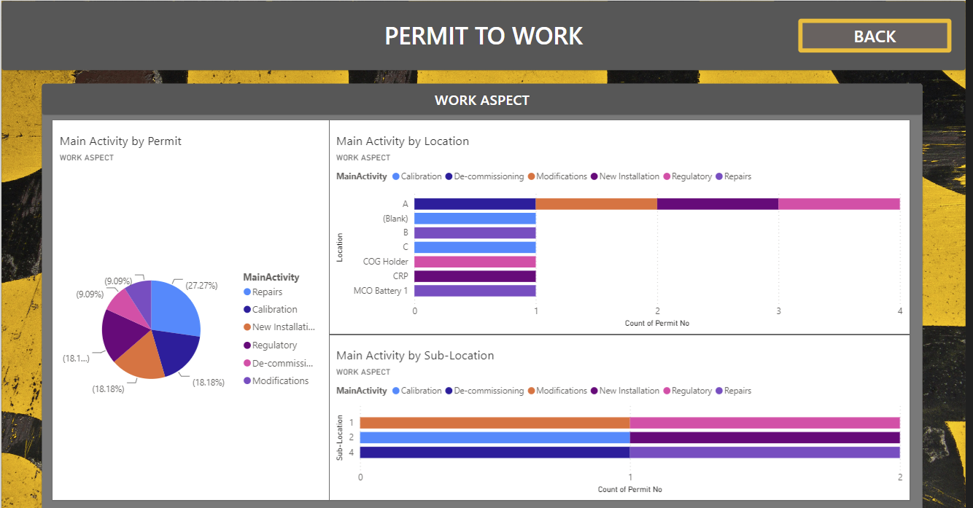
Figure 9 - Work Aspect Dashboard
Additionally, the Microsoft suite has built-in visualisations for further information, including the time it takes to complete the permitting process, run time estimations, and averages for workflow completion. The system administrator can use these to identify further improvements throughout the process.
For example, the average permit completion time displayed in Microsoft Forms is 11 minutes and 24 seconds. This is 1 minute and 24 seconds longer than the expectation, this would reduce the financial saving expectations, however, this part of the process was disseminated to contractors, therefore the cost is effectively eliminated.

Figure 10 - Average Permit Completion Time

Financial Analysis
Table 1 - Financial Analysis
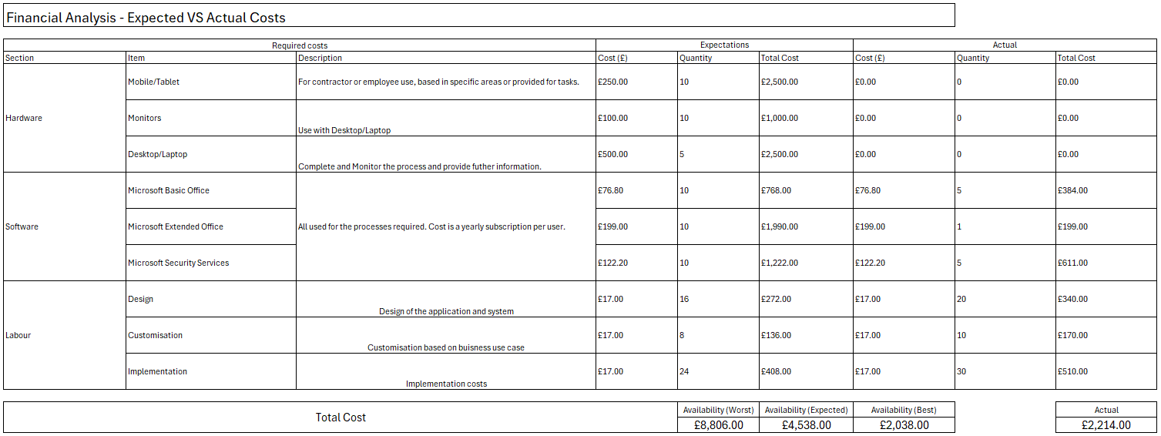
The financial overview provided in the spreadsheet displays the expected versus actual costs involved in the project, segmented into categories like Hardware, Software, and Labour. This breakdown is required to assess how well the project was budgeted and measure the project outcome's success.

Hardware and Software Costs
For hardware, the projections included essential items such as mobile/tablet and desktop/laptops for specific tasks like administration, data management, or remote task execution. The budget allocated specific amounts and quantities for these to cover all necessities. In the software segment, necessities such as Microsoft Basic Office and Security Services were budgeted to ensure that the project’s software infrastructure was capable and regulatory compliance was ensured. The actual expenditures listed indicate whether the project management could stick to these financial plans or if adjustments were made.

Labour Costs
The costs associated with Design, Customisation, and Implementation reflect the investment in resources essential for the project outputs to meet specific requirements. These figures represent the financial outlay for labour but also gauge whether the project was effectively managed in terms of both budget and project timelines.

Financial Outcome Analysis

By comparing the anticipated costs against the actual expenses, the table provides an evaluation of the financial efficiency of the project. For example, the underspending in this case coulde indicate a commendable saving of resources but could also suggest that some areas of the project were potentially under-resourced, affecting the overall quality or delivery of the project outcomes.
Table 2 - ROI Financial Analysis (Comparison)
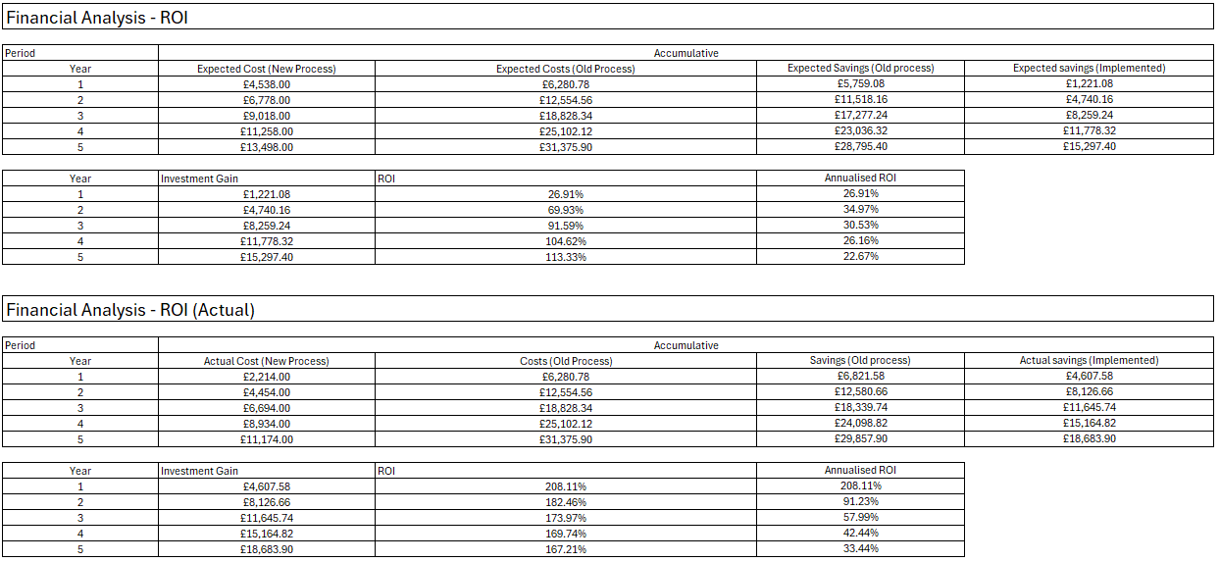

Return on Investment
The "Actual ROI" data reveals the real-world outcomes following the implementation of the new process, providing a comparison to the earlier projections.
The actual costs associated with the new process were lower than expected and should continue to be cost-effective. This indicates effective project management. The savings achieved were higher than expected, which might reflect an underestimation of the old process's inefficiencies.
The actual investment gain and the annualised ROI are higher than expected. In Year 1, the ROI is more than double the expected figure, highlighting initial conservative estimates or unexpected additional benefits from the process change.
Multiple factors have contributed to this success:
- Efficiency Improvements: The new process introduced significant operational efficiencies, reducing costs more than anticipated.
- Management: The project management team adapted more effectively to the new process, optimising it past initial expectations.
- Forecasting: Initial forecasts were conservative, with actual performance demonstrating the potential of the new process changes.
Comparing expected versus actual outcomes provides critical insights into the project's planning and execution phases.

Survey and Feedback
The feedback from the trial of the electronic Permit to Work (ePTW) system offers promising results. A notable 62% and 69% of the participants identified as front-end daily users, demonstrating engagement with the system. This level of interaction suggests that the ePTW system reception is positive. The feedback results are crucial to identify step-change improvements for the future.

Familiarity with Digital Systems
Participants showed a varied level of comfort with digital technologies. Half of the participants expressed confidence in digital literacy. This split suggests that while some users can navigate digital systems, others may benefit from additional training or support.

Navigation
Feedback on system navigation reveals that 57% of users found the system easy to use, which indicates a generally positive user experience. Additionally, 31% of users remained neutral, suggesting that while they did not encounter difficulties, the system did not stand out as particularly user-friendly. Only a minor 13% encountered challenges, underscoring that most users could navigate the system with little to no issues.

Permit Completion
A significant 56% of users reported that they could complete permits effortlessly. Another 25% needed minimal assistance; notably, 68% did not face any technical issues, highlighting the system's operational effectiveness and user-friendly design.

Meeting User Expectations
69% of the participants felt the system met their needs well, and 63% were satisfied with its functionality. The willingness of 69% of users to recommend the system to colleagues reflects strong user approval and confidence.

Benefits and Collaborative Feedback
Feedback from Welsh Water employees underlined the system's benefits, especially its utility, managing remote permits centrally. Additionally, feedback from TSUK emphasised the importance of collaboration between those drafting and those executing the permits, indicating the system's role in operational cooperation.

Discussions

The implementation of the electronic Permit to Work (ePTW) system demonstrates the digitisation causing improvements in managing operational permits with increased efficiency, data handling and compliance adherence. This transition to a digitalised system consisting of a suite of Microsoft technologies including Forms, Word templates, Power Automate, SharePoint, Power Apps, and Power BI, each playing a crucial role in enhancing the system's functionality.

Integration and System Functionality
The use of Microsoft Forms streamlined the submission process, capturing all necessary details such as project specifics and safety considerations, which are crucial for regulatory compliance and operational safety. The integration of a QR code system further enhanced site access management, linking directly to the permit input form. This level of automation reduced administration and improved data security processes.
The generation of a formatted permit document using an automated Word template demonstrates the system’s efficiency. By automating this step, the project significantly reduced the time required to prepare and distribute permit documents and document handling became more streamlined and secure, while being less prone to human error.

Automated Workflows and Data Management
Power Automate was critical in managing data workflows, from initial submissions to the closing of permits. The design of these workflows included automatic notifications and the logging of permit status in SharePoint lists, ensuring a seamless flow of information and timely updates. This automation facilitated faster processing times and a systematic approach to permit management.
The SharePoint lists served as a structured data architecture for all permit information, designed with access controls to comply with GDPR requirements. This centralisation of data ensures data integrity and security.

User Interaction and Experience
The Power Apps application provided a user-friendly interface that significantly improved the interaction between the system and its users. Featuring real-time dashboards, the application allows users to monitor and manage permits effectively, providing insights into high-risk activities and permit statuses by location and work aspect. This level of visibility is required for managing operational risks and the decision-making processes.

Data Visualisation and Insights
The integration with Power BI enabled data visualisation was required for monitoring the effectiveness of the new system and for identifying areas for improvement. Visualisations such as the active permits by location and open permits by activity type provided stakeholders with actionable information, allowing for a proactively managing work areas and resource allocation.

Operational and Financial Insights
From a financial perspective, the system demonstrated significant cost reductions. The reduction in manual processing and the decrease in time delays translated into cost savings, demonstrating the financial viability of switching to an automated ePTW system. The actual ROI achieved was notably higher than projected, showcasing system efficiency but also the accuracy of the implementation strategy. However, this also highlights the conservative nature of the initial costings. The time and resource allocation of the implementation was 20% higher than originally estimated, mainly due to the project team’s experience within the power platform.

Conclusions

The development of the electronic Permit to Work (ePTW) provides a significant improvement in managing operational permits within any organisation. This project was designed to leverage digital technologies to streamline documentation processes, enhance the approval workflow, and integrate dynamic risk assessment capabilities. The outcomes have largely met these targets, demonstrating the successful application of the project's original specifications.

Comparison to Specification
The initial aim of the project was to create a digital system that would increase the efficiency of permit management, enhance the accuracy of risk assessments, and allow for real-time monitoring of contractors. Built on Microsoft’s comprehensive suite, including Power Automate, Power Apps, SharePoint, and Power BI. The system has successfully achieved these aims. It has drastically reduced the time spent on manual permit processing through administrative reductions, improved the reliability of risk assessments with dynamic tools, and provided a platform for tracking contractor activities effectively.

Deviations from the Project Scope
Although the project remained largely true to its defined scope, there were some deviations, particularly noted during the integration and testing phases. The complexities involved in integrating various Microsoft tools were initially underestimated, which extended the development timeline slightly. The Project team decided the scope of user testing needed to be improved to ensure the system was robust and user-friendly across various operational settings. This change, while causing a minor delay, was vital for delivering a system that was tested for both performance and ease of use.

Main Successes and Failures
A significant success of the project is the impact on the permit management process, which demonstrates a reduction in manual tasks and an increase in data accuracy. The integration of mobile capabilities, which enabled remote permit approvals and reviews, marked a considerable improvement in operational flexibility. However, the project encountered challenges with initial data integration, particularly in syncing real-time data across platforms, which required additional troubleshooting and resources.
Suggestions for Improvement and Future Work: Looking ahead, there are several areas where the ePTW system could be enhanced:
- Risk Assessment Scoring Mechanism: Introducing an automated scoring system for risk assessments could help quantify risks more accurately, enabling better decision-making, prioritising the oversight of permits by area by day.
- Automated Prioritisation of High-Risk Permit Notifications: Providing further notification systems to automatically highlight high-risk permits sending notifications to stakeholders by area ensuring that urgent high-risk permits are monitored correctly, enhancing overall safety management.
- Integration of Accident and Near Miss Processes: By incorporating accident and near miss reporting and analysis into the ePTW system, the platform could evolve from a permit-only system to a comprehensive safety monitoring solution. This would allow for attribution of work aspects with permanent high-risk status. This allows organisational improvement in safety management, capturing a wider range of safety data and insights into operational improvement and continuous improvement spending activities.
Continuing to refine the system based on user feedback will ensure the ePTW process remains effective and aligned with evolving operational needs. Expanding its capabilities to handle increasing data volumes as the company and regulatory guidance grows will be crucial. Implementing more sophisticated security measures, particularly in areas of advanced encryption and intrusion detection, will ensure the system remains secure against evolving cyber threats.
In summary, the ePTW system has laid a solid foundation for safe and efficient permit management. It is successful operationally while aligning very well with the scope and organisational goals set out in the planning phase, saving financially and through accurate resource allocation.

Self-Evaluation

Reflecting on my role as Implementation Manager for the development of the ePTW system, I have improved my technical execution and project oversight abilities. This role required and demonstrated development from theoretical design to practical execution, transitioning from an outdated paper-based system to an integrated digital solution. This Project influenced growth in my technical abilities and improved my regulatory knowledge.

Technical Knowledge and Skill Development
Throughout the Project, using Microsoft’s suite, particularly Power Automate and Power Apps, required an understanding of where and when to use my developing skills in these environments, including workflow design, minor coding and data structuring. Each system element, from input forms to data handling mechanisms, was designed to align with multiple organisational and operational requirements. Additionally, ensuring compliance with relevant regulatory frameworks required an understanding of regulations and improving my ability to integrate compliance into technological solutions with the assistance of colleagues.

Personal Growth Through Project Challenges
The development from a paper-based system to a digital system caused challenges. Primarily, due to the initial process causing conceptual difficulties to integrate digitally. This required innovation and adaptability, pushing the whole team to conceptualise and implement interconnected solutions. As the implementation lead, this required significant thought and planning to understand functionally. Mainly how each piece of the Microsoft suite should be used concurrently, each challenge encountered was a learning opportunity that encouraged me to think critically. Overcoming this improved my problem-solving skills.
The implementation SharePoint lists highlighted the critical importance of structured data architecture, which became the backbone of the project. However, initial setbacks in integrating Power BI due to data gateway issues and server refresh rate issues offered new learning opportunities related to system integration that are transferable to other projects using the server environments.
These experiences highlighted the requirement of thorough testing and validation of every component. I utilised Power Automates diagnostic tools collaboratively to troubleshoot and refine our workflows, ensuring operational functionality. These challenges demonstrate the importance of a proactive approach to planning in digitalisation.
The completion of this Project significantly enhanced several of my capabilities, including:
- Regulatory Compliance: Engagement with regulatory frameworks such as GDPR and industry-specific safety regulations and legal standards, which will move to the forefront of my career later.
- Technical Proficiency: I developed an advanced proficiency in utilising features of the Power platform, including Power Automate, Power Bi, and Power Apps, enhancing my ability to conceptualise complex systems. This technical dexterity required a further developed ability in testing and validation, ensuring the reliability and efficiency of any project.
- Project Management and Leadership: Leading digitalisation implementation improved my project management skills, particularly in team coordination, stakeholder communication, and strategic planning. My role also improved my leadership qualities, particularly in mentoring team members in complex and advanced systems where they previously had minimal understanding.

Reflection on Individual Contributions
Reflecting on my contributions, I recognise my role in various aspects of the Project. Firstly, from understanding the scope and previous system to conceptualising the solution. Then, describe this to the team to further understand the complex structure and project intentions. Creating the initial automated workflows in collaboration with colleagues, to troubleshooting integration issues between Power BI and Power Apps, my efforts were steering the Project towards the scope objectives. My involvement in developing the SharePoint architecture and assisting in app development further demonstrates my engagement with the Project. These contributions demonstrate my technical skills and development.

References

Brandl, F. J., Roider, N., Hehl, M., & Reinhart, G. (2021). Selecting practices in complex technical planning projects: A pathway for tailoring agile project management into the manufacturing industry. CIRP Journal of Manufacturing Science and Technology, 33, 293–305. https://doi.org/10.1016/J.CIRPJ.2021.03.017
GOV.UK, 2022. Information security accreditation. [Online]
Available at: https://www.gov.uk/government/news/information-security-accreditation
[Accessed 18 October 2024].
GOV.UK, 2024. Data Protection Act 2018.
Available at: https://www.gov.uk/data-protection
[Accessed 18 October 2024].
Ghafoori, A., Gupta, M., Merhi, M. I., Gupta, S., & Shore, A. P. (2024). Toward the role of organizational culture in data-driven digital transformation. International Journal of Production Economics, 271, 109205. https://doi.org/10.1016/J.IJPE.2024.109205
Health and Safety Executive (2005) Guidance on permit-to-work systems – a guide for the petroleum, chemical and allied industries. Available at: https://books.hse.gov.uk/gempdf/hsg250.pdf (Accessed 22 October 2024)
Kotter, J. P. (1996). Leading Change. Harvard Business School Press.
Lewin, K. (1939). Field Theory and Experiment in Social Psychology: Concepts and Methods. American Journal of Sociology, 44, 868 - 896.
T., M., Makkithaya, K., & V.G., N. (2023). A trusted IoT data sharing and secure oracle-based access for agricultural production risk management. Computers and Electronics in Agriculture, 204, 107544. https://doi.org/10.1016/J.COMPAG.2022.107544
Martinez, E., & Pfister, L. (2023). Benefits and limitations of using low-code development to support digitalization in the construction industry. Automation in Construction, 152, 104909. https://doi.org/10.1016/J.AUTCON.2023.104909
Nickell, E. B., Schwebke, J., & Goldwater, P. (2023). An introductory audit data analytics case study: Using Microsoft Power BI and Benford’s Law to detect accounting irregularities. Journal of Accounting Education, 64, 100855. https://doi.org/10.1016/J.JACCEDU.2023.100855
Reddy, V. & Reddy, I., 2015. Study of Electronic Work Permit System in Oil and Gas. IJISET - International Journal of Innovative Science, Engineering & Technology, 2(4), p. 533.
Soultan, D., Bragg, M., Thompson, T., & Hoover, A. (2021). PO-1708 In-House Incident Learning System for FMEA Using Microsoft Sharepoints and Powerapps. Radiotherapy and Oncology, 161, S1435–S1436. https://doi.org/10.1016/S0167-8140(21)08159-7
Sorour, A., & Atkins, A. S. (2024). Big data challenge for monitoring quality in higher education institutions using business intelligence dashboards. Journal of Electronic Science and Technology, 22(1), 100233. https://doi.org/10.1016/J.JNLEST.2024.100233
The Confined Spaces Regulations 1997. Available at: https://www.legislation.gov.uk/uksi/1997/1713/contents/made (Accessed 25 October 2024).
The Control of Substances Hazardous to Health Regulations 2002. Available at: https://www.legislation.gov.uk/uksi/2002/2677/contents/made (Accessed 25 October 2024).
The Health and Safety at Work Act 1974. Available at: https://www.legislation.gov.uk/ukpga/1974/37 (Accessed 25 October 2024).
The Management of Health and Safety at Work Regulations 1999. Available at: https://www.legislation.gov.uk/uksi/1999/3242 (Accessed 25 October 2024).

