Research Paper
Character design, and Stylization in animation and film
Joseph Long
Swansea College of Art, UWTSD
Jlong.145703@student.uwtsd.ac.uk

1. Abstract
Within this research paper, the practice of stylization in characters within animated films is explored and analysed to find why it is popular in the film industry. It explores shape theory and the appeal it creates as well as its application upon designing characters by means of analysing others work and taking part in practice itself. Stylization was found to be a leading factor in conveying the entire character to an audience as quickly as possible to enable the story and its messages to be told clearly. The answers found greatly help intuitive and clever character design for both stylized and realistic characters.
Keywords: Appeal, Shape theory, stylisation, realism.
2. Introduction
The entertainment industry in particular, visual media such as film is currently populated with high amounts of CG and animation. These different pieces of creative arts constitute of many differences, much of these are in the form of the visual style. The most notable lay within the character’s design itself and the appeal that they give, which this paper will be exploring deeply. These differences that will be focused upon in research is what is known as ‘Stylized’.
“If something is stylized it’s represented in a non-naturalistic conventional form.” (Vocabulary.com)
Character design varies on not just on costume, skin and such, but the style of the modelling or drawing given to said character. This can consist of giving a character exaggerated or sharper features producing a more defined shape, similar to caricature but not to such an extent. Within animation and film, there are many examples showing that stylization is indeed a common and popular practice within the film industry. Of course this means every model within the film will be stylized and not just the characters, but the particular area being examined is character design itself.
Disney in fact has many, if not all of their characters as what can be categorised as stylised within their animated films. however, there are other examples that can be given such as the film ‘MegaMind’ (McGrath,2010), which features characters with exaggerated features and do not follow correct anatomy.
Seeing this practice to stylize characters, poses the question, why is stylization used?
To acquire the answer, the process of design itself must be considered and investigated to uncover the thought process of creating appealing characters and where the appeal comes from.
The research will be conducted through reading, and studying books and journals created by those in the same field of practice and research. Particularly those who have shared knowledge and written on the topic of character design and creating appealing characters.
Through initial research into the topic, via simple searches and observation there is an obvious answer, which is to gain a larger audience and higher income that stylization reaches due to the appeal. However, this is only a small part of the answer, on the business side of design choice. Though, creative aspect of design choice is the most important and complicated to an artist’s work.
3. Methodology
Within research there are multiple paths to be taken each of which can suit a practice or study and present findings and information gathered, increasing the knowledge of both the writer and reader. This paper is focused upon creative arts, in particular commercial arts, in which these multiple forms of study could be applied. As creative commercial arts are very much based upon the opinion of others in terms of audience reaction and success, this drives the need for qualitative research to take place. This is primarily exploratory research taking part in observations and participation, conducted through studying and analysing the works of others within the practice of character design, as well as studying research and journals surrounding the before mentioned practice. To then gain a greater understanding of the new-found knowledge, art practice will take place, applying what has been discovered during research.
“Making art is an important means of understanding art” (Sjoberg, 2018)
This is cannot only be applied classic art but is also an essential part of providing a greater understanding and insight into the methods and thought process of manufacturing visually and intellectually intriguing character designs and how theories and studies are applied to them. Taking part in the practice itself enforces a more direct approach of research rather than only the dissection of work, it pushes for more engaging creations enabling the artist to better analyse theirs as well as others works. This practice requires the interpretation of theories, research and art, and to then apply it to practice based on personal understandings from the information gathered.
“within a given practice, we must be both-and, both readers and writers” (Hannula, Suoranta and Vadén, 2014)
To present the information and knowledge that has been discovered from researching into character stylization, a series of character silhouettes will be created with intention of showing appeal and character purely from shape and form, generated by applying the discoveries of theories and others research.
To achieve this, an artist during creation must think as their audience as well as the creator, enabling themselves to craft their art into stimulating and interesting imagery that will captivate their targeted audience. This means to approach an audience with what they want to see, creating something that has meaning to them and they will engage with it. Whether this practice has been successful or not commercial wise can be measured through how well a film or short has done through money or views gained which will tell if the artists involved had successfully reached their targeted audience.

4. Critical and contextual review
Character design is a complex process which takes time, there is much more to be considered than just how to make the character look good. An artist may go through many iterations of a single character before deciding what the best direction is. A consideration that at the forefront of an artist mind is appeal. This is the first step into thinking about a characters design, but what is appeal?
Something that is appealing is what is able to attract interest or is easy to like. For an artist this means making a character that an audience would want to see and find interesting through both visuals and their personality traits, whether this is a villain or hero.
Creating appeal is something that can be a very difficult task to undertake, as to be successful the artist should combine the characters personality to the visuals and keep it interesting. How this is done is what the research initially started with, and whilst taking place a conversation with peers lead to the notion of shape theory.
Investigating into this idea, a post was found by Maree Railton on the exanimate website, an article titled ‘The Art of Designing Appealing Characters for Your Animation’ (Dec 18, 2015) within this she brings up shape theory but talked about sparsely, giving simple explanations but from this a better understanding has been gained. From reading the information my personal understanding is that when an audience consumes visuals they break them down into familiar shapes which have their own meanings to them. For example, squares are seen as strong robust shapes, which can commonly be seen in large characters such as a henchman who has square shoulders representing their strength. Along with that circles are a friendlier, harmless shape used generally in protagonists that are more bland and simple such as characters within young children’s shows.
However, not all characters have one particular shape used within them, they are mostly more complicated than that. Combining multiple shapes to show more of their character and what these shapes tell depends on how they are used within the character. An example from the before mentioned site states, “a character design with a rectangular body and circular head could be a dim-witted lackey (large rectangle, small circle) or a mega-mind genius (thin rectangle, large circle)”
This is important information to go forward with but perhaps more is required to understand the theory fully to enable it to be applied to practice. As Maree Railton states herself at the end of her article “The above points are a solid starting ground” to which she is right, this was able to point the research into a straight direction to expand on what information she has provided.
In the paper titled ‘To Stylize or not to Stylize? The Effect of Shape and Material Stylization on the Perception of Computer-Generated Faces’ (Zell, Botsch, et al, 2015, p2) suggests that the material itself is what affects the audience reaction with “… appeal, eeriness, and attractiveness are mainly affected by the stylization level of material, and not shape; realistic materials reduce appeal in general.” This is something that myself must somewhat disagree with as during testing they relied more on the characters facial expression than the stylization itself, each example had similar expressions however, still different as a realistic model can be made to be unappealing through exaggerating the expressions too much, making them look creepy and causing the “Uncanny Valley” affect to which was achieved through their shown expressions. For this test to be more valid the examples provided should have featured a more neutral expression or the exact same expression, all exaggerated or under exaggerated equally. Although the material does have an effect, the shape is also equally important.
Valentin Schwind, Katrin Wolf, Niels Henze state in their paper ‘Avoiding the Uncanny Valley in Virtual Character Design’ (2018) to “Steer clear of atypicalities at high levels of realism.” Meaning to avoid anything that is against the known norms, such as exaggerating the shapes on a character like elongating their heads or exaggerating a smile as well as matching the textures to the model. To show their point they used the example of a character from a recent trailer of ‘Alita: Battle Angel’

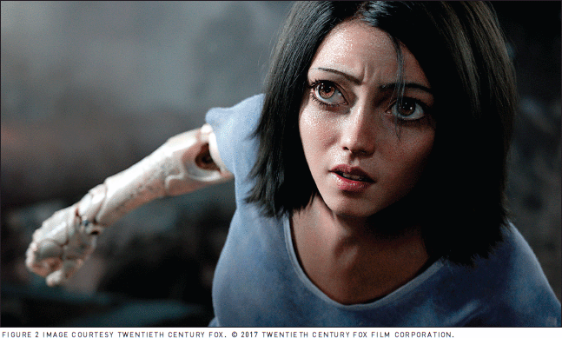
Figure 1 : (Alita: Battle Angel (Trailer), 2018)
Another example of this can be found within the film ‘The Polar Express’ (Zemeckis, 2004) a film that although was successful in making money, found that audiences were creeped out due to the characters who caused this Uncanny Valley affect because of the style they chose. This consisted of characters that seemed realistic but had something about them that threw that off, whether this was intentional or not is unclear but it did not work too well. As seen in figure 2.
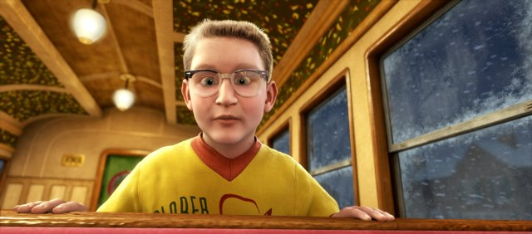
Figure 2 (The Polar Express, 2004)
“Shape has a way of communicating universally, because the concept of circular versus triangular shapes originate very much from nature Rounded shapes tend to be safe, while angular shapes make us cautious.” - How Can a Character's Personality be Conveyed Visually, through Shape (Ekström, 2013, p6) suggesting that shapes on their own are able to give a perception of the character to an audience without giving away too much detail within a single image. This is something that an artist should consider greatly to avoid having to give too much exposition about a character, to enable their designs to convey what their character is about such as if they’re the hero or a villain.
Supporting this, on the site ‘Graphic mama’ Bilyana mentions David Colman, an Emmy winning character designer, story artist and art director for studios such as Sony pictures and Disney, she speaks of his research and practice claiming that “Facial expression is really secondary when reading a character. First thing to notice is the face shape, posture and body language” suggesting that the main feature of a character is body and clothes, which tells the audience both who and what the character is as well as the style of which it is modelled/drawn. It is hard to see this through a fully coloured and rendered image because as we analyse them we find it hard to ignore and see the shapes we are being shown, despite the fact they are noticed first when a character is seen. To show this we can use silhouettes as an example of what David Colman tells us, due to all that can be observed in silhouetted character are just the shapes used to create them, with no detail within. From what has been learnt so far, it suggests that silhouetting a character design is a good method of conveying a character without going too far into it.

5. Project Specific Research
Ben Mauro, a character concept artist for Sony Pictures uses this in his practice in as seen in figure 3
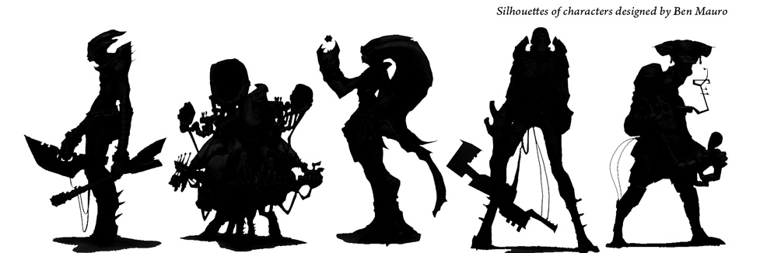
Figure 3 (Ben Mauro, cancelled project)
Analysing this artwork, it can be seen that these are alien species, each holds a quite confident pose, telling us as the viewer that themselves are confident in what they do, imagining that each character takes bold actions to achieve their goals. A few of which use rounded shapes within their form, which according to shape theory means they are friendlier characters with good intentions, perhaps they are supporting characters to the main cast throughout the film these were intended for. In particular the character on the far right of figure 3 gives the impression of perhaps they are an engineer or mechanic, the same could maybe be said about the second character from the left or perhaps a trader of sorts. On the opposing side of this there are a couple who have got more angular and sharper shapes used within, both of which are very obviously holding weapons and have some form of armour. Instantly telling the viewer that they are of villainous intentions.
This is important to do when designing a character, because it enables a viewer to understand the character without having to be told every bit of detail through either exposition or some elaborate added on story that diverts from the main story which ultimately means nothing to it, unless it is indeed important to the story and its message it wishes to convey.
As stylization allows an artist to have more creative liberty in designs when it comes to anatomy and real-world expectations, research suggest that shape theory can be applied more so within stylized characters which could be best shown through their silhouettes. To express better what is meant by this, it will be of use to analyse an example from a stylized film.
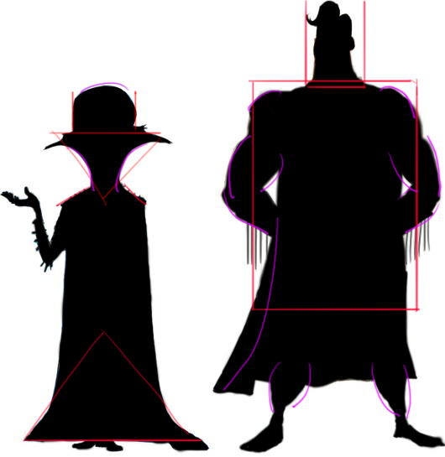
Figure 4 (MegaMind, 2010)
The example shown in figure 4 is from the film ‘Mega Mind’ (McGrath, 2010) the red lines upon the presented example show where angular shapes are used and the purple lines highlight curves. Squared shapes show power and strength, they are used in the hero on the right known as Metro Man. Particularly in his overall body shape and his head, which as a stylized character this is able to be upon. As discussed previously realism must stick to conventional norms to avoid the Uncanny Valley. Due to this, it is easy for the viewer to read that, that is a hero. Combined with his pose which is very much superman-esque, in which his arms create a curve themselves support the portrayal of this character. These curves represent the friendliness of the character, again pushing this hero aspect.
On the opposing side we have the character who is perceived as the villain due to the very sharp shapes used within his costume and pose. He is also smaller than the hero, giving the idea that he is a physically weaker character but he has been given a rather large head to convey his intellect, showing that this is his main weapon, what he fights all his battles with. That area is particularly interesting because even though he is a villain, a curve is used. This could be due to his bumbling nature, a sort of failed supervillain, which is shown in the film. Or it is to match his character arc which by the end of the film he has a change of heart and becomes the hero, taking over the job of Metro Man. A prime example of how combining shapes in clever and complex ways can convey a lot about a character, such as his personality and possibly his path which he will take. This can also be used against the audience to deceive their expectations of a character that may have a look that is generally perceived as evil or one that is seen as good, and turn out to be the opposite.
To further understand shape theory, it is best to put them to use within personal practice of silhouettes, and attempt to create a sense of the characters and their personalities in form of stylized characters as well as a set of characters closer to realism range of character design. With this the results expected are to find that the stylized character designs are more readable than realistic designs. These will then be critically analysed to discover if shape theory has been applied correctly, determined by their readability.
The first set of silhouettes as seen will contain characters that have considerably close to realistic propositions and shapes, for their bodies and costumes with shape theory applied where possible, in an attempt to convey their character clearly. However, as mentioned, these must keep within the realistic spectrum, meaning that they cannot have unreasonable, otherworldly shapes such as oversized armour. The second set will contain the opposite, much more stylised shapes pushing outside realism.
6. Practice and Results
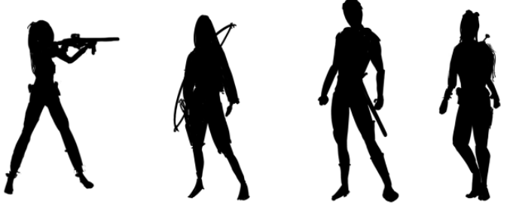
Figure 5
Figure 5 contains silhouettes that use ideas within shape theory, before discussing this they are to be analysed then it will be explained how they were made. As these are limited to realism, the focus pushed towards but not confined to the idea of combining shapes to convey character. While analysing these silhouettes peers gave their input in who they thought each character was the following is the documentation of the average comments and personal thoughts on the impression the silhouettes give. The same will be repeated further on for the stylized silhouettes.
Interestingly, the first character is perceived as somewhat ambiguous to where their allegiance lies despite them having a gun, but it is clear that they are an experienced marksman, a peer suggested that she looks like a mercenary, neither good nor bad.
The second- and third-characters others read them as a watchtower guard and a knight hero both on the ‘good’ side, who are confident and perhaps key characters in their story.
Again, the last is a little more ambiguous although it shows attributes of a Junker or mechanic character who doesn’t get involved with anything outside her own life. However, she was perceived as a character with allegiance for the ‘good’ side.
Although the costumes tell the viewer what roles the characters have such has knight or archer it’s quite difficult to say what these characters are like.

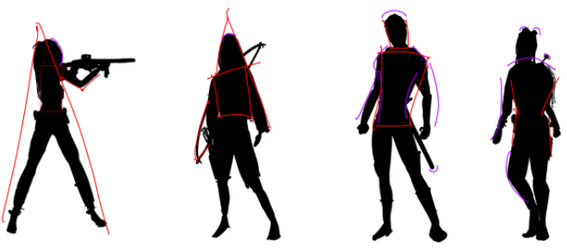

Figure 6
Figure 6 follows the same format as figure 4, red represents angular and shape shapes while purple represents curves. Once again, starting from left to right, the first character used triangular shapes to represent a ‘bad’ side, and a strong stance to give them power. There are few curves used within the design, this was to encourage a feeling of perhaps the character did or will turn good, this might be where the idea of her being a mercenary came from.
The second character, though correctly interpreted as a strong archer, she was meant to be conveyed as a villain through once again using triangular shapes, using her body and bow to deliver these shapes.
The third character was received quite well, correctly recognised as the strong hero. This is evidence of the angular shape in his posture and pose working well to portray strength and the curves in his body and sheath to show him as a friendly and trustworthy character.
The last character was understood as a Junker character. However, she was misunderstood to be a good character which is reasonable as she uses a lot of curves but this was to convey her as a passive character.
After putting these realistic silhouettes under scrutiny, it has come to light that pose has a large impact on how a character is perceived. Additionally characters are given an assumed allegiance based off their costumes that are associated with certain characters. After telling a peer of the true nature of the archer character, they revealed that the assumption was due to their hooded look matched with the bow gave them the impression of a guard in the rain. These characteristics may subconsciously be associated with other characters in media such as Legolas from The Lord of the Rings (Jackson, 2001) who is a good character with a similar style of costume. This also could be the case for the knight character who is common within fairy tales, all of which usually follow a similar hero knight look within film and animation.
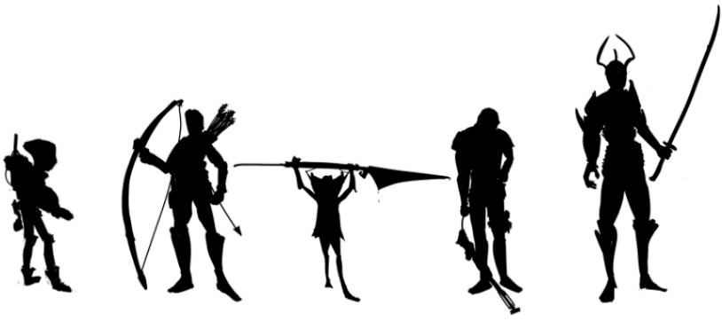
Figure 7 shows the set of stylized silhouettes, this gave leeway to have more creative control with proportions and shapes. It enabled the use of using larger than possible characters as well as the use of what would in the real-world be impractical weaponry and armour as they wouldn’t serve their function very well.
Figure 7
Comments came quicker with this set of silhouettes, with the exception of the first character on the left. He was seen as a traveller who gathered equipment and gear, though unsure of his alliance and personality.
The second was instantly seen as a tall, strong hero, the “do-gooder” who seeks out people to help. Described to have a “stuck up” pompous attitude due to the hair and how he stands.
The third and smallest character straight away was called a goblin, a bloodthirsty minion of evil, celebrating taking a victim’s life.
Moving onto the fourth silhouette, he is thought to be a tough marine type character, who’s down on his luck. One commented that he seems like he has disappointed someone and he is disappointed in himself for that.
The final character was instantly recognised as the villain, Sauron-esque (The Lord of the Rings, Jackson, 2001), the height of evil in the world who has dominion over the goblin character. One peer suggested they all live within the same world battling against these evil characters.

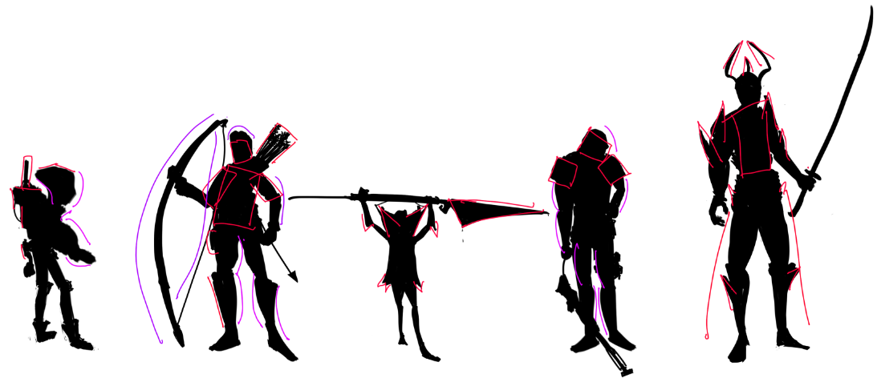

These silhouettes were made to have similarities to the previous set in roles and allegiances. These characters where mostly correctly recognised, for both their character types and allegiance apart from the first character, this may be because most of the shapes used within the character are rounded and has a very neutral pose. Although the character does not have a particular allegiance, much like the previous Junker character, he is a lone traveller staying out of others business.
The archer used a combination of curves and ridged shapes to show a strong but heroic character, this time using the bow to make curves instead of a triangular shape and oversizing it as well as the characters features. These have given off more of a personality to the character than the realistic silhouettes as the shapes used were able to be exaggerated more through both his pose and figure.
The goblin character has high readability, this was made easy through its appearance. Due to the allowance of going against realistic shapes and sizes, it enabled the ability to really exaggerate the fact that the character is small and not human through giving it a large weapon and elbows that stick out. The use of triangles helped this along, really exaggerating that although small, he is a dangerous character.
Again, the fourth silhouette was received as intended, however exaggeration is subtle, its mainly within over-sized shoulder pads and helmet, so perhaps on that one it did not work so well as he looks he could exist within the real-world as his height seems that of a normal man appose to the archer who looks he could be quite tall.
The last character was the easiest to convey that he is a villain using spiny shapes for his armour and a large weapon as well as giving him a large stature too, with the use of ridged shapes to give him a strong and powerful look, as if none could stand in his way.
5. Conclusion
This research set out to discover why stylized characters are used. From studying this it was found that it came down to appeal, and this came from exaggerated features that the characters had through their costume and body shape. During the search the uncanny valley was explored, researching the effects of realistic characters that contain a small amount of stylization within them. Through this, it was discovered that stylized features on realistic looking characters causes this uneasy feeling towards an audience, meaning that characters and their personalities are harder to convey through their costume and body shape.
Continuing the research, It was found that shape theory has a large influence on stylization and its effects on an audience. Deciding to look at this in its simplest form, silhouettes show the shape that an audience first sees when a character is revealed. This was analysed in Figure 4 where the shapes used within the characters were discovered, as well as what they covey about the character. This showed that even without large amounts of detail the characters were still readable.
To further investigate this and realistic characters, two sets of silhouettes were created which found that the realistic looking characters were harder to read even with shape theory applied. Without the extra detail of the story being shown they are not so readable apart from what job they may have, their role and personalities were hard to convey.
Opposed to this, the stylized characters were read quite easily, giving the impressions that were intended. This leads the belief that shape theory is better applied to stylized characters as it allows for more creative freedom and exaggeration of shapes.
To conclude the question is posed again; why are stylized characters used?
It allows the artist to convey a character, its purpose and personality to an audience quickly, allowing for simpler character designs that are easy to read. As stylization is usually within films aimed towards a younger audience it is to enable them to understand the character easier and make them easier to watch as realistic characters can be too complicated to understand. Hints to their roles and attributes are more subtle and the details smaller due having to stick to conventional realism, to quote ‘Avoiding the Uncanny Valley in Virtual Character Design’ again “Steer clear of atypicalities at high levels of realism”.
Therefore, stylization is a quicker method of reaching an audience and grasping their attention and interest to a character as they are easier to understand.

References
Alita: Battle Angel (Trailer). (2018). [video] Directed by R. Rodriguez. USA: 20th Century Fox. [Figure 1]
Bouwer, W. and Human, F. (2017). The Impact of the Uncanny Valley Effect on the Perception of Animated Three-Dimensional Humanlike Characters. The Computer Games Journal, 6(3), pp.185-203.
CHARACTER DESIGN QUARTERLY 6. (2018). [S.l.]: 3DTOTAL PUBLISHING.
GraphicMama Blog. (2018). How to Convey Character's Personality Through Shape, Variance and Size. [online] Available at: https://graphicmama.com/blog/conveying-characters-personality/ [Accessed 17 Oct. 2018].
Hannula, M., Suoranta, J. and Vadén, T. (2014). Artistic research methodology. Frankfurt: Peter Lang GmbH, p.4.
Kaba, F. (2013). Hyper-Realistic Characters and the Existence of the Uncanny Valley in Animation Films. [ebook] Turky: Anadolu University, Faculty of Fine Arts. Available at: http://irssh.com/yahoo_site_admin/assets/docs/17_IRSSH-436-V4N2.44204045.pdf [Accessed 16 Oct. 2018].
Kojima, H (nd). Death Stranding. Japan: Kojima Productions.
The Lord of the Rings: The Fellowship of the Ring. (2001). [film] Directed by P. Jackson. Hollywood: New Line Cinema.
Mauro, B. (2008). Silhouettes for a cancelled project. [image] Available at: http://benmauro.blogspot.com/search?updated-max=2012-09-09T17:35:00-07:00&max-results=40&start=52&by-date=false [Accessed 20 Oct. 2018].
McDonnell, R. (2012). Motion In Games. Appealing Virtual Humans, [online] 1(1). Available at: https://www.scss.tcd.ie/Rachel.McDonnell/papers/MIG2012.pdf [Accessed 25 Dec. 2018].
Megamind. (2010). [film] Directed by T. McGrath. DreamWorks Animation: Paramount Pictures.
Methods.manchester.ac.uk. (2018). Practice as Research - methods@manchester - The University of Manchester. [online] Available at: https://www.methods.manchester.ac.uk/themes/qualitative-methods/practice-as-research/ [Accessed 23 Oct. 2018].
Railton, M. (2018). The Art of Designing Appealing Characters for Your Animation. [online] Explanimate!. Available at: https://www.explanimate.com.au/the-art-of-designing-appealing-characters-for-your-animated-video/ [Accessed 17 Oct. 2018].
sjoberg, j. (2018). Practice as Research - methods@manchester - The University of Manchester. [online] Methods.manchester.ac.uk. Available at: https://www.methods.manchester.ac.uk/themes/qualitative-methods/practice-as-research/ [Accessed 15 Oct. 2018].

The Polar Express. (2004). [DVD] Directed by R. Zemeckis. United Kingdom: Warner Bros. Pictures. [Figure 2]

Vocabulary.com. (2018). stylized - Dictionary Definition. [online] Available at: https://www.vocabulary.com/dictionary/stylized [Accessed 15 Nov. 2018].

Zell, E., Aliaga, C., Jarabo, A., Zibrek, K., Gutierrez, D., McDonnell, R. and Botsch, M. (2015). To stylize or not to stylize?. ACM Transactions on Graphics, 34(6), pp.1-12.

