

Module Name: Digital Skills for Personal Development and Business Growth
Module Code: BMSW4008
Assignment Name: Portfolio
Student Name: Vera Yasmin Ahmed
Student Number: 2432984
Lecturer: Gareth Hughes
Deadline: Monday, 16 March 2026

TABLE OF CONTENTS

- INTRODUCTION………………………………………………………………..4
  - REPORT REMIT...............................……………………………………..4
- ANALYSIS REPORT.........................…………………………………………5
  - FINDINGS.…………………………………………………………………..5
  - PERSONALISED PRODUCTS.........…………………………………….6
  - SEGMENTATION AND MARKETING SEO STRATEGY ..……………6
  - CONCLUSION………………………..…………………………………….6
- REFERENCES…………………………………………………….………….7-8
- THE IMPORTANCE OF EXCEL IN THE DIGITAL ERA ……………….9-10
  - MICROSOFT EXCEL SPREADSHEET………………………………..11
- REFERENCES…………………………………………………………………12

APPENDICES

APPENDIX 1 - IMAGE OF QUESTIONNAIRE RESPONSES
APPENDIX 2 - IMAGE OF QUESTIONNAIRE RESPONSES
APPENDIX 3 - IMAGE OF QUESTIONNAIRE RESPONSES
APPENDIX 4 - IMAGE OF QUESTIONNAIRE RESPONSES
APPENDIX 5 – IMAGE OF FLYER
APPENDIX 6 – IMAGE OF WEBSITE DESIGN AND BULDING DESIGN
APPENDIX 7 – LINK TO VIDEO ADVERTISING HASHIRA HOUSE CAFE

- INTRODUCTION
Before launching Hashira House Café, I wanted to do deep marketing research to see if people would actually be interested in an anime themed cafe in Swansea. The cafe is inspired by the famous anime Demon Slayer, people will enjoy Japanese food with anime experiences like a VR “Infinity Castle” and battle simulation, themed events, and merchandise (Kurita, 2025). I created a short questionnaire to find if people will be interested in Anime theme cafe in Swansea City Centre. The questions mainly focused on people’s interest in anime, how often they go to cafes, their food preferences, interest in VR experiences, and whether they would attend events like cosplay nights or screenings. The purpose of the survey was to provide real insights from potential customers rather than relying only on assumptions (Kyamko,2025). The questionnaire collected 18 responses. As an Influencer I also did research on people interest in anime themed art and entertainment through my Instagram account. I’ve observed a growing demand for anime themed businesses.
  - Report Remit
The main goal of this report is to analyse the questionnaire results and other marketing research to see what is the potential demand for Hashira House Cafe. The report focuses on the most interesting findings, culture and anime popularity, and explains how these insights can help shape the business. I also discuss how the cafe could offer personalised products, what events are desirable, identify market segments, using SEO still matters, but for most businesses it delivers the best results when it’s used alongside a wider marketing strategy (Miller, 2025).

- ANALYSIS REPORT

  - Findings and Discussion
One of the first things I looked at was interest in anime. Most respondents were already fans 70% said they watch anime regularly, and 20% watch it occasionally. Only a small number had no interest. This fits with the wider trend in the UK where anime has become more mainstream, partly thanks to streaming platforms, Netflix and social media. Demon Slayer Infinity Castle Net worth is 1bilion worldwide making Demon Slayer highest grossing film globally (Animehunch, 2025). This business idea reflects on my personal passion for anime and the growing interest in Asian pop culture, Japanese Anime what is significantly growing in the UK (Business Research, 2026). As an influencer, I have been sharing my anime artwork on Instagram stories to monitor audience interest. Both of my posts were shared by the official Demon Slayer verified account, resulting in 128,854 views within 24 hours and 37,401 views in just 2 hours. End of the day the account reached 240.000 viewers. These metrics highlight not only the strong engagement of anime content but also the rapid response from a passionate audience, demonstrating significant potential for anime related content and business opportunities.
Another interesting finding was that most participants said they would visit an anime-themed cafe. About 80% said they would probably or definitely go. This confirms that customers are drawn to experiences rather than just food. The combination of Japanese food, themed decor, and interactive VR experiences will make the cafe stand out in Swansea and be the first Cafe of this kind in the UK (Dale, 2026). With social media and never ending changing the game, many young people looking for content more than anything else. And that is what Hashira House Cafe is about.
The third key finding relates to events and extra experiences. Respondents were asked how likely they would be to attend themed events such as cosplay nights, anime screenings, birthday parties, content events or student discount nights. Most people said they are interested to attend those events, with cosplay nights and screenings being particularly popular.
"Please see Appendix 1-4 images of the questionnaire responses."
  - Personalised Products and Experiences

The questionnaire also gave ideas for personalised products (Ornstein, 2013). Many respondents said they would enjoy experiences that reflect their favourite anime characters or series. Birthday party packages will include themed decorations, food, and music tailored to customer preferences. VR experiences will be optional, allowing customers to choose which adventures to try. Offering these options makes customers feel more connected to the cafe, increasing the likelihood of repeat visits and social media sharing. Hashira House Cafe is not just another Cafe but Anime Land.
"Please refer to Appendix 5 for an image of the Flyer."
  - Segmentation and Marketing Strategy and SEO Strategy
The questionnaire results indicate that the cafe’s main target audience are students, young adults and fans aged 18–35, who are interested in anime and Japanese culture and food. Many of these respondents are already active on social media and enjoy attending events, Comic Cons or visiting unique cafes (BBC, 2022). A secondary audience includes families with children, shown interest in attending to birthday parties or themed events. Social media platforms such as Instagram, TikTok, and YouTube are ideal for advertisement and global exposure, VR experience’s introduction, and event highlights (Digital Marketing Institute, 2024). Creating short, visually engaging videos can generate interest and encourage followers to visit. Collaborations with local universities, Influencers around the world or anime fan clubs can also help promote events like cosplay nights or screenings.
The cafe’s website should use search engine optimisation (SEO) to reach potential customers. Keywords could include “anime cafe Swansea,” “VR experiences Infinity Castle,” “Japanese food,” and “Demon Slayer UK” (lsdigital,2024). Blog posts, event announcements, and images can improve search engine ranking and attract new visitors. Social media content should link back to the website, Giveaways competition on social medias will attract large scale of fans or people not particularly interested; to try win free Hashira House experience with free drink and meal of choice, this will encourage online bookings or newsletter signups for more freebies and prices. SEO and digital marketing together will ensure the cafe reaches its target audience effectively and builds a strong online presence before and after opening.
"Please refer to Appendix 6 for an image of the website and Hashira House Café building design."
  - Conclusion
Overall, the questionnaire provided valuable insights into customer interest, expectations, and strong demand for Hashira House Cafe.
- REFERENCES

Kurita, C. (2025). Demon Slayer: Kimetsu no Yaiba Cafe in Japan. Available at: https://jw-webmagazine.com/tips/demon-slayer-kimetsu-no-yaiba-cafe-in-japan/ (Accessed: 10 March 2026).
Kyamko, M. (2025). Surveys: The small business owner’s secret weapon for success. Crowdspring Blog. Available at: https://www.crowdspring.com/blog/surveys/ (Accessed: 12 March 2026).
Miller,M. (2025). How to integrate SEO into your broader marketing strategy. Available at: https://searchengineland.com/integrate-seo-broader-marketing-strategy-452030 (Accessed: 10 March 2026).
Animehunch Team. (2025). Demon Slayer: Infinity Castle movie earns over 17 billion yen, breaks into top 10 highest earning movies in Japan. Available at: https://animehunch.com/demon-slayer-infinity-castle-movie-earns-17-billion-yen-breaks-into-top-10/ (Accessed: 13 March 2026).
Business Research Insights. (2026). Anime Market Size, Share, Trends | Forecast to 2035. Available at: https://www.businessresearchinsights.com/market-reports/anime-market-118294 (Accessed: 28 February, 2026).
Dale, H. (2026). Why themed restaurants are booming globally in 2025. Available at: https://www.alibaba.com/product-insights/anime-cafe-trend-why-themed-restaurants-are-booming-globally-in-2025.html (Accessed: 08 March 2026).
Ornstein, M. D. (2013). A companion to survey research. London: Sage Publications Ltd.
BBC News. (2022). London Comic Con: Cosplayers bring colour to ExCeL centre. Available at: https://www.bbc.co.uk/news/uk-england-london-63430883 (Accessed: 05 March 2026).
Digital Marketing Institute. (2024). Which social media platforms should you use for your business? Available at: https://digitalmarketinginstitute.com/blog/which-social-media-platforms-should-you-use-for-your-business (Accessed: 05 March 2026).
Lsdigital. (2024). Digital Marketing Strategy for Cafe. Available at: https://lsdigitalmarketing.co.uk/digital-marketing-strategy-for-cafe/ (Accessed: 01 March 2026).

- THE IMPORTANCE OF EXCEL IN THE DIGITAL ERA
In today’s world, almost every business relies on data to make decisions, it is nearly impossible keep track with everything that is necessary to run a business, to plan for the future, and track how things are going (McKinsey, 2022). Microsoft Excel is one of the most useful tools what helps keep everything in order (GeeksforGeeks, 2025), especially for small businesses or startups like Hashira House Cafe. Excel allows you to organise information, calculate numbers, income, loses, create Pro rata, to keep everything in check. It is a simple but powerful way to make sure a business is on track financially and to help plan growth in the future and organise business smoot running. Excel is really good for organising data. For a cafe like mine, there are lots of things to keep track of sales from food and drinks, revenue from VR experiences, and money from merchandise. On top of that, there are expenses like rent, staff wages, staff schedules, utilities, marketing, and ingredients. Using Excel, I can put all these numbers into a spreadsheet and see everything clearly in one place. This makes it much easier than trying to do it all on paper, and it reduces risks of making mistakes when adding up totals or calculating profits. One of the main benefits of Excel is that it helps with financial planning (Financial Strategy News, 2025).
Before opening Hashira House Cafe, I needed to know if the business could make enough money to cover costs and eventually make a profit. Using Excel, I created a monthly projection for a whole year, including estimated income from food, VR experiences, and merchandise. I also added all the regular costs, like rent for the cafe, wages, and utilities. By using simple formulas, I could calculate total income, total expenses, and monthly profit or loss (Jahan, 2024). This gave me a clear picture of whether the business idea was financially possible before I even opened the doors. Excel is extremely helpful for seeing patterns over time. For example, I can use it to make a chart comparing income and expenses for each month. This helps me notice if sales are higher during certain months because of events, holidays, or student holidays in Swansea. Also, this will help me to be prepared for higher customer demand, to be able invite a special event guests or have special prices for exact holidays as complimentary gift for my customers and even better experience.
For Hashira House Cafe, charts like this can show which months need more marketing or when we should plan special events like cosplay nights, anime screenings, or student discount nights. Visualising the numbers makes it much easier to make decisions than just looking at a list of figures. Another way Excel helps is by keeping track of how marketing or events perform (Charlesworth, 2024). In the cafe, I plan to have things like VR anime experiences, themed birthday parties, and merchandise sales. By recording how many customers attend events or buy VR experiences, I can see what works best and what does not. For example, if cosplay nights are really popular but anime screenings are less attended, I can focus marketing on the more popular events or try to improve the less popular ones. Excel allows business owners to see this clearly with tables and charts, which makes planning much easier. Excel also helps with budgeting and cost control (Cheusheva, 2025). By comparing projected expenses with actual monthly expenses, I can quickly see if I am spending too much or if something needs adjusting. If marketing costs are higher than expected, I can reduce them in the next month or find cheaper ways to advertise. Same goes for food sales if they are lower than expected, I can run promotions or create market research to find what customers looking for. In conclusion using this tool is really important for small businesses like Hashira House Cafe because it helps with planning, tracking, and decision making. Excel is not just about numbers, but about understanding your business and being able to make smart choices. This tool let me manage income, VR experiences, and merchandise, while keeping an eye on costs like rent, wages, and utilities. It also helps me plan events, see customer demands and changing behaviour. Even though it might seem like a simple tool, Excel is really powerful and essential in the digital age for any business that is trying to succeed (Rosvi.S, 2025).

  - Microsoft Excel spreadsheet - the finances of Hashira House Cafe over a 1 year.

- REFERENCES
McKinsey. (2022). The data-driven enterprise of 2025. Available at: https://www.mckinsey.com/~/media/mckinsey/business%20functions/mckinsey%20analytics/our%20insights/the%20data-driven-enterprise-of-2025/ (Accessed: 01 March 2026).
GeeksforGeeks.(2025). Importance of Microsoft Excel in the workplace (with real-world examples). Available at: https://www.geeksforgeeks.org/importance-of-microsoft-excel-in-workplace/ (Accessed: 02 March 2026).
Financial Strategy News. (2025). The best uses of Excel for financial analysis. Available at: https://financialstrategynews.com/the-best-uses-of-excel-for-financial-analysis/ (Accessed: 04 March 2026).
Jahan, M. (2024). How to track income and expenses in Microsoft Excel (step-by-step). Exceldemy. Available at: https://www.exceldemy.com/track-income-and-expenses-in-excel/ (Accessed: 02 March 2026).
Charlesworth, L. (2024). What is Microsoft Excel used for and is it still relevant? Kaplan UK. Available at: https://kaplan.co.uk/blog/features/is-microsoft-excel-still-relevant (Accessed: 11 March 2026).
Cheusheva,S. (2025). Excel budgeting tips for small businesses. Available at: https://www.sheetnerds.com/tutorials/excel-budgeting-tips-for-small-businesses (Accessed: 01 March 2026).
Rosvi,S. (2025). The timeless power of Excel. LinkedIn. Available at: https://www.linkedin.com/pulse/timeless-power-excel-why-still-reigns-digital-age-rosvi-s-xaghc (Accessed: 10 March 2026).

Appendix 1
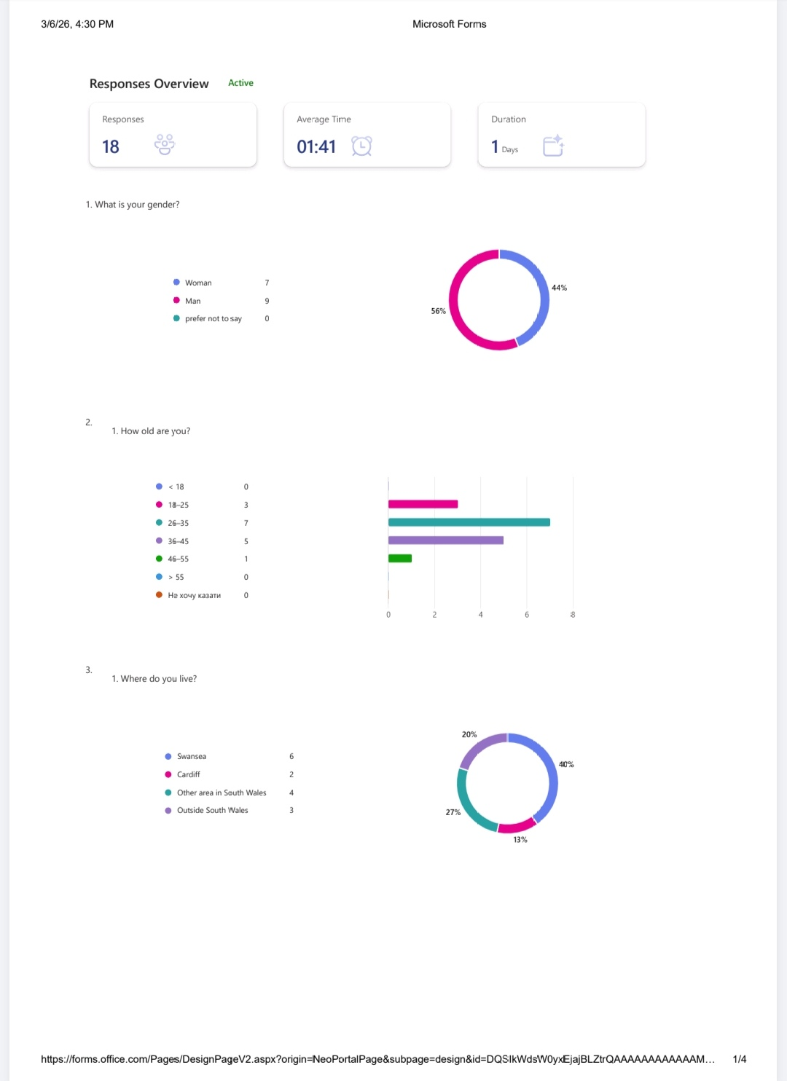

Appendix 2

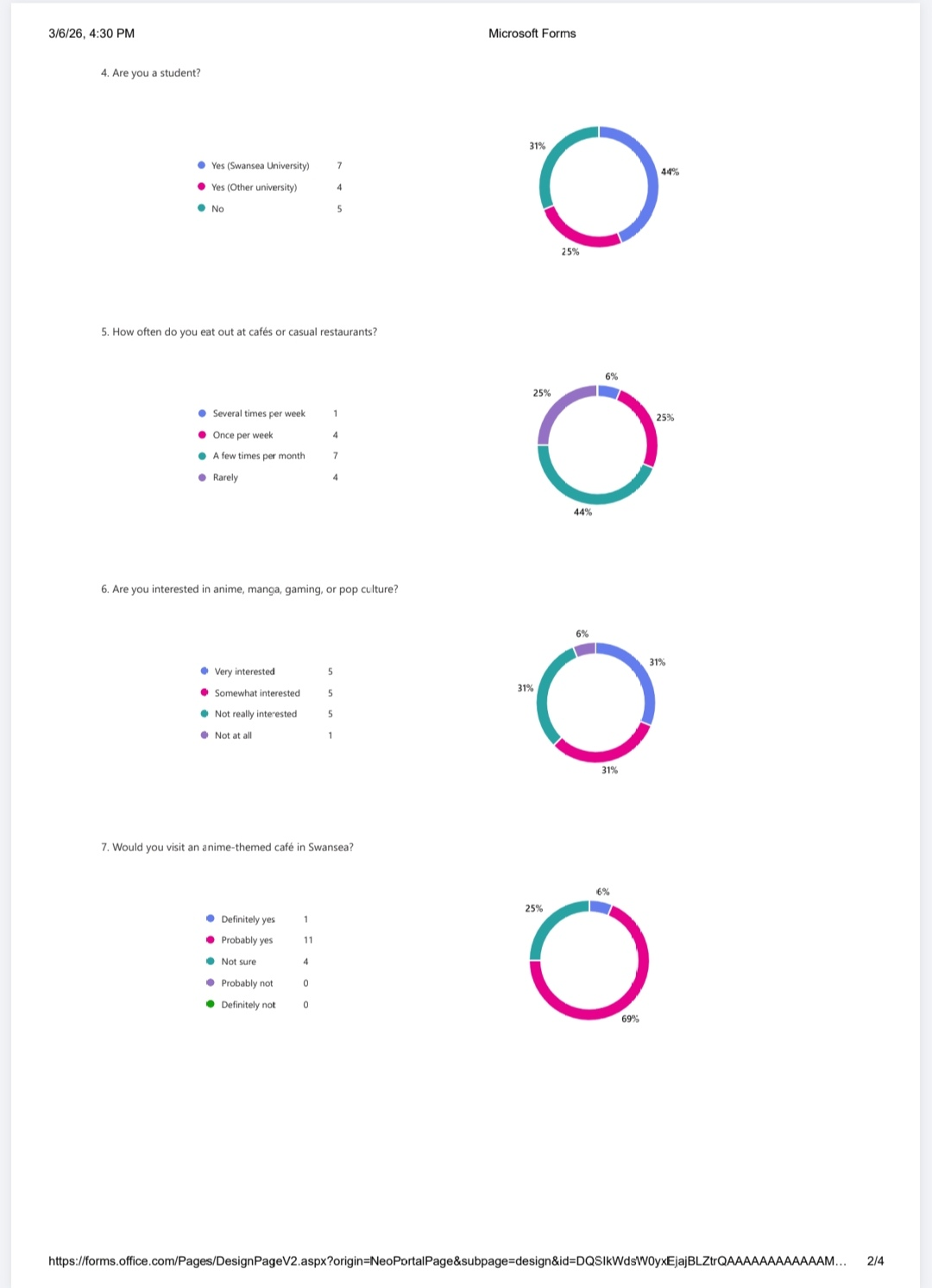
Appendix 3

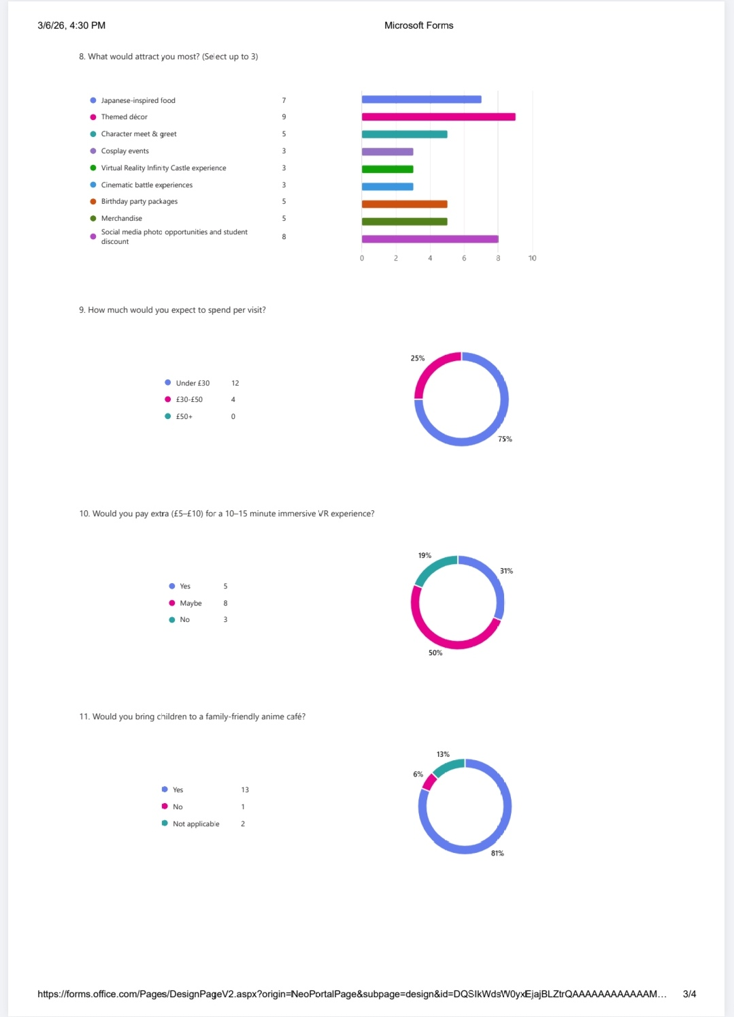
Appendix 4
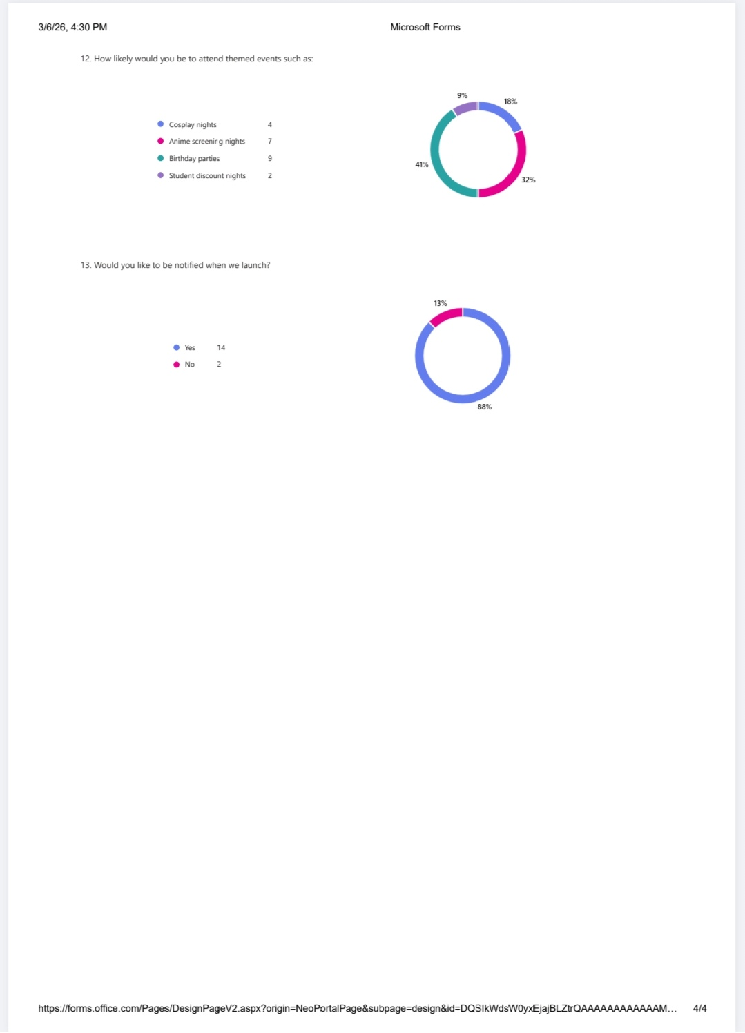

Appendix 5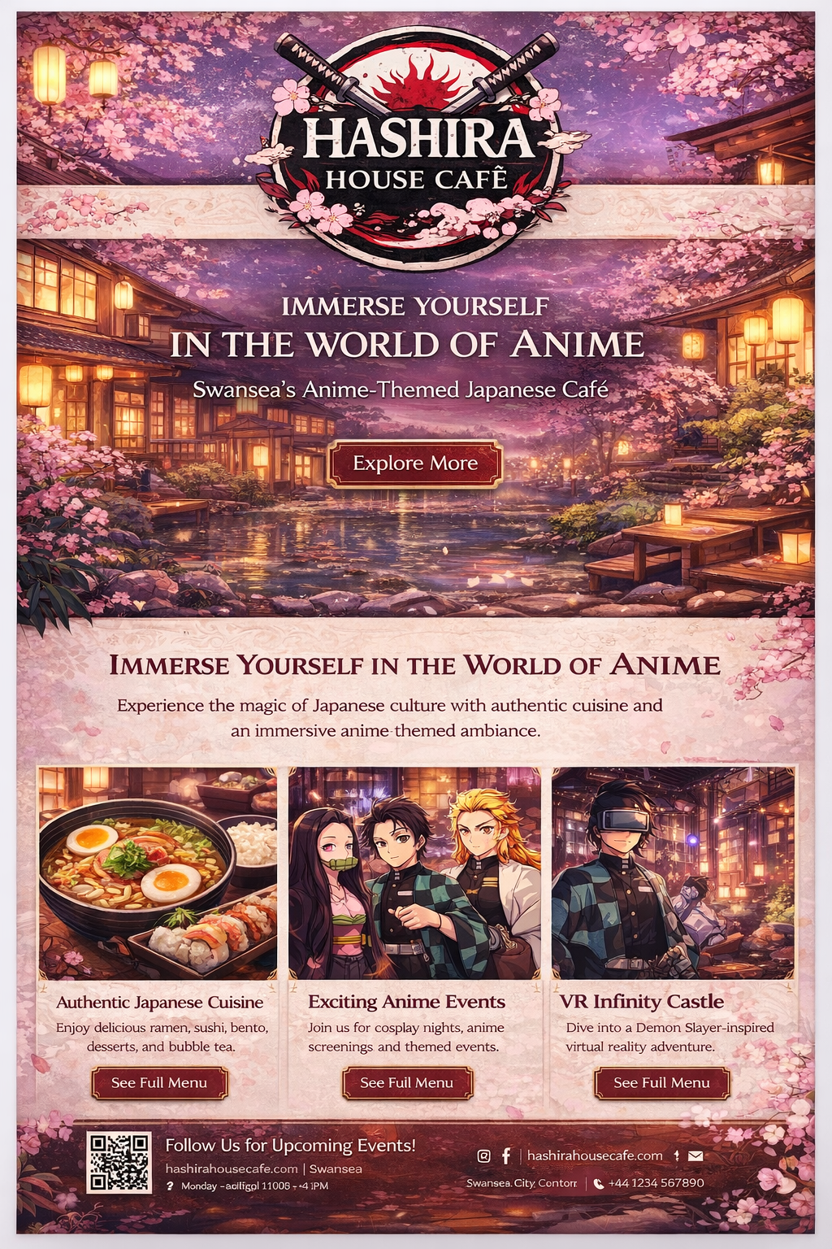
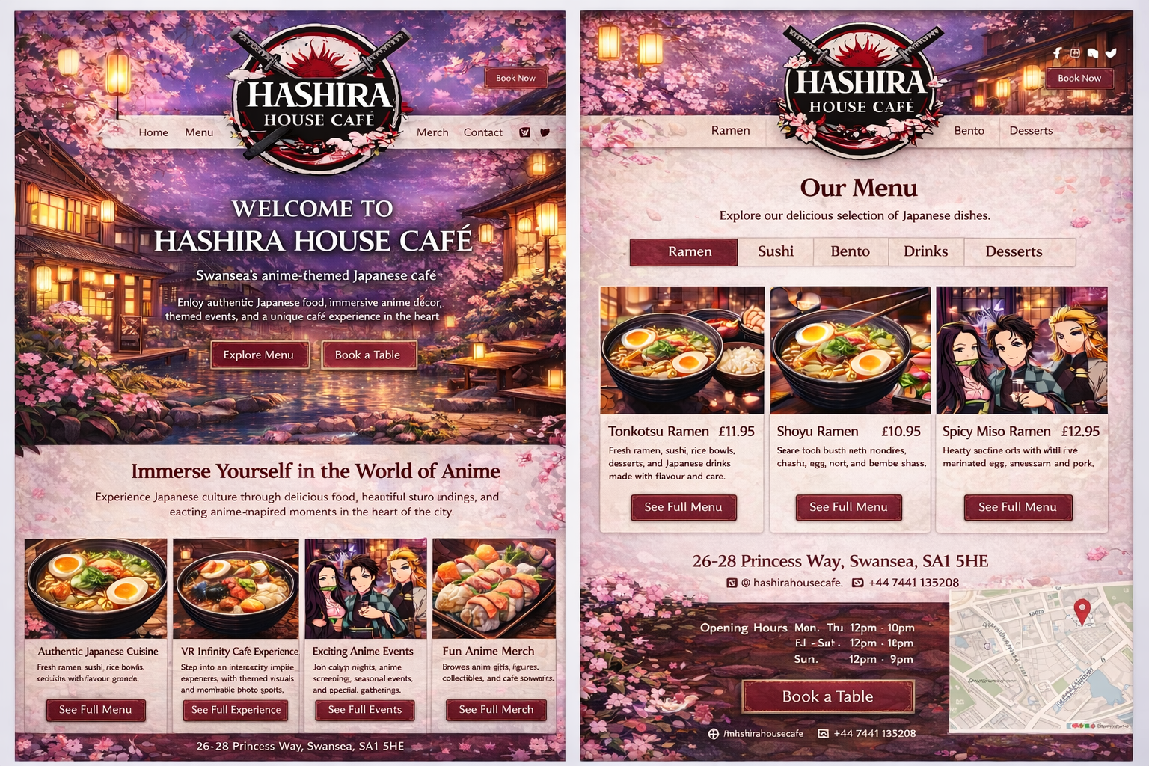
Appendix 6

APPENDIX 7

https://uowtsd.sharepoint.com/:v:/t/DigitalSkills_kqqmpl_GRP/IQCulkaEtSvRR7sT96cFMJW5ASdG9NM09OEH2ZF4oynmjpA?nav=eyJyZWZlcnJhbEluZm8iOnsicmVmZXJyYWxBcHAiOiJTdHJlYW1XZWJBcHAiLCJyZWZlcnJhbFZpZXciOiJTaGFyZURpYWxvZy1MaW5rIiwicmVmZXJyYWxBcHBQbGF0Zm9ybSI6IldlYiIsInJlZmVycmFsTW9kZSI6InZpZXcifX0%3D&email=gareth.hughes%40uwtsd.ac.uk&e=vhaIb5

