

Security Policy and Management
  - CIA Model and MITM Attack, Prevention and
  - Detection
Marius-Catalin Bobitiu - 1813436

Network OS and Security | ACCC5003 | Md Sadeque Shaikh

Table of Contents
Introduction 1
CIA Model 2
Confidentiality 3
Integrity 3
Availability 4
Man-in-the-Middle Attacks (MITM) 5
Key concepts 6
MITM Examples 6
Types of Man-in-the-Middle Attacks 7
1. Rogue Access Point 7
2. ARP Spoofing 7
3. mDNS Spoofing 7
4. DNS Spoofing 8
Man-in-the-Middle Attack Techniques 8
1. Sniffing 8
2. Packet Injection 8
3. Session Hijacking 8
4. SSL Stripping 9
How to detect a Man-in-the-Middle Attack 9
How to prevent Man-in-the-Middle Attacks 9
Conclusion and Summary 10
CIA Model 10
Man-in-the-Middle Attack 10
Recommendations 10
References 11

Introduction
Nowadays, we are using the information technology more often. The information which until recently was based on paper, now takes on an electronic form. This new way of working, in which computer has become an indispensable tool and a mean of communication, it also entails specific risks. Proper management of documents in electronic format makes it necessary to implement specific measures. The measures should ensure the protection of information against loss, destruction or unauthorized disclosure.


In this report, you will find out about the confidentiality, integrity and availability, known as the CIA Triad, which is a model designed to guide policies for information security within an organization. The Man in the Middle or MITM attack, which shortly is exactly as it sounds, it takes place between to communicating hosts, while the attacker is in the middle of the communication stealing information. And you will also learn how to prevent and detect the MITM attack, and some recommendations for your data privacy and security.

CIA Model
Confidentiality, Integrity and Availability, known as the CIA triad, is the most fundamental concept in cyber security, it serves as guiding principles for information security. It is a model designed to guide IT security policies and practices. There is no one component without the other, all three are vital for the IT security.
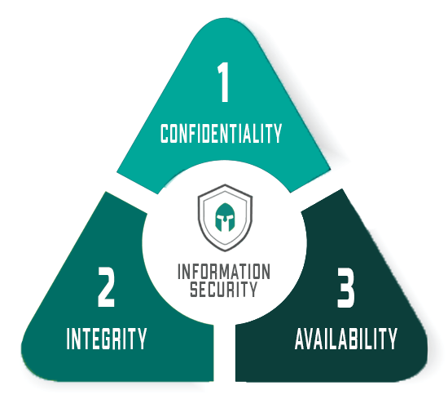

Confidentiality
Confidentiality means protecting the information from being protecting the data from being exposed to an unauthorized party. Confidentially relates to the safety of information from any unauthorized or meticulous access that may cause a danger for your organization.



Confidentiality failure means that someone who had not the right to access managed to get into the personal information. Some measures to keep the confidentiality are encryption, password, two-factor authentication and bio-metric scans.

Integrity
Integrity means maintaining the precision and the integrity of the information. Integrity relates to protecting the data from being changed or used by an unauthorized party, it involves maintaining the consistency and validity of the information for all the time.
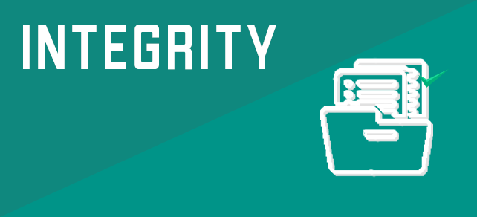

Integrity fails means someone who should not have access to the information managed to get into it and modify it before sending it to the intended recipient. Some measures to keep the data integrity are encryption, user access controls, version control, backups.

Availability
Availability means that information should be accessible anytime to the authorized people. Availability relates to the possibility of authorized users to access their data whenever they need. It also holds a great value, similarly to confidentiality and integrity.

The information is more vulnerable to availability threats than to the confidentiality or integrity. The data can easily be destroyed by the damage caused to the hard drives by natural disasters or even attacks. Some measures to mitigate the threats to availability are off-site backups, disaster recovery, redundancy, virtualization.
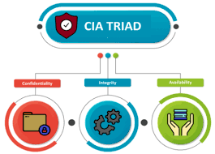

Man-in-the-Middle Attacks (MITM)
A man-in-the-middle attack or MITM is a common type of cybersecurity attack where a malicious user gets himself into a conversation between two end-users, impersonating both users and gaining the information that the two users were trying to send to each other. It allows a user to intercept, send and receive information meant for somebody else, or not meant to be send at all, without anyone knowing it until it was too late.
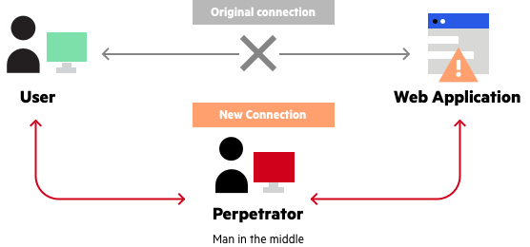

Key concepts
A man-in-the-middle attack is a type of eavesdropping attack that occurs when an unauthorized user managed to get himself as a relay/proxy into a communicating session between two end-users or systems.
A MITM attack manipulates real-time process of a transactions, conversation or a transfer of information.
MITM allows attackers to intercept, send and receive information meant to be for another user, or not meant to be send at all, without the users knowing until it is too late.

MITM Examples
(2) Erika and Luka are talking to one another through the phone in Spanish.
Lucy wants to listen to their conversation but cannot tap the phone line. She observed that Erika is always calling Luka, not the other way around, she recognized they are both speaking in Spanish, so she learned the language. She then slips a business card into Erika’s purse which says “Luka” but has Lucy’s number.
When Erika called the number, Lucy is the one to answer, so she answered in Spanish while imitating Luka’s voice. She then immediately calls Luka on another phone imitating Erika’s voice. Now Lucy continues both conversations switching between them as needed.
Erika and Luka are both certain they are talking to each other, when in reality they are talking to Lucy who relays communication between them. She knows all the secrets now and can also manipulate the information that both girls are sharing with one another.
In this scenario, the attacker tricked Erika with a fake business card, figured out the encryption (the language), and she authenticates by imitating voices.

Types of Man-in-the-Middle Attacks

- Rogue Access Point – Wireless Cards
- ARP Spoofing – Address Resolution Protocol Spoofing
- mDNS Spoofing – Multicast Domain Name Server Spoofing
- DNS Spoofing – Domain Name System Spoofing

Rogue Access Point
Gadgets equipped with remote cards will much of the time endeavor to auto interface with the passageway that is transmitting the most powerful signal. Aggressors can set up their own remote passage and trick near gadgets to join its domain. The entirety of the casualty's network traffic would now be able to be controlled by the aggressor. This is risky because now the aggressor does not need to be a trusted network, he just needs to be close enough.

ARP Spoofing
The Address Resolution Protocol (ARP) is a protocol used by Internet Protocol (IP) to map IP Network to physical MAP (Media Access Control) addresses in a local area network. When a host wants to communicate to a host with a given IP address, the ARP cache resolves the IP Address to a MAC address.
With a few correctly positioned packets, an attacker can sniff the confidential traffic between two hosts. Important data can be drew out, like “exchange of session tokens, full access to application accounts that the attacker should not be able to access.” (Anonymous, n.d.)

mDNS Spoofing
Multicast DNS is similar to DNS, only that it is done on LAN using broadcast like ARP, making it perfect aim for spoofing attacks. The local name resolution system is making the configuration simple, by resolving all the communication between the devices. The devices that use this protocol are TVs, printers, entertainment systems since they are usually on trusted networks. When an application needs to know the address of a device, an attacker could easily respond to that request with fake information, instructing it to resolve to an address it has control over. Because the devices keep a local cache of the addresses, the victim will see attacker’s device as trusted for a period of time.

DNS Spoofing
Domain Name System (DNS) resolves domain names to Internet Protocol (IP) addresses. “When using a DNS Spoofing attack, the attacker attempts to introduce corrupt DNS cache information to a host in an attempt to access another host using their domain name, such as www.example.com. This leads to the victim sending sensitive information to a corrupt host, with the belief they are sending information to a trusted source.” (Anonymous, n.d.) An attacker who has already spoofed an IP address may want to have a much easier time spoofing DNS simply by resolving the address of a DNS server to the attacker’s address.

Man-in-the-Middle Attack Techniques
- Sniffing
- Packet Injection
- Session Hijacking
- SSL Stripping

Sniffing
Attackers utilize packet capture equipment to look into packets at a low level. Using particular wireless gadgets that are authorized to be placed into scanning can permit an attacker to look packets that he should not be seeing, consisting of packets addressed to different hosts.

Packet Injection
An attacker can also influence their gadget’s tracking approach to implant malicious packets into data transmission streams. The packets can accommodate with legitimate data transmission streams, fulfilling to be part of the transmission, but malicious in essence. Packet implant generally entails first sniffing to decide how and when to make and transfer packets.

Session Hijacking
Almost every web program use a login instrument that produces a temporary session token to utilize for eventual requests to keep away from asking the person to write his password for every page he is going to use. An attacker can sniff sensitive traffic to determine the session token for a person and utilize it to make requests as the person. The attacker does now no longer need to spoof as soon as he has a session token.

SSL Stripping
Since the use of HTTPS is a popular shield against ARP or DNS spoofing, attackers use SSL stripping to hijack packets and adjust their HTTPS-based address requests to run on their HTTP equal endpoint, making the host to make requests to the server unencrypted.

Detecting a Man-in-the-Middle Attack
Detecting a Man-in-the-Middle attack is a tough task, in case you are not searching precisely to determine if your communications had been intercepted, an attacker can probably pass unnoticed until it is too late. “Checking for proper authentication and implementing some sort of tamper detection are generally the key techniques to detect a possible attack, however these approaches may require extra forensic evaluation after-the-fact. Being aware of your browsing practices and recognizing potentially harmful areas can be essential to maintaining a secure network.” (Anonymous, n.d.)

How to prevent Man-in-the-Middle Attacks
Strong Router Login Credentials – It is very important to make sure your default router login is changed. Having strong unique credentials is a very important step in protection.
Virtual Private Network (VPN) – Using VPN every time you can, will also help you protect sensitive information. A VPN encrypts your internet connection to protect the private data you send and receive.
Force HTTPS – You can always type https:// instead of http:// to make sure that the website is secure. Https can be used to securely communicate over HTTP using public-private key exchange.
Security – Installing an internet security solution on your device will also be in good hands. Always keep it up to date.

Conclusion and Summary

CIA Model
Confidentiality, Integrity and Availability, known as the CIA triad, is the most fundamental concept in cyber security, it serves as guiding principles for information security.
- Confidentiality – The information should be protected from unauthorized access.
- Integrity – The information should be consistent and valid through all time.
- Availability – The information should be accessible anytime to the authorized people.

Man-in-the-Middle Attack
A man-in-the-middle attack is a type of eavesdropping attack that occurs when an unauthorized user managed to get himself as a relay/proxy into a communicating session between two end-users or systems.
Checking for proper authentication and implementing some sort of tamper detection are generally the key techniques to detect a possible attack.
Always change your default router login, use VPN whenever you can, force https to the websites to browse securely and installing a security software are the best ways to protect yourself from a Man-in-the-Middle Attack.

Recommendations
Always stay on guard against potential phishing emails asking you to update any of your credentials. If you do receive an email like this, try to manually type the website address, while also forcing the https.
Never connect to a public Wi-fi router directly, if possible. Use a VPN to encrypt your internet connection on the public hotspot and protect your information.
Update your router login credentials to be strong and unique. Also, there is an even better way to protect, install a VPN firmware on the network router.
(Spyridon Samonas, 2018)

References
Anonymous, 2020. ProtectYourWP. [Online]
Available at: https://protectyourwp.com/definition-man-in-the-middle-mitm-attack/?v=7516fd43adaa
[Accessed August 2020]

Dan Swinhoe, 2019. CSO. [Online]
Available at: https://www.csoonline.com/article/3340117/what-is-a-man-in-the-middle-attack-how-mitm-attacks-work-and-how-to-prevent-them.html
[Accessed August 2020]

Anonymous, n.d. Rapid7. [Online]
Available at: https://www.rapid7.com/fundamentals/man-in-the-middle-attacks/
[Accessed August 2020]

Anonymous, 2019. Smart Eye Technology. [Online]
Available at: https://smarteyetechnology.com/confidentiality-integrity-availability-basics-of-information-security/
[Accessed August 2020]

Spyridon Samonas, D. C., 2018. The CIA strikes back: Redefining confidentiality, integrity and availability in security. Journal of Information System Security, 10(3), pp. 21-25.

