FOOD ALLERGY : Please speak to our staff about any allergy requerment before order.

Student Name: Salman Ali Student Id: 2119165
M. Bosch, F. Zhu, N. Khanna, C. J. Boushey and E. J. Delp, (2011) "Combining global and local features for food identification in dietary assessment", ICIP.
H. Hoashi, T. Joutou and K. Yanai, (2010) "Image recognition of 85 food categories by feature fusion", ISM,

STARTERS
Waldorf Chicken Salad with chillies 12
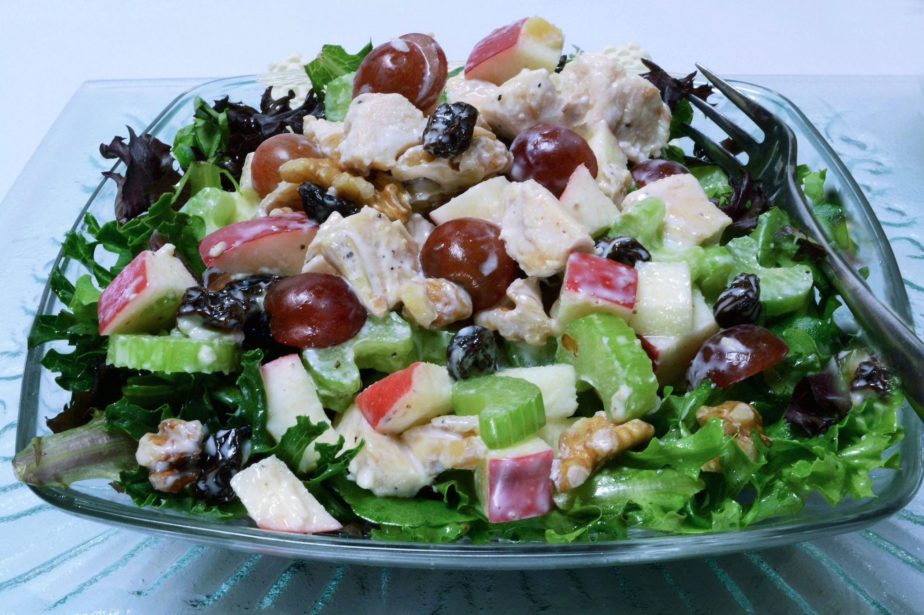
Tiger prawn & chorizo risotto 10
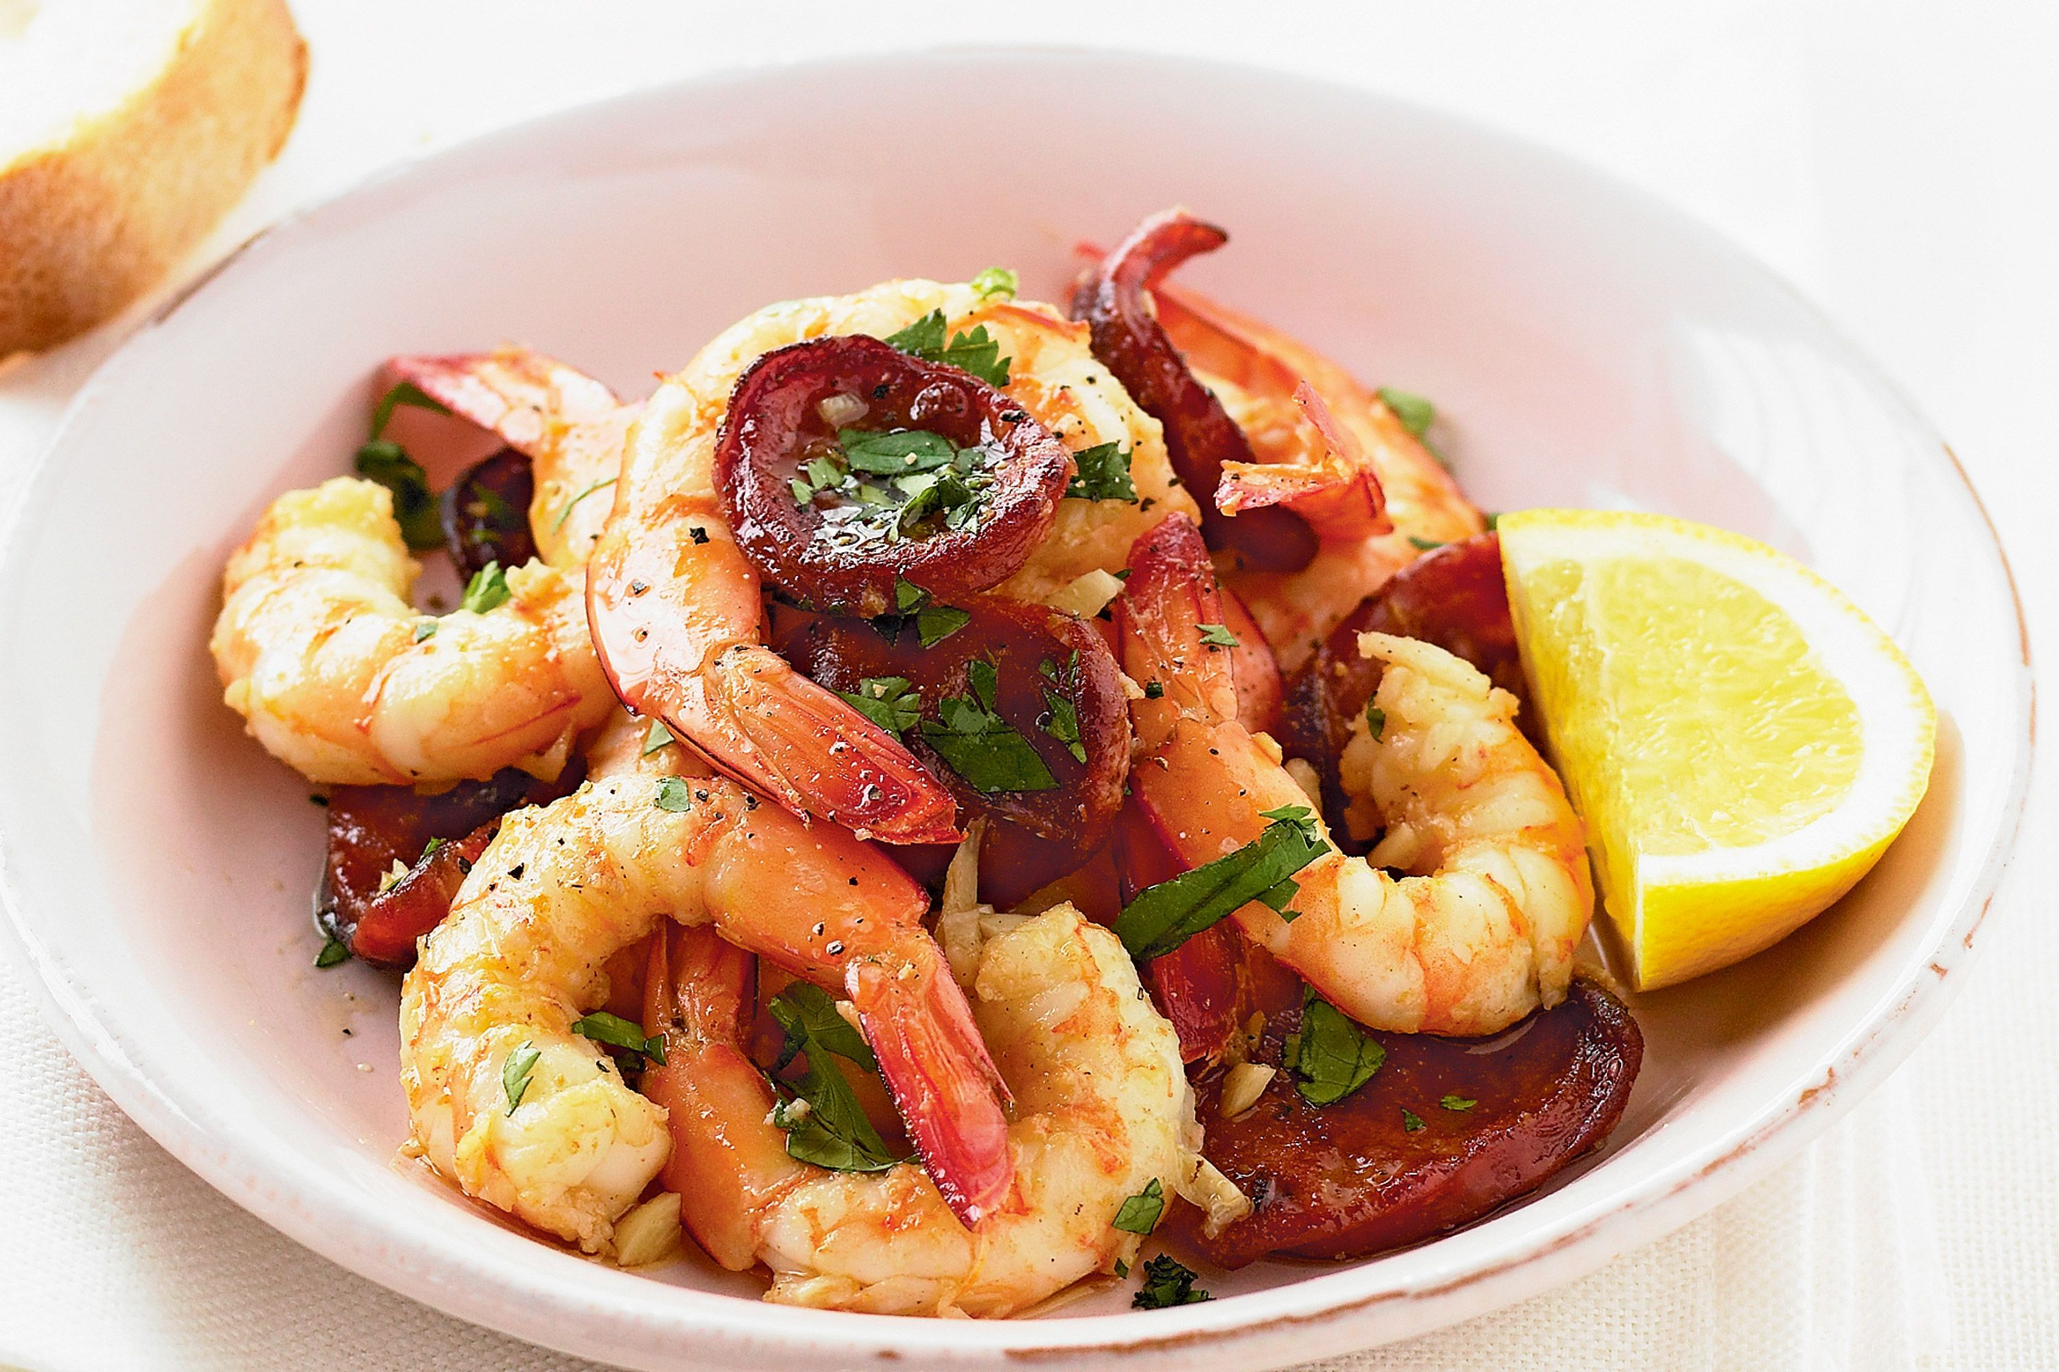
Saffron risotto with mushroom 8
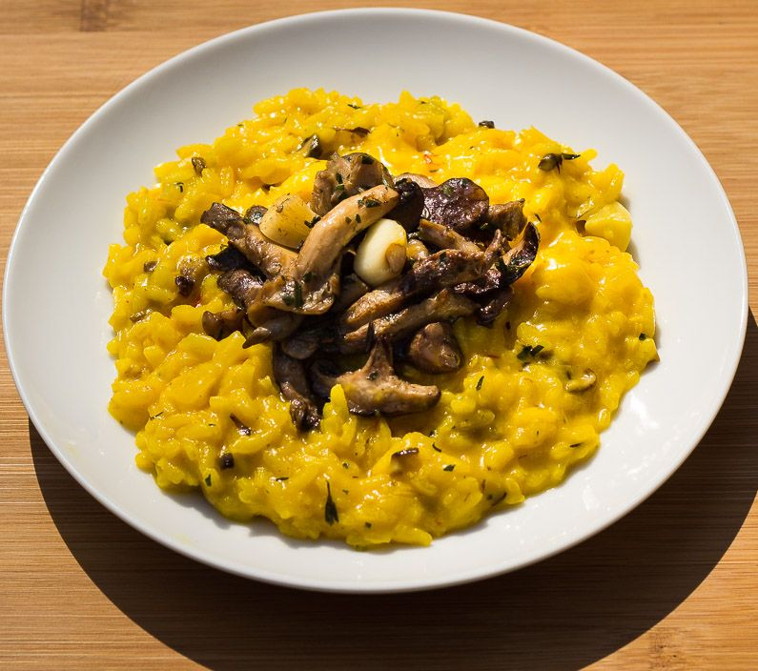
WINE LIST
DOC Montefalco Rosso 30 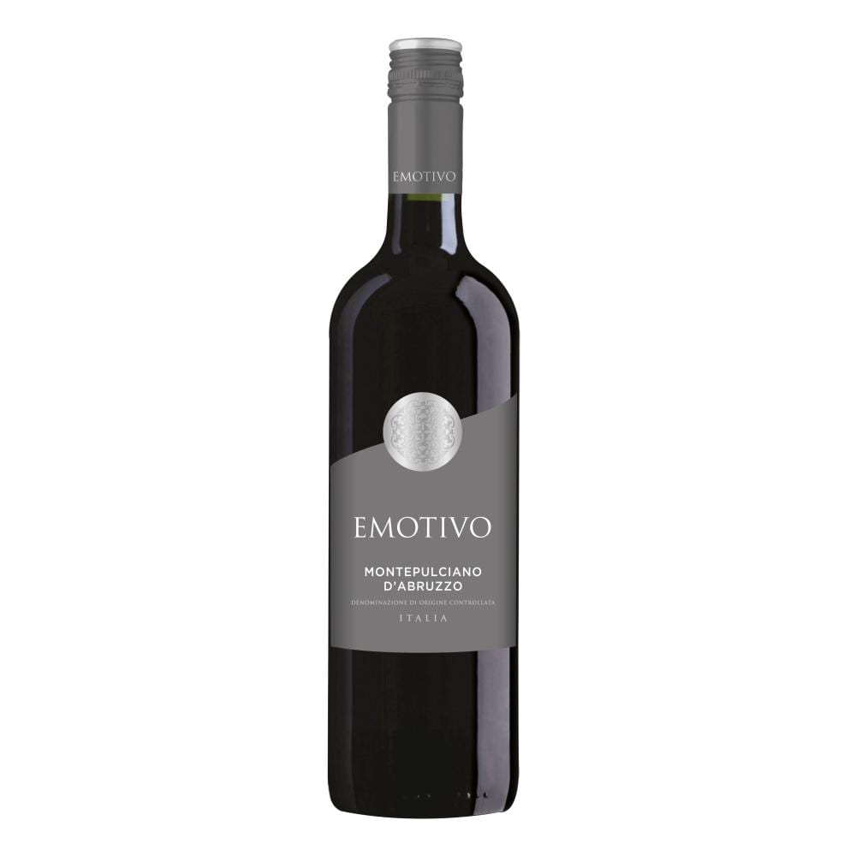
Montepulciano d'Abruzzo 25 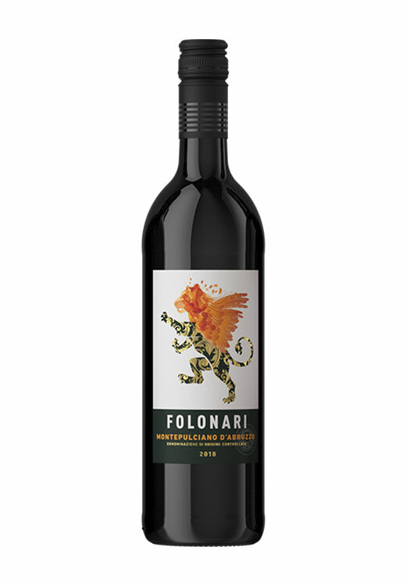
Ero d'Avola Sicilia 30 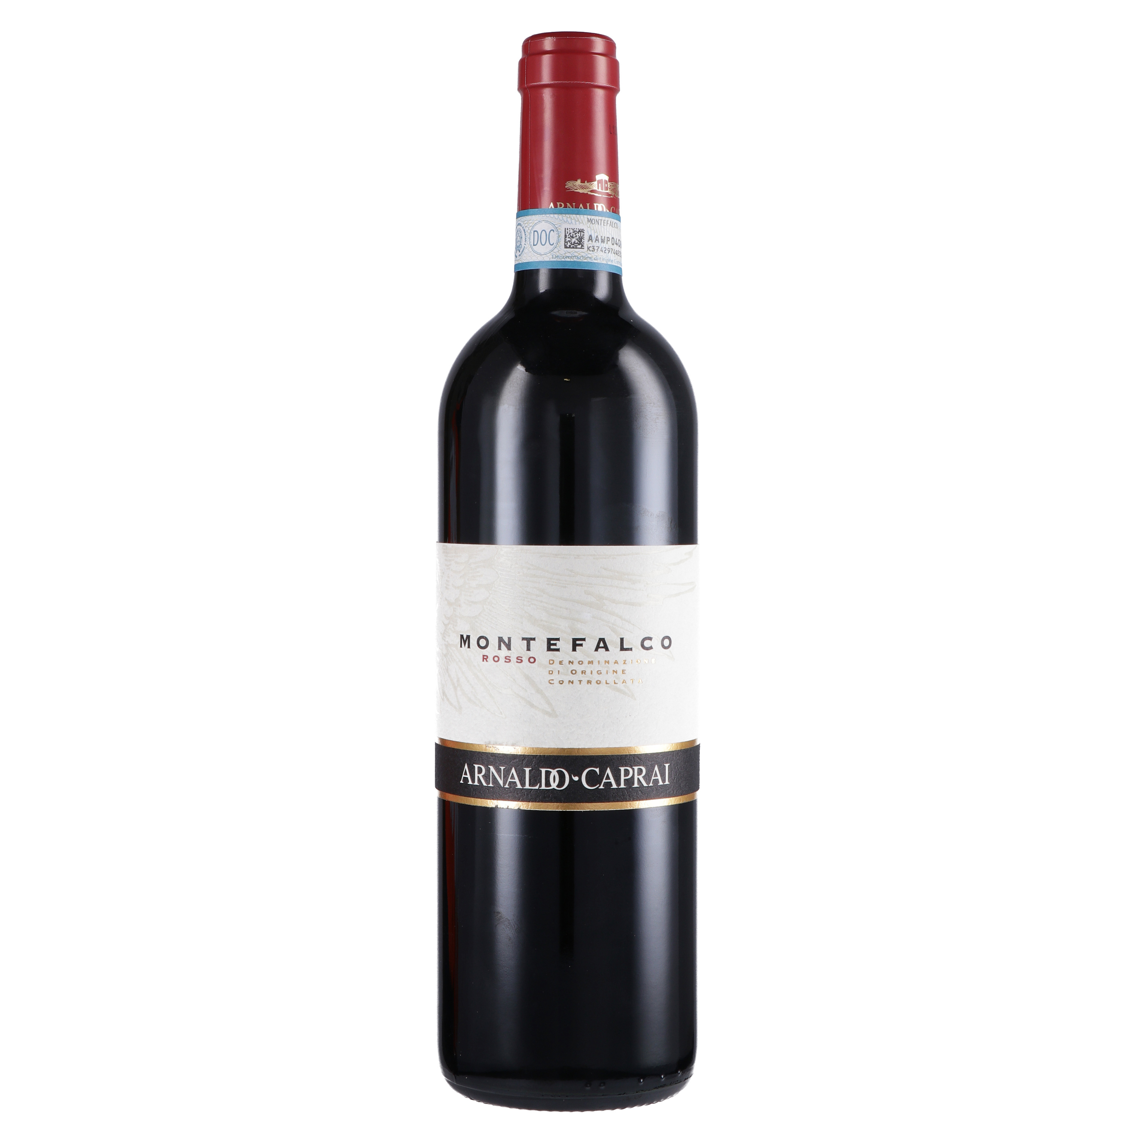

Trinity
Hotel
321 Oyster mouth, Swansea, United Kingdom
Food Menu
Takeaway Service
Service Time
Lunch: 12pm - 2pm
Dinner: 6pm – 10pm
(Everyday)
Contacts
Phone - 077743543453
Email- hoteltrinity@gmail.com
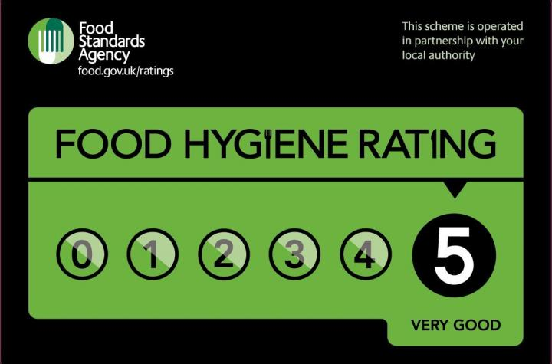

MAINS
Bashmata Biriyani & Masala Kheema 22
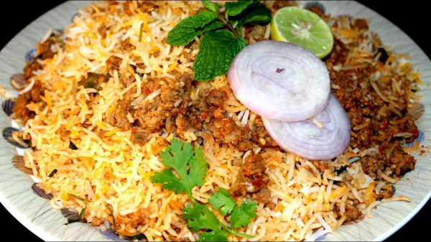
Rosted chicken breast 25
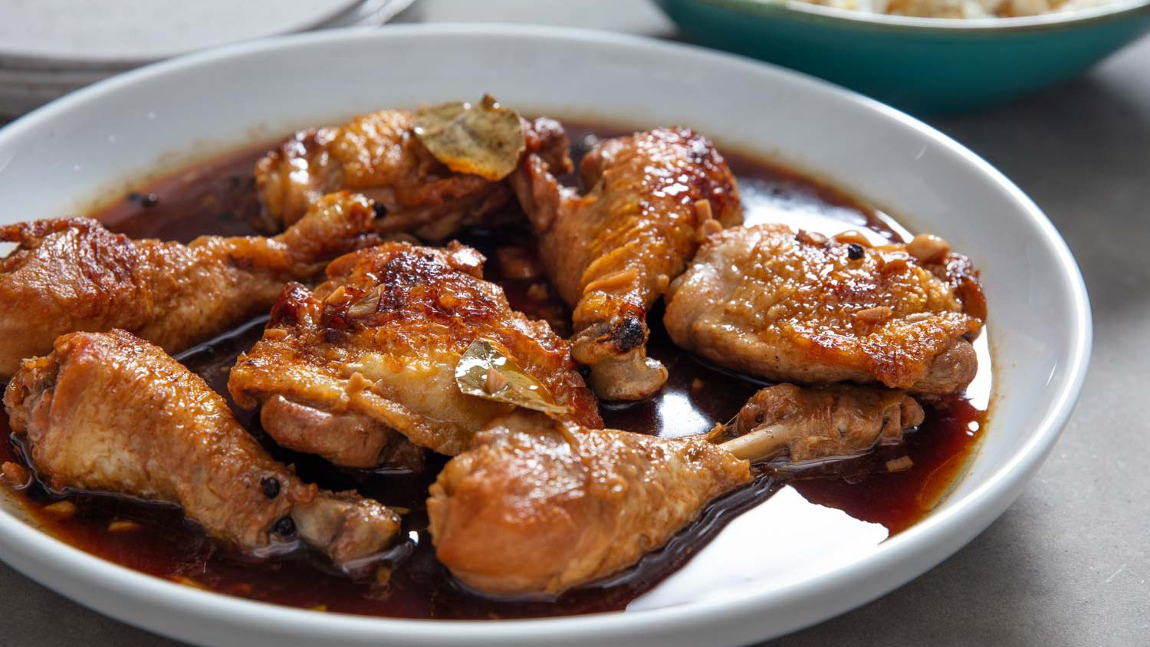
Filipino Chicken Adobo 18
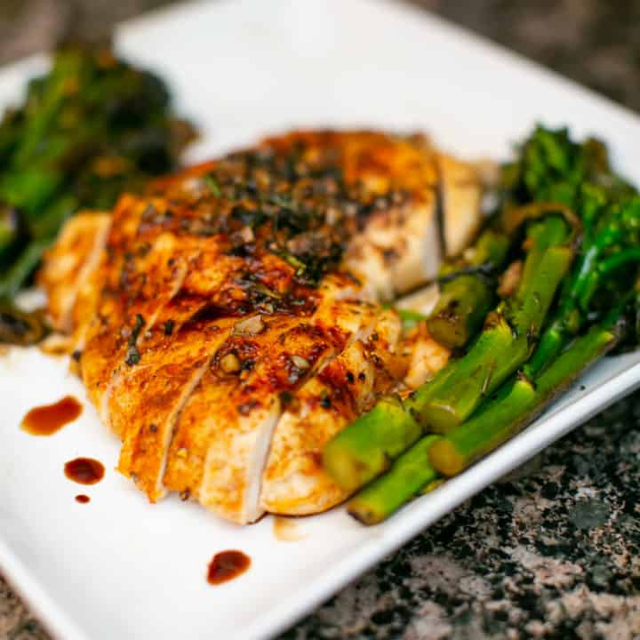
SIDES
Pizza- 9 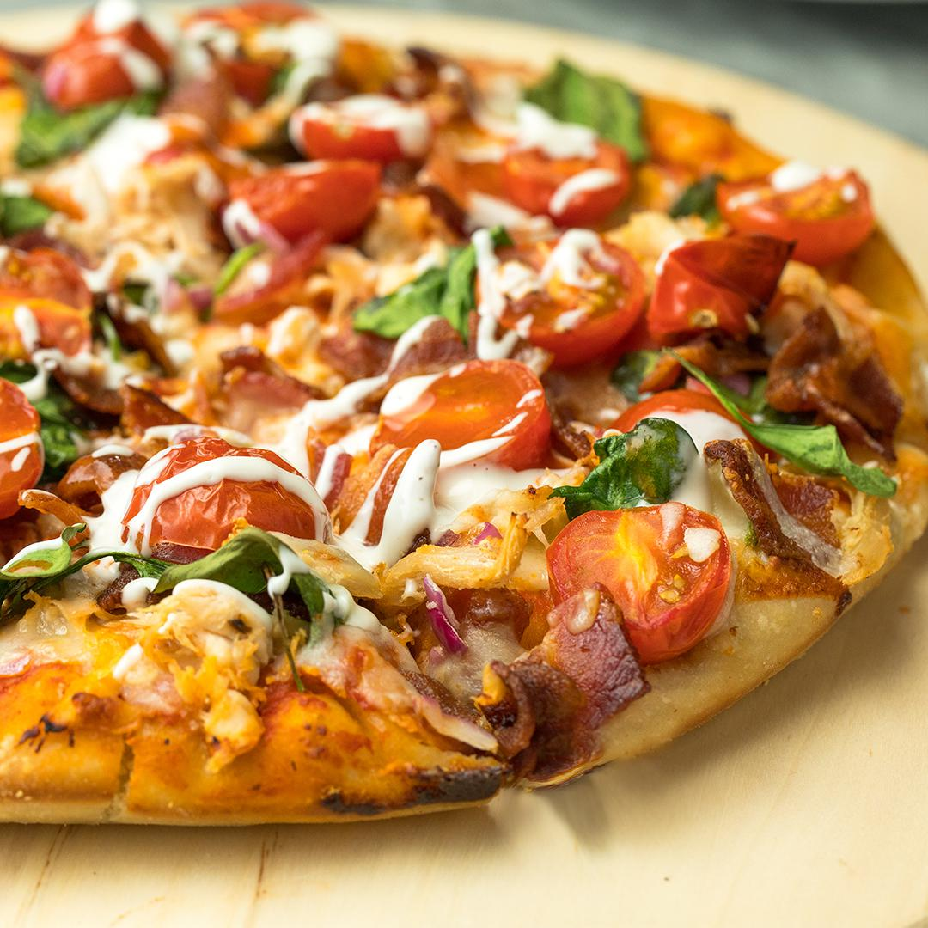
Burger-10 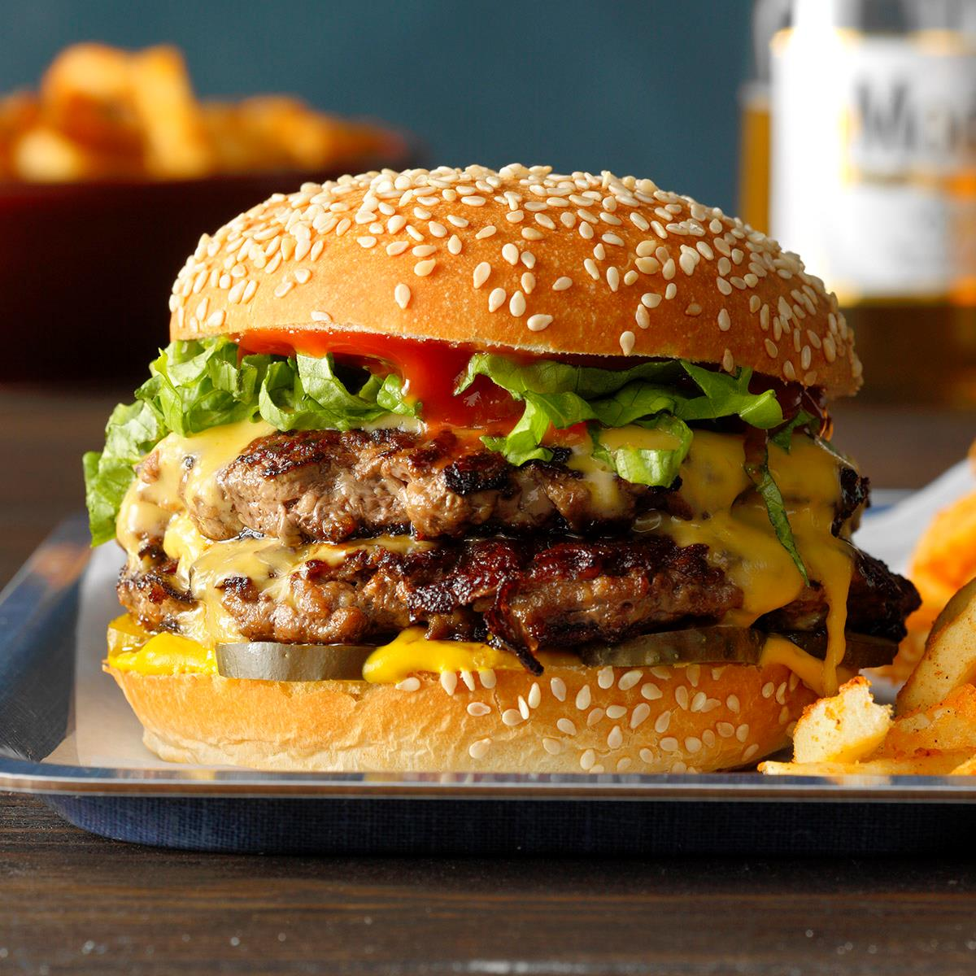
French fry- 5 

