
REPORT

Social media and customer base

Module name: Digital Skills
Module code: LCLM4002
London Campus
Student name: Emilia Deliu
Student id: 2335587
Group: 2
Dr: Hoang Nguyen

Table of Contents

Table of Contents 2
Introduction 3
Overview of social media and Its development in recent years 3
What is marketing is, what methods are open to companies, traditional vs modern. 3
Social Media as a Tool for Marketing and Reaching New Customers 4
Advantages of using social media as a tool for reaching new customers. 4
Conclusion 5
Referencing 7

Introduction
The use of social media has drastically changed the way businesses engage with their customers, by reaching the audience via social media platforms. Social and digital media refer to online platforms and websites that allow users to create, share, and interact with content. For businesses, social media is an essential way to reach customers, gain insights, as well as grow brands. This is because social media has become the dominant channel for communication, expression, and marketing. With platforms such as Facebook, Instagram, Twitter, LinkedIn, TikTok, and YouTube, businesses now have unprecedented opportunities to connect with diverse audiences worldwide. This report explores the various strategies through which social media can be leveraged to expand a customer base, while also considering the advantages and disadvantages of this approach.

Overview of social media and Its development in recent years
Social media is the collective of online communications channels dedicated to community-based input, interaction content sharing and collaboration (Ele,2019). Social media has evolved rapidly over the past two decades, transforming from simple networking sites into powerful tools for communication, entertainment, and commerce. (attached graph1 below). Initially designed to connect people, social media platforms have grown to accommodate a wide display of functions, including business marketing. The shift towards digital media has been driven by the increasing accessibility of the internet, the proliferation of smartphones, and the demand for instant, interactive communication. Today, social media is not only a platform for personal expression but also a critical part of business strategies across various industries (Bashar, 2012).

What is marketing is, what methods are open to companies, traditional vs modern.
Marketing is the practice of promoting products or services to customers, which can be approached through traditional or modern methods. traditional marketing includes strategies like print ads, tv commercials, and direct mail, which typically target a broad audience and rely on mass communication channels. in contrast, modern marketing utilises digital tools such as social media, email campaigns, influencer partnerships, and search engine optimisation to reach specific audiences with personalised content. While traditional marketing stays valuable for certain demographics and contexts, modern methods tend to be more cost-effective, measurable, and offer better targeting capabilities, making them particularly suitable for today’s highly competitive and connected marketplace. (NFI, 2021).

Social Media as a Tool for Marketing and Reaching New Customers
Social media offers a terrific way for businesses to promote their products and services and attract new customers. Through platforms like Facebook, Instagram, Twitter, and LinkedIn, companies can create engaging content, interact with their audience, and highlight what they offer. By using targeted ads, businesses can reach specific groups of potential customers based on their interests and behaviour’s. This personalised approach helps them connect with people who are more likely to be interested in what they have to offer. Moreover, social media enables businesses to communicate in real-time, respond quickly to inquiries, and build strong relationships with customers, which can lead to increased brand recognition and customer loyalty (Venkatakrishnan, 2023).

Advantages of using social media as a tool for reaching new customers.
Using social media to connect with new customers offers both advantages and disadvantages. One of the primary benefits is the extensive outreach it provides, as social media platforms boast massive user bases, enabling businesses to connect with diverse audiences worldwide. Targeted ads allow businesses to reach specific demographics, ensuring their products are seen by the right customers. Additionally, social media helps direct interaction with customers, fostering engagement and building relationships that can lead to increased customer loyalty. Moreover, social media marketing is often more budget-friendly than traditional methods, making it accessible for small businesses looking to grow. The analytics provided by these platforms offer detailed insights, allowing businesses to track their performance and make informed decisions. Consistent content sharing and engagement can significantly boost brand visibility and awareness among potential customers. Social media also enables businesses to address customer inquiries and feedback promptly, ensuring customer satisfaction. Finally, content shared on social media has the potential to go viral, reaching a large audience and increasing brand exposure. By using these advantages effectively, businesses can use the power of social media to attract new customers and expand their brand presence (Wardana, 2024).
Disadvantages of using social media as a tool for reaching new costumers.
However, alongside the advantages, there are also significant disadvantages to using social media as a brand. With the vast amount of content on these platforms, it can be challenging for businesses to stand out and effectively engage with their target audience, often leading to information overload. Negative feedback is another concern, as customers can publicly share their opinions, including negative reviews, which can harm a business's image. Managing social media accounts requires considerable time and effort, from creating engaging content to responding to messages and monitoring activity. This often leads businesses to hire social media managers, adding to their expenses. Additionally, social media platforms often update their algorithms, affecting how posts and ads are seen, which can make it difficult for businesses to consistently reach their audience. Advertisement saturation can also lead to user fatigue, making it challenging for businesses to capture and keep attention. Relying solely on social media is risky, as changes in platform policies or potential shutdowns could disrupt a business's marketing strategy. Security concerns, such as data privacy issues, pose risks to both businesses and customers. Finally, miscommunication on social media can lead to misunderstandings, resulting in confusion and potentially negative feelings of the brand (Fernandes, 2022).

Conclusion
In conclusion, using social and digital media to reach a wider costumer base has its benefits helping businesses reach their potential as well as grow their customer base. However, with benefits come disadvantages. To improve social media usage, it is crucial to focus on creating valuable content, engaging with customers actively, and managing feedback effectively. Developing a strong social media strategy that includes regular content updates, customer interaction, and adapting to platform changes is key. By consistently refining strategies, prioritising customer needs, and keeping authenticity, businesses can effectively harness social media to connect with their audience and achieve their marketing goals. (Hwang, 2015).

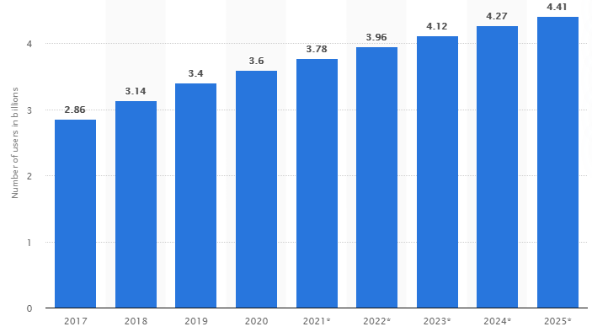

Number of global social network users 2017-2025 Graph 1

Referencing

- Bashar, A., Ahmad, I. and Wasia, M., 2012. Effectiveness of social media as a marketing tool: An empirical study. International Journal of Marketing, Financial Services & Management Research, 1(11), pp.88-99.
- Ele, A. and Dalmis, AN, 2019 Review of mobile malware forensic. The Journal of International Scientific Researches, 4(3), pp.264-282.
- Fernandes, S., Panda, R., Venkatesh, V. G., Swar, B. N., & Shi, Y. (2022). Measuring the impact of online reviews on consumer purchase decisions – A scale development study. Journal of Retailing and Consumer Services, 68
Available at: https://doi.org/10.1016/j.jretconser.2022.1030
- Hwang, H. and Kim, K.O., 2015. Social media as a tool for social movements: The effect of social media use and social capital on intention to participate in social movements. International Journal of Consumer Studies, 39(5), pp.478-488.
- NFI (2021) What is social media? Everything you need to know, Available at: https://www.nfi.edu/what-is-social-media/ Accessed: 9 August 2024
- Venkatakrishnan, J., Alagiriswamy, R., & Parayitam, S. (2023). Web design and trust as moderators in the relationship between e-service quality, customer satisfaction and customer loyalty. TQM Journal, March. Available at: https://doi.org/10.1108/TQM-10-2022-0298
- Wardana, M.A. (2024) ‘The impact of social media interaction and customer service quality on consumer trust with customer satisfaction as a mediator’, Journal Mantik, 7(4), pp.3454-3456. Available at: https://scholar.google.com/scholar?hl=ro&as_sdt=0%2C5&q=How+Does+Social+Media+Influence+Customer+Service+in+2024%3F&btnG=#d=gs_qabs&t=1723213481053&u=%23p%3DihosBvQ53yIJ

