EXAMINING THE EMPLOYEE WELLNESS PROGRAM'S EFFECTIVENESS IN FOSTERING A PRODUCTIVE AND HEALTHY WORK ENVIRONMENT

STUDENT NAME- KEVIN DABHI
STUDENT ID- 2241836

Table of Contents
Introduction 2
Background 2
The Significance of the Study 4
Research Aim and Objectives 4
Research Aim 4
Research objectives 5
Research Questions 5
The rationale of the Study 6
Literature Review 6
The significance of employee wellness program in the organisation 6
The impact of the wellness program on the workforce's mental well-being, physical health, and job satisfaction 7
Theoretical framework 8
Resource-Based View theory 8
Social Exchange theory 9
Methodology (Including ethics) 9
Research Method 9
Research Philosophy 10
Data Collection 10
Data Analysis 10
Ethical Considerations 11
Project Management of the Research (Including Potential Risks, Timeline) 11
Conclusion 13
References 14

Introduction
The study discusses “examining the employee wellness program's effectiveness in fostering a productive and healthy work environment”. Wellness programs in organisations that provide key resources for employee’s mental health, like workshops or counselling services on stress reduction, contribute towards a healthier environment of work by addressing problems. Employees who mainly feel supported and receive assistance in maintaining their mental and physical health are likely to contribute and perform well at the workplace.

Background
Wellness programs involve initiatives like fitness challenges, access towards gym memberships as well as healthy eating programs. By motivating workers to be involved in physical activity as well as make choices for healthier lifestyles, these wellness programs decrease absenteeism because of illness and enhance energy levels, resulting in high-level productivity. Most of their wellness programs integrate stress management methods like mindfulness meditation, relaxation exercises and yoga (Berry, Mirabito and Baun, 2020). By giving the workforce tools specifically to deal with stress levels, these well-being programs upgrade mental well-being as well as decrease burnout, allowing the workforce to concentrate better on their tasks. For example, Salesforce is one of the leading and strongly positioned cloud-based software organisations, that prioritizes workforce wellness mainly through the initiative of "Ohana Culture". This involves offering workforce access to yoga and mindfulness classes, resources for mental health, and holistic coverage of health insurance. Salesforce also motivates employees mainly to participate and volunteer in community wellness programs (Priya, et al. 2023).
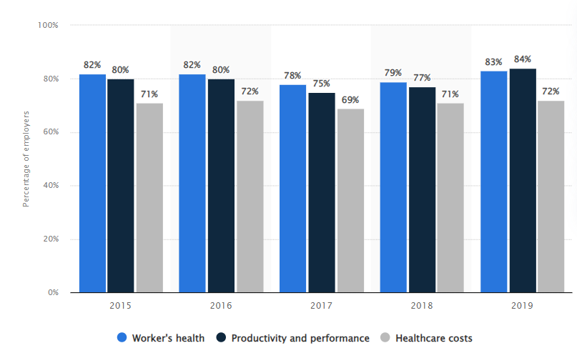
Figure 1: In the U.S Employers percentage who declared their organisation’s wellness program and initiative has positive influence from 2015 to 2019
(Source: Yang, 2023)
The above study shows the level of managers in the U.S. who mainly expressed their organization's employee program or events had positive effects between 2015 and 2019. Almsot 83% of businesses said their organisation's wellbeing and wellness program decidedly affected laborer's wellbeing starting around 2019.
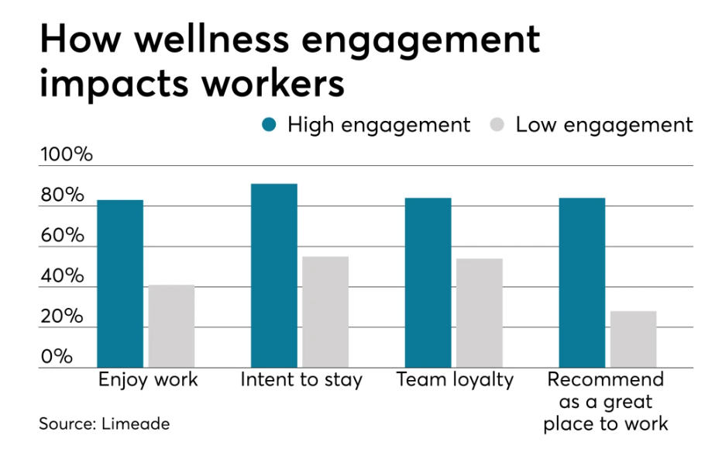
Figure: Wellness engagement effect employees
(Source: Madsen, 2020)
The above figure shows that to help employees' health and reduce costs associated with medical care, employers all over the nation continue to spend capital on well-being initiatives. According to research conducted by the "National Business Group on Health", large as well as midsize employers are mainly expected to invest almost $3.6 million on employee wellness programs in 2019. Supported by these huge investments, numerous workers are detailing positive results from these measures and drives. Among individuals with access specifically to manager-supported wellness events, 57% report that the measures emphatically affected their well-being, as per a new UnitedHealthcare wellness study.

The Significance of the Study
The significance of the research is that in the current competitive business landscape, employee well-being and health are increasingly acknowledged as an essential factor in every organisational success and growth. This research addresses the significance of workforce wellness programs specifically in fostering the mental, physical as well as emotional health of every employee. By assessing the potency of such wellness programs, enlighten their potential mainly to reinforce employee satisfaction as well as overall well-being. Moreover, a healthy environment of work is directly connected to employee performance and productivity. By examining the effect of such programs specifically on these results, the research provides useful information to companies seeking to advance their employee’s effectiveness (Vonderlin, et al. 2020). Comprehending how wellness measures impact productivity can assist resource allocation and strategic decision-making within companies. Wellness programs also play an imperative role in amplifying employee retention as well as engagement. A positive environment of work that focuses on employee well-being or welfare is likely to retain and attract top talent. Also, by exploring the connection between wellness measures and factors like turnover rates and job satisfaction, the research presents valuable insights and knowledge into their effect on employee retention tactics. Workforce wellness programs contribute towards improving organizational culture and ambience by directing an organisation’s commitment towards supporting its workforce's well-being and health (Leitão, Pereira and Gonçalves, 2021). This research searches how wellness measures influence employee perceptions and the organisational culture of their company. Comprehending these dynamics helps companies to stimulate a supportive and positive culture that enriches employee loyalty and satisfaction.

Research Aim and Objectives

Research Aim
The research aim is to analyse the effectiveness and potency of an employee wellness program specifically in nurturing a healthy as well as productive work environment within a business organisation.

Research objectives
- To understand the significance of wellness programs for employees and their effect on employee health and productivity.
- To examine the components, features and implementation of employee wellness programs in multiple organizations.
- To analyse the effect of the wellness program on the workforce's mental well-being, physical health, and job satisfaction.
- To identify and examine the factors impacting the engagement of employees with the wellness program.
- To determine any challenges or barriers obstructing the successful implementation as well as the effectiveness of workforce wellness programs.
- To evaluate the relationship between indicators of productivity, like turnover rate, job performance absenteeism rates and workforce participation mainly in the wellness program.
- To provide suggestions for improving the wellness program's effectiveness in nurturing a healthy as well as productive environment of work.

Research Questions
- What is the significance of wellness programs for employees and their effect on employee health and productivity?
- What are the components, features and implementation of employee wellness programs in multiple organizations?
- What are the effects of the wellness program on the workforce’s mental well-being, physical health, and job satisfaction?
- What are the factors key impacting the engagement of employees with the wellness program?
- What are the challenges or barriers obstructing the successful implementation as well as the effectiveness of workforce wellness programs?
- What is the relationship between indicators of productivity, like turnover rate, job performance absenteeism rates and workforce participation mainly in the wellness program?
- What are the suggestions for improving the wellness program's effectiveness in nurturing a healthy as well as productive environment of work?

The rationale of the Study
The rationale of this research is that the employee’s well-being is important for their overall performance, satisfaction, and engagement in the organisation. A wellness program mainly aims to help and support the workforce in maintaining mental, emotional as well as physical health, which directly affects their satisfaction and productivity level at work. With growing awareness of the prominence of employee well-being or welfare for organizational success and growth, there's an increasing interest in comprehending how workforce wellness programs mainly contribute towards nurturing healthier as well as highly productive work ambience (Gorgenyi-Hegyes, Nathan and Fekete-Farkas, 2021). Employers acknowledge that a healthier workforce tends to be highly productive, engaged and less susceptible to absenteeism, which eventually affects the bottom line. Most business organizations view workforce wellness measures as a key part of their comprehensive CSR efforts. Also, by showing a commitment as well as dedication towards employee well-being and health, the business organisation can strengthen their reputation and image as a socially accountable entity and enhance its employer brand. Many companies invest important resources mainly in healthcare advantages for their workforce. By fostering wellness as well as preventing health problems, organizations are able to decrease healthcare expenses related to absenteeism, chronic diseases and presenteeism (Galanti, et al. 2021). A healthy and collaborative workforce is always a highly productive one. The study recommends that the workforce who are mentally and physically healthy also tend to be more energetic, resilient and focused, resulting in higher productivity levels as well as better performance results. Providing inclusive wellness programs is a competitive edge in retaining and attracting top talent.

Literature Review

The significance of employee wellness program in the organisation
In the view of Tringali et al. (2022), wellness programs in the workplace for employees are coordinated and harmonised, employer-sponsored measures that mainly aim to help and support the workforce by providing opportunities and resources for employees, as well as sometimes their close members or families specifically to sustain and adopt healthy behaviours that aid decrease chronic disease risk, and improve different well-being dimensions involving emotional, physical, financial and social health. Also, enhancing work performance as well as quality of life. Inclusive workforce wellness programs always include the promotion and delivery of health risk evaluation, health education and coaching associated with nutrition and physical activity, and interventions for stress management and tobacco cessation. When the workforce is mentally and physically well, they become highly productive. Employee wellness programs that stimulate healthy habits, like balanced nutrition, stress management and regular exercise, result in enhanced energy and concentration levels, and lead to a high level of productivity. Workforces who take part in wellness events are less possibility to take time off or sick days because of health-associated problems (Johnson, Park and Chaudhuri, 2020). By encouraging healthy behaviours as well as giving resources for precautionary care, companies decrease absenteeism as well as confirm that their employees remain constantly engaged. Investing capital and time in workforce wellness shows that the company cares about the employee’s well-being beyond their total work output. Thus, this enhances job satisfaction and morale, resulting in higher employee retention and engagement levels. For example, Google is widely known and famed for its inclusive wellness program the employees, which involves on-site fitness centers, options for healthy meals in cafeterias, meditation and mindfulness classes, and also access towards onsite services for healthcare. This company also gives financial incentives mainly to the workforce who take part in wellness programs or activities and accomplish health-related objectives.

The impact of the wellness program on the workforce's mental well-being, physical health, and job satisfaction
According to the view of Cleary et al. (2020), wellness programs always involve activities like mindfulness sessions, workshops for stress management and yoga. These help the workforce learn overcoming mechanisms and decrease stress levels, which means upgrading mental well-being. Also, through training and education on the awareness of mental health, the workforce enhances resilience in opposition to common stressors of the workplace. Feeling supported, cared and valued by their manager through wellness measures boost morale as well as contributes towards a positive environment of work. Wellness programs always give resources as well as education or knowledge on nutrition, preventive screenings and smoking cessation. These endeavours foster healthier lifestyle decisions among employees, resulting in better physical health. In addition, wellness programs in the organisation that provide flexible arrangements of work or support specifically for personal time contribute towards a better balance between professional and personal life, which is connected to job satisfaction (Chung, et al. 2020). Taking part in wellness events and activities stimulates a sense of community mainly among the workforce, enhancing workplace bonds and satisfaction mainly with the workplace. For example, Salesforce provides many wellness benefits, involving wellness reimbursement events that cover fitness classes, wellness-associated expenses and gym memberships. The business organisation provides meditation and mindfulness spaces in its workplace for stress reduction and foster mental well-being. Therefore, Salesforce's focus on workforce wellness has largely contributed towards high retention and job satisfaction levels.

Theoretical framework

Resource-Based View theory
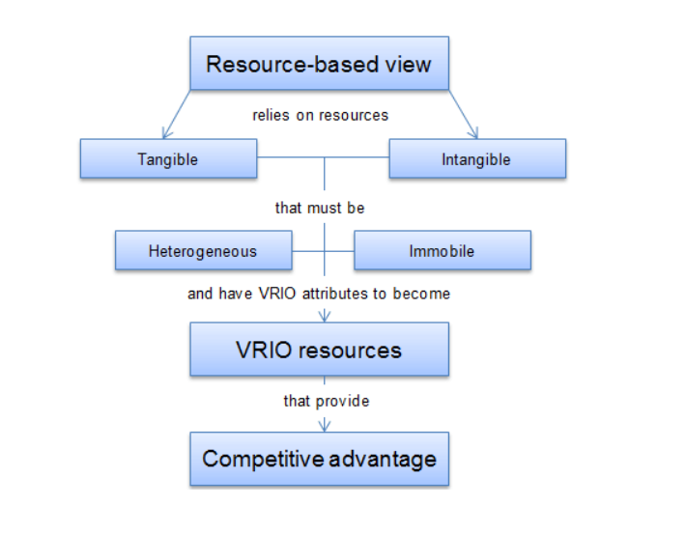
Figure: Resource-Based View theory
(Source: Jureviciusand Nagawalliya, 2023)
The theory underscores the prominence of human capital as an important organizational resource. Workforce well-being as well as health are human capital critical components, as they also directly impact engagement, performance and productivity (Barney, Ketchen and Wright, 2021). Organizations utilise this theory to focus on investments mainly in wellness programs of employees as a way of improving human capital as well as obtaining a competitive edge through a productive and healthier workforce.

Social Exchange theory
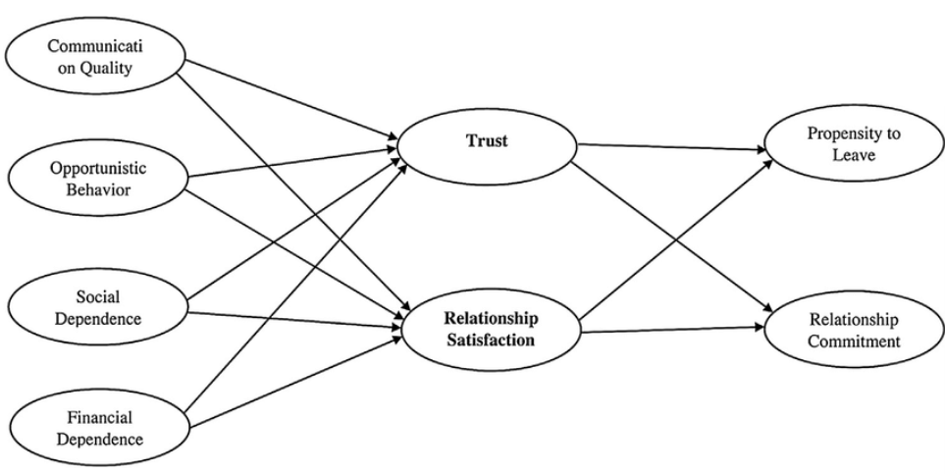
Figure: Social Exchange theory
(Source: Jeong and Oh, 2020)
This theory underlines the significance of social connection as well as support networks mainly in shaping people's behaviour and results. In the wellness program context, social support specifically from supervisors, organizational leaders and coworkers plays an important function in fostering participation, strengthening healthy behaviours and sustaining motivation (Arsawan, et al. , 2020). Companies can take advantage of this theory’s principles by simplifying the social support network formation within the organisation, giving opportunities for the workforce to mainly connect with peers or associates who share the same health objectives, and nurturing the social support exchange and motivation for wellness-associated with activities.

Methodology (Including ethics)

Research Method
The investigator in the whole research will use and follow the secondary research method because this includes examining information that has formerly or has already been amassed by other organizations as well as researchers. In the study of analysing an employee wellness program, there are already reports, data and studies available that examine the effectiveness and success of wellness programs in different business organizations (Thunberg and Arnell, 2022). Using these existing data or sources can present valuable insights and knowledge without the requirement to organise new information collection, saving resources and time.

Research Philosophy
The investigator in the whole research will use and follow the interpretivism philosophy because this philosophy allows the investigator to delve into the distinctive circumstances of the workplace as well as how the workforce experiences and interprets the wellness program (Alharahsheh and Pius 2020). This approach recognizes that employees may respond and perceive to the wellness program distinctively based on their professional and personal backgrounds. This philosophy lines up with the secondary qualitative research technique, which is important for searching the depth and richness of workforce experiences and organisation reports mainly with the wellness initiative and program. The analysis techniques of qualitative data like narrative analysis or thematic analysis will be utilised to uncover themes, meanings and patterns embedded in organisation performance reports about their employee involvement in the program.

Data Collection
The investigator will utilise the secondary data collection techniques because of the availability of all existing data pertinent to the subject matter. Secondary data collection allows the examiner to amass insights and knowledge from multiple sources, involving industry reports, academic journals, organizational case studies and government publications (Pandey and Pandey, 2021). This broader outlook can present an inclusive understanding of workforce wellness programs, involving different strategies, outcomes and approaches across different industries, organisations and contexts.

Data Analysis
The investigator in the whole research will use and follow the thematic data analysis because this data analysis method allows the examiner to flexibly examine a large range of valuable data sources, involving existing literature, documents and reports associated with employee wellness programs. Thus, this form of flexibility is specifically effective in secondary exploration where data accumulation techniques are predetermined (Peel, 2020). This data analysis enables for a deep study of the underlying patterns and themes within the available literature on workforce wellness programs. Also, by systematically categorizing and analyzing these themes, the examiner can acquire a holistic understanding of the factors impacting such a program’s effectiveness.

Ethical Considerations
The examiner must avoid copying or plagiarism by rightly citing as well as referencing every original information source. They should appropriately represent the key findings, arguments and ideas of others as well as give credit mainly where it is attributable. The examiner also should critically assess the both reliability and quality of the secondary information they represented and used. They must examine the source's credibility and take into account any limitations or biases that may impact the data interpretation. Affirming data integrity and uprightness is important for supporting the trustworthiness and validity of this research findings.

Project Management of the Research (Including Potential Risks, Timeline)
Project management of this research study involves choosing the research subject matter, identifying the aim, objectives and questions, organising a literature review, preparing the research methodology, accumulating and analysing information, presenting key findings of the research, and submitting the complete report. Apart from this, it also guarantees a systematic, organised way to complete research and effective transmission of results.
The timescale is shown in a Gantt Chart:
Activity | Duration | Week 1 to 2 | Week  3 to 4 | Week  5to 6 | Week  7 to 8 | Week  9 to 10 | Week  11 to 12 | Week 13 to 14 | Week  15 to 16
Research topic selection | 1 week
Design research aim, objective and questions | 2 week
Focus on literature and information | 3 week
Proposal submission | 2 week
Preparing introduction | 4 weeks
Preparing Literature review | 4 weeks
Preparing methodology | 5 weeks
Analysing and accumulating data | 5 weeks
Preparing the conclusion | 4 weeks
Submission of the final file | 1 weeks

Table: Gantt Chart
(Source Created by Author)
Potential Risk
Misinterpretation of data, ethical issues, limited access data and unpredicted problem are all potential risk in the research. To manage these risks as well as maintain the reliability, validity, authenticity and moral uprightness of this research project, management techniques will be adopted.

Conclusion
It is concluded that wellness programs for employees play an essential function in nurturing the employee’s holistic well-being, driving the success of the organisation, and developing a positive environment and culture of the workplace. Wellness programs have a varied or multifaceted influence on the employees, improving both organizational culture and individual well-being. However, the success of these wellness programs differs depending on aspects like employee participation, organizational support and program design. Adaptation and regular assessment of wellness measures are important to confirm they align with the evolving requirements of the employees.

References
Alharahsheh, H.H. and Pius, A., 2020. A review of key paradigms: Positivism VS interpretivism. Global Academic Journal of Humanities and Social Sciences, 2(3), pp.39-43.
Arsawan, I., Wirga, I.W., Rajiani, I. and Suryantini, N.P.S., 2020. Harnessing knowledge sharing practice to enhance innovative work behavior: the paradox of social exchange theory. Polish Journal of Management Studies, 21.
Barney, J.B., Ketchen Jr, D.J. and Wright, M., 2021. Resource-based theory and the value creation framework. Journal of Management, 47(7), pp.1936-1955.
Berry, L., Mirabito, A.M. and Baun, W.B., 2020. What's the hard return on employee wellness programs? (pp. 2012-2068). SSRN.
Chung, H.C., Chen, Y.C., Chang, S.C., Hsu, W.L. and Hsieh, T.C., 2020. Nurses’ well-being, health-promoting lifestyle and work environment satisfaction correlation: A psychometric study for development of nursing health and job satisfaction model and scale. International journal of environmental research and public health, 17(10), p.3582.
Cleary, M., Schafer, C., McLean, L. and Visentin, D.C., 2020. Mental health and well-being in the health workplace. Issues in Mental Health Nursing, 41(2), pp.172-175.
Galanti, T., Guidetti, G., Mazzei, E., Zappalà, S. and Toscano, F., 2021. Work from home during the COVID-19 outbreak: The impact on employees’ remote work productivity, engagement, and stress. Journal of occupational and environmental medicine, 63(7), p.e426.
Gorgenyi-Hegyes, E., Nathan, R.J. and Fekete-Farkas, M., 2021. Workplace health promotion, employee wellbeing and loyalty during COVID-19 Pandemic—Large scale empirical evidence from Hungary. Economies, 9(2), p.55.
Jeong, M. and Oh, H., 2020. Business-to-business social exchange relationship beyond trust and commitment. International Journal of Hospitality Management, 65, pp.115-124.
Johnson, K.R., Park, S. and Chaudhuri, S., 2020. Mindfulness training in the workplace: Exploring its scope and outcomes. European Journal of Training and Development, 44(4/5), pp.341-354.
Jurevicius, O. and Nagawalliya, G., 2023. All you need to know about resource-based view, Strategic Management Insight. Available at: https://strategicmanagementinsight.com/tools/resource-based-view/ (Accessed: 02 February 2024).
Leitão, J., Pereira, D. and Gonçalves, Â., 2021. Quality of work life and contribution to productivity: Assessing the moderator effects of burnout syndrome. International Journal of Environmental Research and Public Health, 18(5), p.2425.
Madsen, R., 2020. Making wellness work: 5 ways employers can improve programs, Employee Benefit News. Available at: https://www.benefitnews.com/opinion/how-employers-can-improve-wellness-programs (Accessed: 02 February 2024).
Pandey, P. and Pandey, M.M., 2021. Research methodology tools and techniques. Bridge Center.
Peel, K.L., 2020. A beginner's guide to applied educational research using thematic analysis. Practical Assessment, Research, and Evaluation, 25(1), p.2.
Priya, J., Machani, P., Agyei, I.T., Suryanarayana, N.V.S., Thandayuthapani, S. and Lourens, M., 2023. Effects of performance and target pressure on the psychological well-being of corporate employees. Journal for ReAttach Therapy and Developmental Diversities, 6(8s), pp.218-227.
Thunberg, S. and Arnell, L., 2022. Pioneering the use of technologies in qualitative research–A research review of the use of digital interviews. International Journal of Social Research Methodology, 25(6), pp.757-768.
Tringali, V., Fritts, M., Giandonato, J., Luehr, M., Reilly, C., Moody, J. and Aldridge, C., 2022. The relationship of workplace health climate and participation in an employee wellness program. American Journal of Health Research, 10(1), pp.13-19.
Vonderlin, R., Biermann, M., Bohus, M. and Lyssenko, L., 2020. Mindfulness-based programs in the workplace: a meta-analysis of randomized controlled trials. Mindfulness, 11, pp.1579-1598.
Yang, J., 2023. Impact on worker health, productivity and healthcare costs from wellness programs U.S. 2019, Statista. Available at: https://www.statista.com/statistics/731721/impact-on-workers-from-company-offered-wellness-programs-in-us/ (Accessed: 02 February 2024).

