Psychology in Health and Social care

Name: Nisa Azad
Student number: 2025737
Module code: BMHP4003_BIRM
Lectures name: Muhammad Hossain

Contents
Introduction 3
Statistics of re-offending 4
Social identity theory 4
The theory of planned behaviour 5
Frustration aggression hypothesis 7
Conclusion 8
References 8

Introduction
This report will aim to assist the team to be aware of the potential causes for Mason’s behaviour and aid them to understand why Mason may behave this manner. This will support the team to then create a support plan for Mason in the upcoming weeks. This report will examine certain theories such as social identity theory, theory of planned behaviour and frustration aggression hypothesis and it will also describe how these theories could be relevant to the case study and Mason’s actions and behaviour. Additionally, this paper will exhibit recent evidence implying the statistics of re-offending.
Statistics of re-offending
GOV UK (2022) suggests the total proven reoffending rate have reduced in 2020 by 2.0% from the same time scale in 2019 and this is the least rate in the timeseries, and they think it is due to the offenders’ associates were impacted by the effects of Covid-19 and the pandemic. During this period young offenders reoffending rate dropped by 2.3 % from the same period in the previous year.
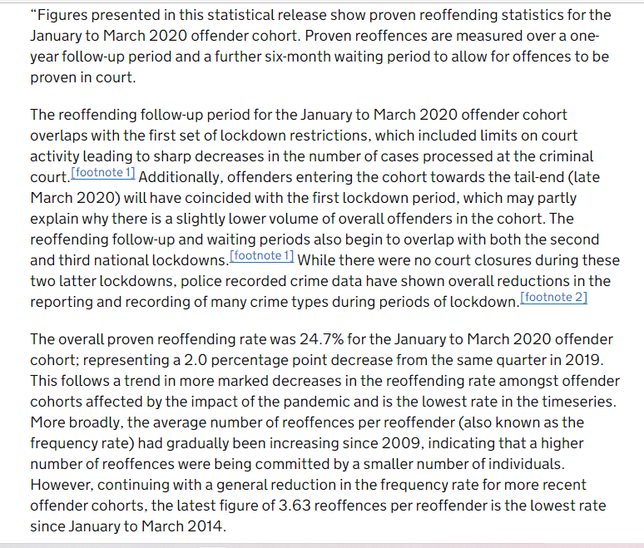

Social identity theory

Mcleod (2008) and entails social identity theory which is established by Henry Tajfel in the 1970s describes the association among personal and social identities. Social identity theory foresees which environment individuals believe they are individuals or as a group member.
Corresponding to the theory, Abrams ET, AL (1990) declares they are three psychological processes, these processes describe how each individual generate and distinguish their position in the environment. The three processes are social categorization, social identification, and social categorization. When individuals class themselves and other individuals as group members rather than independent and distinctive individual this is called social categorization. Individuals who know who they are and how to relate to others, this is linked to how these individuals examine other individuals and groups who around them, this is called social identification. When individuals from groups assess their group with additional groups to recognise, they are better and greater, these groups have superior team and status this helps them to boost their self-esteem, this is called social comparison.
From reviewing this case study, before leaving custody Mason took the chance to join an apprenticeship with a college, social identity theory connects to Mason’s situation as Mason was enthusiastic and determined to better himself by willing to further his education to develop his career. However, four weeks of being released, a change in Mason’s behaviour was acknowledged which was triggered by social interactions with known former acquaintances. According to theory it clarifies how social identity impacts individuals’ behaviour, by analysing the case study, Mason is imitating behaviour that he is seeing from his former associates, these former associates are not positive role models or influences to Mason’s life however, he is replicating their behaviour in the meeting as he was verbally aggressive. The theory defines how people generate and distinguish their position in the environment. In this instance, Mason shown he was eager to accomplish further education when he was released and when he appeared the parole meeting, but his attitude and behaviour was changed when he was seen with the known former acquaintances, and he is not concerned anymore to better himself in the society or enduring his studies as he is more concern with the known former associates he was seen linked with.

The theory of planned behaviour
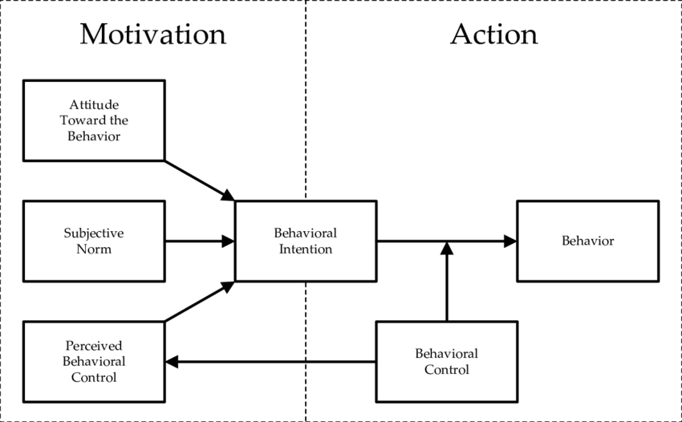
Brookes (2021) implies the theory of planned behaviour is an extension to the theory of reasoned action and it was established in the 1980s by Icek Ajzen. The objective of this theory is to explain various types of behaviour that individuals have and how they have the ability to operate self-control. This theory also recognises an individual’s goals and intentions which contributes to their behaviour at a particular time and place. The essential component to this theory is behavioural. Behavioural is inspired by the mindset and attitude approach, the objectives for behavioural are the possibility that the behaviour will have the likely effects and the specific assessment of the consequences and advantages of that outcome.
This theory has been applied efficiently to assume and simplify a diverse range of health behaviours and aims including drinking, smoking, health facilities and various of substance use and along with others. This theory purposes that behavioural achievements contrast on similarly intent and behavioural control. They are three types of principles behavioural, normative and control which they distinguish between.
Armitage ET, AL (2003) proposes this theory is comprised with six concepts which are behavioural intention, attitude, subjective norm and perceived behavioural control, these concepts are equally imply to an individuals’ sincere control over their behaviour.

This theory links with this case study, Mason is presenting his personal intentions through his behaviour at parole by demonstrating himself in an appropriate and approachable manner. Mason took the offer to undertake an apprenticeship with the local college before leaving custody but subsequently leaving custody his behaviour changed by not attending college and he is seen with his former associate that is known by the police. Mason behaviour went from approachable to aggressive. Mason behaviour was acknowledged during probation when he was approached by the team and questioned regarding the situation. The theory of planned behaviour can be implemented in this case study, Mason demonstrated a variety of behaviour at certain places, time, and people his was around, this all depended on what environment and circumstances he was in. Mason shown indication of behavioural belief when he was at parole, this encouraged his approach and attitude in relation to his behaviour. Mason acknowledged him taking this opportunity with this apprenticeship was going to be help and better him which was going to be a beneficial to him hence, why he had an approachable attitude towards his behaviour. However, when Mason was noticed with a former associate that are known by the police, his behaviour drastically altered in aspects of missing college and becoming verbally abusive and aggressive. These are numerous indications of normative beliefs that Mason was demonstrating. Mason may have been conducting in this manner as he may want to act that manner, and as well as that Mason intentions may have been to demonstrate the intensity of value that he holds on these individuals’ beliefs. Jointly, this specifies the subjective norm that is demonstrated in a substantial part of his decision on what particular ways to behave or not.

Frustration aggression hypothesis
Miller (1941) and Lewis ET, AL (1992). refers this theory is created by Dollard ET, AL (1939) and it is based on psychodynamic clarification of catharsis. Dollard ET, AL (1939) believed the desire for aggression is natural, like the desire for food. He claimed to reduce aggression he thinks it is appropriate to take part in activities that releases the aggression. This will result them to feel in ease as they have discharged the aggression.
Nickerson (2017) suggested Dollard ET AL. (1939) projected if an individual is frustrated it can lead to aggression. Aggression is a way to free the build-up of frustration. Dollard explained individuals have an ego defence mechanism to protect themselves and these methods are managed in the catharsis of aggression. Sublimation is one, this is when individuals use their aggression by doing activities like sports e.g., boxing and also displacement is another way this is when individuals release their aggression to an object or someone.
However, Bateson (1941) claimed Berkowitz (1969) modified the frustration-aggression hypothesis theory, as he believed that individuals who are frustrated don’t always get aggressive, he identified that he believes aggression may occur due to certain warnings such as if weapons are involved it can trigger aggression.
This theory is associated to this case study, Mason has a form of aggression as he has previously been in custody for offending. So, this theory relates to Mason as him being aggressive is in his nature. Mason doing an apprenticeship before leaving custody, this was keeping him engaged and this theory therefore links to Mason as it implies the way you can decrease aggression is by undertaking activities which helps discharges aggression. Mason being frustrated and started to become verbally aggressive when he was approached by the team during his probation visit and then stormed out of the meeting proves what the theory implies which is frustration leads to aggression. Mason used both defence mechanism by undertaking the apprenticeship he used the sublimation method and by getting aggressive and verbally abusive to the team he was using the displacement method. However, Berkowitz (1969) states aggression can only occur with effects from objects, occurrences, and individuals and in this case, Mason may be affected by his former associates.

Conclusion
Overall, throughout this report there is a discussion on three theories that are linked to Mason case study and explained how these theories may have applied to his situation. Abrams ET, AL (1990) clarified there is three psychological process and why these processes are vital and how these three processes summarize how individuals create their place in the society. Brookes (2021) and Armitage ET, AL (2003) proposes the planned behaviour theory evaluates an individual’s intentions of their particular behaviour at certain times and place, it also deliberated the six concepts. As well as this, a statistic of re-offending was provided and by looking at these statistics it indicated they has been a decrease in re-offending and it may have been due to COVID-19 however, it also stated they was a drop of re-offending year prior COVID-19. Dollard ET, AL (1939) stated in the Frustration aggression theory that he believed aggression is in individual nature, He proposed to decrease aggression he believed it is suitable to take part in activities that releases the aggression. This report emphasises why Mason behaviour was changed from respectful to aggressive and also expresses what triggers changes behaviour and how it can influence individual behaviour and attitude in this case Masons behaviour.

References
Abrams, D., & Hogg, M. A. (1990). Social identification, self-categorization and social influence. European Review of Social Psychology, 1, 195–228.

Armitage, C.J., Christian, J (2003). From attitudes to behaviour: Basic and applied research on the theory of planned behaviour pp. 187–195

Brookes, E., 2021. The Theory of Planned Behavior - Simply Psychology. [online] Simplypsychology.org. Available at: https://www.simplypsychology.org/theory-of-planned-behavior.html [Accessed 12 March 2022].

Bateson, G. (1941). IV. The frustration-aggression hypothesis and culture. Psychological Review, 48(4), 350–355. https://doi.org/10.1037/h0055948

GOV.UK. (2022). Proven reoffending statistics: January to March 2020. [online] Available at: https://www.gov.uk/government/statistics/proven-reoffending-statistics-january-to-march-2020/
proven-reoffending-statistics-january-to-march-2020 [Accessed 12 March 2022].

Lewis, W. A., & Bucher, A. M. (1992). Anger, catharsis, the reformulated frustration-aggression hypothesis, and health consequences. Psychotherapy: Theory, Research, Practice, Training, 29(3), 385–392. https://doi.org/10.1037/h0088540

Mcleod, S., (2008). Henri Tajfel's greatest contribution to psychology was social identity theory. [online] Simplypsychology.org. Available at: https://www.simplypsychology.org/social-identity-theory.html [Accessed 12 March 2022].

Miller, N. E. (1941). I. The frustration-aggression hypothesis. Psychological Review, 48(4), 337–342. https://doi.org/10.1037/h0055861

