DS 1 Assessment_ Jabir Hassan Ibrahim

Screenshot/Photo 1


I use my mobile phone every day to make calls, send message, and communicate with friends and family.

Screenshot/Photo 2


I use Facebook to connect with friends and family and share information.

Screenshot/Photo 3
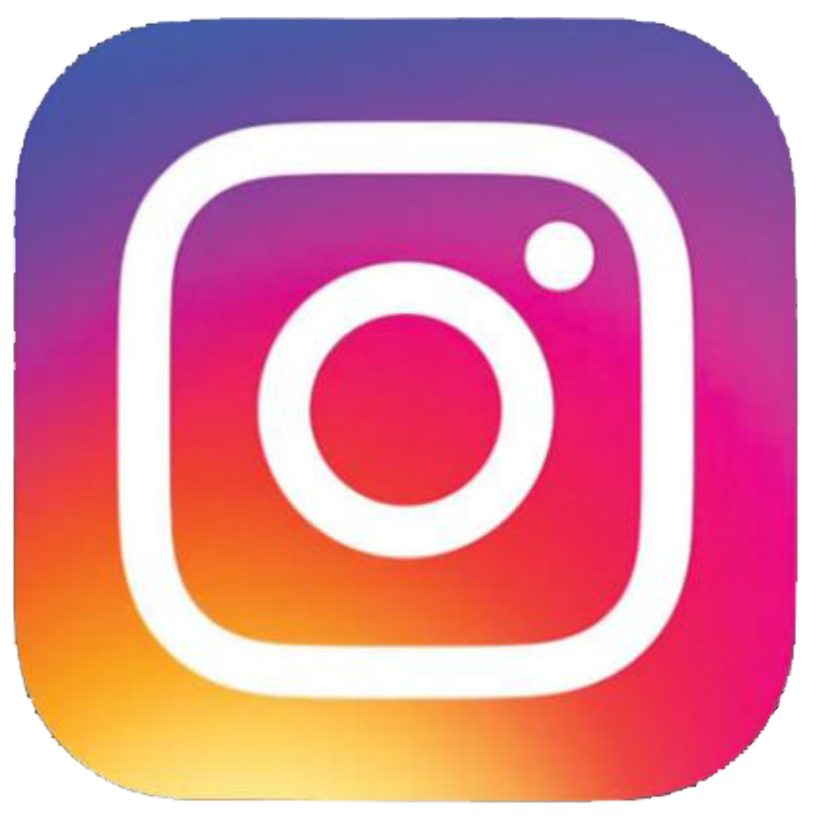

I use Instagram to call and message people.

Screenshot/Photo 4


I use the HSBC mobile banking app to check my bank balance and manage my money.

Screenshot/Photo 5

I use google to search for information, learn new skills, and find answers to my questions.

Screenshot/Photo 6

I use email to receive important message from my university and communicate with staff.

My Short Reflection

