University of Wales Trinity Saint David
School of Engineering



Application of automation in wastewater treatment Control & Automation
Mechanical Engineering and Energy & Environmental Engineering
(ACMA5001)

Tia Ball
2220258
April 2025

Objectives
The objectives of this report are to examine the role and significance of Instrumentation, Control, and Automation (ICA) in modern wastewater treatment and to analyse the historical development and adoption of these technologies within treatment facilities. It aims to explore how key ICA components, such as sensors, controllers, and actuators, are applied to optimise process control and improve operational efficiency. The report will investigate how ICA contributes to greater autonomy in plant operations and will review the regulatory frameworks and standards that ensure safe and compliant wastewater treatment. To support the technical discussion, relevant diagrams and images will be included. Additionally, the report will assess recent advancements in ICA technologies and their impact on automation, sustainability, and future industry developments.

Contents
Objectives 2
Table of Figures 4
Introduction 5
Historical Development of ICA in Wastewater Treatment 6
Sensors 7
Process Controllers 8
Actuators 8
Case Studies and Industry Examples 12
Case Study: Thames Water, United Kingdom 12
Case Study: Emschergenossenschaft, Germany 12
Smart Village Projects in India 12
Singapore’s Deep Tunnel Sewage System (DTSS) 13
Regulations and Standards 14
Environmental and Discharge Standards 14
Instrumentation and Control Standards 14
Cybersecurity and Data Protection 15
Advanced and Emerging Technologies in ICA 16
Artificial Intelligence and Machine Learning 16
Internet of Things (IoT) 16
Digital Twins 17
Cloud Computing and Big Data Analytics 17
Conclusion 18
References 19

Table of Figures
Figure 1 - Process Control Instrumentation (Royce Water Technologies, 2025) 8

Introduction
Wastewater treatment is a critical process for ensuring public health and environmental protection, especially in rapidly urbanising areas where the demand for efficient wastewater management systems is growing (EEC Environmental, 2023). Over the years, Instrumentation, Control, and Automation (ICA) technologies have become integral to the operation of wastewater treatment facilities, significantly enhancing their efficiency, reliability, and safety. The use of ICA systems in wastewater treatment enables the real-time monitoring of various process variables, automates complex tasks, and optimises the entire treatment process. These technologies, which include sensors, controllers, and actuators, enable treatment plants to function with greater autonomy and precision, reducing the need for human intervention and ensuring consistent performance.
This report will explore the role of ICA in this sector, focusing on how these technologies have been applied to improve the operational efficiency of wastewater treatment facilities (EEC Environmental, 2023). Additionally, the report will delve into the historical development of these technologies, regulatory considerations, and the latest innovations that continue to drive the automation and modernisation of the wastewater treatment industry. Through this exploration, the report aims to provide a comprehensive understanding of how ICA systems are shaping the future of wastewater treatment.

Historical Development of ICA in Wastewater Treatment
The evolution of instrumentation, control, and automation (ICA) in wastewater treatment has significantly improved efficiency and reliability over time. In the early 20th century, operations relied on manual monitoring, with operators adjusting flow rates and chemical dosing based on observation and experience, an approach that was labour-intensive and prone to errors (Comas, 2014).
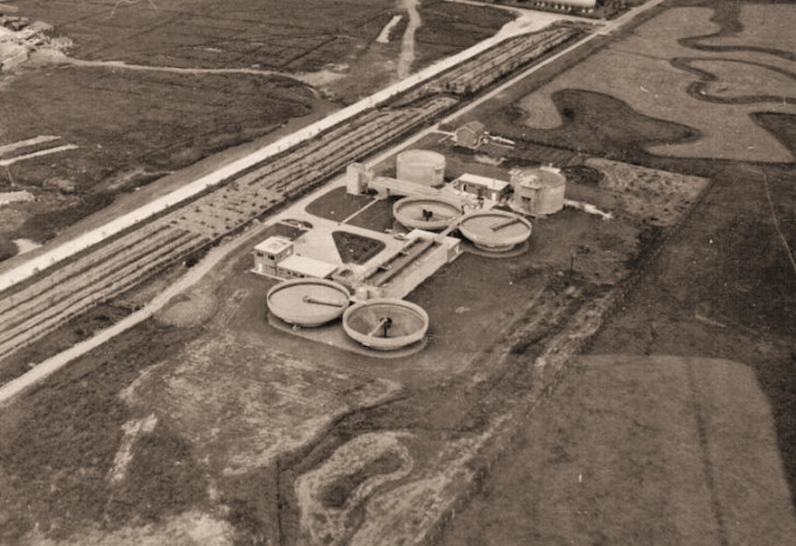
By the 1960s and 1970s, basic analog sensors were introduced to monitor parameters such as pH and dissolved oxygen (DO). While these devices provided more data, control remained largely reactive with limited automation (Comas, 2014). In the 1980s and 90s, the adoption of Programmable Logic Controllers (PLCs) enabled automated control of pumps, valves, and aeration systems. This digital shift also brought centralised control rooms, allowing operators to oversee entire facilities from a single location (Olsson, 2014).
Figure 1 - Sewage Treatment Plant in 1967 (Janet Penn, 2020)

The 2000s saw the rise of Supervisory Control and Data Acquisition (SCADA) systems, offering real-time visualisation, historical data analysis, and remote monitoring. More recently, Industry 4.0 technologies—such as IoT, AI, and digital twins—have pushed wastewater treatment towards fully data-driven and autonomous operations, reducing manual oversight and enhancing process optimisation (Olsson, 2014).

Key Components of ICA: Sensors, Process Controllers, and Actuators
Instrumentation, control, and automation systems comprise several key components that work in concert to monitor and control the operations of wastewater treatment plants. These include sensors for data acquisition, process controllers for decision-making, and actuators for executing control actions. Each plays a distinct and crucial role in ensuring efficient and compliant treatment processes.
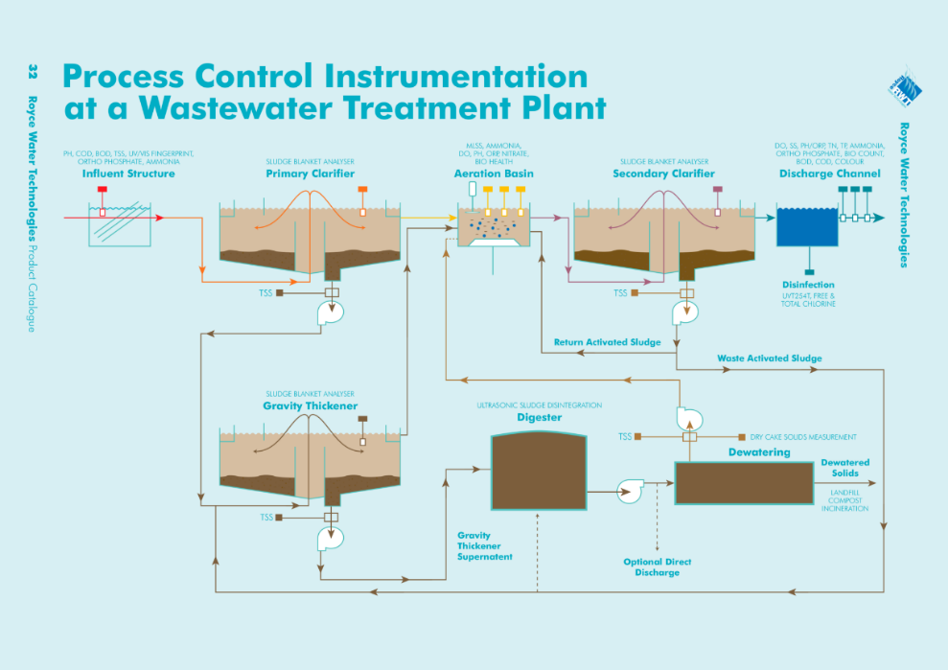
Figure 2 - Process Control Instrumentation (Royce Water Technologies, 2025)

Sensors
Sensors are the primary tools for data acquisition in a WWTP. They provide continuous real-time information on the physical, chemical, and biological parameters of the treatment process (Archer, 2021). Commonly used sensors include:
- Flow sensors - These measure the volume of influent and effluent to control dosing and hydraulic loading.
- Dissolved Oxygen (DO) sensors - Essential in aeration basins to regulate oxygen supply and support biological treatment (Archer, 2021).
- pH and ORP sensors - Help monitor chemical balance and redox potential for chemical treatment and disinfection (Archer, 2021).
- Turbidity and TSS sensors - These measure the clarity and suspended solids in the water, which is helpful in the sedimentation and filtration stages (Archer, 2021).
Modern sensors are often equipped with self-cleaning mechanisms and diagnostic features that alert operators to fouling, drift, or calibration needs.

Process Controllers
Process controllers interpret sensor data and generate commands to maintain optimal operating conditions. Controllers can range from simple Proportional-Integral-Derivative (PID) loops to more complex adaptive, model-predictive control systems. Programmable Logic Controllers (PLCs) and Distributed Control Systems (DCS) are the most used hardware platforms for process control in WWTPs. They are designed for real-time operation in harsh industrial environments, offering high reliability and flexibility (Wainwright, 2025).
Advanced control strategies enable the system to adjust chemical dosing, aeration rates, and sludge wasting in response to load fluctuations and predictive algorithms. These approaches reduce energy consumption, improve effluent quality, and extend the life of equipment (Automation Community, 2023).

Actuators
Actuators are the final control elements that carry out the decisions made by the controllers. They physically alter the system’s operation by adjusting valves, turning pumps on or off, and modulating blowers (Fabian, 2024). Common actuator types include:
- Electric actuators - for precise control of valves and dampers.
- Pneumatic actuators - often used where fast or powerful actuation is needed.
- Variable Frequency Drives (VFDs) - for adjusting motor speeds in pumps and blowers.
The integration of smart actuators with embedded sensors provides additional feedback to the control system, allowing for self-verification and failure detection.
The synergy between sensors, controllers, and actuators creates a closed-loop control environment that can automatically maintain the desired performance of complex treatment processes (Fabian, 2024).

Supervisory Control and Data Acquisition (SCADA) Systems
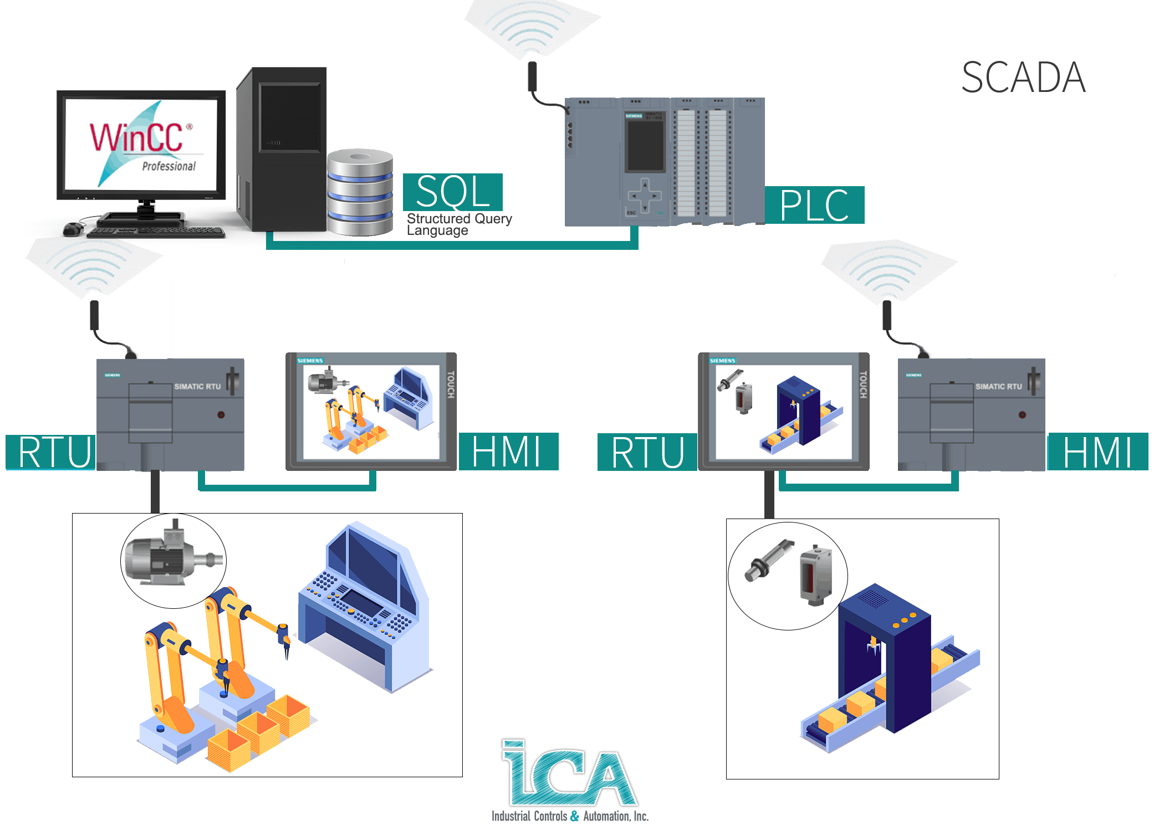
SCADA systems are a cornerstone of modern wastewater treatment plant automation. They serve as the central nervous system of the facility, integrating data acquisition, monitoring, and control into a unified platform. SCADA provides operators with real-time visibility into plant operations, enabling them to control equipment and processes remotely (GEOVAP, 2025).
Figure 3 - Basic SCADA set-up (ICAIN USA, 2021)

A typical SCADA system comprises several components:
- Human-Machine Interfaces (HMIs) - Graphical user interfaces that display process data, alarms, and trends. Operators use HMIs to monitor system status and make manual adjustments when needed (Teja, 2024).
- Programmable Logic Controllers (PLCs) - Often integrated into SCADA architecture for localised control and decision-making (Teja, 2024).
- Communication infrastructure - Wired and wireless networks that facilitate data exchange between devices, controllers, and central servers.
- Modern SCADA systems often include cybersecurity features, cloud-based access, and support for mobile devices, ensuring both security and flexibility (Teja, 2024).

The benefits of SCADA systems in wastewater treatment are numerous. They provide:
- Real-time alerts for abnormal conditions (e.g., equipment failure, chemical imbalance).
- Historical data analysis for performance optimisation and compliance reporting.
- Integration with Enterprise Resource Planning (ERP) systems for maintenance and resource planning (Taylor, 2025).
- Enhanced decision support through trend visualisation and predictive analytics.
For example, suppose a SCADA system detects a sudden drop in dissolved oxygen in an aeration tank. In that case, it can automatically trigger the activation of additional blowers or alert operators via SMS or email. This level of responsiveness helps prevent regulatory violations and protects the biological integrity of treatment processes (Taylor, 2025).
The scalability of SCADA also allows it to be implemented in both small, decentralised treatment units and large metropolitan WWTPs. In highly automated plants, SCADA systems serve as the interface between human operators and the automated control hierarchy, supporting autonomous operation while allowing for human oversight when necessary (Taylor, 2025).

Case Studies and Industry Examples
Real-world case studies offer practical insights into how ICA technologies are transforming wastewater treatment facilities worldwide. These examples highlight the diverse ways in which sensors, automation, and SCADA systems contribute to efficiency, compliance, and sustainability.

Case Study: Thames Water, United Kingdom
Thames Water, the UK’s largest water and wastewater services provider, has implemented comprehensive ICA systems across its treatment works. One notable example is the Beckton Sewage Treatment Works in East London. As one of the largest treatment plants in Europe, Beckton uses an advanced SCADA system to manage a vast network of sensors and controllers (FIDO, 2022).
The system enables real-time control of aeration, sludge digestion, and effluent discharge. Using predictive analytics and automated control strategies, Thames Water has significantly reduced its energy consumption and chemical usage. It has also improved compliance with Environment Agency discharge permits. Remote monitoring capabilities have enabled faster responses to operational issues and reduced reliance on on-site staff (FIDO, 2022).

Case Study: Emschergenossenschaft, Germany
Emschergenossenschaft, one of Germany’s oldest water management associations, has modernised several wastewater treatment plants using high levels of automation. In the Bottrop WWTP, ICA systems monitor over 1,000 data points, including ammonia, nitrate, and flow rates (EWRA, 2013). The integration of model predictive control enables the system to anticipate changes in influent load and adjust aeration accordingly, resulting in a 20% reduction in energy costs. A central SCADA interface provides operators with an overview of multiple facilities, ensuring optimal regional performance and compliance with EU standards (EWRA, 2013).

Smart Village Projects in India
In rural India, decentralised wastewater treatment systems (DEWATS) have adopted low-cost ICA solutions for essential process monitoring. In partnership with NGOs and technology providers, small-scale treatment plants use GSM-based remote monitoring to transmit data on flow and pH to a central dashboard. These systems ensure reliable operation without the need for permanent on-site staff, thereby improving hygiene and public health in underserved communities (Syed, 2025).

Singapore’s Deep Tunnel Sewage System (DTSS)
Singapore’s DTSS is a landmark in integrated wastewater management. This multi-billion-dollar infrastructure project uses ICA and SCADA extensively to monitor and control flow in deep tunnels, pumping stations, and treatment plants. Sensors continuously assess water quality parameters while AI-driven controllers optimise energy use and predict maintenance needs. The result is a resilient, future-proof wastewater network that supports water reuse in line with Singapore’s water sustainability goals (Government of Singapore, 2025).

Regulations and Standards
The application of ICA in wastewater treatment must comply with a complex framework of regulations and standards. These frameworks ensure that the deployment of instrumentation and automation technologies does not compromise public health, environmental safety, or data integrity. Regulatory requirements vary by country but often share common goals, such as pollution control, operational safety, and ensuring water quality.

Environmental and Discharge Standards
In the United Kingdom, wastewater treatment operations are regulated by the Environment Agency, which enforces discharge permits under the Environmental Permitting Regulations (EPR). Plants must meet strict effluent quality standards concerning parameters such as biochemical oxygen demand (BOD), total suspended solids (TSS), ammonia, and phosphorus. Automated monitoring systems, utilising sensors and SCADA, are instrumental in maintaining compliance, as they enable the real-time detection and correction of deviations (GOV.UK, 2019).
The Urban Wastewater Treatment Directive (91/271/EEC) of the European Union similarly mandates nutrient removal and continuous monitoring of effluent parameters. Compliance is facilitated through data logging and process optimisation enabled by ICA systems.

Instrumentation and Control Standards
Various international standards govern the design, implementation, and operation of instrumentation and control systems:
- IEC 61511 - Focuses on the functional safety of safety instrumented systems in the process industry (International Society of Automation, 2025).
- ISO 14001 - This standard relates to environmental management systems and emphasises operational control, including the use of automation strategies.
- EN 15216 - Provides guidelines for the use of process control and monitoring in wastewater treatment (Automation Community, 2023).
- BS EN 61131-3 - Specifies programming languages for programmable logic controllers (PLCs).
Compliance with these standards ensures that automation systems are safe, reliable, and interoperable. They also promote standardisation in software development and hardware configuration, which is crucial for maintaining and upgrading systems over time.

Cybersecurity and Data Protection
As ICA systems increasingly rely on digital communications and remote access, cybersecurity becomes a critical concern. The UK's National Cyber Security Centre (NCSC) and the EU's NIS Directive (Directive on Security of Network and Information Systems) mandate safeguards against unauthorised access, data breaches, and cyberattacks (txOne, 2024).
SCADA and PLC systems must incorporate encrypted communications, user authentication, intrusion detection, and routine audits to ensure system integrity. Regulations also require that data collected from instrumentation be stored securely and made available for inspection and compliance reporting.
Failure to adhere to cybersecurity guidelines can result in legal penalties and operational disruptions, significantly if critical infrastructure is compromised (txOne, 2024).

Advanced and Emerging Technologies in ICA
Recent advancements in technology have significantly enhanced the capabilities of ICA systems in wastewater treatment. These emerging solutions focus on increasing efficiency, reducing operational costs, improving sustainability, and enabling predictive and autonomous operations. Technologies such as artificial intelligence, the Internet of Things (IoT), digital twins, and advanced analytics are now integral to modern WWTPs.

Artificial Intelligence and Machine Learning
AI and machine learning algorithms are being deployed to optimise wastewater treatment processes. These technologies analyse vast amounts of historical and real-time data to identify patterns and predict system behaviour.
For example, machine learning models can forecast influent quality based on weather data and historical trends, allowing the plant to adjust aeration or chemical dosing proactively (Staff, 2025). AI-driven control systems also enable continuous process optimisation by learning from operational data and adjusting to reduce energy consumption and improve effluent quality.

Internet of Things (IoT)
IoT devices extend the connectivity and intelligence of traditional sensors and actuators. These smart devices are equipped with communication capabilities that enable them to transmit data to cloud platforms or SCADA systems in real time (IDRICA, 2023).
IoT enables:
- Remote monitoring of decentralised or mobile treatment units.
- Asset tracking and condition monitoring for proactive maintenance.
- Seamless integration with mobile applications and dashboards.
IoT also facilitates edge computing, where preliminary data processing occurs at the device level, reducing latency and enabling faster decision-making (IDRICA, 2023).

Digital Twins
A digital twin is a virtual replica of a physical process or system that simulates its real-time behaviour. In wastewater treatment, digital twins allow operators to model scenarios, test control strategies, and predict failures without affecting live operations (Staff, What Is a Digital Twin? Definition, Types, and Uses, 2025).
These models can be integrated with real-time data streams from the ICA system to provide insights into:
- System bottlenecks and optimisation opportunities.
- Equipment wears and failure forecasting.
- System bottlenecks and optimisation opportunities.
- Operational impact of changes in load or climate conditions.
Digital twins are valuable tools for training new staff, conducting what-if analyses, and supporting decision-making at both operational and strategic levels.

Cloud Computing and Big Data Analytics
Cloud platforms provide scalable storage and processing capabilities, allowing wastewater facilities to manage and analyse large datasets generated by ICA systems. Big data analytics tools can uncover trends and anomalies that would be difficult to detect manually, supporting compliance reporting and strategic planning (geeksforgeeks, 2024). Benefits include:
- Centralised data access across multiple facilities.
- Real-time dashboards for operational visibility.
- Long-term performance benchmarking and environmental impact assessments.
These systems support more informed decisions and foster a proactive rather than reactive approach to plant management.

Conclusion
Instrumentation, Control, and Automation have transformed wastewater treatment from labour-intensive operations into intelligent, responsive, and efficient systems. From its historical roots in manual monitoring, ICA now encompasses sophisticated sensors, advanced controllers, and centralised SCADA platforms. These systems ensure high-quality effluent, regulatory compliance, and optimised resource use.
As wastewater treatment becomes increasingly important in the face of climate change, population growth, and urbanisation, the continued advancement of ICA will be crucial. Investments in innovative technologies and automation will not only support environmental goals but also ensure resilient and cost-effective water infrastructure for future generations.

References
Archer, C. (2021, July 12). The 4 Types of Sensors Used In Wastewater Treatment Controls. Retrieved from WELLAWARE: https://blog.wellaware.us/blog/the-4-types-of-sensors-used-in-wastewater-treatment-controls
Automation Community. (2023, December 30). What is Industrial Automation? History, Types, Advantages, Disadvantages. Retrieved from Automation Community: https://automationcommunity.com/industrial-automation-history-types-advantages-disadvantages/
Comas, J. (2014). Water Science & Technology. Instrumentation, control and automation in wastewater, 5-9.
EEC Environmental. (2023, May 22). Wastewater Treatment Compliance and Meeting Regulatory Requirements. Retrieved from EEC Environmental: https://eecenvironmental.com/wastewater-treatment-compliance/
EWRA. (2013). Advanced energy recovery strategies for wastewater treatment plants and . In V. Berger, Advanced energy recovery strategies for wastewater treatment plants and (pp. 15-24). Essen: E.W. Publications.
Fabian, T. (2024, January 10). Wastewater Treatment Solutions: What Will Change in 2024? Retrieved from IDE Technologies: https://ide-tech.com/en/blog/wastewater-treatment-solutions-what-will-change-in-2024/
FIDO. (2022). Leak team gets total success from FIDO-led work orders. Case study: Thames Water, 1-2.
geeksforgeeks. (2024, May 27). Role of Cloud Computing in Big Data Analytics. Retrieved from geeksforgeeks: https://www.geeksforgeeks.org/role-of-cloud-computing-in-big-data-analytics/
GEOVAP. (2025). Visualization and control of the treatment process at the Humpolec Wastewater Treatment Plant. Czechia: Reliance Industrial SCADA/HMI system.
GOV.UK. (2019, January 17). Waste water treatment works: treatment monitoring and compliance limits. Retrieved from Environment Agency: https://www.gov.uk/government/publications/waste-water-treatment-works-treatment-monitoring-and-compliance-limits/waste-water-treatment-works-treatment-monitoring-and-compliance-limits
Government of Singapore. (2025, March 4). Deep Tunnel Sewerage System. Retrieved from PUB - Singapore's National Water Agency: https://www.pub.gov.sg/Professionals/Requirements/Used-Water/DTSS
IDRICA. (2023, August 7). The technological revolution taking place in wastewater treatment plants . Retrieved from IDRICA: https://www.idrica.com/blog/the-technological-revolution-taking-place-in-wastewater-treatment-plants/
International Society of Automation. (2025, February 06). ISA Standards. Retrieved from International Society of Automation: https://www.isa.org/standards-and-publications/isa-standards
Olsson, G. (2014, June 15). Instrumentation, control and automation in wastewater - From London 1973 to Narbonne 2013. 15: April. Retrieved from https://www.researchgate.net/publication/261520191_Instrumentation_control_and_automation_in_wastewater_-_From_London_1973_to_Narbonne_2013
Staff, C. (2025, January 28). Machine Learning vs. AI: Differences, Uses, and Benefits. Retrieved from Coursera: https://www.coursera.org/articles/machine-learning-vs-ai?msockid=00acfc05372a6e7710e5e97f36916fef
Staff, C. (2025, March 15). What Is a Digital Twin? Definition, Types, and Uses. Retrieved from Coursera: https://www.coursera.org/articles/digital-twin?msockid=00acfc05372a6e7710e5e97f36916fef
Syed, S. (2025, April 3). How These 6 Indian Villages Went Completely Zero-Waste. Retrieved from The Better India: https://thebetterindia.com/417499/zero-waste-villages-india-2025-sustainability-success/
Taylor, E. (2025, March 7). Advantages and Disadvantages Of Scada. Retrieved from TheKnowledgeAcadademy: https://www.theknowledgeacademy.com/blog/advantages-and-disadvantages-of-scada/
Teja, R. (2024). SCADA System. What Is It & Everything About It, 6.
txOne. (2024, April 19). The Ultimate Guide to PLC Cybersecurity. Retrieved from txOne Networks: https://www.txone.com/blog/ultimate-guide-to-plc-cybersecurity/
Wainwright, O. (2025). ‘Cathedral of crap’: is this the world’s most beautiful sewage treatment plant? The Guardian, 3.

