Student Name: Ionut Tudureanu
Student number: 1917144
Programme: BA Business Management
Module: International Business Communications
Module code: LCBB6001
Lecturer’s name: Zainab Atta
Assignment tittle: Individual assignment

International Business Communications

Individual assessment
Unilever Report

Table of contents

1.Introduction…………………………………………………………………….………3
2. Unilever (company background)……………………………………………………3
3. The importance of international business and communication………………….4
4. Indonesia: country background………………………………………………..…...5
5. Hofstede theory on UK vs Indonesia……………………………………...…...…..6
5.1. Definition………………………………………………………………………………....6
5.2. Hofstede model analysis…………………………………………………….7
6. Cultural sensitivity……………………………………………………………………11
7. Importance of network……………………………………………………………….12
8. Communication barriers between UK and Indonesia…………………………….12
9. Conclusion…………………………………………………………………………….14
10. References………………………………………………………………………………..15

1.INTRODUCTION

International business communication is shaped by the norms, values, and cultures of the people involved. Working with someone from another culture demands an understanding of their language and customs. Understanding the other businessperson's beliefs and standards might help. Communicators may also detect and appreciate cultural variances (A.Lyke,2022). This research analyses the relevance of international business communication using Unilever as an example. The firm is concerned about cultural differences and sensitivities. I've been asked to submit a thorough report for the company's higher management that stresses the Indonesian setting, cultural sensitivity, cultural communication difficulties, and international business communications methods.

2. Unilever (company background)

Unilever PLC is a UK consumer goods holding company. The company's subsidiaries sell beauty and personal care products, food and drinks, and home care items. Unilever owns 400+ brands in 190+ countries such as: Dove, Vaseline, Lipton, Hellmann's, Ben & Jerry's, Seventh Generation, and Sunlight. The company focuses on creating trustworthy, well-known brands to compete in the global consumer products sector: Nestlé S.A., Procter & Gamble Co., Johnson & Johnson, PepsiCo Inc., and Colgate-Palmolive Co. are competitors (CL)

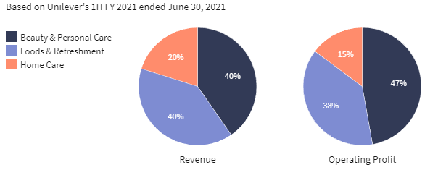
Fig.1: Unilever product breakdown
Source: G.McFarlane, 2021

3. THE IMPORTANCE OF INTERNATIONAL BUSINESS AND COMMUNICATION

International business requires transferring employees and management across borders. Expatriates are a new sort of employee made available by globalization; they are dispatched by their firm to work in a foreign nation for a specific assignment (H.Ornoy, 2013).
Due to different worldviews and communication styles, international business communication must be flexible. Translators can overcome a linguistic barrier. Nonverbal cues help professionals communicate (A.Lyke, 2022).
When communicating with people from other cultures, remember that they may use radically different communication and business practices. It's crucial to understand the cultural backdrop of business, but avoid making insulting assumptions. Knowing the locals and immersing oneself in the other firm's culture may help businesses avoid misconceptions about the area's people and habits (A.Lyke, 2022).
Cross-cultural businesspeople should learn the other culture's interpersonal communication norms and practices. Some communities emphasize direct interaction, while others prefer ambiguity and politeness to prevent disagreement. Professional agreements can be reaffirmed orally or in writing. So is building relationships before a company launch.
International business communicators may study the other company's beliefs, values, and practices. Business savvy people make less social faux pas during negotiations. Religion, superstition, and cultural restrictions on hand gestures may be natural ways individuals express themselves. Societies value collaboration, uniqueness, and social standing differently (A.Lyke,2022).

4. INDONESIA: COUNTRY BACKGROUND

Indonesia contains more than 300 cultural groupings. Since the late 1990s Asian financial crisis, the economy has grown (worldbank,2022). The country’s population and economy rank 4th and 10th, respectively. Indonesia halved poverty from 1999 levels before COVID-19.
Due to economic recovery, rising commodity exports, and a pandemic-resistant budgeting plan, Indonesia's GDP is predicted to expand 5.1% in 2022. COVID-19 scarring and global issues hinder healing (worldbank,2022).
Indonesia's coastal regions will bear the brunt of climate change's negative consequences on the economy, society, and environment, including water scarcity, poor health and nutrition, inadequate disaster preparedness, and unchecked urban development. Indonesia has the most mangroves and peatlands. Covering 9.4 million acres, it boasts the world's third-largest tropical rainforest (3.31 million hectares). These natural resources must store carbon for Indonesians' livelihoods and long-term development. The World Bank helps Indonesia's land use, oceans, energy, and supporting climate change activities. The World Bank helped create carbon pricing systems and the National Mangrove Program.
In Indonesia, business customs reflect culture. Despite ethnic, religious, and cultural diversity, Indonesia's business culture maintains similar principles. According to the World Bank, Indonesian culture is based on family, societal peace, and religion (2022).

5. HOFSTEDE THEORY ON UK VS INDONESIA
5.1. Definition
Hofstede's Cultural Dimensions Theory, founded by Geert Hofstede, is a framework for examining cross-national cultural variances. Hofstede identifies six primary dimensions: power distance, uncertainty avoidance, individualism/collectivism, masculinity/femininity, and short-term vs. long-term orientation. Researchers have since added the concept of moderation vs. excess to this list. The extent to which different countries share essential characteristics is affected by a number of factors. Understanding etiquette and improving cross-cultural communication are two areas where Hofstede's cultural dimensions see widespread use (C. Nickerson,2022).
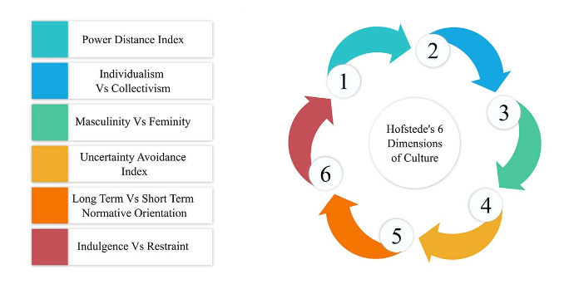
Fig.1: Hofstede’s Model
Source: C. Nickerson,2022

5.2. HOFSTEDE MODEL ANALYSIS

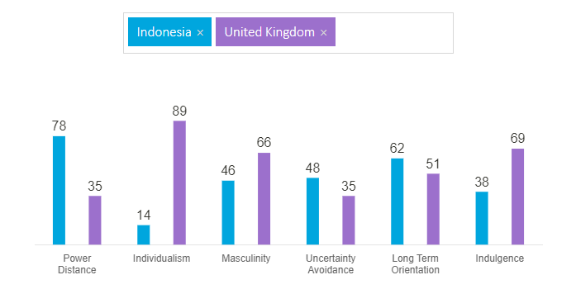
Fig.2: Hofstede’s model on UK and Indonesia
Source: Hofstede-insights.com, 2022

- Power Distance Index

This axis addresses the reality that humans aren't born equal and shows the cultural perspective on social difference. "Power gap" refers to how much less powerful people in a society anticipate and tolerate unequal power distribution in institutions and organisations (J.R.Brown, 2021).
Indonesia's 78 on this criteria shows the following: Hierarchy, uneven rights between power holders and non-power holders, inaccessible superiors, directive leadership, control and delegation by management. Managers require full loyalty from workers, and authority is centralised. Workers want to know what to do and when. There is a very expected control and respected supervisors. Minimal direct contact, camouflaged criticism. High Power Distance suggests that Indonesian co-workers expect clear instructions from their supervisor or manager; this is the standard Guru-Pupil relationship.
Britain is one of the least egalitarian nations, ranking 35th on the Progressivity of Disadvantage Index (PDI). According to studies, the British upper class has a lower PD index than the working class. The PDI score seems to contradict the conventional British class structure, highlighting a contradiction in British culture: the assumption that a person's birthplace shouldn't define their social and economic opportunities. Fairness inspires the belief that individuals should be treated equally.

- Individualism
This dimension focuses on members' connection. It's whether people say "I" or "We" about themselves. Individualists worry only about themselves and their families. In collectivist civilizations, people belong to "in groups" that care for them.

Indonesia has a low collectivist score (14). This shows a need for a social framework that requires people to adhere to societal and in-group ideals. This is visible in Family connections. In Indonesia, one must meet a woman's family before marrying her since her family is highly significant. If a man wants a woman to take him seriously, he must meet her parents. It's wrong to pursue a woman and date her without telling her parents. The kid-parent bond exemplifies Indonesia's collectivism.

Indonesian children and parents are dedicated to each other. They want to help their parents. Parents want help and caring. "You can have another wife or husband, but not another mother or father," says an Indonesian adage. Indonesian households keep their senior folks (such grandparents) at home rather than in an institution, demonstrating their familial love. Individualist societies prioritize the nuclear family.

Only Australia and the United States, which it established, are more individualistic than the UK (89). Individualistic and private, the British are. Children are taught to think independently and to find their life's purpose and contribution to society. Happiness comes from self-satisfaction. As Britain's prosperity has grown over the past decade, with riches ‘spreading north,' uncontrolled consumerism and the 'ME' culture have become hot topics.

- Masculinity

A high score (Masculine) on this dimension means that the society will be motivated by competition, accomplishment, and success, with success defined as the winner/best in field - a value system that begins in school and continues throughout the organization's life.
A low score (Feminine) suggests that care for others and quality of life are valued. A feminine culture values life quality above standing out from the crowd. People are motivated by a desire to be the best (masculine) or love their profession (feminine) (Feminine) (C.Nickerson, 2022).
Indonesia has a low Masculine score of 46. Indonesia is less masculine than Japan, China, and India, but not as much as much of Northern Europe, which is feminine. Prestige and external measures of performance are important in Indonesia, although money isn't always an incentive. The Indonesians value a person's position over his or her personality and must be meticulously maintained to convey an appearance of distinction.
Negotiation and compromise resolve conflicts. Free time and adaptability are valued. Well-being is prioritized over prestige. A helpful boss participates in decision-making. Masculine nations and, to a lesser extent, lower Masculine countries that don't score too low to be categorized as Feminine display fewer Masculine qualities (C.Nickerson, 2022).
Britain is a Masculine, ambitious civilisation. The seeming clash between the British culture of humility and understatement and its success-driven value system confuses outsiders. British people "read between the lines" Not everything spoken is meant and Brits live to work and have a performance aim.

- Uncertainty avoidance

Uncertainty Avoidance is how a society tackles the unpredictable future: should we try to control it or let it happen? Uncertainty produces anxiety, and many cultures have created coping mechanisms. Uncertainty Avoidance demonstrates how much a culture fears uncertain occurrences and has built beliefs and structures to avoid them (C.Nickerson, 2022).
Indonesia (48) avoids ambiguity poorly. Indonesia is dominated by Javanese internal and exterior isolation. Indonesians suppress their wrath. They're nice and smile while being sad. Nobody wants to offer bad news or harsh comments in Indonesia. Conflict resolution is another part. Indonesians mistrust direct dialogue to address problems. Using a mediator to resolve disputes is a tried-and-true method. It's one of Indonesia's Uncertainties since it enables for free speech without losing face. A mediator removes uncertainty from a dispute.
The UK's low Uncertainty Avoidance score of 35 shows that people are fine not knowing what the day will bring and adjusting their plans as needed. British society follows few norms (the most famous of which of course the British love of queuing which has also to do with the values of fair play).

- Long term orientation

This dimension shows how every society must maintain links to its past while tackling present and future challenges, and how different civilizations prioritize these two existential goals. Low-scoring normative cultures, for example, value tradition and approach societal change with mistrust. High-scoring cultures emphasize frugality and modern education to prepare for the future (Hofstede.insights.com, 2022).
Indonesia has a pragmatic culture (62). Truth is circumstance, context, and time-dependent in pragmatic cultures. They can adapt traditions to new conditions, are thrifty and persistent in achieving goals.

- Indulgence

Humanity has always struggled with how well young infants are socialized. We aren't "human" without socializing. This dimension describes how much people try to control their desires based on their upbringing. Indulgence is weak control, and Restraint is strong control. Indulgent or restricted describes civilizations.
Indonesia's low score of 38 shows moderation. Low-scoring societies are cynical and gloomy. Restrained cultures lay less emphasis on leisure time and restrict wish fulfilment. This worldview holds that societal standards restrain conduct and self-indulgence is wrong (C.Nickerson, 2022).
The 69 score indicates that British culture is Indulgent. People in high-Indulgence civilizations are ready to enjoy life and have fun. They're positive and happy. They value leisure time, act freely, and spend money as they like.

6. CULTURAL SENSITIVITY DISCUSSION

As Hofstede’s model discussed, the Indonesians place a premium on social peace and unity. In the Indonesian business culture, keeping one's "face" together is of the highest significance. One's basic human right to be treated with dignity is universally shared. Outward displays of hostility or violence are never appropriate. It's crucial in deliberative or decision-making settings for all parties involved to be able to walk away with their dignity intact. Because of this, dealings may take more time than is typical for some people to bear (C.Nickerson, 2022).
The Indonesians' unwillingness to use clear terms like "no" despite the fact that this is what they mean may drag down negotiations. In Indonesia, religion plays a significant role in daily life. Roughly 82% of the people there identify as Muslims, however sizable Christian and Hindu minorities also exist. The national motto, "unity in variety," expresses how the archipelago's religious diversity has led to a culture of religious tolerance. The vast majority of Indonesia's Muslims practice a mellow kind of Islam, while a tiny fringe group promotes a stricter version C.Nickerson, 2022).

7. IMPORTANCE OF NETWORK
'Networking' means developing professional contacts. Networks now encompass acquaintances and friends. Expanding your network may be as simple as talking to co-workers, making friends with students, and staying in touch with childhood friends.
When the corporation communicates with foreigners or connections move, its network becomes global. Developing a global network may take more time and effort, but it will serve you well for years to come. (E.Carter, 2021).
Indonesia's official language is "Bahasa Indonesia," a Malay dialect. In trade, formal education, and the media, Indonesian is the single official language, however most people are bilingual. Most natives speak Javanese, Sundanese, or Madurese. The archipelago has 700 indigenous languages, making it a multilingual country. Outside large cities and tourism regions, few Indonesians speak English (E.Carter, 2021).

8. COMMUNICATION BARRIERS BETWEEN UK AND INDONESIA. ANALYSIS AND STRATEGIES
Sharing ideas and information is crucial in any group setting. It is expected that both parties will have a solid grasp of the conversation thanks to the use of a standardized language. But every once in a while, there's someone in the group who doesn't see the point of a certain kind of communication. For obvious reasons, international students' academic success depends heavily on their ability to communicate effectively in the target language. According to Jones (1999), difficulties in group communication stem from a lack of communication skills and the resulting prevalence of misunderstanding. A breakdown in communication occurs when one or more people involved are unable to understand one other. Avval (2011) defines communication breakdown as the inability to understand, accept, or express information. As a general rule, communication breaks down when one party communicates in a language that is not their native tongue (N.Fitriani, 2019).
A good example of communication barriers in Indonesia can be the new law that the government wanted to introduce in order to be used their own language everywhere . In the past decade, the Indonesian government has tried to mandate Indonesian in all aspects of life. These regulations go beyond language's role in culture and education and into commerce. This Indonesian regulatory saga involves multimillion-dollar lawsuits and repeated attempts to regulate immigrant employees' and businesses' language.
Law No. 24/2009 controls the replication and use of the national flag, language, emblem, and song to protect their sacredness. Article 26 of this law requires Indonesian in all contracts between Indonesian organizations and people (A.Surinata, 2020).
Indonesian President Joko Widodo lifted the ban to encourage international investment. The House of Representatives' demand led to a more liberal clause in Presidential Regulation No. 20/2018, which compels corporations to fund Indonesian language education for overseas workers. Then came Presidential Rule No. 63/2019, a language implementation rule (A.Surinata, 2020). The legislation detailed the contexts in which Indonesian must be used, including verbal and electronic workplace communications.
FDI is a crucial part of this ongoing language policy issue. Local companies argue such restrictions would deter international investment.
Later the Indonesian Ministry of National Development Planning modified Presidential Regulation No. 63/2019 and translating essential regulations into English and other foreign languages (A.Surinata, 2020).
Asian MNEs prefer to interact with their subsidiaries in their local language, according to business literature. They use their own citizens as expatriates to prevent communication errors and maintain control. The impacts of L2 English are unknown. This supports prior studies showing that Japanese is vital for Japanese multinationals in cross-border situations and dispels the myth of English's primacy, at least in the context of Japanese multinationals.

9. CONCLUSION
Unilever makes and sells fast Consumables. The company makes and sells food, cosmetics, beverages, home care products, vitamins, minerals, and supplements. The company must consider Indonesia's culture and social standards before relocating its operations. The company should adapt to these cultural aspects, not merely accommodate them. This technique requires "on-the-ground" supporters.
Indonesians value societal peace and unity, like many Asian cultures. Indonesian corporate culture emphasizes public "face." Everybody wants respect. Violence and rudeness are inappropriate in public. In conversation or decision-making, it's important to achieve a consensus that preserves face. This might make transactions lengthier than outsiders are used to.
Indonesian business culture is bidirectional. First, an authoritarian organization with natural-born leaders and followers. Well-defined links. Each group believes community decisions escape individual accountability.

10. REFERENCES

G.Mcfarlane, (2021), “How Unilever Makes Money”, Available at: https://www.investopedia.com/articles/markets/012916/how-unilever-makes-money-ul.asp , Accessed: 14.08.2022.
J.Excel, (2020), “Reshoring UK manufacturing: how, why and who?”, Available at: https://www.theengineer.co.uk/content/in-depth/reshoring-uk-manufacturing-how-why-and-who , Accessed: 14.08.2022.
Hofstede-insights.com, (2022), “Hofstede theory on UK and Indonesia”, Available at: https://www.hofstede-insights.com/country-comparison/indonesia,the-uk/ , Accessed:15.08.2022.
Worldbank.com, (2022), “The World Bank In Indonesia” , Available at: https://www.worldbank.org/en/country/indonesia/overview#2 , Accessed: 15.08.2022.
J.R.Brown, (2021), “Beauty and personal care products generate the most profit” Available at: https://www.investopedia.com/articles/markets/012916/how-unilever-makes-money-ul.asp , Accessed: 14.08.2022.
A.Lyke, (2022), “What Is Involved in International Business Communication?”, Available at: https://www.wise-geek.com/what-is-involved-in-international-business-communication.htm , Accessed:15.08.2022.
D.Mcrill, (2019), “The Importance of Communication in International Business”, Available at: https://bizfluent.com/info-7761139-importance-communication-international-business.html , Accessed: 14.08.2022.
I.A. Eddymurthy & B.D. Adhijoso, “Doing Business in Indonesia: Overview” , Available at: https://uk.practicallaw.thomsonreuters.com/5-501-2646?transitionType=Default&contextData=(sc.Default)&firstPage=true , Accessed: 15.08.2022.
E.Carter, (2021), “The importance of an international network”, Available at: https://www.ef.com/wwen/blog/language/importance-international-network/ , Accessed: 15.08.2022.
M.D. Revindo, S. M. Indrawati & S. Hambali, (2019), “The Role of Networking
in the Internationalization of Indonesian SMEs”, Jejak Vol 12 (2) (2019): 421-445 DOI: https://doi.org/10.15294/jejak.v12i2.21821 .
N.Fitriani, (2019), “ Communication Breakdown among Indonesian EFL Learners: Barriers and Strategies” , [pp.35:41].
A.Surianta, (2019), “Language barriers blocking business in Indonesia”, Available at: https://www.eastasiaforum.org/2020/08/22/language-barriers-blocking-business-in-indonesia/ , Accessed:16.08.2022.

