

Module: (LCBB4004) Marketing Fundamentals

Student’s Name: Madalina Ana Maria Ochesel
Student ID: LCBB4004\2114285
Lecturer’s Name: Mr. Mohammad Rahman
Due date: 10\01\2022

Table of contents

1.Introduction…………………………….……………………………….……. Page 3
2.The Impact of Coronavirus (COVID-19) on the daily basis ……………………. Page 4
3.Macroenvironment/PESTLE………………………...….…Page 5
3.1 Political Factors Affecting Tesco………………. Page 5
3.2 Economical factors affecting Tesco………….…. Page 5
3.3 Social Factors Affecting Tesco…………………. Page 6
3.4 Technological Factors Affecting Tesco…………. Page 7
3.5 Legal Factors Affecting Tesco…………………...Page 7
3.6 Environmental Factors Affecting Tesco….……. Page 8

4.Marketing Mix………………………………….…………………………Page 8
5. SWOT Analysis……………………….……………………………………...Page 10
6. Porter’s Five Forces Analysis………………………………………………. Page 11
6.1 Rivalry……………………………………………………. Page 11
6.2 Bargaining the Power of Customers…………………….…Page 11
6.3 Bargaining the Power of Suppliers………………………...Page 11
6.4 Threat of Substitutes ………………………………………Page 11
6.5 Threat of New Entrants………………………………….... Page 11

Appendix and Recommendations ………………………………………. Page 12

References ……………………………………………………. Page 13

1.Introduction

COVID-19 have had a huge impact over the businesses all around the world, a good one or a bad one. This virus changed the human being lives on another level. Everything that has brought in our lives were illness and death, changings in our behaviour of living a normal life, expanding very fast and, in one way, taking our freedom away.

Many organisations’ managements changed over the night when the virus has been discovered, as well as traveling and seeing the loved ones. The impact was huge and considered by many people of taking the freedom that we had before. A face covering has been mandatory since the beginning, either you are going for groceries, travelling or being in a public environment. ‘People are living differently, buying differently and, in many ways, thinking differently. Retailers are closing doors and supply chains have been tested. ’Babu and Kumar (2020)

This case study will present an analysis based on TESCO PLC, a popular and loved business, on the internal and external factors that impacted the company during these sad times. We will analyse how the company managed the whole situation and how every little step of this journey was handled.

2.The Impact of Coronavirus (COVID-19) on the daily basis

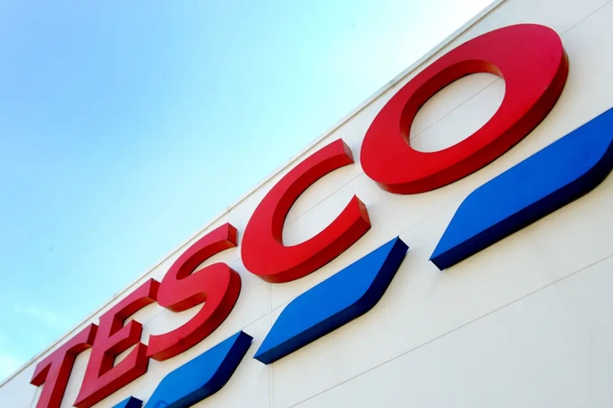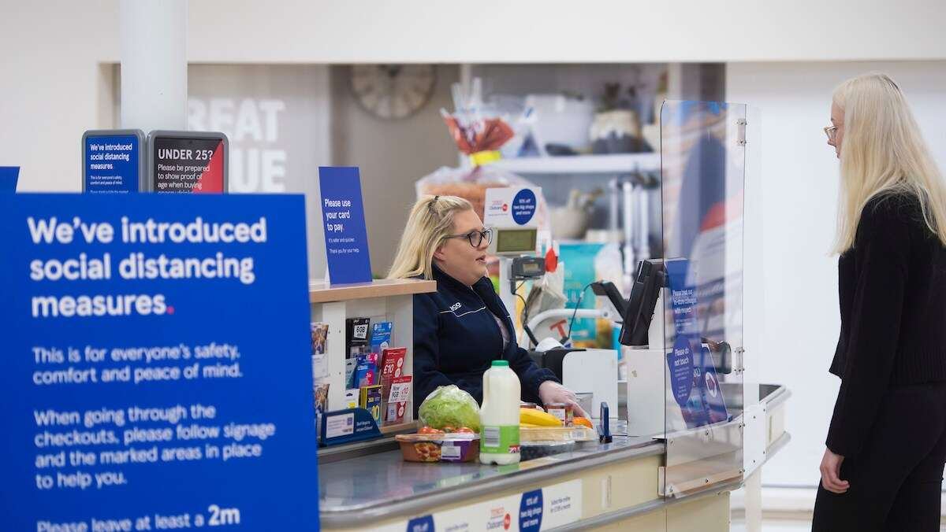

The impact brought to companies and small businesses was bigger than we can imagine, many couldn’t recover after that strike and had to close the doors, but there were the big companies that had a profitable time and were able to make the money out of it, eighthing for an online platform, offering to customers the possibility of a faster purchasing and an easier way to get their groceries done within minute due to the restrictions applied. The stores were full, and the ques were interminable. ‘COVID-19 has shaken businesses in all over the world. Focus shifting towards E-Commerce sales and digital media. Daily essentials are booming, medical consultation, E – learning, donations are increased and mobile phones &electronics, fashion &accessories, beauty &cosmetics, travel &luggage are reduced. ‘Babu and Kumar (2020)

The pressure of the virus was felt immediate, working on rapid implementation and changes. The whole chain of stores had to adapt the conditions of social distancing and changing the rules as Alan Stewart said “A challenge like no other” for ICAEW Insights. Alan Stewart from Tesco explained how “Our businesses probably changed more in a couple of months following the outbreak than in the whole of the last 10 years”. There was a lot of pressure for the employees taking in consideration every safety measure.

The demand was high taking in consideration the big amount of the customers, the organisation had a fully stock to fulfil the large amount of demand ‘the business more than doubled its capacity for online grocery shopping – in April, it became the first retailer to fulfil one million online grocery orders in a week ‘said Alan Stewart for ICAEW Insight.

3.PESTLE Analysis for TESCO

Tesco is a British, one of the biggest groceries retail companies, established in more countries around the world ‘The brand has a network of 7000 retail stores globally in 2021.’ Shaw, (2021)

3.1 POLITICAL FACTORS AFFECTING TESCO

Tesco is a multinational brand and operating its business in different countries across the world, such as China, India, Ireland and many others. Due to political differences from country-to-country Tesco has managed to be the top retail in the market.
The government and political regulations vary from country to country. Therefore, the brand should keep be careful about them and make decisions accordingly. The company follows the safety regulations in different to offer safe products.

One of the political factors which is affecting Tesco operating is the Brexit deal (exit of Britain from the EU) which has created an environment of uncertainty in the business community. The chairman of Tesco, John Alan, said in an interview with BBC that Brexit would increase the prices by approximately 3% to 5%. The British Prime minister said that deal would include tariff-free trade. But it’s not as simple, because there’s administration cost is involved. [Available at: https://www.bbc.co.uk/news/uk-55460948]

3.2 ECONOMICAL FACTORS IMPACTING TESCO

The pandemic of covid-19 has impacted very badly businesses and companies. It was due to the restriction on physical contacts, social-distancing, lockdown, and shutdown of businesses. The e-commerce platform and online shopping saved Tesco from becoming the victim of the pandemic.
In fact, the pandemic increased the sale and profitability of the company. ‘Mr Murphy told a conference call with journalists the first half of this year had "tested our business in ways we had never imagined", but employees had "risen brilliantly to every challenge”. He said he felt "very comfortable in my own skin and my ability to lead this business".’ (Simpson, 2020) [Available at: https://www.bbc.co.uk/news/business-54445399]

The demand was bigger, supply was short, so the store implemented rules on the products and each customer had to follow the rule “5 products for each customer”, they were giving each customer the opportunity to get the essentials ‘Shoppers are limited to buying no more than five of certain goods, including antibacterial gels, wipes and sprays, dry pasta, UHT milk and some tinned vegetables. The rules apply in stores and online. The supermarket said it was in talks with its suppliers to ensure customer demand was met.’ Wilson, B (2020)
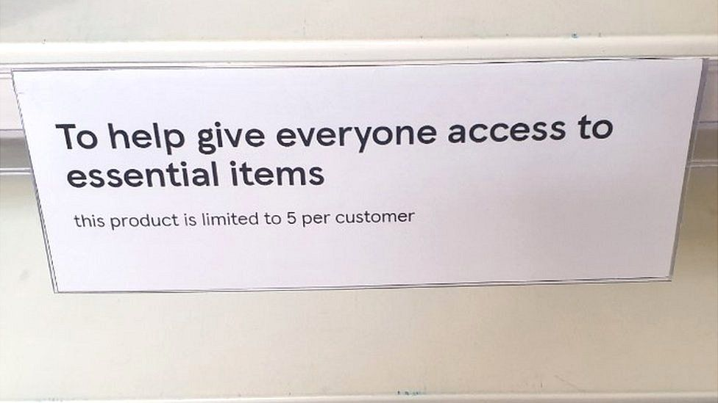
Tesco has introduced signs at point-of-sale in supermarkets, informing shoppers of restrictions

Although Tesco survived the blow of pandemic and months of lockdown and shutdown of business, not many other people did. The lockdown permanently shut down many small businesses and many became unemployed as a result.

3.3 SOCIAL FACTORS AFFECTING TESCO

Tesco follows the local social and cultural trends of different communities and serves them food accordingly. For instance, the company uses the label of Halal meat in the UK for Muslim customers. The brand also owns the halal meat label and brand in Thailand and Malaysia. Tesco also offers kosher products for Jewish customers in the UK. Tesco keeps an eye on the cultural trends and changing attitudes and behaviour of customers. It offers them the products according to their requirements. ‘Many people practising Ramadan are looking for inspiration on meals to cook as they are unsure of the best foods to eat to keep their bodies feeling full during the fasting period. Tesco has partnered with a top chef after a study found many people needing Ramadan mealtime inspiration because they are unsure of the best foods to eat to keep them feeling full during the fasting period.’ Bentley (2021)

Tesco started a new scheme “FareShare” to feed to the children by purchasing a specific kind of product. ‘Tesco shoppers can now help feed millions of children this summer thanks to a new UK-wide initiative where the grocer will donate a penny for every piece of fresh fruit and vegetable purchased in its stores.’ Wright (2021)

According to a study by Guardian, the unemployment rate is boosting. The most important function Tesco performs is to provide employment opportunities to young people. ‘Tesco is to permanently employ 16,000 extra staff taken on during the pandemic to help support a surge in online grocery trade.’ (Butler, 2020)

3.4 TECHNOLOGICAL FACTORS AFFECTING TESCO

The usage of technology is increasing among businesses and companies it helps them to be efficient in various processes and provides a better customer experience. Tesco has also adapted to the latest technology and it’s one of the main reasons for the company’s success. Payment through the mobile application, m-commerce, and barcode scanning system are some of the main examples.
The pandemic of covid-19 has boosted the trend of online shopping and e-commerce. People started ordering groceries online to avoid getting infected with the virus. Tesco survived the pandemic and lockdown of businesses because of staying on the e-commerce platform and delivering the products on time. The company plans to recruit 16000 more people to provide a better delivery service. ‘The hiring comes as online groceries have risen to 16% of Tesco’s sales during the pandemic, up from about 9% at the beginning of the year. The supermarket is expecting online sales of £5.5bn this year, up from £3.3bn last year. The supermarket’s experience reflects rapid growth in online sales across the UK so that home deliveries now account for 13.5% of the grocery market, up from 7.4% before lockdown.’ (Butler, 2020)

3.5 LEGAL FACTORS IMPACTING TESCO

The legal structure and government rules and regulations of governments are different. Therefore, the brand must follow local and international laws. ‘Tesco has a number of strict lockdown rules in place, including a more recent crackdown on the wearing of face masks. In a statement on the food giant’s website, it says: “To protect our customers and colleagues, we won’t let anyone into our stores who is not wearing a face covering, unless they are exempt in line with Government guidance.’ Benady (2021)

3.6 ENVIRONMENTAL FACTORS AFFECTING TESCO

Tesco has recently launched phase 2 of the recycling plan and it comprises of remove, reduce, reuse, and recycle the plastic. It would help the company to decrease and remove the non-recyclable plastic. Most importantly, reducing waste. It’s a very good step for cleaning up the environment. ‘The supermarket chain is aiming to establish a nationwide recycling network for these harder to process plastics. The recycled material will be used to package food, household and beauty products, Tesco said.’ BBC NEWS (2021) [Available at: https://www.bbc.co.uk/news/business-56345661]

After an in-study of the pestle analysis of Tesco, we have realized that Tesco is true of the top retail supermarkets in the UK and worldwide. The lawsuits, controversies, and the uncertain economic environment are serious threats to the company. The company should keep its eyes open to the changing laws and regulations.
Each company has its own management process responsible to satisfy consumers requirements, creating long-term relationships creating profitability.’Covid-19 caused many businesses to drastically change their course, restructure or make a radical change to plans. However, for Tesco it solidified a strategy that allowed the retailer “to really be at our best”.’ Fleming (2020)

4. Marketing mix of Tesco analyses the 4Ps (Product, Price, Place, Promotion) which involves product improvement, pricing approaching, planning promotion, placement of products, helping the brand to success.

Tesco is one the largest retailers based out of UK. It has a huge range of products offerings at its various stores. The product offering is vast to approach to every need and preference of the customers from different segments of the market. The product strategy in the marketing mix of Tesco can be understood as below. MBA SKOOL TEAM, (2021)
Some of the products available at Tesco are - Food, Pet care products, Beverages, Frozen food, Bakery products, home electrical products, Home and garden products, Toys and car products, Sports and leisure products, Baby and toddler products, Party and gift products, Health and beauty products, Clothing and jewellery, Entertainment and books. MBA SKOOL TEAM, (2021)

Below is the pricing strategy in Tesco marketing strategy:

Tesco got the strategy of cost leadership in its strategy.

It provides the lowest priced goods while at the same time maintaining quality. Tesco continuously works with its suppliers to make the supply chain efficient and reduce the prices. Tesco has restructured its product team to get the best offer for customers. To serve its customers during the pandemic, the store put a limit of selling on 5 products as essential needs per customer. MBA SKOOL TEAM (2021) ‘Shoppers are limited to buying no more than five of certain goods, including antibacterial gels, wipes and sprays, dry pasta, UHT milk and some tinned vegetables. The rules apply in stores and online. The supermarket said it was in talks with its suppliers to ensure customer demand was met.’ Wilson, B (2020)

Following is the placing and distribution strategy in the Tesco marketing mix:

Tesco has more than 7000 stores in the world. Depending upon the size of the store, Tesco has different types of stores. They are classified as Tesco Metro, Tesco Express, Tesco Extra, Tesco Superstore. MBA SKOOL TEAM, (2021)

The promotional and advertising strategy in the Tesco marketing strategy is as follows:

Tesco has a strong image which relies on low prices. Tesco uses television ads, and charitable events as promotional channels. It also uses to a large extent promotional discount and offers such as buy one get one. Tesco has a loyalty card called ‘Tesco Clubcard’ which allows Tesco to target its customers.

5. SWOT Analysis

SWOT stands for strengths (S), weaknesses (W), opportunities (O), and threats (T). It’s one of the most used tools when making decisions or analysing a component of a business. You can use the SWOT framework to guide any type of business decision, such as repositioning your brand, launching a new product, or entering a new market. Dundas, (2021)

Strengths  Tesco is a leading retailer, has 27.2% of grocery market. Kantar (2021) The brand of Tesco has a long history in The United Kingdom continuing to operate in great force nowadays. Its stores appeal to cultural need which offers the company to provide products to different cultures. Tesco it is well known for their small prices. The brand operates in many countries such as India, Ireland, China and many more. | Weaknesses  Although the company has a strong economy and big power, the brand has got a few failures as well around the world. Tesco failed in USA and Japan. In the US adventure proved so difficult and none of the 300 store there has made any profit, Tesco couldn’t understand overseas markets.
Opportunities  A good opportunity for Tesco to Grow online and offering home delivery. The brand can tend to strategic alliances to explore in other countries than the ones it failed to retail. Introducing their discount card in 1994, it’s an important move in gaining more customers. | Threats  Larger in the United Kingdom such as ASDA and Sainsbury are a major threat for the organisation. Tesco faces other price threats from Lidl and Aldi, the two competitors are well-known as best promotors, making a huge impact on Tesco’s profit.

6.Porters’ Five Forces

The intense rivalry of Tesco’s business environment was examined with Porter’s Five Forces analysis. The model is as it follows.

6.1 Rivalry

The United Kingdom retail is so competitor due to the enormous number of organisations (e.g. Aldi, Morrison’s, Sainsbury) which are operating in the same segment as Tesco. The biggest companies compete over products, prices and promotions, making the level of similarity very big. Chernev (2018)

6.2. Bargaining the Power of Customers

Is also relatively high as the costs in the retails industry are low. Customers got a big range of retailer from which they can choose, if they are not so happy with what Tesco is providing, maybe products or customer services. Tesco serves more than 80 million customers weekly (Tesco, 2018d). This the factor that can reduce the power of customer so quick.

6.3 Bargaining the Power of Suppliers

Is quite low due to the big number of suppliers all around the globe, more than 1,000, when Tesco is providing food and non-food products. (Tesco, 2018e) the price can be negotiated and haunt the highest quality.

6.4 Threat of Substitution

The threat in the retail industry in medium. The major threat substitutes of the large chains of small stores and organic shops which do not pose a threat to Tesco’s financial sustainability, because Tesco provides the same goods at a cheaper price, getting attractive to the customers options. (Tesco 2018e) On the other hand, the non-food products can be purchased from other well-known retailer best known for clothing and home apparel such as Zara and H&M.

6.5 Threat of New Entrants

The threat of new entrants is kind of low taking in consideration the large amounts of money must invest in in establishing a good conduit and presence in the retail market. (Smithers, 2018) ‘Some of the major competitors of Tesco are Safeway, Sainsbury, Morrison’s, Insta Cart, Giant Eagle, Iceland, Carrefour, Waitrose, Lidl, Argos, ASDA, and Walmart’ Shaw, (2021)

Appendix

The above presentation is considering all the factors and decision that have been taken in place making Tesco function great and helping the company survive and grow during the hard times of the pandemic. In a few words, the brand didn’t have to suffer that much and got the greatest for the online shop making profit as well. The decisions were prompt, and everything was in place for a safe working place for the customer. Tesco gained their customer’s confidence.

Recommendations

- More staff training for customer service.
- Less plastic bags for a better environmental protection.
- Be more explicit in what they are offering on their promotions. Let the customers know if the price is 50% less or they are getting 50% less product.
- Tesco should change packaging for croissants and biscuits from plastic containers ones to paper bags.
- The company should be more organised and put the promotions for the Clubcard in the right and not to be confusing.

References
Babu G. C. and Kumar S. (2020) Study on Consumer Behaviour pattern shift in the period of Corona (COVID-19) Pandemic, Aut Aut Research Journal, pp. 523 -524

ICAEW Insights (2020), Adapting to COVID-19: the Tesco story, Available at: https://www.icaew.com/insights/interviews-and-profiles/2020/july-2020/adapting-to-covid19-the-tesco-story Accessed on: 15th of December

Wilson B (2020), Coronavirus: Tesco limits sales of essential items, BBC NEWS, Available at: https://www.bbc.co.uk/news/business-51790375 Accessed on 19th of December 2021

Chernev, A. (2018) Strategic Marketing Management, Chicago: Cerebellum Press.

Tesco (2018d) Key facts, Available at: https://www.tescoplc.com/about-us/key-facts/ Accessed on 19th of December

Tesco (2018e) Tesco annual report 2018, Available at: https://www.tescoplc.com/media/474793/tesco_ar_2018.pdf Accessed on 19th of December 2021

Smithers, R. (2018) Supermarket sales of organic food and drink continue to risk, Available at:https://www.theguardian.com/environment/2018/sep/04/supermarket-sales-of-organic-food-and-drink-continue-to-rise Accessed on 19th of December 2021

Shaw, A. A. (2021) PESTLE Analysis of TESCO, Available at: https://swotandpestleanalysis.com/pestle-analysis-of-tesco/ Accessed on 19th of December 2021

BBC NEWS, (2020), Tesco: Brexit impact on food prices 'very modest', Available at: https://www.bbc.co.uk/news/uk-55460948 Accessed on 19th of December 2021

Simpson, E. (2020), Tesco profits surge as online orders double BBC NEWS, Available at: https://www.bbc.co.uk/news/business-54445399 Accessed on 19th of December 2021

Butler, S. (2020), Tesco gives permanent jobs to 16,000 staff taken on in Covid crisis, The Guardian, Available at: https://www.theguardian.com/business/2020/aug/24/tesco-gives-permanent-jobs-to-16000-staff-taken-on-in-covid-crisis Accessed on: 19th of December 2021

Wright, G. (2021), Tesco launches new scheme with FareShare to feed the children this summer Retail Gazette [online] Available at: https://www.retailgazette.co.uk/blog/2021/07/tesco-launches-new-scheme-to-feed-children-this-summer/ Accessed on: 19th December 2021

Bentley, D. (2021), Ramadan 2021 - amazing iftar meals to try as Tesco teams up with top chef, Available at: https://www.birminghammail.co.uk/whats-on/food-drink-news/ramadan-2021-amazing-iftar-meals-20393039 Accessed on: 20th of December 2021

Benady-Mauro, R. (2021) UK lockdown roadmap: Tesco, Asda, Sainsbury's, Morrison’s, M&S, Aldi and Lidl's latest rules as lockdown eases, Available at: https://www.essexlive.news/news/essex-news/uk-lockdown-roadmap-tesco-asda-5241339 Accessed on: 20th of December 2021

BBC NEWS, (2021), Tesco to start recycling bread bags and crisp packets Available at: https://www.bbc.co.uk/news/business-56345661 Accessed on: 20th of December 2021

Fleming, M. (2020), Tesco on how COVID-19 helped it really at its best, Available at: https://www.marketingweek.com/tesco-covid-19-brand-be-at-best/ Accessed on: 28th of December 2021

MBA SKOOL TEAM, (2021) Tesco Marketing Strategy and Marketing Mix (4Ps), Available at: https://www.mbaskool.com/marketing-mix/services/16731-tesco.html Accessed on: 28th of December 2021

Dundas, K. (2021), What is a SWOT analysis? Available at: https://www.techradar.com/news/what-is-a-swot-analysis Accessed on: 28th of December 2021

Kantar (2021), Great Britain: Grocery market share, Available at : https://www.kantarworldpanel.com/en/grocery-market-share/great-britain Accessed on 8th of January 2022

Rahman, M. Marketing Essentials: Swot Analysis of Tesco (Tesco SWOT), Available at: https://howandwhat.net/swot-analysis-tesco-tesco-swot-analysis/ Accessed on 8th of January 2022

BBC News, (2013), US Tesco brand Fresh & Easy ‘wasn’t aspirational’, Available at: https://www.bbc.co.uk/news/av/business-22181904 Accessed on 8th of January 2022

Sudhakaran, A. (2020), Tesco SWOT Analysis 2020: A detailed Report, Available at: https://pestleanalysis.com/tesco-swot-analysis/ Accessed on 8th of January 2022

UK Essays, SWOT Analysis of TESCO, Available at: https://www.ukessays.com/guides/swot-examples/tesco-swot-2021.php Accessed on 8th January2022

