ACADEMIC AND EMPLOYABILITY SKILLS

STUDENT: LUSINE EHIAN 1906943
TUTOR: LLOYD BEHARY
MODULE: ACADEMIC AND EMPLOYABILITY SKILLS

Table of Content

Introduction
1.1. Developing a set of own responsibilities and performance objectives
1.2. Personal Development and Learning
2.1. Evaluating own effectiveness against defined objectives
2.2. Recommendation for improvement
2.3. How motivations techniques can be used to improve quality of performance
3.1. Develop solutions to work based problem
3.2. Identifying effective time management strategies
3.3. Suggesting alternative ways to complete task and achieve team goals
4.1. Evaluating tools and methods for developing solutions to problem
4.2. Evaluating the potential impact on the business of implementing the strategy
Conclusion
References

The global world is transforming. It’s imposing new and higher standards. Both in the learning process and in the ways and approaches to doing business. Awareness and application of one’s own responsibilities and proper goal setting need a good knowledge of established theoretical models and their application. The key moments are an adaptation of these models in a real-world environment.
In this paper, the most important characteristics of habits and skills for decision-making models were identified, which enable positive results to be achieved.

  - Developing a set of own responsibilities and performance objectives

In developing an accurate view of our abilities, we need to gather evidence (P. Morgan, 2017).
The learning process is characterised by defined rules and criteria. To a large extent, the student’s responsibilities are defined in the legislative framework. That the student enrolled in the institution means that the student meets the requirements. In the learning’s course process, it is necessary to build further development and refine several skills. To accept new responsibilities to be successful. It is crucial that this process begins at the initial stage of training. The learning process places each new student in a new environment. Furthermore, requires increased responsibilities. Missing this initial stage can cause difficulties in the learning process for both parties. As a result, these difficulties can lead to unsatisfactory learning outcomes.

  - Personal Development and Learning
To develop an accurate view of our capabilities, we must gather evidence. A significant approach to our own qualities would bring better objectivity to the overall picture because of the weakness of each individual to overestimate their qualities and skills. At this stage, it is convenient for the student to seek the opinion and advice of the teachers of the institution. The student may be well acquainted with his / her qualities, but he/she perhaps misses some of what should improve because it does not yet have a good knowledge of the learning process. It is here that the advice of teachers would be useful to give the student a good direction.
Building these skills requires not only a student’s desire but also a good understanding of the theoretical foundations of the process. The Kolb’s Learning Process can be applied.

Four-stage cycle
Specific experience
Mental observations
Abstract conceptualisation
Active experimentation
Removal, Assimilation, Convergence, Adaptation.

Within the process of skill building, all the elements of Soft Skills (Academic skill, Employability skill, Communication, working with a team, Time management, Referencing and avoidance of plagiarism, Paraphrasing and Summarising)

Soft Skills

Comunication
Listening
Speaking
Reading
Writing
Working with a team
Time management

2.1.Evaluating own effectiveness against defined objectives
We must guide the following basic principles in the development of the goals set in the framework of improving personal qualities and achieving good results in the educational process. The goals set must be positive, they must be within the scope of our own competences and must be specific. It is pointless to set abstract goals that are beyond our purview because they will not produce any results.
The definitions of SMART vary, but most focus on specific measurable achievable goals that have a particular time frame (A Conzemius, J O'Neill – 2009)
SMART targeting technology is widely known and has proven effective. It is also fully applicable to the formation of goals by the student within the learning process. SMART is foremost a specificity, which is what makes this targeting system so successful.
Concurrency in the planned desire, Measurability in concrete units, harmonisation with the real state of affairs, the fulfilment of obligations to achieve the goals in time, limited to achieve the goals in time

SWOT

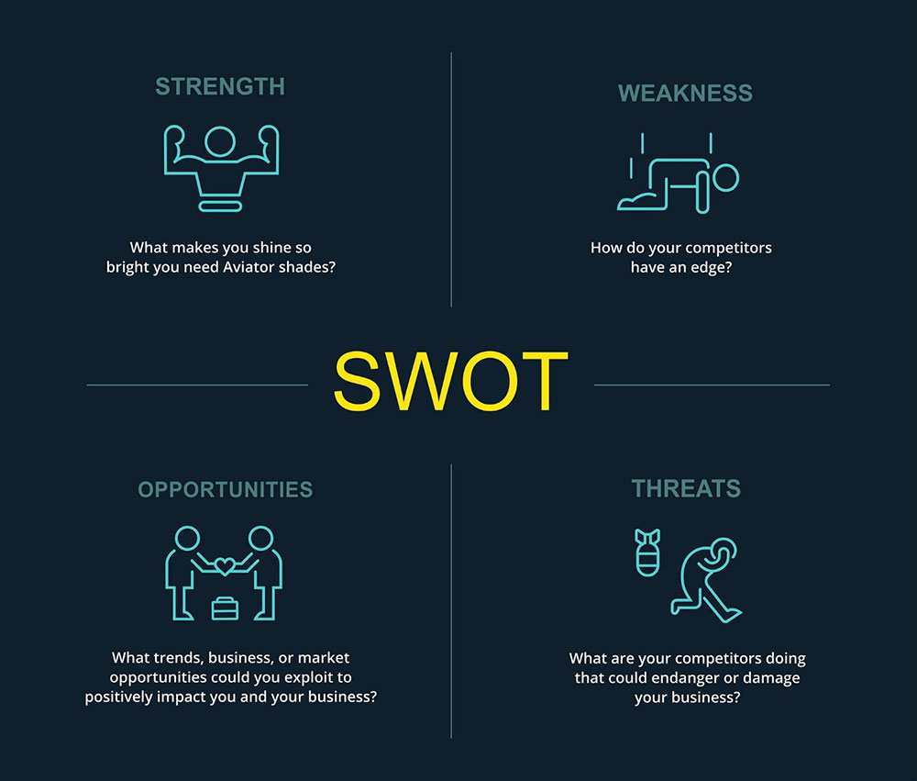

The SWOT evaluation of academic and employability experiences is essential for an individual to know their effectiveness and weaknesses that an individual might own.

2.2. Recommendation for improvement
The building of qualities and the acquisition of habits start from the earliest childhood. Family and school environments are important in this respect. The student in the conditions of study at a higher education institution needs to gain new habits and improve the already gained ones. For the successful realisation of the student within the educational process, it is necessary to improve the following habits and qualities. Responsible attitude towards work and colleagues - development of industriousness, attentive attitude towards people, development of a sense of personal responsibility, a high degree of personal discipline. Increasing the level of professional knowledge.
Gaining the qualifications and successful passing of exams in the professional field, ability to work with scientific literature and a wide range of scientific and official information, habits and skills for interaction at different levels within the state, the institute and among colleagues.

2.3. How motivations techniques can be used to improve quality of performance

According to a survey conducted by Grand 2008, motivated employees are oriented toward greater independence.
Motivated individuals are more committed to their tasks and more likely to take on responsibilities. (Kuvaas, B. and Dysvik, A 2009)
In this respect, high commitment to the learning process is a prerequisite for achieving better results, which are a motivator for the student.
A passive approach to the learning process in which the student gains knowledge but does not apply the knowledge gained and does not upgrade his knowledge is unacceptable.
Improving knowledge requires this high level of commitment that Grand is talking about and high motivation.
It is for this reason that building habits related to the learning process and a high level of self-discipline are the prerequisites fundamental for assuming responsibilities and achieving better results.

3.1. Develop solutions to work based problem
Problem-solving in the learning process is a prerequisite after the completion of the learning process. The student has developed good enough skills to overcome the problems and to solve problems in his work. The steps to build solutions to overcome the problems are as follows.
Problem determination, Brainstorming. We should focus brainstorming on the specific problem, and it is desirable to take place within a small professional group, colleagues, fellow students. Choosing a solution. Implementation of the decision. Review and analysis of results achieved. The solution should be relatively simple and aimed at solving the problem, not postponing it.

Communicate in a variety of styles and appropriate manners at various level

Communication styles determine a person’s behaviour when interacting with other people. The choice of a particular communication style is determined by several factors, among which the following are important: the purpose of communication, the situation in which it is carried out, the status and personal characteristics of the interlocutor, his worldview and position in society, and a characteristic of the form of interaction itself.
The dialogue, or humanistic style, is opposed to authoritarian and manipulative types because based on equal partners. It manifests itself during a friendly conversation, dialogue, exchange of views. So, we often communicate with classmates, teammates, colleagues, fellow travellers on the train, etc. The purpose of such communication is not to subordinate, not to manipulate, but to understand the other person, his views, preferences, interests. Such communication allows you to achieve complete mutual understanding, build a common reality with other people, learn about the world.

3.2. Identifying effective time management strategies
Time-management - a set of techniques aimed at developing skills for the effective organisation of personal time. The time management techniques helped cope with a lot of things in a short time, to get rid of chronic fatigue, the pressure of time restrictions and eternal stresses. With the correct application of the recommended techniques, labour productivity is significantly improved, and we find time for rest.
Various time management systems train conscious control over the time spent on tasks, optimally distribute the work, and contribute to professional and personal growth.
Eisenhower’s matrix is ​​a well-known time management concept for prioritising. The main purpose of the method is the competent sorting of cases into categories of urgency and importance. The approach recommended by US President Dwight Eisenhower helps you not to get lost in an endless list of tasks, easily highlighting the main thing.

Eisenhower matrix is used for short-term planning, with this method all day cases are arranged by priority of importance and urgency. (Yevdokymov, Konotoptseva)
The importance of a business is determined by its impact on business, urgency - by its attachment to a specific date/time. I should enter each case in a matrix scheme and distribute into separate columns corresponding to the characteristic type:

Franklin Pyramid

Benjamin Franklin’s planning system is an excellent assistant in quality time management. We use it in life and in business.
According to the pyramid, life or work goals are allocated to individual items of some importance:
1. Foundation - the main mission, values ​​and guidelines, the vector of the direction of motion.
2. A global goal.
3. The general plan for implementing the idea, intermediate tasks.
4. Long-term plan for 1-5 years with exact deadlines.
5. Short-term plan for the week/month.
6. Daily plan.

3.3. Suggesting alternative ways to complete task and achieve team goals

Planning is shaping the order of action to be taken. It involves setting a goal, achieving it, and choosing the best options. At this stage, it is necessary to know ​​the alternatives available. Plans are being drawn up for both the economic entity and for individual units. We, therefore, require coordination to ensure consistency. An alternative. This is the conditional naming of some possible ways of achieving the goal. Each individual alternative differs from other ways of solving the problem by the sequence and methods of using active resources, a specific set of instructions to whom, what, whereby what and by what time. Where the chosen strategy has led to the achievement of the set goals, it is worth to think about how to use it and, naturally, trying to improve it. If, however, a significant discrepancy is found between the results got and the desired results, other strategic alternatives should be sought and perhaps other approaches may be used.

4.1. Evaluating tools and methods for developing solutions to problem

I understand management as finding a specific variant of achieving a goal or solving a specific problem, i.e. solving a problem by applying a set of techniques or operations.
Indecision theory, there are three conceptual approaches:

1. Qualitative-object concept (descriptive approach).
2. The concept of mathematical choice of solutions (normative approach).
3. The complex concept of management decisions.

Descriptive decision theory is aimed at empirically investigating and describing the behaviour of individuals and groups of people in the decision-making process. It has a pronounced explanatory, not prescriptive character. It uses psychological models that take into account the processes and forces that explain the real behaviour of the leader.
The purpose is to identify patterns of decision making in the process of interaction of the initial parameters of the problem being solved and the characteristics of the subject (individual or collective), the decision-maker.
The normative theory is not concerned with the description and explanation of real decision-making processes but concentrates its attention on the development of organisational information, methodological bases for making a rational (economically sound) decision. It strives for the development of “traffic rules” in management work, which will ensure that it makes the optimal decision.
In the framework of mathematical decision theory, it develops normative models of decision making.
To develop managerial decisions, the manager must not only possess theoretical knowledge, rich experience, managerial foresight but also be qualified enough to put into practice:
- the method of management decision making;
- methods of development of management decisions;
- organisation of management decision development;
- evaluation of the quality of management decisions.

4.2 Evaluating the potential impact on the business of implementing the strategy

Balanced Scorecard. Attempts to streamline and plan key targets and balance the framework of goals are constantly being made. In 1992, Robert S. Kaplan, a professor at the Harvard Business School and David P. Norton, an independent consultant, proposed a company performance metric called the Balanced Scorecard. The idea of ​​a balanced scorecard was to link financial metrics to operating metrics such aspects of the enterprise as customer satisfaction, in-house business processes, and innovative activity.
Within this concept, the balance is multifaceted, covering: Relationships between monetary and non-monetary dimensions of measurement; Strategic and operational levels of management; Past and future results.; Internal and external aspects of the company.

Conclusion
Based on all theoretical models for skill building and goal setting, it can be concluded that the process requires a high level of awareness and commitment. It must be recognised that, with the right approach, improving skills leads to better and more positive results. On the one hand, the pursuit of such results builds habits of serious work. On the other hand, it refines the skills already achieved.

References

P.Morgan. The business students guide to study and employability,2017, page 22

A Conzemius, J O'Neill - 2009 The power of SMART goals: Using goals to improve student learning, 2009
“A management development model”, Journal of Management Development, Vol. 26 No. 4, pp. 353-69. Kuvaas, B. and Dysvik, A. (2009)

Adam M. Grant (2008) Employees without a Cause: The Motivational Effects of Prosocial Impact in Public Service, International Public Management Journal, 11:1, 48-66, DOI:
Pages 48-66 | Published online: 03 Mar 2008
BASICS OF PLANNING TIME MANAGEMENT OF PUBLIC SERVANT
Yevdokymov V. O., PhD in Economics, Associate Professor, Associate Professor of Public Administration Department KRI NAPA; Konotoptseva Iu. V., PhD in Public Administration, Associate Professor, Associate Professor of Public Administration Department KRI NAPA Kharkiv





