Prepared for:
Gavin Traylor

Client Letter
BIM
Date Completed: 16th January 2024

Word Count: 2514

Luke Hunt
Table of Contents
1.0 – Client Letter 2
2.0 – LOD and LOI Information Need 4
2.1 – BIM Maturity 4
2.2 – RIBA Stages and BIM Maturity 7
2.3 – CAFM System 8
2.4 – LOD and LOI 9
References 12

1.0 – Client Letter

LOH Ltd,
46 Morfydd St,
Swansea.
Sa1 8BU

Neath Port Talbot CBC,
Civic Centre,
Port Talbot.
SA13 1PJ

Dear Client,
I am the lead consultant of LOH Ltd, in charge of delivering a ‘state of the art’ infant school in your constituency. As your primary point of contact, I have taken the initiative to provide you with an outline of the measures that will be taken by my company to show the level of competency of the project team in reaching the BIM maturity requirements. As this project is a joint funded venture with the Welsh Government, my company is required to meet these standards of BIM maturity, and so in this letter, I will identify how information will be shared, coordinated, and managed throughout to provide you with the level of information and detail required for the outcome of this project.
As the client you will have the opportunity to create an EIR, Exchange Information Requirement, for the project (Catenda, 2024). An EIR gives a brief on the information and data requirements of the client. This document can be used by my company as a guide for the development of BIM through the life cycle of the project. This is a crucial document to attain for the project as it provides the foundations for the construction BEP, BIM Execution Plan (NBS, 2023). The BEP is a plan that laid out by the project team, where it uses the clients EIR to outline how the project will be implemented, managed, and delivered. This collaboration of the project team and the client will allow us to work in much better alignment with each other, and to integrate a greater project execution.
The EIR and BEP will help the project team to make decisions on the LOD and LOI. The BIM model is defined by the levels of information and details throughout the project to both the client and the project team at different stages of the RIBA process. Each stage will have a level of detail and a level of information linked to it, which will provide the necessary information needed at that stage.
The government has outlined the requirements that are to be met in terms of BIM maturity. It states that any government backed project must achieve a minimum BIM Maturity level of 2. Our company will ensure these requirements are met. However, throughout these stages, through collaboration, coordination, and integration, both you and my team will be able to discuss and make decisions on the level of information and level of detail that is required at each stage should you wish for the project to have a higher level of BIM maturity.
BIM maturity is there to ensure that there is a collaboration between the client, the project team, and other professional disciplines, in order to bring all the data together at any given time to make one integrated BIM model. At each stage of the RIBA plan of works, we can discuss the levels of information and detail needed, which will then provide us with a BIM model with the necessary information and detail required. This collaboration can allow information to be shared, coordinated, and managed in the most effective way possible.
The information will be collected into one place, using a COBie format file. This file allows all professional disciplines to attach their files together where they become integrated into one big BIM model. This creates a data rich BIM model that can be used by the whole project team to identify the details and information needed for a specific stage of the project. Furthermore, there are systems such as the CAFM system (Computer Aided Facilities Management), which use a collaboration of all the shared information of the completed project. This provides you with all the necessary information about your facility to ensure that maintenance is upheld throughout the life cycle of the building, and management systems are put in place to ensure performance of the building is coordinated and maintained.
I hope this letter helps you to gain some clarity on how we will work together on this project and how we will generate and improve on collaboration, coordination and management throughout the life cycle of this project.

2.0 – LOD and LOI Information Need

In order to reach the BIM Maturity requirements, appropriate for project 5010 (Ysgol Yr Afan), it is crucial to identify and understand the Level of Information (LOI) and Level of Detail (LOD) needed in, and throughout this project. The RIBA Plan of Works Stages provides a framework for the design and construction of a project but, it is the LOD and LOI information that provides a level of clarity and consistency within the BIM models.

2.1 – BIM Maturity
BIM Maturity is the level of information required for a project, based on the level of detail and information needed. The higher the level of maturity, the higher the level of LOD and LOI. BIM is designed to provide a more collaborative and efficient approach to the coordination, information sharing and management of construction projects, in order to reduce error and cost within the public sector of the industry. It was also implemented to improve productivity and reduce waste within the sector, in an attempt to improve the UK’s building economy, along with other countries (PlanRadar, 2020). BIM maturity can be explained by looking at the image below. It identifies what level of information is required to achieve the acceptable BIM Maturity (United BIM, 2023).
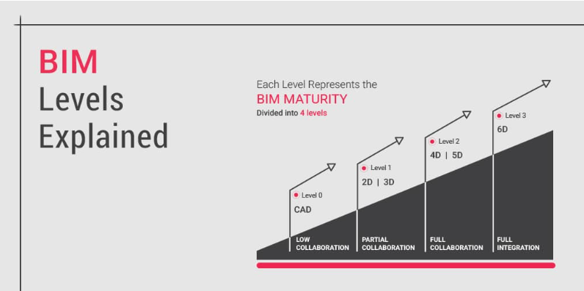

Project 5010 is a joint funded venture with the Welsh Government. Because of this, it means that there is a level of standard that must be met to reach the appropriate Maturity. The Welsh Government requires that any project funded by the government is to attain a BIM Maturity level 2. As shown on the image above, Level 2 requires a full collaboration process for the project and requires 4D/5D details of the project. This suggests that the maturity level for this project is relatively high and will therefore require a high level of detail and information to match the maturity level.
Due to the fact that the government requires a minimum of level 2 BIM Maturity, our company will ensure that this is achieved. However, should the client wish to enhance the maturity level, or the LOD and LOI for this project, then discussion can take place with the lead consultant in order to implement this via the LOD and LOI format and through the RIBA Stages. Below explains in further detail, the level 2 BIM maturity which will hopefully provide the client with clarity and comprehension of what the minimum requirements for this project are (Constructing Excellence in Wales, 2024).
Level 2 BIM maturity requires a fully collaborative working method which enables the flow of information sharing between the different project parties but does not require a fully integrated system. An example of this would be that individual parties within the project provide their own drawings and models with any data attached and share this information in a file format. This data can then be collaborated with other individual disciplines to provide a federated BIM model (MepBIM, 2024). Some of the more common file formats used for this are IFC (Industry Foundation Class) and COBie (Construction Operations Building Information Exchange).
The Government has laid out requirements to be achieved across the whole the project life cycle, in order to attain a level 2 BIM maturity, some of which include:
- Collaborative 3D models
- Common Data Environment (CDE)
- Standardized Data Exchange Formats
- Government Mandates
- Information Exchanges
- Employer Information Requirements (EIR)
- BIM Execution Plan (BEP)
- Level of Detail (LOD)
- Level of Information (LOI)
- Clash Detection
- BS (PAS) 1192 (PAS 1192-2 specifies five stages of information delivery)’ (MepBIM, 2024).

As per the International BIM Standards, there are different levels of collaboration and integration, as mentioned above. Level 1 BIM maturity being the most basic, and level 3 being the most complex. Below are some of the ISO standards that must be adhered to when focusing on which level of maturity a client is aiming for (James Ocean, 2020).
BIM maturity level 1:
- BS 7000-4 – Design management
- BS 8541-2 – Recommendations about 2D symbols to use with building elements.
- ISO 12006-2 – Information classification in construction (framework)
- BS EN ISO 13567-1, 13567-2 – CAD overview, codes, and formats used in the construction documentation.
BIM maturity level 2:
- PAS 1192-2. Data management specifications for the delivery and capital phases of the construction project in the context of BIM.
- PAS 1192-3. Data management specifications for the operational phase of the BIM project.
- BS 1192-4. Collaborative information creation and exchange.
- PAS 1192-5. Smart asset management, digital environments, and security-related BIM specifications.
- BIM protocol.
- dPoW (Digital Plan of Work).
- BS 8536-1. Everything about building infrastructure.
- Implementation of ISO 12006-2:2015 about classification.

BIM maturity level 3:
- ISO 12006-3. Building construction.
- ISO 16739. Facility management.
- ISO 29481-1. Methodology and format of IDM.
- ISO 29481-2. Interaction with IDM.
- BS 8541-1, BS 8541-3, BS 8541-4, BS 8541-5, BS 8541-6

2.2 – RIBA Stages and BIM Maturity
The RIBA Stages provide a project with a plan of the design and construction processes, whilst the BIM maturity levels identify the project’s progression by providing a specific level of information and detail throughout each stage. The RIBA stages identify, in order, the complete lifecycle of a project, from design, through to handover. As written by the Royal Institute of British Architects, here are the RIBA stages (2024) and how they link in with BIM maturity to identify the level of information and detail needed at each stage of the project (Sinclair, 2019) – It must be kept in mind that these practices can and will most likely vary from project to project, however, this does give a good generalization for the clarity of the client:

- Strategic Definition (Stage 0) / Preparation and Brief (Stage 1) – At stages 0 and 1 the level of maturity includes a basic form of 2D drawings and there may be some information exchanges.

- Concept Design (Stage 2) / Spatial Coordination (Stage 3) – Stages 3 and 4 would begin to include BIM maturity level 2. This would include a more collaborative form of working with 3D models in a federated environment.

- Technical Design (Stage 4) – At stage 4, the project may progress to maturity level 2, focusing on technical design and information exchange.

- Construction (Stage 5) – Maturity level remains at level 2 whilst the construction process takes place. Clash detection and coordination of all professional disciplines is integrated to provide a collaborative and efficient construction phase.

- Handover and Close Out (Stage 6) – At stage 6, the maturity level may progress onto level 3. This is where all information becomes integrated and collaborated for the purpose of facilities management and operation of the completed project. This stage can remain at level 2, or progress onto level 3, depending on what the information the client needs during handover, and the level of detail at which the information needs to be at.

2.3 – CAFM System
CAFM, or Computer Aided Facilities Management is a type of software that has been designed to aid organizations, and governments etc. in efficiently managing and maintaining physical facilities and assets. It is a way of bringing all the information generated by all disciplines within the project together and creating a unified platform the identifies a way to manage different aspects of facility operations. This includes the following (Agarwal, 2023):

- Maintenance Management – To ensure proper use and function of the facility, it is crucial to provide regular tracking and maintenance, but to also monitor the performance of internal building systems. The CAFM system will help to prioritize and schedule these tasks.

- Physical Building Administration – CAFM systems can be linked up to other systems like HVAC (Control Systems, 2023), to provide the ability of remote access of infrastructure. For example, remote access to lighting, computer systems, locking doors and windows etc. This ensures maximum safety and minimizes energy usage.

- Life Cycle Management – CAFM systems can ensure that a facility is run, yet maintained to its full potential, and in the most cost-effective way all through its life cycle.

- Asset Tracking – CAFM assists in the maintenance of the assets within a facility. It can aid in the maintenance and tracking of any machinery, equipment, and furniture.

- Document Management – Documentation is crucial for any facility. It provides useful information such as floor plans, manuals, maintenance records etc. CAFM systems will aid this by centralizing all of this information, making it relatively easy to find.

- Integration with BIM – The more information and level of detail put into CAFM systems, the easier it will become to analyse it. BIM models can be integrated into these systems, which provides a 3D visualization of all the building information. This integration and collaboration provide the client with a much more efficient life cycle management of the facility.

- User and Access Management – These systems can incorporate authorised users only with access to any sensitive information and provide certain personnel with specific management roles.
The CAFM System will provide the clients with the necessary information for the school at the right level of detail to aid them in maintaining the building. This system also provides safety for the client as they can refer back to it as and when needed.

2.4 – LOD and LOI
LOD and LOI or Level on detail and Level of information are two formats used in the context of BIM to identify the information and detail content of a BIM model during each stage of the construction process. They provide a standardised way of identifying and communicating the necessary information and detail for the element within the BIM project.
LOD is a graphical and geometric scale used in order to stipulate the level of detail within a model. Each LOD level demonstrates the amount of detail that will be represented in a specific stage of a project. Here is an example below of the level of detail as stated in the BIM Protocol and PAS 1192 (NBS, 2023):

LOD 2 – Conceptual – This provides minimal graphical detail.

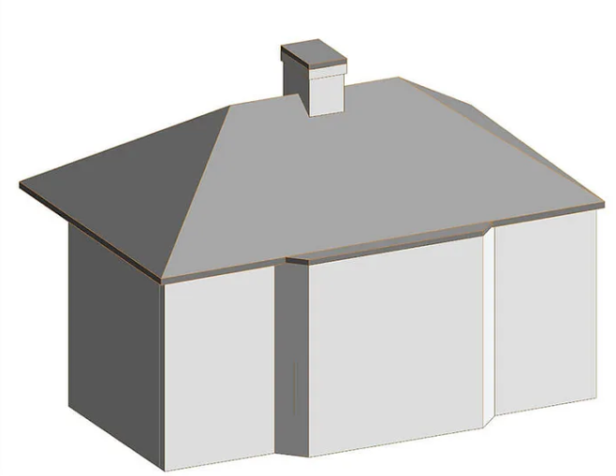

LOD 3 – Spatial Coordination – Defined designs, components, and materials.

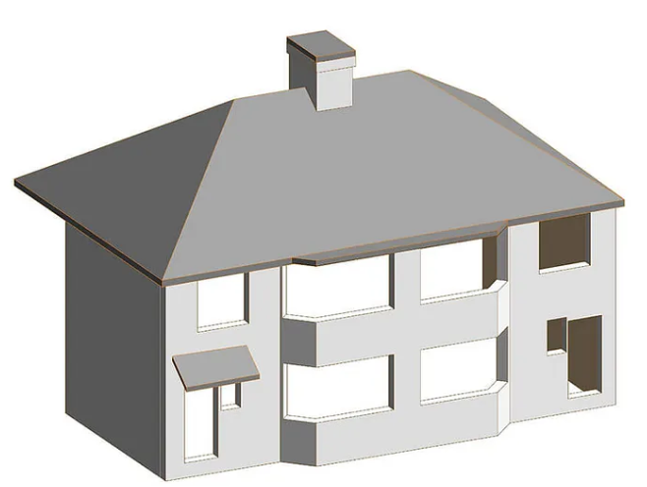

LOD 4 – Technical Design – Precise designs, components, elements, materials with specific detail.
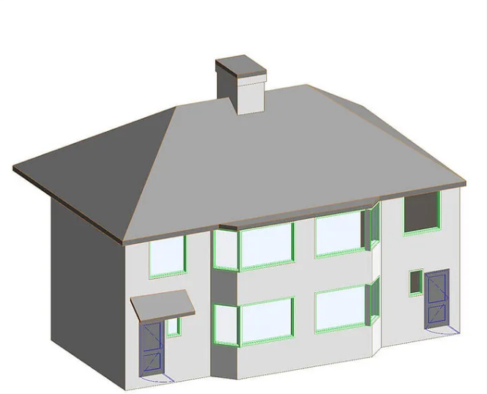

LOD 5 – Construction – Accurate representation of the model (NBS, 2023)

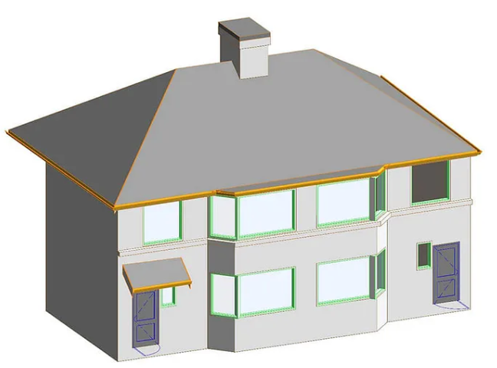

These LOD levels above give good clarity on how the level of detail changes based on the amount information and detail needed for a specific stage within the project. LOD 1 and 2 would be a sufficient level of detail for BIM maturity level 1. LOD 3 Would be sufficient for BIM maturity level 2 and LOD 4 would be sufficient for BIM maturity level 3. It is helpful to visualize this using model, and much easier to link LOD and BIM maturity together. As the government requires a BIM maturity level 2 for this project, LOD 3 or more would be considered sufficient for this project.

LOI, or Level of Information is a non-graphical grading scheme that links in with both LOD and BIM maturity. Although there isn’t graphical representation as such, the same approach is taken when identifying the levels of information required for sufficient BIM maturity. LOD 1 would provide basic levels of information that would go along with a more basic form of LOD, whilst LOD 4 would show a collaboration of rich and detailed data provided for the BIM model (Marcie, 2020).

References
Agarwal, K., 2023. What is CAFM? All About Computer-Aided Facility Management. [Online]
Available at: https://www.selecthub.com/cmms/facility-management-cmms/computer-aided-facilities-management/
[Accessed 11th Janaury 2024].
Catenda, 2024. What is the Employer’s Information Requirements?. [Online]
Available at: https://catenda.com/glossary/bim-eir/
[Accessed 11th January 2024].
Constructing Excellence in Wales, 2024. BIM. [Online]
Available at: https://www.cewales.org.uk/current-programme/bim/
[Accessed 12th January 2024].
Control Systems, 2023. What Is an HVAC System? A Comprehensive Guide to Heating, Ventilation, and Air Conditioning. [Online]
Available at: https://bmscontrols.co.uk/blog/what-is-an-hvac-system-a-comprehensive-guide-to-heating-ventilation-and-air-conditioning/
[Accessed 11th January 2024].
James Ocean, 2020. BIM Standards: ISO 19605 and more. Different Levels of BIM.. [Online]
Available at: https://revizto.com/en/bim-standards-level-of-information-bim/
[Accessed 11th January 2024].
Marcie, 2020. LOD and LOI and everything you need to know. [Online]
Available at: https://medium.com/@vibim/lod-and-loi-and-everything-you-need-to-know-af7e24165c38
[Accessed 12th January 2024].
MepBIM, 2024. BIM Maturity Levels. [Online]
Available at: https://www.mepbim.com/building-information-modeling/bim-maturity-levels/
[Accessed 10th January 2024].
NBS, 2023. Level of detail (LOD) and digital plans of work. [Online]
Available at: https://www.thenbs.com/knowledge/level-of-detail-lod-and-digital-plans-of-work
[Accessed 12th January 2024].
NBS, 2023. What is a BIM Execution Plan (BEP)?. [Online]
Available at: https://www.thenbs.com/knowledge/what-is-a-bim-execution-plan-bep
[Accessed 11th January 2024].
NBS, 2023. What is the PAS 1192 framework?. [Online]
Available at: https://www.thenbs.com/knowledge/what-is-the-pas-1192-framework
[Accessed 12th January 2024].
PlanRadar, 2020. BIM adoption in the UK – history and impact. [Online]
Available at: https://www.planradar.com/bim-in-uk-construction-technology-market/
[Accessed 10th January 2024].
RIBA Architecture.com, 2024. RIBA Plan of Work. [Online]
Available at: https://www.architecture.com/knowledge-and-resources/resources-landing-page/riba-plan-of-work
[Accessed 10th January 2024].
Sinclair, D., 2019. Sustainability, BIM and procurement have all affected the Plan of Work's latest overhaul. So what has changed?. [Online]
Available at: https://www.ribaj.com/intelligence/updates-to-the-riba-plan-of-work-2019-dale-sinclair-gary-clark
[Accessed 10th January 2024].
United BIM, 2023. BIM Maturity Levels Explained- Level 0, Level 1, Level 2, Level 3. [Online]
Available at: https://www.united-bim.com/bim-maturity-levels-explained-level-0-1-2-3/
[Accessed 10th January 2024].

