Chapter 4- Analysis of results.
4.1 Introduction
Within the methodology chapter, it was discussed how research conducted would be able to answer the objectives of this dissertation and assist in understanding further the topic of gender inequality within policing and the modern-day challenges that female police officers are faced with by using a Quantitative approach to gathering the data.
This chapter analyses and examines the data gathered by using a Quantitative approach.
Within this chapter of the dissertation, results from a survey surrounding gender inequality within policing and the modern-day challenges female police officers are faced with, will be analysed to assist in gaining a greater understanding surrounding how police officers feel towards this topic from their own experience. A survey was created and uploaded onto Police platforms such as social media pages and group chats for serving/ex-serving police officers to respond to. The particular target audience for the survey was both male and female officers who were current serving officers, or ex serving officers.
The survey received twenty-five responses in total which consisted of both male and female police officers which again, has provided a greater understanding towards the current operational culture withing modern day policing. The age range of participants ranged between eighteen to sixty. Ninety-six percent of participants were current serving police officers, while four percent were ex-serving police officers. Sixty-four percent of participants were male, whereas thirty-six percent of participants were female, this means that opinions were able to be gained from not just female officers, but also, a large number of male officers who may have opinions in relation to what they have particularly witnesses in relation to gender inequality within policing and modern-day challenges female police officers are faced with.
The created survey adhered to ethical guidelines and participants were informed, prior to taking part in the survey, responses will remain anonymous meaning that no information which is personal will be released. An anonymous survey means to review opinions from responses received with no name behind the responses and therefore, this the responses cannot be traced back to anyone. (Balamurugan, 2025). This provides the responder with a sense of anonymity and the confidence to provide feedback to how they are really feeling about the subject matter.

4.2 Gender inequality within policing and the modern-day challenges female police officers are faced with.
Gender inequality within policing and modern-day challenges female police officers are faced with is an already well discussed topic which is reflective within the literature review specifically in the Metropolitan Police, however the below pie charts from a created survey will breakdown and provide recent responses in relation to how both current serving and ex-serving police officer feel in relation to the subject matter which will assist in truly discovering the dissertation subject and analyse data from responses provided. Data analysis is described as a method used to summarise numerical data in order to receive a statistical result. (Coursera, 2024). The method of a pie chart will be used to summarise data received within the survey. A pie chart is often described as cylindrical statistical representation of data which is proportionate to the data value within each section of the cut-out slices. (Ricks, 2014).

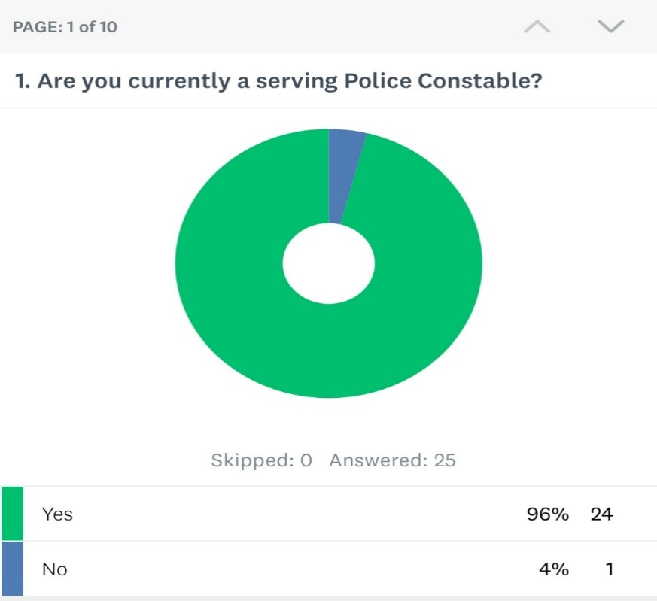
The question asked was “Are you currently a serving police constable?” This question received twenty-five responses. Each participant within this question apart from one responded that they were a serving police constable with one reponing that they were not, which indicates that they are an ex-serving police constable.
Therefore ninety-six percent of participants stated that they are current serving police constables and four percent of participants stating that they are not a current serving police officer.

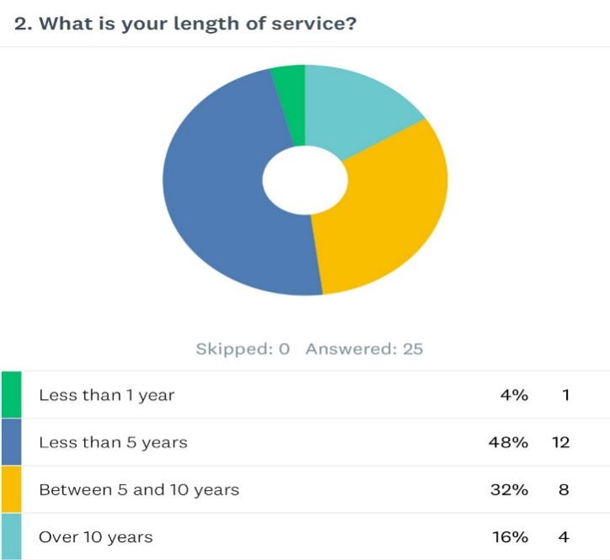
The second question asked was “what is your length of service.” Sixteen percent of participants had over ten years’ service, thirty-two percent having a length of service between five and ten years. Forty-eight percent of participants having less than five years’ service and four percent of participants having less than one year of service within the police force. This suggests that responses to upcoming questions within the survey will have varied responses which is positive as many respondents have had a number of years’ service within their retrospective force and will therefore be able to provide their true feelings which will be reflective upon their experiences.

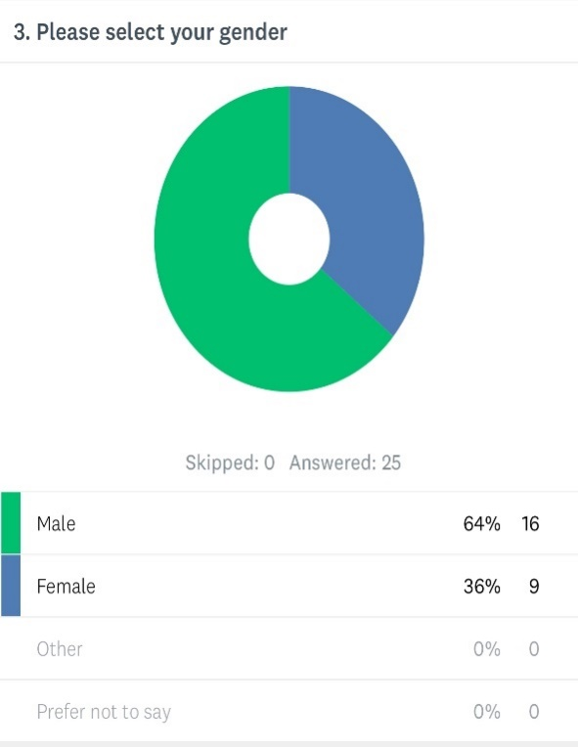
The third question asked was for the participant to select their gender to which sixty-four percent of participants selected that they are a male and thirty-six percent of participants selected that they are female. The number participants who are male is significantly higher than female participants, however on reflection of the literature review, it was found that there is a higher percentage of males than females within police forces and therefore, this may be the rationale behind why there are more male participants than female participants.

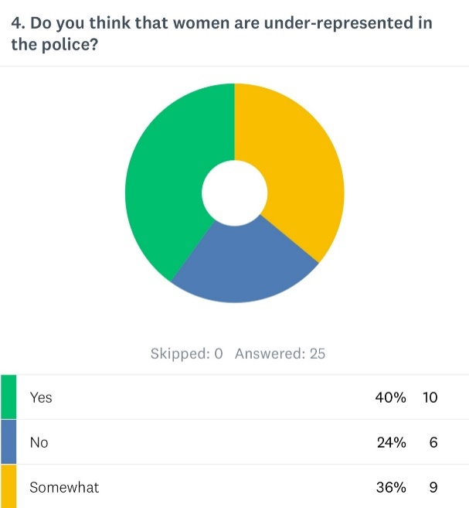
Question four of the survey relates to an underrepresentation of females within the police, to which the question was asked “Do you think that women are under-represented within the police?” There were twenty-five responses to this question whereby forty percent of participants responded yes. Thirty-six percent responded somewhat, and twenty-four percent responded as no.
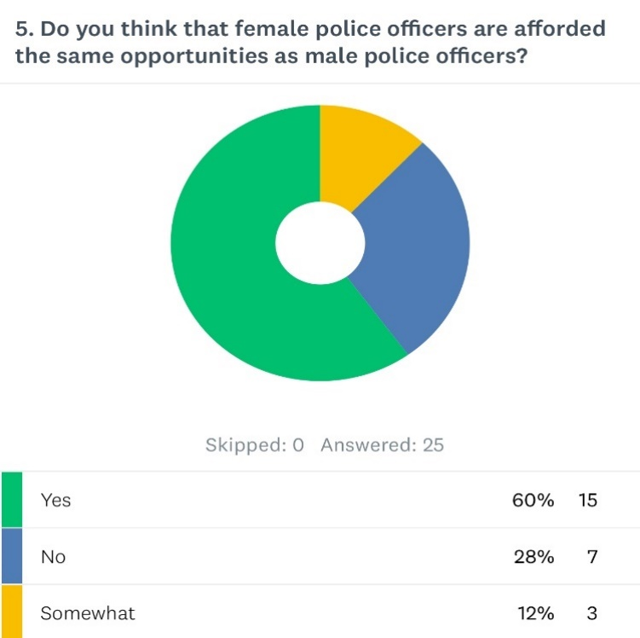
Within question four of the survey, the question was asked whether “do you think that female police officers are afforded the same opportunities as male police officers?” whereby sixty percent answered yes. Twenty-six percent answered no and twelve percent answered somewhat. this displays that there is a general consensus amongst participants that females are underrepresented within policing.

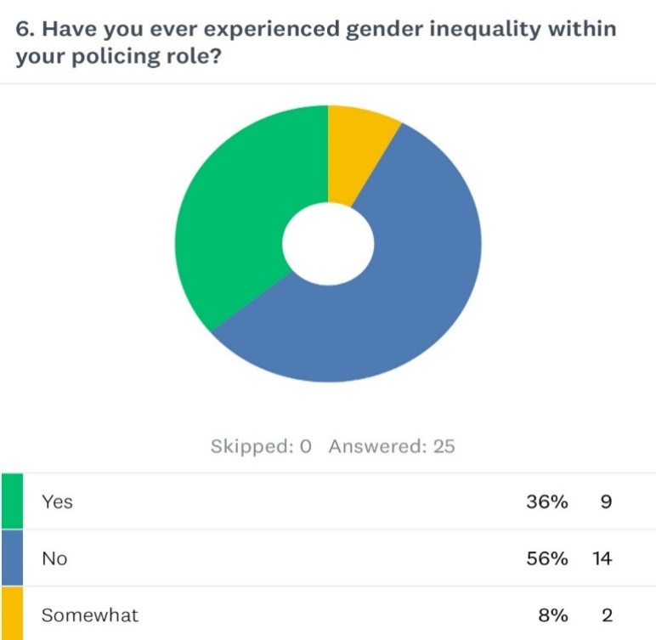
Question 6 of the survey asks the participants “Have you ever experienced gender inequality within your policing role. There were twenty-five participants to this question, whereby thirty-six percent answered yes, eight percent answered somewhat and fifty-six percent answered no. it appears from this that although over half of the participants said no, there is just under half that said yes, this suggests that there is a sense of inequality within policing from the participants own experiences.

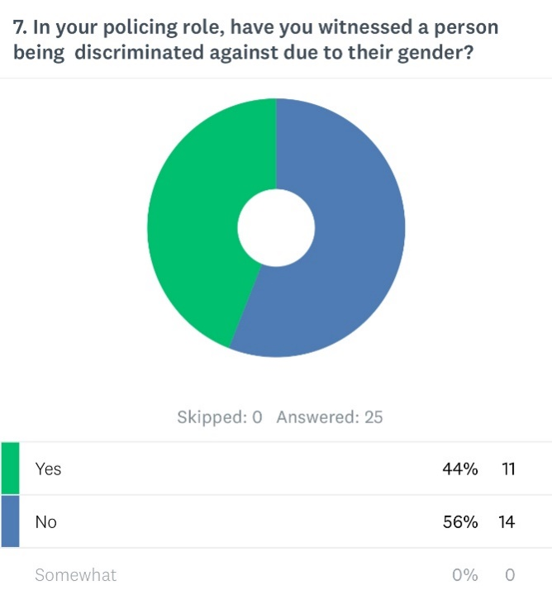
Question 7 asks the participant “In your policing role, have you witnessed a person being discriminated due to their gender?”. There were twenty-five participants to this question. Forty-four percent of participants answered yes, whereas fifty-six percent participants answered no. These statistics suggest that police officer have witnessed a person colleague taken prejudice against due to their gender and therefore suggests that there is an element of gender inequality within policing.

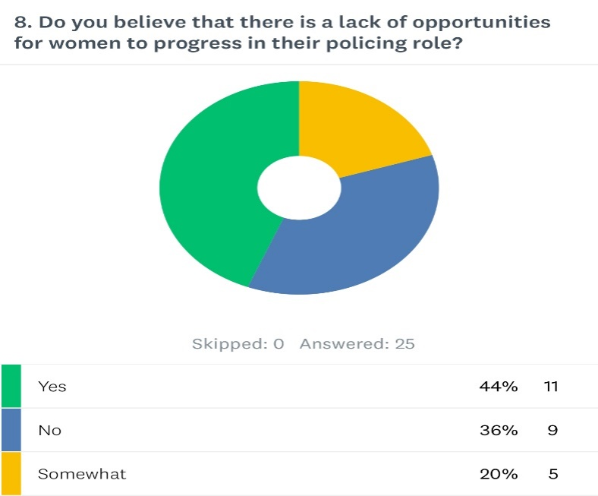Question eight of the survey asks the participant “Do you believe that there is a lack of opportunities for women to progress in their policing roles?” Just under half of participants, forty-four percent answered yes. Twenty percent of participants answered somewhat and 36% of participants answered no. These results suggest that over half of the participants believes that there is a lack of opportunities of females to progress within their policing role and additionally suggests that females are not provided with the same opportunities as their male counterparts.

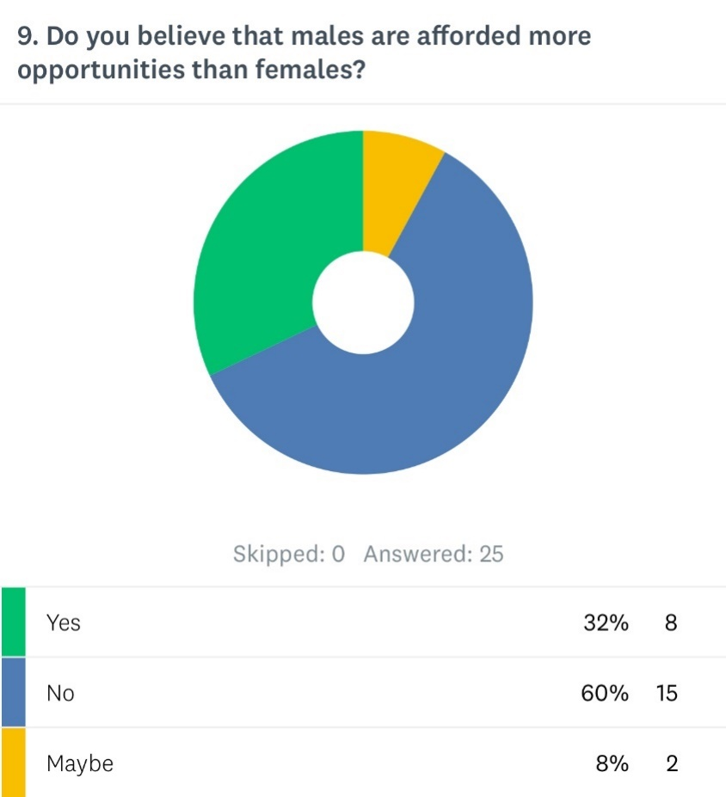Question nine of the survey asks the participant the question of “do you believe that males are afforded more opportunities than females?”. There where 25 responses to this question. Thirty-two percent of respondants answerd yes. Sixty percent answered no, and eight percent answered maybe. This suggests that approxiamtely fourty percent of the partcipants feel that males Police Officers are afforded more opportunties that female officers andtherefore, creates a consensus that gender inequality is present within policing.

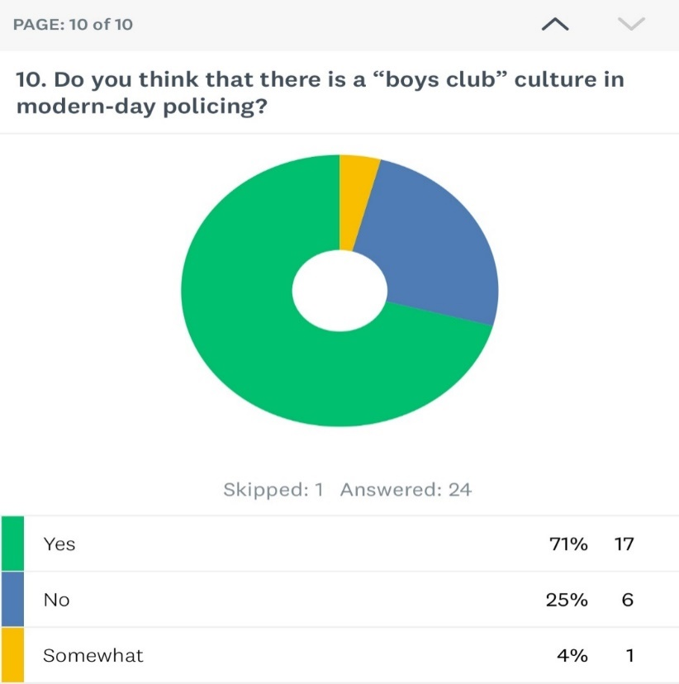 Question ten relates to a Boy’s club culture within policing, whereby the question was asked “do you think that there is a boys club culture within modern-day policing?” There were twenty-four participants to this question to which, a hefty seventy percent of participants responded yes, four percent responding somewhat and twenty-five responding, no. Due to a large figure of participants selecting yes, it is apparent that a particular modern-day issue that female Police Officers are faced with is a Boys Club culture within policing. The term modern day suggests that this is a recent occurrence. (Cambridge dictionary, 2025).

4.3 Conclusion.
In conclusion, it is evident that Gender Inequality is present within modern day policing, which is reflective upon the analysation of the survey responses including a general consensus that females are currently underrepresented within policing roles. The respondents from the survey also suggested that there is an element whereby females have not been afforded the same opportunities as their male counterparts, however over half of the respondent’s disagreed with this. In addition, just under half of the respondents stated that they had experienced gender inequality within their policing role which may reflect experiences mentioned by female Police Officers within the literature review and therefore, suggests that gender inequality is fairly common within British Police Forces. It also appears that gender discrimination is a common facet within policing as just under half of the respondents stated that they had witnessed a colleague being discriminated against due to their gender, which again, is reflective upon incidents that female police officers have discussed within the literature review chapter such as female police officers being allocated administration related tasks and their male counterparts being allocated more physically demanding tasks, as described within the literature review by (Rabe-Hemp, 2007). It appears that a pattern of discriminative behaviour has been identified within policing.
Speaking in terms of equal opportunities over half of the respondents suggested that they felt there are a lack of opportunities for women to progress within their policing roles, this suggest again, that gender inequality is quite apparently present within policing. Speaking in the realms of “Boys Club cultures” an enormous seventy percent of participants stated that they felt there is a boys club culture within policing, again this is in agreement with incidents that female Police Officers described within the literature review chapter from (Moss, 2023), regarding reported misogynistic behaviour and cliquey “boys club cultures”, to which this suggests that a male dominated culture is quite apparently present within modern day policing.
The findings from the survey have achieved the following objectives.
- Is there an under representation of women in policing and what is the effect on female police officers due to under-representation.
- What are the challenges that female police officers face in policing and why do they face them.

Chapter 5- Findings conclusion.
5.1 Main findings
In order to conclude this dissertation, there have been a number of findings throughout the dissertation of which relate to the topic of “Gender inequality withing policing and the modern-day challenges that female Police Officers are faced with” and support the theory of whether there is an element of gender inequality within policing and whether female police officers face certain challenges primarily due to their gender.
The main findings were collated through and online questionnaire and the aim of this was to answer the following objectives.
- What is gender inequality within policing and why is it so prevalent in relation to policing?
This objective has been achieved my means of an online questionnaire which provided an insight into the current feelings of police officers and whether they have experienced gender inequality within their policing role. Sources within the literature review of this dissertation additionally discussed Gender inequality within policing and why they felt it was so prevalent, again assisting the researcher in gaining a further understanding into the topic.

- Is there an under representation of women in policing and what is the effect on female police officers due to under-representation?
Again, this objective was achieved by means of creating and online questionnaire which was taken part bay serving/ex-serving police officers alongside real-life stories which were mentioned within the literature review.

- What are the challenges that female police officers face in policing and why do they face them?
This objective was achieved, and it allowed the researcher to truly evaluate some of the difficult challenges that female police officers have been faced with.

It is apparent that Gender inequality is prevalent in policing and various challenges have been faced by female police officers.

5.2 Limitations.
One of the limitations that has been faced within this research, is not being able to interview current serving/ex-serving female police officers regarding the challenges they have faced within their policing role due to time constraints as only so many answers can be provided in a survey and there was not an option within the survey to type a written response which may have been useful to better answer objective one.

5.3 Improvements
In order to improve research next time, a consideration would be made to conduct the research over a longer period of time to identify patterns and changes within the world of policing and additionally, consider additional means of gaining information regarding feelings of current serving police officers by completing an interview as only limited information can be gathered from a survey such as “Yes” or “No” to questions and therefore, I does not detail Police Officers opinions.

5.3 Self-reflection
Upon reflection of this dissertation, and consideration of whether I were to do this again, I would make improvements on my time management skills in order to allow myself added time to complete deeper research which will really enhance my knowledge surrounding the subject area. Nonetheless, I have genuinely enjoyed conducting this research and I feel that I have obtained a great deal of knowledge surrounding the topic.

