Assignment Title: Building Survey
Module: Digital Surveying and Highway Design



Prepared for:
H.Williams

Created by:
H. Johal

Date completed:
31st December 2025

Table of Contents
Page Number
1.0 Executive Summary 3
2.0 Introduction 3-4
3.0 Practical – On Site Survey Execution 4
3.1 Survey Setup and Method 4-5
3.2 Execution Summary 5
3.3 Adaptions made during the survey 5-6
3.4 Issues Encountered 6
3.5 Evidence of Practical Activity 6
3.6 Survey Evidence – Manual Measured Plans 6-7
4.0 Measurement and Analysis 8
5.0 Comparison with Traditional Methods 8-9
6.0 Conclusion 9-10
7.0 References 11

- Executive Summary
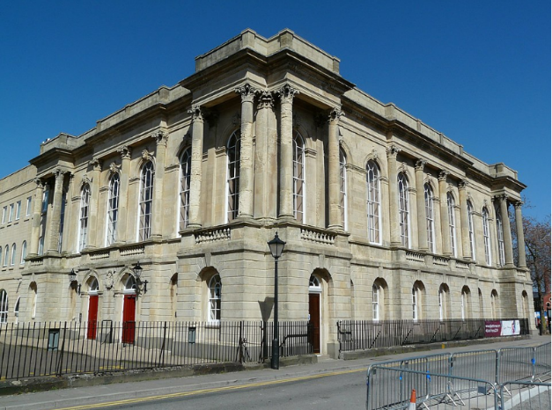
This digital building survey project was undertaken to plan, execute, and analyse a professional laser scanning survey of the Dylan Thomas Centre, Swansea, Wales. Constructed in 1852, the building holds significant historic value, and the survey was completed to demonstrate practical competency in applying modern digital surveying technologies. The primary focus of this project was the use of 3D terrestrial laser scanning to capture accurate spatial data as an alternative to traditional manual measurement methods.
The survey concentrated on the internal layout of the Dylan Thomas Centre, prioritising the documentation of key architectural features and spatial dimensions that are significant within a historic building. A structured survey plan was developed which defined the scope of the survey areas, anticipated access arrangements, scanning positions, lighting and line-of-sight considerations, and relevant site safety procedures under the United Kingdom Health and Safety Executive (UK HSE) guidance. This plan was subsequently implemented on site using a terrestrial laser scanner, adapting to real-world constraints and environmental conditions where necessary.
Following data capture, the processed point cloud outputs were used to extract essential measurements, including internal room sizes, door and window openings, and floor-to-ceiling heights. A comparative assessment between digital measurements and traditional surveying techniques highlighted the operational advantages of laser scanning, particularly in terms of accuracy, time efficiency, and completeness of recorded information, especially within older buildings where irregularities and complex geometry are common.
Overall, the project demonstrates how digital surveying technologies can provide reliable records for design, maintenance, asset management, and future refurbishment works within historic structures such as the Dylan Thomas Centre.
2.0 Introduction
This report outlines the planning and preparation for a digital building survey of the Dylan Thomas Centre, Swansea. Constructed in 1852, the building now functions as a public cultural venue and contains internal spaces that have changed in layout and use over time (Swansea Council, 2024). The focus of the survey is the internal corridors, with the objective of obtaining accurate spatial data to reflect current conditions and to verify the reliability of existing building information.

A 3D laser scanning approach was selected for this assessment due to its ability to rapidly capture high-density measurement data (point clouds) and reduce the potential for human error common in traditional measurement methods (Surveybase, 2025; LaserSurveys, 2025). The technique enables detailed documentation of continuous internal spaces such as corridors where cumulative measurement errors can occur with manual methods. Pre-survey planning was undertaken to define the scope, confirm access, and assess site constraints. Health and safety planning was integrated in accordance with guidance issued by the UK Health and Safety Executive (HSE, 2023). This established a structured methodology for the subsequent on-site survey work.
3.0 Practical – On Site Survey Execution
The practical element of the project involved conducting an on-site survey of the Dylan Thomas centre’s internal corridors, using a combination of 3D laser scanning and traditional manual measurement techniques. The objective was to follow the established survey plan as closely as possible while responding to real conditions during the visits, such as objects and people that may disrupt the survey.
3.1 Survey Setup and Method
The survey commenced with the placement of the laser scanner at strategic positions along the corridors to achieve full coverage, a floor plan of the corridors can be seen below for reference:
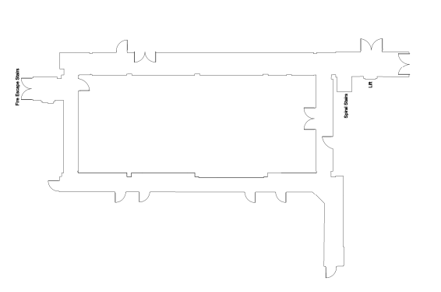

Scan locations were selected to ensure adequate overlap between point clouds and to maintain a clear line of sight along each corridor section. This structured progression supported consistent data capture and simplified subsequent measurement extraction.
Alongside the digital scan, we had also carried out a manual measured survey. This involved recording primary dimensions such as corridor lengths, widths, junctions and door openings using the below tools:
- Tape measure
- Ruler
- Handheld laser distance meter
- Paper which the results which drawn on
Manual measurements provided a benchmark for verifying accuracy, which is recognised as a valid cross-checking method in professional surveying practice (Surveybase, 2025) The sketch plans produced on site will be included as supporting evidence and provide traceability of the decision making and measurement process.
3.2 Execution Summary
The survey proceeded in accordance with the planned methodology. The scanning sequence was completed in the intended order and measurements were recorded at each stage. Lighting levels and corridor geometry were suitable for scanning operations, and scanner positions were sufficient to cover the specific corridor it was in.
Key aspects that were successfully carried out as intended included:
- Positioning and operating the laser scanner in sequence
- Collecting overlapping point cloud data
- Recording manual measurements alongside scanning
- Maintaining consistency in working direction and station spacing
- Completing the survey without interruption or safety concerns
Health and safety considerations were continuously observed throughout the activity, consistent with UK guidance on risk prevention and safe working practices (HSE, 2023).
3.3 Adaptations made during the survey
Only minor adjustments were required. In a small number of cases, scanner angles were rotated slightly to improve visibility around internal corners, which ensured that the point cloud remained continuous. Short pauses were made where required to maintain clear walkways. These adaptations are consistent with accepted on-site professional judgement and did not deviate from the intended methodology (LaserSurveys, 2025).
No additional scanning stations were needed, and all corridor areas were included in the final dataset.
3.4 Issues Encountered
There was no significant technical, operational, or safety issues during the survey. The equipment functioned as expected and calibration did not require adjustment. There were no conflicts between manual spot checks and digital data that indicated measurement error. Periodic verification checks using the handheld laser distance meter supported confidence in the dimensional accuracy of the scan, and this method is commonly used to validate point cloud reliability. (Surveybase, 2025).
In the absence of major challenges, the focus remained on process accuracy, correct tool handling, and ensuring adequate data capture.
3.5 Evidence of Practical Activity
Evidence of on-site practical work will be demonstrated through the inclusion of the manually produced corridor plans and measurement sketches. These documents record:
- Dimensional observations
- Corridor geometry
- Manual reference points
These records support transparency and provide traceable measurement evidence that complements the digital data.
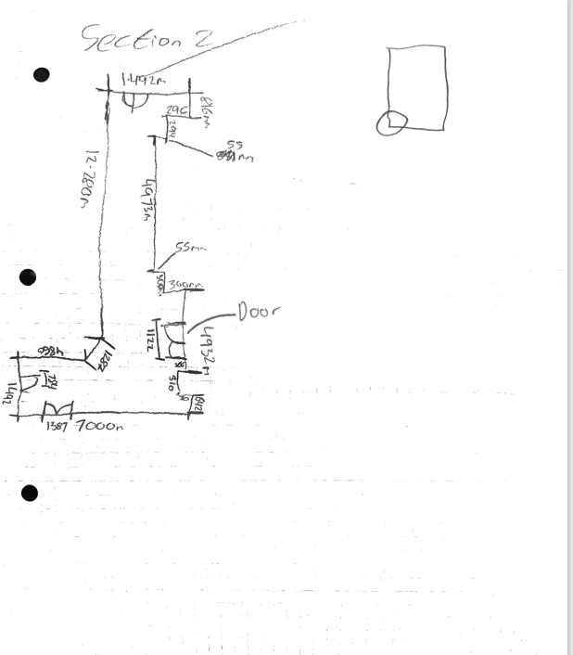
3.6 Survey Evidence – Manual Measured Plans
Figure 1: Corridor Section 2

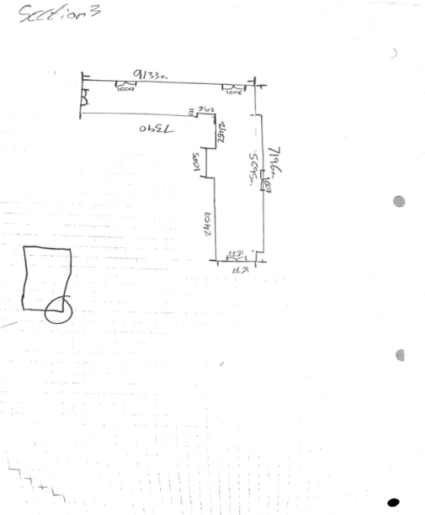
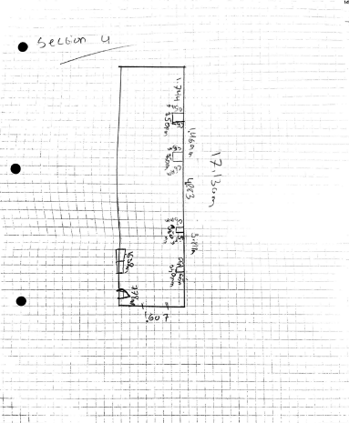
Figure 3: Corridor Section 4
Figure 2: Corridor Section 3

4.0 Measurement and Analysis
The processed 3D laser scan of the internal corridors was imported into AutoCAD, where the point cloud was used as the basis for spatial measurement. The point cloud provided a visual and measurable digital reconstruction of the corridor spaces, enabling dimensions to be taken directly from the scan data. This supported the retrieval of key spatial information such as corridor lengths, widths, and door opening dimensions, alongside floor-to-ceiling height readings where the scan data presented a clear vertical reference. The use of AutoCAD for interrogation of the point cloud aligns with industry practice, where digital platforms are routinely used to derive measurable data from 3D environments (Surveybase, 2025).
Although the primary intention of this stage was dimensional extraction, the process also acted as a practical evaluation of the quality of the data capture. The clarity of the point cloud within AutoCAD indicated that the scanner placement strategy had been effective and that the dataset was suitable for architectural interpretation. This reflects the effectiveness of laser scanning as a survey method, particularly in internal environments where continuous geometry is critical for spatial analysis (LaserSurveys, 2025).
5.0 Comparison with Traditional Methods
Digital measurement extraction from point clouds offers multiple advantages when compared to traditional surveying techniques. In terms of time efficiency, the ability to collect all spatial information simultaneously provides a significant benefit, as multiple measurements can be taken from a single digital model rather than through repeated site visits (Surveybase, 2025). This is particularly effective in complex internal environments where access limitations or operational activities could restrict traditional surveying.
Regarding accuracy, laser scanning reduces manual handling of measurements and therefore minimises the potential for human error. Traditional methods, which often involve sequential tape measurements, are more vulnerable to cumulative inaccuracies and data transcription mistakes. In contrast, laser scanning datasets retain consistent internal geometry, enabling high-confidence measurements and reducing the risk of dimensional discrepancies (LaserSurveys, 2025). This also provides a long-term asset record, allowing further measurements to be taken at any time without requiring physical re-entry into the building.
However, traditional surveying retains value. Manual measurements can provide immediate validation and offer flexibility in confined or obstructed spaces where line-of-sight scanning may be restricted (HSE, 2023). Traditional surveying tools, such as tape and laser distance measurers, still provide cost-effective solutions
for small-scale works and scenarios where digital tools may be impractical. While digital data collection supports greater data completeness and long-term usability, the combination of both approaches still represents best practice when validating high-priority or safety-critical information (HSE, 2023).
Overall, the integration of laser scanning into the survey process aligns with the construction industry’s ongoing digital transformation, providing improvements in accuracy, efficiency and data accessibility, while traditional survey methods remain relevant as a supporting tool for validation and small-scale applications (Surveybase, 2025; LaserSurveys, 2025).
Below is an also a simplified comparison table:
Aspect | Laser Scanning (Digital) | Traditional Surveying (Manual)
Time Efficiency | Fast data capture in one visit | Slower, may require repeat visits
Accuracy | High accuracy, reduced human error | Risk of human and measurement error
Data Output | Full 3D model/point cloud for reuse | Only recorded measurements, not reusable
Equipment | Specialist scanner and software needed | Simple tools (tape/laser measure)
Best Use | Detailed surveys and complex buildings | Small/simple spaces and quick checks

6.0 Conclusion
The digital building survey undertaken within the Dylan Thomas Centre demonstrates the practical value of 3D laser scanning as a contemporary survey methodology. The structured workflow from planning, through practical execution, to data analysis aligns with current industry processes and reflects best practice for internal building documentation (Surveybase, 2025). Effective planning ensured that survey objectives were achievable and that the equipment setup supported consistent data capture. The practical scanning exercise provided comprehensive spatial coverage, and the subsequent AutoCAD analysis confirmed the effectiveness of the scanning strategy in generating an accurate representation of the internal corridors.
Laser scanning offers substantial advantages when compared to traditional recording methods, particularly in terms of accuracy, data completeness and long-term usability (LaserSurveys, 2025). Whilst traditional measurement retains its relevance for validation and small-scale surveying tasks, digital surveying provides a more robust solution for long-term asset management and design decision-making, supporting the transition towards modernised digital workflows within the built environment (HSE, 2023). The outcomes of the project reinforce the importance of emerging technology within construction practice and demonstrate how digital data collection can support improved architectural interpretation, spatial analysis and future building management.
In conclusion, the survey provides a practical demonstration of how digital surveying methods can be integrated into professional surveying and construction practice. The exercise meets the requirements of the assignment while also offering a realistic representation of industry-level expectations and standards. As the construction sector continues to progress towards digital transformation, the utilisation of laser scanning will increasingly become the standard for efficient and accurate building documentation (Surveybase, 2025; LaserSurveys, 2025).

7.0 References
Health and Safety Executive (HSE) (2023) Construction (Design and Management) Regulations 2015 (CDM 2015).
Available at: https://www.hse.gov.uk/construction/cdm/2015/index.htm (Accessed: 24 November 2025).
LaserSurveys (2025) 3D Laser Scanning Survey.
Available at: https://www.lasersurveys.co.uk/3d-laser-scanning-survey/ (Accessed: 24 November 2025).
Surveybase (2025) 3D laser Scanning.
Available at: https://www.surveybase.co.uk/services/laser-scanning-survey (Accessed: 25 November 2025)
Swansea Council (2024) Dylan Thomas Centre - Building Information.
Available at: https://www.swansea.gov.uk/ (Accessed: 25 November 2025).

