University of Wales Trinity Saint David

Wales institute of Science and Arts


Project Planning

Engineering Management (ACHA5012)

Jamie Woodberry

2007714

11/2022
Table of Contents
1 Introduction 2
1.1 Project Objectives 2
1.2 How success will be measured 2
2 Roles and Responsibilities 3
2.1 Skills and personality traits 4
3 Overall tasks and timing for the project 5
4 Detailed list for my tasks 6
4.1 Bill of Materials 7
5 Milestones 8
5.1 Gateway objective 8
6 Areas of concern 9
7 Overall summary and Gantt chart 10
8 References 11

Introduction

In this project my group were asked to design and manufacture a tooling system that can be attached to Cobot (Robotic arm). The challenge is to be able to pick up and move the mobile phones into a new storage centre as the one currently can only store 4 mobile phones, as a group we are hoping to accomplish increasing the number of phones being stored by developing a new storage centre where we can increase the storage by 500%.

Project Objective

The final goal for this project is to be able to design a fully functioning robotic arm that will be able to transfer the mobile phones from its current storage centre to the new one without any problems or manual handling.

How success will be measured

As a group we will know when we have been successful when we have a fully functioning tooling system that will be picking up the 2 mobile phones and moving into a new storage centre that will be able to capacitate 20 new phones, rather than the old one only being able to store 4. With the tooling system we need it to be perfect as we will be using suction cups, therefore we can’t afford for there to be any leaks within the design as this could lead to the phones getting dropped or not being placed correctly into the storage centre. If all goes as said, we would not have been successful in our project. Therefore, we need to have everything to be 100% so we can minimise any failures.

Roles and Responsibilities

Josh Todd- Team Leader, Tooling design

Making sure that everything is going to plan, and that people are doing what they’re supposed too. Designing of the tooling design, to be designed on CAD.

Callum Thomas- Project Planning, storage Design

Keeping track of the meetings and planning when we can have another one to progress on our tasks. Creating a new storage centre where we can increase the storage capacity of the mobile phone.

Nathan Skyrme- Robotic Programming

Writing a script for the tooling system so when the design is competed the Robot will know what to do and where to store the phones.

Abdulazim Mohammadain- CAD design, Tooling, Dimensioning

Designing and coming up with ideas for the tooling system and the dimensioning for the storage and the tooling system.

Ollie Turner- CAD, design and 3D printing

Role that was assigned to ollie was the CAD designing also and 3D printing as he has had previous experience with 3D printing

Jamie Woodberry- Materials and budgeting

I will oversee finding the materials and budgeting the project.

Skills and personality traits

I oversee the Material selection and budgeting. For the budgeting I have found all the components that were needed for our project, and then put them into a table where I could then see how much everything was to buy. Once, I had double checked that all the components that we ordered for the manufacturing of the tooling system that we are making was correct. As I didn’t want to order the parts and once they arrived the were the wrong size or the parts weren’t correct. If this would’ve happened, it would slow down the project significantly as they would need to be sent back and another order would have to be placed.

My skills for this role are that I have good organization skills therefore when it comes to finding the correct materials and budgeting for all our parts and components for the project it will be well organised and will not be confusing. I am confident with numbers, and this is very important when it comes to budgeting and materials because when ordering materials, I will need to calculate the correct measurements otherwise there may not be enough material for the design, and this would lead to having to reorder and will delay the completion date. With everything that is happening in the world right now with the war in Ukraine and Coronavirus. It has put a demand on a lot of websites with delivery times. This is important that everything is correct when ordering supplies otherwise we will not hit the deadlines that we want.

This role was suitable for me with Belbin’s module, we completed a self-perception inventory in a lecture, and this gave everyone in the class an idea from answering questions what their contribution would be when working with a team. I scored very high in implementer, this person has strengths that would be practical, and they are reliable for a team role. They will turn people’s ideas into actions and is very good at organizing work and makes sure that is completed for deadlines (The nine belbin team roles 11/2020).
I also scored high in complete finisher, this means that I like to make sure everything is perfect and there is no problems before anything is finished.

Overall tasks and timing for the project
Task | Assigned to the tasks | Date Given | Completion Date
Group Roles | Everyone | 03/10/2022 | 10/10/2022
Material Selection | Jamie | 10/10/2022 | 24/10/2022
Tooling design and confirmation | Joshua  Abdulazim | 03/10/2022 | 24/10/2022
Material Purchase | Jamie | 24/10/2022 | 31/10/2022
Storage Design and confirmation | Callum  Ollie  Joshua | 03/10/2022 | 24/10/2022
Budget Marketing | Jamie | 10/10/2022 | 14/11/2022
Selection/purchase of Arduino sensors | Nathan | 07/11/2022 | 14/11/ 2022
Tooling dimensions and fine tuning | Ollie  Abdulazim | 24/10/2022 | 12/12/2022
Storage dimensions and fine tuning | Callum  Ollie  Abdulazim | 24/10/2022 | 12/12/2022
Viva PowerPoint and Presentation | Everyone | 28/11/2022 | 12/12/2022
Robotic Programming and Planning | Nathan | 07/11/2022 | 27/3/2023
Construction of Tooling and storage | Joshua  Ollie  Callum  Abdulazim | 12/12/2022 | 09/01/ 2023
PLC/Arduino communication | Nathan | 09/01/2023 | 23/01/2023
Air Monitoring system integration | Joshua  Nathan | 09/01/2023 | 06/02/2023
Sensor setup and program integration | Nathan | 09/01/2023 | 06/02/2023
Program integration of tooling and storage | Nathan | 06/02/2023 | 13/02/2023
Completion of primary script | Nathan | 13/02/2023 | 20/02/2023
Cobot reliability testing | Everyone | 20/02/2023 | 27/03 /2023
Final Viva showcase and preparation | Everyone | 06/03/2023 | 27/03 /2023
Final report | Everyone | 20/02/ 2023 | 26/03/2023

Detailed list for my tasks

Task | General Description | Detailed explanation of the task | Completion dates | Total Hours
Group Roles | Decide who was most suitable for each role | For deciding why, I was suitable for the role that I chose in the group, I referred to the Belbin’s module which I completed in a lecture. And this show my strengths when working with a group and I could then go off to research what was the most suitable for me | 10/10/2022 | 3 hours
Material Research | Researching what materials would be suitable for the project | This was important with the number of hours I put into finding the most suitable and reliable materials that are needed for the project. For this I was looking on many different websites and researching materials that wouldn’t be too costly. | 20/10/2022 | 15 hours
Material Selection | Finalising the materials before purchasing | Decided on what materials will be be used for the project and can then find them off a website, for this I used the same website as it’s a reliable one as it’s the same as what the University use to order parts from. This means that I can trust it will arrive and the components that will be getting ordered are of a high quality. | 24/10/2022 | 3 hours
Material Purchase | Final decision for the materials and place the order | Once the material selection was completed and a reliable website was found where the order could be placed and have a good delivery time and there wasn’t any demand on the parts, and they would be delivered within a reasonable time. I sent the receipt off to Jordan where he could then check over it and place the order. | 31/10/2022 | 2 hours
Budget Marketing | Researched websites to compare price and find reliable websites | The detail of this part was for me to make sure that the project wasn’t too expensive and when it came to ordering and 3D printing, nothing was inaccurate or unreasonable because this will lead to unrealistic prices. | 14/11/2022 | 10 hours
Preparation for the presentation | Creating a PowerPoint that can be presented on the 12/12/2022 | For this part I will need to add my parts to the presentation where I can then go on to speak about in the Viva, I want to be prepared for this so I can get my word across for my role in the group. |  | 15 hours
Viva PowerPoint and Presentation | This is the first Viva and what we will be marked on from we’ve completed so far. | For the first Viva we will be doing a presentation and going into detail and how the Cobot will work and all the background behind of it. For example, I will be speaking about the materials and budgeting and why I chose some materials over others. | 12/12/2022 | 1 hour
Cobot reliability testing | To make sure everything is correct before showcasing our design | The final part where I would have finished the manufacturing aspect of the project and will need to have a last testing and making sure that nothing will be at fault on the showcasing day. | 27/03 /2023 | 10 hours
Final Viva showcase and presentation | Here this will be where we present the tooling system that we designed | At this point we should have a completely functioned tooling system and storage centre where we now would’ve increased the storage capacity by 500% prior to previous storage. And then a presentation will be completed about the design. | 27/03 /2023 | 1 hour
Final report  Final report….. | Write up the report of the whole | Here is where I will be writing my report about the challenge that I faced with designing the tooling and whether it went to plan and the outcome that we wanted. | 26/03/2023 | 20 hours
Group meetings | Meeting up to see where we can progress on the project | This is very important that these meetings happen as we can see our progress and see how we can move on. The hours that have been shown is just meeting once a week and it will be more some weeks. | 27/03/2023 | 50 hours

Bill of Materials

Item | Price | Approximate Lead times
Suction cup holders x4 | £115.87 | 25/11/2022
Vacuum generator | £44.60 | 25/11/2022
Pneumatic Line 4mm | £26.64 | 25/11/2022
Aluminium Strut 30x30mm | £59.89 | 9/12/2022

Item | Price | Estimated time
Aluminium shelf | £20 | 16/12/2022

This is the order that has been placed and what will be placed soon for the group to complete the task. All the parts that are needed to create the tooling system has been placed, therefore we can make a start on that when they have been delivered. The materials that are being used for the storage centre has been chosen, the final design needs to be completed with the dimensions and then the order will be placed. I could make an educated guess and how much material will be needed. But this could lead to a waste of material.

Milestones

For project of this calibre there was many milestones from start to end that were needed to be made for the group to meet targets with the dates that we have chosen. The main milestone that we had was to discuss and decide the group roles that would be most suitable for each team member. This was in our first lesson on the project ( 03/10/2022), the deadline that we gave for this was the same day because we needed to decide who was doing each role and could then progress onto the next milestone. As a group we had milestones for each week, therefore we could keep up to date and wouldn’t fall behind on our work. The reason for this is because we want to be well organised throughout the project and when falling behind and trying to catch up and that’s where mistakes will happen. A big milestone for us a group was to have a final design of the tooling system and the storage design. Because without having any of these it would slow down the process significantly when it comes to ordering the parts and the budgeting for the project. The final date we wanted for the confirmation of the tooling and storage design was the (24/10/2022). A big milestone for the group would be the first Viva presentation, at this point we should have started to construct the tooling system or if not, everything should be complete to start the construction of the storage centre and the tooling system (12/12/2022). The final major milestone that we are hoping to aim for is the completion of the whole project which will be 27/03/2022 latest, if we can manage this it would be great for when we present on the that day for the final Viva as we will have functioning design that we were hoping to achieve.

Gateway objective

My main gateway objective will be finding the correct components to create the tooling system. This is very important as there is a high demand on a lot of these products and if ordering incorrect parts will be a waste of time and could put the group behind deadlines. If I ordered the incorrect parts thinking they were correct, and we went into trialling our design one of the parts wasn’t suitable for our design, this could lead to failure of tooling system and could drop the phone as it may not be producing enough suction to pick up and move the phone into the storage centre. For this to be fully functioning the vacuum generator and pneumatic line must have zero leaks as it will lead to failure. For me to succeed this was by using RS Components as a website because they are 100% reliable, this is where the robotics lab orders their parts from and they are good quality. I wanted this research in detail and find out if all the components that are being used are suitable and can withstand the vacuum suction and also that they do not have a demand on them which means it was possible for me to reach my deadline for the purchase (31/10/2022).

Areas of concern

A way that I can prevent from causing areas of concern is by using the 80/20 rule. The rule is that 80% of the consequences is 20% of the cause. A way to solve this problem is to prioritise the 20% of the cause and this will mitigate the outcome (Asana, 2022). From doing this method it will benefit me from having concerns with the project.

A main area of concern regarding the project will be ordering incorrect parts as this will slow down the process of our project. As there is a high demand on a lot of the parts that we need if we ordered an incorrect part and it then needed to be returned, the part that we would need may not be in stock and we could be waiting a long time for the parts to be delivered which will slow down our project significantly and we will not be able to see if the design will work for a long time. To mitigate anything like this happening in our project I can make sure that everyone can have a look over the receipt before any order has been placed.

A concern that could happen with working as a group could be absent or people within the group not doing the group work that has been asked of. As of now this hasn’t been a problem, if it does start to be a problem and group members start becoming absent with our group meetings we could start to fall behind of schedule on when tasks need completing by. Another problem along these terms of group member not completing these tasks is not keeping in contact with each other between group meetings and waiting till each meeting to see whether they have completed the task at hand for each person.

Overall summary and Gantt chart

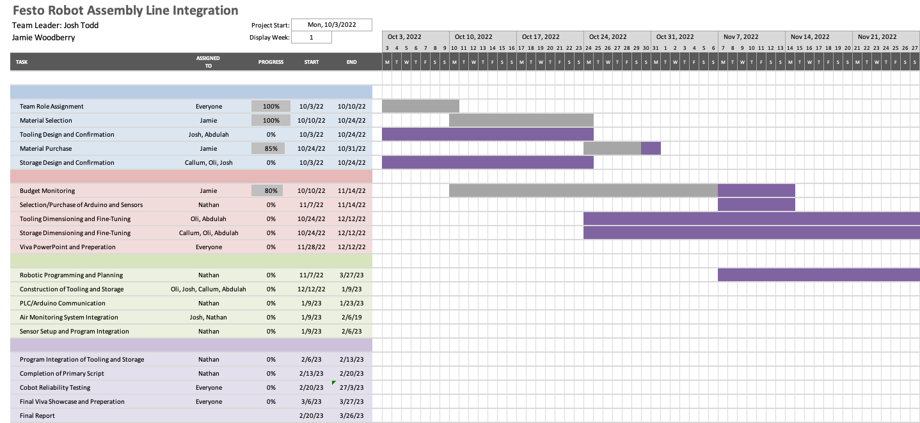

References

- The nine belbin team roles (no date) Belbin. Available at: https://www.belbin.com/about/belbin-team-roles (Accessed: November 19, 2022).
- Asana, S.L. (2022) Learn the pareto principle (the 80/20 rule) [2022] • asana, Asana. Available at: https://asana.com/resources/pareto-principle-80-20-rule (Accessed: November 20, 2022).

