

TABLE OF CONTENTS
CONTENT | PAGE
TASK 4  Reflect on the importance of effective L&D strategies using research to underpin your arguments. What might the L&D strategies of the future look like / include? | 3-7
Presentation Slides | 8
Supplementary notes | 9 -11
References | 12 - 14

TASK 4
A learning and development (L&D) plan describes how an organisation builds the abilities, talents, and capabilities of its workforce, what those competencies are needed for, and how to develop them to create a successful, long-lasting business (The Chartered Institute of Personnel and Development, 2022). The Chartered Institute of Personnel and Development (2022), states that learning and development (L&D) strategy is also a crucial component of the entire company strategy.
According to The Chartered Institute of Personnel and Development (2022), the L&D strategy has succeeded in achieving this goal while also aligning with the company and its stakeholders. There are several more advantages, including ones related to competitive advantages, organisational culture, achieving goals, employee engagement and employee motivation (Nichols, 2023). Constructivist learning theory, adult learning theory (andragogy), learning curve theory, connectivism, and collaborative learning are the five theories identified by Nichols (2023). But, just three theories will be discussed in this study as they pertain to the significance of the successful L&D approaches employed by Adidas which are adult learning theory (andragogy), connectivism theory, and collaborative learning theory.
Adult learning theory, often known as andragogy, concentrates on the particular requirements and traits of adult learners, like self-directed learning and the significance of what they are learning to their jobs (Nichols, 2023). Adidas places a high value on good L&D strategies since they assist in identifying and evaluating their developmental requirements, measure the effects of leadership development on company outcomes, acknowledge the significance of technology, and promote resource customisation. Adidas highlights that under their “Diversity, Equity, and Inclusion (DEI)” programs, they have created leaders that control the game and serve as role models, enabling everyone to realise their potential in the ‘Leadership pillar’ (Adidas Annual Report, 2022).
One of their successful strategies is having their workforce participate in "DEI" learning programmes, which provide a portfolio of leadership development interactions for each level of management through every market and function (Adidas Annual Report, 2022). Additionally, it has been suggested that Adidas' workforce and culture are which contribute to its achievement and allow it to execute its strategy of “Own the Game”, according to Anand & Baji (2023). Despite being perceived as lacking distinctiveness owing to resource limitations, a weak reaction to quick fashion trends, and a reliance on the sports market, it provides vitality to the brand's belonging, which is developed through its objectives, mindset, and mission (Pereira, 2023). By taking into account the unique requirements and experiences of their employees as well as the corporate goals, this method is in line with the principles of adult learning. Future L&D initiatives are anticipated to give DEI even more of a focus, with training in areas like inclusive leadership, unconscious prejudice, and equal opportunity for all workers.
The modern learning theory is called connectivism, and it places a strong emphasis on the role that connections, networks, and digital technology perform in education (Nichols, 2023). It was created at a time when the internet was drastically altering how people across the world received information and examines the role that networks play in how we learn (Nichols, 2023). Given Adidas' investments in digital learning and development possibilities, which provide fair access to educational materials as well as just-in-time upskilling and/or reskilling, this approach can be applied to the company more effectively (Adidas Annual Report, 2022). According to the Adidas Annual Report for (2022), over 59,000 workers throughout the globe devoted a combined 1,175,000 hours to seminars and training sessions. Informal learning and mentorship are the main supports of their continuous learning and development services (Adidas Annual Report, 2022). The fact Adidas's own digital transformation is regarded as conforming to the connectivism theory's criteria. In addition, Adidas views this as important because it supports a culture of continuous learning by enabling access to knowledge networks, fostering an agile organisational environment, and measuring return on investment through data collection using digital platforms and tools. The most successful businesses will invest in cutting-edge L&D programmes, stay adaptable and quick, and develop the human skills required to handle the digital era, claim Brassey, Christensen, and Dam (2019). L&D will place a substantial emphasis on digital skills in the near or distant future. Additionally, digital literacy initiatives and AI-driven personalised learning routes will close the skills gap in the digital age (Boi, 2023).

Additionally, the collaborative learning theory places more emphasis on situations in which individuals share their knowledge and experience through mentoring and learning from one another (Nichols, 2023). Collaborative learning is opposed to top-down, traditional learning environments where teachers define learning objectives and deliver instruction (Nichols, 2023). It is Bottom-up learning (Nichols, 2023).
Adidas is advised to give the collaborative learning theory more thought to adapt and give it more significance because there is evidence that they place a significant value on future technological learning and development prospects that enhance sales and promote profitability with the DEI and Own the Game. This indicates that although not all staff members are being studied, some are. The workforce of the future must be adaptable across the board. Adidas should implement ideas into its management, DEI, leadership development, and learning and development plans and projects. Since, it promotes inclusivity and diversity to develop a sense of belonging. Investing in staff development has a beneficial influence on both retention and engagement, according to Terry (2020). Employees are more likely to feel welcomed and wish to stay with an organisation when they see possibilities for skill development and progress (Terry, 2020). Businesses like Squarespace conduct “yearly business kick-offs, quarterly all-hands meetings, year-end wrap-ups, routine workshops, and a variety of other collaborative learning activities” (Karpenkova, 2023). The capacity to identify and develop current talent while putting your people first may indicate a crucial aspect of the company's future (Terry, 2020). As a result, these cooperative activities, training, and learning also would significantly contribute to Adidas AG's present and future success, as well as increase employees' job satisfaction and inspire them to pursue career advancement chances if was to applied (Karpenkova, 2023). As the saying “Teamwork makes the dream work”. In conclusion, as discussed, the theories that Adidas AG has utilised the most are Andragogy theory which is being leaders to own the game and building role-model leadership development as well as connectivism theory. While, collaborative learning theory needs more attention on it.

Presentation Link
https://uowtsd.sharepoint.com/:v:/r/teams/LeadingandDevelopingPeople-Assessment2_GRP/Shared%20Documents/General/Recordings/General-20230905_120135-Meeting%20Recording.mp4?csf=1&web=1&e=cgAQGX&nav=eyJyZWZlcnJhbEluZm8iOnsicmVmZXJyYWxBcHAiOiJTdHJlYW1XZWJBcHAiLCJyZWZlcnJhbFZpZXciOiJTaGFyZURpYWxvZyIsInJlZmVycmFsQXBwUGxhdGZvcm0iOiJXZWIiLCJyZWZlcnJhbE1vZGUiOiJ2aWV3In19
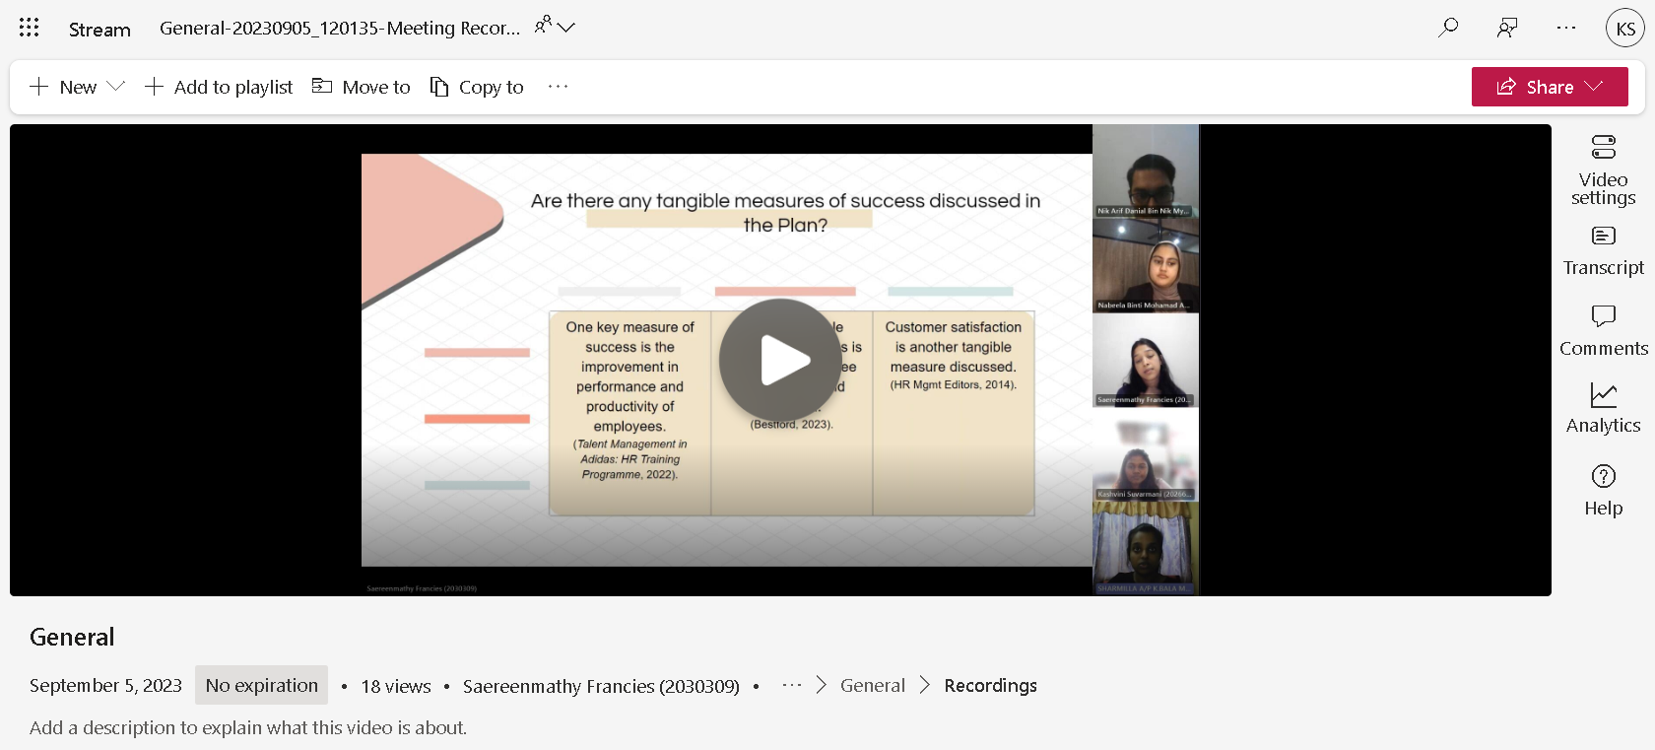

Supplementary notes
Hi, I’m Kashvini and I will be presenting Reflect on the importance of effective L&D strategies and What might the L&D strategies of the future look like. Before, we go into why is important. We will be discussing the 3 out of 5 theories that can be applied for better learning outcomes in the organization.
The theories are adult learning theory (andragogy), Connectivism theory, and collaborative learning theory. It has suggested which are adult learning theory (andragogy) and Connectivism theory are shown and given importance compared to collaborative learning theory. This is because the elements of an effective strategy organization that is mainly focused on investing in digital learning and development opportunities, offering equitable access to learning content and just-in-time upskilling and/or reskilling in the theory of connectivism and it helps to continuous learning culture and agility
The Andragogy theory, emphasizes in their portfolio of building role-model leadership development and this gives alignment with the business strategy, assessment and needs analysis, measurement and evaluation, technology, and resources to Adidas.
While collaborative learning theory did not give much importance in Adidas since they are more emphasis on the future, AI-driven personalized learning paths and digital literacy programs can boost profitability and increase sales with the DEI and Own the Game. This is why it is important in L&D strategy important.

What do learning and development (L&D) serve to do?
They outline how an organization develops its workforce's capabilities, skills, and competencies and It’s basically a key part of the overall business strategy.

Is there any evidence that your case study strategy has been a success so far?
As mentioned before the organisation is heavily investing in innovative L&D programs, remaining flexible and agile, and building the human talent needed to master the digital age. According to Brassey, Christensen, and Dam (2019), the future of L&D will undoubtedly involve a significant focus on digital skills. And, AI-driven will personalized learning paths and digital literacy programs in the future. Moreover, according to Anand & Baji (2023), it has discussed that Adidas' culture and workforce are what make it successful and enables it to carry out its strategy of “Own the Game”. It gives life to the brand's identity, which is established through its mission, attitude, and purpose even though it was considered as lacking uniqueness due to resource constraints, slow response to fast fashion trends, and dependence on the sports market (Pereira, 2023).

What might the L&D strategy of the future look like?
- Talent Retention and Engagement:
· It has consistently shown that investing in employee development positively impacts retention and engagement (Terry, 2020). When employees see opportunities for growth and skill development within the organization, they are more likely to stay committed and engaged.
- Diversity, Equity, and Inclusion (DEI):
· As mentioned in Adidas, DEI initiatives are a vital component of L&D. It demonstrates that diverse teams outperform homogeneous ones, but inclusive workplaces are needed to realize these benefits.
· Future L&D strategies will likely place even greater emphasis on DEI, including training on unconscious bias, inclusive leadership, and equitable opportunities for all employees.
- Digital Transformation
- Continuous Learning
• The L&D strategies of the future may include a shift towards continuous learning models, where employees are encouraged to acquire skills incrementally.
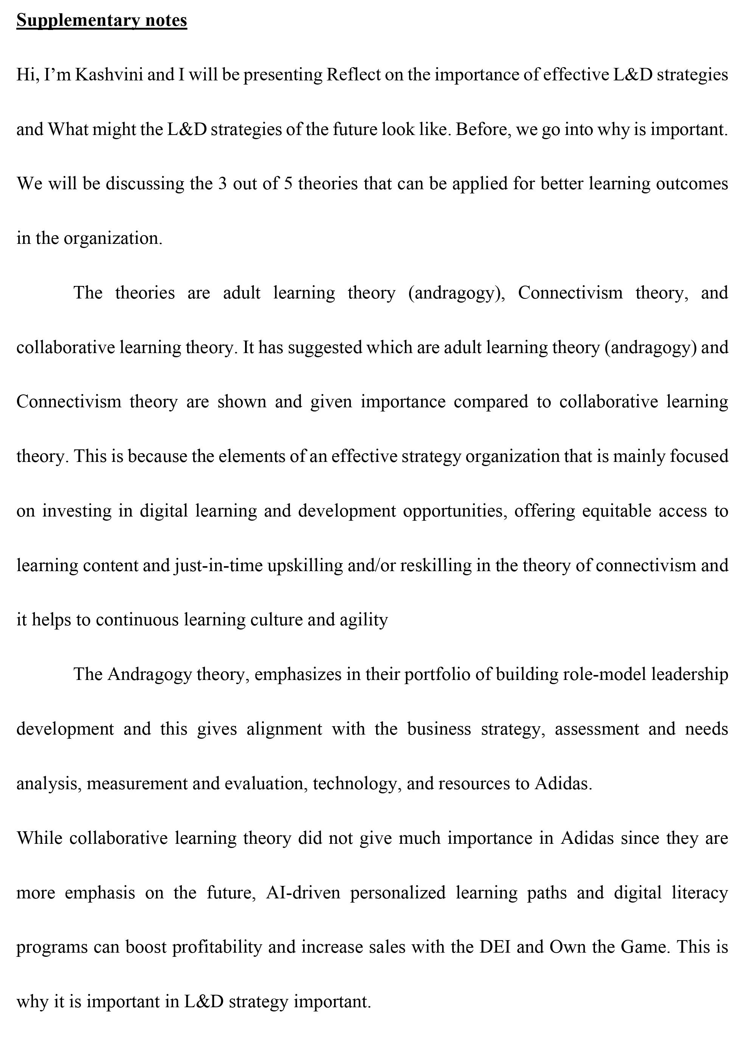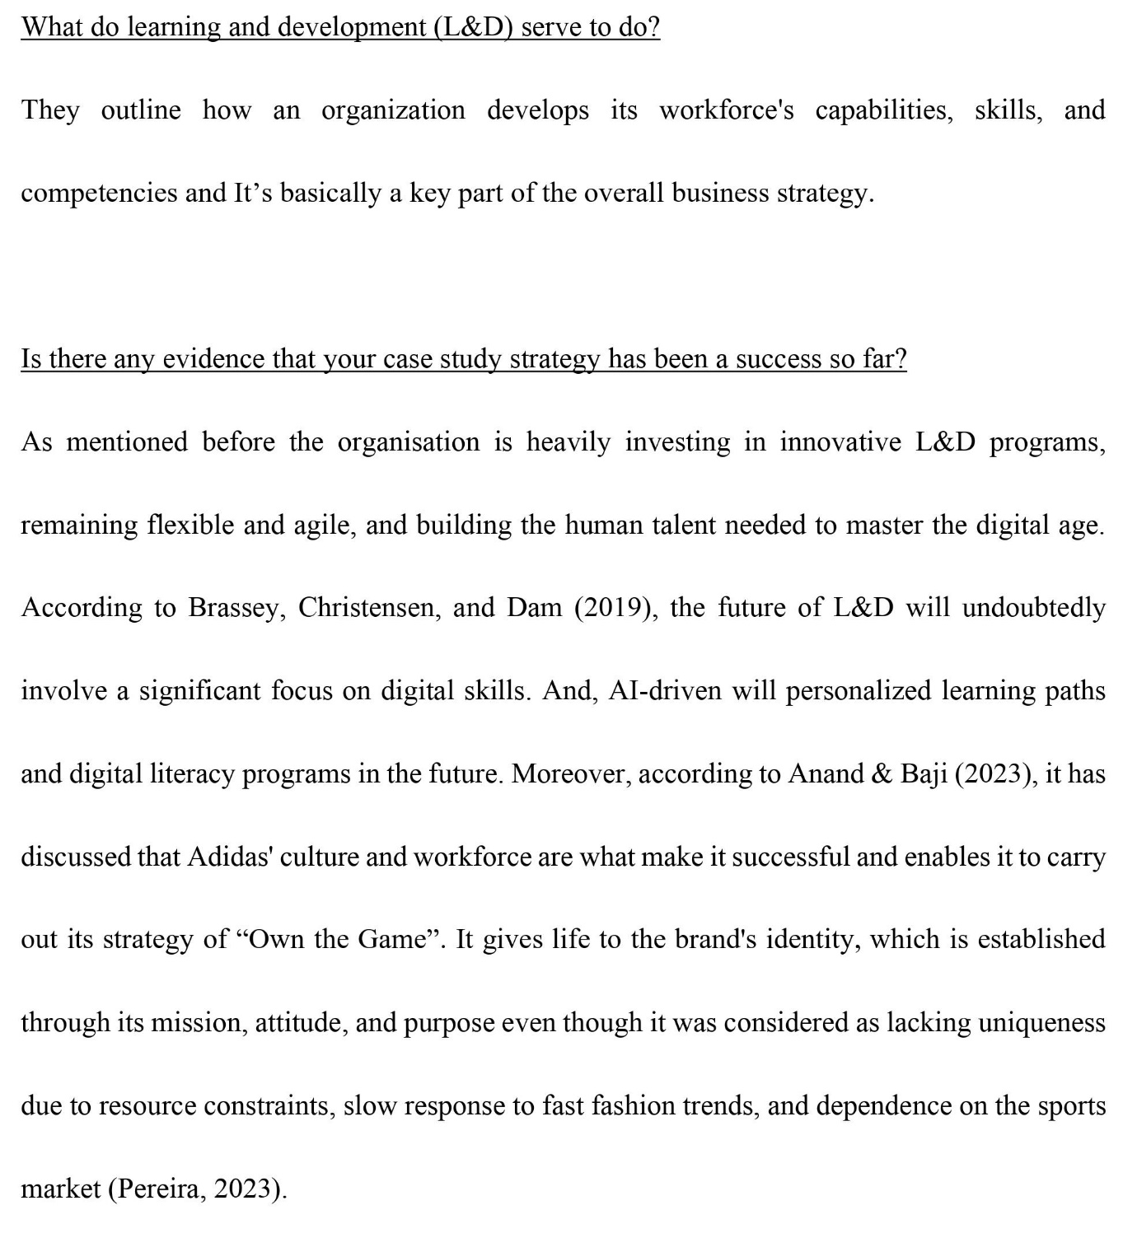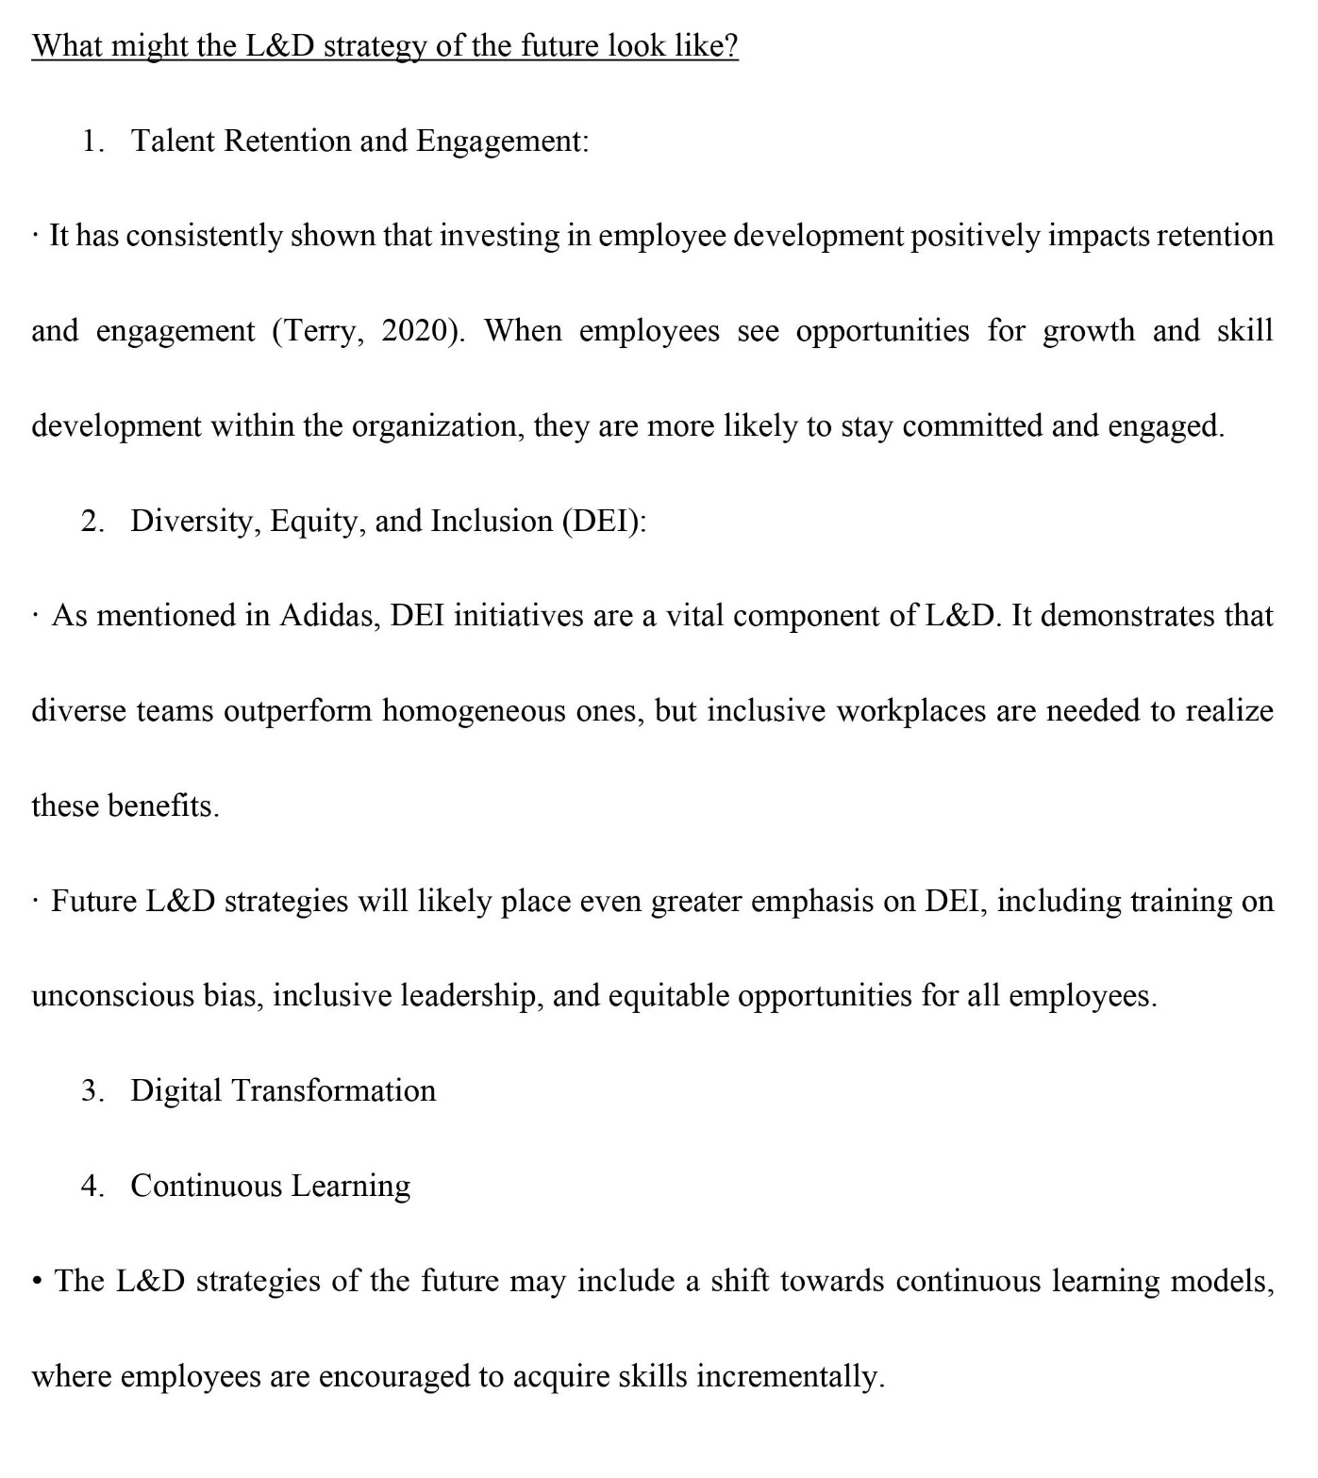

Reference
- Adidas Annual Report. (2022). Downloads. [online] Available at: https://report.adidas-group.com/2022/en/services/downloads.html.
- Adidas group. (2020). adidas - Employees. [online] Available at: https://www.adidas-group.com/en/sustainability/social-impacts/employees/#/building-role-model-leadership/.
- Anand, S. and Baji, A. (2023). Adidas: The Emergence of a Leading Sports and Fashion Brand. [online] StartupTalky. Available at: https://startuptalky.com/adidas-success-story/.
- Božić, V. (2023). Artificial Intelligence as the Reason and the Solution of Digital Divide. LET Journal , [online] 3(2), pp.90–103. doi:https://doi.org/10.13140/RG.2.2.10494.66880.
- Brassey, J., Christensen, L. and Dam, N. van (2019). Essential components of a learning and development strategy | McKinsey. [online] www.mckinsey.com. Available at: https://www.mckinsey.com/capabilities/people-and-organizational-performance/our-insights/the-essential-components-of-a-successful-l-and-d-strategy.
- Business Unmasked (2021). The true story behind Adidas. youtube. Available at: https://www.youtube.com/watch?v=NqP8G6UZr9E&t=807s.

- Caruso, S. (2021). Three Categories of Learning Theory. [online] HRDevelopmentInfo.com. Available at: https://hrdevelopmentinfo.com/three-categories-of-learning-theory/.
- Herzogenaurach (2021). Adidas Presents Growth Strategy ‘Own the Game’ until 2025. [online] Adidas group. Available at: https://www.adidas-group.com/en/media/news-archive/press-releases/2021/adidas-presents-growth-strategy-own-the-game-until-2025/.
- Karpenkova, A. (2023). 10 Examples of Corporate L&D Programs & Strategies (2023) | Whatfix. [online] The Whatfix Blog | Drive Digital Adoption. Available at: https://whatfix.com/blog/learning-and-development-examples/.
- Latham, S. (2022). Adidas CEO stepping down next year . [online] www.linkedin.com. Available at: https://www.linkedin.com/news/story/adidas-ceo-stepping-down-next-year-5414820/#:~:text=%F0%9F%91%9F%20In%20a%20statement%2C%20supervisory [Accessed 3 Sep. 2023].
- Lewis, R. (2017). Adidas AG | History, Products, & Facts. In: Encyclopædia Britannica. [online] Available at: https://www.britannica.com/topic/Adidas-AG.
- Nichols, R. (2023). 5 Learning Theories L&D Professionals Should Know. [online] Vyond. Available at: https://www.vyond.com/resources/learning-theories-for-learning-and-development/#Constructivism.

- Saraev, N. (2022). What Impactful Learning & Development Programs Have In Common | Together Mentoring Software. [online] together. Available at: https://www.togetherplatform.com/blog/learning-and-development-programs#toc-4 [Accessed 3 Sep. 2023].
- Terry, M. (2020). Employee Engagement and Retention – The Impact of Talent Management. [online] talk freely. Available at: https://www.talkfreely.com/blog/employee-engagement-and-retention.
- The Chartered Institute of Personnel and Development (2022). CIPD | Learning & Development Strategy and Policy | Factsheets. [online] CIPD. Available at: https://www.cipd.org/en/knowledge/factsheets/strategy-development-factsheet/#:~:text=A%20learning%20and%20development%20(L%26D)%20strategy%20sets%20out%20the%20workforce.

