

Program Name: MBA International Business

Student Name: Kumbhani Trupil Rajeshbhai
Student ID: 2431306
Topic: A Study on the Impact of High Competition and Pricing
Strategy of Reliance Trends in India
Word Count: 2595
Supervisor Name: Charles Oham
Table of Contents

1. Introduction 3
1.1 Background of the Study 3
1.2 Research Aim 3
1.3 Research Objectives 3
1.4 Research Question 3
1.5 Structure of the Proposal 4
2. Literature Review 4
2.1 Competition in the Retail Fashion Industry 4
2.2 Pricing Strategies in Retail Marketing 4
2.3 Competitive Pricing in the Indian Fashion Retail Market 5
2.4 Research Gaps 6
3. Methodology 7
3.1 Research Design and Approach 7
3.2 Research Onion Framework 8
3.3 Data Collection Method 8
3.4 Data Analysis 9
3.5 Ethical Considerations 9
4. Expected Findings 9
5. Limitations 10
6. Timeframe 11
7. Conclusion 11
References 13

1. Introduction

1.1 Background of the Study
Indian retail fashion Industry has changed tremendously over the last ten years. The industry is very competitive today and numerous local and international brands compete over the shoppers (Gurnani and Gupta, 2024). Other large retailers like Reliance Trends, Pantaloons, H&M, and Zara have their customer base as they provide fashionable products at reasonable prices. Reliance Retail operates Reliance Trends, which is a chain of fashions in India. It markets cost-efficient men, women and children apparel and accessories in most of its shops around the country. Continuous revision of the prices offered by Reliance Trends based on competitors and customer expectations needs to be utilized in order to remain competitive and grow. Tactic tricks discount pricing, promotion and value-based pricing are some of the common strategies that facilitate fashion retailers to attract customers and increase sales. Therefore, the issue of the role of stiff competition in the pricing strategy is an important aspect of research in this industry (Gurnani and Gupta, 2024).

1.2 Research Aim
The primary aim of this study to examine how high competition would influence the pricing strategies used by Reliance Trends in the Indian fashion retail market.

1.3 Research Objectives
To analyze the competitive landscape of the fashion retail industry in India and its influence on pricing strategies.
To examine the pricing strategies used by Reliance Trends and their relationship with market positioning.
To evaluate the impact of competitive pressure on pricing decisions and how these strategies help maintain competitiveness.

1.4 Research Question
The central research question guiding this study is:
What is the effect of intense competition in the market on the price policy of Reliance Trends in the Indian fashion retail industry?

1.5 Structure of the Proposal
This proposal of dissertation is structured in a number of sections. The literature review is done after introduction where existing research on competition and pricing in retail is analyzed. And after this next section is methodology. The anticipated results, limitations of the study, timeline of the study are discussed later and the conclusion is presented.

2. Literature Review

2.1 Competition in the Retail Fashion Industry
Fashion retail business has turned out to be one of the competitive sectors in the world. There is a competition between the retailers in terms of the variety of the product, its price, quality and the customer experience (Bascur and Rusu, 2020). Any tough competition would compel companies to continue improving their strategies in order to maintain a market share and sell to consumers. In the emerging economies such as India, the fashion retail business has developed at a drastic rate as the local and international brands enter. The rivalry in retail markets will force companies to use strategies of pricing in order to remain appealing. When there are a lot of outlets that offer the same products then the customers are able to compare prices and value and then they purchase. Organizations have to come up with pricing that is profitable and competitive. The usual features are promotion-discounts, seasonal sales and value-based pricing which are effective in differentiating and gaining loyalty. The Indian fashion market integrates retail, both organization and inorganization. Zara and H&M have chains like Reliance Trends, Pantaloons and Lifestyle as the competitors. These players have made the competition of prices to be heightened by their emergence. Companies have to keep on surveying market and pricing of their competitors (Bascur and Rusu, 2020).

2.2 Pricing Strategies in Retail Marketing
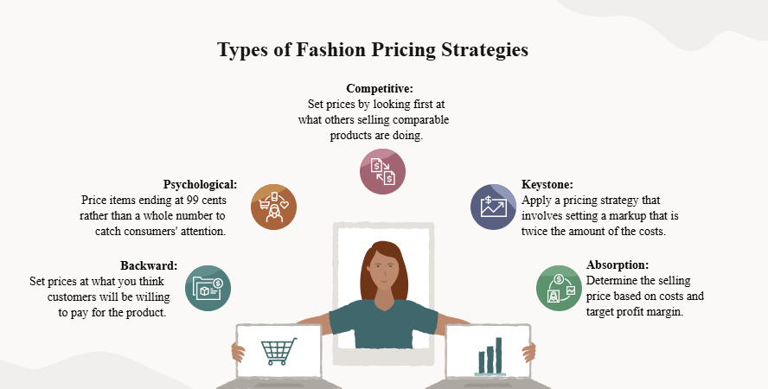
Figure- 1: Types of Fashion Pricing Strategies
Source: (Tsidulko, 2023)
The pricing strategy determines the impression and demand of consumers, as well as the profit of a company. Price choices are important in fashion retail as price is usually a sensitive issue and brand comparison among shoppers (Park, Jung and Choi, 2020). Competitive pricing is used by many retailers: they use prices close to competitors to remain afloat. Another method is value-based pricing which involves offering value-based prices to the shoppers contrary to merely cost. Promotional pricing which includes festival prices, clearance sales, or campaigns will assist in increasing the amount of traffic and sales but will lead to a decrease in margins when over applied. The right pricing should be between the internal (costs, profit targets) and the external (competition, demand) factors. Through harmonizing these, the retailers will be able to develop strategies that help in sustaining competitiveness and sustainability in the long run (Park, Jung and Choi, 2020).

2.3 Competitive Pricing in the Indian Fashion Retail Market
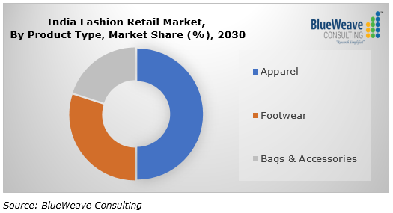
Figure- 2: India Fashion Retail Market
Source: (Blueweaveconsulting.com, 2019)
The fashion retail market in India has erupted due to urbanization, increment in income levels and the growth in fashion awareness. This has increased the competition in retail. Firms are now fighting based on design, brand image as well as price in order to capture many categories of shoppers (Kumar Singh, Singh Patel and Samuel, 2022). Reliance Trends puts itself as low-cost fashion merchandiser to middle-income consumers. Its business strategy is centered on fashionable apparel at reduced prices as compared to the high-end foreign brands. It will target a wide group of customers in the country through its competitive prices and constant offers. Retailers should also be sensitive to price of shoppers. Most people demand frauds, seasonal sales, and offers on purchasing fashion items. They have also incorporated the concept of promo pricing in their overall strategy to retain interest of customers and in attracting traffic. These are strategies that enable the firms to remain competitive as they fulfill the need to produce low-cost fashion (Kumar Singh, Singh Patel and Samuel, 2022).

2.4 Research Gaps
The current literature on pricing strategy and competition in retail business has involved a lot of studies but not many have specifically addressed the competition pressure on pricing in Reliance Trends. The existing literature covers most stories about pricing in general or about the international fashion brands and not about the domestic Indian retailers (Jain, Mishra and Mukhopadhyay, 2021). As the market of Indian fashion retail is evolving and expanding fast, it is necessary to know how such domestic retailers as Reliance Trends adapt their pricing policies to the growth of the rivalry. The analysis of this relationship helps people to understand competitive positioning and consumer perception of the industry significantly through the selection of prices. The study will bridge this gap by examining the issue of high competition rates on the market and their impact on pricing strategies of Reliance Trends. Through focusing on the Indian fashion retail market, the study is an addition to learning more about the ability of the domestic retailers develop competitive pricing strategies in a dynamic retail environment (Jain, Mishra and Mukhopadhyay, 2021).

3. Methodology

3.1 Research Design and Approach
Qualitative approach fits well since the study aims at examining what is known, trends in the industry and strategic ways of conducting business in terms of pricing and competition instead of trying to determine how (Krishnamurthy and Venkitachalam, 2022). Secondary researches enable the researcher to go through the published sources of literature, company reports and industry analysis in order to get the relationship between the competitive pressures and the pricing strategies. The study is based on the inductive methodology, constructing the conclusions due to the analysis of the existing literature and available data. This technique is appropriate in exploratory research that seeks to gain more insight on the business strategies in a given market situation (Krishnamurthy and Venkitachalam, 2022).

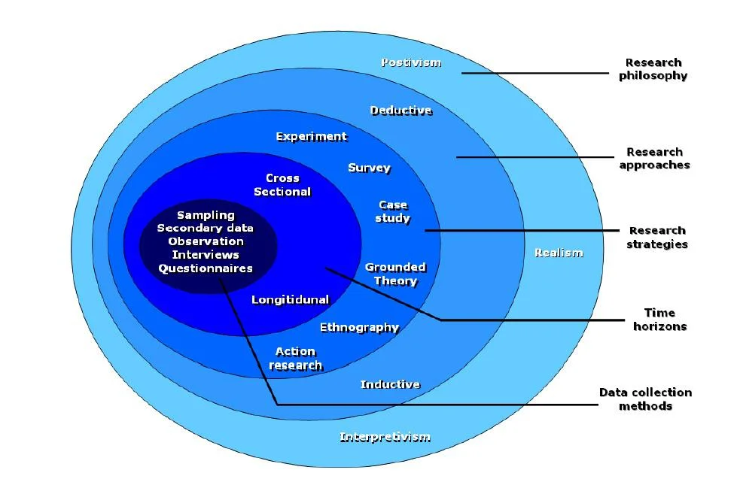
3.2 Research Onion Framework

Figure- 3: Research Onion Framework
Source: (Strayer, 2017)
The research paper is based on the research onion model created by Saunders, Lewis and Thornhill that includes the steps taken in advancing to the design of a research process (Abdelhakim and Badr‎, 2021). These frameworks are the research philosophy, research approach, research strategy, and the methods of collecting information. On the surface, the research is based on an interpretivist philosophy. Interpretivism tries to realize the phenomena of business through interpretation of the available information and knowledge. The philosophy is appropriate in the research purpose of explaining the impact of competitive environment on pricing strategies in the fashion retail industry. The second level is the research methodology. The research paper has used inductive approach and its findings are generated by examining previous research and industry data. The third layer is the research strategy, in this instance, it is the secondary data analysis. The last level is the one that relates to data collection methods, in which the researcher will synthesize data on valid secondary sources (Abdelhakim and Badr‎, 2021).

3.3 Data Collection Method
The study depends on secondary data as the main source of information. Secondary data is data that has been collected and published by other researchers, organizations or even institutions (Baldwin et al., 2022). The application of secondary data is relevant as it would allow access to a broad scope of information on the competition in the retail sector, pricing strategy, and trends in the market without conducting the primary survey and interviews. The secondary data will be gathered using reliable sources including academic materials, books, company annual reports, company publications in the retail industry, and reliable involved internet databases like Google scholar. The reports of the company in Reliance Retail and market research reports in the sector of Indian fashion retail will also be analyzed to comprehend the pricing strategies and competitiveness (Baldwin et al., 2022).

3.4 Data Analysis
The thematic analysis will be applied in analyzing the collected secondary data. This technique scans and classifies the data available in different sources to establish the critical themes and trends in terms of competition and pricing policy. The analysis aims at learning the methods through which the fashion retailers apply pricing strategies to the competition pressures. The research will be able to determine trends by comparing the results of scholarly and business sources to spot common strategies and trends, which act as an explication of how Reliance Trends will position its pricing strategy as a highly competitive retail setting (Carvalho and Kazim, 2021).

3.5 Ethical Considerations
Ethical concerns play a significant role in any research study. All materials will be cited and referenced accordingly so as to be academically responsible and not to plagiarize. The research relies on the publicly available information and abides by ethical standards of conducting academic research set by the university (Carvalho and Kazim, 2021).

4. Expected Findings
Based on available literature on the competition and pricing in retailing, it is possible to predict some main findings. Firstly, its believe that the research will establish the fact that high competition in the market has a strong effect on pricing determination in the fashion retail sector (Wood, Watson and Teller, 2021). With a large number of brands competing to gain the attention of consumers, retailers tend to employ intense pricing strategy to win the shopping attention of consumers and maintain their market share. Companies competing in the note of high competition usually monitor the prices of rivals keenly and lower their prices or increase their prices to match the current competitive rival. In this regard, we expect that the Reliance Trends constantly experience an analysis of the competitors pricing in relation to its own pricing of products (Wood, Watson and Teller, 2021).
Second, study also assume that the promotion pricing technique will be extensively applied by the fashion retailers in order to remain competitive. The common tools to boost footfall as well as sales are seasonal discounts, sales during festivals or special deals (Wood, Watson and Teller, 2021). Reliance Trends will have to adopt the same strategies to compete with other fashion retailers in India. Such moves would assist the company in attracting price-sensitive customers and consolidate itself in the low- end fashion market. Third, the research will tend to indicate that the Reliance Trends will position itself as the value-based brand that will target the middle-income shoppers with affordable and stylish clothes. It is likely that its pricing strategy is able to provide a balance between the affordability and the perceived product value that would allow the company to compete successfully with both domestic and international retailers, keeping customers loyal in the meantime (Vidani, 2024).
Fourth, study expect to point out the increasing role of retail competition via online means on pricing. This has increased competition because the emergence of online stores has provided consumers with easy access to prices when compared between brands (Vidani, 2024). Thus, the retailers would adjust their price strategies to compete in the online as well as in the offline world. Lastly, it also anticipates the results to indicate a strong association between pricing strategic, market positioning strategic and brand strategy. Companies that develop a competitive pricing strategy with the efficient promotional campaigns will have a higher probability of customer retention and maintain the competitive edge. On the whole, the research must offer beneficial data on how retailers such as Reliance Trends are modifying the pricing judgement in cases of competition pressure (Vidani, 2024).

5. Limitations
Although this study is intended to provide insights on effect of competition on pricing strategy of Reliance Trends, a number of limitations are likely to influence its coverage (He, 2024). To begin with, the research does not use primary data but only secondary data, i.e. published literature, reports and articles. Lack of primary data through interviews or survey means that the analysis will rely on the accessibility and usefulness of the available data, which might not be in-depth. Second, the company level-specific data is not likely to be publicly available. Absence of internal financial information or strategic reports may limit an in-depth study of some of the pricing practices. Third, there is a limited time frame of the research that restricts the length of literature that we could analyze. In spite of these limitations, the credible sources will be utilized in order to make the findings powerful and scholarly (He, 2024).

6. Timeframe
The study will be done using a systematic timeline to see that every dissertation phase will be done effectively and at the right time. The schedule consists of such stages as literature review, data collection, an analysis, and writing.
Research Timeline
Week 1-2: Finalize topic of research, research question and research objectives; discuss with supervisor and prepare dissertation proposal.
Week 3-5: Review and conduct extensive literature review. Go through theoretical journals, books and industry reports on competition and pricing in a fashion retail business.
Week 6-7: Work on the methodology and find suitable secondary data available in the company reports and market research publications.
Week 8-10: Collect secondary data in reputable databases, release of company, and reports in the retailing sector.
Week 11-12: Process the data in the form of thematic analysis in order to identify trends and information about competition and pricing.
Week 13-14: Prepare the findings, discussion, and conclusion of study.
Week 15-16: Finalize editing, proofreading, formatting and submit the dissertation.

7. Conclusion
The research proposal is defined to investigate the influence of high competition on the pricing strategy of Reliance Trends in the fashion retail business among Indian companies. It throws light on the stiffening competition in the market and effective pricing is necessary to appeal to the customers and remain competitive. The proposal contains the aim of the research, its goals, and guiding question, and the literature review connecting market competition and pricing strategies. The secondary method of data is adopted due to the feasibility of the strategy. In general, the proposed study can contribute to the further comprehension of ways fashion retailers react to the competitive pressure based on pricing, which helps retail managers as well as provides an informative background in further research.

References
Abdelhakim, A.S. and Badr ‎, R.M. (2021). Adopted Research Designs by Tourism and Hospitality Postgraduates in the Light ‎of Research Onion. International Journal of Tourism and Hospitality Management, [online] 4(2), pp.98–124.doi: https://ijthm.journals.ekb.eg/article_206774.html.
Baldwin, J.R., Pingault, J.-B., Schoeler, T., Sallis, H.M. and Munafò, M.R. (2022). Protecting against Researcher Bias in Secondary Data analysis: Challenges and Potential Solutions. European Journal of Epidemiology, 37(1), pp.1–10. doi: https://doi.org/10.1007%2Fs10654-021-00839-0.
Bascur, C. and Rusu, C. (2020). Customer Experience in Retail: A Systematic Literature Review. Applied Sciences, [online] 10(21). Available at: https://www.mdpi.com/2076-3417/10/21/7644.
Carvalho, G. and Kazim, E. (2021). Themes in data strategy: thematic analysis of ‘A European Strategy for Data’ (EC). AI and Ethics. doi: https://doi.org/10.1007/s43681-021-00102-y.
Gurnani, K. and Gupta, N. (2024). Factors Affecting Consumer Behaviour in Indian Fashion Retail Industry: A Study of Recent Trends and Preferences. IJFMR240218688, [online] 6(2). doi: https://pdfs.semanticscholar.org/317c/8279e2a4ce429dc238b5e425ea1a7b1189d2.pdf.
He, W. (2024). The Nexus of Market Competition and Pricing Strategies. Advances in economics, business and management research/Advances in Economics, Business and Management Research, [online] pp.32–38. doi: https://doi.org/10.2991/978-94-6463-459-4_4.
Jain, S., Mishra, S. and Mukhopadhyay, S. (2021). Critical success factors for luxury fashion brands in emerging markets: Insights from a qualitative study. Journal of Global Fashion Marketing, [online] 12(1), pp.1–15. doi: https://doi.org/10.1080/20932685.2020.1845765.
Krishnamurthy, S.M. and Venkitachalam, K. (2022). The changing face of retailing, 1980–2020. Journal of Strategy and Management. doi: https://doi.org/10.1108/jsma-02-2022-0035.
Kumar Singh, A., Singh Patel, B. and Samuel, C. (2022). Understanding customer-perceived values for apparel retailing in India. International Journal of Retail & Distribution Management, 50(11), pp.1337–1357. doi: https://doi.org/10.1108/ijrdm-08-2021-0347.
Park, I., Jung, I. and Choi, J. (2020). Market Competition and Pricing Strategies in Retail Supply Chains. Managerial and Decision Economics, 41(8). doi: https://doi.org/10.1002/mde.3200.
Vidani, J. (2024). Enhancing Customer Relationship Management in Retail: A Case Study of Reliance Trends. Social Science Research Network. [online] doi: https://doi.org/10.2139/ssrn.4848111.
Wood, S., Watson, I. and Teller, C. (2021). Pricing in online fashion retailing: implications for research and practice. Journal of Marketing Management, [online] 37(11-12), pp.1–24. doi: https://doi.org/10.1080/0267257x.2021.1900334.
Blueweaveconsulting.com. (2019). Blueweave Consulting.oi [online]d: https://www.blueweaveconsulting.com/report/india-fashion-retail-market.
Strayer, D. (2017). Saunders Research Onion Model: Understanding and Application (UPDATED) | UKEssays.com. [online] UKEssays.com.doi: https://www.ukessays.com/essays/psychology/guide-saunders-research-onion-model.php.
Tsidulko, J. (2023). Fashion Pricing Strategies and Tactics. [online] Oracle.com.doi: https://www.oracle.com/retail/fashion/fashion-pricing-strategy/.

Appendix

