Lighting Layout And Sound Index Calculation
ACBA 4006
Ayesha Williams

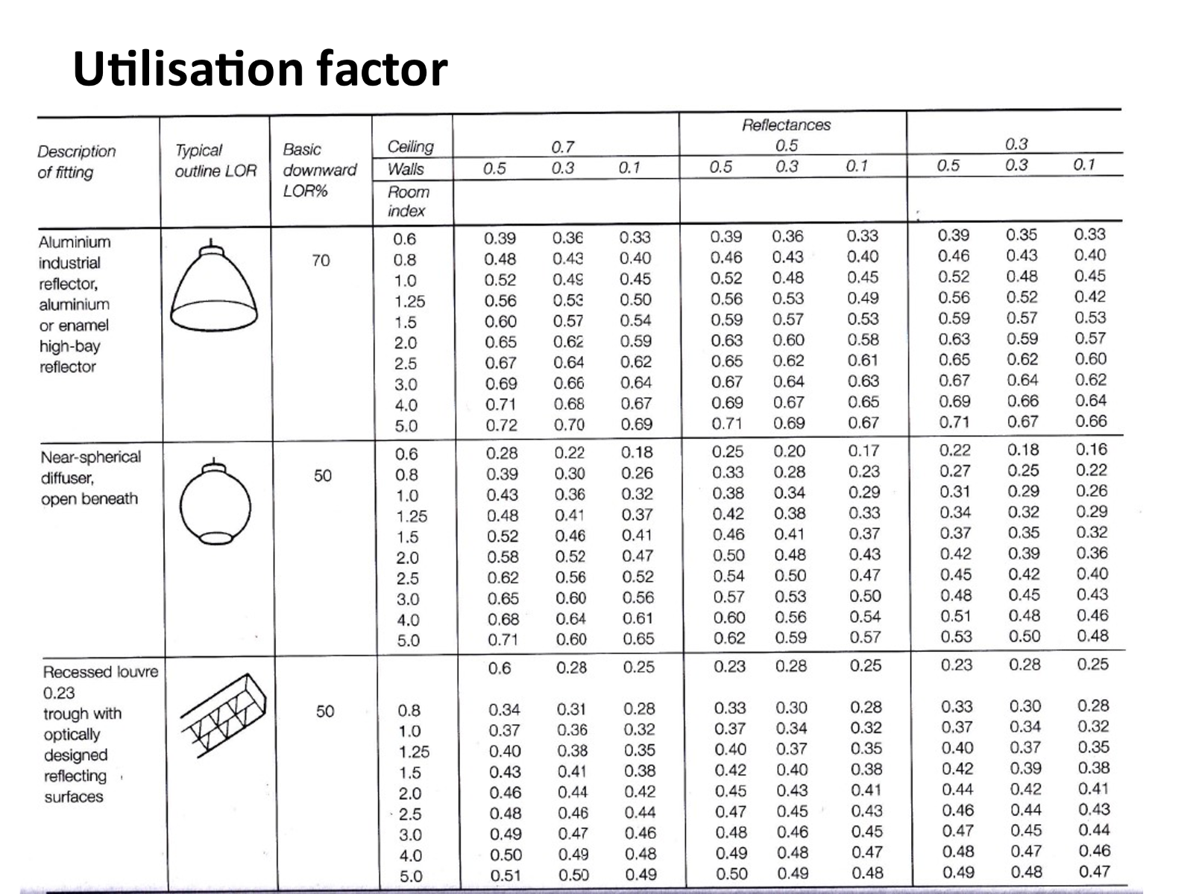
Task A
Calculations:
- Room Index-
RI=(LxW)/H_{m}(L+W))
L=60 m, W=24 m, H_{m}=8-1=7m
Substituting values
RI=(60x24) /(7(20+24))
RI=1440 / 308
RI= 4.67

- The Utilisation Factor-
Using the table attached above, to find the utilisation factor, you must first calculate the ‘Room Index’ once this has been calculated you must analyse the structure of the light to establish which of the ‘Description of fittings’ to use, for example, we are to use the ‘Fluorescent lamps in recessed louvre’ fitting once in the correct light fitting description, ensure the DLOR (Downward light output ratio) is correct, for this it must be 50%, next, use the ‘Room Index’ from the calculation to its nearest figure (4.67 to the nearest figure =5.0), find the room reflectance’s for both ceiling and walls (0.3 and 0.5). Finally, meet all figures in both the room index column and the room reflectance’s and meet in the table when both columns collide (0.49)
Utilisation factor = 0.49

- The number of lamps required-
E= 200 Lux
A=60m x 24m = 1440m²
F= 18,000lm
UF=0.49
LLF=0.75
N= E x A =
F x UF x LLF
Substituting values-
200 x 1440 =288000
18,000 x0.49 x 0.75 =6615
288000 / 6615 = 43.53 (to the nearest even number = 44)
44 lamps required

- Suitable layout (value of S) for the lamp fittings –
Suitable layout-
Fluorescent tubes =
S_{max} = 1.5 x H_{m} (The mountain height) = 7 meters
(Mountain height is the distance between the working plane and lamp)
S_{max} = 1.5 x 7 = 10.5 meters apart (Maximum)

Task A- 2 – Draw the plan layout on scale drawing -
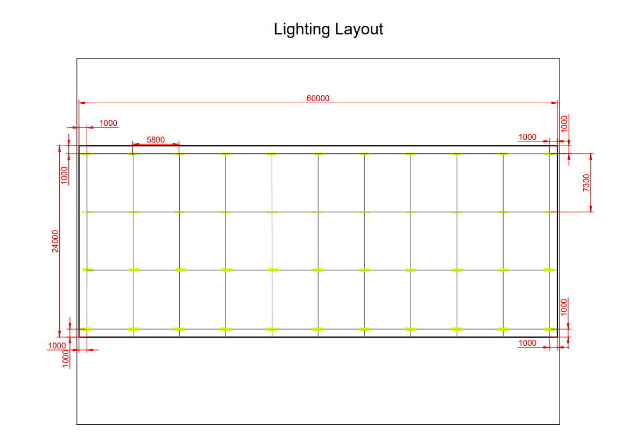

(Lamps = Green colour)

Calculations-
1m edge to edge = 1m edge to edge
24m – 2m =22m 60m – 2m = 58m
22m / 3 rows =7.3 m 58 / 10 lamps = 5.8m between each lamp centre
11 lamps x 4 rows = 44 Lamps
Task B
- Sound Reduction Index –
To= (T₁ x A₁) + (T₂ x A₂) + (T₃ x A₃)
A₁ + A₂ + A₃
SRI= 10x(Log₁₀(1/T))

For Brickwork: Window:
T₁ =? T₂?
A₁= 20-2 = 18m² A₂= 2m²
SRI =50dB SRI= 10dB

Brickwork: Window:
SRI =10 x (log₁₀(1/T)) SRI = 10 x (log ₁₀(1/T))
50=10 x (log₁₀ (1/T₁)) 10=10 x log₁₀(1/T2))
5 = log10 x (1/T₁) 1=log₁₀ x (1/T₂)
1/T₁ = 10⁵ 1/T₂ = 10¹
T₁ = 10⁻⁵ T₂= 10⁻¹
=0.000010 (Transmission Coefficient for brick) =0.10 (Transmission Coefficient for window)

Using Average formula and substituting –

To= (T₁ x A₁) + (T₂ x A₂)
A₁ + A₂
= (10⁻⁵ x 18) + (10⁻¹ x 2)
18 + 2
=1.8_{x10}⁻⁴ +0.2
20
=0.01000

Using SRI formula and substituting-
SRI = 10 x (log₁₀ (1/T))
= 10 x (log₁₀ (1/0.01000))
=10 x log₁₀(20)
=10 x 13.010
=130.1dB
SRI =130.1dB overall sound reduction index for the entire wall

Building regulation connected to workspace lighting as stated by (Designing Buildings Wiki, 2020) –“Site lighting is generally run off mains electricity at a voltage of 230 V, rather than through the use of generators. Sometimes it can be necessary to reduce the voltage to 110 V”, also stating that “working areas: 15 lx”

1) Building Fabric Resonance-
Frequency and wavelength have large impacts on building resonance depending upon the shape, density and stiffness of the object. Resonance happens when “the frequency at which the maximum-amplitude oscillation occurs” (IRIS, N.D). All buildings are designed with building resonance in mind, especially when it comes to the entire building and its comfort levels of its occupiers. When buildings are constructed, they all have natural resonance, which is the number of seconds it takes for any buildings to move or vibrate in a forward or backward motion, this is all down to the ground in which the building has been constructed on, each ground has its own resonant frequency which needs to be taken into consideration e.g. harder foundations have higher frequency waves than softer foundations (IRIS, N.D). Also, Buildings must have services to enable living standards therefore when built, a lot of the services are not actually attached to any surface, they are suspended and by doing this, reduces noise and vibration levels. The use of ceilings helps within the building fabric resonance as they provide an additional noise and vibration barrier which overall reduces the total resonance. Internally as well as the services and celling’s, humas are also contribute to resonance as well as absorb any vibrations.

2) Partition Wall Construction Technique-
Generally, all sound penetrates through walls to some extent, however different frequencies and wavelengths travel more easily through partition walls especially the low bass frequencies compared to high frequencies, although the lower bass frequencies do lose energy as they pass through the wall (SoundStop Specialists, N.D). Partition walls are built up using multiple layers of different materials, the layers of these different materials would make it harder for the frequencies to penetrate because frequencies lose energy once they pass through each material.

3) The insulation Material Choice
For the choice of insulation materials this can be in the form of a physical insulation properties. In relation to partition walls, these provide a multiple layer function which restricts how much the sound can travel through. Insulation in a partition wall should be dense to reduce the wavelengths but not too dense that the wavelengths reflect off the insulation itself, Polyurethane is said to be the best for blocking high frequencies (Phelps , N.D). It Should be noted that insulators can also come in the form of physical bodies such as people, having humans around a sound, will absorb some of the wavelengths and frequencies the sound give off. There are more insulators such as windows, doors, floor with dense materials such as carpets which will use the fibres and soft features to trap sound, ceilings can also provide insulation for sound.

References
Designing Buildings Wiki, 2020. Lighting of construction sites. [Online]
Available at: https://www.designingbuildings.co.uk/wiki/Lighting_of_construction_sites
[Accessed 2022 April 29].
IRIS, N.D. Building Resonance: Structural stability during earthquakes. [Online]
Available at: https://www.iris.edu/hq/inclass/animation/building_resonance_the_resonant_frequency_of_different_seismic_waves
[Accessed 2022 April 18].
Phelps , N.D. Material for Sound Proofing and Sound Dampening. [Online]
Available at: https://www.phelpsgaskets.com/blog/material-for-sound-proofing-and-sound-dampening
[Accessed 2022 April 29].
SoundStop Specialists, N.D. The Science of Soundproofing. [Online]
Available at: https://www.soundstop.co.uk/science-of-soundproofing
[Accessed 2022 April 21].

