

GRADUATE CERTIFICATE in Consolidation of Social Work Practice
LEVEL 6 - 60 Credits
BMPF6044

LEARNER PORTFOLIO
(PORTH AGORED and UNIVERSITY OF WALES TRINITY SAINT DAVID)

Learner’s name: Kirsty Carter

Email address: 1803596@student.uwtsd.ac.uk

Learner’s University Registration Number:
1803596

Cohort: 21 onwards

Reference List
Information about referencing in written assignments and how to avoid plagiarism can be found on Moodle. It is important that you are aware of the importance of ensuring that the work submitted is your original work.

Age UK, 2023. Age UK issues clarion call for a big shift towards joined up home and community-based health and social care services for older people.

Barrow-Grint, K., Sebire, J., Turton, J. and Weir, R., 2022. Policing Domestic Abuse: Risk, Policy, and Practice. Routledge.

BASW, 2021. The BASW code of ethics for social work

Borton, T. (1970) Reach, Touch and Teach. London: Hutchinson.

Brown, C., 2024. Towards a ‘Social Model’of Mental Capacity for Social Work. The British Journal of Social Work, 54(4), pp.1610-1626.

Children Act, 1989. Retrieved from: Children Act 1989 (legislation.gov.uk)

Children Act, 2004. Retrieved from: Children Act 2004 (legislation.gov.uk)

Dixon, J., 2023. Adult Safeguarding Observed: How Social Workers Assess and Manage Risk and Uncertainty. Policy Press.

Hargreaves, J. and Page, L., 2013. Reflective practice. John Wiley & Sons.

Hamblin, M. and Crisp, P., 2022. Negative Focus, Self-Doubt, and Issues of ‘Tool Proficiency’: Beginner-Coaches’ Reflections on Reflective Practice. Physical Culture and Sport. Studies and Research, 95(1), pp.1-13.

Higham, P., 2019. Communication and interviewing skills for practice in social work, counselling and the health professions. Routledge.

Higham, P., 2019. Communication and interviewing skills for practice in social work, counselling and the health professions. Routledge.

Howe, K. and Gray, I.L., 2012. Effective supervision in social work.

Hoyle, R., 2015. Informal learning in organizations: How to create a continuous learning culture. Kogan Page Publishers.

Karim, S., 2023. Power-informed practice in social work. Journal of Social Work, 23(6), pp.1062-1079.

Kihlström, A., 2012. Luhmann’s system theory in social work: Criticism and reflections. Journal of social work, 12(3), pp.287-299.

Koprowska, J., 2008. Communication and interpersonal skills in social work.

Lamura, G., 2015. SP0220 Don't Forget the Carers! Why We Need a Europe-Wide Strategy for Carers.

Lazarou, I., Nikolopoulos, S., Petrantonakis, P.C., Kompatsiaris, I. and Tsolaki, M., 2018. EEG-based brain–computer interfaces for communication and rehabilitation of people with motor impairment: a novel approach of the 21 st Century. Frontiers in human neuroscience, 12, p.14.

Lyons, A., 2018. Different laws, same principles: Mental health and incapacity legislation across the UK. Publisher.

Mackreth, P. and Walker, B., 2020. A Handbook for Support Workers in Health and Social Care: A Person-centred Approach. Routledge.

Meeuwissen, S.N., Gijselaers, W.H., Alexander, E.K. and Ramani, S., 2023. Understanding and strengthening collaboration in the workplace: How to work towards constructive conflicts. The Clinical Teacher, p.e13701.

Mental Capacity Act 2005. (2005). An Act of the Parliament of the United Kingdom

Mishna, F., Van Wert, M. and Asakura, K., 2013. The best kept secret in social work: Empirical support for contemporary psychodynamic social work practice. Journal of Social Work Practice, 27(3), pp.289-303.

NHS, Mental Capacity Act. 2024.

Nicholson, T.R., Cutter, W. and Hotopf, M., 2008. Assessing mental capacity: The mental capacity act. Bmj, 336(7639), pp.322-325.

Phillips, C., 2016. Wales’ safeguarding policy and practice: a critical analysis. The Journal of Adult Protection, 18(1), pp.14-27.

Sanecka, A., 2014. Social barriers to effective communication in old age. The Journal of Education, Culture, and Society, 5(2), pp.144-153.

Social Care Wales, 2017.

Social Care Wales (SCW), 2024.

Social Services and Wel-being (Wales) Act, 2004. Retrieved from: Social Services and Well-being (Wales) Act 2014 (legislation.gov.uk)

Social Services and Well-being (Wales) Act 2014, An Act of the National Assembly for Wales.

Stats Wales, 2023. Children Placed on the child protection register during the year, by local authority, category of abuse and neglect. Retrieved from: Children placed on the child protection register during the year, by local authority, category of abuse and age (gov.wales)

Thompson, S. and Thompson, N., 2023. The critically reflective practitioner. Bloomsbury Publishing.

Wales Safeguarding Procedure, (2019).

Welsh Government, 2022. Social Services and Well-being (Wales) Act 2014: Working Together to Safeguard People: Code of Safeguarding Practice. For individuals, groups and organisations offering activities or services to children and adults in Wales

World Health Organization. (2021). World Report on Ageing and Health

Zimunya, S. and Alpaslan, A.H.N., 2022. Experiences of service-user violence and coping strategies employed during social work service delivery: suggestions for ensuring social workers' personal safety. Social Work, 58(1), pp.1-18.

Detail of Workshops Attended

Please record in the table below the dates of each consolidation programme workshop you attended.

Consolidation workshop | Date Attended
1 | 30/11/2023
2 | 13/02/2024
3 | 23/04/2024
4 | 16/07/2024

Notes

Mentor’s report

With reference to the 3 learning outcomes please comment fully on the learner’s development over the duration of the whole programme. Reflect on information provided by the learner at the outset of the programme in Task 1 (Part a) and the later perspective given in Task 1 (Part b). Where you have seen or discussed feedback from individuals in need of care and support and/or their carers with whom the learner has worked, you are encouraged to comment on this with regard to the learner’s development and their future development.

I have mentored and supervised Kirsty since she first joined our team as a newly qualified Social Worker. Kirsty identified in Task 1 (part a) that she lacked confidence in completing mental capacity assessments, working collaboratively with other professionals and seeking support through supervision. When Kirsty first joined the team, she did sometimes present as lacking confidence, particularly when faced with making decisions around mental capacity as she lacked some confidence in how she approached this with the individual – as in ensuring that she was diligent in complying with the MCA principles. Also, I think that Kirsty has excellent social work values and ethics and was very aware of the responsibility of making best interest decisions and the potential consequences of that decision for the person assessed as lacking capacity for a specific decision. Similarly, in relation to collaborative working with other professionals, Kirsty sometimes lacked confidence in her role as a social worker and having the confidence to validate her views if faced with conflicting opinions. Again, I believe that this was due to relative inexperience and lack of confidence on occasions. I feel that Kirsty utilised supervision effectively and discussed openly any issues or concerns that she had which enabled us to have productive supervision. As Kirsty’s supervisor, I welcomed Kirsty identifying areas of practice or individual cases which she felt that she needed some support and guidance, as this demonstrates to me that Kirsty is a responsible practitioner and will seek support as needed.
In task 1 (part b), Kirsty reflected that she still lacks confidence in respect of completing MCA’s and identified steps that she has taken such as training, peer support and supervision to support her practice. I can confirm that Kirsty is more confident in seeking support from peers and via supervision and that she has identified and undertaken training in the areas of practice where she feels more training will benefit her practice as a social worker. Over the past year, I have observed Kirsty to develop more confidence and skills in the areas of practice which she identified as requiring further knowledge/skills. I have observed Kirsty to have more confidence in her skills and knowledge as a practitioner and she has a good understanding of the principles of the MCA – this is reflected in her written assessments. We have discussed how a decision does not always have to be made on the first assessment visit and that it is good practice to return to the assessment in order to validate and confirm the decision made.
In relation to collaborative working, I have observed Kirsty growing in confidence in her role as a professional social worker. For example, Kirsty had a case where the person was living in the community and was potentially placing himself at risk going in to the community. Kirsty assessed the person as lacking capacity in respect of recognising the risks and, although the mental health professional felt the person should be admitted to residential care, Kirsty took into account the impact that a deprivation of liberty, choice and control would have on the individual and assessed for a less restrictive option and, with contingency plans in place, advocated for the individual to remain in the community for as long as possible. Kirsty explained her rationale to the health professional who was then able to agree with the person’s care and support plan.
Task 2 – observation of practice. I observed Kirsty completing a review as described in Kirsty’s reflection of the task. Kirsty prepared well for the visit and, as she has reflected in her feedback, Kirsty demonstrated excellent social work skills in considering her approach to the individual given the information that she had (person’s low mood and suicidal thoughts since have a stroke). Kirsty considered her approach, and I observed her to demonstrate empathy and understanding towards the person’s situation and also the person’s wife/main carer’s perspective. Kirsty enabled the person and his wife and daughter to reflect on their individual perspectives and summarised back to them her understanding of their lives and situation. The person tended to wander off subject of discussion and, initially, Kirsty seemed hesitant to bring the conversation back to topic; however, as the visit progressed, Kirsty was able to steer the conversation back to subject in a way which was respectful and demonstrated that, although she was listening, she needed to assess outcomes related to his situation. This was also reflected in the service user’s feedback.
In summary, Kirsty is a thoughtful and reflective practitioner and is keen to continue to develop her skills and knowledge in order to enhance her practice, skills and confidence. In this team, Kirsty has had opportunities to practice social work in a very busy and challenging workplace environment and she has embraced this experience with a positive attitude and from a learning approach. Kirsty is more confident in her role as a social worker and she has excellent social work values and ethics. Kirsty demonstrates empathy and understanding towards the service user’s situation and demonstrates this in her approach when assessing the individual’s and family’s situation. Going forward, I am confident that Kirsty will continue to grow in confidence, particularly when advocating for individuals and managing challenging situations, for example when there are challenges from professionals or families, which I know through discussions with Kirsty, is an area which she sometimes finds challenging as a practitioner. Kirsty has demonstrated that she will seek peer support or via planned or ad hoc supervision when required and she is also now at a stage where she is able to offer advice and support to her peers.

Kirsty is always prepared to support the team and her colleagues. For example, Kirsty will volunteer for ‘duty’ – the duty system is usually very busy and can often present cases where the individual or family is in crisis. Kirsty has demonstrated that she has managed these cases well and always finds a solution – such as arranging a placement at short notice; liaising with other professionals to contribute towards a care and support plan. I believe that, although this work can be challenging at the time, it has contributed towards Kirsty’s confidence and development as a professional social worker.

As her mentor/supervisor, it has been a pleasure to observe Kirsty’s journey and development into becoming a competent and more confident practitioner.

Note for Mentor – Please ensure that you provide a signature of verification of this report in the section titled ‘Signatures and Line Manager Verification’

Learner Details

Learner details, Signatures and Line manager verification.

It is the learner’s responsibility to ensure that their university learner number is correctly inserted wherever requested within the portfolio.

Learner Details
(NB it is essential that you inform your Workforce Development/Training Unit and the University of Wales Trinity Saint David if your name or your address for correspondence changes).

1. Name of Learner: Kirsty Carter

2. Learner’s University Number: 1803596

Address for Correspondence:

35 Glyndwr Place,
Swansea,
SA1 6NJ

Telephone Number:

E-mail address: 1803596@student.uwtsd.ac.uk

Date of Professional Qualification: June 2022

Date of registration with Social Care Wales: 31/08/2022

3. Name of Learner’s Agency

Agency Contact details:

Name: Social services

Address: Adult Services, Civic Centre, Oystermouth Road, Swansea, SA1 3SN

Telephone Number: 01792 636000

E-Mail address: Kirsty.carter@swansea.gov.uk

4. The evidence I have provided within this portfolio is in:

Welsh only Welsh and English English only X

Mentor’s details

5. Mentor’s details

Name: Helen O’Sullivan

Address: The Guildhall, Swansea.

Telephone Number: 07887 055325

E-Mail address: helen.o’sullivan@swansea.gov.uk

6. Observer details

Name: Helen O’Sullivan

Work Address:
The Guildhall, Swansea.

Professional Qualification and date of qualification: Bsc (Hons) Social work. August 2011.

Telephone number: 07887 055325

Email address: helen.o’sullivan@swansea.gov.uk

Signatures and Line Manager Verification

CONFIDENTIALITY and PLAGIARISM – to be completed by the learner.

All information provided in this portfolio complies with guidance on confidentiality. I confirm that all work apart from comments by others (e.g. mentor, individuals in need of care and support and/or their carers) is all my original work and has not been copied. I understand that plagiarism is taken very seriously by the University and the programme.

Signed: 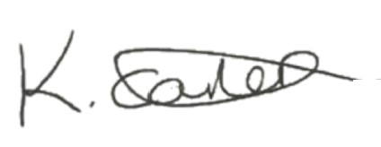 (Learner)

Date: 17/09/2024

Feedback and comments from an individual using services, their family and/or carers (Task 2) - to be completed by the Observer.

I confirm that I am a registered social worker with knowledge of the learner’s area of practice and that the observation summary and the comments above from the individual in need of care and support and/or their carers are about the same piece of practice that I observed on the date given.

Signed:  (Observer)

Date: 02/10/2024

Mentors Report (to be completed by the mentor)

I can confirm that I am a registered social worker and that in my role as mentor I have provided a written report of the learner’s progress over the duration of the programme.

Signed: 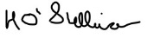(Mentor)

Date: 02/10/2024

Line manager verification.
Guidance: This section must be completed and signed by the learner’s line manager and/or senior practitioner. Where the line manager is not a registered social worker, verification must also be provided by a social work practitioner in a senior position (this could be the mentor) who is familiar with the learner’s work and can verify that the learner has been involved with the safeguarding case evidenced in Task 3 of the portfolio and that the learner has met all the required criteria listed below.

In this section, please confirm that you have seen sufficient evidence of the learner’s work during the period they have been undertaking the Consolidation programme. If necessary, please consult with other managers who the learner has worked with. In signing this section, you are confirming that you are content with the:

- level of supervision and mentoring support received by the learner;
- learning and development undertaken;
- reading and personal research undertaken;
- level of knowledge and skills demonstrated;
- understanding shown of the Code of Professional Practice and National Occupational Standards;
- core values of the learner;
- work and commentary referred to within the portfolio, that it is the learner’s own work and based on current practice;
- completion of accurate, cogent, coherent and analytical recording skills;
- Line manager to verify the learner has been involved with safeguarding.
- Mentor’s report, and that it provides evidence of observations of Professional Practice that has been undertaken over the duration of the Graduate Certificate in the Consolidation of Social Work practice pathway (work-based practice which is equivalent to 7,000 words).

I confirm that this learner has achieved an appropriate level of professional practice.

Line manager VERIFICATION:

name of Line manager: Sarah francis
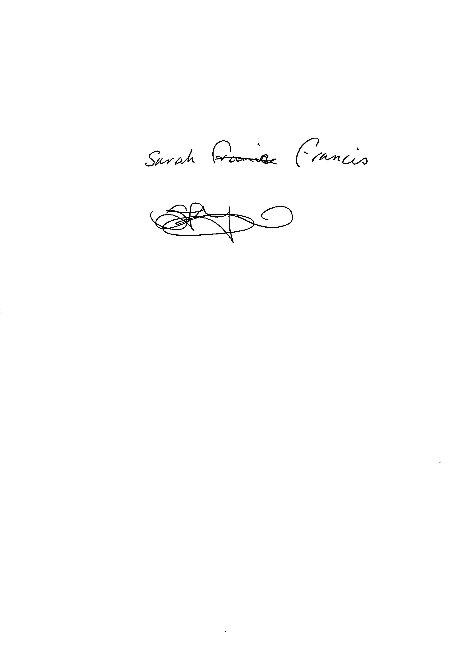
Signature of LINE MANAGER:
DATE: 02.10.24

Registered Social WORKER’S VERIFICATION (Where the line manager is not a registered social worker, this can be the mentor).

name of Social worker:
Signature of social worker:
POSITION:
DATE:
Learning Agreement

PORTH AGORED AND UNIVERSITY OF WALES TRINITY SAINT DAVID

GRADUATE CERTIFICATE IN CONSOLIDATION OF SOCIAL WORK PRACTICE

LEARNER AND EMPLOYER’S LEARNING AGREEMENT

Name of Learner | Kirsty Carter
Name of Team/Agency | Community Initial Assessment Team
Name of Mentor | Helen O’Sullivan
Name of Line Manager | Sarah Francis

Study Duty

The learner will undertake all elements of the Graduate Certificate programme diligently, including mandatory attendance at induction, four Consolidation Workshops, and participation in an evaluation survey or focus group on completion of the programme.

The learner’s full and effective participation on the Graduate Certificate is mandatory given that Social Care Wales has made completion of the programme a requirement within the first (three-year) period of registration as a Social Worker. This applies to social workers who qualified after April 2016.

Study Leave

The employer undertakes to support the learner by providing time within their normal contract of employment to attend all agreed mandatory elements of the programme which include; induction day and four Consolidation Workshops. Additional time may be provided for programme evaluation meetings and any training agreed as a requirement of the programme.
Three further study days will be provided by the employer as a contribution towards the time involved in personal research and developing the portfolio for submission. The study days can be taken on any week-day (or combination of days) as long this is (i) appropriate to the stage of portfolio preparation at the time, and (ii) agreed with the Team Manager who will take into account team and service needs. Where the learner works less than 37 hours a week, mandatory days and study leave will be approved in accordance with the employer’s local policies.

Resources

Learners are able to access learning and library materials from their employer’s existing resources or as described in the Programme Handbook, from the University. The employer understands that the Graduate Certificate is to be completed by newly qualified Social Workers in their first period of registration and will support this timescale. There is also an expectation that as it is a professional development programme, learners will take responsibility for their own learning and will also use their own time for personal study and portfolio preparation.

The employer’s training department agrees to:

- arrange for eligible staff to join the programme;
- pay course fees directly to the University;
- pay Porth Agored partnership fees for each learner;
- provide additional guidance and support by:

  - facilitating access to existing learning materials or library resources;
  - providing appropriate training opportunities from existing internal training programmes as agreed with the learner and mentor;
  - providing programme induction and Consolidation Workshops;
  - providing learners with guidance and support about programme requirements and portfolio completion;
  - helping to resolve any programme difficulties encountered by the learner, mentor or service managers.

The learner agrees to:

- work actively towards completing the qualification within the agreed timescale of 12 months from the date of registration on the programme;

identify with manager/mentor appropriate internal training and arrange to attend these courses;

identify with manager/mentor and Training Coordinator/Manager any special requirements e.g. dyslexia and contact the University’s Student Services office directly about additional support that may be required;
- attend induction and four Consolidation Workshops. These are mandatory components of the programme;
- produce work and evidence appropriate to the portfolio and learning outcomes within agreed timescales;
- make and keep agreed appointments with mentor/line manager;
- ensure they are prepared adequately and obtain all necessary consent for observed practice;
- inform mentor/line manager and training department immediately of any problems or changes in circumstances while undertaking the programme, especially where this may affect completion of the programme by the agreed deadline or ability to attend a mandatory workshop;
- liaise with their line manager/mentor to confirm study days and use their own time in addition for self-directed study, research and portfolio preparation;
- take personal responsibility for preparing and completing all work necessary to submit their portfolio;
- act at all times in accordance with the Code of Professional Practice and the employer’s and University’s policies, procedures and processes;
- ensure that they understand the need to complete the programme within the first (three year) period of registration with Social Care Wales. (Qualifying after April 2016).

Line Manager/Mentor agrees to:

Line-manager/mentor can be one in the same person or the role can be undertaken by two separate people. The mentor must be a registered SW with a minimum of 3 years post qualifying experience.

- attend an induction meeting to become familiar with the requirements of the programme;
- provide or arrange to provide sufficient assessment opportunities in order for the learner to evidence competency and undertake required observations. Where opportunities may not be immediately available within the team arrange to provide these elsewhere within the Service;
- guide and support the learner for the duration of the programme;
- release the learner for the programme induction and the four Consolidation Workshops, and any internal training courses agreed as being appropriate to meet agreed learning needs;
- agree with the learner, use of up to 3 additional study days over the whole duration of the programme, as an employer contribution towards time needed for personal study, research or portfolio development;
- ensure that regular formal supervision is provided to the learner by their line manager in line with organisational policy (line-manager);
- ensure that mentoring sessions are provided in line with Social Care Wales First 3 Three Years in Practice guidelines. Mentoring sessions, where possible, should be arranged as a separate event from supervision. A full record of when mentoring sessions are undertaken must be kept.

Completion and submission of portfolio

Learners are expected to complete the Graduate Certificate and will normally submit their portfolio within 12 months of attending induction to the programme. Any learner anticipating any difficulty in meeting this requirement should immediately discuss the matter with their Training Manager/Co-ordinator. It is the learner’s responsibility to inform the university if they are not going to meet the submission deadlines.

The portfolio submission process and dates for each programme cohort will be published on Moodle. Once registered on a programme, learners CANNOT change the due submission date without gaining agreement from the employer and University.

Pressure of work is not regarded as a reason for non-attendance at any Consolidation Workshop.

I understand and accept the terms and conditions of this learning agreement as stated above.

Signed: Print Name: Kirsty Carter Date: 17/09/2024
(Learner)
Signed:…………………… Print Name: Sarah Francis Date: 02.10.24
(Line Manager/Mentor)

Signed: Print Name: Helen O’Sullivan Date: 02/10/2024
(Mentor, if different to above)

PLEASE PLACE THE SIGNED COPY OF THIS LEARNING AGREEMENT IN THE PORTFOLIO.

