

January 27, 2020
Paul Gormlie (P149642)
Lecturer: Dr. owen williams
M6X00408
ACM: Ricardo Wave
Engine simulation and validation

Contents
Contents 1
Introduction: 2
Methodology: 3
Analysis: 8
Initial basic analysis: 8
10250 RPM: 10
13000 RPM: 15
14400 RPM: 17
Discussion: 19
Conclusion: 20
Appendix: 21

Figure 1: Example of Triumph supplied combustion data 3
Figure 2: Example of Pressure vs Volume diagram, Triumph supplied data 10250 RPM 4
Figure 3: Wiebe curve fit 14400 RPM 4
Figure 4: Matlab code to generate Wiebe curve fit 5
Figure 5: Example interpolation to find 10% MFB 5
Figure 6: Burn durations per RPM range 6
Figure 7: Example of pumping cycle from PV diagram 6
Figure 8:Example of constants table for original data runs. 8
Figure 9: Original Engine data output table, WavePost 8
Figure 10: PV diagram highlighting discrepancies between Real and Supplied data. 9
Figure 11: Constants table illustrating set parameters for first run 10250 RPM 10
Figure 12: PV diagram run 110250 RPM 10
Figure 13: Chart showing alignment with real data following adjustments 11
Figure 14: Constants table run 2 11
Figure 15: Valve lift and duration profile set to manufacturers specification 12
Figure 16: 10250 RPM correct valve timing 13
Figure 17: Power figures from 10250 RPM 13
Figure 18: Cylinder pressure within 1% of real Triumph data 14
Figure 19: PV diagram showing closest fit found to Triumph real data 14
Figure 20: 13000 RPM run 1 15
Figure 21:13000 RPM run 1 constants table 15
Figure 22: Wiebe curve from 13000 RPM run 1 where ignition timing is incorrectly set 16
Figure 23: Adjusted Wiebe curve illustrating correct ignition timing 16
Figure 24: Power and pressure figures from corrected Wiebe and enrichment of AFR. 17
Figure 25: Data tables showing generated Power, torque and pressure figures for 14400 RPM 17
Figure 26: Chart showing correct pressures and pumping loop. 18

Introduction:

For level 6 A.C.M module 1: Ricardo wave component, students have been tasked with a Ricardo wave model analysis and validation exercise, utilising data obtained from a 3-cylinder Triumph 675 motorcycle engine.
The data obtained was directly from the manufacturer and given in its raw form and consisted of basic parameters for the engine in question. From these parameters the student was required to develop a model from first principles for the engine, this model was then used to validate a previously prepared Wave simulation.
Any discrepancies discovered in the wave model were required to be remedied by adjusting the engine parameters of the given model, thus validating the first principle data.
Any adjustments made can then be discussed and their effects within the model further analysed with the aim of demonstrating the benefit of simulation software when predicting engine flow and thermodynamic behaviour in a 1-zone simulation.
Main validation areas in this case will be comparison between power output and torque figures from the simulation as opposed to manufacturer quoted figures.
Limitations and assumptions encountered within the model and software can then be discussed and methods of mitigation applied in order to achieve desired results.

Methodology:

To begin, data obtained from Triumph was assessed and processed to be included in an excel file. Parameters supplied from the manufacturer included:
- Crank angle for one 4-stroke cycle, i.e. 720 degrees of crankshaft rotation.
- Cylinder pressure per degree (BAR)
- Percentage of fuel burned
- Cylinder volume, expressed as a percentage of total cylinder volume
- Time in seconds
In order to utilise data effectively, it is necessary to convert required parameters to S.I units in order to calculate a first principle engine model. An example of the data is shown is shown below as supplied from the manufacturer:
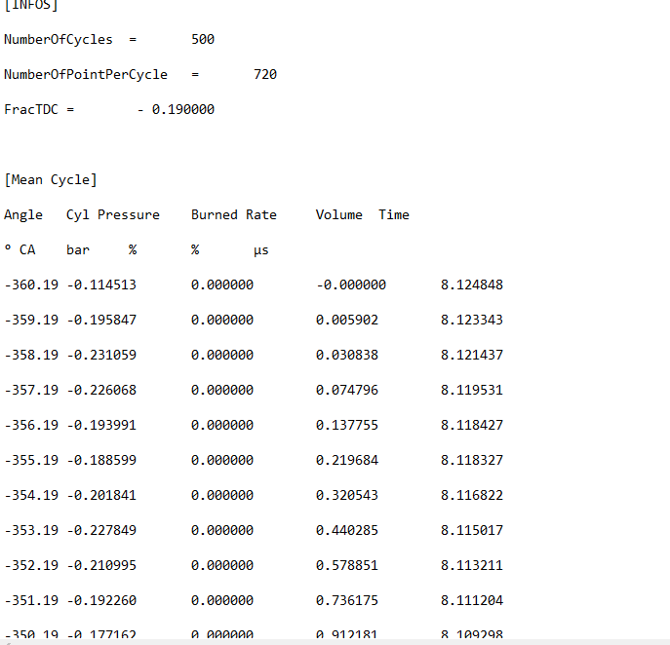
Figure 1: Example of Triumph supplied combustion data

Following conversion of necessary data, a set of charts were compiled to represent the combustion and pumping phases of the 4-stroke cycle in the form of a Pressure vs Volume diagram. This diagram can then be used as an aid in the reverse engineering process of the supplied Wave model.

Figure 2: Example of Pressure vs Volume diagram, Triumph supplied data 10250 RPM
This data was then combined with engine geometry supplied in a data sheet as given by the course lecturer, outlining the bore, stroke, valve dimensions, compression ratio and other necessary geometry data in order to produce a working analytical model for the purposes of a simulation model.
At this point, charts were compiled for data supplied across all rev ranges, 10250, 13000 and 14400 RPM, displaying PV, Mass fraction of fuel burnt and log PV charts used to calculate polytropic index in compression and expansion.

From the MFB charts generated it was possible to calculate the 10%, 50% and 90% burn point for each RPM range. This also allowed for calculation of the Wiebe exponents A and M using the curve fitting function in MatLab, this was generated using the general Wiebe equation. It must be noted that when using Ricardo wave software, only the ‘M’ exponent of the Wiebe function is considered, as the software will calculate the ‘A’ exponent from calculations within the software.
Shown below is an example of the curve fit from MatLab and a section of the MatLab code used to perform the function:
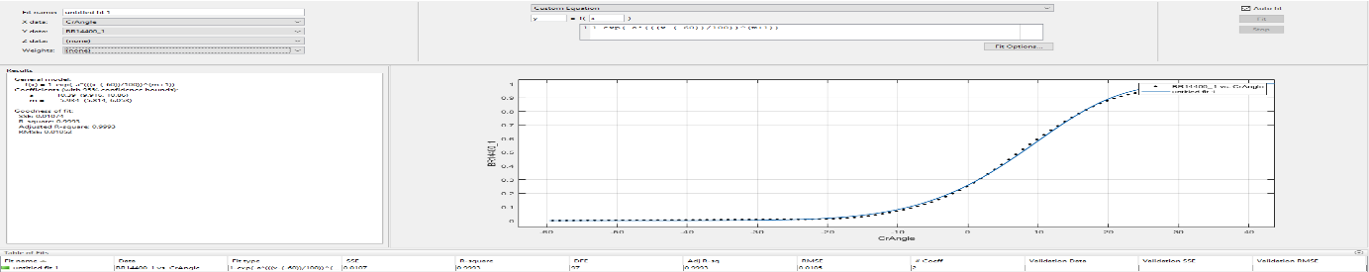
Figure 3: Wiebe curve fit 14400 RPM
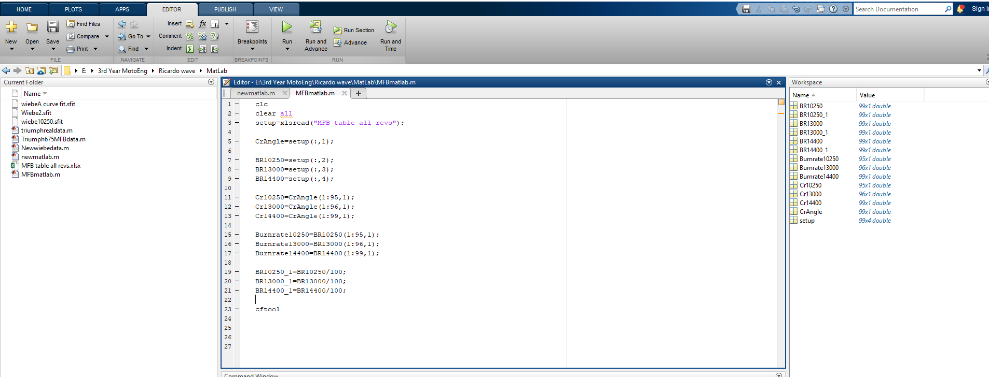
Figure 4: Matlab code to generate Wiebe curve fit
Following fitting of the curve, values for Wiebe exponents can be obtained, which will be used when inputting data into the Wave simulation. The values obtained are, 6.847, 6.36 and 5.934 for each respective RPM range. (10250,13000 and 14400) These values will be used in the preliminary stage of the engine simulation, in an attempt to reproduce manufacturer quoted benchmarks.
The burn duration can also be calculated at his point by measuring the amount of crank angle between 10% and 90% MFB as measured from obtained Triumph data. The figures calculated are interpolated from real data as the manufacturer data is supplied in an unconventional format, whereby the crank angle is specified approx. 0.2 of a degree adrift of actual crank angle. An example of this is shown below:

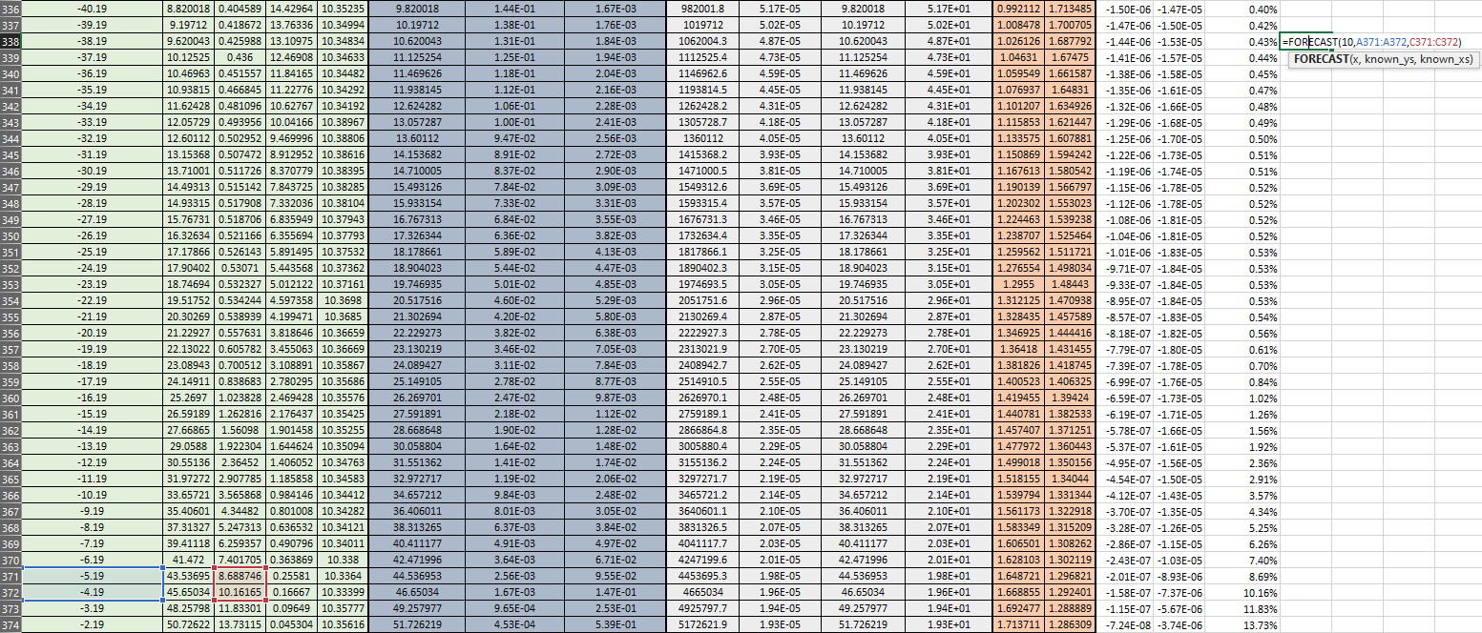
Figure 5: Example interpolation to find 10% MFB

This method is also then used to calculate values for 50% and 90% MFB respectively. This allows calculation of overall theoretical burn duration for each RPM range also.
An example of these calculations is shown below:
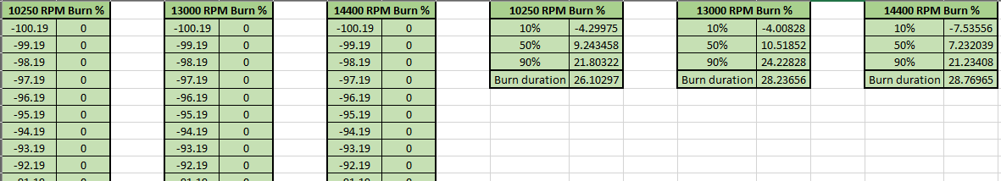
Figure 6: Burn durations per RPM range

Before commencing any Wave simulations, various other data must be considered in order to achieve desired results within the program, factors to be considered prior to performing a simulation run include;
- Engine geometry
- Valve profiles (lift & flow)
- Valve geometry
- Ambient temperature
- Ambient Pressure
- Duct geometry
- Wiebe parameters
- Heat transfer parameters (Woschini)
- Valve timing
- Ignition timing
These parameters can be mostly gathered from supplied data sheet, although certain values have to be calculated from first principles such as the valve timing and Wiebe components.
In order to calculate the valve timing, the valve lift profile was analysed and the max. opening point of the valve determined. From here, the cam duration at 1mm lift can be found and the opening point of the inlet and exhaust valves set for the pumping loop component of the four-stroke cycle.
Cam duration for inlet was found to be 250 degrees and duration for exhaust was found to be 234 degrees (at 1mm lift). To achieve the Triumph specification for valve lift and duration, multipliers have been applied to attain 258.5 and 246 duration for the inlet and exhaust camshafts respectively and also 9.25mm and 8.5mm lift respectively.
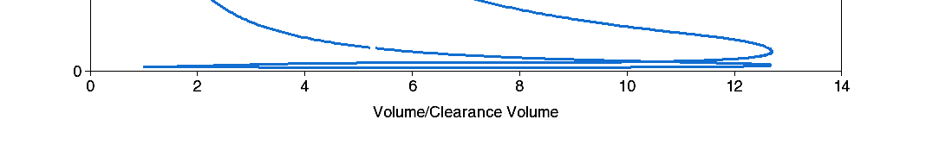
Figure 7: Example of pumping cycle from PV diagram
In wave, the heat-transfer co-efficient (Woschini) is considered to be a multiplier and controls the amount of heat loss from combustion to the cylinder walls. This model accounts for the gas velocity in the cylinder without taking swirl into account and is included in the supplied wave model, a less complex heat-transfer model has been proposed by Annand also, this model assumes a constant gas velocity and is not used for the purpose of this study. (Colorado State University, 2020)
When all variables have been compiled, it is possible to run a Wave case in the Wave Build applet of the software.
Initial variables are programmed into the constants table and the number of cases to be run is selected, initially a case has been run for the 10250 RPM range with the supplied data in order to achieve a set of baseline values.
A number of cases have been run for each RPM range with experimental values entered for each area in the constant table. The data retrieved can now be analysed and compared to the real data traces as supplied from Triumph, these results will be discussed in the analysis section of this report.

Analysis:

Initial basic analysis:

To begin analysis, a benchmark set of case runs can be carried out in Wave, using the original data with only valve lift profiles and flow co-efficients loaded into the model, 3 cases can be run to produce data for post analysis. Shown below are examples of the initial runs for various RPM ranges:
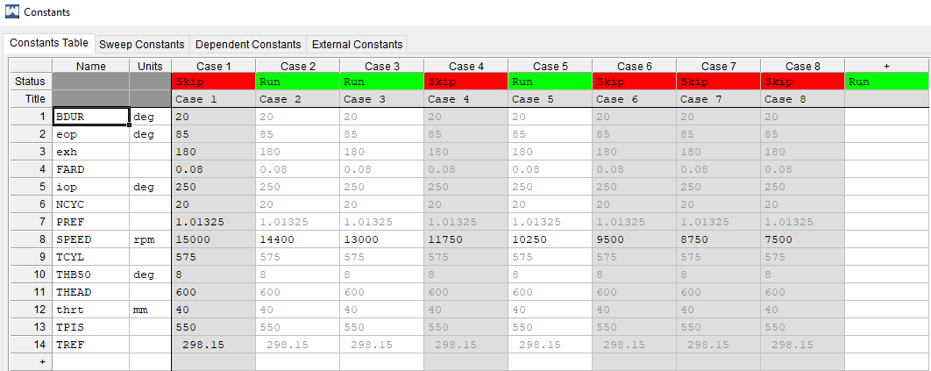
Figure 8:Example of constants table for original data runs.
As can be seen, the constants table above has the same parameters set for each case. The results from these runs will determine what adjustments may have to be made to the engine parameters in order to validate the model.

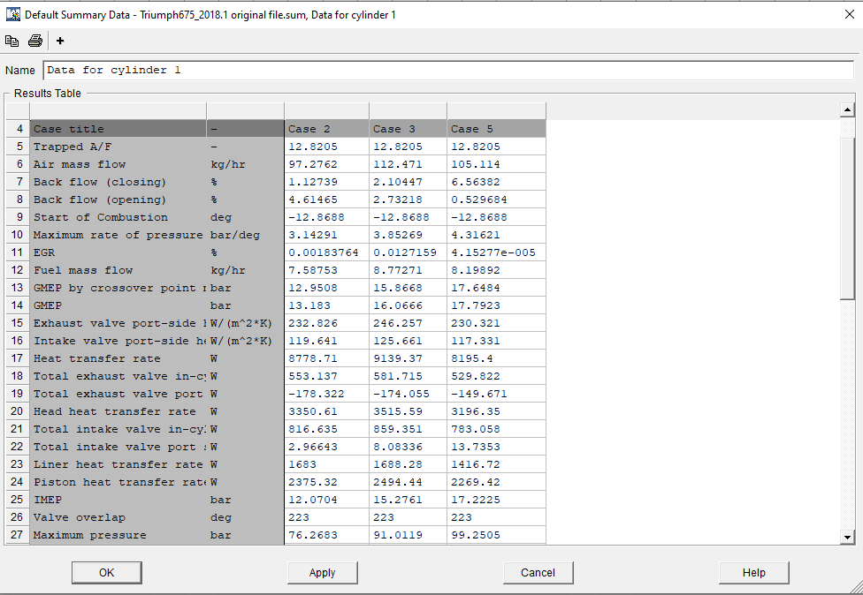
Figure 9: Original Engine data output table, WavePost
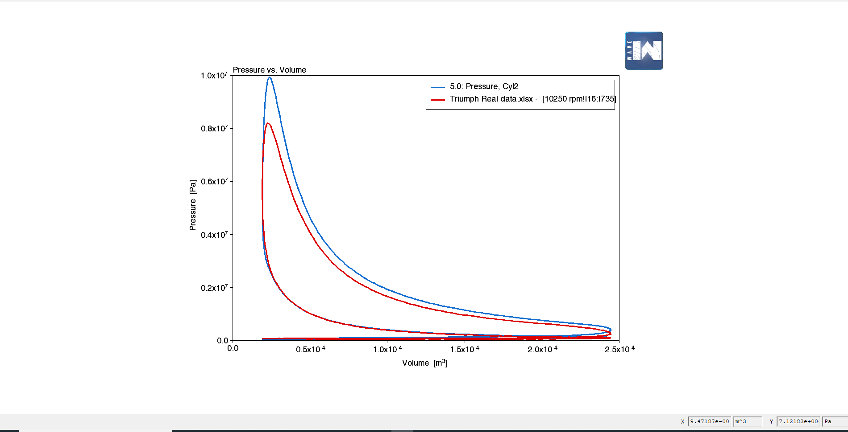
Figure 10: PV diagram highlighting discrepancies between Real and Supplied data.
The chart above displays the discrepancy in the cylinder pressure from the Wave run (blue trace) for this case as opposed to the trace imported from the real Triumph data shown in red. It is quite clear to see that the cylinder pressure is far higher in the initial Wave model in this instance, also the pumping loop begins earlier, i.e. the exhaust valve opening point is too early in the Wave model.
The next stage of analysis is to begin entering supplied engine parameters to the model, such as,
- Engine geometry
- Valvetrain geometry
- Compression ratio
- Check firing order and engine configuration
Also, basic parameters must be set from the following list;
- Ambient temperature
- Ambient pressure
- Wiebe exponents
- Check on Woschini heat transfer co-efficient values
A few discrepancies were found in the model namely in geometry, whereby the valve diameters and con-rod length required adjusting, also the compression ratio was set to the wrong value initially. Also, the port diameter had to be reduced in diameter to suit the reduction in valve diameter on the inlet side as preliminary runs produced an error pertaining to duct geometry. After remedying these issues, it is now possible to proceed with model validation at each RPM range.

10250 RPM:

To begin validating the 10250 RPM model, the charts produced from initial runs give an idea of what areas of combustion will need to be altered to validate.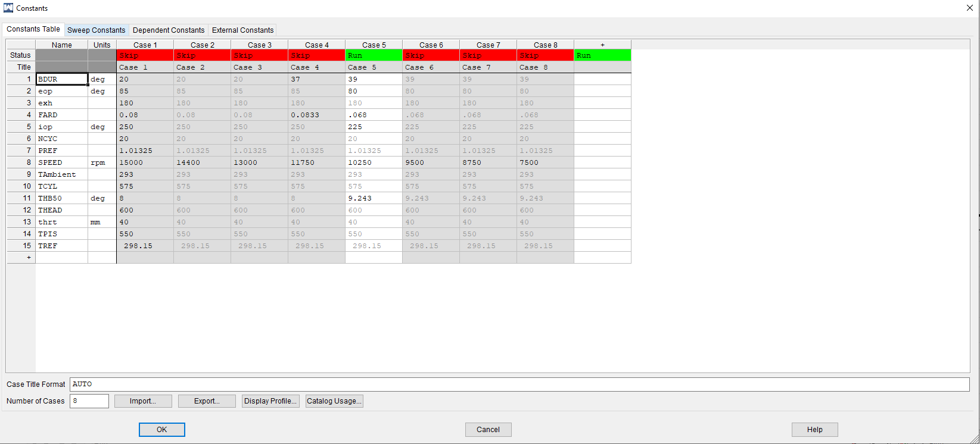
Figure 11: Constants table illustrating set parameters for first run 10250 RPM
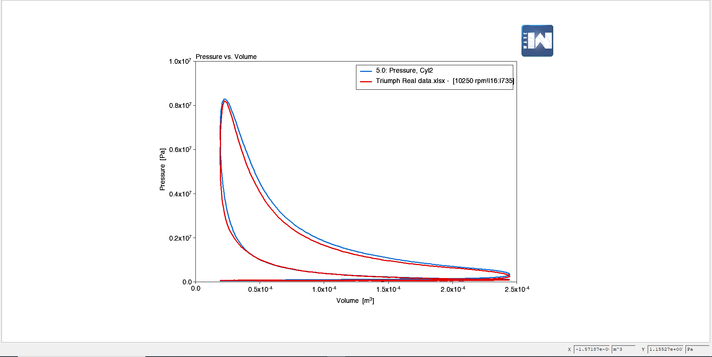
Figure 12: PV diagram run 110250 RPM
As can be seen in the above charts, the PV trace is not too far from the real Triumph trace, this gives an idea of which areas of combustion should be altered to achieve desired results, in this case incremental changes were made to the valve timing, AFR and burn duration as the THB50 was presumed to be a constant from previous calculations. Enrichment of the air/fuel mixture appeared to yield favourable results, with a trend towards the correct pressure, expansion and compression curves. Charts for the adjustments are shown below:

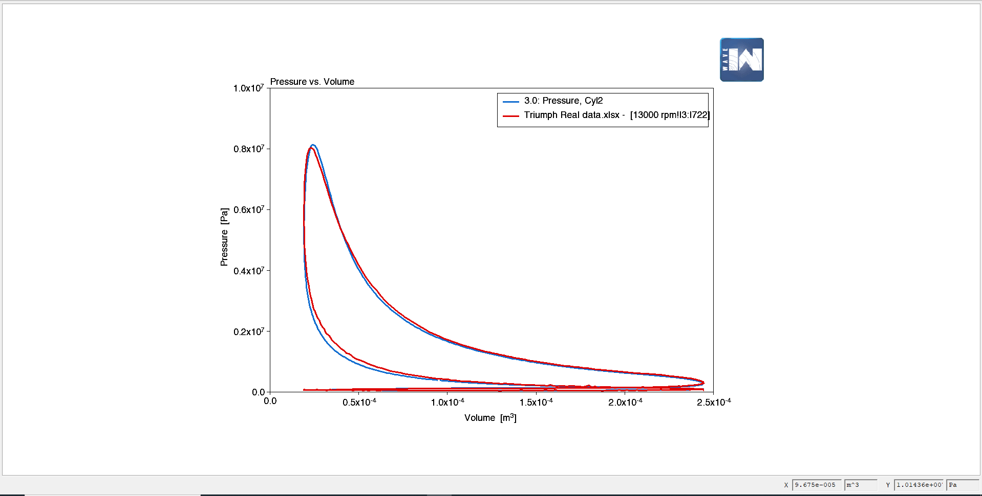
Figure 13: Chart showing alignment with real data following adjustments
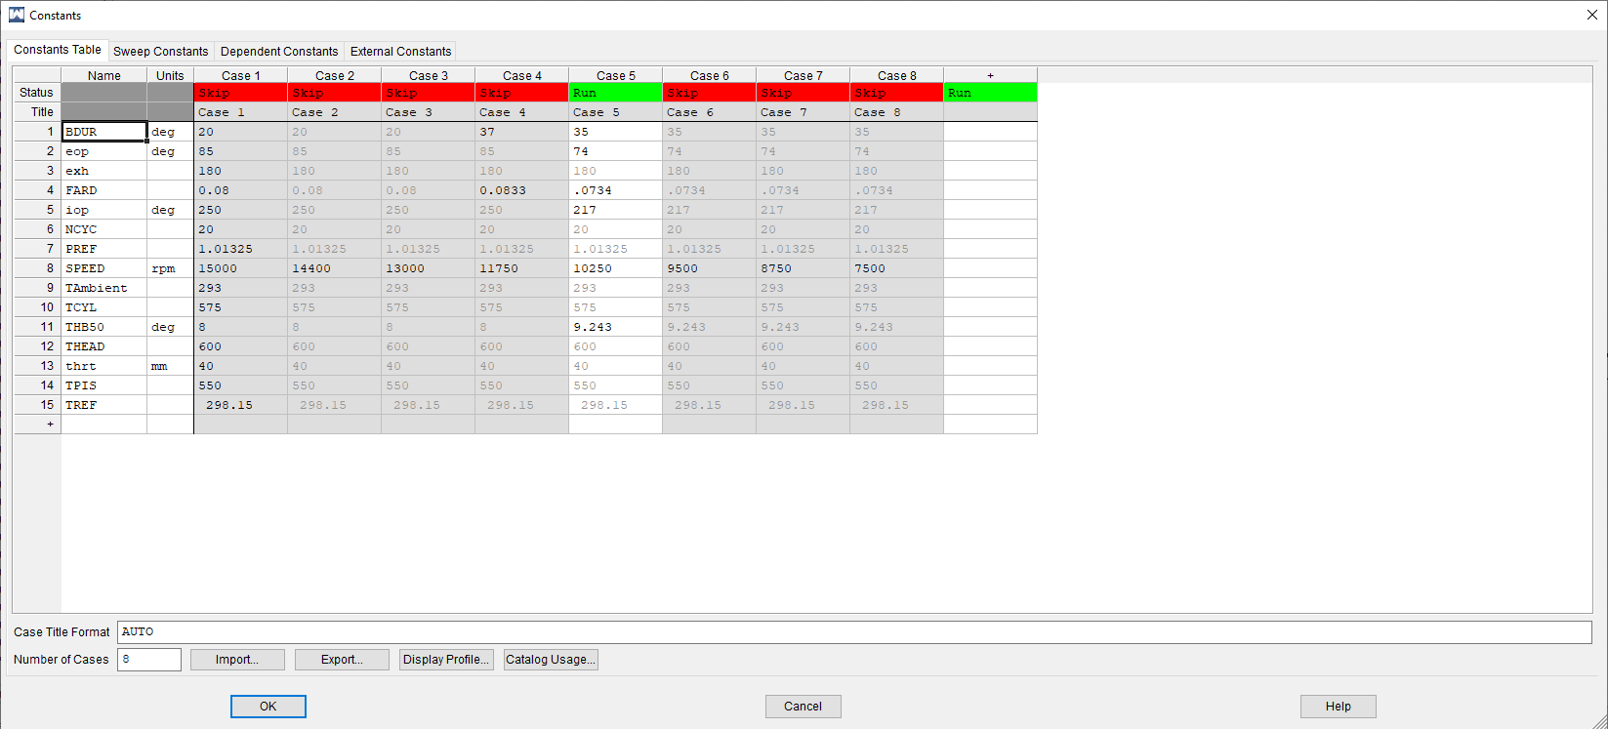
Figure 14: Constants table run 2
At this stage a decision was made to calculate valve timings and lift profiles from given data. A set of data from a Triumph workshop manual was obtained and the camshaft durations and correct lift profiles were input to the valves tab within general engine parameters in the wave model. This was achieved by using the multipliers section of the valves tab. Calculations performed suggested that camshaft duration multiplier should be set to:
2.034 for inlet valves as $\frac{258.5}{250}$ = 1.034 the .034 was added as this represents an overall 3.4% increase in duration to achieve Triumph specification.
The same theory was applied to the exhaust cam duration, giving a result of 2.05182 for the multiplier,
Again, the principle was applied to the valve lifts where the desired max valve lift was 9.25mm for inlet and 8.5mm for the exhaust valves.
At this time, the valve lash was included also in an attempt to replicate geometrical conditions as closely as possible.
Following these adjustments, the valve timing was set also according to Triumph recommendations, whereby the inlet cam was set to open at 27.25˚ ATDC (at 1mm lift) and the exhaust set to open at 43 ˚ BBDC (also at 1mm lift). (Triumph Group, 2008) This satisfied the valve timing aspect of the simulation and allowed a set geometry for the valvetrain for the remaining RPM ranges as this is a fixed geometry within the engine.
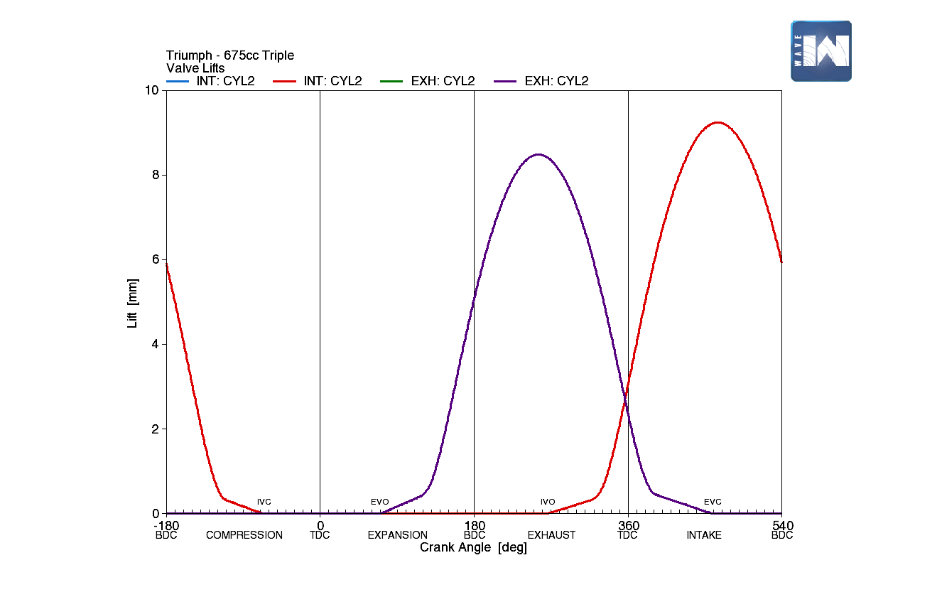
Figure 15: Valve lift and duration profile set to manufacturers specification
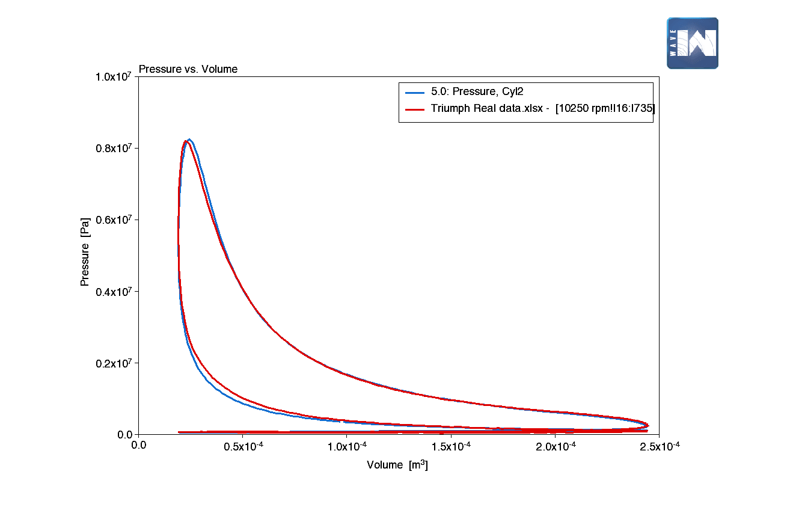
Figure 16: 10250 RPM correct valve timing
As seen in the above charts, the PV trace is becoming closer to the Triumph model, suggested adjustments at this point would be alteration to the air/fuel ratio and also alteration of the THB50 location to adjust ignition timing. (MDPI, 2019) This appeared to yield favourable results, with a <1% difference in cylinder pressure and sensible figures for power at this RPM range at approx. 77Kw or 103 hp .
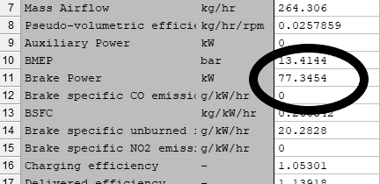
Figure 17: Power figures from 10250 RPM
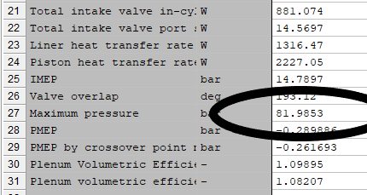
Figure 18: Cylinder pressure within 1% of real Triumph data
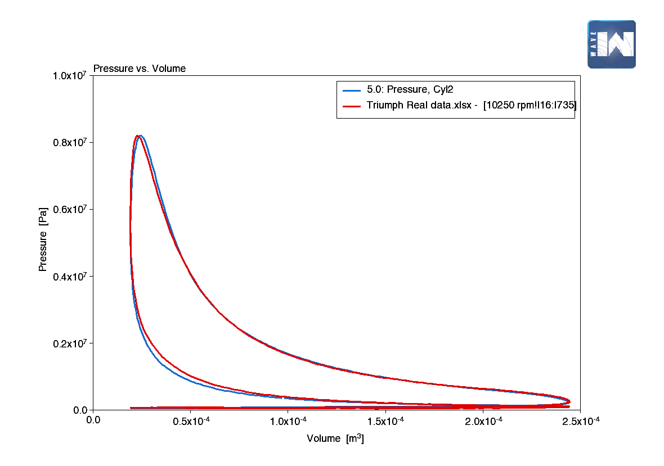
Figure 19: PV diagram showing closest fit found to Triumph real data
Following modification to model inputs, the PV traces proved to be a useful tool to validate the model, figures fell within specification from real data and suggested that procedures taken have been effective.

13000 RPM:

To validate the 13000 RPM model, the same steps were taken, although the valve timing has remained set as before, as this is a geometry condition of this particular engine. Subsequently, modifications to the air/fuel ratio and adjustment of ignition timing via THB 50 values may suggest favourable results. Using calculated MFB data the values for burn duration and THB 50 have been input to the constants and a series of runs undertaken, this yielded the following charts:
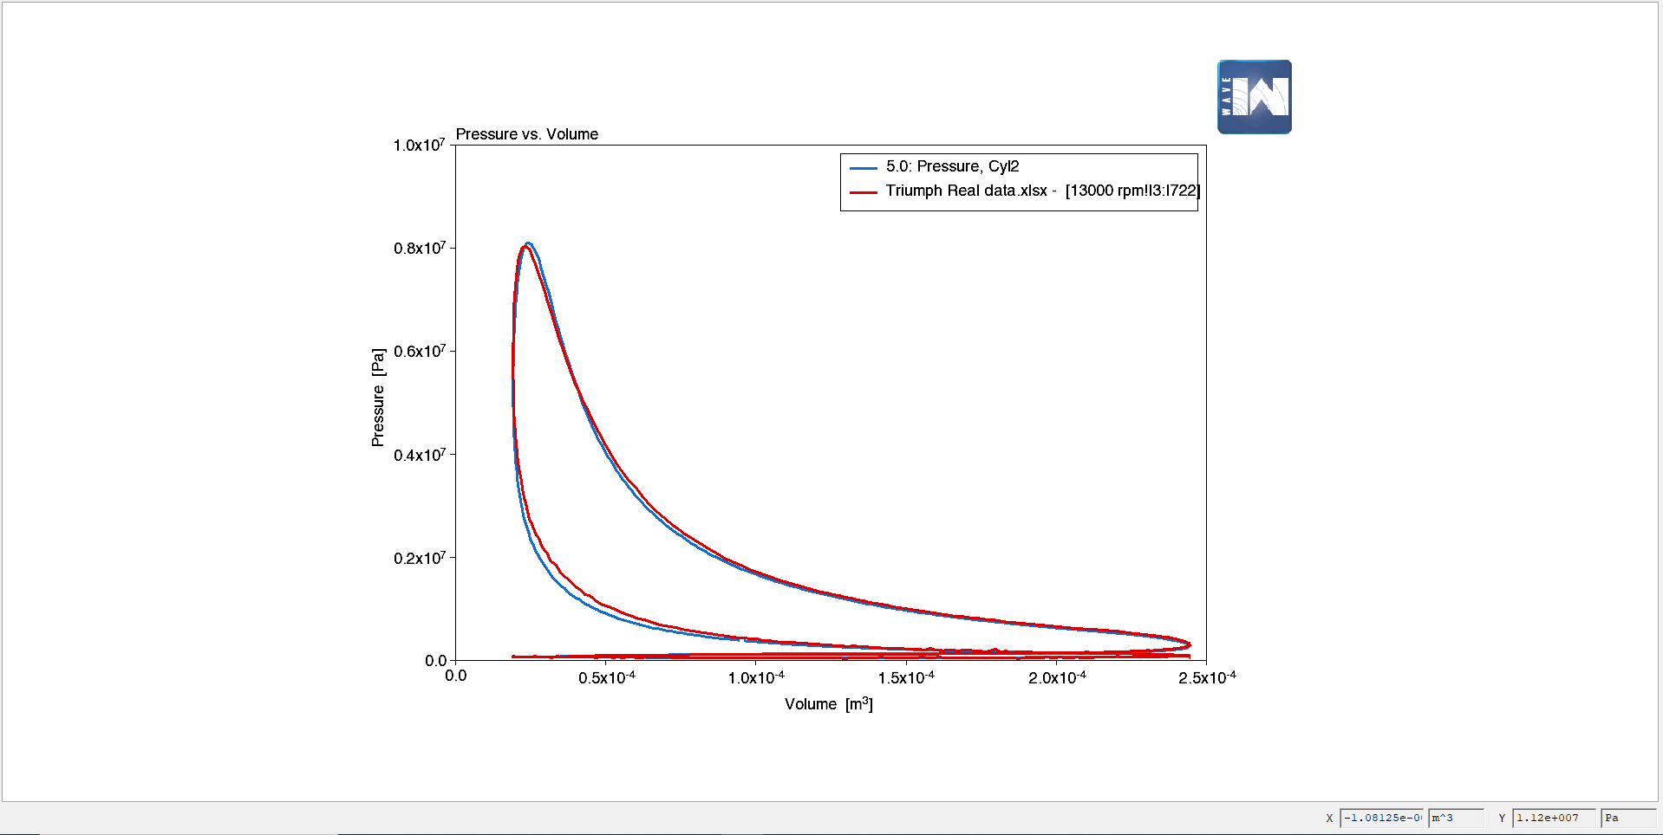
Figure 20: 13000 RPM run 1
Figure 21:13000 RPM run 1 constants table
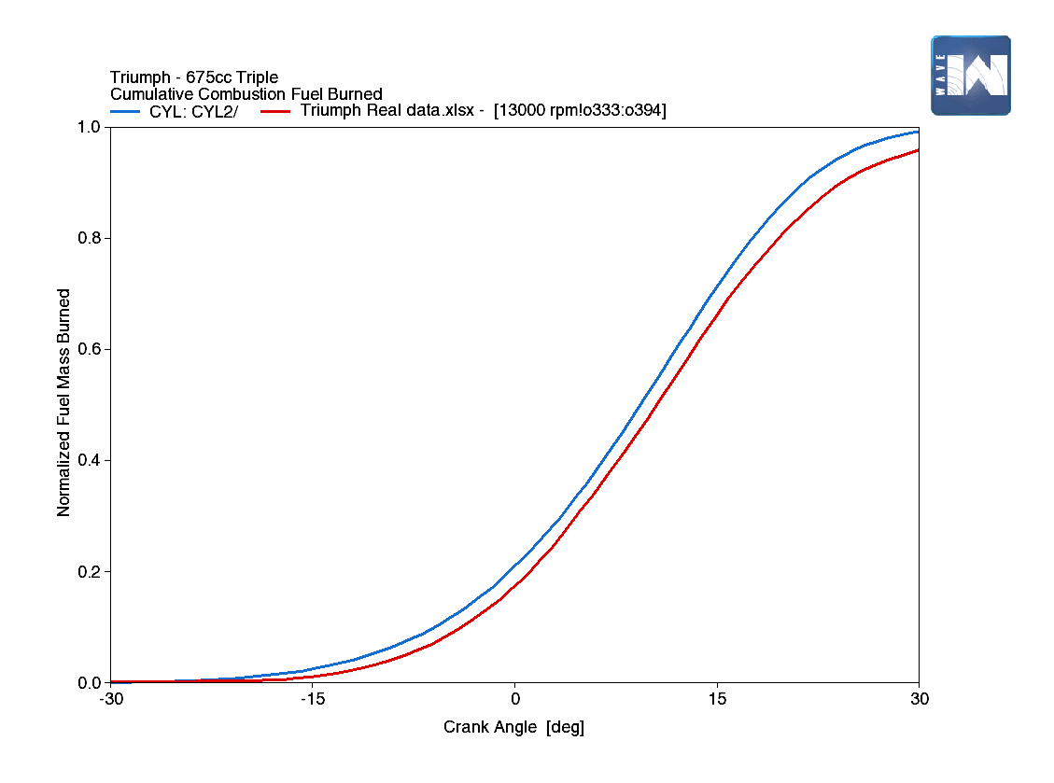
Figure 22: Wiebe curve from 13000 RPM run 1 where ignition timing is incorrectly set
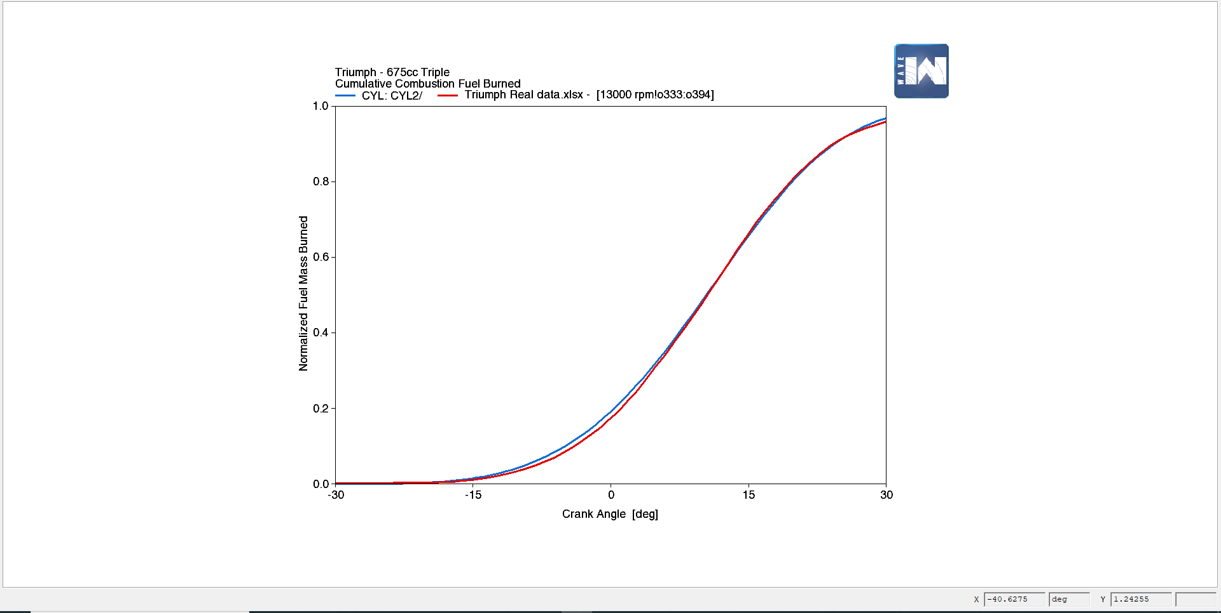
Figure 23: Adjusted Wiebe curve illustrating correct ignition timing
As can be seen from the above charts, traces are almost in line with the real data, minor adjustments to AFR and THB 50 should yield desired results.
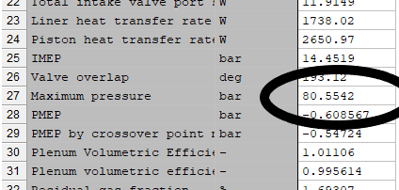
Further enrichment of mixture and advance on ignition timing by approx. 1.5˚ did appear to produce a valid model, (MDPI, 2019) whereby cylinder pressures and power figures fell within 2-3% of manufacturer quoted, thus proving the validation model for the selected RPM range. The following charts display correct power and pressure figures for the 13000 RPM range. Peak torque at 13000 RPM was calculated to be approx 71Nm also which is within 5% of quoted.
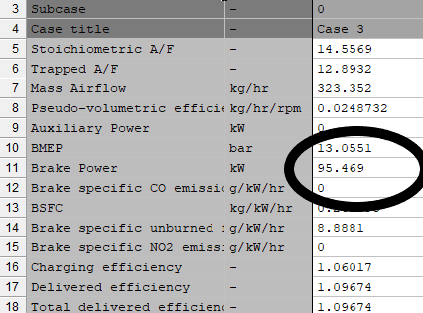
Figure 24: Power and pressure figures from corrected Wiebe and enrichment of AFR.

14400 RPM:

To validate the 14400 RPM model, further timing advance and AFR adjustments were made to the model, as this rev range appeared to be at the rev. limit of the engine, expected figures for power and torque should appear to be lower than those at 13000 RPM as the motorcycle is quoted as making its peak power at 12600 RPM.
Analysis taken from runs with fuelling and timing adjustments carried out do follow this trend. In this range the timing has been advanced by a degree at a time until the desired results have been achieved, at 5 degrees further advance, the PV diagrams began to follow trends towards calculated cylinder pressure. Power and torque appear as expected also with a noticeable reduction, possibly due to friction at high engine speeds and lower volumetric efficiency in the cylinder.
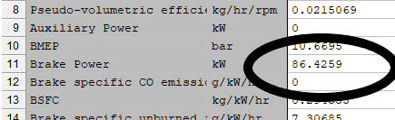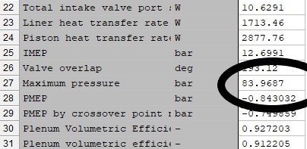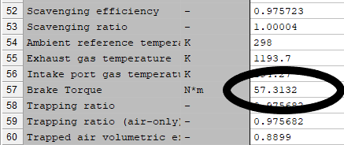
Figure 25: Data tables showing generated Power, torque and pressure figures for 14400 RPM
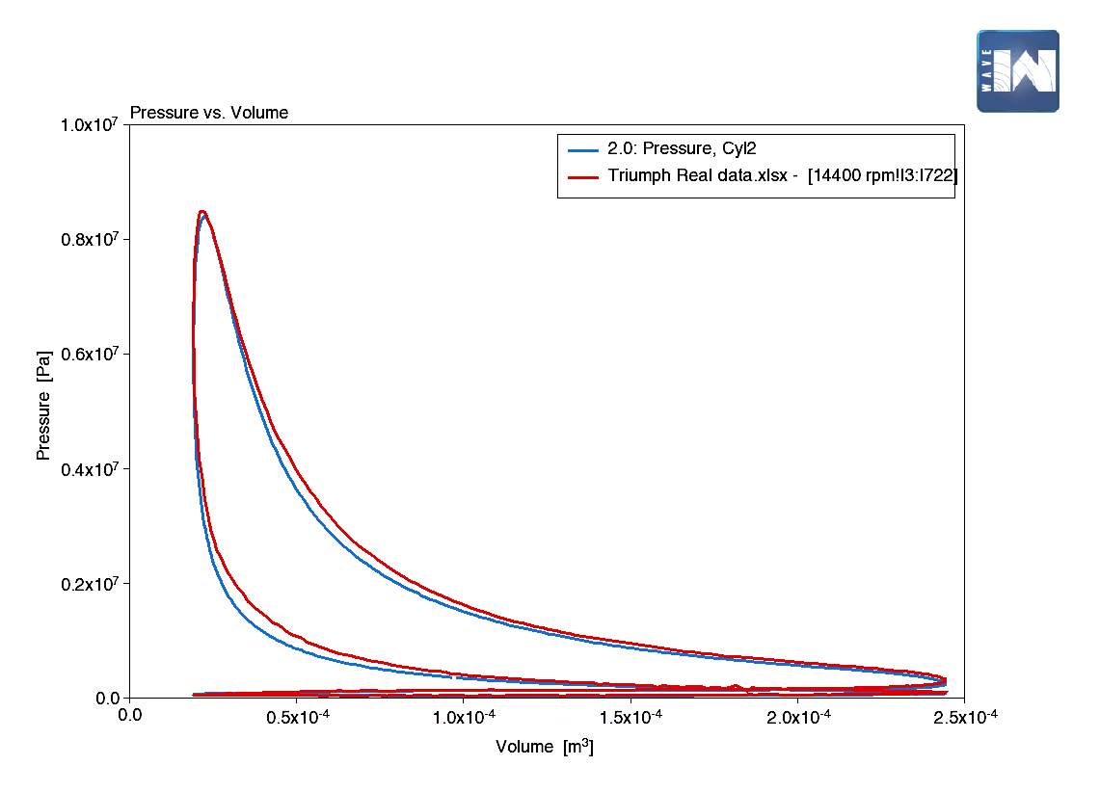
Figure 26: Chart showing correct pressures and pumping loop.
In the above chart it can be seen that although pressure and power figures fall within an expected range, the compression and expansion areas in combustion cannot be matched up, adjustment of fuelling and burn duration was found to remedy this situation, but had an adverse effect on other parts of the cycle. This unfortunately doesn’t validate the model in this respect, possible changes to camshaft profile or duration would allow for operation of the engine at higher speeds where power gains may be made.

Discussion:

Upon completion of the assignment, there are a number of areas where improvements could have been made to further enhance the validation model, for example, data pertaining to ignition advance curves and general engine timing may have yielded more positive results.
Although the validity of the data has been verified from a power and pressure standpoint, the real-world characteristics of the engine are not entirely apparent from the model. If possible an interactive code to produce timing advance curves and possibly the inclusion of variable valve timing could have resulted in a more robust model being generated, more in line with modern engine technology.
Another point to mention, is that following the curve fitting exercise to find the Wiebe exponents, the values found did not allow for an accurate calculation when implemented in the model. Experimentation had to be carried out in order to find the correct exponent in order to satisfy the Wiebe function through curve comparison using Excel. This may be as a result of a coarse curve fit from MatLab or slightly incorrect application of the equation given, as the values found to satisfy the function were within a reasonable margin of error.

Conclusion:

To conclude, the assignment can be deemed successful, in the sense that a working engine model has been produced from first principle data and through a number of reverse engineering processes has yielded results within a 5% margin of error from quoted.
As spoken about previously, there are areas where improvements could be made by the student, but also areas where the software could be improved in order to allow for easier data input for the user, particularly for generating required charts for analysis.
To the contrary, the power of the software is undisputed and it is an extremely useful tool in predicting engine behaviour and in 2-zone form predicting emission outputs also, this is invaluable for the ICE’s longevity in today’s ever-increasingly, environmentally conscious consumer market, as a cost saving tool and to overcome governmental sanctions imposed by high polluting vehicles on vehicle manufacturers.

Bibliography
Colorado State University. (2020, 1 24). Finite heat release with heat transfer. Retrieved from Colorado State University Thermodynamics: https://www.engr.colostate.edu/~allan/thermo/page8/page8.html
Heywood, J. B. (2018). Internal combustion engine fundamentals. Cambridge, Ma: McGraw Hill education.
MDPI. (2019). Investigation of burn duration and NO emission in lean mixture with CNG and gasoline. MDPI, 12.
Merker, G. P. (2006). Simulating Combustion, simulation of combustion and pollutant formation for engine development. Berlin, New York: Springer.
Triumph Group. (2008). Triumph Daytona 675 service manual. London: Haynes.

Appendix:


