 Alexander’s Encyclopaedia of Chinese Religion 
Personal-Cultivational Modalities of Religion:
The Eight Pieces of Brocade(八段錦bāduànjǐn)
Background
The eight pieces of brocade (bāduànjǐn)(八段錦) is a style of qìgōng (气功) which was developed during the Southern Song Dynasty (1127-1279) by a martial artist named Marshal Yue Fei who derived this technique from traditional Chinese medicine as a method of improving health within the military (Yang, 1997, pp. XII-XV & 11-14). The word brocade (jǐn)(錦) is taken from a piece of beautiful shinning silk cloth as a metaphor for one own body which will be radiant due to the health benefits the qì energy grants if you practice this technique (Yang, 1997, p. XV). Qì(气) is the vital energy pervading the human body and universe (Sommer, 1995, p. 370). Whilst the word Gōng(功) can be comprehended as merit or skill (Ling, 2002, p. 672). Qìgōng can be classified as a Taoist personal cultivational practice of manipulating qì for the benefit of the human body, mind (yì)(意) and spirit (shén)(神)(Yang, 1997).
Physical-Practice
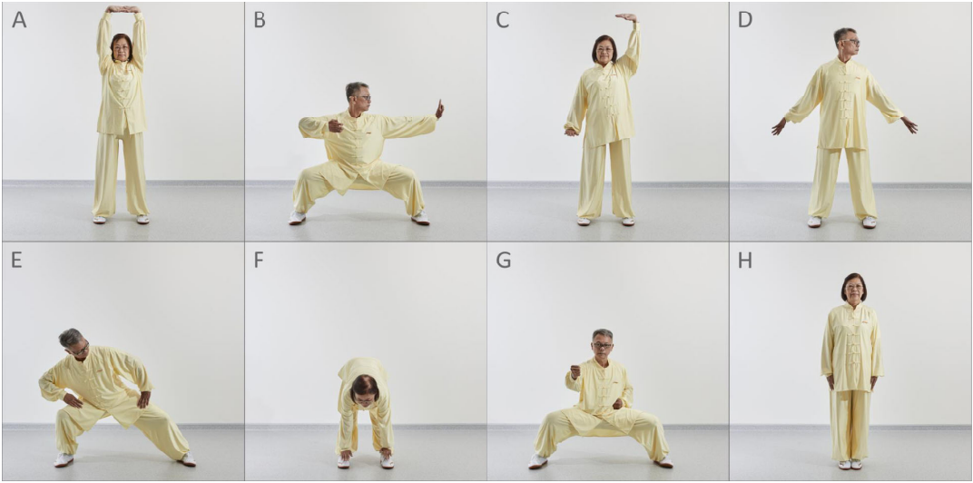
Figure 1.] Displays the Eight Movements of Standing Bāduànjǐn (Liu et al., 2020, p. 4).
The eight movements and their functions are listed below:
A.) Two Hands Holding up to the Heavens: Regulate the sān jiāo (三焦)(Triple-Burner)
B.) Drawing a Bow to Shoot a Hawk: Regulate Kidneys and Waist
C.) Rocking the Qì Channels Alive: Regulate Spleen and Stomach.
D.) Turning Head Looking Back: Regulate Emotions
E.) Sway the Head and Shake the Tail: Ease the Xīn Huǒ (心火)(Hearts Fire).
F.) Two Hands Holding Feet: Strengthen Muscles and Bones
G.) Clench Fists with Fiery Eyes: Increase Qì
H.) Raising up on Toes: Eliminates Illnesses
(Yang, 1997, pp. 56-76).
Modalities of Religious Behaviour
Adam Yuet Chau (2019, pp. 25-31) outlines five modalities of “doing” religion: discursive/scriptural, personal cultivational, liturgical, immediate practical and relational. These modalities were created as an attempt to get around the inability to conceptualise religious categorisations such as Taoism (dào jiào)(道教)(Chau, 2019, pp. 25-26). Thus, bypassing the non-applicability of the term religion (zōng jiào)(宗教) to China and the impossibility of placing individual practice within a particular framework due to overlap between religious spheres (Hedges, 2010, p. 46)(Hedges, 2021).
Bāduànjǐn meets Chau’s (2019, p. 27) criterion of a personal cultivational modality of doing religion with the long-term goal of cultivation of the yì, body and shén within this lifetime and future cycles of reincarnation. Chau’s (2019, p. 27) approach may better classify bāduànjǐn than the phrase Taoists as whilst practiced by Taoist to reach immortality (xiān)(仙) or enlightenment may also be practiced by Buddhists to reach Buddhahood or Nirvana, though ancient definitions of immortality may be better described today as higher levels of consciousness (Yang, 1997, p. 21)(Kohn, 2006, pp. 205-210).

There are no deities, gods or ancestors involved in this practice, hence bāduànjǐn is not relational. This practice is only relational between the human body and the universe (Shan, 2014, p. 85) achieving mystical communion and creating cosmological attunement (Kohn, 2006, pp. 209-210). However, occasionally within ancient folklore you may find internal energies personified as body Gods (Kohn, 2006, p. 208). It does not involve worship or prayer hence is not liturgical. Results are not instant, magical or God given, therefore it cannot be classified as an immediate practical modality. One must work for to gain this merit, hence the phonetical and etymological connection of the word gōng(功) with (gōng)(工) indicating work (Wieger, 1965, p. 212).
Whilst this practice is not theological, it contains a discursive/scriptural element. The first account of bāduànjǐn was given within the Yíjiānzhì (夷坚志) by Hong Mai and more so formed an illustrated instruction manual than a philosophical doctrine (Kohn, 1989, pp. 348). However, alternative ancient variants of (seated) bāduànjǐn trace to the eighth-century Taoist cannon Xiūzhēnshíshū (修真十书) and is attributed to one of the immortals of Chinese folklore (Kohn, 2006, p. 208).
Meditation
Bāduànjǐn was developed as an extension of sitting mediation (Wang, 2019, pp. 179-180). This is yet another personal cultivation method expressed by Chau (2019, p. 27) practiced for attaining xiān (Kohn, 1989, p. 126). The aim of bāduànjǐn was to create a new method of cultivation using mindfulness and breathing techniques incorporated with the yin(阴) and yang(阳) principles of stillness and motion which simultaneously strengthens the body by boosting the circulation of blood and qì which otherwise stagnate during long periods of sitting (Wang, 2019, pp. 179-180).
Spiritual Cultivation
Bāduànjǐn is an external alchemy (wàidān)(内丹) practice in which the body movements, the breath and the yì are used to increase qì circulation through the meridians and the three elixir-fields (dāntián)(丹田) nourishing bodily organs, calming the yì, maintaining jīng(精)(essence) and enlivening the shén (Yang, 1997, pp. 21-45). This practice is combined with internal alchemy (Nèidān)(外丹) at the highest levels of practice to attain enlightenment, the practice of nèidān entails moving the qì using only the yì, hence an internal practice (Yang, 1997, pp. 22-23).
Nèidān intersects the discursive/scriptural modality through texts which trace back to the Jin (266–420 AD) and Wei (386-534 AD) dynasties (Shan, 2014, pp. 83-86) and through the tradition of secret esoteric teachings (Yang, 1997, p. 23). Whilst the personal cultivational component of Nèidān is associated with the supplementary religious practices of abstinence, isolated retreats (Yang, 1997, p. 23) and moral examination of self through Buddhist precepts and Confucian ethics (Kohn, 1989, p. 152).
Modern Research
Within clinical trials bāduànjǐn has been found to enhance positive moods and cognitive performance of young individuals (Chen et al., 2017) with similar effects found for (sitting) bāduànjǐn within the elderly populous increasing cognitive and motor functions (Bao et al., 2019). As well as proving beneficial for health conditions including asthma, indigestion, neurasthenia and osteoarthritis (Koh, 1982). This research investigates modern non-religious practices of bāduànjǐn as a secular exorcize for health, vitality and longevity (Kohn, 2006, p. 205) as well as for social and community well-being (Cheng, 2015). Whilst it is natural for Chinese religions to overlap with social spheres (Hedges, 2021) approached from a modern or westernised perspective the aims of bāduànjǐn exclude xiān however, still meets the criteria of a personal cultivational modality of religion in terms of the Confucian aim of becoming a Jūnzi(君子) “virtuous man” due to the psychological benefits.

Word count (1096)

References

Bao, X., Qiu, Q., Shao, Y. J., Quiben, M. and Liu, H. (2019) Effect of sitting ba-duan-jin exercises on balance and quality of life among older adults. Rehabilitation Nursing, 45(5), p. 1.
Chau, A. (2019) Religion in China: ties that bind. Cambridge: Polity Press.
Chen, T., Yue, G. H., Tian, Y. and Jiang, C. (2017) Baduanjin mind-body intervention improves the executive control function. Frontiers in Psychology, 7(1).
Cheng, F., K. (2015) Effects of Baduanjin on mental health: A comprehensive review. journal of bodywork and movement therapies, [online] 19(1), pp. 138–149. Available at: https://www.sciencedirect.com/science/article/pii/S1360859214001879 [Accessed 23 May 2020].
Hedges, P. (2010) Chapter 2: China. In: Religion in everyday life and culture: Religion in the practice of daily life in world history volume 1. Oxford: Praeger.
Hedges, P. (2021) Understanding religion: theories and methods for studying religiously diverse societies. California: University of California Press.
Koh, T. C. (1982) Baduanjin - an ancient Chinese exercise. The American Journal of Chinese Medicine, 10, pp. 14–21.
Kohn, L. (1989) Taoist meditation and longevity techniques. Michigan: Center for Chinese Studies University Of Michigan.
Kohn, L. (2006) Daoist body cultivation: traditional models and contemporary practices. Magdalena: Three Pines Press.
Ling, Y. (2002) The contemporary Chinese dictionary: Chinese-English edition. Beijing: Foreign Language Teaching and Research Press.
Liu, X., Seah, J. W. T., Pang, B. W. J., Tsao, M. A., Gu, F., Ng, W. C., Tay, J. Y. R., Ng, T. P. and Wee, S. L. (2020) A single-arm feasibility study of community-delivered baduanjin (qigong practice of the eight brocades) training for frail older adults. Pilot and Feasibility Studies, 6(1).
Shan, C. (2014). Major aspects of Chinese religion and philosophy Dao of inner saint and outer king. Berlin: Springer.
Sommer, D. (1995) Chinese religion: anthology of sources. Oxford: Oxford University Press.
Wang, Y. (2019) Climbing the steps to Qingcheng mountain: a practical guide to the path of Daoist meditation and qigong. London: Jessica Kingsley Publishers.
Wieger (1965) Chinese characters; their origin, etymology, history, classification and signification. New York: Paragon Book Reprint Corp.
Yang, J. (1997) Eight simple qigong exercises for health: The eight pieces of brocade. Massachusetts: YMAA Publication Center.



