Introduction to Public Health

Name: Carona Ottey
Student number: 1918348
Module code: LCHS4008
Lecturer name: Mumtaz Goolam
Assignment title: Assessment 2 – Report on a Health Issue

Introduction

There are two different types of diabetes type 1 and type 2. According to NHS (2025), type 2 diabetes is a popular disease where your body cannot produce a sufficient hormone called insulin, or the insulin it creates does not work correctly. Type 2 diabetes is determined with a blood test that checks how high your glucose level is. These are some of the signs of type 2 diabetes: repeated infection, tingling or numbness, poor vision and slow-healing cuts or wounds (Salem, 2022). However, the most common signs of type 2 diabetes include extreme fatigue, frequent urination, constant thirst, and unexplained weight loss. According to Public Health England (2018), an estimated 422 million adults are living with diabetes globally. Data also shows almost 4.6 million people in the UK live with diabetes diagnoses, and 1.3 million live with type two diabetes who are yet to be diagnosed. The report aims to outline the key aspects of type 2 diabetes and the factors that affect community and health services.

Every year, complications resulting from diabetes cost the UK health system £6.2 billion indicating the severity of the disease as well as a timely requirement for effective care and treatment of individuals who have been diagnosed with diabetes. According to Diabetes UK 2024, with correct treatment and resources, people can manage their diabetes very well and have a high quality of life. On the other hand, poor care can lead to serious health problems. Every seven days, diabetes is associated with about 2,990 new diagnoses of heart failure, more than 930 strokes, approximately 660 heart attacks and 184 amputations. Obesity raises the risk of type 2 diabetes and heart disease, harms bone health and fertility, and increases the likelihood of certain cancers while impairing sleep and mobility, reducing overall quality of life. Currently £4.4 billion is spent on crucial diabetes care services. Funding is for a range of services including diagnostic, general practitioner, nurse consultations, eye examinations, laboratory tests, medication provision, support programs and specialised care teams for people with diabetes. It was noted that research indicates a potential significant role for funding through enablement to help reduce the economic burden of complications attributable to this illness, which are highly disproportionate and represent around 60% of overall diabetes-related spend in the NHS (Diabetes UK, 2024).

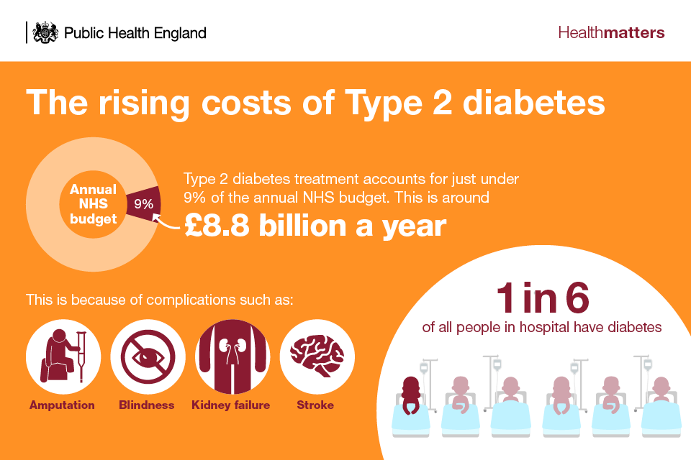

This infographic shows rising costs of type 2 diabetes is overwhelming the NHS. This costs the NHS 9% of their annual budget, which 80% of the direct costs are connected to the difficulties of type 2 diabetes (Public Health England, 2018).

People living in the poorest households are 2.3 times more likely to be diagnosed with type 2 diabetes than those in wealthiest homes. According to Parliament UK 2023, South Asian immigrants who are from India, Pakistan, or Bangladesh are more likely to developed type 2 diabetes in adulthood, this is two to four times higher than for White Europeans. The risk for people in Black African and Black Caribbean populations is 1.5 to 3 times that of their White European peers. Also, adults of working age are less likely to have higher than average income from employment, due to lower job opportunities within certain Asian and Black populations compared with White peers. Currently, 20% of the population in UK faces food insecurity, causing both mental and physical health problems. However, research shows that poverty and social inequality induce people to seek high-calorie foodstuffs. Stress and an uncertain future increase the push towards calorific foods. As a result, people on low incomes are forced to take more calories for their money often purchasing ultra-processed items that contribute no nutritive value at all (Parliament UK, 2023). The likelihood of someone in a low-income environment developing type 2 diabetes is significantly greater, even after adjustment for such factors as Body Mass Index (BMI).
From earliest adulthood, people in Black African, African Caribbean and South Asian groups are significantly more at risk of developing type 2 diabetes at age 25, which is markedly earlier than their White peers who do not tend to see such an increased risk until around 40 years. Although the causes of this variation are not yet clear, adopting healthier habits may reduce your risk.
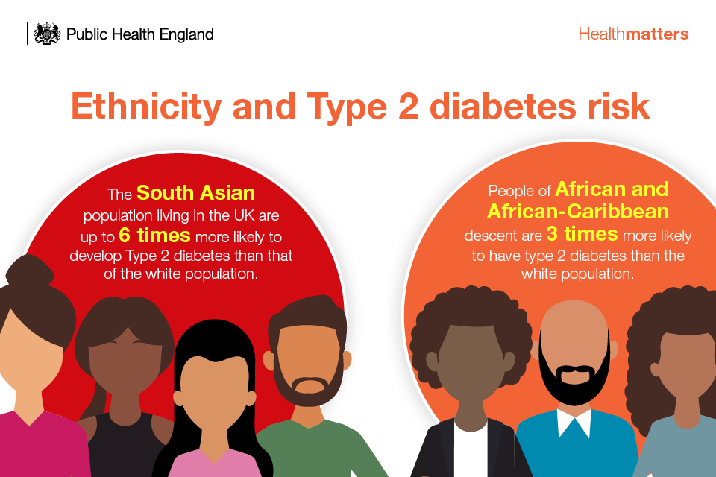
The above infographic explained the link between ethnicity and Type 2 diabetes risk in the UK. The illustration shows the high risk of type 2 diabetes in different ethnicities, where South Asian populations are 6 times more likely to develop type 2 diabetes and African and African-Caribbean populations are 3 times more likely than the White population (Public Health England, 2018).
Family plays a key role in help managing diabetes when a family member has been diagnosed with type 2 diabetes. It is difficult and complicated with everchanging requirements of family members. However, relatives may find themselves feeling it is up to them to sensibly intervene in their diabetic family member's care. This includes appointments, help taking medications, supportive, planned diet, activities etc (Grabowski et al., 2017). The diagnosis of Type 2 diabetes can seriously affect an individual's social relationships and quality of life, and this in turn has an influence on their mental health. Research indicates that those who have the Type 2 diabetic condition are more likely to suffer from depression than people without such a diagnosis. This mental problem, along with all the various complications arising out of Type 2 diabetes, increases an individual risk of premature death (Public Health England, 2018). There are more mental health and quality of life problems though, Type 2 diabetes produce a situation with significant social overtones influences, family relations as well educational opportunity and job options available to those in its grip. Although these issues have been commonly ignored by the health research field their broad causes are just as important for public health and clinical health outcomes.
An important part of managing diabetes is getting an early diagnosis. It can worsen things hugely for people if the diagnosis or treatment of actual illness is delayed. Therefore, primary healthcare facilities need to make rapid screening for essential diagnostic tools such as blood glucose testing a priority in their repertoire of services. In addition, there may be ongoing management or treatment for complications from specialists. Cost-effective interventions of various kinds can benefit patient outcomes across all types of diabetes. This includes such steps as keeping blood sugar levels stable by using a balanced diet and increasing physical activities controlling blood pressure and lipid levels to lessen cardiovascular risks and doing routine checks for potential harm to the eyes, kidneys or feet to intervene promptly (WHO, 2023). According to Diabetes UK 2023, People with type 2 diabetes who are managing their condition should consider the following advice, which can help them keep their blood sugar levels in check such as, have a healthy diet and increase physical activity, lose weight, use insulin in conjunction with other drugs that help with lowering blood sugar, think about surgery to lose weight, get help for mental health etc.

For those managing type 2 diabetes, the use of either a flash glucose monitor, or a continuous glucose monitor can make managing blood sugar levels easier. Compared to daily finger-sticks, this technology requires less frequent monitoring but not everyone has access to it. It is advisable to check NHS eligibility for these monitoring devices before going down that route. Type one diabetes is still an unpreventable condition, no matter how hard one tries. On the other hand, strategies have been proved to prevent type 2 diabetes and reduce the associated complications and early death rates of all types of diabetes (Diabetes UK, 2023). These strategies involve policies and practices that require action from the entire population at large as well as workplaces, schools and other specific parts of an environment. They consist of certain elements including engaging in regular physical exercise, eating a healthy diet, giving up smoking and managing blood pressure and lipid levels properly.

Conclusion
Type 2 diabetes, a common disorder, is characterised by the body's insufficient production of insulin, or by its inability to use it effectively. Classic symptoms for this condition include chronic tiredness, increased urination, unquenchable thirst, and mysterious weight loss. The rising costs of type two diabetes are overwhelming the NHS, costing the NHS 9% of their annual budget, with 80% of direct costs connected to the disease. The UK health system spends £6.2 billion annually on complications resulting from diabetes, indicating the severity of the disease and the need for effective care and treatment. Currently, £4.4 billion is spent on crucial diabetes care services, including diagnostic, general practitioner and nurse consultations, eye examinations, laboratory tests, medication provision, dispensing fees, diagnostic technologies, diabetes management tools, education and support programs, and specialized care teams. People living in the poorest households are 2.3 times more likely to be diagnosed with type 2 diabetes than those in wealthiest homes. South Asian immigrants, Black African and Black Caribbean populations, and adults of working age are less likely to have higher than average income from employment due to lower job opportunities within certain Asian and Black populations. Food insecurity affects 20% of the UK population, leading to mental and physical health problems. Family plays a crucial role in managing diabetes, as it can be difficult and complicated with ever-changing requirements of family members. Early diagnosis is essential for managing diabetes, and primary healthcare facilities should prioritize rapid screening for essential diagnostic tools like blood glucose testing. Cost-effective interventions, such as maintaining blood sugar levels through a balanced diet, increasing physical activity, losing weight, using insulin with other drugs, considering surgery, and seeking help for mental health, can help manage blood sugar levels.

References
- Diabetes UK (2023). How Many People in the UK Have diabetes? [online] Diabetes UK. Available at: https://www.diabetes.org.uk/about-us/about-the-charity/our-strategy/statistics. [Accessed 20 Oct 2025]

- Diabetes UK (2024). Cost of Devastating Complications Highlights Urgent Need to Transform Diabetes Care in the UK. [online] Diabetes UK. Available at: https://www.diabetes.org.uk/about-us/news-and-views/cost-complications-highlights-urgent-need-transform-diabetes. [Accessed 22 Oct 2025]

- Diabetes UK (2023). Type 2 diabetes treatments. [online] Diabetes UK. Available at: https://www.diabetes.org.uk/about-diabetes/type-2-diabetes/treatments. [Accessed 21 Oct 2025]

- Grabowski, D., Andersen, T.H., Varming, A., Ommundsen, C. and Willaing, I. (2017). Involvement of family members in life with type 2 diabetes: Six interconnected problem domains of significance for family health identity and healthcare authenticity. SAGE Open Medicine, 5, p.205031211772865. doi:https://doi.org/10.1177/2050312117728654. [Accessed 20 Oct 2025]

- National Health Service (2025). What is type 2 diabetes? [online] NHS. Available at: https://www.nhs.uk/conditions/type-2-diabetes/what-is-type-2-diabetes/. [Accessed 21 Oct 2025]

- National Health Service (2025). Symptoms - type 2 diabetes. [online] NHS. Available at: https://www.nhs.uk/conditions/type-2-diabetes/symptoms/. [Accessed 20 Oct 2025]

- Public Health England (2018). Health matters: Preventing Type 2 Diabetes. [online] GOV.UK. Available at: https://www.gov.uk/government/publications/health-matters-preventing-type-2-diabetes/health-matters-preventing-type-2-diabetes. [Accessed 22 Oct 2025]

- Parliament.uk. (2023). Available at: https://committees.parliament.uk/writtenevidence/129467/html/. [Accessed 21 Oct 2025]

- Public Health England (2018). Health matters: Preventing Type 2 Diabetes. [online] GOV.UK. Available at: https://www.gov.uk/government/publications/health-matters-preventing-type-2-diabetes/health-matters-preventing-type-2-diabetes. [Accessed 20 Oct 2025]

- Salem, J. (2022). 10 Early Signs of Diabetes that Shouldn’t be Ignored | Summa Health. [online] www.summahealth.org. Available at: https://www.summahealth.org/flourish/entries/2022/01/10-early-signs-of-diabetes-that-shouldnt-be-ignored. [Accessed 22 Oct 2025]

- WORLD HEALTH ORGANIZATION (2023). Diabetes. [online] www.who.int. Available at: https://www.who.int/health-topics/diabetes#tab=tab_3. [Accessed 22 Oct 2025]

