

Program : MSC Data and Artificial Intelligence
Student ID : 2418784
Student Name: SADANAND TANNERU
Module Code : ACCA7028
Module : Data Security, Governance and Compliance
Lecturer : Muhammad Azeem Abbas

Abstract
In this report, the design and execution of an integrated Information Security Framework and Governance Approach of NatureGreen (NG) is analysed, which is a global health and wellness organisation that depends primarily on cloud and wireless technologies. Ng has increased cyber security issues as a result of the implementation of the BYOD policies, regulatory compliance requirements, and lack of an official information security governance system.
The report considers internationally recognised standards, such as ISO/IEC 27001, NIST Cybersecurity Framework (CSF), ITIL 4, COBIT, and Zero Trust Architecture and assesses their applicability to the context of NG. According to this literature, a detailed governance and security model is suggested and it includes risk management, policy development, alignment of compliance and technical controls.
The proposed solution is meant to promote data confidentiality, integrity and availability, business continuity and compliance with regulatory requirements. The report ends by discussing the need to continuously revise standards of security and governance structures to be resistant to any new technological and cyber threats.

Contents
Abstract 2
1. Introduction 6
1.1 Problem Statement: 6
1.2 Purpose and Objectives: 6
1.3 Scope and Structure: 6
2. Literature Review: Security Frameworks and Models 7
2.1 Introduction to Information Security Frameworks 7
2.2 ISO/IEC 27001 – Information Security Management System (ISMS) 7
2.3 NIST Cybersecurity Framework (CSF) 8
2.4 ITIL 4 – Information Technology Infrastructure Library 9
2.5 COBIT – Governance and Management of Enterprise IT 9
2.6 Zero Trust Architecture (ZTA) 10
2.7 Comparative Analysis of Frameworks 10
2.8 Integrated Framework Approach 12
2.9 Scholarly Perspectives 13
3. Application: Design of Security, Governance and Compliance Approach for NG 13
3.1 Assumptions and Context 13
3.2 Proposed Governance Structure 13
2.3 Security Policy Framework 14
3.4 Risk Management Approach 15
Step 1 – Risk Identification 15
Step 2 – Risk Assessment: 15
Step 3 – Risk Treatment: 16
Step 4 – Monitoring & Review: 16
3.5 Service Level Agreements (SLAs) and ITIL Integration 16
3.5 Compliance Strategy 16
3.6 Technical and Operational Controls 17
3.7 Integration with ITIL, ISO 27001, and NIST CSF 17
3.8 Training, Awareness, and Cultural Developmen 19
3.9 Implementation Roadmap 19
3.10 Summary of Section 20
4. Discussion (Importance of Continuous Regulation and Standards Update) 20
4.1 The Dynamic Nature of Cybersecurity Threats 20
4.2 Evolution of Standards and Frameworks 21
4.3 Benefits of Continuous Standards Update 21
4.4 Challenges and Considerations 22
4.5 Summary of Discussion 22
5. Conclusion 22
References 24

Figure 1: PDCA Loop (Yin, 2024) 7
Figure 2: NIST Cybersecurity Framework (CSF) National Institute of Standards and Technology. (n.d.) 8
Figure 3: Zero Trust Access Flow 9
Figure 4 Integrated Information Security Governance Model 10
Figure 5: Integrated Governance Model for NatureGreen 15
Figure 6: Gantt chart 16

Table 1: Comparative Analysis of Frameworks 11
Table 2: Proposed Governance Structure 13
Table 3: Security Policy Framework 13
Table 4: Risk Assessment: 14
Table 5: Service Level Agreements (SLAs) and ITIL Integration 14
Table 6: Integration with ITIL, ISO 27001, and NIST CSF 15
Table 7: Implementation Roadmap 17

Introduction
With modern digital economy, organizations are becoming more and more dependent on connected networks and cloud-based infrastructures in order to facilitate international activities. Although they provide flexibility and scalability, these technologies create new serious cybersecurity and compliance issues. In the case of international organizations such as NatureGreen (NG) which manufactures and markets health and wellness products, the protection of data integrity and maintenance of governance of various digital platforms is a strategic and operational priority.
NG is presently served by a huge wireless network and cloud services and about 95% of their IT ecosystem is hosted by the cloud. The firm is experiencing increased internal and external pressures to allow the use of personal devices to access the company in accordance with the Bring Your Own Device (BYOD) policies. Even though BYOD enhances mobility and staff productivity, these devices expose NG to increased threats of data leakage, identity theft and regulatory failures. Also, NG does not have an in-depth information security governance framework, or formalized security framework, which exposes its digital assets and intellectual property to cyber threats.

1.1 Problem Statement:
Lack of complete security policy and governance structure puts NG at high risks of operational, financial, reputational risks. The company needs to have a systematic way of dealing with security, risk, and compliance in the international business.

1.2 Purpose and Objectives:
This report aims to develop an overall information security and information governance framework at NG by:
- Examination of developed international security frameworks and models;
- Combined with such frameworks to suggest a customized governance and compliance strategy;
- Describing an implementation roadmap containing performance metrics;
- The necessity to constantly revise the security standards is a critical issue to be discussed.

1.3 Scope and Structure:
The literature review of the major frameworks (ISO 27001, NIST CSF, ITIL 4, COBIT and Zero Trust Architecture) is provided in Section 2. Section 3 transfers these frameworks to the environment of NG suggesting a combination of governance and compliance strategy. The fourth section is a rationale of the continuous development of standards and regulations. The fifth section is a conclusion of the report.

2. Literature Review: Security Frameworks and Models

2.1 Introduction to Information Security Frameworks
Information security frameworks offer systematic strategies of safeguarding digital assets, controlling cyber threats, and regulatory compliance (Dalal, 2023). They establish governance frameworks, policies and control systems that can allow organisations to promote confidentiality, integrity and availability ( CIA ) in consistency across processes and systems (Aminzade, 2018). In the case of a global company like NatureGreen (NG), in which the company works with wireless networks and cloud-based infrastructure, these structures are the basis of developing resilience and regulatory confidence.
The report is a critical review of five popular frameworks, including ISO/IEC 27001, NIST Cybersecurity Framework (CSF), ITIL 4, COBIT, and Zero Trust Architecture (ZTA). Each of them is discussed in the context of the purpose, structure, strengths and applicability to the context of NG.

2.2 ISO/IEC 27001 – Information Security Management System (ISMS)
ISO/IEC 27001 is an internationally recognised standard of establishing, implementing, maintaining and continuously improving an Information Security Management System (ISMS) (Ganji et al., 2019). It is risk based and process oriented, where the security controls are suitable to organisational risk (British Standards Institution, n.d.).
The essence of the standard is the CIA triad, which is confidentiality, integrity, and availability, and the Plan-Do-Check-Act (PDCA) loop in the cycle of continuous improvement. Key components include:
- Defining information security objectives and policies.
- Carrying out risk evaluation and management plans.
- Assigning roles and responsibilities towards information security.
- Performance measurement by use of internal auditing and management reviews.
- 93 control measures will be found in Annex A and will be divided into domains which include access control, cryptography, operations security, supplier management, and incident response.
NG relevancy: ISO 27001 would give NG a certifiable system of governance which would guarantee that risks identified in BYOD and cloud will be managed in a systematic manner; through documented policies, controls, and auditing of them.
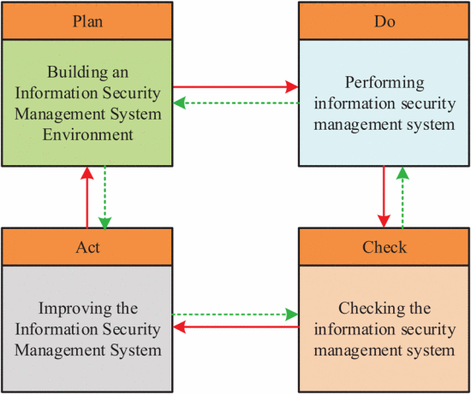
Figure 1: PDCA Loop (Yin, 2024)

2.3 NIST Cybersecurity Framework (CSF)
The NIST CSF is a flexible and non-prescriptive model that has been developed by the U.S. National Institute of Standards and Technology as a way of identifying and managing cybersecurity risks (Wolff, 2024). It divides security operations into five fundamental functions, which include Identify, Protect, Detect, Respond, and Recover and each one is subdivided into categories and subcategories of controls (National Institute of Standards and Technology, n.d.).
The framework promotes organisations to match the cybersecurity priorities to business outcomes, and measure the current versus target maturity state.
NG relevance: The CSF supplements ISO 27001 in operationalising risk management in the cloud and BYOD settings of NG. It helps sustain the on-going evaluation of vulnerabilities, preparedness, and recovery capabilities that are major requirements of a wireless and global distributed organisation.
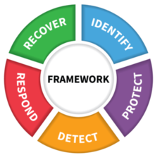
Figure 2: NIST Cybersecurity Framework (CSF) National Institute of Standards and Technology. (n.d.)

2.4 ITIL 4 – Information Technology Infrastructure Library
ITIL 4 is concentrated on the alignment of IT Service Management (ITSM) and organisational strategy and value creation. It presents the Service Value System (SVS) and Service Value Chain that combine the process of governance and continuous improvement with service delivery (Tuomisto, 2022).
Service design and service delivery is linked with the definition of Service Level Agreements (SLAs), the management of risks, and change controlling mechanisms (Salovaara, 2015). The focus of customer value and lifecycle management stipulated in the framework is a guarantee that the IT services are efficient, secure, and resilient.
NG relevance: ITIL 4 offers an avenue of integrating security metrics in the NG service operations- especially in handling uptime, incident response, and service continuity in the NG cloud ecosystem.

2.5 COBIT – Governance and Management of Enterprise IT
The COBIT (Control Objectives of Information and Related Technology) is a governance framework designed by the ISACA that interconnects strategic business goals and IT processes (De Haes et al., 2019). COBIT also differentiates between governance (Evaluate-Direct-Monitor) and management (Plan-Build-Run-Monitor) objectives so that accountability and performance measurement is established throughout the enterprise.
Its principles highlight the value of stakeholders, holistic governance, risk optimisation and resource management. The design of COBIT can be easily integrated with ISO 27001, ITIL and NIST CSF, offering a high level of oversight structure and not technical controls.
NG relevance: In NG, COBIT sets up top-down governance, which means the introduction of such positions as the Chief Information Security Officer (CISO) and driving committees as the main factors of ensuring that business strategy and security performance align.

2.6 Zero Trust Architecture (ZTA)
Zero Trust Architecture formalized in NIST SP 800-207 is based on the philosophy of never trust, always verify (Stafford, 2020). It presupposes the possibility of internal and external network security breach and requires the ongoing authentication, authorization, and monitoring (Palo Alto Networks, n.d.).
Key tenets include:
- Users are granted the permissions required to perform their work (Principle of Least Privilege Access).
- This mode is used to partition networks in order to limit lateral movement (Micro-Segmentation).
- Identity, device health, and context are measured at each access attempt (Continuous Validation).
Relevance to NG: NG can counter the credential theft and insider threats with the help of ZTA that involves the use of multi-factor authentication (MFA), device compliance verification, and behavioural analysis.
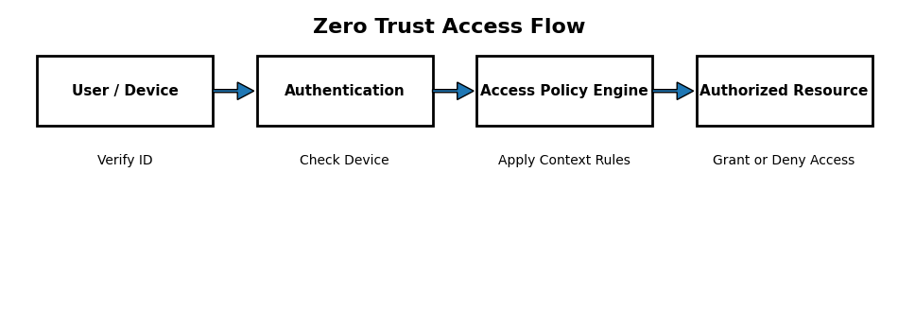
Figure 3: Zero Trust Access Flow

2.7 Comparative Analysis of Frameworks
Framework/Model | Primary Focus | Key Strengths | Limitations | Relevance to NG
ISO/IEC 27001 | Information Security Management System | Globally certifiable; structured risk-based governance; continual improvement | Implementation cost and documentation overhead | Establishes foundational ISMS for governance and compliance
NIST CSF | Cyber Risk Management | Flexible, scalable; aligns with business goals | U.S.-centric origin; requires mapping to other standards | Prioritises cloud/BYOD risk management and resilience
ITIL 4 | IT Service Management | Aligns IT services with business objectives; defines SLAs | Less focus on technical security controls | Embeds security in service delivery and continuity
COBIT 2019 | IT Governance | Strategic alignment, accountability, performance metrics | High-level; needs integration with technical frameworks | Provides executive oversight and compliance tracking
Zero Trust Architecture | Access & Network Security | Identity-centric; adaptive; suitable for cloud/mobile | Implementation complexity; user-experience impact | Secures BYOD and remote access through least-privilege controls
Table 1: Comparative Analysis of Frameworks

2.8 Integrated Framework Approach
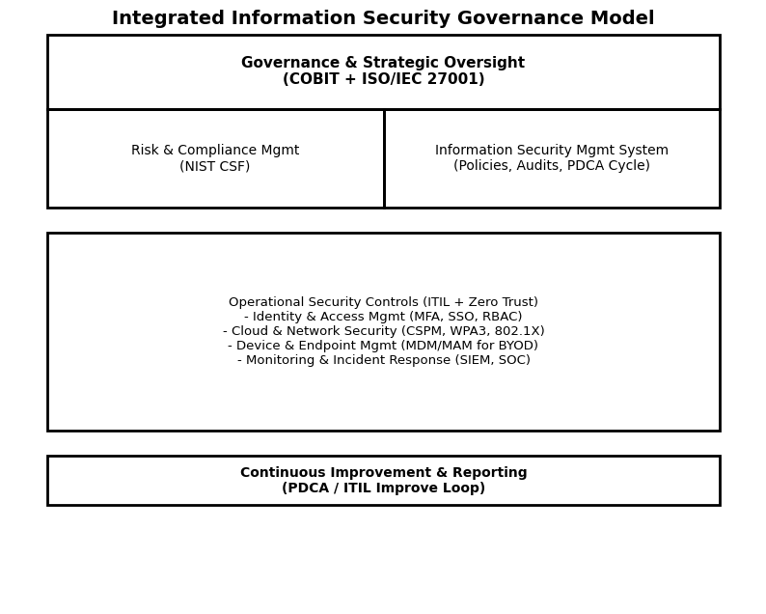
Figure 4 Integrated Information Security Governance Model
Each of these frameworks handles a different information security dimension individually. However, the combination model is more mature and resilient. The integration can be theorized as follows:
- Governance Layer indicates strategic direction, risk appetite and responsibility (COBIT + ISO 27001).
- Operational Layer converts the governance goals into processes, service management, and incident management (ITIL 4 + NIST CSF).
- Technical/ Access Layer (Zero Trust) implements constant checking and network fragmentation.
This hierarchical integration is the creation that governance (COBIT, ISO 27001) defines what and why, operational models (ITIL, NIST) define how, and technical controls (ZTA) provide execution.

2.9 Scholarly Perspectives
The need to integrate frameworks as opposed to being adopted a single model is highlighted in recent studies. Axelsen and Damsgaard (2025) believe that, hybrid governance architectures are more scalable and able to comply with cross-frameworks. Equally, Salihu and Dervishi (2024) emphasize that NIST CSF and ISO 27001 are compatible in the creation of measurable risk-management measurements.
These academic findings promote the implementation of the mixed strategy rather than adopting any single model.

3. Application: Design of Security, Governance and Compliance Approach for NG

3.1 Assumptions and Context
NatureGreen (NG) is a multinational health and wellness organisation with its headquarters in UK and regional offices in North America, Europe and Asia-Pacific. The organization has an employee base of about 5,000 employees and contractors, most of which use cloud applications, mobile phones, and wireless networks in their day-to-day activities. Approximately, 95% of the IT infrastructure of NG is hosted on public and hybrid clouds and there are various Software-as-a-Service (SaaS) platforms that underpin the business operations.
The organisation has recently come up with a BYOD (Bring Your Own Device) policy that has made the organisation more flexible and helped in saving some money on hardware expenses. But the lack of a formal governance system, role-defined information-security and standard risk management processes have led to poor compliance practices, unreliable access controls, and poor incident reporting.
Thus, the proposed model to be used in NG combines the best practices of ISO/IEC 27001, NIST CSF, COBIT 2019, ITIL 4, and Zero Trust Architecture (ZTA) into a unified governance and compliance solution.

3.2 Proposed Governance Structure
NG requires a clearly defined Information Security Governance Structure to operationalize this framework that establishes roles, accountability, and communication lines.
Role / Body | Responsibilities
Board of Directors / Executive Committee | Approve information security strategy, budget, and risk appetite and ensure alignment with corporate objectives.
Chief Information Security Officer (CISO) | Lead the ISMS, oversee compliance, policies, and risk management.
Information Security Steering Committee | Cross-functional team (IT, Legal, HR, Operations, Marketing) to prioritise security initiatives and review incidents.
Security Operations Centre (SOC) | 24/7 monitoring, incident detection, threat intelligence, and response.
Risk & Compliance Team | Maintain risk register, conduct internal audits, and ensure adherence to ISO 27001 and NIST CSF controls.
IT Service Management (ITIL Team) | Implement SLAs, patches, change management, and service continuity.
Data Protection Officer (DPO) | Oversee data privacy compliance, Data Protection Impact Assessments (DPIAs), and user consent management.
Table 2: Proposed Governance Structure
This structure aligns with COBIT governance principles (evaluate, direct, monitor) and ensure segregation of duties between strategic oversight and operational control.

2.3 Security Policy Framework
A comprehensive security policy framework is vital to NG’s information security management system. The framework is design in alignment with ISO/IEC 27001 Annex A controls and NIST CSF functions.
Policy Area | Objective | Key Controls / Standards Applied
Data Classification & Handling | Define sensitivity levels (Public, Internal, Confidential, Restricted) | ISO 27001 A.5–A.8; encryption using AES-256; classification metadata tagging.
Access Control | Ensure only authorised access to systems and data | Zero Trust + MFA; Role-Based Access Control (RBAC); least privilege enforcement.
BYOD & Mobile Device Policy | Regulate use of personal devices for corporate data | MDM enforcement; containerisation; remote wipe; continuous device compliance checks.
Acceptable Use Policy | Define user responsibilities and prohibited actions | Annual attestation; monitoring via SIEM tools; disciplinary procedures.
Incident Response Policy | Detect, respond, and recover from security incidents | NIST CSF Respond/Recover; predefined playbooks; 24/7 monitoring.
Vendor & Cloud Security Policy | Ensure third-party compliance and service-level adherence | ISO 27036; cloud contracts with SLA, audit rights, and data residency clauses.
Data Protection & Privacy Policy | Ensure GDPR and DPA 2018 compliance | Appointment of DPO; privacy impact assessments; consent management.
Table 3: Security Policy Framework
These policies should be version controlled, approved by the ISSC, and communicated to all stakeholders using organisation intranet and training sessions.

3.4 Risk Management Approach
Risk management assists as the backbone of NG’s ISMS. The process follows ISO 27005 and NIST CSF guidelines which integrate both qualitative and quantitative risk analysis methods.

Step 1 – Risk Identification
- Identify assets (data, systems, personnel) and potential threats (malware, phishing, data leakage, insider misuse).

Step 2 – Risk Assessment:
- Evaluate likelihood and impact using a 5x5 risk matrix such as shown in table 4.
Risk Category | Likelihood | Impact | Risk Level | Proposed Mitigation
Data loss via BYOD | High | High | Extreme | Enforce MDM; encryption; remote wipe; awareness training.
Cloud misconfiguration | Medium | High | High | Regular configuration audits; implement Cloud Security Posture Management (CSPM).
Insider threat | Medium | Medium | Moderate | Behavioural monitoring; access recertification; security awareness.
Ransomware attack | Medium | High | High | Endpoint protection; regular patching; offline backups; incident playbooks.
Table 4: Risk Assessment:

Step 3 – Risk Treatment:
- Apply mitigation, transfer (cyber insurance), acceptance, or avoidance strategies.

Step 4 – Monitoring & Review:
- Conduct quarterly risk reviews and annual independent audits to ensure continual improvement, as per ISO 27001 PDCA cycle.

3.5 Service Level Agreements (SLAs) and ITIL Integration
Under ITIL 4, SLAs align IT service delivery with business expectations and integrate security metrics into operational performance.
SLA Category | Metric / Target | Purpose
Incident Response | Critical incidents acknowledge ≤ 15 min; containment ≤ 1 hour | Ensures rapid reaction to cybersecurity events.
System Availability | ≥ 99.95 % uptime for customer-facing systems | Supports business continuity and customer satisfaction.
Patch Management | Critical vulnerabilities remediated within 72 hours | Reduce exposure to known exploits.
Backup & Recovery | RTO ≤ 4 hours; RPO ≤ 30 minutes for critical systems | Ensures data resilience.
Compliance Reporting | Monthly internal audit and quarterly management report | Demonstrates accountability and transparency.
Table 5: Service Level Agreements (SLAs) and ITIL Integration

3.5 Compliance Strategy
NG must ensure compliance with multiple data protection and cybersecurity regulations such as:
- Personal data protection and cross border data transfer such as GDPR.
- UK-specific privacy compliance such as UK Data Protection Act 2018.
- Formal certification objective such as ISO/IEC 27001:2022 within 18 months.
- Maturity assessments such as NIST CSF Alignment every six months.
- PCI DSS for processing credit-card payments via e-commerce platforms.
Compliance will be managed by the Compliance Officer further supported by automated governance, risk, and compliance (GRC) software for audit trails, document control, and evidence tracking.

3.6 Technical and Operational Controls
The technical dimension of NG framework is supported by Zero Trust Architecture (ZTA) and ITIL-aligned operational processes.
Key Controls Include:
- Identity and Access Management (IAM)
- Multi-factor authentication for all users.
- Centralised identity federation (Azure AD / Okta).
- Continuous access evaluation and adaptive authentication.
- Network Segmentation and Monitoring
- VLAN segmentation by department and sensitivity.
- Intrusion detection/prevention systems (IDS/IPS).
- Centralised logging using a Security Information and Event Management (SIEM) tool (e.g., Splunk).
- Data Encryption
- End-to-end encryption for data in transit (TLS 1.3) and at rest (AES-256).
- Key management via Hardware Security Modules (HSMs).
- Incident Response and Business Continuity
- Defined escalation paths, communication plans, and digital forensic procedures.
- Alignment with NIST CSF “Respond” and “Recover” functions.
- Regular disaster recovery drills and backup verification.
- Vulnerability Management and Patching
- Continuous vulnerability scanning and monthly patching cycles.
- Integration with change-management workflow under ITIL.

3.7 Integration with ITIL, ISO 27001, and NIST CSF
- The integrated model ensures harmony between governance, operational, and technical layers:
Layer | Framework Integration | Primary Focus
Governance | COBIT + ISO 27001 | Strategic direction, risk ownership, compliance oversight.
Operational | ITIL 4 + NIST CSF | Process efficiency, service delivery, and incident response.
Technical / Control | Zero Trust Architecture | Continuous authentication, least privilege, data-centric protection.
Table 6: Integration with ITIL, ISO 27001, and NIST CSF
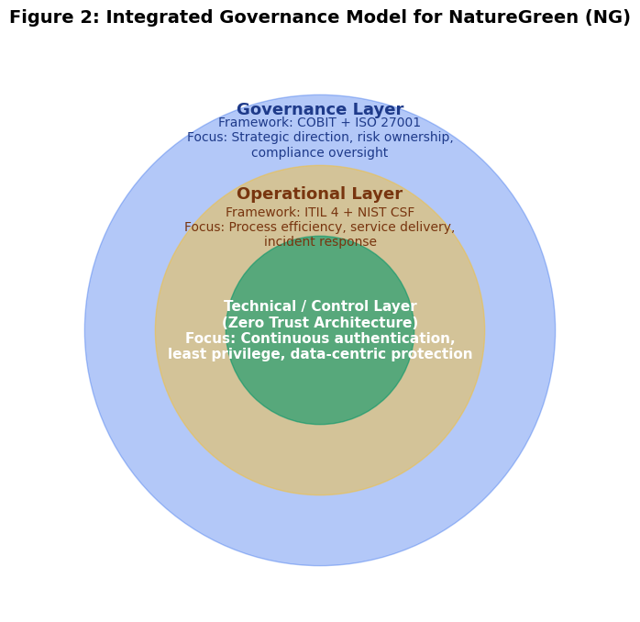
Figure 5: Integrated Governance Model for NatureGreen
This synergy enable continuous monitoring, improvement, and alignment between IT operations and corporate governance which ensure security supports business objectives rather than restricting them.

3.8 Training, Awareness, and Cultural Developmen
Security culture is a critical success factor for the framework sustainability. NG should introduce a Security Awareness and Behavioural Change Program such as:
- Mandatory induction and annual refresher training.
- Simulated phishing campaigns and incident-reporting exercises.
- Executive workshops on governance responsibilities.
- Reward schemes for proactive security behaviour.

3.9 Implementation Roadmap
Following implementation plan will help NG adopt the proposed framework effectively over 18 months.
Phase | Timeline | Key Activities | Deliverables / KPIs
Phase 1: Foundation | 0–3 months | Establish ISSC, appoint CISO, baseline assessment | Security governance charter, initial risk register
Phase 2: Framework Design | 3–6 months | Draft policies, define SLAs, design ISMS scope | Approved security policies, compliance matrix
Phase 3: Deployment | 6–12 months | Implement IAM, MDM, SIEM; user training | 90% user compliance; active monitoring
Phase 4: Certification & Continuous Improvement | 12–18 months | ISO 27001 audit, maturity assessment | Certification achieved; quarterly KPIs >95% compliance
Table 7: Implementation Roadmap
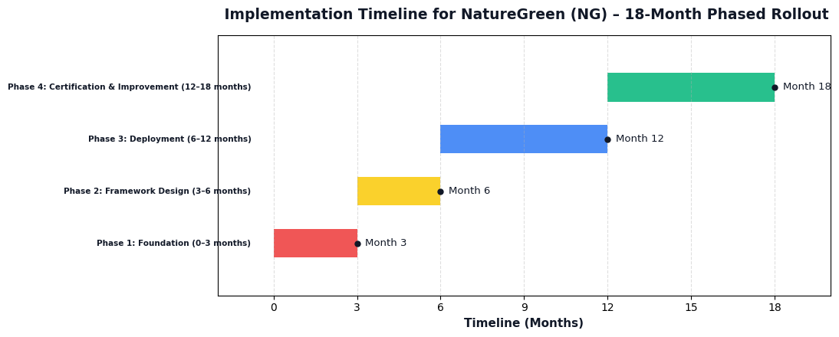
Figure 6: Gantt chart

3.10 Summary of Section
The suggested integrated security, the governance, and compliance framework will provide NG with a structured, risk-based, and technology-enabled information security strategy. This enables NG to balance its security resilience posture and regulatory compliance through the management structure of ISO 27001, operational maturity of NIST, process orientation of ITIL, governance oversight of COBIT, and modern technical defence of Zero Trust.
The key to success in implementation lies with the senior-level leadership commitment, cross-departmental cooperation, and the ongoing training of the framework to keep it updated with the threats that have arisen, as well as with the new regulations.

4. Discussion (Importance of Continuous Regulation and Standards Update)

4.1 The Dynamic Nature of Cybersecurity Threats
The field of cybersecurity is fast changing due to the appearance of newer technologies, variations in regulations, and complex threat actors (Safitra, Lubis and Fakhrurroja, 2023). Conventional forms of perimeter based defence mechanisms are no longer effective enough to prevent advanced persistent threats (APTs), artificial intelligence (AI) attacks, and Internet of Things (IoT) vulnerabilities. Recent research findings state that more than 74% of cyber-attacks currently take advantage of human a mistake (Information Commissioner’s Office, n.d.).
In a case of an organisation such as NatureGreen (NG) that uses cloud based systems and mobile connectivity, they cannot use old security systems. The ongoing changes on standards and governance models are the key to relevancy of the policies and controls, to keep them exhaustive and responsive to the recent threats.

4.2 Evolution of Standards and Frameworks
International standards organizations keep change their frameworks to accommodate new technologies and attack points. The IS/IEC 27001:2022 version, in particular, reduced the number of sets of controls to 93 and added the new domains, including threat intelligence, data masking, and secure coding practices. Similarly, the NIST Cybersecurity Framework 2.0 draft version (particularly, 2025) widens its attention on supply-chain risk and cross-sector interoperability.
The same data privacy laws are also regulated continuously. General Data Protection Regulation (GDPR) has also impacted the privacy regulation of the world, and the laws of regions, such as the California Consumer Privacy Act (CCPA) and the UK Data Protection Act 2018, mirror the emerging worries on the data sovereignty and ethical processing. As an international organization, NG must, therefore, keep in check not only with either ISO or NIST but also with the emerging laws on cross-border data.

4.3 Benefits of Continuous Standards Update
Maintaining standards and governance systems up to date has a number of strategic benefits such as:
- Updated frameworks use emerging threats to inform future frameworks and enable NG to become resilient through the implementation of current controls, including Zero Trust and AI-assisted monitoring.
- Frequent updates reflect due diligence and best practice by NG minimizing legal risks and audit reports.
- The incorporation of new process optimisations due to the implementation of such frameworks as ITIL 4 and COBIT 2019 facilitates easier incident management and service delivery.
- Having certification and compliance will ensure that investors, regulators, and customers will know that NG is actively dealing with risks.

- Finally, the standards updating process should not be considered only a part of the administration but a continuous integration of the business goals, technology, and compliance requirements.

4.4 Challenges and Considerations
However, there are no challenges facing the implementation of new standards. The revision of frameworks requires investment of finances, expert skills and change management. The constant shift in regulations may also lead to compliance fatigue especially in organisations that have international operations. NG will thus be required to strike the balance between innovation and being practical and have updates prioritised based on risk impact and business value.
To cope with it, the Information Security Steering Committee (ISSC) of NG needs to institutionalise the process of standards review every year, assessing new regulatory requirements, ISO/NIST changes, and technological trends. Incorporating this review into the governance cycle is also in line with the ISO 27001 principle of Plan-Do-Check-Act (PDCA) and will ensure that the ISMS of NG keeps updating depending on the external environment.

4.5 Summary of Discussion
To maintain the cybersecurity maturity in the face of the emerging threats, continuous regulation and updates to the standards are necessary. In the case of NG, the adaptive governance model which will be based on ISO, NIST, COBIT and Zero Trust principles should be developed through periodical examination, audit and enhancement. Such a dynamic solution does not just make the organisation resilient but also increases compliance assurance, trust in stakeholders and business continuity in the long term.

5. Conclusion
The environment that NatureGreen (NG) is forced to exist in is a complex digital environment that is typified by cloud based infrastructure, wide spread wireless connectivity and an increased acceptance of the Bring Your Own Device (BYOD) tendencies. Although the technologies allow the organisation to be flexible and efficient in its operations, it also places the organisation at significant risk regarding cybersecurity, privacy, and compliance.
This report has critically evaluated the major international security and governance frameworks, such as; ISO/IEC 27001, NIST Cybersecurity Framework (CSF), ITIL 4, COBIT and Zero Trust Architecture (ZTA) and combined their best practices to develop a custom Information Security and Governance strategy to be implemented by NG. The proposed model provides the roles of governance, risk management processes, and technical controls that are backed by the alignment of compliance with the data protection laws including the GDPR and the UK Data Protection Act 2018.
The monitored and controlled implementation plan of this report allow NG to make a gradual and systematic enhancement of its security posture by applying specific stages, namely, assessment, policy development, technical integration, and continuous improvement. The use of performance indicators and audit controls guarantee accountability and transparency which are measurable.

In addition, the debate on the continuous updates highlighted that cybersecurity governance should change with the change in technology innovation and regulations change. Frequent reorganization of frameworks and controls will make NG reliable, compliant and trusted in the global digital market.

References
- Dalal, A., 2023. Building Comprehensive Cybersecurity Policies to Protect Sensitive Data in the Digital Era. Available at SSRN 5424094.
- Aminzade, M., 2018. Confidentiality, integrity and availability–finding a balanced IT framework. Network Security, 2018(5), pp.9-11.
- Ganji, D., Kalloniatis, C., Mouratidis, H. and Gheytassi, S.M., 2019. Approaches to develop and implement iso/iec 27001 standard-information security management systems: A systematic literature review. Int. J. Adv. Softw, 12(3).
- British Standards Institution. (n.d.). Transition to the ISO/IEC 27001:2022 standard: What you need to know. Retrieved from https://www.bsigroup.com/en-GB/insights-and-media/insights/blogs/transition-to-the-iso-iec-27001-2022-standard/
- Yin, Y., 2024. Information security and risk control model based on Plan-Do-Check-Action for digital libraries. Journal of Cyber Security and Mobility, 13(2), pp.305-326.
- Wolff, J., 2024. Harmonizing US Cybersecurity Regulations: Opportunities & Challenges. Available at SSRN 5044551.
- National Institute of Standards and Technology. (n.d.). The CSF 1.1 Five Functions: Identify, Protect, Detect, Respond, and Recover. Retrieved from https://www.nist.gov/cyberframework/getting-started/online-learning/five-functions/
- Tuomisto, J., 2022. Value co-creation in ITIL 4-framework.
- Salovaara, A., 2015. Developing Service Design & Management Processes Towards ITIL Compliance.
- De Haes, S., Van Grembergen, W., Joshi, A. and Huygh, T., 2019. COBIT as a Framework for Enterprise Governance of IT. In Enterprise governance of information technology: Achieving alignment and value in digital organizations (pp. 125-162). Cham: Springer International Publishing.
- Stafford, V., 2020. Zero trust architecture. NIST special publication, 800(207), pp.800-207.
- Palo Alto Networks. (n.d.). What is Zero Trust Architecture? Retrieved from https://www.paloaltonetworks.com/cyberpedia/what-is-a-zero-trust-architecture
- Axelsen, H. and Damsgaard, J., 2025. Designing the Hybrid Cooperative: A Socio-Technical Architecture for Scalable, Global Coordination Using Blockchain. arXiv preprint arXiv:2509.13156.
- Salihu, A. and Dervishi, R., 2024, October. Evaluating the Impact of Risk Management Frameworks on IT Audits: A Comparative Analysis of COSO, COBIT, ISO/IEC 27001, and NIST CSF. In 2024 International Conference on Electrical, Communication and Computer Engineering (ICECCE) (pp. 1-8). IEEE.
- Safitra, M.F., Lubis, M. and Fakhrurroja, H., 2023. Counterattacking cyber threats: A framework for the future of cybersecurity. Sustainability, 15(18), p.13369.
- Information Commissioner’s Office. (n.d.). Learning from the mistakes of others – A retrospective review. Retrieved from https://www.ico.org.uk/about-the-ico/research-reports-impact-and-evaluation/research-and-reports/learning-from-the-mistakes-of-others-a-retrospective-review/

