Understanding the impact of training and development programs on staff productivity: A case of McDonald's UK

Abstract
Providing proper educational and cultural training to the employees is one of the most common responsibilities of the leaders of the business organisations in order to enhance their productivity level and make them more confident. Thus, this research report focuses on the positive impact of training and development programs on increasing the productivity level of the individual employees. The effectiveness of proper training has been mentioned in this research report and problems are characterised with the help of suitable questions in the aims and objective part of this report. In the finding and analysis section, the statistical information has been provided along with the graphical presentations which are helpful for the readers to make the concept clear regarding this topic. A literature review section has been provided in this particular report, which is helpful for further investigation. Additionally, several theoretical aspects and models have been used to complete this research work. In the methodology part, the primary qualitative data collection method has been utilised which helps in conducting an interview on 10 employees. In this way, the study has procured effective outcomes with the help of thematic analysis. Moreover, some recommendations have also been provided based on the necessary requirements for developing an effective research study.
Acknowledgement
The research for this study is noticed to be successfully concluded with the aid and guidance of the teachers and tutors who patiently helped me in the activity of collecting information for the successful execution of the project. The research was also concluded with the aid of my fellow batch mates that guided me in the activity of obtaining the required hold on the information that favoured me to grow with the study, in a meaningful and significant way. I would also like to expand my deepest gratitude to all those who have directly and indirectly guided me in writing this case study.

Table of Contents
Chapter 1: Introduction 6
1.1 Background of Study 6
1.2 Significance of Study 6
1.3 Research Rationale 7
1.4 Research Aim and Objectives 7
1.5 Research Questions 8
1.6 Research Framework 8
Chapter 2: Literature Review 10
2.1 Introduction 10
2.2 Training and developmental programs 10
2.3 Importance of Training and development programs in enhancing business productivity 11
2.4 Correlation between training and development and employee performance 14
2.5 Role of training and development assisting staff to attain potential capabilities 17
2.6 Types of training and development strategies used by McDonald’s 21
2.7 Benefits of Training and development programs 23
2.8 Literature Gap 26
2.9 Conceptual Framework 27
2.10 Conclusion 27
Chapter 3: Methodology 29
3.1 Introduction 29
3.2 Research onion 29
3.3 Research Approach 30
3.4 Research Philosophy 30
3.5 Research Strategy 31
3.6 Research design 32
3.7 Data collection method 32
3.8 Data analysis 32
3.9 Research ethics 33
3.10 Research limitations 33
3.11 Conclusion 34
Chapter 4: Analysis and Discussion 35
4.1 Introduction 35
4.2 Findings 35
Impact of training and development of the staff productivity 35
Enhancement of employee productivity through training and development 35
Necessity of training in increasing organisation productivity 35
Obstacles encountered during the performance of staff training 36
Improved productivity after a training program. 36
Strategies for addressing training and development difficulties 36
4.2.1 Impact of training and development of the staff productivity 36
4.2.2 Enhancement of employee productivity through training and development 39
4.2.3 Necessity of training in increasing organisation productivity 42
4.2.4 Obstacles encountered during the performance of staff training 45
4.2.5 Improved productivity after training program. 47
4.2.6 Strategies for addressing training and development difficulties 50
4.3 Discussion 52
4.3.1 Importance of training and development in staff productivity 52
4.3.2 Training and development influencing productivity and performance of employee workforce 53
4.3.3 Employee Training as an aspect of improving organisational productivity 54
4.3.4 Issues related to executing the training process of employees 55
4.3.5 Effective strategies for mitigation of training and development challenges 56
4.4 Conclusion 56
Chapter 5: Conclusion 58
5.1 Introduction 58
5.2 Discussion 58
5.3 Recommendations 60
5.4 Future scope of the study 60
5.5 Conclusion 61
References 62
Appendices 75
Appendix 1: Interview questions 75
Appendix 2: Interview questions and answers 76
Appendix 3: Ethics Approval Form 80

Chapter 1: Introduction

1.1 Background of Study
Training, as well as development, is highly required for making the employees skilled and developed. The provision of effective training is important to teach the subordinates the actual tactics of tackling business which is necessary for running the company (Kaizer et al. 2020). The profound training is useful for helping the workers to learn the technique of framing suitable strategies which are innovative and will guide the organisation in delivering distinctive services to the customers (Avtgis, 2023). This is the approach that will assist any organisation to increase its brand value by creating a strong image which will make that company one of the successful competitors in the market. The training guides the workers to acquire knowledge about specific skills which are highly essential for working superficially and this approach will indirectly guide the brand in enhancing its reputation. The study will pay attention to evaluate the importance of training the workers of McDonald's which is a famous and well-known brand delivering more than 69 million consumers regularly in 100 nations.
The organisation has its headquarters in Chicago, United States, and has many other branches in several countries which have accelerated the success ratio of the company (Solomon et al. 2021). The discussion will be made about the impact of training on the subordinates related to McDonald's of the United Kingdom. The research will concentrate on explaining the significance related the training to improve the performance of the workers associated with the corporate platform. The discussion will be made about the relationship that exists between training as well as staff productivity. The concentration will be given on illustrating the role of training in guiding the workers to learn the latest skills. The attention will be laid on describing the strategies which are being adopted by McDonald's in the United Kingdom to operate the training of workers to make them more skilled.

1.2 Significance of Study
The researcher has analysed the specific context to outline the importance of the program related to training as well as the development of the workers of McDonald's in the UK. It has highlighted the efficacy of the department of management to provide the suitable training which is necessary for improving the success ratio. It has justified the relationship that exists between the productivity of the workers and training. It has explained the existence of the positive relationship between training and the productivity of the subordinates which are extremely required for the proficient growth as well as the prosperity of the brand.
The research has emphasized that the provisions of suitable training are required to make the employees skilled which is useful for guiding the workers in meeting the objectives of the company that is necessary for improving the brand value that can make the brand better off in the long run (Daumiller et al. 2021). It has explained the strategies which are being adopted by McDonald's to provide proficient training to the subordinates for increasing the profit of the brand which is necessary for guiding the organisation in reaching the hierarchy of success followed by the formation of positive externalities.

1.3 Research Rationale
This study examines the profound importance of training and development for increasing the growth as well as success of McDonald's. There are a number of strategies and techniques employed by the organization to increase employee productivity (Niati et al. 2021). The rationale behind the conduct of the study is to provide valuable insights on these strategies that effectively improve productivity among the organization’s staff. In addition to that, employee “training and development programs” have a significant impact on their performance. Research in this area would assist in identifying the sectors which need greater attention and resources. Therefore, the results of the study can be used to make meaningful changes in the organisational structure of McDonald’s and improve their employees’ performance. However, the researcher has faced certain issues in conducting the study and the major cause behind the problem in the present situation is the less amount of time that has created hurdles for the researcher to collect data within the given time frame.

1.4 Research Aim and Objectives
Aim
The specific goal of the study is to comprehend the effectiveness of training and development on employees and their productivity. Also, the study is intended to show a realistic scenario of McDonald's being the most respected firm and standing out above other competitors when it refers to quality service.
Objectives
- To comprehend the significance of training and development programs to employees in improving corporate performance.
- To uncover specific training and development strategies used by McDonald's inside its organization.
- To determine the relationship between training & development and staff productivity.
- To determine how training and development may help employees obtain new abilities.

1.5 Research Questions
- What role do staff training and development programs have in boosting organizational performance?
- What strategies does McDonald's utilize in staff training and development?
- What is the relationship between staff training & development and productivity?
- How can training and development help employees obtain new skills?

1.6 Research Framework
Introduction
In The introduction part of the research work, various significant elements that are required for a comprehensive understanding of the subject of the research are provided (Newman and Gough, 2020). The introduction section includes the research background, research rationale, aims and objectives as well as the research that is going to be solved to accomplish the study. In addition to this, the introduction also provides an elaborated Idea regarding the significance of the study. For this particular report, the subject of the investigation is to evaluate the influence of training and development on employee productivity in the context of McDonald’s.
Literature Review
The literature review section provides a comprehensive understanding of the topic and elements that are related to the topic (Zawacki-Richter et al. 2020). In this particular portion, Data and information that have been gathered from various resources such as research papers, journals, articles, scientific websites, and so on at discussed with proper interpretation as well as new points to provide a better comprehension of the topic as well as objectives of the assessment process.
Research Methodology
In research, research methodology plays a significant role because it helps in directing the process appropriately to the right path for accomplishing the particular objective appropriately (Babii, 2020). The research methodology includes various significant aspects such as “research design”, “research philosophy”, “research strategy”, “data collection method”, “data analysis approach”, “sampling strategy”, as well as “ethical consideration”. This aforementioned research has utilised a qualitative research strategy with a sample size of 25. In addition to this, descriptive research design has also been used in this research.
Findings and Discussion
Findings and discussion help in providing a significant understanding of the result that has been acquired from the research. In the finding section with the help of various statistical as well as scientific graphs and charts, a detailed graphical interpretation is being put forward. In addition, in the discussion portion, elaborated explanations are provided in the context of the findings.
Conclusion and Recommendation
The conclusion section summarises all the execution operations and procedures that have been performed throughout the research work to accomplish and achieve the desired objectives (Sileyew, 2019). Moreover, this mentioned section also gives a piece of effective information about the limitations as well as the knowledge gap that is needed to be eliminated. Moreover, recommendations facilitate research with a set of effective ideas that can be utilised to enhance efficiency and accuracy next time.

Chapter 2: Literature Review

2.1 Introduction
Businesses are aware of the crucial role learning and growth initiatives play in boosting worker efficiency in today's cutthroat business climate. McDonald's UK, a well-known convenience store business famous for its dedication to staff growth, is the subject of this case study. The purpose of the research is to examine how learning and growth activities affect worker efficiency at the company. It is analysed that effective training initiatives help workers to acquire essential abilities, encourage continuous growth, establish an atmosphere of acquiring knowledge, and boost morale among staff members by looking at the tactics and procedures used by the organization. For businesses looking to boost efficiency and promote achievement through efficient education and training campaigns, recognizing this influence is essential.

2.2 Training and developmental programs
In the words of Kareem, (2019), the initiatives of “training and development” within an organisation signifies “educational activities” that are designed for improving the job performance of the individual or the group in question. These programmes provide beneficial insights on enhancing the competencies and capabilities such as “technological intelligence”, “skill development”, “interpersonal skills”, “leadership qualities” and others that assists in advancing the worker’s knowledge and skill sets and instilling higher motivation for productivity and engagement in their respective job profiles (Ozkeser, 2019). By broadening the scope of developing the human resources’ technical and behavioural skills in the organisations, “training and development” helps the employee in attaining their personal growth in alignment with the organisation's vision.
According to Royle, (2022), plans for training and development are essential for increasing employee efficiency in companies. The same applies to McDonald's UK. The company is renowned for its dedication to worker growth, and its training courses have significantly increased staff efficiency. Instruction courses at the firm give staff members the abilities and information they need to do their jobs well. New hires go through extensive training courses that include all facets of their employment, such as preparing food, dealing with clients, and security protocols. The company makes sure that its staff members receive instruction so they can carry out their duties with competence. Workers are more productive as a result of their ability to do duties effectively and with confidence. Based on Salamon, (2022), the company places a strong emphasis on lifelong learning by offering continual training possibilities. The business makes investments in initiatives that support workers in advancing their professional development. For instance, the organization provides training courses in management that help staff members move into administrative or oversight and performance. positions. The emphasis on skill development and career promotion results in an inspired staff that is more inclined to be effective. Employee commitment and performance at work are increased when they are valued and empowered by the company.
On the other hand, Mohammad et al. (2019), vouch for “productivity” as the means of drawing efficiency for the employee’s or the organisation’s well-being by converting inputs, like capital and labour, into formidable outputs, such as services and products. For enhancing the productivity of the employee in a company, organisational managers employ incentives, goals and communication strategies that help in boosting the performance and morale of the employee and ensures a healthy internal work environment for the workforce and a competitive advantage over the company’s rivals.
An environment of curiosity and innovation is also promoted at the company by development and training initiatives. As per Copland, (2022), the organization fosters a growth mentality and a readiness to accept changes by pushing people to continuously improve their abilities. Workers who operate in an environment where training is valued grow more adaptive and receptive to new ideas, which increases efficiency. They can handle difficulties more effectively and help the business succeed. Additionally, the company's training initiatives contribute to higher employee happiness and enthusiasm. Workers' engagement and job satisfaction are more likely to occur when staff members have confidence and are encouraged in their work. Personnel that are happy with their jobs are likely to be more efficient because they are driven to work hard and treat clients properly. The company's educational and training initiatives have a big impact on workforce productivity. According to Mikołajczyk, (2022), these initiatives support a more productive workforce by providing staff with the necessary abilities, encouraging ongoing growth, establishing a culture of acquiring knowledge, and boosting spirits among workers. For other businesses looking to optimize worker efficiency and accomplish goals for the organization, the firm's dedication to learning and growth serves as a powerful model.

2.3 Importance of Training and development programs in enhancing business productivity
In order for a business to be successful, “training and development programs” are essential. Khan and Abdullah, (2019), state that “Training and development (T&D)” are vital obligations in today’s rapidly evolving and quick-paced business climate. Throughout business sectors, both the phrases “employee training and development” are frequently utilized conjointly in reference to an assortment of learning approaches for workers. “Training and development” initiatives designed to assist staff obtain particular competencies or know-how to enhance productivity have become essential. Abbas, (2020), additionally claims that as a result of “training and development” programs, employees are able to acquire new skills, enhance their knowledge, and gain a deeper understanding of their role in the organization. Therefore, establishing suitable training and development opportunities for staff holds substantial advantages. Ali and Anwar, (2021), postulate that personnel are able to enhance their job performance, optimize effectiveness, and become more effective leaders through training by developing novel capabilities and polishing old ones.
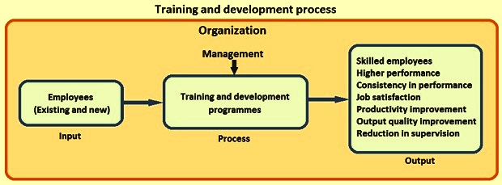
Figure 1: Significance of Training and Development Programs within an Organization
(Source: ispatguru, 2023)
In adherence to this scenario, Zhang and Zhu, (2019), highlights that T&D endeavors assist in determining the flaws that the staff possess. A large percentage of staff exhibit certain inadequacies in their work-related capabilities. The corporation is able to foster the competencies that every staff member requires to reinforce through a program of training. Every staff member is pushed up to a comparable level by a development initiative, providing them with an equal set of capabilities. Usuga Cadavid et al. (2020), underpins the fact that this in return, lowers any areas of weakness in the organization that depend predominantly on individual staff to carry out basic job responsibilities. Offering the required training brings about informed and skilled personnel as a whole and provides employees the opportunity to enhance their knowledge of the industry, allowing them to make more informed decisions and deliver better customer service.
As per Stahl et al. (2020), training and developmental programs for employees help in “increasing performance and productivity” because when the workforce undergoes different training programs, it helps them to attain expertise regarding their job role and thus boosts their confidence level. This in turn helps the firm to influence the employees to work effectively. Moreover, Kozhakhmet et al. (2022) stated that confident employees with the requisite skills for the job are more likely to be productive and successful in their roles. Additionally, a well-designed training program facilitates the development of better working relationships between employees as employees are taught to communicate and collaborate with one another more effectively. Thus, this enhances “uniformity among the team members regarding work process” and thereby standardizes the work process among the staff.
Additionally, Zhang et al. (2022) stated that when the employees are trained, and thus are able to make the proper usage of the resources, tools, and equipment and thereby limit “wastage”. This in turn also aids in minimizing damage to the organizational equipment. Likewise, at MnDonald’s, the executives offer training regarding the management of the inventory. Moreover, through training and developmental programs, the employees become competent in handling the business operation. This in turn helps the organization lower its continuous supervision. Furthermore, it also aids the employees to work as per their responsibility without continuous interruption. This helps in offering motivation to the employee because the workforce feels that their executives believe them and thereby attains job satisfaction.
Also, Di Vaio et al. (2020) stated that when the organization offers consistent training and development to their organization, it improves their skills regarding the job role and therefore helps them to work more professionally and in a productive way. Thus, when the business becomes efficient with its processes, it generally offers the customer an elevated service and thereby helps to retain its customers by “enhancing customer evaluation”. In addition, Apriana et al. (2019) stated that periodic training and developmental programs help employees to function in a productive way which in turn aids in boosting organizational performance along with enhancing the “workplace environment”. The workplace environment within the organization plays a major role in encouraging employees to feel valued and important along with offering insight into the corporation's policies and objectives. It also helps to boost brand reputation and thus helps to attain and broaden their customer base.

2.4 Correlation between training and development and employee performance
As per the viewpoint of Iis et al. (2022), the management of human resources has recently become the highest consideration for all companies. For maximizing earnings and institutional advancement, every company’s human capital needs to be at its peak. There are plenty of approaches that have been deployed in order to boost performance among staff members, involving recruitment, strategies for motivation, recognition, and developmental and training programs. Alqudah et al. (2022), state that the key component essential in order to obtain the greatest return out of employee assets has become “training and development”. It is capable of being employed in order to enhance or create performance standards for personnel with regard to their employment prospects.
Diamantidis and Chatzoglou, (2019), demonstrate that a collection of measures referred to as “training and development” attempt to raise both the productivity of the organizations and worker efficiency. These strategies are suitable across all sorts of staff members, from “front-line employees” to the Chief Executive Officer”, in the contemporary work environment and have evolved on an extensive variety of functions, from training in particular and precise job competencies to ongoing career advancement. Davidescu et al. (2020), also stressed the fact that in the contemporary business climate, where “learning organization” is an emerging catchphrase, “training and development” has arisen as an integral organizational activity and has gained recognition as an area of expertise with distinctive concepts and strategies. It has become a widely recognized reality that the performance of a company relies heavily on how effectively its staff members function in their existing responsibilities. Paais and Pattiruhu, (2020), strongly claimed that staff drive, dedication, and involvement represent some of the attributes that influence how effectively they operate on the job, but multiple research studies have demonstrated that training and development are actually one of the most crucial elements of boosting workers’ productivity.
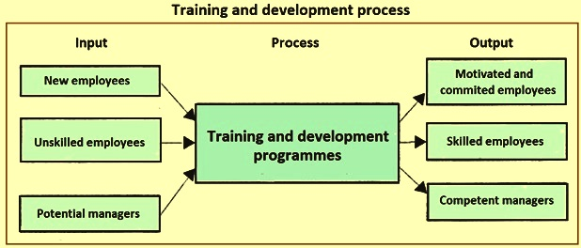
Figure 2: Relationship between the Training and Development Program and Staff Performance
(Source: businessjargons, 2023)
Swanson et al. (2020), underpins the notion that the efficiency and productivity of staff members are capable of being strengthened in a significant way through training and development measures. Efficient employee development and training initiatives could give staff greater self-assurance and a sense of self-determination. As a consequence, training and development enhance staff competence levels, which subsequently in return boosts organizational productivity standards. According to Wu et al. (2019), suitable and effective training and development practices assists in “boosting the understanding, competencies, and capabilities of the staff members” that ultimately lead to the long-term accomplishment of the organization as a whole. The absence of the understanding and competencies needed to successfully complete a particular assignment precludes personnel from functioning efficiently. Manzoor et al. (2019), also claim that the performance of staff members gets better as a result of undergoing development and training practices, which aids personnel reach their goals by developing the appropriate capabilities and skill sets. In conjunction with enhancing productivity and efficiency, training initiatives additionally assist staff members in altering their viewpoints toward the job they do.
Cooke et al. (2019), correspondingly, assert that successful communication and exchange of information practices in work environments help a company sustain its retention rate of workers while strengthening the efficiency and effectiveness of the company in order to remain competitive in today’s highly competitive business climate. The “social exchange theory” is considered to be one of the most crucial ideas regarding the issue of staff retention due to the way it favors collaborative conduct and connection among employees. In accordance with this specific instance, Duggan et al. (2020), states that “staff quit due to a breach of the terms of exchange”. Every time the organization’s fundamental values undergo modification, unforeseen difficulties appear. With the goal of keeping the staff members satisfied, the person in charge of human resources of a particular organization provides “courteous behavior to every single one of the staff”. The principle thereby allows HR executives to comprehend the significance of “training and development” together with “collaboration and communication” in progressing the performance of employees.
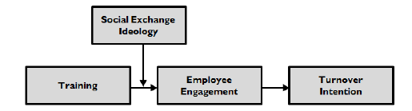
Figure 3: Depiction of “Social Exchange Theory” Framework
(Source: prezi, 2023)
In this sense, Abbas, (2020), highlights the fact that McDonald’s supports “on-the-job training” and gives staff instruction while also letting them learn. Additionally, the business provides the “McTalent Development Programme”, a fast-track developmental program that takes care of the talents that are employed from outside the company and provides employees with specialized training for quick progress in the fast-food industry.
As per the opinion of Pinzone et al. (2019), “training and development” endeavors also exhibit a close association with the performance of the employees by “saving time and costs”. Whenever a staff member is uncertain of “what, when, or how” to carry out a given assignment, it will be evident in the way they perform. By emphasizing the particulars of the task at hand and proving the staff members with the knowledge and abilities they require to carry out their duties effectively, training helps in overcoming these difficulties with performance. However, Abarantyne et al. (2019), asserts that by performing this, the amount of time wasted committing blunders and repeating endeavors in the workplace become lessened. The work efficiency of the workforce ultimately rises as a direct consequence of both time and financial savings.
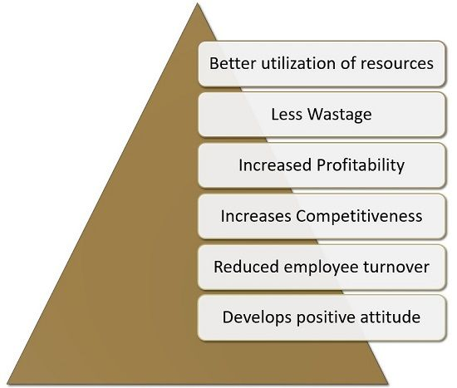
Figure 4: Importance of Training and Development Program within an Organization
(Source: geeksforgeeks, 2023)
Amor et al. (2020), states that staff understanding, abilities, and perspectives have been enhanced by training and development practices. As a consequence of this, individuals exhibit a stronger trust concerning their line of work, which inevitably boosts their general sense of feeling worth and fulfillment. Personnel begins to operate in an approach that amplifies organizational responsibility as an outcome of their boosted satisfaction. They put forth greater diligence given that they consider themselves a part of the corporation, thereby enhancing the way they perform and also the quality of the work. On the other hand, Gopal et al. (2021), underpins that the real institutional concentration on the staff member’s advancement, whether that be as an individual or as a valuable asset to the company, serves as one of the most crucial facets of training. A “self-fulfilling prophecy” of better performance by the staff member could arise from the corporation’s concentration in conjunction with greater demands. A study conducted by Pham et al. (2020), demonstrates that the staff members who obtain frequent, organized opinions, incorporating training, in addition to an upsurge in demands, truly exhibit a greater standard of employee performance. The “Pygmalion Influence” is the term that has been given to this phenomenon.

2.5 Role of training and development assisting staff to attain potential capabilities
As opined by Mikołajczyk, (2022), for the successful and viable operations of the corporations on a worldwide platform, training and development endeavors that are aimed towards enhancing the potential of the employees serve as of utmost importance. These initiatives not merely provide prospective chances to strengthen the capabilities of the workers but additionally for the employers to expedite the efficacy of the staff as well as enhance the work culture within the business setting. Correspondingly, Irkinovna et al. (2022), states that to enhance the productivity of the staff inside the corporation, “employee developmental activities” serves as the persistent endeavor by providing strategic activities such as “coaching”, “training activities”, and “leadership mentoring”. On the other hand, offering newly hired or recently upgraded staff suitable training has become a standard practice. Tumi et al. (2022), claim that training is a particular occurrence that imparts innovative and novel expertise and capabilities. The personnel with responsibility for the organization’s human resources are generally in control of scheduling and carrying out these attempts, and they are both vital responsibilities.
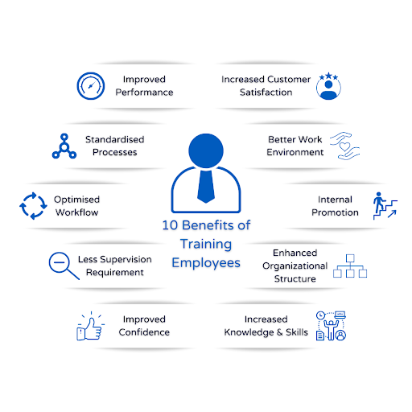
Figure 5: Role of Training and Development in Benefiting Staff
(Source: nxtdecade, 2023)
De La Torre et al. (2022), postulates that getting the right training boosts the ability of a staff member to do his or her work effectively. The employees understand more about ethical behaviours and the correct way to carry out simple responsibilities effectively, and suitable T&D practices played a significant role. Given that the staff had gained a greater knowledge of the company’s operations and the obligations associated with the position that the staff holds, the training could contribute to boosting the staff member’s morale. With a greater sense of confidence, the staff could strive harder and come up with creative strategies to achieve success. In addition, Kaewnaknaew et al. (2022), asserts that ongoing training keeps the firm’s staff members abreast of current market conditions. Skilled staff members who keep up with constantly evolving industry norms, which in turn, benefit the respective business to sustain its position of supremacy and its edge over competitors in today’s extremely volatile market industry.
In light of this context, as per the viewpoint of Masenya, (2022), one of the most predominant theories is the “human capital theory”, a concept that centres predominantly on a worker’s “education”, “training”, and “development”. In line with this premise, every staff member boasts a few essential expertise or talents that might possibly be expanded or broadened with the right training and development activities, leading each employee to flourish as a more efficient and successful expert in an area of expertise. As an outcome, HRM practitioners are under an obligation to guarantee that staff members are looked after properly and given the necessary training that will help them accomplish their assigned duties with greater effectiveness. Workers feel compelled to continue working for the particular business entity as an outcome.
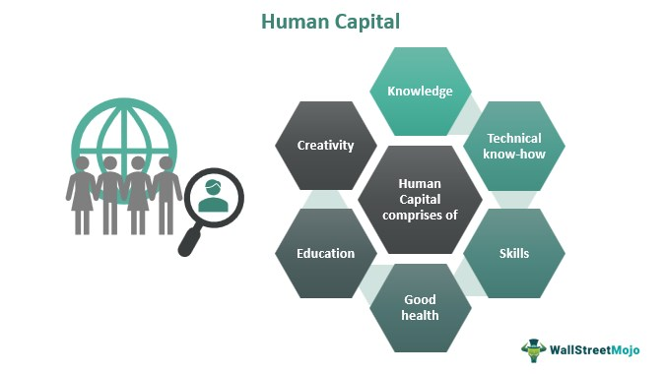
Figure 6: Depiction of “Human Capital Theory” Framework
(Source: wallstreetmojo, 2023)
In accordance with the topic at hand, Haldorai et al. (2022), underpins that practically all businesses, notably McDonald’s, provide essential training and development practices in order to assist its personnel handle their work-related demeanour and taking part in constructive interaction. Professionalism remains an essential facet for delivering client satisfaction given that if they receive unacceptable conduct or service from an organization, those clients will make the choice to migrate to a rival company. Furthermore, Rostini et al. (2022), contend that strong interaction assists company personnel to perceive the requirements, wants, and difficulties that the consumer is experiencing, thereby making it a useful tool.
Farzaneh et al. (2022), highlight that the personnel is helped by McDonald’s basic training and development endeavours on inventory management to learn the proper portion sizes to make in order to reduce food waste. This in turn can help the business increase its profitability. Besides that, McDonald’s provides additional training as needed through its foundational training program. Therefore, according to Blanka et al. (2022), via efficient training, McDonald's team members acquire high levels of training and possess the capacity to focus on the policies and procedures that define organizational performance. Additionally, the training provided by McDonald’s can help the employee develop life skills that they can apply in a variety of circumstances.
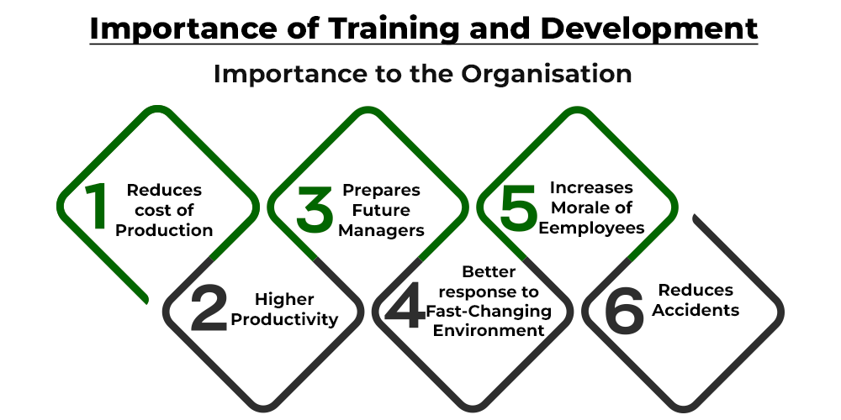
Figure 7: Contributions of Training and Developmental Programs inside a corporation
(Source: ispatguru, 2023)
Subsequently, Alqudah et al. (2022), demonstrate that “training and development” practices employ a broader staff development strategy that places an emphasis on prospective achievement as contrasted to immediate promotion to a professional role. Therefore, providing staff with appropriate chances for training and development has significant benefits. Through training, staff can advance their work output, maximize effectiveness, and evolve into competent leaders by learning new skills and honing the prior ones. According to this premise, Mawardi, (2022), states that T&D attempts to aid in identifying the staff members’ shortcomings. Many employees display specific limitations in their ability to do work-related tasks. Through a training program, the company is able to cultivate the skills that each employee needs to strengthen. Every staff member is pushed up to a comparable level by a development initiative, providing them with an equal set of capabilities. This in return, lowers any areas of inadequacies in the organization that depend predominantly on individual staff to execute basic job responsibilities.

2.6 Types of training and development strategies used by McDonald’s
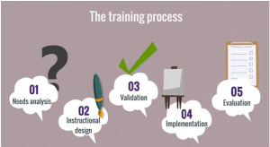
Figure 8: Training and Developmental strategies used by McDonald’s
(Source: facilitatedtraining, 2023)
The success and attainment of revenue for the fast food sector highly depend on client influx along with the proficient usage of the inventory. Antunes and Pinheiro, (2020) stated that in this regard, offering training and development to the staff can assist as a vital approach to the continual influx of the customer. Basic training and development are offered by almost every organization including McDonald’s that guides the employees to make effective communication and manage their professional mannerisms. According to Sousa and Rocha, (2019), mannerisms serve as an essential tool for offering customer satisfaction because if the customer does not get proper behaviour and service from the organization, they will choose to change their preferences. In addition to that, effective communication also serves as an effective tool because it will help the firm to comprehend the needs and desires along with the problem faced by the customer. McDonald’s also offers basic training and developmental processes on the management of inventory because it helps the employees to understand the amount of portion needed to prepare to lower the wastage of food. This in turn can aid the firm to boost the profitability of the organization.
However, Nussenbaum and Hartley, (2019) delineated that other than the general training there is also specialized staff training that McDonald’s generally offers to the workforce to emphasize the potentiality of the employees and bring the best out of them to enhance the overall performance of the organization. Moreover, the training and developmental programs offered by the organization not only help the employee to serve the current organization but also help them to grow personally which the employees can further implement in their future job. Thus, the employees with the help of training and developmental programs develop their talents, attains the opportunity to work in a more proficient way, grow professionally, and get reward and recognition. Additionally, as per Darling-Hammond et al. (2020), the foundation of the training system of McDonald’s offers additional training when and where needed. Thus, through effective training, McDonald’s team members become highly trained and occupy the potential of concentrating on the policies and procedures that specify the organizational performance. Additionally, Meulenbroek et al. (2019) suggested that the training offered by McDonald’s can serve as life skills that the employee can use in different situations.
For McDonald’s, the training and developmental process as stated by Iqbal et al. (2022), is an investment that the executives of the organization plan and offer to the workforce to attain the best outcome and flourish in a substantial position within the cut-throat fast food business. As per Tien, (2019), the offering of training first needs analysis because if the company does not understand which type of training the employees generally need, the firm will fail to offer proper training. Therefore, the higher executives keep a keen watch on the performance of the employees and pinpoint the essential factors. Also, the executives by analysing the performance of their working process rectify their behaviours. In this regard, Bouilheres et al. (2020) stated that the firm believes in “on-the-job training” and offers training to the employees while also allowing them to learn. It is also practiced by the firm because the organization believes that individuals generally learn faster when making practical implementation rather than just attaining theoretical knowledge.
Moreover, Kiron and Schrage, (2019) stated that McDonald’s for the implementation of the training principles uses a “blended learning approach” which signifies that the firm uses a wide range of methods to deliver training and developmental programs. The firm uses “digital platforms” that enable the employees to initiate a “self-learning journey” and perform independently to assess the relevant operational knowledge and standards. Also, “on-the-job training” training offers the employees to work in alignment with the executives and thus aids to develop practical skills (Moreno-Guerrero et al. 2020). The firm also offers the “McTalent Development Program” which is a fast-track developmental program that looks after the talents that are hired externally and offers tailor-made training for the employees to get a rapid advancement regarding the fast food sector.
Also, the training and developmental process of McDonald’s is a continuous process because the firm keeps on altering innovative technologies and adopting cutting-edge technology and strategies to make its business process run parallel with the current business trends. According to Childs et al. (2022), with the adoption of new technology, the firm offers training to the employees after the organization finalizes the training tools and also offers “new employee handouts” and “pocket quality reference guides” and also gathers feedback from the employees regarding the training processes to comprehend whether they understood or not. As per Lal et al. (2022), when the training and developmental programs are offered by the organization through a shortcut process, a lack of performance can be observed in the employees, thus, the mentors of McDonald’s, regarding this, evaluate the knowledge of the employee through “quizzes” and “on-the-job observations”. However, a lot of emphasis is given by McDonald’s to the training and developmental programs because the company understands that more proficiency in employment will lead to more profitability.

2.7 Benefits of Training and development programs
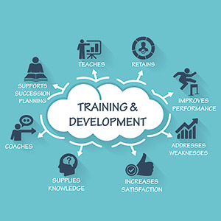
Figure 9: Benefits of Training and Developmental Programs
(Source: cloudfront.net, 2023)
As per the statement of Elsafty and Oraby, (2022), employees are one of the vital assets of the organization which helps the business to attain growth and thrive success. Therefore, investing funds in offering them training and development helps to enhance their potential and thereby eliminating skill gaps, attaining knowledge regarding new technologies, and in turn helps the firm to get the best out of them. This also impacts the overall performance and customer service along with thriving innovation. Thus, Bedeker et al. (2022) stated that there is a wide assortment of benefits that an organization can attain with the help of offering training and developmental programs to the workforce.
As per Akter et al. (2022), employee training and developmental programs can serve as tremendously beneficial to the organization specifically when it comes to the “incorporation of new and inventive technologies, strategies, and operations”. However, due to the alteration of market dynamics at a rapid pace, offering one-time training to the employees are not sufficient, and it needs regular training according to the shifting trends in order to upskill its workforce if the firm intends to earn profit substantially from employee training and developmental programs. Cilliers et al.(2022) stated that consistent employee training and developmental programs enable the workforce to become swiftly adapted to the changing business dynamics and the newest technical developments and thus imply it to accelerate business operations. Moreover, as per El Khatib et al. (2022), it is essential for the firm to maintain a balance with the changing business dynamics because if the business fails to cope with the changing business process, the firm, in turn, will fail to maintain its position in the cut-throat market. Therefore, employee training and developmental programs become crucial if the company tries to “maintain a competitive edge within the market”. Moreover, offering training and developmental programs to the employees helps to stay ahead of the competitors.
Alam, (2021) stated that in addition to multiple benefits, employee training and developmental programs offered by the organization influences employee to “attain career growth” from both personal and professional perspectives. Moreover, when the workforce feels that their executives and seniors are helping them to enhance their base of knowledge and skill sets, they feel motivated and attain job satisfaction. This in turn helps them to stay engaged at work and thus improve productivity and profitability. Additionally, Chiang et al. (2022) suggested offering training and developmental programs to the employees is worth investing in because when the employees obtain the opportunity to grasp and master new skill sets and acquire knowledge, it assists in “lowering employee turnover”. Moreover, it also assists in retaining potential employees and therefore aids the firm to lower operational costs in terms of the hiring and recruiting process. Also, employee training and developmental programs, as per Sinambela et al. (2022), support the firm to attain “internal promotional scope”, thus, helping the higher executives of the firm to fill the slots for internal promotions. This, therefore, helps the firm to practice a cost-effective solution, because the hiring process needs the usage of organizational funds and is thus regarded as additional expenses which the firm can cut through the internal promotional scope. Moreover, Kaewnaknaew et al.(2022) stated that the existing firm is well aware of the organizational processes and thus can function instantly without any additional training and development.
As per Kontostavlou and Drigas, (2022), one of the key benefits of employee training and developmental programs for an organization is its willingness to “draw in high calibre talent”. This enables the firm to establish a set of guidelines for training and developmental programs hand thereby helping to attract top-notch talent. Multiple research has been conducted regarding this and this portrays that job seekers highly consider training and developmental programs as an integral benefit. Therefore, from the viewpoint of the organization training and developmental programs for the workforce helps to attract great talent along with retaining qualified and potential staff.
Loucks et al. (2022) opined that offering training and developmental programs to the employees helps the firm to confer the business with the “competitive edge” it needs to thrive in success and attain growth. In this current business dynamic, inventiveness, organizational trends, and technology are constantly evolving. Therefore, in this situation, the firm needs to comprehend the importance of employee training and developmental programs to maintain one step ahead of the competitors. This will also help the employees to be better able to maintain a balance with the changing environment and thereby allows the company to attain a proficient competitive edge for the firm. Kalet et al. (2022) also stated that training and development programs help the employees to “maintain and boost their knowledge and skill sets” because every skill requires a steady and consistent rehearsal otherwise it will lead to forfeiting control over it. Moreover, frequent employee training programs function as revision sessions for the workforce and thereby permit the organization to retain a high level of knowledge and competence while simultaneously helping the personnel in polishing the talents which they already mastered.

2.8 Literature Gap
Evaluating the influence of training and development endeavours on employee productivity, particularly emphasizing the instance of McDonald’s UK, is the primary objective of this part of the dissertation. The requirement of assessing training and development initiatives efficiency on employee productivity serves as one of the investigated issues of the review of the literature section, however, the relationship between training and development in conjunction with communication and cooperation efficacy has not been emphasized. In addition, it came to light that the investigator confronted an assortment of hurdles while putting together the various approaches that had previously proven successful in incorporating programs for training and growth among the workforce. This is because many approaches become widely recognized to achieve this purpose. A review of the variables related to programs for training and development that may boost the efficacy of these program undertakings in an organizational entity is another topic addressed in the study’s findings. Yet, the approaches for embedding these aspects into the workforce have not been adequately stressed. In the part that reviews literature, several preventive measures have been addressed for alleviating concerns driven by the poor standards of training and development practices, but the assets that organizations will need to put into practice have not been demonstrated.

2.9 Conceptual Framework
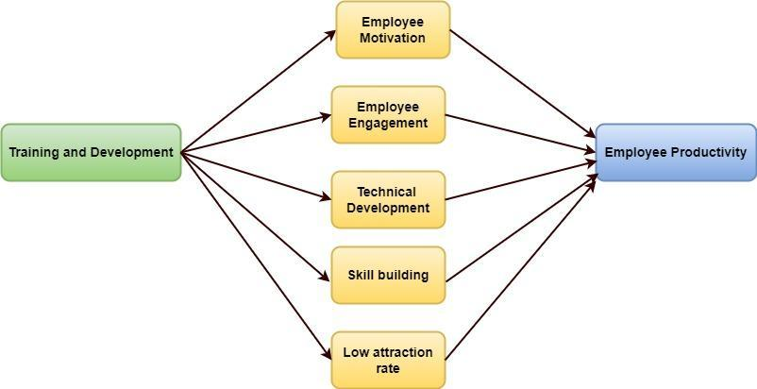
Figure 10: Conceptual Framework
(Source: Self-Created)
The “conceptual framework” explores the relationship between the “dependent variable” and the “independent variable” by examining the bridge linking the elements in association with the “empirical findings” that justify the research subject in cognizance with the formulated objectives of the research study (Varpio et al. 2020). The concerned research establishes factual information that brings “connectivity” between “training and development” and “employee productivity” prevalent at McDonald’s in the UK. On the basis of the aforementioned statement, “training and development” is considered as the “dependent variable”. This is followed by a critical link with its associated factors of “employee motivation”, “employee engagement”, “low attrition rate”, “technical development” and “skill building” as its “independent variables”. These “independent variables” influence the scope of the “dependent variable” with the objective of enhancing the performance and productivity of the workforce functioning at the UK’s McDonald’s.

2.10 Conclusion
The company's initiatives to train and develop employees have had an important effect on worker efficiency. McDonald's has developed a motivated and skilled staff by offering extensive training, encouraging continual growth, establishing an environment of acquiring knowledge, and boosting employee morale. Workers have the tools they need to carry out their responsibilities effectively and with assurance, which boosts performance. Additionally, the organization's emphasis on developing abilities and advancement in their careers promotes staff engagement and contentment. The company is a great illustration of how funding training and development programs may increase worker efficiency, thus boosting the efficiency of the company.

Chapter 3: Methodology

3.1 Introduction
The methodology is explained as the tactic which is being adopted by the researcher to tackle the investigation for accomplishing the goals related to the topic. It comprises certain rules or postulates that the researcher has to follow for doing the research with a convenient approach. All the layers associated with it have been explained in the following manner. It is illustrated as the overarching strategy which is extremely useful to investigate any content that is beneficial for meeting the relevant questions of the research. In other words, it is the system related to principles and techniques to analyse any context which is suitable for creating positive externalities. The segments of the methodology are research strategy, research ethics, research philosophy, research design, research strategy, research approach, and information collection technique as well as fact analysis.

3.2 Research onion
Research onion is explained as the proficient model which is mainly used for computing and preparing the design of research methodology. The framework is effective for designing the strategies and helps in enumerating the experimental research, survey as well as case study. It assists the investigators in making suitable decisions about the investigation which is advantageous to meet the relevant goals associated with the research that is proficient for creating a suitable response (Newman and Gough, 2020). There are many layers associated with the structure of the research onion such as research design, research strategy, research ethics, research philosophy, research approach, data collection tactics, data scrutiny and time horizon. Research philosophy is regarded as the first layer associated with the research onion followed while the second layer of the framework is the research approach.
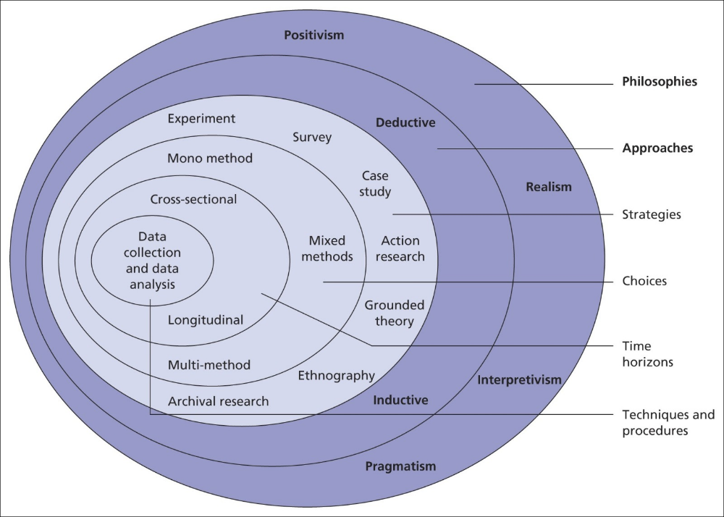
Figure 11: Research Onion
[Source: Saunders et al. 2023]

3.3 Research Approach
The research approach is being determined with the assistance of the selective technique that are being chosen by investigators for carrying out the method of investigation. It is explained as the proficient protocol which is profoundly computed by the investigators to conduct the tactics related to analysis. It has been categorised in two forms namely inductive as well as the deductive approach. For conducting an investigation on the relevant topic, the researcher has included the “inductive approach” for enhancing the findings.

Justification
The study has utilised the “inductive approach” for analysing the effects of training and development on the employee productivity in the context of UK’s McDonalds. This methodlogy priovides beneficial insights on evaluating the qualitative data findings based on the set objectives and theories implemented in the research study (Synder, 2019). The approach also validates the findings through conclusive generalised outcomes from specific findings.

3.4 Research Philosophy
It is defined as the essential component related to the process based on the research methodology which focuses on describing the theoretical ground based on which the norms or the principles are being formed (Urcia, 2021). There are four patterns related to the research philosophy that are “pragmatism, realism, positivism as well as interpretivism”. To carry out the research, the investigators have adopted interpretivism tactics which have guided in completing the investigation profoundly

Justification
The researcher has incorporated an “interpretivism philosophy” for conducting this study because this philosophy interprets all relevant elements of a study and emphasizes that the social world is open to subjective interpretations (Nickerson, 2022). Furthermore, this philosophy has allowed the researcher to analyze qualitative data in a more humanistic and reliable manner. Moreover, “positivism” or “realism” philosophies have not been considered for this study because they focus on scientific and objective experiences which are not required for this study.

3.5 Research Strategy
Research strategy is one of the beneficial steps which is required for collecting the essential information that is necessary for the operation of the research associated with the given topic. It is the process of framing the blueprint related to the investigation and is considered as the integral portion of the methodology which is useful for correlating the philosophy and approach related to the study (Patel and Patel, 2019). The processes of investigation require the implementation of suitable strategies of research work seldom based on quantitative as well as qualitative strategies. The investigation has been developed on the basis qualitative strategy that boosted the work significantly.
Justification
To tackle the activities based on the specific investigation, the researcher has chosen the qualitative which has assisted the investigator in creating effective perceptions regarding the investigation of the given topic (Hafidz and Elihami, 2021). It is effective for contributing towards selecting information as well as the technique of accumulation method. This is the approach that is extremely suitable for creating a situation related to positive externalities. The implementation of the specific research design has guided to creation a transparent inference related to the topic.

3.6 Research design
It is the process of framing the blueprint related to the investigation and is considered as the integral portion of the methodology which is useful for correlating the philosophy and approach related to the study.
There are three patterns which is associated with the research strategy such as Exploratory, explanatory and descriptive design (AI-Ababneh, 2020). To complete the research, the researcher has chosen a descriptive design.
Justification
The investigators have chosen the descriptive design for investigating the context which has assisted in creating the profound observation regarding the investigation that has been responsible for creating the positive externalities. The development of the in-depth analysis of the topics required the potential control over the suitable sets of variables. The investigation analysed the features of the population in an elaborative way.

3.7 Data collection method
In order to analyse and support suitable inferences in the research study, the “data collection method” assists in drawing answers for relevant research questions based on the collected data sets from various sources for improving the reliability and credibility of the study (Pandey and Pandey, 2021). This methodology is divided into two subcategories, namely, the “primary data collection method” and the “secondary data collection method”. This research has implemented the “primary data collection method” for achieving the desired objectives in a systematics manner.
Justification
The application of the “primary data collection method” has been appropriate in terms of analysing the implications of training and development on the productivity of the employee workforce functioning in McDonald’s in the UK. This method proposes for accurate findings as well as adheres to the aims and objectives of the study through updated information on the subject matter. This study has evaluated the responses of 10 employees, inclusive of 6 male and 4 females, working at UK’s McDonald’s through interviews conducted via Zoom Meetings.

3.8 Data analysis
The method of analysing the information that has been gathered to do the investigation is called as the process of information analysis (Dodds and Hess, 2020). The procedure of evaluating the facts helps in understanding the context properly followed by the formation of the outcome that has made the researcher as well as the readers better off. There are two forms of analysing the facts that have been collected namely thematic analysis and statistical information evaluation methods. For the particular investigation, the investigator have chosen the thematic analysis which has guided in creating a favourable response.
Justification
The researcher has used thematic analysis that has assisted the investigator for the specific topic to explore the content profoundly which has assisted in creating the profound observation. With the appropriate incorporation of the thematic analysis, and after the successful collection of information from the interview transcript, access has been made to the issues that are associated with the topic. Following this process, with the help of this analytical method, the proper identification and interpretation of the qualitative data has been presented in a patterned manner (Wohlin and Runeson, 2021). Formation of codes and presenting the thesis on the topic, in alignment to the words identified through the interview, has been benevolently possible due to this analytical method. Therefore, the information from the interview has been analysed followed by formation of codes, through the incorporation of this method.

3.9 Research ethics
There are certain ethics that must be maintained for doing the research properly. The researcher may avoid the possibility of errors while conducting the investigation by abiding by the proper norms based on the ethical code which is useful for reaching the hierarchy of success (Pereira et al. 2021). The maintenance of code related to ethics has enabled the investigators of the particular context to properly care about accuracy which has guided in generating the perfect observation.

3.10 Research limitations
Research limitations take place when the investigators face issues in analysing the content properly due to inadequate facts which has been responsible for creating negative possibilities (Hughes and Barlo, 2021). The problem based on the inadequate information has prevented the investigators of the particular context to analyses the issues that are being faced by the workers of McDonald's during the time of taking training which has created the situation related to the unfavourable possibilities that have made the investigators worse off to some extent. The quality of the investigation is considered to be discerned by the selection of the population which proved to be difficult while conducting the investigation. Moreover, the opinion of the population is considered to be affected by a wide range of factors like income, status, ability, social class and so on.

3.11 Conclusion
The section has concentrated on explaining each step related to the research methodology. It has been observed that the investigators related to the particular topic have used primary data along with an inductive approach and interpretivism philosophy. In addition, the researcher has used exploratory design and qualitative tactics to meet the goals of the research. Moreover, the researcher has followed the ethical codes while doing the research which has assisted it in generating the perfect outcome.

Chapter 4: Analysis and Discussion

4.1 Introduction
The findings chapter is critical in research projects since it assists in determining the study's key contributions by comparing numerous research journals and publications. This chapter is critical in regard to the setting of worker efficiency at McDonald's UK because it throws light on the many facets of employee behaviour during training sessions. It emphasises the significance of developmental and training initiatives and their influence on employee productivity. Furthermore, this chapter gives valuable insights into employees' perceptions of the success of development and training programmes and their impact on overall productivity. The researcher can get a better grasp of the link between educational programmes and staff productivity by reviewing and analysing these data, therefore contributing to the current body of knowledge in the field.

4.2 Findings
Themes for the analysis have been evaluated by dividing into themes with their respective code and it has been depicted in the following table:
Code | Themes
A | Impact of training and development of the staff productivity
B | Enhancement of employee productivity through training and development
C | Necessity of training in increasing organisation productivity
D | Obstacles encountered during the performance of staff training
E | Improved productivity after a training program.
F | Strategies for addressing training and development difficulties

Themes were developed by meticulously analysing the comments of interview respondents. Throughout the course of the interview data, repetitive trends, ideas, and ideas were recognised via coding and categorising. These trends were subsequently put together to generate cohesive topics that reflected the participants' primary thoughts and observations. Main concepts concerning the effect of training and development on employee efficiency, the importance of training for organisational efficiency, challenges came across during staff training, improved efficiency after training, and solutions for addressing training and development obstacles emerged from an examination of the parallels and disparities in the answers provided by the respondents. This thorough research gave a full grasp of the viewpoints of the participants as well as significant findings into the connection between development and training and worker efficiency.

4.2.1 Impact of training and development of the staff productivity
Participants | Question | Answer
1 | Q4 | McDonald's training and development programme can help the company maintain its competitiveness.
4 | Q7 | Participation in training and development programmes has resulted in noticeable changes, most notably a decrease in staff turnover. Employees seem to be more pleased and independent in their work areas after participating in these programmes.
3 | Q7 | Participation in training and development programmes has resulted in a decrease in worker absenteeism. As a result of these programmes, it seems that employees are more satisfied with their jobs.
8 | Q4 | This aids in gaining a better grasp of how to collaborate effectively in group assignments. The program's enhanced knowledge and skill set has enabled students to participate more effectively to team-based activities.
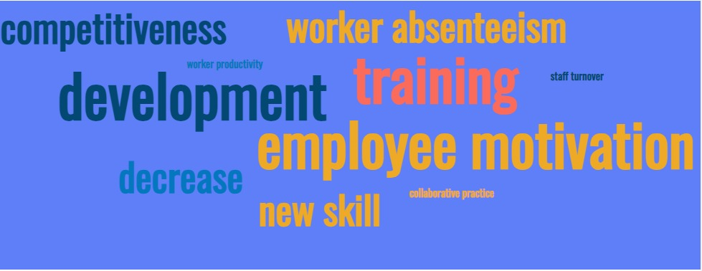
Figure 12: Word Cloud for Theme 1
(Source: Self-created)
The concept of training and developing are considered an essential benefactor to contribute to the performance index of employees.
Employee 1 assertions that "proper training and development scopes increase the acceptance of new skills and learning," proving the statements in the preceding statement.
Employee 2 believes that training and development programmes are "extensive growth programmes for employee future development."
Employee 5, on the other hand, claims that "training and development programmes increase job confidence, which increases worker productivity."
Employee 6 has also stated that "aside from job confidence, training programmes also improve employees' collaborative practises, allowing them to work on multiple scenarios."
Employee 7 has confirmed, however, that "training packages offered by organisations tend to be designed for their own advantages rather than the benefits of the workers."
Employee 8 has also stated that "while training programmes may be successful at learning new skills, the majority of the skills are organization-specific and are only centred for their long-term benefit."
Aside from that, employee 5 disagreed with employees 7 and 8, arguing that "training and developmental programmes are critical in adding to the cultural advancement of the organisation." Employees 9 and 5 shared comparable perspectives on the impact of training programmes.
Employee 10 stated that "training programmes increase employee motivation for work even more."
Similarly, employee 3 stated that "proper training programmes facilitate decreased organisational staff turnover."
While employee 4 said that “it decreases the absenteeism rate of employees as they are more satisfied and well-trained for their job role”.
Training and development have an indisputable impact on employee productivity since they improve both the work environment and the general development of the organisation. Employees continuously push for the execution of excellent training programmes, recognising the importance of these programmes in improving efficiency rates. Such programmes promote continual development and allow employees to learn new abilities that they are able to immediately apply to their business operations. Furthermore, comprehensive training instills job confidence in employees and fosters a collaborative atmosphere, increasing their productivity. In conclusion, investing in training and development activities has a significant impact on employee productivity, resulting in tangible advantages for both people and the organisation as a whole. This increases the job satisfaction of employees and makes them more independent in their workspaces. With rejuvenated enthusiasm, organizations are likely to administer lower staff turnover and ultimately less absenteeism to promote business growth. However, there are also employees who believe that training programs are usually an organization's way of increasing its employee retention strategy. The training programs provided by the organizations are usually catered for business benefits of the companies and are not typically meant for professional gain for employees. Therefore, for any business to thrive in the corporate sector, it is essential to invest in appropriate training and development scope for its workforce which would not only increase the satisfaction levels of employees, but would also contribute towards market gain.

4.2.2 Enhancement of employee productivity through training and development
Participants | Question | Answer
2 | Q9 | The development of strong problem-solving and decision-making skill after participating in the training and development program.
6 | Q9 | Participating in the training and development programme helped to gain useful skills and approaches that have been successful in overcoming obstacles.
7 | Q9 | Through their training and development, it aids in acquiring self-discipline and problem-solving skills.
9 | Q7 | As part of their training and development program, it develops self-discipline and problem-solving abilities.
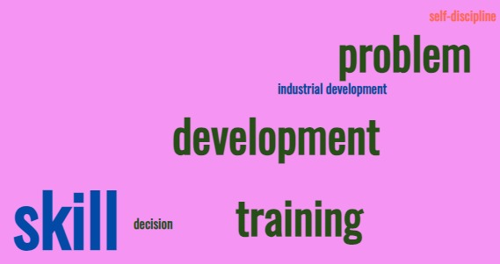
Figure 13: Word Cloud for Theme 2
(Source: Self-created)
McDonald's have an appreciable power over the market, therefore it is essential for the fast-food chain to invest in suitable training and development programs for its workforce to enhance their skill development.
Employee 1 answered that “McDonalds needs to participate in more training programs for its employees since that would train the employees for new responsibilities”.
However, employee 2 answered that “necessary training and development programs would help employees to learn about the industry McDonald's belongs to and the current market trends”.
In a comparable manner, employee 3 stated that "acquiring knowledge about industrial developments would help workers build agility and promptness in their work delivery."
Moreover, employee 4 stated that “initiating workers' training schemes contributes to the enhancement of the professional development of employees with the knowledge of new soft and technical skills like handling of machinery and cooking equipment, as well as learning new recipes”.
However, employee 5 also added that “training programs make every employee independent, wherein they improve in the management of tasks and handle each task individually or in groups”.
Further, employee 6 has confirmed that “training and development programs in McDonald's are significant in enhancing collaboration and teamwork skills of employees, bringing cohesiveness in work delivery”.
On the other hand, employee 7 has stated that “Mcdonald's offers training programs for its employees to instill the required skills, usually pinpointed by employers to maximize the productivity levels of employees”.
On a similar note, employee 8 has also answered that “while McDonald's offers training to its employees only for self-gain, it helps in inculcating continuous improvement ability of the employees, wherein they require less supervision with time”.
Nonetheless, employee 9 has confirmed that “Mcdonald's implements training for its staff and employees to inculcate job confidence and timely delivery of work”,
While employee 10 believes that “the significance of training programs are beneficial for improving employee engagement in the workplace”.
The importance of development and training initiatives at McDonald's is apparent, since they successfully foster workers' advancement as professionals. The responses certainly show that greater training efforts are needed within the company. Employees are not only given new competencies and duties through these programmes, but they are also educated about the sector and current market conditions. This knowledge enables individuals to develop a work identity customised to their abilities, allowing them to operate independently and efficiently. In general, the concentration on training and development is critical in improving staff competencies and performance at McDonald's, thereby supporting their progress within the organisation. The increased job confidence and independence of the employees makes them a reliable asset of the organization with lesser need of supervision. However, many employees also believe that the training programs appointed by McDonald's are usually overlooked by the employers to inculcate the business values among its workforce that is required to Long-term benefit of the organization. Although it increases the engagement, team-building, and coordination skills between employees, it hardly contributes to Long-term professional gain of employees. Therefore, it is essential for McDonald's to invest in training programs which can indulge in the independent development of employees.

4.2.3 Necessity of training in increasing organisation productivity
Participants | Question | Answer
1 | Q3 | Training and development programmes play an essential role in fostering organisational cultural growth.
5 | Q3 | Higher involvement in the work process and higher motivation have resulted from a well-organized educational and training programme.
10 | Q3 | The significant role of training programmes stems from their potential to increase employee engagement in the workplace.
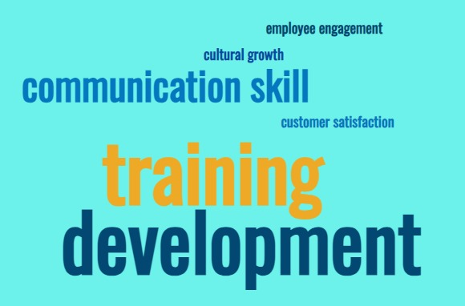
Figure 14: Word Cloud for Theme 3
(Source: Self-created)
The effectiveness and efficiency of an organization can be directly impacted by training. When the question regarding the need for training the participants to increase organizational productivity was raised,
Employee 1 responded by saying that “Training and development programs assists them in staying competitive and increasing the organization’s productivity.”
While, on the other hand, employee 2 was of the opinion that “Training programs help in developing team spirit and communication skills within the organizational staff”.
Similarly, employee 4 stated that “training programs in McDonalds provide them with an opportunity to broaden their knowledge base about the process of customer satisfaction and improve their job skills”.
In addition to that, employee 5 also believes that training programs in their organization help them in “remaining current and up to date in their profession”.
Additionally, on similar grounds, employees 6 were of the opinion that “by participating in training and development programs, they are able to develop new communication skills and become more familiar with their roles and responsibilities”.
This as result increases their morale and job satisfaction levels that have a direct impact on the productivity and performance of the organization. Most of the employees had similar views on the necessity of training programs in the organization.
Employee 9 remarked that "training and development programmes can improve law and regulation conformity."
Employee 10 went on to say that "training in the organisation is essential to boost the motivation level of employees to perform their job well and increase the company's efficiency."
Analysing McDonald's employees' perspectives on the importance of training demonstrates its critical significance in increasing organisational productivity. Programmes of training are believed necessary for strengthening staff technical skills and allowing them to carry out their tasks more efficiently. Employees understand the importance of these programmes in increasing overall productivity and lowering manufacturing expenses in order to satisfy the expectations of a competitive market. Employee training is becoming increasingly important for engagement as the business faces substantial labour shortages. In conclusion, the importance of training in McDonald's is clear: it not only improves employee abilities but also performs an important role in enhancing organisational efficiency and maintaining market competitiveness.Furthermore, as employee 4 observed, providing training to employees not just helps improve their knowledge and skills, it also has a direct impact on customer satisfaction and customer experience. For McDonald’s improved productivity, training and development of employees is of utmost importance as it fosters knowledge and skill development and increases employee motivation and engagement. It also encourages a culture of continuous learning within the organization and ensures compliance with processes and laws.

4.2.4 Obstacles encountered during the performance of staff training
Participants | Question | Answer
3 | 8 | McDonald's has seen an increase in personnel turnover, which has made it difficult for participants to engage in the work environment.
4 | 8 | In McDonald's training and development programmes, the key experienced hurdles, mainly language barriers that impede interpretation of materials and instructions.
6 | 8 | It has detected uncertainty over conflict resolution and other related issues that impair the training style's execution.
7 | 8 | The changing culture of the firm creates growth and learning problems, as efforts must take into account the various demands and tastes of a diverse collection of employees.
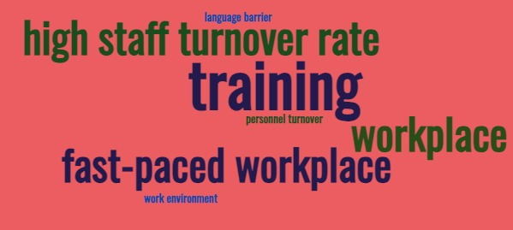
Figure 15: Word Cloud for Theme 4
(Source: Self-created)
Organisations have to conquer a number of obstacles while carrying out staff training in order to guarantee positive results.
From the assessment of the survey, the first employee responded that “Training initiatives are frequently difficult and tricky, but they are essential for improving staff productivity, skills, and understanding”.
For training initiatives to be carried out successfully and to have the greatest possible impact, it is crucial to recognise and solve these issues. The process of determining the requirement for training presents a substantial obstacle during implementation.
Employee 4 countered, saying, "McDonald's is notorious for its high staff turnover rates and its fast-paced workplace , with numerous staff members departing the firm within a short period of time”.
In the opinion of respondent number 5, "McDonald's works in a fast-paced workplace where staff must manage numerous jobs at once. They only have a limited amount of time to take part in extensive training programmes as a result”.
Employee 7 adds, "The company's changing culture presents challenges in learning and growth, as the initiatives must take into account the distinctive needs and tastes of a diverse group of workers."
In addition, it is noted that the second employee expressed the opinion that "Language barriers make it tough for employees to completely grasp and participate with the training resources and directions.
Conducting training programmes for workers presents a number of obstacles for organisations seeking to improve worker competence, efficiency, and comprehension. Identifying requirements for training becomes a huge challenge, made even more difficult by McDonald's employee turnover rates, which necessitate ongoing education for new staff, using important resources. Furthermore, supporting varied workers with varying needs and preferences in training programmes increases complexity. To overcome these obstacles, adequate preparation and allocation of effort, time, and monetary funds are required to enable the efficient implementation of staff development projects. It has also drawn attention to the difficulty McDonald's staff members experience in finding enough time for thorough training because of the fast-paced nature of the workplace. Employee involvement and understanding of training materials and instructions are often hampered by language problems. It is critical to adequately address these issues if successful training programmes with maximum impact are to be achieved. Therefore it can be said that organisations like McDonald's over these challenges and construct efficient training and development programmes by recognising the need for training, giving enough resources, taking into account the various staff demographics, and putting language assistance mechanisms in place.

4.2.5 Improved productivity after training program.
Participants | Question | Answer
1 | 5 | Improving time management abilities and providing better service to clients.
2 | 5 | Following the training and development programme, various changes were seen, including the growth of team-building spirit and enhanced communication skills.
9 | 7 | Realisation of the significance of collaboration and improved the work abilities
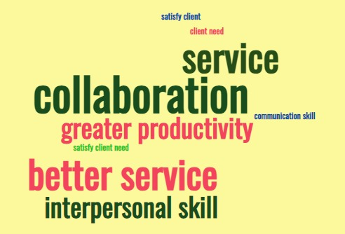
Figure 16: Word Cloud for Theme 5
(Source: Self-created)
According to the 1st employee , "the programme assisted in the development of enhanced interpersonal skills, greater productivity, sympathy, capacity to solve problems, and the ability to handle challenging situations. It assists in becoming more proficient at providing a great customer experience, which promotes client happiness and loyalty."
Employee 4 noted that "McDonald's training and development programme frequently includes engaging tasks and simulation that foster cooperation and cooperation among employees. These experiences have taught the value of working collaboratively successfully, using each other's skills, and encouraging one another in order to achieve common goals and enhanced interpersonal skill. They learn collaboration, cooperation, and dispute resolution competencies, which are necessary for a fast-paced and diverse professional setting."
According to employee 5, "This programme teaches employees how to prioritise tasks, manage their time efficiently, and operate with an awareness of pressure without sacrificing quality. Employees have the capacity to undertake various jobs at the same time as a result of the programme, resulting in greater productivity and the ability to satisfy client needs effectively."
Employee 6, on the other hand, stated that "this programme helps to learn to analyse circumstances, discover possible fixes, and make educated choices to effectively resolve difficulties." Employees acquire critical thinking skills, flexibility, and the capacity to make solid judgements under pressure by confronting obstacles and actively participating in problem-solving activities.
McDonald's development and training programme has effectively equipped staff with a variety of useful characteristics, such as improved communication skills, empathy, capacity to solve problems, and the capacity to deal with stressful circumstances. As a result, client interactions have gotten better, contributing to higher satisfaction among customers and engagement. Worker collaboration as well as collaboration have improved as a result of the program's emphasis on enjoyable events and simulations. Addressing hurdles in the staff development execution process has been fruitful, demonstrating the beneficial effect of McDonald's training activities on both staff members and consumers. Employees get valuable insight into the importance of collaboration, using one another's abilities, and being there for one another in order to accomplish shared objectives through these experiences. They gain skills in teamwork, cooperation, and conflict resolution, all of which are crucial in the dynamic and varied professional environment of McDonald's. The enhancement of effective cognitive and time management abilities. Employees learn how to prioritise projects, efficiently manage their time, and complete jobs under pressure without sacrificing quality with this programme. Employees are able to manage numerous tasks at once as a consequence, which increases productivity and makes it possible to efficiently address consumer requests. The program's effects on decision-making and problem-solving abilities. Employees gain the ability to analyse problems, find viable solutions, and take well-informed decisions through the programme. They learn how to think critically, how to adapt, and how to make good decisions even while under duress. It has been summarised that the training and development programme at McDonald's has had an advantageous impact on employees, giving them stronger interpersonal abilities, empathy, problem-solving aptitudes, operational teamwork and collaboration aptitudes, successful time management and multitasking aptitudes, and strong problem-solving and decision-making aptitudes. These acquired skills help employees develop personally and professionally, and they also improve customer experiences, boost efficiency, and help McDonald's as a whole succeed as a business.

4.2.6 Strategies for addressing training and development difficulties
Participants | Question | Answer
7 | 10 | Employees will find the programme more enjoyable and beneficial if it includes social events and aspects of role-playing.
5 | 10 | Giving feedback following everyday tasks can be an effective way to positively correct employees' gaps.
4 | 10 | The organisation may conquer the problems of training staff members by assessing their capabilities and measuring the success of their training.

Figure 17: Word Cloud for Theme 6
(Source: Self-created)
The employees of McDonald’s were asked about the strategies they think are necessary for improving the training and development programme and the ways in which they can overcome the challenges associated with it.
According to employee 2, “by focusing on individual strengths of the team members, the organisation can develop a cohesive team that is able to overcome training and development challenges”.
Similarly, employee 3 is of the opinion that “training and development programs can be customized in order to meet the needs of each individual employee”. This is because every employee is unique and has his or her own skills and goals.
On the other hand, employee 4 stated that, “the organisation should make these programs accessible and available for all employees at a greater frequency”.
Furthermore, in accordance with all these replies, employee 6 stated that “training and developmental programs should be more interactive and engaging”.
Employee 7 also stated that “the program can be made more enjoyable and beneficial for employees by including group activities and elements of role-play in the program”. This will help in overcoming challenges related to cultural differences and language barriers.
Moreover, employee 8 answers that, “greater guidance and feedback can help in overcoming the challenges associated with training and development in the organisation as the employees will be able to know that they are making progress and are on the right track”.
As per employee 10 who responded that “the organisation can overcome the challenges of training the employees by evaluating their capacity and quantifying the effectiveness of their training.”
According to the responses provided by the participants, The McDonald's organisation can put methods into place that concentrate on comprehending specific staff capabilities in order to solve training and development issues. The organisation can improve the effectiveness of the training and development programme by tailoring it to meet certain employee demands and offering relevant training for their work positions. To guarantee the program's success, customised development plans can be used. Additionally, scheduling proper time of conducting the programme is essential to ensure no employees do not miss them and their development is consistent with all others. Moreover, keeping the employees engaged is important and understanding their cultural differences and similarities is needed to improve the programme of training and developing them. In addition, as employee 8 mentions, providing real-time feedback is crucial for accelerating employee performance. Measuring the performance of the employees post training is an effective way of assessing and improving the employee training programs.

4.3 Discussion

4.3.1 Importance of training and development in staff productivity
According to Karim et al. (2019), employees are an organization’s most valuable assets and hence, investment in training and development plays a pivotal role in establishing the objectives of the company, followed by the sustenance of the company’s growth and productivity. Considering the commitment needed to pursue lengthy business processes for recruiting and hiring credible, proficient and competent human capital, the reliance on training and development forms a cohesive framework for fostering employee engagement and an efficient and competitive workforce that stands critical to the firm’s performance and brand valuation (Kenny, 2019). As a result, Nguyen, (2020), mention that almost 93% of the employees in renowned organizations like McDonalds, retain their job profiles over the company investing in their “career development” as well as ensuring that the employees suffice in increasing their job satisfaction, improved productivity and revenue generation. Furthermore, as per Sheeba and Christopher, (2020), the businesses featuring actively interested and dedicated staff reflect only 41% lower “absenteeism rates” as well as 17% higher productivity has also agreed upon by McDonald employee 3.
Moreover, according to Rodjam et al. (2020), several organisations rely on training and development during significant periods of employee turnover while realising the importance of delivering consistent and ongoing training programmes.Vincent, (2020), points out that formalised training programmes assist in measuring the strengths and weaknesses of the organisation’s staff with respect to aspects such as resilience, adaptability, digital fluency, communication, interpersonal skills, collaboration and others. Therefore, Jain and Sharma, (2019), believe that training and development mainly revolves around learning precise skills or knowledge that would cater to a more “expansive employee growth plan” for future performance as well as help employees function both individually and as a team for organisational achievements as stated by employee 2 at McDonalds. Thus, it helps in determining the importance of training and development in improving employee and corporate performance simultaneously while also building a proportional relationship between “training and development” and “staff efficiency”.

4.3.2 Training and development influencing productivity and performance of employee workforce
As a critical move to enhance the productivity and performance of the employee workforce, training and development programmes are “catalysts” that assist in boosting the scope of success for the individuals in improving their engagement and satisfaction in their roles in the organisation through “in-house trainings”, “third-party trainings” or “off-site activties” as major career-based opportunities (Nwali and Adekunle, 2021)). Furthermore, Al-Rawahi, (2022), states that these programmes are beneficial aspects for the retention of the employee as a result of skill-building in their current job profiles, followed by introducing “leadership skills” and “software knowledge” for the future. In addition to the above, the process of training and development is also an important facet of shaping the organisational workplace culture which, as viewed by employees 5 and 9 at McDonalds, while also aiding in motivating and encouraging employees at work, as per McDonald employee 10.
However, Hamadamin and Atan, (2019), project that training and development programmes might only foster the organisation’s long-term benefits through skills suitable for the concerned organisational structure and not the employee’s well-being in the company, attested by McDonald employees 7 and 8. Nonetheless, Ali and Anwar, (2021), contradict the notion by stating that training and development programs do spike the employee productivity and performance with a decrease in the “staff turnover rate” and increased opportunities for employees in their learning process. According to Avtgis, (2023), better understanding of processes and clearly defined goals are crucial factors that discuss the influence of training and development programmes on the employee’s productivity and performance while making the workforce well-versed in their respective skills to save their time and the company’s expenditure in finding solutions for the tasks. Furthermore, the enhancement of the competencies and capabilities of the “proficient personnels” provides a positive influence on the employee’s engagement to the change process and innovation while ensuring a quality output of the organisational operations through the training and development process.

4.3.3 Employee Training as an aspect of improving organisational productivity
As per De La Torre et al. (2022), it is imperative that the effectiveness of training and development programmes for upscaling the employee’s technical and interpersonal skills for efficient contribution to the organisational goals has seen solid returns of investment with higher proficiency affecting the employee’s and the organisational productivity simultaneously. Since McDonalds has struggled with staff shortages over the years, the opinion of employee 4 testifies on the training process meant for catering not only to the employee’s skill enhancement but also to emphasise on customer satisfaction and loyalty for the organisation’s sustenance in the industry. Thus, El-Khatib et al. (2022), evaluates learning and development seminars and programmes aiming to make the objectives and goals of the organisation more transparent and relevant to the personal aspirations of the workforce while increasing the competitiveness of the internal workplace environment. For instance, the establishment of flexible and micro-based training techniques as per the convenience of the employees and the management, during the working hours, assists the organisational productivity through diverse opportunities pertaining to the same.
In cognizance with the performance of the employees, training and development provides a fair ground for preparing the employees to venture into new assignments by optimising the employee’s performance and boosting the engagement as a driving factor of the organisation. This further related to the response of employee 5 of McDonalds who states that as a fast-paced workplace, the need for “team-building spirit” and effective communication strategy is bound to be adhered to through such training and development programmes as well as by learning how to prioritise tasks and manage time in the due course of the employment. Therefore, investment in training and development imbibes the discovery of cognitive thinking processes as well as assists in analysing organisational circumstances while monitoring the staff cooperation to counter conflicts subliming the organisation’s functionalities for higher productivity and performance of the company.

4.3.4 Issues related to executing the training process of employees
Despite the efficacy and affluence of training and development of the human capital functioning in an organisation, the relapse of ineffectiveness over lack of constructive job training regimes, poor on boarding and recruitment process as well as a decline in employee engagement and motivation initiate the need for a proper training programmes that counters the above issues. Furthermore, according to Masenya, (2022), resistance of the workforce in incorporating new tools or software in the organisation might trigger the employees feeling burdened over the value of change management for improving the productivity of the organisation.
The immediate focus involved with the immediate processes of recruiting the employees lies with the factors of on boarding of the potential workforce. According to Aldawood and Skinner (2019), the initiation of the training programs is considered to be developed with the encouragement of the employees on the basis of the requirements of the job roles. This has been perceived to be creating major hindrances in leading the service oriented aspects. In addition to this, the navigation of the variations in the workplace without the adaptations to the standards of anticipation of the workforce have been observed to be acting as the major criteria indulged with the resistance to the changes associated with the work. The effectiveness of performing standards of the factors have been considered to be navigating the needs of the training and developmental aspects in detailed processes. This eventually raised the potential obstructions in relating the consequences of future times in generating the required outcomes. The ineffective methods involved with the training programs have been evaluated to obtain the hindrances in generating the fruitful conclusions. The significant rise in the innovative aspects associated with the "employee engagement" have been taken into consideration while balancing the production scale that were hampered by the common issues leading to the worsened conditions of work.

4.3.5 Effective strategies for mitigation of training and development challenges
The involvement of the several efficient tactics required for the mitigation of the training as well as developmental threats. The tailoring of the skill as well as the development of the experiences that distinctively add to the objectives as well as interests of the workforce. According to Pham et al. (2019), the placement of the skills along with the development of the learning experiences are considered to be involved with the tactics of developing the suitable base required for the provision of the skill as well as position across business organizations. The implementation of the training tactics has been considered to be burdened with the geographical limitations as well as the cost-oriented factors leading to the optimal environment of work. The necessity of the training of the employees have been observed to be affected by the critical factors of enhancing the training programs involved with the uses of several techniques of efficient programs. As Cop et al. (2020), acclaimed that the delivery of the potential outcomes have been considered to be generated through the consistent factors of overcoming the potential limitations as well as linguistic barriers that are considered to create major issues of translating followed by the virtual sets of requirements involved with the training. It has been observed that the complications involved with the training programs requiring the potential trainees to hold the demands involved are suitable for gaining the required recognition in the workplace. In addition to this, the new role of the technological factors lead to the research as well as development of the several factors engaged with the constant evolution of the workplace. Through the development of the factors of suitable communication have been observed to be mitigating the potential complications involved with the collaborative actions. The continuation of the deployment of the factors influencing the behavior of the workforce is considered to lead to the reducing of the suffering due to the factors of chaos in decentralisation of the organizational functions.

4.4 Conclusion
The finding chapters are an important aspect of any research project, but they are especially relevant for this study as the study emphasizes on investigating how training and development activities impact employee and organizational productivity. McDonald's is heavily focused on employee training and development in order to improve their productivity. In the above chapter, valuable insight is provided regarding training and development programs available to the employees of the organization. The chapter helps in understanding what are the ways in which training programs can assist the employees and what are the challenges associated with these programs. Further, the study also discusses the mitigation strategies for overcoming the problems associated with the program.

Chapter 5: Conclusion

5.1 Introduction
The “training and development” of staff is essential for any organisation to remain competitive in an ever-changing business environment. The above study has illustrated the impact of T&D on the productivity of Mcdonald’s employees. In this study's conclusion, the topic matter has been critically discussed and summarized. Also, the chapter provides some recommendations for filling future research gaps more effectively.

5.2 Discussion
Training and development are essential for the employees of an organization as this enhances the productivity level of an employee (McDonald et al. 2022). An employee is the prominent essence of the organization and an organization survives on the contribution of work from the employees. An organization is a new place for an employee to explore and understand its significance. to enhance the working capacity and to multiply the productivity of the employee and the organization, development, and training through various methods are necessary (Islam et al.2022). The organization has to follow and execute a few objectives to meet the respective program of the organization. The first objective is “To understand the importance of training and development programs to workers in improving organizational activities” To meet this objective, the respective research aligned to the United Kingdom has incorporated and implemented various development programs to enhance the productivity of the employees. The programs include many tasks that are equally distributed according to the capacity of the employees and progress toward increasing the capability. with proper supervision, the organization has possibly met the respective objective which is required for the particular organization (Chen, and Li, 2022). The employees also understand the significance of the program as this enhances their capabilities to a certain extent and also assists in understanding their respective capabilities that are required for the organization. Additionally, the next research objective is “To reveal particular training and development frameworks utilized by Mcdonald’s inside its company”. To meet this particular objective the respective research has revealed the particular training and development strategies to the employees. such as “in-house training” or “third-party training”. the organization has developed many strategies out of which the “in-house training” focuses on the employees and the training is developed in the particular organization by the particularly recruited trainers or supervisors. this way the employees are trained more particularly and this also boosts up the confidence level of the employees. The respective employees are aware of the flaws and requirements in their work, hence the respective training process assists in improving the quality of the employees and the employees become much more confident regarding their quality (Dhand et al. 2022). With the introduction of the “third-party training” process, the organization focuses on the employees and trains them through third-party involvement distinctively. this assists the employees in interacting with unknown corners of the requirement in the quality and also enhances the working productivity. The third objective that the organization has met is “To facilitate the connection between training and development and staff engagement”. To meet the objective the research has established a relationship between training and development. The respective organization has incorporated training sessions in the organization to analyze the required development that is necessary for the employees. The training is to understand and analyze the potential of the employees and where the actual development is required. After the execution of the training, the development phase is introduced as the final step of enhancing employee productivity (Singh, 2019). the development ensures the enhancement of the employee productivity level. the organization develops itself in every program that it organizes for the employees. this shows that the training and development of the employees also enhance and leverage the level of the organization. The next objective, which is the fourth objective “To understand how development may support workers to ascertain new potential” is met by the understanding of the significance of the objective. The organization “McDonald’s” is a prominent food brand and organization around the globe. The organization is strict toward employee training and development for the progress of the organization. Additionally, the scope of innovation is nothing new to the organization as to survive in a multi-dimensional and dynamic environment an organization has to evolve all the time in terms of everything (Mira, and Odeh, 2019). Hence, the process of obtaining new abilities is also required to understand the changing and modifying demons of the economy. An organization is made of its employees and that is why development assists in ascertaining innovative abilities in the employees so that the organization can move along with the modifying phase of the economy. The training programs are commenced to identify the possible requirements of enhancements and the developments are executed on the basis of that. As development is the last stage of the training process, the first step is identifying (Ju, and Li, 2019). The organization at first identifies the required field to train all the employees, then it focuses on the part which is required to be rectified specifically and then the employees are trained by providing them with appropriate tasks where the employees learn and understand the organizational process and try to appropriately work according to it (Ozkeser, 2019). The employees are provided with challenging tasks that make them analyze their potential.

5.3 Recommendations
Following the completion of the given study, it is evident that certain specific areas have not been adequately addressed, resulting in further improvement being necessary. In this regard, some recommendations may be useful in order to appropriately state the subject matter. Firstly, not much insight has been provided in the study on the effects of “training and development” in an organizational culture and the productivity of the employees. Therefore, a more comprehensive knowledge can help in understanding the effects of the “training and development” program and the unknown aspects related to it (Kareem, 2019). Moreover, the study should address other areas such as “job satisfaction and employee morale” that are important factors for the successful implementation of “training and development” programs in an organization (Nguyen, 2020). Furthermore, the study does not emphasize the manner in which “training and development” influence communication and cooperation effectively. Therefore, the study needs to provide a comprehensive assessment of the problem areas in order to facilitate future research.
Moreover, from the study, it is apparent that the “primary qualitative methodology has been adopted for the successful completion of the study. In spite of the fact that this method has provided scope for discussing the analytical aspect in a structured manner, the adaptation of the method has made the process more time-consuming and prone to error (Nayak and Narayan, 2019). Hence, it is evident that adopting a “mix method” that combines primary as well as secondary sources would be effective and advantageous for presenting the study in a coherent manner. Additionally, the research must integrate appropriate materials into the study in order to effectively present the impact of T&D programs on various aspects of employee performance.

5.4 Future scope of the study
The above-conducted study has the potential for providing greater insights into increasing employee productivity and performance through “training and development” strategies. For future research on the topic, the researcher can investigate and conduct a comparative analysis of “T&D'' programs of Mcdonald's and its rival fast-food firms. The study can also focus on the “impact of technology” in these programs and the way in which it assists in increasing staff productivity in the organization. Furthermore, as Alal and Florah, (2021) point out, along with employee productivity, the researcher can investigate the impact “training and development” strategies have on the retention rates of McDonald's employees and the subsequent role played by motivation. Moreover, Olimovich et al. (2020) state that there is also a scope for studying the impact “T&D” programs have on employees’ quality of customer service and overall rates of customer satisfaction. Leadership roles in training programs can also be further investigated in a comprehensive manner.

5.5 Conclusion
Thus, it can be concluded that the probable findings of this study were critically examined and effectively discussed in this section of the study. As part of the study, all the necessary results were evaluated that provided significant conclusions with regard to the subject matter. The chapter provides useful recommendations for the study and identifies the areas that need further investigation for a complete and coherent study.

