

Programme Name: Master of Business Administration
Name and Code of Module: Marketing Management and LCMB7024
Title of Submission: Strategic Brand Extension for Netflix: Developing Netflix Play to Enhance Digital Entertainment and Customer Engagement
Lecturer’s Name: Dr. Tola Odugbsesan
Student ID: 2530032
Student Name: Niral PopatBhai Ranavaya
Word Count: 2732

Table of Contents
Introduction 3
Element 1: Brand Extension Poster Presentation 3
Element 2: Develop a Segmentation, Targeting, Differentiation, and Positioning (STDP) Analysis for the brand extension 4
Element 3: Marketing Mix 8
Element 4: Reflection 12
Conclusion 13
References 14
Appendix 18

Introduction
Netflix is a leading advanced digital streaming company known for its innovative entertainment services. In today's competitive market, brand development has become extremely important for precise rapid growth and overall customer engagement. This entire report specifically presents a special new brand extension called Netflix Play, which is a high-quality interactive gaming platform. Its main objective is to analyse how this entire extension can quickly attract all users using advanced marketing strategies such as STDP and marketing mix. Additionally, it can be quickly analysed in the proper way how it can particularly help increase engagement from various aspects and contribute to different business growths.

Element 1: Brand Extension Poster Presentation
Netflix Introduction
Netflix is a globally advanced digital streaming platform that specifically provides movies, series, and all of its own content to millions of users around the world. It is particularly known for innovation and customer-centric entertainment.
Idea of Brand Expansion- Netflix Play
Netflix Play is an advanced platform specifically integrated with the entire Netflix app for interactive gaming and storytelling. All users can play games, choose parts of the story in the correct way, and quickly enjoy all the exciting entertainment experiences here (Pajkovic, 2022).
Market Appeal
This special high-quality expansion is designed targeting Gen Z and Millennials, who prefer interactive and fully personalized content in various ways. It grows rapidly along with the increase in advanced digital gaming and screen time. As per Hsiao (2024), Netflix Play aligns accurately with current entertainment trends and quickly increases overall user engagement.
Alignment with Sustainable Development
Netflix Play uniquely encourages advanced digital usage, which significantly reduces the diverse requirements of various physical gaming products. It greatly helps in minimising different kinds of impacts on the environment and specifically supports sustainable business practices.

Element 2: Develop a Segmentation, Targeting, Differentiation, and Positioning (STDP) Analysis for the brand extension
Segmentation
Segmentation greatly helps Netflix to meaningfully divide the entire market based specifically on all customer characteristics. For the proposed brand extension Netflix Play, four main segmentation variables are specifically used.
Geographic Segmentation
Netflix precisely operates its various high-quality activities in more than 190 countries in the worldwide. It quickly reaches over 700 million viewers across the globe. Its main markets include North America, Europe, and Asia-Pacific, where the use of various advanced digital infrastructures and smartphones is extremely high (Straubhaar et al., 2025). Emerging markets like India are also very important. Because it seems that Netflix's popularity is growing significantly faster among Gen Z users outside of the metro cities. This global expansion is particularly helpful in the rapid expansion of the entire Netflix play.
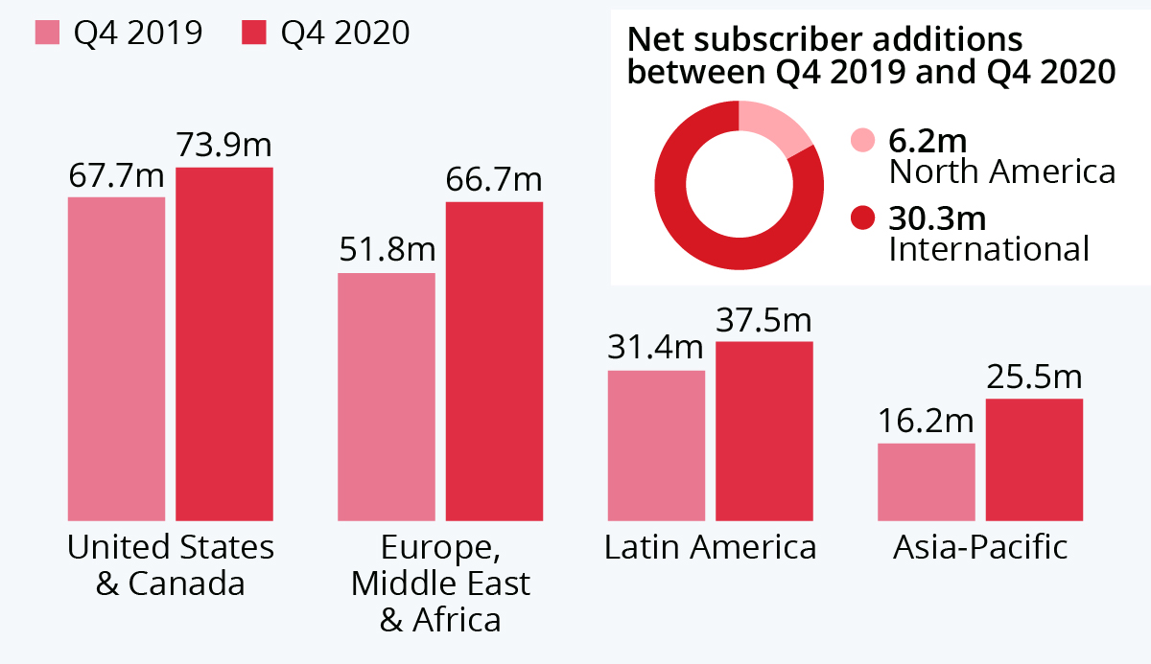
Figure 1: Netflix Global Expansion Growth
(Source: Richter, 2021)
Demographic Segmentation
All individuals aged 18-40 are included in the main demographic category. This is especially the Gen Z and Millennials people. This entire group forms the largest portion among Netflix users to a very high degree. Among them, only Millennials specifically represent about 41% of the viewers. All these users are generally students or various working professionals, whose disposable income is moderate and who have high engagement with digital media to a great extent (Goncharenko et al., 2023).
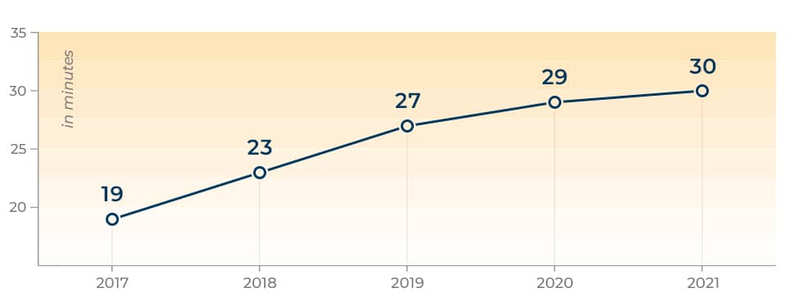
Figure 2: Netflix Streaming Age Division
(Source: Branka, 2024)
Psychographic Segmentation
Psychographically it can be said that Netflix is primarily targeting tech-savvy individuals who value entertainment, and convenience. All Gen Z consumers see streaming as a significant part of their daily lifestyle and identity (Jindrová, 2025). They prefer all personalised and immersive experiences quickly. This makes them particularly ideal for high-quality interactive platforms like the entire Netflix play.
Behavioural Segmentation
Behavioural segmentation specifically highlights all types of usage and engagement quickly. Moreover, all Netflix users are extremely active, and on average, they spend about 63 minutes daily across this advanced platform in various ways. Many users, particularly, binge-watch entire series, among whom millions of different users finish a series very quickly, almost within 24 hours of its release (Schaffner et al., 2023). Additionally, among all viewers, various gaming habits are particularly strong, as around 65% of users play games on a weekly basis, which is known to often stretch over more than 12 hours in different aspects. This particular alignment between high-quality various streaming and gaming behaviors quickly supports the relevance of Netflix Play.
Targeting
Netflix Play has adopted a special, distinct targeting strategy. This is specifically designed to quickly and accurately focus on Gen Z and Millennials aged 18-35. All these users are often particularly engaged with various online content, social media, and interactive entertainment. They also show a particularly high level of loyalty toward the brand and are highly willing to spend in different ways for an enhanced digital experience (Jindrová, 2025). For example, a significant portion of all Millennials watch Netflix multiple times a day, while all Gen Z users use it in various ways several times a week. Moreover, this entire section responds particularly strongly to novelty. According to Jindrová (2025), the increasing popularity of gaming platforms and immersive experiences proves that all young audiences are quickly leaning towards interactive entertainment rather than passively watching something. Therefore, if all these groups are targeted precisely, the usage and specifically the engagement of Netflix Play are ensured to grow rapidly.
Differentiation
Netflix Play has distinguished itself from others in the right way. Netflix has done that by uniquely combining streaming and gaming on a single platform, which is currently a rare and uncommon market (Joonas, Mahfouz and Hayes, 2023). All major competitors like Amazon Prime Video or Disney+ mainly focus on various content streaming. On the other hand, high-quality gaming platforms are operated separately in a specialized way.
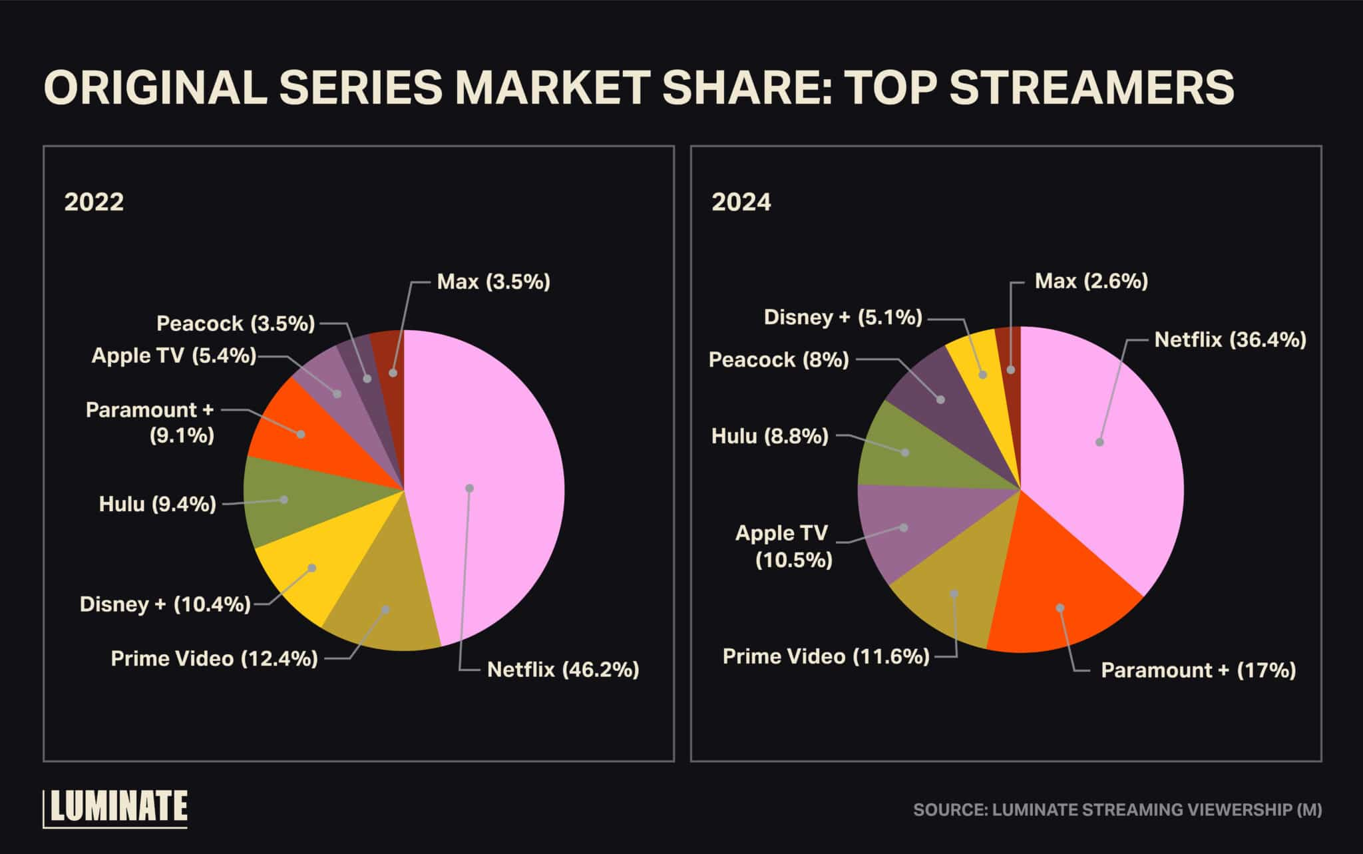
Figure 3: Netflix Beats Competition
(Source: Brown, 2025)
Although Netflix has already entered the gaming world rapidly and has downloaded games from over 81 million worldwide, its complete unique integration with various storytelling content creates a distinct advantage quickly. What Netflix Play offers:
- Various interactive storytelling experiences connected with popular shows
- No special advanced gaming devices required
- Enjoy a seamless special experience within the existing Netflix app
These integrations quickly reduce various costs for users of switching to other platforms. Additionally, they precisely increase engagement, making the entire service significantly more attractive in many ways compared to other competitors.
Positioning
Netflix Play has been precisely presented as a special innovative, integrated advanced digital entertainment platform. It provides a rapid integration of streaming and interactive gaming specifically for all modern users.
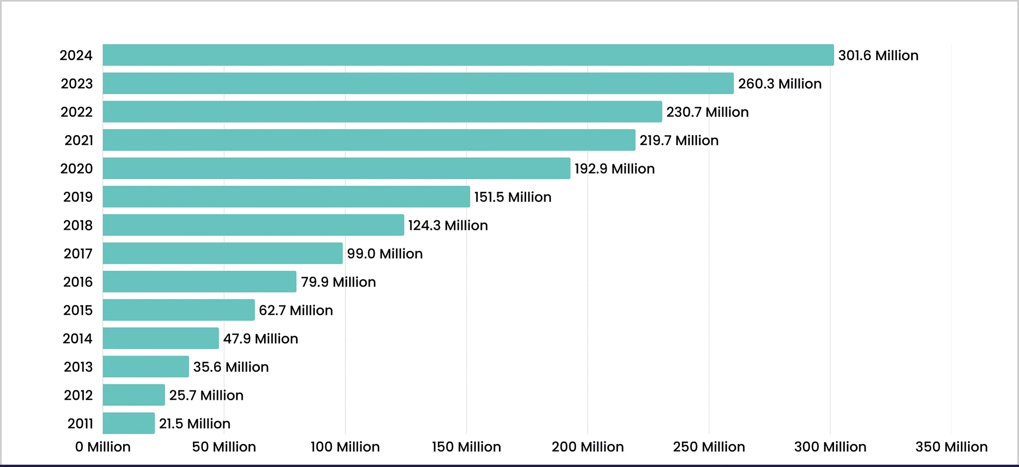
Figure 4: Netflix Subscriber Revenue
(Source: Singh, 2025)
Netflix Play integrates gaming with streaming from all aspects to provide immersive and interactive entertainment very swiftly. It delivers a highly personalized and engaging experience rapidly for various digitally active customers. It is highly consistent for Netflix with all current industry trends. Various types of entertainment are becoming increasingly interactive and immersive in different ways (Goncharenko et al., 2023). By effectively leveraging all its strong brand recognition and global presence in the right way, Netflix can establish Netflix Play as a leading entity in the next generation of advanced digital entertainment.

Element 3: Marketing Mix
Product
The main product is there has been offered by Netflix is a streaming service with subscription fees of films, series, documentaries and also original content in all parts of the world. The company has also made very strong commitments to product differentiation strategies as it is having evidenced by the fact that the company already has been spent around 17 billion a year in the production of its content (Ammar et al., 2018). Original products are also that are very much famous such as Stranger Things and The Witcher have been build brand image and lessen the dependence on out-of-house studios (Dudovskiy, 2023). This represents the differentiation strategy of Porter in which very unique content that could also add some perceived value and also create strong customer loyalty (Hosny, 2024). To make the personalised suggestions Netflix is mainly relies on sophisticated artificial intelligence algorithms with more than 80% of the viewing that are being made by recommended suggestions.
Price
Netflix has been using a differentiation pricing model that helps to provides the basic, standard and ultimate price plans to attract different kinds of customer groups. Pricing is mainly based on features, streaming quality and the differences in geographical location with such kind of prices that are going between $6.99 and $22.99 per month (Netflix, 2026). This is an aspect of price discrimination strategy where various kinds of willingness-to-pay levels are there that captured in the multinational markets with varying economic conditions (Peterson, 2026). Ad-supported plans are also there that has been introduced in 2022 are a case of penetration pricing strategy because they appeal to price-sensitive users and increase the customer base (Biswas, 2026). In the year of 2023 Netflix has stated that it has more than 260 million subscribers worldwide which is mainly indicating that the efficiency of its dynamic pricing model.
Place
Netflix is a business that is having functions under entirely digital distribution system and also offers service in over 190 countries in the whole world effectively. It is compatible with smart televisions, smartphones, tablets and game systems and it ensure versatility and accessibility (Brennan, 2018). This is typical of direct distribution strategy where middlemen are cut out and Netflix has the possibility of retaining control on service delivery and customer experience. In delivering such kind of quality videos in various parts of the world Netflix also provides the streaming technology that are based on cloud services to guarantee that the videos have a minimum buffer (Artusa, 2020). When it comes to Netflix the product is mostly distributed through households as it also consumption on televisions is nearly 70% that is why household-based consumption is very much significant (MyStudies, 2025). The use of high-speed internet is consistent with a problem to access in the areas that lack conducive infrastructure, limiting growth potential in the developing economies.
Promotion
Netflix applies such kinds of digital marketing methods as social media campaigns, trailers and collaborating with all the influencers to promote their content worldwide. The firm is there that incurs expenditure on brand awareness and customer acquisition strategy of more than 2.5 billion dollars on every year expenses on marketing (Yuan, 2023). The promotion activities also involve the content-based marketing where storytelling and teasers are done to create the anticipation prior to content release. Netflix also applies the data analytics to make more promotions content customised, enhancing both the level of engagement and the rates of conversion with the target customers (Kumar and Singh, 2024). Viral campaigns are also needed and those are created with the help of social media such as Instagram and YouTube to address all the audiences of younger age all over the world.
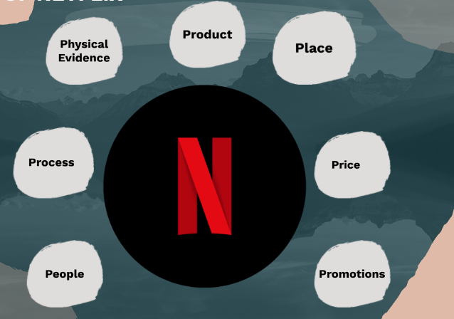
Figure 5: 7P of Netflix
(Source: AlTayar, 2025)
People
Netflix is having more than 12,000 employees that are spread all around the world and the formula is innovation, creativity and information-oriented decision-making in every sphere of the organisation. The company also encourages a sense of responsibility and some freedom where the employees are encouraged to always produce some high-quality work and innovative content (Erdoğan, 2023). Franchisers, producers and talent are there and it is more than enough to make their efforts in ensuring the Netflix preserves its competitive advantage due to a variety of narrations and international attractiveness (Patty McCord, 2014). Subscribers are also very much critical factors in that the behaviour of viewing directly affects subsequent content production and recommendations algorithms (Rahman, 2023). This has been echoing the customer co-creation strategy which means that the customer data should be influence the development of the product and the personalisation of the service which should be more efficient.
Process
Netflix also offers a very smooth user experience during the registration of the account to streaming making it more efficient and convenient along the way. Recommendations are there that are having the capacity to rank using proximate algorithms in order of user preferences and viewing history trends in real time (Bhasin, 2024). This is a parallel to service automation strategy enhancing and upgrading the operational efficiency at a cost of expanding user engagement and satisfaction on new level. Consisting of the adaptive streaming technology internet speed has been also changes the quality of the videos automatically creating some continuous viewing experiences anywhere in the world (Santosh, 2024). The ones that are downloadable enable viewing to be made offline to make it more accessible to users in areas where the internet conditions are not very stable or it could also tell it is not good. Netflix constantly has been improving its interface using some feedback and insights that are related to user behaviour in order to make it easier to use and functional.
Physical Evidence
The digital interface, branding element and the visual identity are physical evidence as far as Netflix is concerned since it has been created a strong image of the company in the eyes of users. The site has a very much effective and easy to use interface that enhancing the ease of navigation and accessibility to users of various demographic groups in the world (Hwang, 2024). The world-known red Netflix logo makes the brand more recognisable and the positioning in the worldwide entertainment market that are highly effective. Individual profile and also the recommendation systems are the tangible that displays of the customised service experiences provided by the platform which it delivers on a regular basis (Semtitans, 2024). This goes in line with branding strategy and it is very much augments confidence, recognition and quality view among all the users in different markets worldwide.

Element 4: Reflection
The advanced process of precisely developing the ‘Netflix Play’ brand extension for Netflix was particularly a highly valuable learning experience. It gave me various opportunities to quickly explore how business growth can be supported in an extremely competitive digital market. Furthermore, it can also be said how brand extension can be used within advanced strategies to rapidly increase all customer engagement.
During this entire project, I have gained precise knowledge, particularly regarding all advanced core marketing frameworks such as Segmentation, Targeting, Differentiation, and Positioning (STDP), as well as the 7Ps marketing mix. By properly applying these advanced models in a real company setting, I realized how all strategic decisions are made based on consumer behaviour market, trends and competitive analysis in the right manner. It is having selected the most highly relevant target audience and also having shown high strategic suitability of the various extensions suggested I gained all strong analytical skills of this process in no long time. The process of preparing and presenting the poster presentation greatly assisted me in practicing my communication skills and special presentation skills in numerous ways within a relatively short time. I also have been able to be learned how to deliver complicated concepts in brief and in an appealing manner under different time constraints. All of these promptly gave me a self-assurance that I could be clearly and properly articulate the marketing strategies of high quality to the audience.
However, I faced some complex challenges, particularly in creating the structure of all the content. Also, ensuring a high level of coherence among the different parts of the portfolio. Time management was another major complex issue where rapid improvement was needed, as maintaining a proper balance among all the research, analysis, and presentation preparation was quite laborious. This whole assignment has had a very positive and accelerating effect on my personal and professional growth, especially in the aspect of enhancing my critical thinking power, innovativeness and also the capacity to resolve all the issues in different manners in a very short duration. Regarding all the subsequent works I should be become more efficient in time management and utilise a wider scope of academic materials more innovatively. Through the enhancement of the skills of establishing all the advanced quality ideas more creative, more stimulating. I hope that to continue to improve my working method in a faster manner.

Conclusion
Overall, this comprehensive evaluation has particularly shown how an advanced strategic brand like Netflix Play can quickly support the overall growth of Netflix and rapidly increase all customer engagement. Through the application of STDP and the 7Ps marketing mix, the project has strongly highlighted the importance of accurately understanding the diverse needs of all customers and the overall market trends. This analysis demonstrates that innovation and effective high-quality marketing strategies can particularly strengthen competitive advantages in various ways in the digital entertainment industry and ensure rapid long-term success.

References
AlTayar, L. (2025) The 7Ps of Netflix. Available at: https://prezi.com/p/efyvvkx9xwkq/the-7ps-of-netflix/ (Accessed: 2 April 2026).
Ammar, W., Groeneveld, D., Bhagavatula, C., Beltagy, I., Crawford, M., Downey, D., Dunkelberger, J., Elgohary, A., Feldman, S., Ha, V., Kinney, R., Kohlmeier, S., Lo, K., Murray, T., Ooi, H.H., Peters, M., Power, J., Skjonsberg, S., Wang, L.L., Wilhelm, C., Yuan, Z., Van Zuylen, M. and Etzioni, O. (2018) Construction of the Literature Graph in Semantic Scholar. Available at: https://arxiv.org/abs/1805.02262 (Accessed: 2 April 2026).
Artusa, C. (2020) Promotion within Netflix extended marketing mix. Available at: https://medium.com/@Cristina.artusa/promotion-within-netflix-extended-marketing-mix-7ab860bcea82 (Accessed: 2 April 2026).
Bhasin, H. (2024) Marketing mix of Netflix and 7Ps (updated 2026). Available at: https://www.marketing91.com/marketing-mix-of-netflix/ (Accessed: 2 April 2026).
Biswas, S. (2026) Netflix just got pricier: See the new subscription costs that you will pay now. Available at: https://economictimes.indiatimes.com/news/international/us/netflix-just-got-pricier-see-the-new-subscription-costs-that-you-will-pay-now/articleshow/129849479.cms (Accessed: 2 April 2026).
Branka (2024). Netflix Statistics - TrueList 2022. [online] TrueList. Available at: https://truelist.co/blog/netflix-statistics/.
Brennan, L. (2018) How Netflix expanded to 190 countries in 7 years. Available at: https://hbr.org/2018/10/how-netflix-expanded-to-190-countries-in-7-years (Accessed: 2 April 2026).
Brown, K. (2025). How Netflix market share of film & TV originals compares with the competition | Luminate. [online] Luminate. Available at: https://luminatedata.com/blog/netflix-originals-measure-tv-film/.
Dudovskiy, J. (2023) Netflix marketing mix (Netflix 7Ps of marketing). Available at: https://research-methodology.net/netflix-marketing-mix-netflix-7ps-of-marketing/ (Accessed: 2 April 2026).
Erdoğan, Z. (2023) Netflix’s machine learning, personalization, culture and marketing strategy. Available at: https://dergipark.org.tr/en/download/article-file/2226567 (Accessed: 2 April 2026).
Goncharenko, M., Zhen, W.Z., Yang, X.Y., Ismail, N.A. and Xu, D.R., (2023). Netflix, the Success of a Global Storytelling. Journal of Business and Social Sciences, 2023. https://iuojs.intimal.edu.my/index.php/jobss/article/view/432
Hosny, A. (2024) Marketing mix: Netflix (7Ps strategy analysis). Available at: https://www.scribd.com/document/966379784/Marketing-Mix-Netflix (Accessed: 2 April 2026).
Hsiao, Y.H., (2024). The business strategy analysis of Netflix. Transactions on Social Science, Education and Humanities Research, 11(10.62051). https://pdfs.semanticscholar.org/0418/cdfee079cdbf834abd369556b64f1fc6fb43.pdf
Hwang, L. (2024) Decoding the 7 Ps of marketing: A step-by-step guide. Available at: https://www.beehiiv.com/blog/marketing-mix-7ps-guide (Accessed: 2 April 2026).
Jindrová, K., (2025). Use of Video Streaming Services Among Generations Y and Z. https://dspace.cuni.cz/handle/20.500.11956/203468
Joonas, K., Mahfouz, A.Y. and Hayes, R.A., (2023). Strategy for Growth and Market Leadership: The Netflix Case. AIMS International Journal of Management, 17(2). https://www.researchgate.net/profile/Kishwar-Joonas/publication/374545358_Strategy_for_Growth_and_Market_Leadership_The_Netflix_Case/links/652356d6d717ef1293d92426/Strategy-for-Growth-and-Market-Leadership-The-Netflix-Case.pdf
Kumar, R. and Singh, A. (2024) Marketing strategy of Netflix. International Journal of Research Publication and Reviews, 7(3). Available at: https://ijrpr.com/uploads/V7ISSUE3/IJRPR61226.pdf (Accessed: 2 April 2026).
MyStudies (2025) Netflix: Different worldwide strategies. Available at: https://www.mystudies.com/en-us/blog/our-tips/netflix-different-worldwide-strategies-17-01-2025.html (Accessed: 2 April 2026).
Netflix (2026) Plans and pricing. Available at: https://help.netflix.com/en/node/24926 (Accessed: 2 April 2026).
Pajkovic, N., (2022). Algorithms and taste-making: Exposing the Netflix Recommender System's operational logics. Convergence, 28(1), pp.214-235. https://journals.sagepub.com/doi/abs/10.1177/13548565211014464
Patty McCord (2014) How Netflix reinvented HR. Harvard Business Review. Available at: https://hbr.org/2014/01/how-netflix-reinvented-hr (Accessed: 2 April 2026).
Peterson, E. (2026) Netflix price: How much a subscription costs in 2026. Available at: https://www.businessinsider.com/guides/streaming/netflix-price (Accessed: 2 April 2026).
Rahman, M. (2023) Marketing mix of Netflix (7Ps of Netflix). Available at: https://www.howandwhat.net/marketing-mix-netflix/ (Accessed: 2 April 2026).
Richter, F. (2021). Infographic: Global Expansion Fuels Netflix’s Growth. [online] Statista Daily Data. Available at: https://www.statista.com/chart/20345/netflix-subscriber-growth-by-region/?srsltid=AfmBOor04gVyTTSIAY1bQcHgc3NCYPz5km-IAllhWBCdpolTC1gFAOOS [Accessed 2 Apr. 2026].
Santosh, P. (2024) System design of Netflix. Available at: https://medium.com/@lazygeek78/system-design-of-netflix-8a31bf9ca53f (Accessed: 2 April 2026).
Schaffner, B., Stefanescu, A., Campili, O. and Chetty, M., (2023). Don't let Netflix drive the bus: user's sense of agency over time and content choice on Netflix. Proceedings of the ACM on human-computer interaction, 7(CSCW1), pp.1-32. https://dl.acm.org/doi/abs/10.1145/3579604
Semtitans (2024) How the 7 P’s collaborate with digital marketing channels. Available at: https://semtitans.com/blog/7-ps-collaborate-with-digital-marketing-channels/ (Accessed: 2 April 2026).
Singh, S. (2025). Netflix Subscribers Statistics (2025) — Users & Revenue. [online] Demandsage. Available at: https://www.demandsage.com/netflix-subscribers/.
Straubhaar, J., Rai, S., Santillana, M. and Dalben, S., (2025). Transnational Streaming Television: Reshaping Global Flows and Power. Taylor & Francis. https://books.google.com/books?hl=en&lr=&id=fPSFEQAAQBAJ&oi=fnd&pg=PA1930&dq=+Netflix+It+quickly+reaches+over+700+million+viewers+across+the+globe.+Its+main+markets+include+North+America,+Europe,+and+Asia-Pacific,+where+the+use+of+various+advanced+digital+infrastructures+and+smartphones+is+extremely+high&ots=k6wdNDImO5&sig=J1N8wDm4bfUtI62nNcj9c0HAySM
Yuan, C. (2023) A case study of Netflix’s marketing strategy. BCP Business & Management, 42, p.185. Available at: https://www.researchgate.net/publication/369398933_A_Case_Study_of_Netflix%27s_Marketing_Strategy (Accessed: 2 April 2026).

Appendix
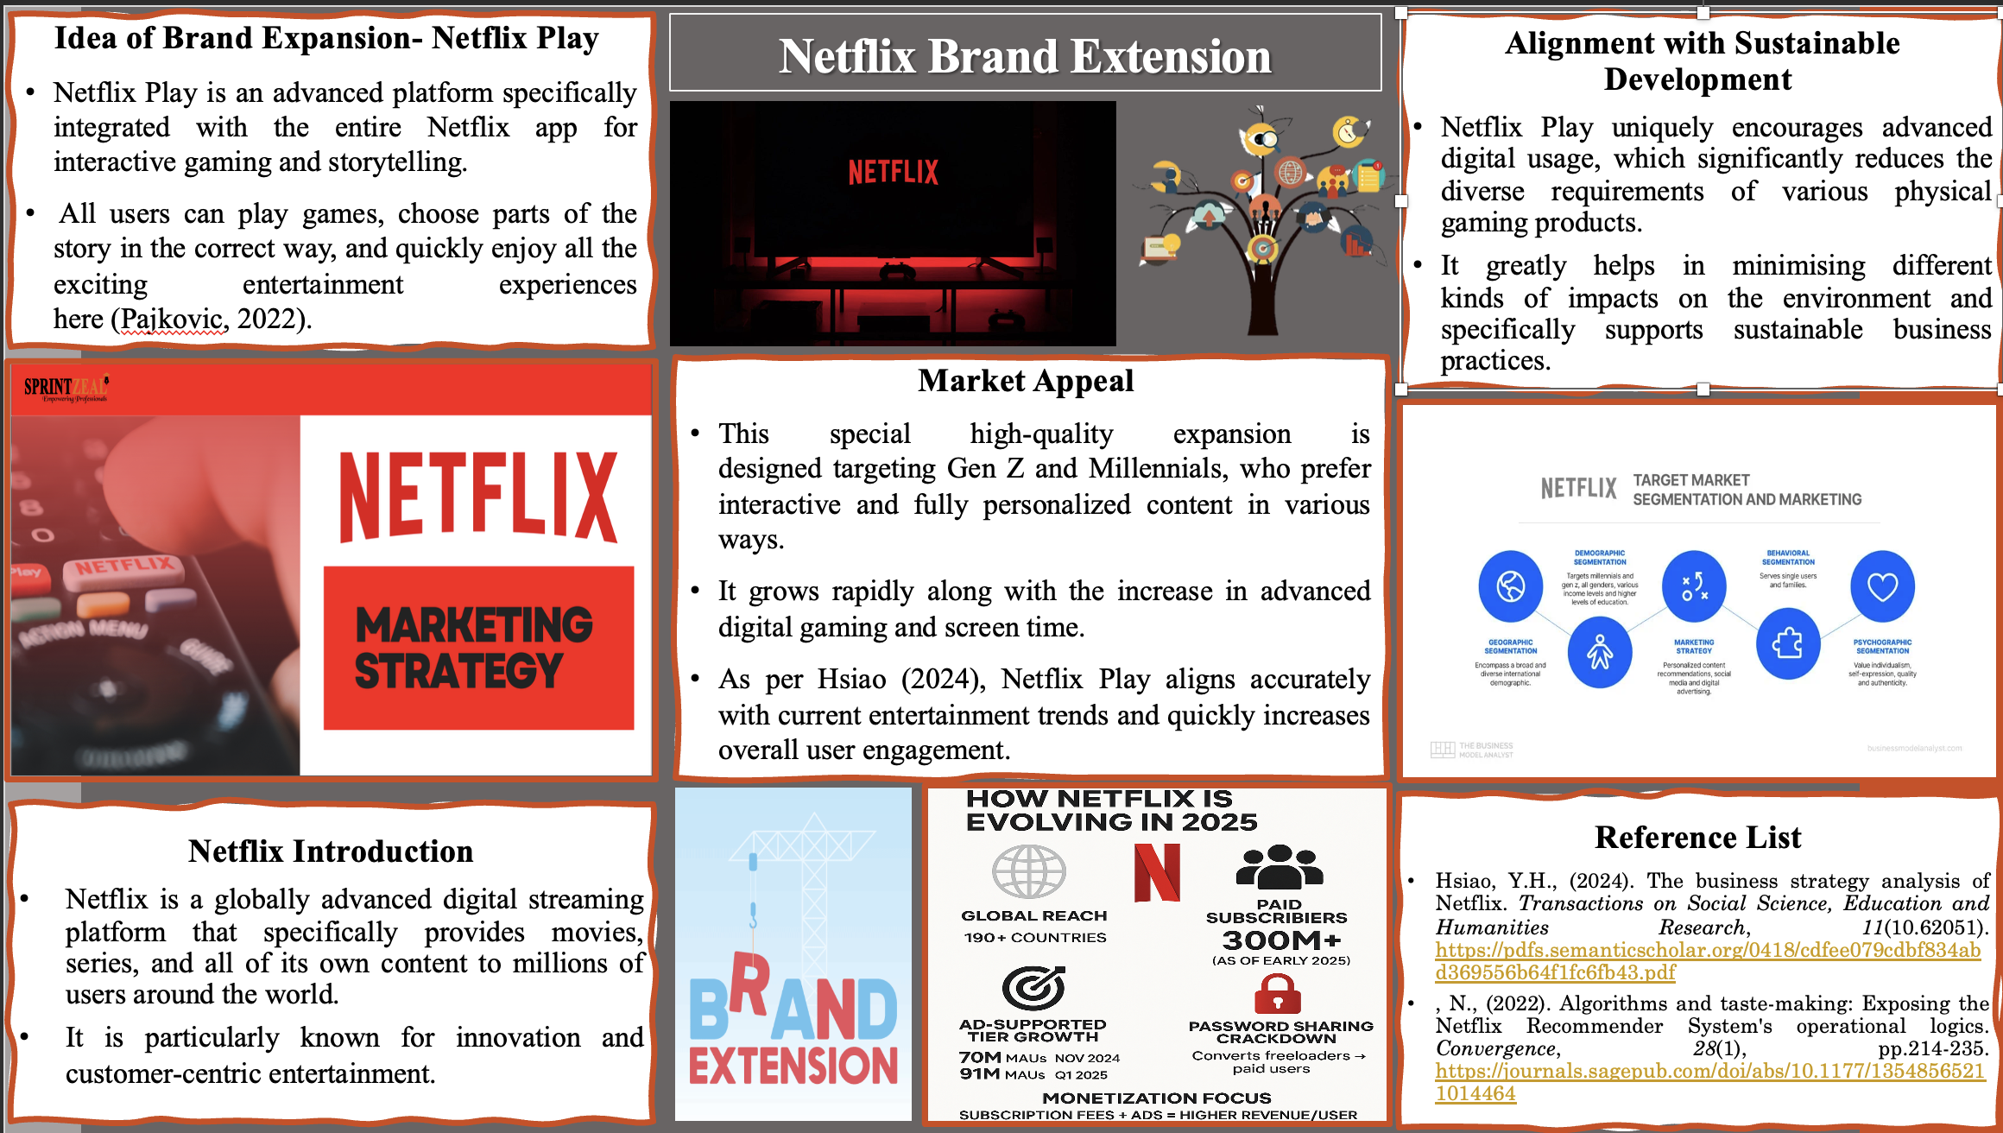
Figure 1: Poster
(Source: Self-made)

