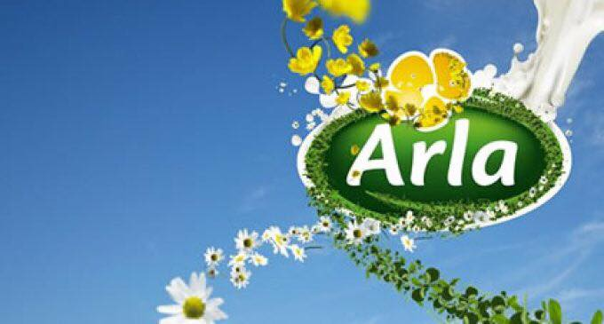

Bianca-Mihaela Poamaneagra, ID: 1809876
Petru Adrian Binisan, ID: 1808250
Nicoleta Claudia Burcus, ID: 1806385
Oana Georgiana Bot, ID: 1714988
Maria-Mihaela Avram, ID: 1809524

History of the company
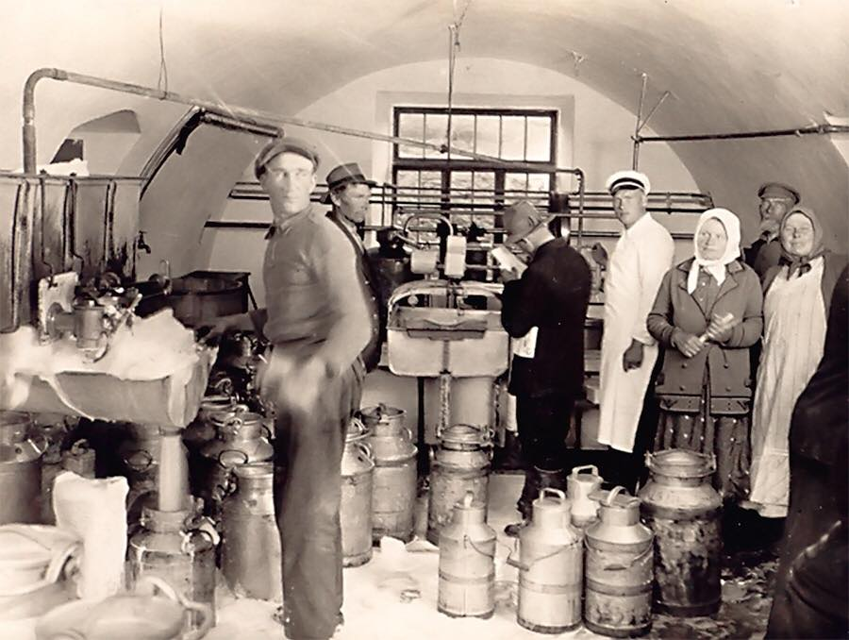

When it comes to the history of Arla, it can be traced back to 1864 when, near Kings Cross station in London, the son of a London dairyman, George Barham formed the Express Country Milk Supply Company. However, the first dates of Arla Foods dates to 1881 when dairy farmers in Sweden and Denmark wanted to invest in common dairy production facilities and so they form small cooperatives to do so.
The roots of Arla Foods can be traced back to a farm in Sweden called Stora Arla Gard, giving a Scandinavian origin. As the time passed the dairies kept growing and as a result the firm began to expand. As a result, in 1882 a Danish cooperative dairy was established in Hjedding. After that, on 1915 the Sweden’s largest cooperative dairy organisation was created by the dairy farmers in Stockholm and the adjoining counties. This new cooperative operated as a chain of shops selling dairy products.
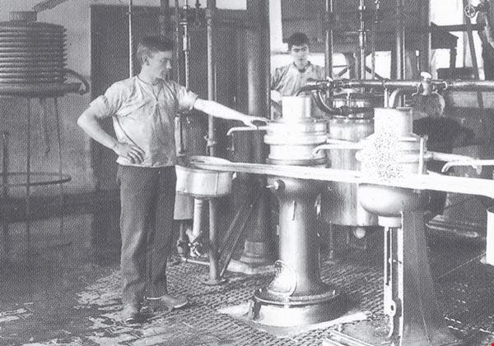
The name under which the company was registered was The Milk Central, shortened MC. This was happening in 1927. Being a large company many other cooperative dairies in other parts of Sweden began joining the big MC.
The name Arla was used between 1909 and 1965 by the largest dairy retailer in Gothenburg. The MC changed its name to Arla in 1975. Before that, in 1970, four dairy companies and three individual dairies formed Majeriselskabet Danmark , known as MD. After 30 years, in 2000, Arla Foods A.m.b.A was formed by the merge of MD Foods with Swedish Arla, having headquarters in Aarhus, Demnark. This is the Arla Foods that we know today.
At the turn of the century, Lurpak butter was introduced to the UK market. This was the link between Arla Food aet al., nd UK. In 2003 Arla Food plc and Express Daries plc merged and formed Arla Foods UK plc, giving the a even bigger company that it was before. In the new formed company, Arla Foods owned 51 per cent of the shares.
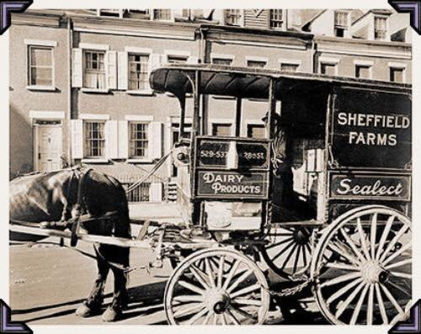
As the company kept growing many changes begin to happen and they needed to keep up with the new generation. With the advent of first-generation computers and rudimentary mobile phones, Arla Food started using email to promote its regular health drink. The expanded print advertisement was given emphasised to communicate with the target audience. The era centred on the search engines, internet and mobile device during the period from 1995 to 2002 (Watson IV et al., 2015). The marketing trends found in this period are early blogging, Pagerank, AdWords, early SEO and others. (Nicoleta Claudia Burcus, 1806385).

Promotion
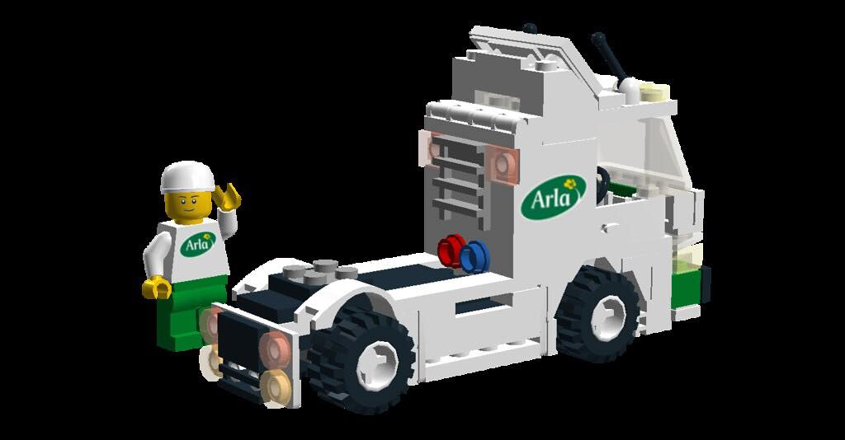
The trends in marketing change with time. Arla organisations take time to accustom with current marketing trends, whereas some change with trends immediately (Armstrong et al., 2015). Grabbing new trends when it comes to creating marketing strategies for target customer groups. An effective marketing strategy depends on the forum, relevance and messaging with the target audience. By considering which marketing strategies have worked well in the past, we could develop a new strategy for its organic health drink. Past trends of marketing are the part of pre-digital age, where we were using printed advertising to promote various health drinks. The common modes advertisements in the previous era are basic print advertisements such as posters, newspapers, phonebooks, flyers and others.
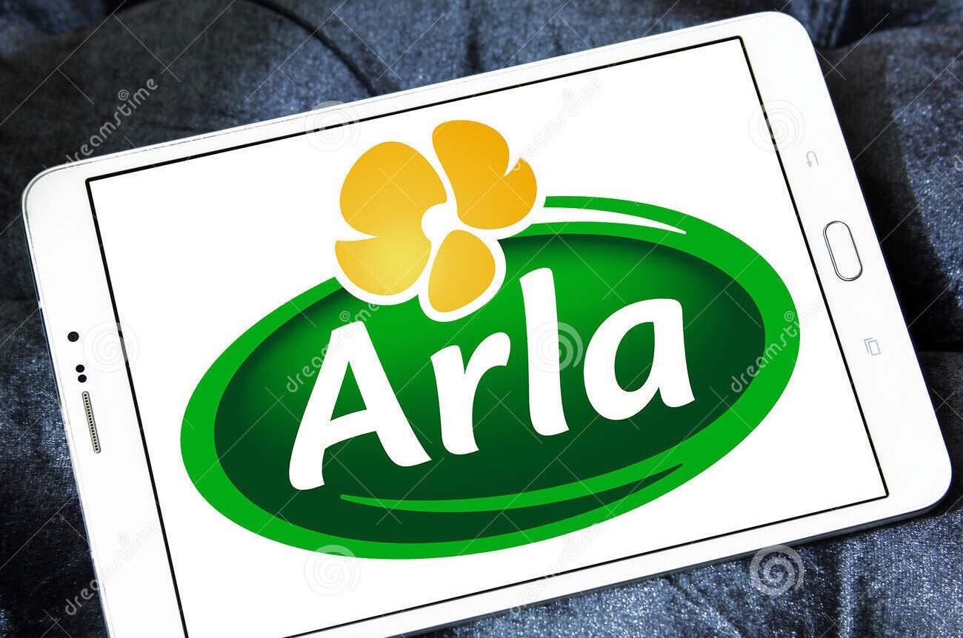

At Arla food we are adopting some common marketing tactics to promote regular health drinks are retargeting campaigns, targeted emails, social media marketing, internet video advertisement and others. The food organisation shall use internet video advertisement and social media campaign in order to communicate with the target audience. It is going to create a page on social media to get views from customers regarding their experience of health drink and the improvements they want in current products. The tagline for social media advertisement created for Natura is “Drink. Energise.Live”.
As our marketing team expects that the organic health drink is going to get much popularity before its introduction due to this creative tagline. It has decided to use Facebook, Instagram and Twitter to promote Natura.
The Internet video advertisement is regarded as the more interactive and engaging marketing trend in current and future marketing perspective. Our marketing team at Arla Food shall develop a video representing the effectiveness of the organic health drink as compared to regular drinks. In-stream and webpage video are the preferred advertisements to be used by our company. In-stream videos pop up during, before and after consumers go through other video contents. The information includes its features, benefit, effectiveness and others.

The future trends of marketing involve making products and promotion strategy more customised. The internet needs of consumers can be understood by connecting with them before utilising ideas for new product development. In-feed videos and interactive banners can shape the advertisement. Future marketing of organic health may involve involving customers in the production and marketing process. Consumers with different age groups may need different varieties of drinks. We can grab this scope for coming with new variants of organic health drinks. (Maria-Mihaela Avram, 1809524)


Our organisation, Arla, launches a new product, which tends to reflect the growing trend for the organic products. We develop an organic drink “Natura” that contains good bacteria and antioxidants infused together with selective minerals and vitamins that helps in boosting the immunity of the body. Arla is one of renowned Food and Beverage Company in UK and its deals with the organic and the product ranges from different variety such as protein products, milk products, and others (arlafoods.co.uk, 2019). With the launch of this product Natura, we want to enter in a new zone of organic drinks that provides health benefits.
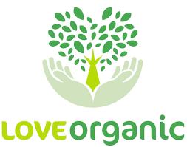

The primary objective of our company is to increase the market shares and the profit generation along with attaining competitive edge among others (Armstrong et al., 2015). This product characteristics are to boost the internal immunity of the body and increase the rate of metabolism. Increasing the metabolism is important because it improves the immunity system of the body and it inculcates the natural healing system in the body. Our products are available at the stores of Arla as well as the company place them in some of the major retail markets in UK like ASDA, Morrisons, TESCO, Sainsbury’s and more others. (Poamaneagra Bianca-Mihaela 1809876)
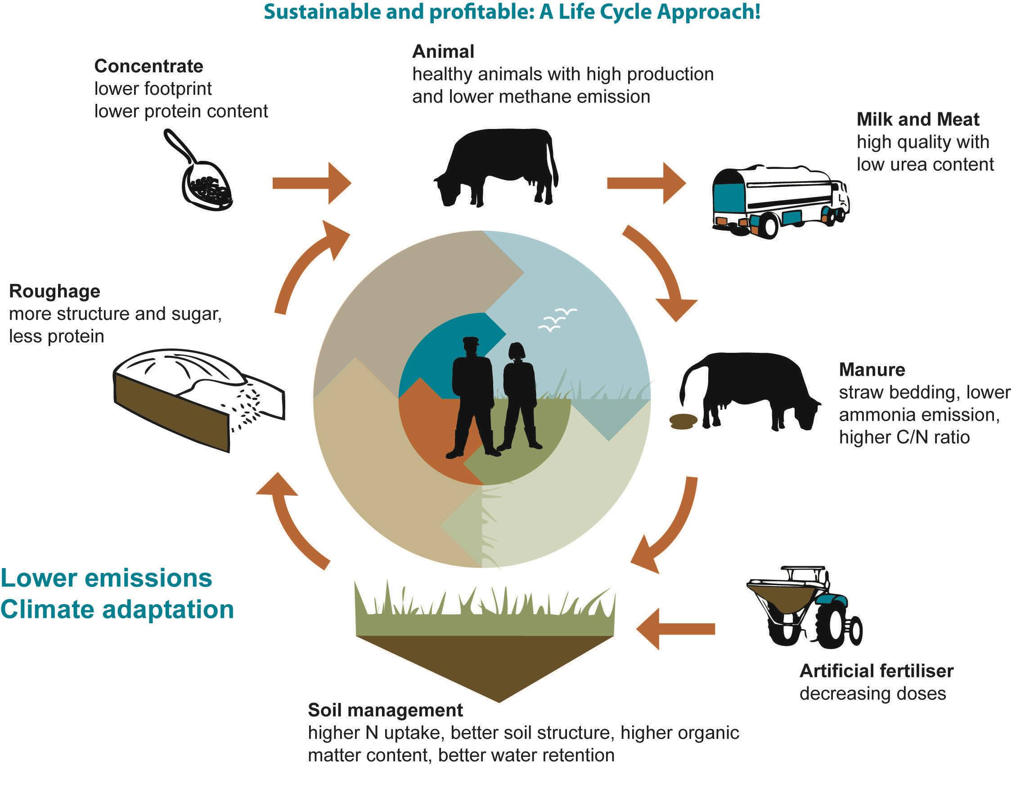

Natura - Segmentation, targeting and positioning for its product
The product “Natura” can be segmented, targeted, and positioned and it is within the estimated food and beverage market. It must be noted that the STP model is usually used for the identifying the right customers and it is through a systematic process. The three major steps are segmentation, targeting and positioning. The basic distinction between the segmentation, targeting, and positioning is that one enables the company to distinguish customers on some basic criteria, the other helps in target the selected group being segmented and the last one enables the company to position the product among the targeted segment of customers (Camilleri, 2018).
It must be noted that the segmentation of the product can be through following the STP model. The segmentation of a product is usually based on the different aspects such as demographical, geographical, firmographic, behavioural, and Psychographic segmentation. The demographic segmentation is based on different parameters such as age, gender, familial background, cultural background, nationality, race, and income. The geographic segmentation depends on the groups in different geographical locations. Further, the firmographic segmentation is based on the different organisations that shall take the product. The behavioural segmentation shall fragment the target market according to the behaviour and decision-making patterns of the customers such as the purchasing patterns, consumption and lifestyle patterns. The psychographic segmentation depends on the lifestyle and personal choices of the target market (Prayag et al., 2015). The segmentation of the product “Natura” shall be based on two parameters, which are demographic and behavioural. The target market shall be segmented based on demography because the product is an organic product and usually a specific age group is known to prefer such drinks. On the similar note, the behavioural segmentation is selected because it understands the purchasing patterns of the target market for such organic drinks. The segmentation of product based on behavioural and demographic parameters because an organic product usually decides according to the age group and prefer of the purchasing patterns of the target customers (Srivastava et al., 2016). (Oana Georgiana Bot, 1714988)
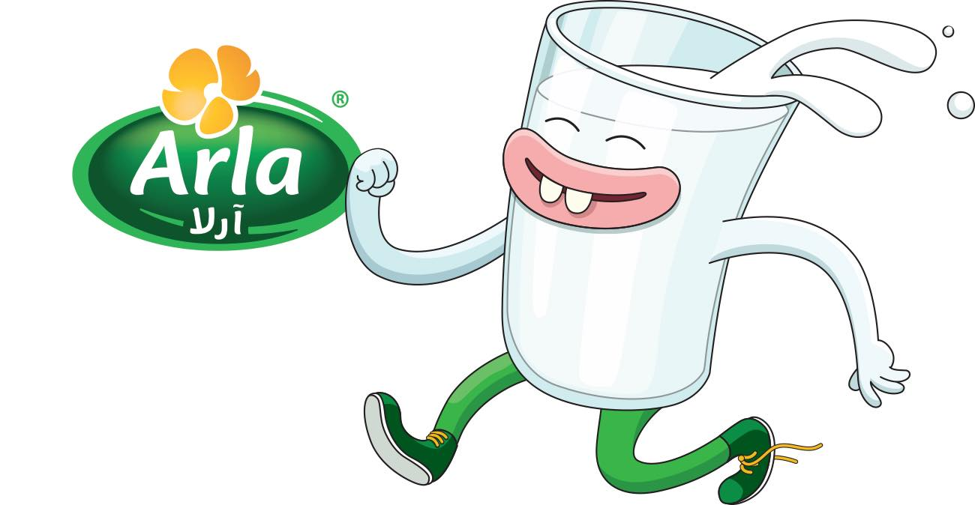
According to the segmented markets for the product “Natura”, the potential customers shall be targeted. Further, for targeting the potential customers, there are several determining factors, which are the profitability of each segment, then analysing the size and growth of each segment and then a PESTLE analysis of each segment. In order to target the customers for the product “Natura”, the organisation Arla shall be analysing each of segment according the above stated factors. Since, the segmentation of this product is based on the demographic and behavioural aspects, the target customers shall be young and fitness conscious people (Rhee et al., 2015). It must be noted that the organisation shall be designing appropriate strategies for attracting the target customers. Moreover, the target customers are known to prefer such products and the organisation attempts to target this customer’s base for increasing the market position of the product.
Positioning of the product is significant because it helps in attracting the target customers. The organisation when positioning its product must select an appropriate marketing mix. Further, the organisation needs to consider its competitors and highlight the unique selling proposition of the product, which shall enable the customers to understand the way the selected segment perceives the product. Moreover, a value proposition for the product must be created in order to understand the way product offering shall be able to meet the needs of the customers (Phillips et al., 2016). Therefore, the product “Natura” needs to positioned among the target customers in order to attract them. Further, the unique value proposition of the product is that it is immunity booster organic drink, which can help in attracting the targeted customers as well as help the organisation to devise appropriate marketing strategies. (Petru Adrian Binisan, 1808250)
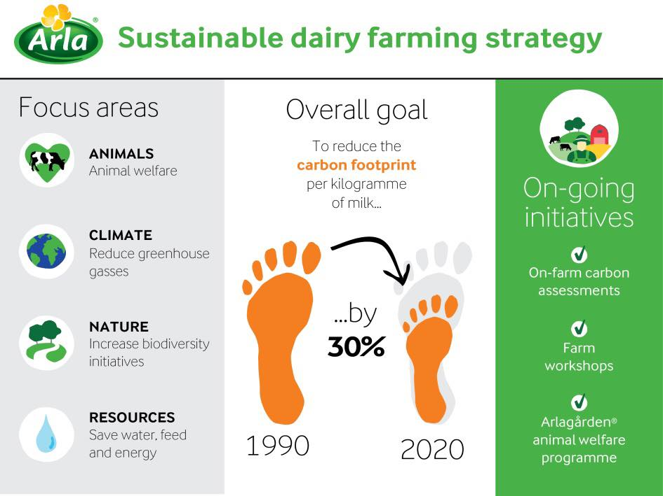
Branding of “Natura”
Brand or product of any organisation underlines the main features of the company and it can be stated that it is more than just a logo. With the advancement of technology and globalisation, the branding of the products has changed over time and according to the needs of the customers along with organisation’s ability to brand it among the target customers. It is important to brand the product because it helps the organisation to gain better customers loyalty, improve the image of the company, and create a more relatable identity (Dinnie, 2015). Moreover, the branding strategies depend on the organisation’s purpose and the capability as well. In other words, the components of branding are organisational purpose, consistency, and emotional connection related to one brand. (Oana Georgiana Bot, 1714988)

Attitude branding can be defined as the ambiguous branding wherein the strategy relates the real life experience or a customised experience in relation to the products and services. Further, the ‘No brand’ branding refers to minimalistic branding and according to it; the organisation follows a simple and generic design for branding of the product. Another strategy is brand extension, which can be defined as the process when the one major brand of the company ventures into a new market and the brand name of the existing brand tend to attract the customers. Private labels refer to the private stores of the company and these not only help in attracting the customers but also are able to achieve edge over its competitors (Gao and Feng, 2016). Crowdsourcing is one of the strategies of branding wherein the branding process is outsourced from public, and the customers are involved in process as well. In other words, the customers’ involvement means that the customers are included in the process of naming and this drives the personal connectivity to the product. (Petru Adrian Binisan, 1808250)
The organisation Arla must adopt effective branding strategies, which shall ensure that the product “Natura” is able to attract the target customers. Since, the organisation is leading Food and Beverage Company in UK, which offers diverse variety of drinks as well as diary products. With the growing trend of organic products, and increasing health risks, it can be stated that the organic drinks can be great hold in the market and as per its unique value proposition of the product “Natura”, it is immunity-boosting drink containing good bacteria. Sence, the organisation Arla can adopt the either brand extension strategy or individual branding strategy. It must be noted that both these strategies can be quite effective for the product. Since, the organisation deals with organic edible products, this drink can be branded by through the brand extension strategy that shall enable to attract the target customers as well as the existing customers of the organisation (arlafoods.co.uk, 2019). Further, the product is an organic health drink and the individual branding strategy is suitable for this product because it shall attract the customers based on its characteristics features.

