7-5-2020
Jose Carmona rodriguez (1917096)

Student name: | Jose Carmona Rodriguez
Student number: | 1917096
Module No: | BMSW4003
Module title: | Digital skills and research methods
Lecturer: | Anupam Mazumdar

Contects
1. Positive impact 2
2. Negative impacts 3
References 4

1. Positive impacts
The IKEA place application continues to be a success in 2020. There are many impacts in the company with this augmented reality since they launched it in 2017.
According to survey made by IKEA, they found out:
- 14% buy wrong size furniture.
- More than 70% have not idea of the measurements of the rooms.
- 33% are confused with the size of furniture.
With these technologies, IKEA helps customers make better decisions. (Lane, 2015).
This application has been downloaded by more than 2 million people and is widely used by customers. The company hopes that customers can browse the products and decorate the house in a more profitable way than build and pay high prices for physical stores. (Marr, 2018)
The type of impact is difficult to measure, but some indicate data can be found.
Usage: It is the second most downloaded free app on Apple ARkit. Becoming the most popular application besides games. It has been rated a 4.7 out of 5.
Ikea´s business impact: Unfortunately, it is impossible to talk about the number of sales, but it was the most sought-after page by Google after launch and generated an incredible marketing shock for the company.
Market impact: IKEA place became a benchmark for being the first to use it. Other companies started doing it later. (Delage, 2018)
As previously discussed, it is difficult to talk about the impact on benefits in IKEA with AR. To get an idea, these are the benefits of this technology.
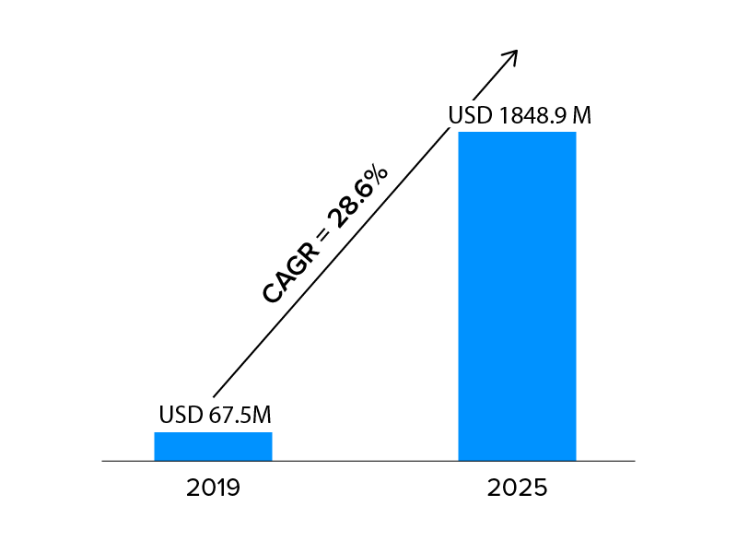
Although most of this technology is used for gaming, these benefits are potentially being for many companies. A proof of them are the 67,5 million dollars in 2019 to 1848,9 million dollars expected to be invoiced by 2025, with a compound annual rate of 28.6%. (Rawat, 2020)
According to these figures, the impact on IKEA could be very positive.
The acceleration of IKEA investments in digital development has helped 46% growth in online sales in 2019, representing 11% of total sales, equivalent to 4.000 million euros. The web received 2.600 million visits. (Eleconomista.es, 2019)
Fewer physical stores and saving fines for the environment will also be two of the most important impacts for the company in the future.
It seems that everything its going well with this type of technology, but as usually happens, there are always some negative points that can affect the company and the workers of the company.

2. Negative impacts
Firstly, IKEA could be its own obstacle because the application can display all kind of furniture but cannot be purchased directly. This can be happened because they do not stop experimenting with the application or it can happen because Ikea place is developed by InterIkea group, which does not have any Ikea store. They sell the franchise to other companies such as Ingka Group. If Ikea would sell the products digitally, it would compete with its own clients. It is also not very clear how the company use data protection. This could create mistrust among clients when showing their houses. (Wilson, 2019)
In my opinion and according to the following photos, this type of application is not currently a substitute for traditional purchases. Also, when the people go to IKEA to buy a piece of furniture, people always buy something else. This small detail could affect the profits of the company.

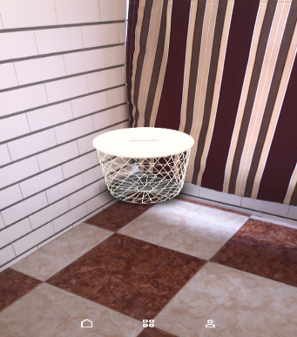
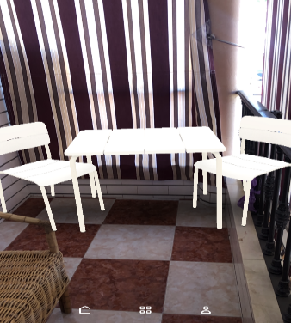


Lastly, this could generate the loss of many jobs. In Coventry city center, UK, a store will close next summer due to the trend of shopping in large shopping center and the internet. It will fire 352 workers. In Spain, for example, 79 people were already fired in 2019. (Europapress, 2020)

References
Delage, S., 2018. Moonshot. [Online]
Available at: http://www.moonshotio.com/2018/06/07/ikea-place-augmented-reality-app-success/
[Accessed 28 April 2020].
Eleconomista.es, 2019. [Online]
Available at: https://www.eleconomista.es/empresas-finanzas/noticias/10103430/09/19/Ikea-aumenta-su-facturacion-un-65-en-su-ano-fiscal-hasta-41300-millones.html
[Accessed 04 May 2020].
Europapress, 2020. [Online]
Available at: https://www.europapress.es/economia/noticia-ikea-cerrara-tienda-reino-unido-pone-peligro-352-empleos-20200204165512.html
[Accessed 04 May 2020].
Lane, A., 2015. Shopifi. [Online]
Available at: https://es.shopify.com/blog/59898373-la-realidad-virtual-y-las-compras-llega-el-futuro-para-revolucionar-el-comercio
[Accessed 28 April 2020].
Marr, B., 2018. Forbes. [Online]
Available at: https://www.forbes.com/sites/bernardmarr/2018/10/19/the-amazing-digital-transformation-of-ikea-virtual-reality-apps-self-driving-cars/#6ddd693376be
[Accessed 27 April 2020].
Rawat, A., 2020. Appinventiv. [Online]
Available at: https://appinventiv.com/blog/augmented-reality-benefits-for-businesses/
[Accessed 28 April 2020].
Wilson, M., 2019. Fastcompany. [Online]
Available at: https://www.fastcompany.com/90406651/the-biggest-hurdle-in-ikeas-quest-to-become-a-tech-company-might-be-ikea-itself
[Accessed 27 April 2020].

