Procurement and Tendering
Procurement Assignement 1
JACK Bailey
2026
Contents
Introduction 1
Advantages and Disadvantages for Procurement Routes 1
The Ideal Procurement Route 2
RIBA Plan of Works 3
Contract Types – JCT Vs NEC4 5
Tendering Processes 5
The Selective Tendering Process and its Variations 6
My Recommendation for Tendering 6
Conclusion 7
References 7
Figures 9

Introduction
As a developer delivering a new construction training centre in Swansea SA1, the priority is achieving strong cost certainty while maintaining quality and functionality. With external funding secured and the project being larger than previous developments, choosing the correct procurement route is essential to manage risk, control expenditure, and ensure predictable delivery.
It is important to recognise that faster delivery can increase the risk of design errors and costly rework, while slower delivery can also lead to excessive costs if not managed effectively, the procurement route must balance programme efficiency with cost control.

Advantages and Disadvantages for Procurement Routes
below are the different procurement routes and their respective pros and cons: -
 | Pros | Cons
Traditional​ | - Clear role definition  - Strong cost certainty at contract award  - High control of design | - Longer duration  - Less flexibility for changes  - Higher risk of disputes
Design and Build​ | - Single point of responsibility streamlined planning.  - Cost certainty earlier  - Faster delivery | - Quality can vary.  - Changes can be difficult.  - Forces transparency
Management Contracting​ | - Transparent cost control  - Flexible with late changes  - Early start on site | - Final cost is uncertain.  - Requires heavy client involvement.  - Relies on management contractors’ competence
Construction Management​ | - High transparency of costs  - Strong flexibility & collaboration  - Maximum client control | - Costs are not known fully till later in project.  - Coordination challenges  - Client exposed to more risk
Collaboration​ | - Cost and time efficiencies  - Higher quality outcome  - Better communication | - Higher initial costs  - Increased time investment early on  - No clear lines for responsibility
PFI/PPP​ | - Predictable long-term costs  - Clear coordination & responsibility  - Risks transferred to private sector | - Expensive costs for long term contracts  - Reduced flexibility  - Can be controversial & have public resistance
(Aquino, 2022), (Sponaugle, 2014)

The Ideal Procurement Route

Given the project’s funding structure and the clear priority of delivering within the fixed budget, the most appropriate procurement route is Traditional (Design – Bid - Build). This route provides the highest level of cost certainty at contract award. This is due to the fully developed design before tendering; this forces contractors to price complete and coordinated sets of information. This can significantly reduce the likelihood of variations, scope creep, or unforeseen cost increases during construction. (“The Pros and Cons of Traditional Procurement Explained”)

Alternatives available such as Management Contracting, Construction Management, and PFI / PPP can ruled out early as they expose the client to higher financial risk, rely on open-ended cost commitments, or require long-term revenue streams that are incompatible with the project’s objectives. While Design and Build and collaborative/partnering approaches offer advantages in programme and integration, they typically involve less design control at tender stage, which can reduce cost predictability and introduce uncertainty around quality and specification. (“Table 1, 2, 3. (Continued)”) (Metroun)
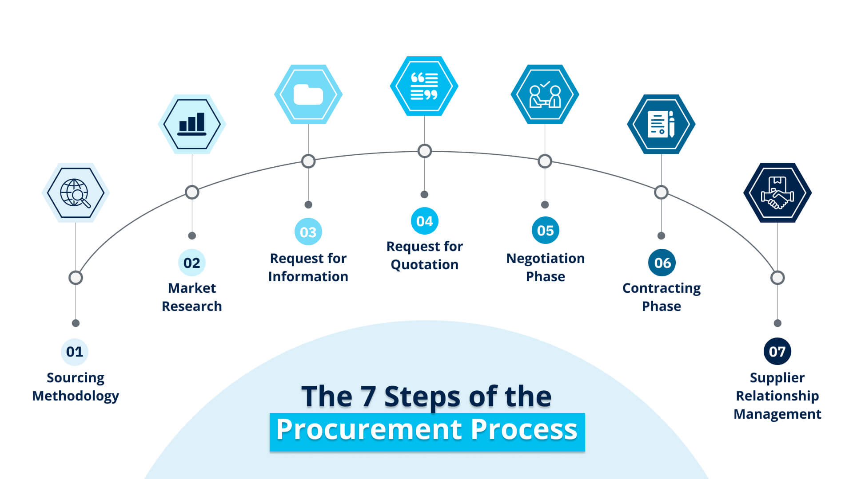
Figure 2 - the procurement steps
Traditional procurement aligns most closely with the project’s goals because it: -
- Maximises cost certainty through a complete pre-tender design.
- Provides clear role definition and accountability, reducing disputes and cost overruns.
- Retains strong client control over design, ensuring the final building meets the intended functional and quality requirements.
- Supports competitive tendering on a like-for-like basis, strengthening value for money.
For a fully funded project where predictable spending and financial accountability are essential, traditional procurement offers the most reliable route to achieving budget certainty while maintaining design quality.

RIBA Plan of Works
We can look to use the RIBA Plan of Works 2020 to help organise the projects; firstly, we can structure and make a roadmap of the entirety of the project. By breaking down the project into eight stages we can identify problems early and co-ordinate all teams working on the project. It is essential to make use of the plan of works to prevent common avoidable errors such as overruns and unexpected delays.
This practice also helps to ensure that all core tasks and process are complete before moving ahead with the project and continues in a loop; by looking back at how the project was run and giving feedback it can help future projects run more efficiently. The stages for the RIBA plan of works are as follows:
Stage 0 (Strategic Definition) establishes the feasibility, the vision for the project and the goals of the job.
Stage 1 (Preparation and Briefing) starts to identify project constraints and sets the cost and quality priorities. These can then used to derive the best procurement route given the need for strong cost certainty.
Stage 2 (Concept Design) as well as Stage 3 (Spatial Coordination) progress the design to a suitable level for accurate cost planning. Under a Traditional procurement route, the design is fully developed by the end of Stage 3, enabling a comprehensive tender package at Stage 4 (Technical Design). This is where contractors price a complete set of drawings and specifications.
Stage 5 (Construction) then starts with clearly defined responsibilities and minimal design change, supporting predictable delivery.
Stage 6 (Handover) ensures the building is commissioned, defects are managed, and the facilities are operational.
Stage 7 (Use) focuses on post-occupancy evaluation and long-term performance.
Aligning the project with all eight RIBA stages reinforces the advantages of Traditional procurement by ensuring design completeness, competitive tendering, and strong cost control before work begins on site. (RIBA Plan for Use Guide RIBA Plan of Work; “RIBA Plan of Work”)
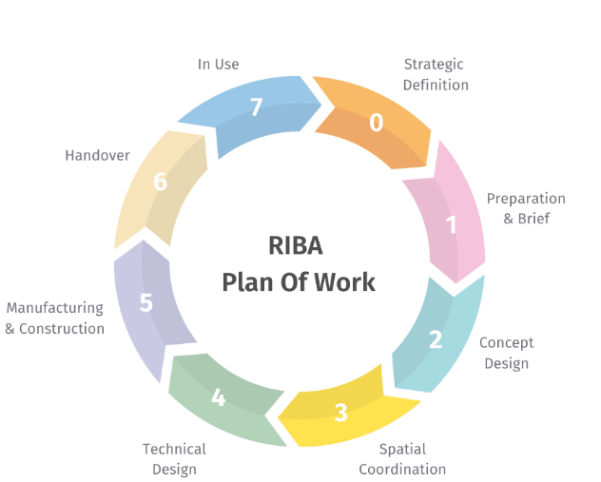
Figure 1 - RIBA Plan of Works

Contract Types – JCT Vs NEC4

Along with these it is important to decide on the contract type, construction contracts set out the legal responsibilities, risk allocation, and payment mechanisms between the client and contractor, meaning the chosen contract must support the selected procurement route.
For this project, I believe the JCT Contract is the most appropriate option because the project starts with a fully developed design before tender. It provides clear separation of design and construction duties and offers strong cost-control mechanisms. JCT contracts also provide defined procedures for variations, extensions of time, and quality standards, reducing uncertainty during the project. (Metroun) (Charles Russell Speechlys)
While NEC4 contracts promote collaboration and flexibility, they require more intensive management and are better suited to projects where design continues during construction. This means that a JCT contract will provide the most predictable and structured contractual environment given the requirements and selected route. (Charles Russell Speechlys)

Tendering Processes

Next, we look at tendering processes. There are multiple process’ to choose from each again having their own advantages and disadvantages. Below is a table based on compatibility with traditional procurement.
Tendering Method | Suitability for Traditional Procurement | Cost Certainty | Characteristics
Selective Tendering | High | High | Best balance of competition and quality
Open Tendering | Moderate | Moderate | Transparent but retain less control
Negotiated Tendering | Low | Moderate – Low | Specialist with limited options
Two stage Tendering | Low | Moderate | Better for collaborative procurement
Serial tendering | Low – Moderate | Moderate - High | Usually for repeat builds, contractors tender for initial builds and adjust for future projects
Framework tendering | Moderate | Moderate – High | Contractors bid on pre-selected framework for the job, tendering for mini competitions
(Quantity Surveying Hub - An Educational Resource for Aspiring and Experienced Quantity Surveyors, 2024), (RICS, 2014)

The Selective Tendering Process and its Variations

With this table we can see that selective tendering would be the best approach given the high-cost certainty. There are two types of selective tendering, either single stage or two stage.
The main difference is that two stage has the contractors involved earlier in the project with minimal information and tenders are submitted on the minimal info provided, the second stage then involves working with the preferred tender to develop a precise specification to then take to construction, this variant is often used for complex projects where the contractor may have valuable design input. (Wood, 2025)
Single stage is more streamlined than the two-stage process. While both options select competent contractors with experience, financial standing and demonstrated ability, the single stage variant has the project fully designed. This forces the contractor to give more competitive pricing as they all base their prices on the same completed framework. (Richardson, 2026), (SCAPE, 2021), (Wood, 2025)

Downsides to this variation include.
- Limited collaboration before the project begins.
- Due to the competitive nature of the tender, pressured contractors may look to cut costs in other places potentially affecting the quality.
- If information is missing or unclear in the tender it will lead to unforeseen costs later
The two stage the selective process compliments the traditional procurement style the best. It enables early contractor involvement while still maintaining competitive tension.

My Recommendation for Tendering

I would recommend using two stage selective tendering as it offers more oversight and assistance during the design phase. Early collaboration on especially in complex projects means that overall risks such as cost controlling and unnecessary programme delays can be avoided more easily. Early engagement of both contractor and client will help to ensure a good outcome with clear input and feedback on what needs to change before moving forward. This communication is vital to ensuring the project’s success and staying within budget. While this can take longer compared to single stage, the potential costs saved from redesigns and errors while in construction outweigh potential time saved via single stage. (Richardson, 2026), (SCAPE, 2021), (Wood, 2025)

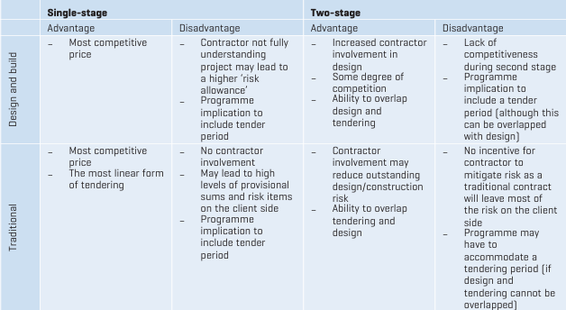
Figure 3 - single vs two stage

Conclusion

In conclusion, given the project and constraints, I would recommend a traditional procurement method due to its strengths and alignment with the targets for the project. I would also recommend going with a JCT contract as this helps to reinforce the strengths of traditional procurement, it also clearly defines responsibility and includes structures for any variations or other costs during the project’s duration. Lastly, I would recommend the two-stage selective tendering due to its emphasis on communication and oversight throughout the project.

References

Builtinteriors.com. (2023). The Pros and Cons of Traditional Procurement Explained. [online] Available at: https://www.builtinteriors.com/blog-posts/the-pros-and-cons-of-traditional-procurement-explained.
Charles Russell Speechlys (2022). JCT v NEC: Which contract is right for your project? [online] Charles Russell Speechlys. Available at: https://www.charlesrussellspeechlys.com/en/insights/expert-insights/construction-engineering-and-projects/2022/jct-v-nec-which-contract-is-right-for-your-project/.
Live.com. (2022). Available at: https://view.officeapps.live.com/op/view.aspx?src=https%3A%2F%2Fwww.riba.org%2Fmedia%2Fqj1nfrg1%2Fribaplanofworktoolbox_jul2022.xlsx&wdOrigin=BROWSELINK.
Marijn Overvest (2022). 5 Popular Procurement Methods in 2026. [online] Procurement Tactics. Available at: https://procurementtactics.com/procurement-methods [Accessed 17 Apr. 2026].
Metroun (2020). The Perks & Pitfalls of a JCT Traditional Procurement Route. [online] Metroun. Available at: https://metroun.co.uk/post/the-perks-pitfalls-of-a-jct-traditional-procurement-route/.
Procurementtactics.com. (2026). Available at: https://procurementtactics.com/wp-content/uploads/2025/02/The-7-Steps-of-the-Procurement-Process.jpg [Accessed 17 Apr. 2026].
quantitysurveyinghub@gmail.com (2024). Tendering Strategies for Construction Contracts - Quantity Surveying Hub. [online] Quantity Surveying Hub - An Educational Resource for Aspiring and Experienced Quantity Surveyors. Available at: https://quantitysurveyinghub.com/tendering-strategies-for-construction-contracts [Accessed 17 Apr. 2026].
ResearchGate. (n.d.). Table 1. (continued). [online] Available at: https://www.researchgate.net/figure/continued_tbl2_319342302.
RIBA Plan for Use Guide RIBA Plan of Work. (n.d.). Available at: https://www.riba.org/media/54tn0pr2/plan-for-use-guide-2021.pdf.
Riba.org. (2020). RIBA Plan of Work. [online] Available at: https://www.riba.org/work/insights-and-resources/riba-plan-of-work/.
Richardson, M. (2026). One-Stage Tendering vs Two-Stage Tendering: Choosing the Right Procurement Route for Your UK Project. [online] Trigon Ltd. Available at: https://www.trigonltd.co.uk/post/one-stage-tendering-vs-two-stage-tendering-choosing-the-right-procurement-route-for-your-uk-project.
Rics.org. (2025). Available at: https://www.rics.org/profession-standards/rics-standards-and-guidance/sector-standards/construction-standards/black-book/tendering-strategies.
SCAPE (2021). Single Stage Vs Two Stage Tendering - Procurement Process. [online] SCAPE. Available at: https://scape.co.uk/news/single-stage-vs-two-stage-tendering.
seanthorpe (2024). Understanding Traditional Procurement Method. [online] Construction Wiki. Available at: https://constructionwiki.co.uk/2024/03/04/traditional-procurement-method [Accessed 17 Apr. 2026].
Udemy Editor (2021). 6 Procurement Methods You Need to Know - Udemy Blog. [online] Udemy Blog. Available at: https://blog.udemy.com/procurement-methods [Accessed 17 Apr. 2026].
Wood, C. (2025). Cost-effective, timely delivery starts with picking the right tendering method. Two common options are single-stage and two-stage tendering - both valid, but with different strategic implications. [online] Linkedin.com. Available at: https://www.linkedin.com/pulse/single-stage-vs-two-stage-tendering-pros-cons-colin-wood-tvyme.

Figures

Figure 1 - RIBA-2.png (940×788)
Figure 2 - The-7-Steps-of-the-Procurement-Process.jpg (1920×1080)
Figure 3 - Practice Standards

