Name:___________________Matthew Hope______________

Student Number: ________________2509337________
__________________________________________________________

WORKSHEET 1 – TESTING (Using Variables)

- Original code:
[Copy and paste your original code from Moodle into this box. Do not change it.]
print("Please enter your Surname?")
userSurname =input()

print("Whats your NI number?")
userNInumber = input()

print("What is your age?")
age = int(input())
while age <= 0 :
print("try again")
age = int(input())

print("Enter number of working hours per week")
workingHours = int(input())

- Code Testing

For each test below, run your code and enter the values provided. Present a screenshot of the programme running. Did the programme behave correctly or did it do something unexpected, and if so, why?

Surname:
- Enter JONES
- Leave blank
- Enter A
- Enter 123

National Insurance Number:
- Enter PE534121B
- Leave blank
- Enter AB11223344556677 (ie too long for National Insurance number format)
- Enter 22PE4088A (ie wrong format)

Age
- Enter 34
- Enter 150
- Enter -4
- Enter a letter

Number of working hours per week:
- Enter 37.5
- Enter 150
- Enter 0
- Enter -2

Fill in a box for each test above. You should present 16 separate boxes, 1 for each test. (Note: the first two boxes are provided as a template)

Screenshot(s) of output:

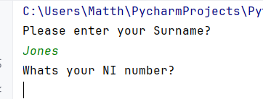
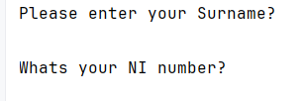

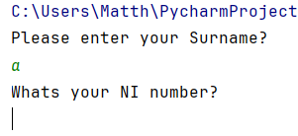
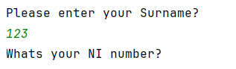
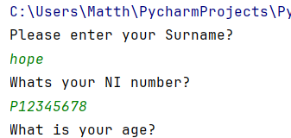

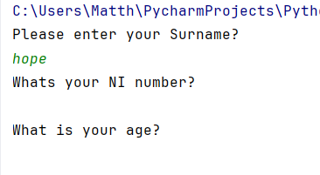
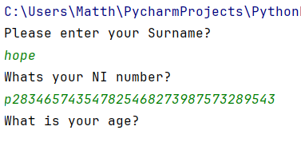
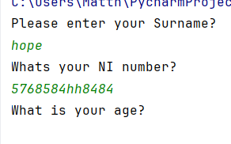

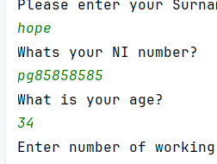

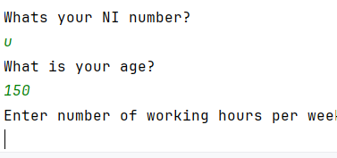

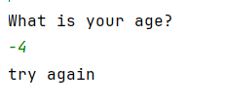
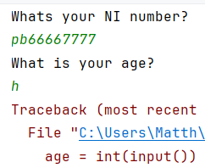

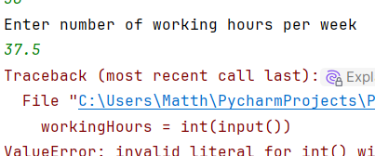

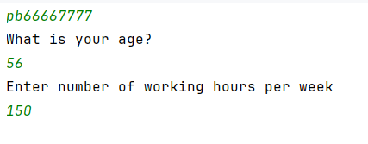

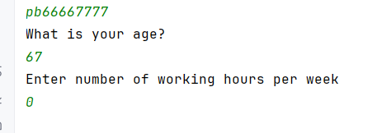

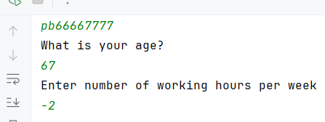

Result: Did the programme behave as expected ie syntactically and logically correct?
YES

- Consider the results of the above tests and revisit your code in order to solve the problems. (Note: you may not be able to solve all of them, but solve as many as you can.)

Paste your revised code here:

[Copy and paste your revised code here – note, do not use a screenshot]

print("Please enter your Surname?")
userSurname = input()

while True:
if userSurname == "":
print("Try again")
userSurname = input()
else:
try:
int(userSurname)
print("Try again - enter a valid surname")
userSurname = input()
except:
break

print("Whats your NI number?")
userNInumber = input()

while userNInumber == "":
print("Try again")
userNInumber = input()

print("What is your age?")
while True:
try:
age = int(input())
if age > 0:
break
else:
print("Try again - enter a valid age")
except:
print("Try again - enter a number")

print("Enter number of working hours per week")
while True:
try:
workingHours = int(input())
if workingHours >= 1 and workingHours <= 100:
break
else:
print("Try again - enter a number between 1 and 100")
except:
print("Try again - enter a number")

