Student name: | Bilquis Ashraf
Student ID number: | 2426398
Programme: | Certificate of Higher Education Skills for the Workplace (Health & Social Care
Module: | Introduction to Health and Social Care (LCHS4003)
Lecturer: | Deniel Haruna
Assignment Title: | Portfolio – Task 1: Community Disability Services

Community Disability Services in the UK
Explanation of the chosen healthcare service
Community Disability Services help people with disabilities in their communities. These services are aimed to promote health, reduce inequality and enable individuals to participate in society. With personalised support, Community Disability Services help individuals maintain dignity, choice and control over their daily lives.

1. What Are Community Disability Services?
Community Disability Services support adults and children, including those with mental health conditions. They aim to support independence, social attachment and a good quality of life.
These services follow personal care method to help everyone’s needs. People with families as active partners, help to choose and support according to their skills and goals.
They follow the Care Act 2014 which promotes safety, dignity, choice and work with health services. The Equality Act 2010 protects people from difference and confirms everyone gets services equally.
2. Key Features and Importance
- Individualised care: Focuses on what is important for the individual, helps to improve health, happiness and be part of society.
- Independence and Attachment: Helps people to live independently in the community, get involved in work, education, freedom and relationships.
- Early prevention and mediation: Early support helps to stop problems from getting worse
- Legal Protections: Social care and equality laws confirm access, responsibility and anti-judgement measures.
3. Examples of Community Disability Services
- Helping with everyday personal care at home, like bathing, dressing, and making meals.
- Helping with equipment and home changes, like mobility aids, to make daily life easier.
- Providing day programs and chances to socialise.
- Helping with everyday routines.
- Getting support from specialist teams, including nursing, therapy, and care staff who help with behaviour management.
- Helping with transport and access, including wheelchair support.
- Helping people with work and learning opportunities.
- Providing programs and community groups to help reduce loneliness.
These services are provided by local authorities, NHS trusts, charities or private providers.

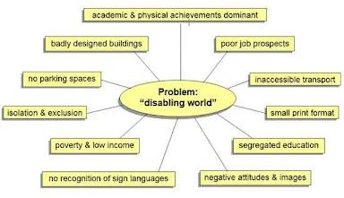

Brief History of Community Disability Services
Before the 1990s care for disabled people in the UK was provided in hospitals, asylums and residential institutions. These places make it hard for people to be independent, individual decisions making and community involvement plus many individuals experienced isolation.
After World War II, the NHS and the 1970 Disabled Persons Act helped support the rights and needs of disabled people.
In the 1980s, the disabled people’s movement worked for change, forming early Centres personal support campaigning against staying for a long time in hospitals. The 1981 Jay Report recommended care in the community.
The NHS and Community Care Act 1990 gave local authorities responsibility for arranging care, promoting community support, independent living, care from public, private, and voluntary providers.
The Community Care Act 1996 gave people money to arrange their own support. The Disability Discrimination Act 1995 and part of the Equality Act 2010 immediately improved legal protections and accessibility for all.
In the 21st century policies like Putting People First (2007) and the Care Act 2014 promoted personalised care, independence and choice supported by personal budgets. This changed care from hospitals to community service but, funding is still difficult.
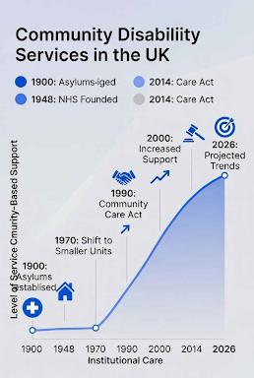

Current Functioning of Community Disability Services
UK Community Disability Services use mixed funding to provide personalised support for independence and health.
Who Provides the Services?
- Local Authorities assess needs, manage funds, provide personal budgets, arrange services and monitor quality.
- Private and third sector organisations provide supported care and support services, break, employment support and specialist condition support.
- NHS Services and ICSs provide specialist support via nurses, therapists and mental health teams.
Other contributors like housing providers, community groups and DPOs, offer support and ways to help plan services.
Usual process for service users
- Referral and Needs Assessment: Assessments consider the person’s comfort, advantages and access to health services.
- Eligibility Purpose: Support is provided according to the person’s disability and its effects and carers can also qualify.
- Care and Support Plans are made with the person, show their goals, required services links to health and housing. Services can be arranged by the authority.
- Personal budgets fund care and can be managed by the authority, an organisation, or the person.
- “Services are delivered by chosen or commissioned providers, with flexibility, quality checks and supervision.
- Support is reviewed at least once a year to update plans, check progress and ensure needs continue to be met.

Key Challenges Facing Community Disability Services
In 2025–2026, Community Disability Services in England face pressure from shifting population needs, limited funding and staff shortages.
Challenge 1: Funding and Resource Pressures
Services face financial stress from rising demand, increasing care difficulty and limited budgets. Councils projected a £623 million overspend in 2025/26, with further savings needed in 2026/27 to meet statutory duties.
Funding pressures lead to:
- Stricter requirements and reduced services
- Decreases in early help and preventive care
- Greater support on unpaid carers
- Delays in assessments and support lead to poorer outcomes and lack of equal access to services.
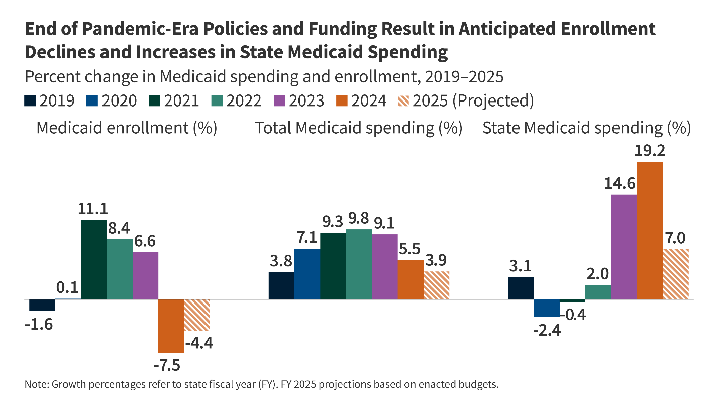
Challenge 2: Workforce Shortages
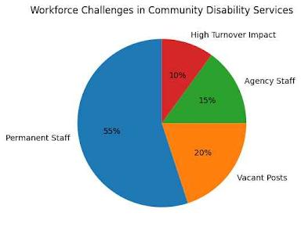
Adult social care has many staff leaving jobs, which affects care and increases use of temporary staff. Key issues include:

► Problems hiring and keeping staff with limited workers on recruiting from abroad due to visa rules
► Low salary and demanding working conditions
► Service ends as contract expires. These problems affect thousands of users
Staff shortages lose trust, affect stability of care and make it harder to provide support.
Funding and staff shortages make it harder for Community Disability Services. They cause service delays, strain unpaid carers and the NHS and create issues. More investment in funding, staff and services is required to keep care strong.

Future improvements depend on:
- Stronger connection between health and social care to improve coordination and reduce costs.
- Reliable funding, fair pay, trained staff and supportive community policies.
With these instructions, Community Disability Services can support people with disabilities and recognise their presence in society.

Conclusion
Community Disability Services help people with disabilities live independently in their communities. They support security, skills, social participation and equal access to everyday activities. Even with challenges like funds, low pay and staff shortages these services remain essential for promoting quality of life.

References
1. Association of Directors of Adult Social Services (ADASS) (2023) Spring Survey Report. Available at: https://www.adass.org.uk/publications/ (Accessed: January 2026).
2. Department of Health and Social Care (DHSC) (2014) Care Act 2014: Statutory guidance. Available at: https://www.legislation.gov.uk/ukpga/2014/23/contents/enacted (Accessed: January 2026).
3. Mencap (2023) Our campaigns. Available at: https://www.mencap.org.uk/what-we-do/campaigning (Accessed: January 2026).

Portfolio Submission: Task 2 (Essay)
Health Care Services
- Pharmacy services

The Development and Influence of Pharmacy Services in the UK
Introduction
Pharmacy services are an important part of healthcare in the UK. They support patients by supplying medicines and giving advice. while also work closely with doctors and other healthcare professionals. Pharmacy services have expanded beyond medicine supply to include clinical care and public health support. This essay explores the historical development of pharmacy services, their role in modern healthcare and improving people’s health.

Historical Origins and Development
Pharmacy in the UK started with pharmacists and people who sold medicine. The Pharmacy Act 1852 officially recognized pharmacy as a profession. It brought in education and registration support to help keep people safe. Anderson wrote about this in 2005.
When the NHS started in 1948, it made medicines free during treatment and set up community pharmacies. By the late 20th century, pharmacists’ care went beyond just medicine. They learned a lot about medicine and got good at helping patients take their medications safely (Pharmaceutical Services Negotiating Committee, 2023).
Modern Functioning of Pharmacy Services (Community Pharmacy Services)
In the UK, pharmacy services are offered through community pharmacies, hospitals and general practice clinics. There are about 11,500 community pharmacies across England and they do more than just hand out medicines (NHS England, 2024). They offer important services like handing out prescriptions and giving health advice. They also run more advanced programs like the New Medicine Service and the Community Pharmacist Consultation Service, which support people starting new medications or dealing with minor health issues.

Hospital and Clinical Pharmacy Services
Hospital pharmacists work in teams to check patient’s medicines, improve treatment plans and offer specialist advice like infection control and cancer care. Clinical pharmacists can also assess patients and prescribe medicines independently within their professional scope (General Pharmaceutical Council, 2022).
Digital and Technological Developments
Technology has made pharmacy services faster. Electronic prescriptions, online consultations, and medicine management apps help patients get care more easily.
Significance of Pharmacy Services in Enhancing Quality of Life
Accessibility and Medication Management
Pharmacy services make everyday life easier by providing medicines and help public health. They have longer opened hours and do not require appointments, which helps people get care for minor illnesses and eases the load on GP services (Todd et al.). Medicine management reviews help patients, especially those with tricky treatment plans, by cutting down on medication problems and keeping them out of the hospital.
Public Health and Preventive Care
Pharmacies play an important role in promoting independent health management. Services such as structured medication reviews help patients understand their treatments and manage their health well. Public health ideas, including smoking end, weight management, vaccination programmes and heart disease prevention, allow pharmacies to deal with wider health factors (Public Health England, 2022).
Services for people with additional needs
Pharmacy services help people who are most weak, such as those who face language issues and social challenges. Home delivery, multilingual staff and links to community services make sure they can access healthcare and get support for other issues affecting their quality of life.
Conclusion
Pharmacy services have changed over the years and became an important part of the NHS. They provide clinical care, health advice and work with other healthcare services. As a result of being easy to reach and offering expert advice, pharmacies help people take their medicines safely, look after their health and prevent sickness. As healthcare focuses more on community care, pharmacies play a bigger role in providing care.

References (Harvard UTWS style)
- Anderson, S. (2005) ‘The historical context of pharmacy’, in Taylor, K. and Harding, G. (eds.) Pharmacy Practice. London: Taylor & Francis, pp. 3–18. Available at: https://books.google.com/books/about/Pharmacy_Practice.html?id=PClwC5JcmfcC
(Accessed: 15 January 2026).

- General Pharmaceutical Council (2022) Standards for registered pharmacies. Available at: https://www.pharmacyregulation.org
(Accessed: 15 January 2026).

- NHS England (2024) Community Pharmacy Services. Available at: https://www.england.nhs.uk/primary-care/pharmacy
(Accessed: 14 January 2026).

